**EECS 1012 Term Project – Phase 2**

**Team Name:** *Game Hunters*

**Project Members:**

* Ao Jiang, Section B Lab 02, [ja2020@my.yorku.ca](mailto:ja2020@my.yorku.ca)
* Omar Shaikh, Section B Lab 02, [omars214@my.yorku.ca](mailto:omars214@my.yorku.ca)

**WIREFRAMES**

*Main Screen*

*Username & Password screen*

*Account creation screen*

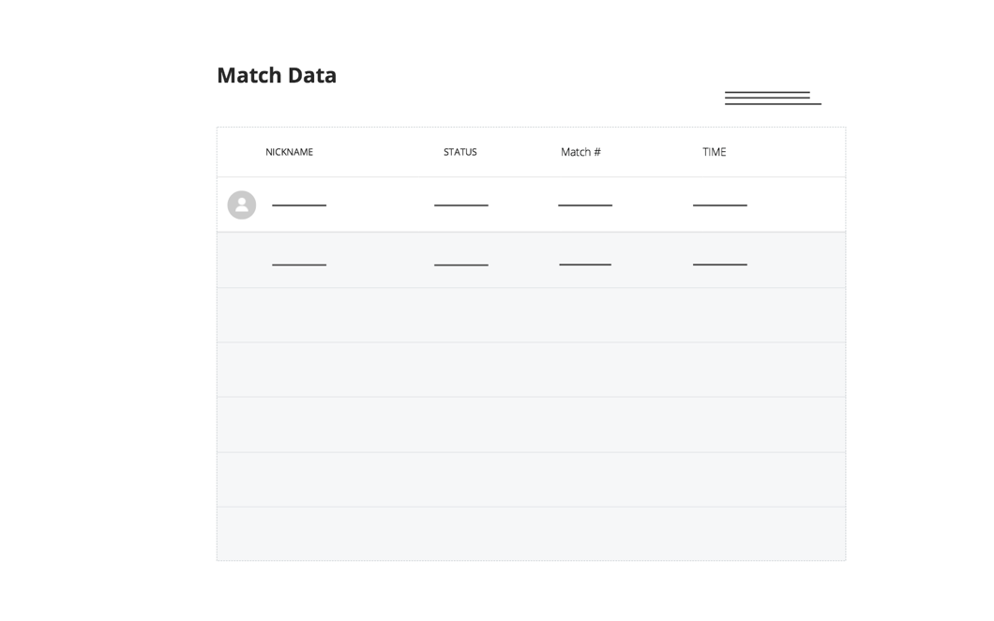

*Settings screen*

*Match Data screen*

*Gameplay screen*