Table of Contents
Question 1 | Page 2-4
Question 2 | Page 4-6
Question 3 | Page 6-
Question 4 | Page
References | Page

Question 1

1.1 You are working on a Linux machine and need to move between directories to locate files.
a. Identify the command used to display your current directory.
Pwd

b. Explain how you would move from your current directory to a directory named projects.
cd
cd /projects

c. Describe how you would return to your previous directory.

cd .. takes you back to the previous destination in your current directory path

1.2 Explain what Linux is and describe two key characteristics that make it different from other operating systems such as Microsoft Windows.

Linux itself is not an operating system, its the kernel (System that allocates compute from a machines hardware to software applications) that all linux distributions run on.

How linux differs from windows
- Linux is free and open source, meaning that all of the source code is publicly available. Due to linux being open source the linux community is able to create different distributions built on the same linux kernel (different versions of the kernel but still the linux kernel).
- Microsoft Windows on the other hand is a proprietary operating system which means that you need to pay for a licensed copy of windows and the source code is not available to the public.
- Another Way the two operating systems differ is how they are packaged. Since linux is a kernel, linux based operating systems can come in different forms called linux distributions with different display managers, package managers and other operating system components built for linux. Most linux distributions are built on a few base distributions including: Arch, Debian and Fedora.
- Windows on the other hand is a single product with iterative versions that follow the same design philosophy which evolve over time with new version releases every couple years which has different licenses for the same operating system that just includes some extra proprietary software but all tiers of the same version of windows Ex. Windows 11 are based on the same operating system.

1.3 While working in your home directory, you are told that some important configuration files are hidden.
a. Explain what hidden files are in Linux.

hidden files in linux are prefixed with a '.' and are not shown by default when looking through a directory.

b. Identify the command used to view hidden files.
ls -a
c. Briefly explain why hidden files are used in Linux systems.

The purpose of hidden files is to keep important configuration or sensitive data files from being accidentally modified or deleted to maintain system integrity.

Question 2
2.1 The company has hired a new employee, Thabo, who will be working in the Finance department. Explain how you would:
a. Create a new user account for Thabo
sudo useradd -m -c "Thabo" -s /bin/bash thabo
sudo passwd thabo
the -m argument adds thabos home directory

b. Assign Thabo to a Finance
group
sudo groupadd finance
sudo usermod -aG finance thabo

c. Explain why groups are important in Linux systems
Groups allow for better security within an organisation by employing the principle of least privilege by giving certain users access only to what they need in their respective groups as opposed to having all groups accessible to everyone in the organisation.
Having groups also makes it easier to manage administrative and security responsibilities when working with a large batch of user accounts in a big company by allowing administrators to properly structure access to company information and keep track of users, ensuring that the right people have access to the right information.

2.2 A file named salary_data.txt must only be accessible to the Finance manager and not to other employees.
Explain how you would:
- Set the correct ownership for the file
- Assign appropriate file permissions
- Describe how Linux enforces access control using permissions
Your answer should include commands and explanations.

Correct File Ownership and permissions
sudo chown financeManager:finance salary_data.txt
sudo chmod 600 salary_data.txt
Set file access so that the finace manager can read and write to the file but the finance group and other users do not have any access to the file.
How linux enforces access control
Linux check read write and execute permissions based on a hierarchy of 3 different classes
- File owner
- Group
- Other Users
we can look at it like this too:
(user)rwx(group)rwx(other)rwx
When we run the command chmod 600 salary_data.txt, we are giving the user read and write permissions. If someone in the finance group that isn't the manager tries to access this file they will be denied access due to them falling under the group category whose file permissions are set to 0 (no read write or execute). The same applies to any other user in the organisation.

Question 3
3.1 The technician ran the following command while logged in as a normal user:
apt install nano
Evaluate this command. In your answer:
- Identify the issue
- Provide the corrected command

- Explain why the correction is necessary in terms of system privileges

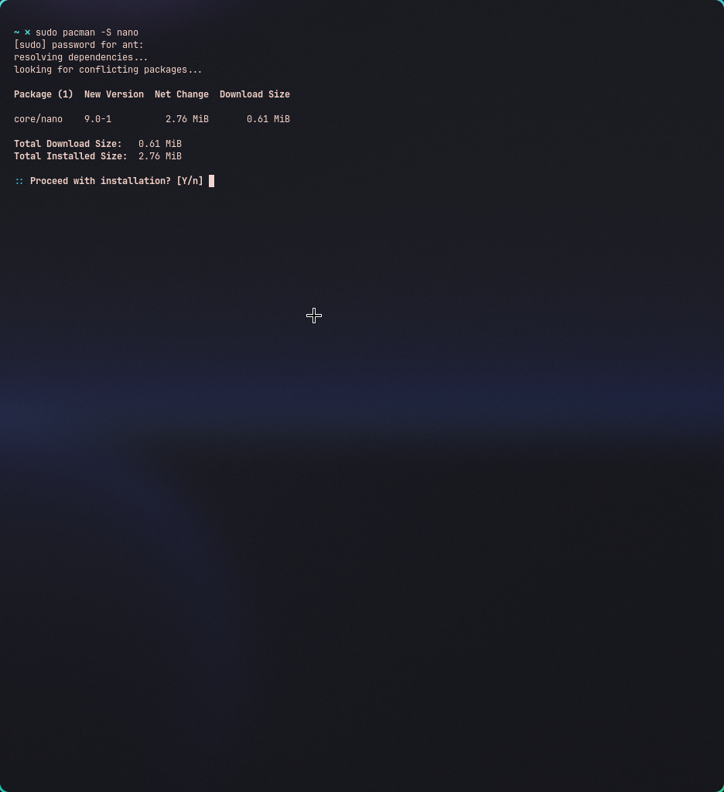
The command requires sudo privileges to run as a normal user.
When preceding the command with the sudo argument it elevates the user to root privileges which means that we can perform tasks such as installation and deletion for example, this does require login credentials.

3.2 The technician attempted to back up a file using the command:
cp report.txt /backup report_backup.txt
Analyse this command and provide:
- What is incorrect
- The correct command to achieve the task
- An explanation of how the corrected command works

cp report.txt /backup/report_backup.txt
3.3 The technician used the following command to update the system:
apt upgrade
Evaluate whether this command is sufficient for updating the system. In your answer:
- Explain any limitation of this command
- Provide the correct sequence of commands
- Justify why the full process is required

There are two issues with this command.
- As stated previously, we need root privileges to be able to install packages so the first fix to make would be to add the sudo argument to elevate to root privileges.
- The next issue is a package manager specific issue.
The package manager apt will not be able to install the latest releases of packages on the machine, we can fix this by running the sudo apt update command first to update the local list of repositories and their versions to the latest provided by apt. Once our list of repositories has been updated to the latest versions, we can run sudo apt upgrade to actually install the updates.

