I. Bluetooth overview

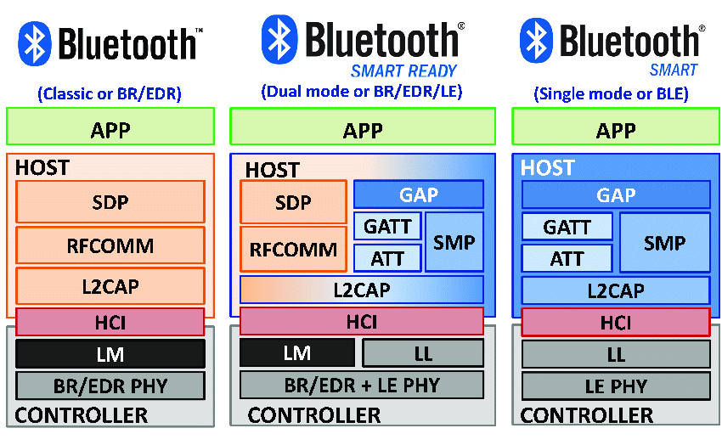

* GAP: defines procedures concerned with device discovery and establishing connections between 2 devices
* GATT: defines higher-level data types based on the attributes held in the attribute table
* ATT: contains a handle, a Universally Unique Identifier (UUID), a value and a set of permission.
* SMP: A protocol used during the execution of security procedures such as pairing
* L2CAP: responsible for protocol multiplexing, flow control and segmentation and reassembly of service data units (SDUs)
* HCI: defines a standardized interface via which a host can issue commands to the controller and a controller can communicate with the host

1. Bluetooh Device roles

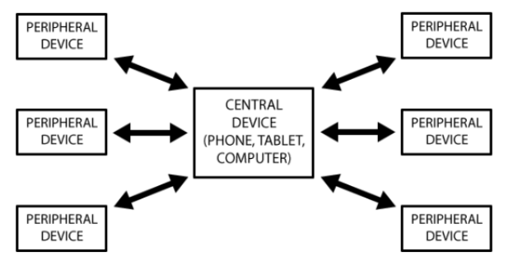

1.1. Peripheral

Usually acts as a server

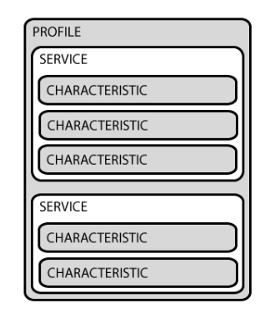

* Characteristic composed of
* A single value (int, float, string)
* Many discriptors
* Profile: Group of services
* Service: Group of related characteristics
* Identified using UUIDs

Ex: Smart Watch

* Profile: Heart rate
* Services: Heart rate
* Characteristics:

- Current heart rate (read/subcribe)

- Settings (read/write)

1.2 Central

Usually acts as a client

* Can connect to up to 7 BLE servers simultaneously
* Reads/Writes/Subscribes to characteristics

II. Android Bluetooth Architecture

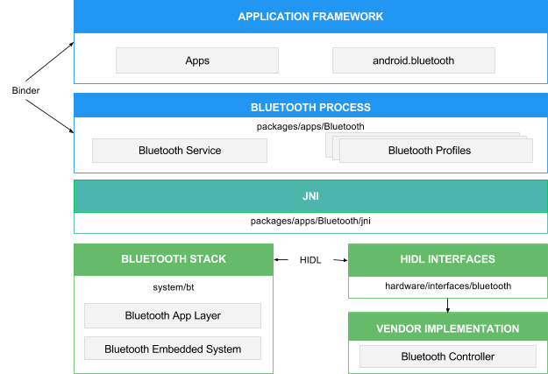

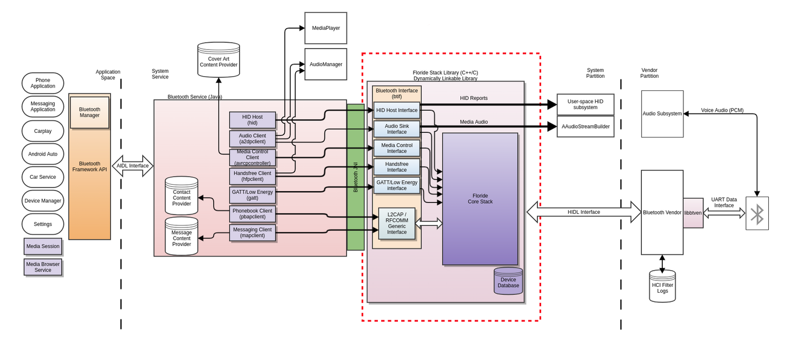

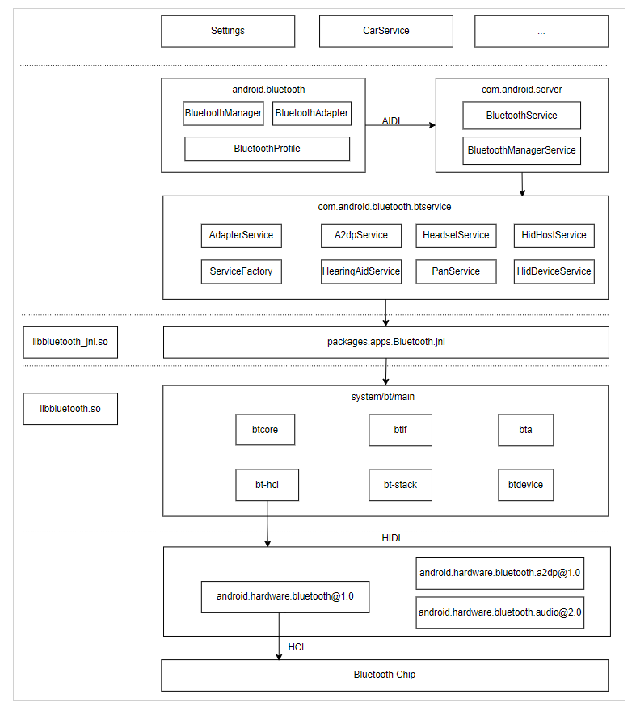

1. Bluetooh stack

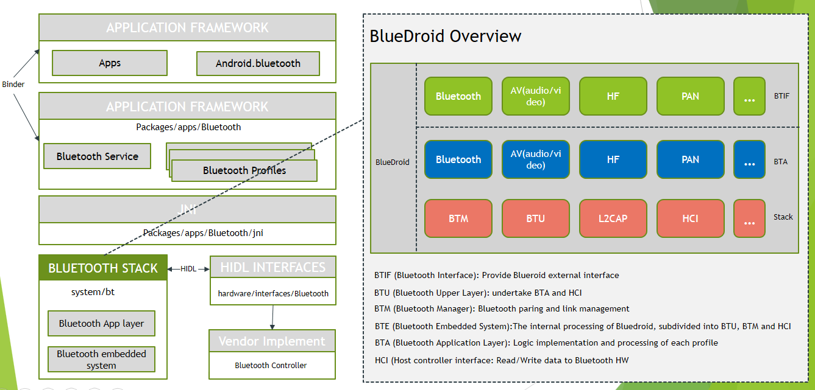

III. HIDL

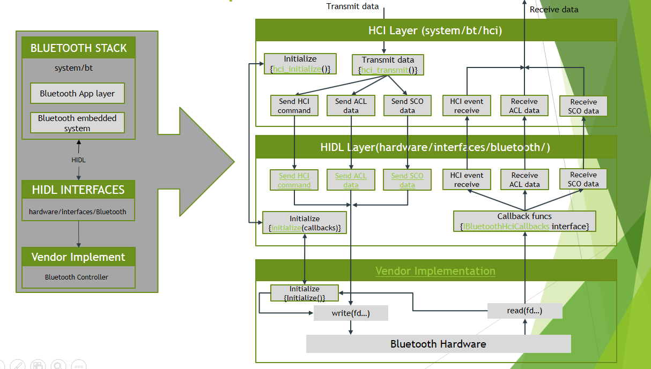

1. Initialize

2. Transmit data

3.

IV. Vendor implementation

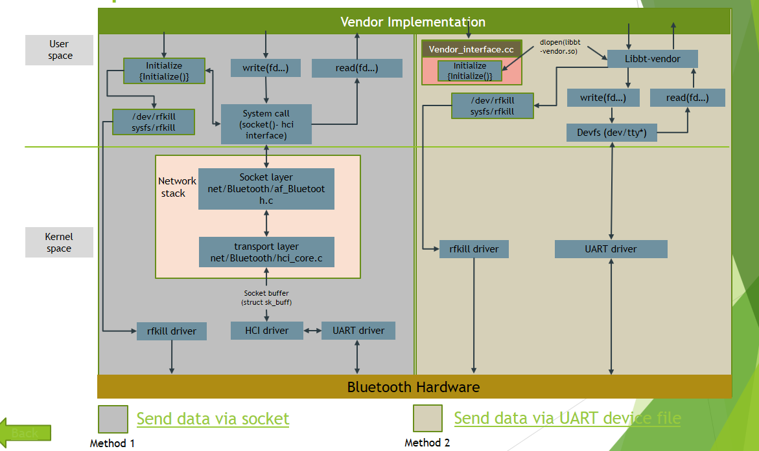

In this part, we discuss the lib-bt only. With the kernel space part, we have a UART document to refenrence.

The lib-bt have 4 attributes are:

Initialized

Cleanup

Create dynamic library entry point

Vendor specific operation

IV. Appendx - Where is the bluetooth components directory

**A2SP software encoding**

**audio_hearing_aid_hw**

**binder**

**device**

**conf**

**utils**

**bta**

**btcore**

**btif**

**common**

**device directory**

**embdrv**

**gd**

**The HCI**

**Include**

**internal_include**

**Main**

**The OSI**

**Packet**

**Profile**

**Proto**

**The service**

**The stack**

1. a2dp

|  |  |
| --- | --- |
| File name | Function |
| a2dp_acc.cc |  |
| a2dp_aac_decoder.cc |  |
|  |  |
|  |  |
|  |  |
|  |  |
|  |  |
|  |  |
|  |  |
|  |  |
|  |  |
|  |  |
|  |  |
|  |  |
|  |  |
|  |  |
|  |  |
|  |  |

**Test (Bluetooth test function and script)**

**Types**

**udrv**

**utils: bt utils**

**vendor_libs**

**vnd directory**

**Refer**

https://blog.csdn.net/xiaojsj111/article/details/12647923?spm=1001.2101.3001.6650.11&utm_medium=distribute.pc_relevant.none-task-blog-2%7Edefault%7ECTRLIST%7ERate-11-12647923-blog-115728286.235%5Ev27%5Epc_relevant_3mothn_strategy_recovery&depth_1-utm_source=distribute.pc_relevant.none-task-blog-2%7Edefault%7ECTRLIST%7ERate-11-12647923-blog-115728286.235%5Ev27%5Epc_relevant_3mothn_strategy_recovery&utm_relevant_index=19

<https://blog.csdn.net/kv110/article/details/117457151?spm=1001.2101.3001.6650.14&utm_medium=distribute.pc_relevant.none-task-blog-2%7Edefault%7ECTRLIST%7ERate-14-117457151-blog-115728286.235%5Ev27%5Epc_relevant_3mothn_strategy_recovery&depth_1-utm_source=distribute.pc_relevant.none-task-blog-2%7Edefault%7ECTRLIST%7ERate-14-117457151-blog-115728286.235%5Ev27%5Epc_relevant_3mothn_strategy_recovery&utm_relevant_index=22>

<https://blog.csdn.net/edmond999/article/details/115728286>

https://blog.csdn.net/u011279649/article/details/119606531?spm=1001.2101.3001.6650.19&utm_medium=distribute.pc_relevant.none-task-blog-2%7Edefault%7EBlogCommendFromBaidu%7ERate-19-119606531-blog-115728286.235%5Ev27%5Epc_relevant_3mothn_strategy_recovery&depth_1-utm_source=distribute.pc_relevant.none-task-blog-2%7Edefault%7EBlogCommendFromBaidu%7ERate-19-119606531-blog-115728286.235%5Ev27%5Epc_relevant_3mothn_strategy_recovery&utm_relevant_index=27