# Roadmap:

* **Budget** $190,000
* **Required skills:**
  + Delivery Management
  + Front End & Back End Developers
  + User Experience Design
  + Quality Assurance
* **Service BC Team members provided:**
  + Product Owner
  + Business subject matter experts
  + Digital Services Architect
  + Existing queue management system developer resource to provide details of current queue management system.
  + Existing Mainframe application developer resource to provide details of current queue management system.

|  |  |  |
| --- | --- | --- |
|  | Phases | Time Estimate |
| Inception | Verify requirements for Minimal Viable Product and additional functionality enhancements.  Provide a working skeleton application to prove out key elements of solution specifically the Calendar entry screens. | October 15, 2018 – November 2, 2018 |
| Proof of Concept | Build APIs and Enhance current database model  Build Minimum Viable Product that includes Room Booking and Exam Invigilation functionality that will allow the:   * Ability for Customer Service Representative(s) to book Room/Industry Training Authority (ITA) appointment(s) and manage inventory. * Reporting for Finance | November 5, 2018 – January 4, 2019 |
| Implementation  Goal 1 | Build APIs and Enhance current database model  Product Testing and Enhancements   * Testing of Minimum Viable Product created in Proof of Concept phase. * Bug Fixes of Minimum Viable Product created in Proof of Concept phase. * Ability for Customer Service Representative(s) to book Service Appointments | January 4, 2019 – February 1, 2019 |
| Implementation  Goal 2 | Build APIs and Enhance current database model  Build Administrative Functions   * Add, Delete, Update room inventory for offices * Add, Delete, Update Exams * Add, Delete, Update list of Invigilators for offices * Other Adminstrative functions | February 1, 2019 – February 22nd, 2019 |
| Implementation  Goal 3 | Build APIs and Enhance current database model  Build Additional Functions   * Ability for external parties to manage Industry Training Authority (ITA) appointments * Ability for Citizens to book their own appointments for exams or services | February 22nd, 2019 – March 29th, 2019 |
|  | Transfer knowledge and documentation of the above to Service BC technical staff and contingency. | Throughout project |

## Draft High Level Requirements for Proof of Concept - Room Booking and Exam Invigilation.

***\*\* These need to be confirmed, updated or modified during inception phase. This is provided to help determine the scope of the Proof of Concept.***

* **Exam Administration** 
  + Central distribution Government Agent Office receives exams from various providers one of which is the Industry Training Authority (ITA).
  + Upon receipt, the exam attributes are entered in the application for various Government Agent office locations.
  + The exam will be sent from the distribution center office to the exam location Government Agent office where it will be received for processing which includes updating the application.
  + The exam status will be maintained at various points in the exam life cycle within the application.
* **Exam Scheduling** 
  + The invigilating Government Agent office will schedule the exam
    - For single exams the student will contact the Government Agent office for scheduling a suitable date, time, and location. The office will assign the invigilator(s).
    - For group exams the Government Agent office will schedule the date, time, location, and invigilator(s).
* **Invigilator Administration**
  + Government Agent offices providing exam invigilation will maintain their list of available invigilators in the application. The office must record the name, type of invigilator (staff, contractor), contact information, availability.
* **Room Administration** 
  + Government Agent offices will maintain their list of onsite rooms which can be used for exam writing and invigilation. The available date, time, capacity, location, booking information (ie room contact information for offsite room booking) must be documented for scheduling.
  + ITA manages the offsite locations and rooms for their exams.
* **Analytics**
  + The application will require integration/posting into the Service Delivery analytics application. The Queue Management System provides an existing API.
* **Billing**
  + Service BC will continue to use the existing method for invoicing. This is presently managed by the Finance unit within Service BC.
  + Monthly, Finance will create the invoices for the Industry Training Authority.
* **Reporting**
  + There will be a requirement to produce operational reports by Government Agent office such as:
    - Weekly, Monthly Exam Schedules.
    - Invigilators.
    - Rooms.
    - Office Statistics.
    - Exam Return Reporting.
    - Unconfirmed Exam Report.
    - Reports for Invoicing.
    - Other reports found in inceptions phase.
  + **Financial**
    - There is a requirement to produce reports for month, year to date revenue.

## High Level Requirements for Implementation Goal 1 - Appointments for Services

**Suggested high level process that would require vetting and additional details:**

1. Receptionist interacts with Citizen to record appointment.
2. Receptionist provides Citizen with appointment print out.
3. Citizen leaves offices.
4. Citizen returns to office and checks in with Receptionist.
5. Receptionist marks appointment as “arrived” in the application which then:
   * Generates a service ticket with appropriate service and comments and places it at top of queue for priority service.

** Assumption: One of the “rooms” (from the previous phase) is to be used for Service appointments within the application.

* **Ability to turn off/on the ability for appointments per office.**
* **Appointment Booking:**
  + Ability to add blackout periods for vacation/holidays.
  + Booking only allows one citizen per 15-minute slot.
  + Ability to indicate the first and last appoint times for day (i.e. Appointments are allowed between 10am – 3 pm).
    - Ability for each office to customize this range.
  + Verify if Service BC would want more than one appointment available per slot.
  + The interval should be configurable by office as offices may want to change appoint slot times.
  + Verify if some services need to take “double slots” as they may take longer than 15 minutes.
  + Booking at least one hour after current time.
    - Ability for each office to customize this time
  + Booking in appointments for service in advance up to one month (ability to change time frame by office).
  + Ability to book any service listed in the existing Queue Management service listing.
    - Record appointment details.
    - Service, Name, Contact details, Reservation number.
      * Need to review privacy and security concerns.
      * Reminder to bring documentation and/or ID for the service, if applicable (prerequisites reminder).
    - Some services may not be offered via service booking.
* **Ability to print a confirmation**
  + With instructions to check in and arrive at least 5 minutes prior to appointment.
  + Appointments after “X” minutes are considered no show.
* **Manage Citizen Check-in**
  + Policy for Late arrivals? Set a time in setup for changing. Default to 10 min late.
* **CSR ability to manage appointments**
  + Ability to contact citizen about the appointment.
    - SMS Text or email reminder option as an option
    - A list of appointments for the next day for a CSR to call as reminder.
  + Ability to cancel or change appointments.
  + Search and provide appointment details.
    - No Shows.
    - Future.
    - Past.
  + Ability to push service to the top of queue, if needed.
    - This is when you can’t find the appointment.
    - Citizens that forgot to check in.
    - Special circumstances.
* **Reporting**
  + Tracking no shows & arrivals.
  + Tracking service types.

** Some services such as drivers test require Knowledge Testing stations. These cannot be reserved. Need to come up with some mitigation.

# Appendix – Current Room Booking application on the mainframe

*Used for reference and background. This is the current solution that we would like changed to make more user friendly.

**CURRENT ROOM BOOKINGS and EXAM INVIGILATIONS PAGES**

The Room Bookings screen is used to record exams and meetings booked in boardrooms and meeting rooms located within Service BC Centres as well as offsite.

Every Service BC Centre has at least one boardroom assigned to it and one ‘offsite’ boardroom. These rooms are maintained on the Individual Maintenance screen in the format: BRDRM98A and OFFSITE98.

‘NOTES’ can be entered in free format text as required for each booking. The maximum amount of characters the notes field allows for is 160 characters. There are no other rules or edits and notes can be added, changed or deleted at any time.

Schedule ITA Exams

ALL **ITA Exams** to be invigilated in your office MUST be scheduled as follows:

* On the eGarms menu, select **Room Bookings**

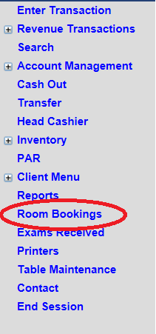

The following screen will display:

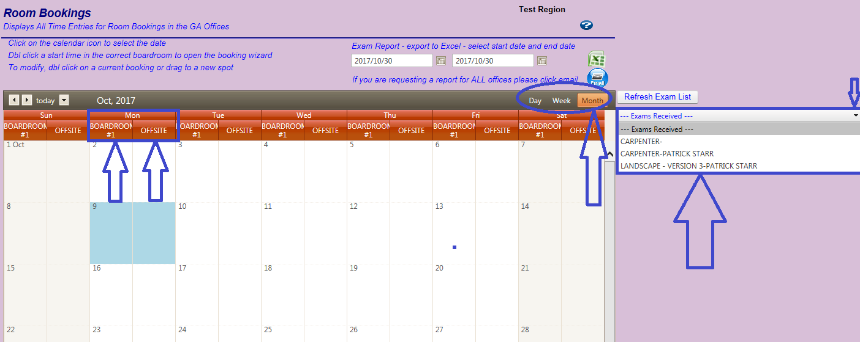

1. The Number of Boardrooms an office has available for booking appears in each day

*This office has 2 boardrooms available for booking – Boardroom #1 and Offsite.*

1. The Room Bookings default is the current **Month** view,

which can be changed to **Day** or **Week** by selecting with cursor.

1. Click on drop down box to the right of the calendar to view all **Exams Received**, but not yet booked.

**Note:**  If an exam is not listed, double-check that your office has received it, and if so, please enter it into **Exams Received** immediately.

* **Place your cursor in the required room and date**

**Double click here and the following box appears**

*Boardroom #1 on October 3 is selected*

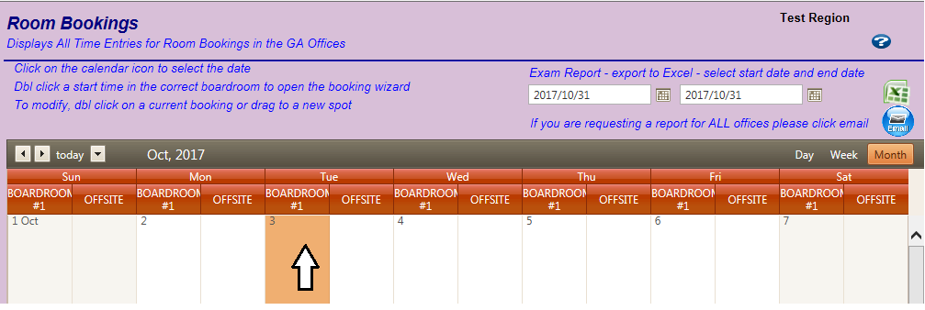

1. Under the drop down menu for **Exam Received**, Select the Client’s Name.

*The Type of Exam (Org No.) and Event ID auto-populates (highlighted in yellow).*

1. Under the drop-down menu for **Invigilator/Contractor, Select** **SBC Staff or Contractor’s Name.**

*SBC Staff is selected.The list also contains all approved Contractor’s names.*

1. As this is a **4-Hour Exam Single Exam**, the exam Start Time and End Time need to be recorded.

Place cursor on the **Clock** to select **Start Time**, i.e. 9:00 AM.

Place cursor on the **Clock** to select **End Time**, i.e. 1:00 PM

1. Select **Save** to record the booking.

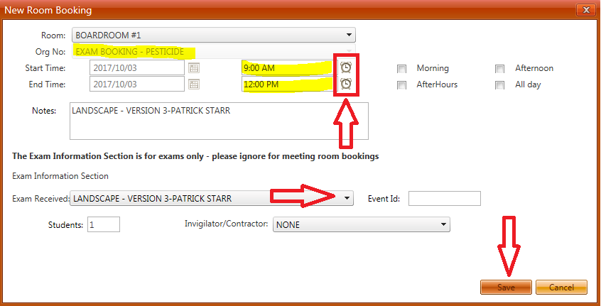

To confirm booking, **Room Bookings** screen will appear:

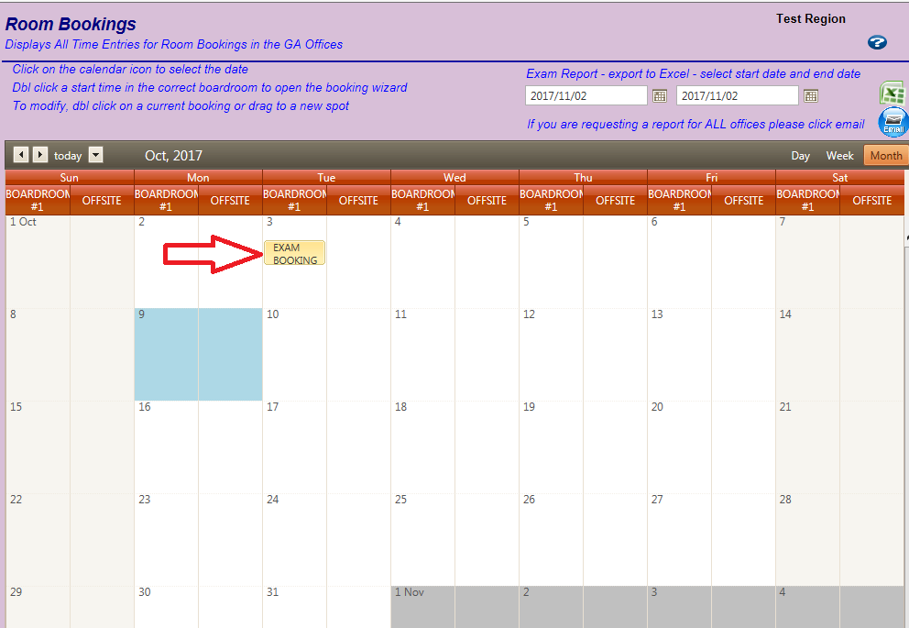

 Schedule Non-ITA Exams

ALL **Non-ITA Exams** to be invigilated in your office MUST be scheduled as follows:

On the eGarms menu, select **Room Bookings**



The following screen will display:



1. The number of boardrooms an office has available for booking appears in each day. *This office has 2 boardrooms available for booking – Boardroom #1 and Offsite*
2. The Room Bookings default is the current **Month** view, which can be changed to **Day** or **Week** by simply selecting with cursor.
3. Click on drop down box to the right of the calendar to view all **Exams Received**, but not yet booked.

**Note:**  If exam is not listed, double-check that your office has received it, and if so please enter it into **Exams Received** immediately.

* **Place your cursor in the correct room and the selected date**
* **Double click here and the following box appears.***Boardroom #1 on October 3 has been selected*

**

* Under the drop down menu for **Exam Received**, Select the Client’s Name. *The Type of Exam (Org No.) auto-populates (highlighted in yellow)*
* As this is a **3-Hour Exam**, the exam Start Time and End Time need to be recorded.
* Place cursor on the **Clock** to select **Start Time**, i.e. 9:00 AM
* Place cursor on the **Clock** to select **End Time**, i.e. 12:00 PM
* Select **Save** to record the booking



To confirm booking, the **Room Bookings** screen will appear:



Edit a Scheduled Exam

There are 2 options:

On the eGarms menu, select **Room Bookings**



**Option 1**

* Select the **date** the Room Booking is scheduled for
* **Double-Click** in the box over the box with the exam (ISPE-4HR SINGLE below)
* Edit the updated information
* Select **Save** to record the changes

**Option 2**

* Select the **date** the Room Booking is scheduled for
* **Right Click** in the box with the exam (ISPE-4HR SINGLE below)
* A box appears with “Edit” or “Delete”
* Select **Edit**
* Enter the updated information
* Select **Save** to record the changes

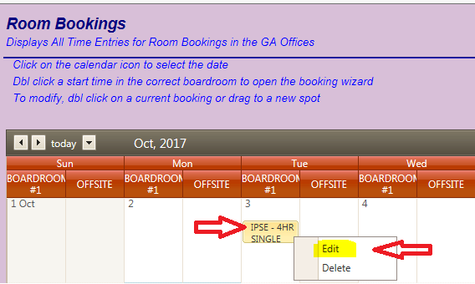

Cancel a Scheduled Exam

There are 2 options:

* On the eGarms menu, select **Room Bookings**



**Option 1**

* Select the **date** the Room Booking is scheduled for
* **Hover the cursor** over the box with the exam (ISPE-4HR SINGLE below)
* Select the **X** in the red box in the top right corner
* A message will prompt, “Are you sure you want to delete this appointment?
* Select **OK** to delete

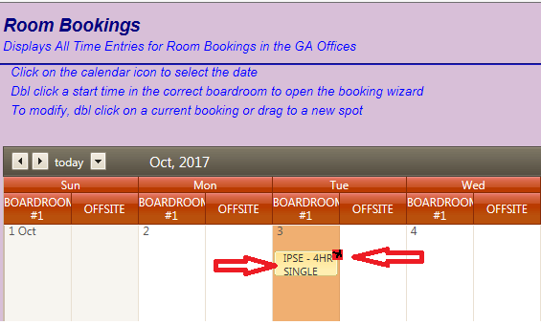

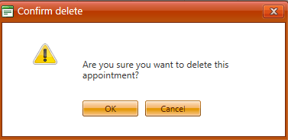

**Option 2**

* Select the **date** the Room Booking is scheduled for
* **Right Click** in the box of the scheduled exam (ISPE-4HR SINGLE below)
* A box appears with “Edit” or “Delete”

Receiving Exams

Recording ITA Exams

All **ITA Exams** received in your office MUST be entered as follows:

* On the eGarms menu, select **Exams Received**

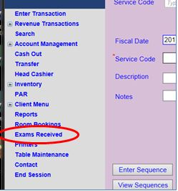

The following page will display:

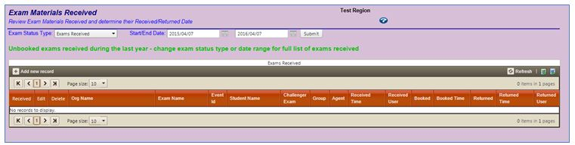

Select + to **Add New Record**

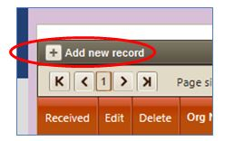

Select **ITA Exam** from the drop-down menu

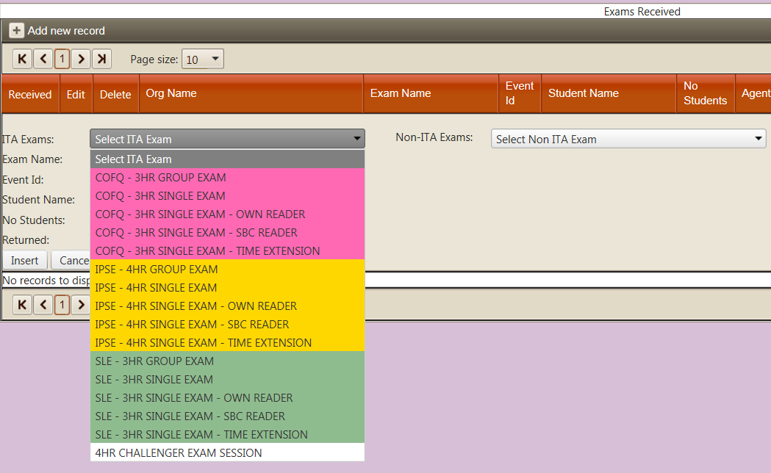

**For ALL Single Exams**, enter the **Required Fields** *(highlighted yellow below*):

* Enter the **Exam Name**
* Enter the **Event ID**
* Enter the **Student’s Nam**e
* Select the **Insert** button to **save** the record

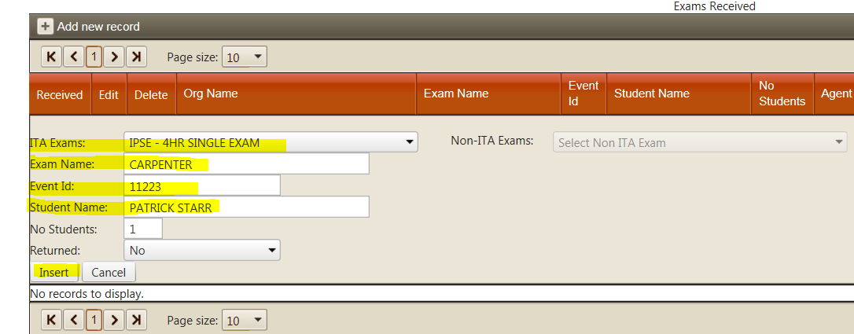

**For ALL Group Exams**, enter the **Required Fields** (*highlighted yellow below*):

* Enter the **Exam Name**
* Enter the **Event ID**
* Enter the **Number of Students**
* Select the **Insert** button to **save** the record

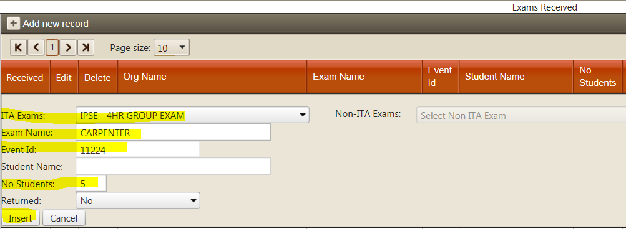

The **Exam Materials Received** page displays:

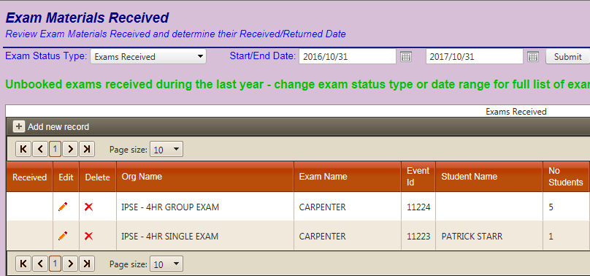

Recording Non-ITA Exams

All **Non-ITA** **Exams** received in your office MUST be entered as follows:

* On the eGarms menu, select **Exams Received**



The following page will display:



Select **+** to **Add New Record**



Select **Non-ITA Exam** from the drop-down menu

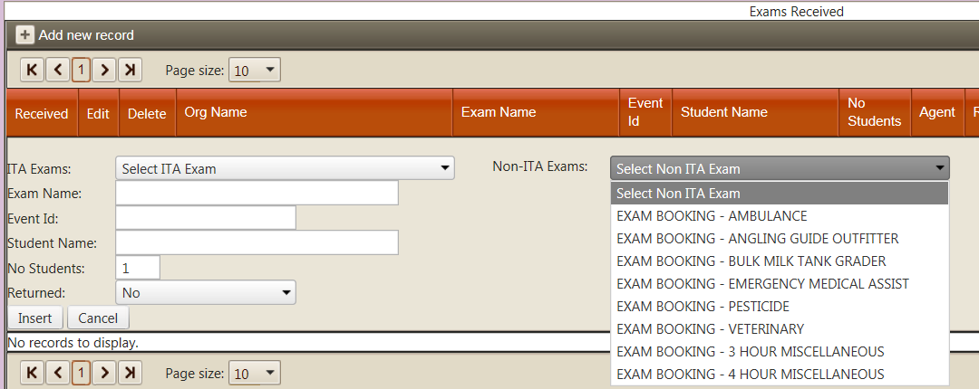

For **ALL Non-ITA Exams**, enter the **Required Fields** (*highlighted yellow below*):

* Enter the **Exam Name**
* Enter the **Student’s Nam**e
* Select the **Insert** button to **save** the record

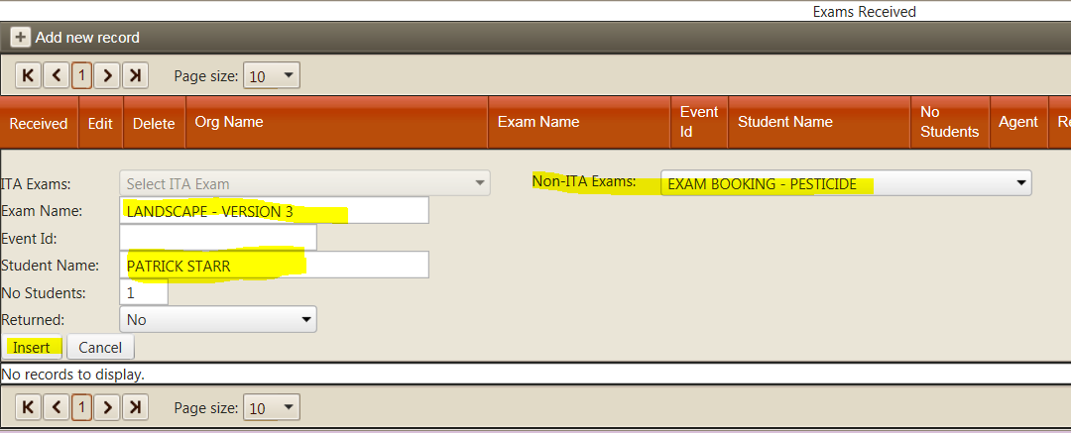

The **Exam Materials Received** page displays as follows:

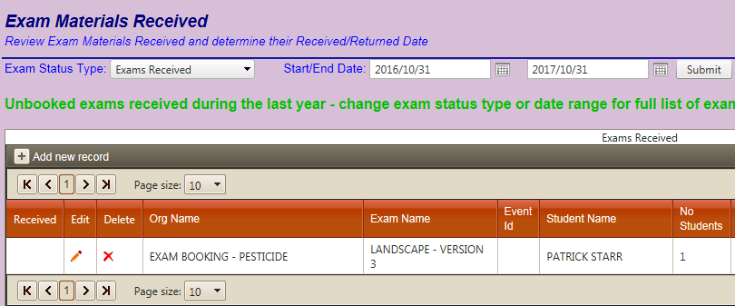

Editing an Exam

To edit a **Received Exam**, the record MUST be updated in eGarms:

* On the eGarms menu, select **Exams Received**



The **Exam Materials Received** screen appears

* Select the **Edit Icon Image of edit pencil gif**beside the exam to be edited

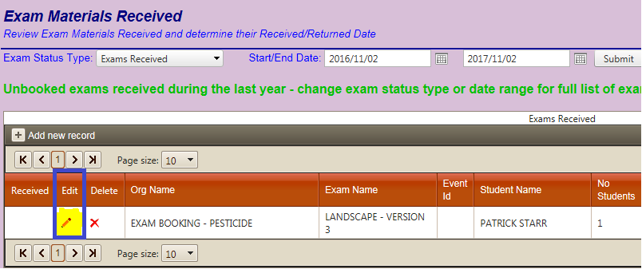

* Enter the edited information as required
* Select the **Update** button to **save** the record

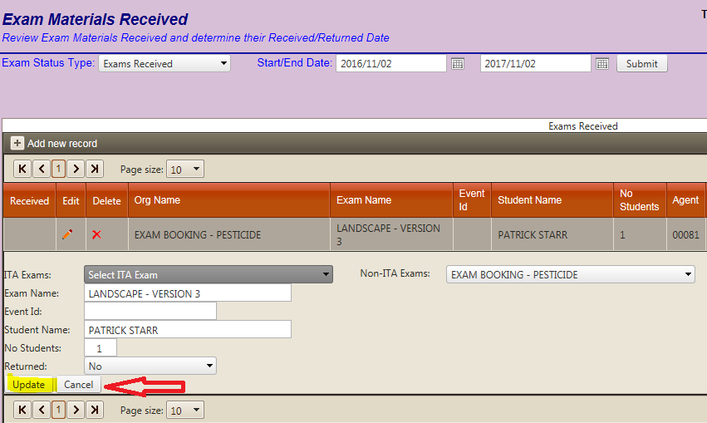

Returning Exams Not Written

A **Received Exam** that has NOT been scheduled for invigilation within the required timeframe (i.e. ITA exams are 45 days), the exam needs to be returned to the client ministry immediately.

Timeframes and procedures for physically returning the exams are set in the job aids for that type of exam (i.e. ITA, Pesticide).

The **Received Exam** MUST also be updated in eGarms as **Returned**:

* On the eGarms menu, select **Exams Received**



The **Exam Materials Received** screen appears

* Select the **Edit Icon edit icon**beside the exam to be returned

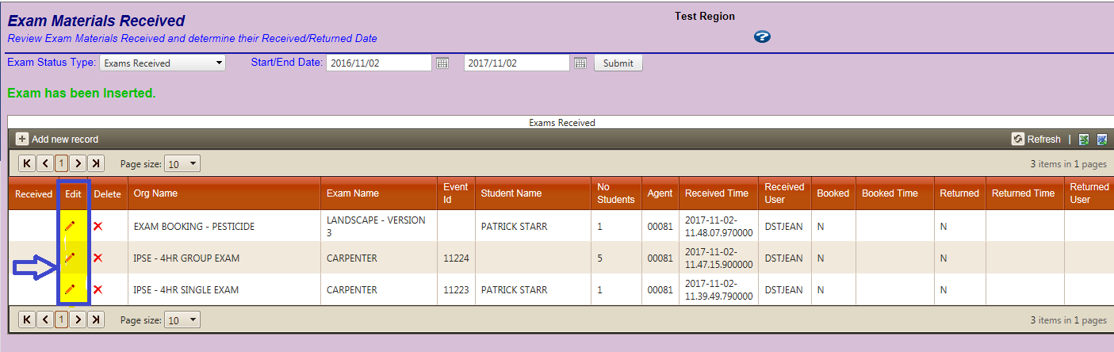

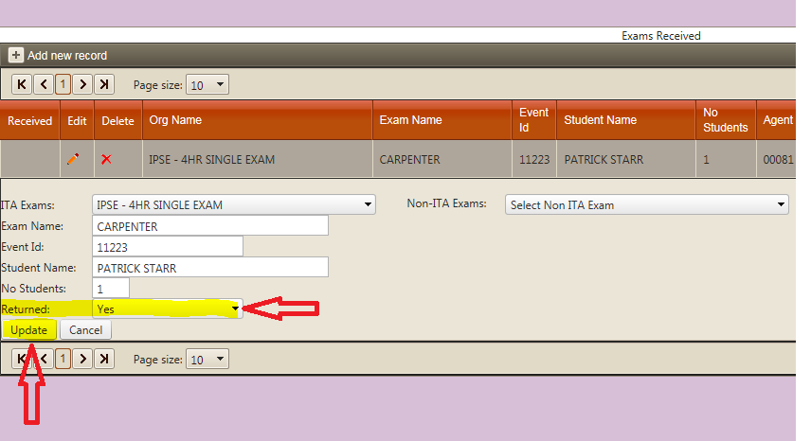

* Select **Yes** from the drop down-menu under **Returned**
* Select **Update** to **save** the record.

Deleting an Exam

Exams are to be deleted ONLY when the exam should not have been entered in the **Exams Received** (i.e. exam sent to incorrect office). Exams sent back to the client ministry (i.e. ITA), should always be updated in the system as “Returned”, not deleted.

To delete a **Received Exam**, the record MUST be updated in eGarms:

* On the eGarms menu, select **Exams Received**



The **Exam Materials Received** screen appears

* Select the **Delete Icon Delete icon** beside the exam to be deleted from the system

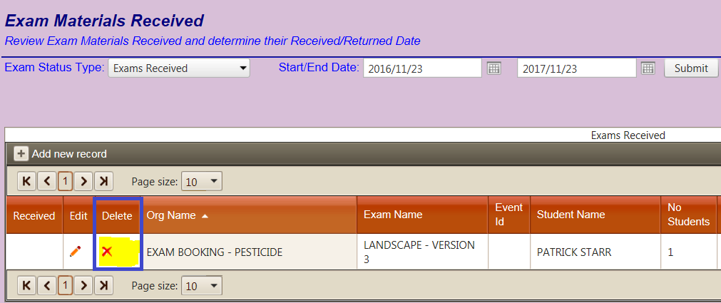

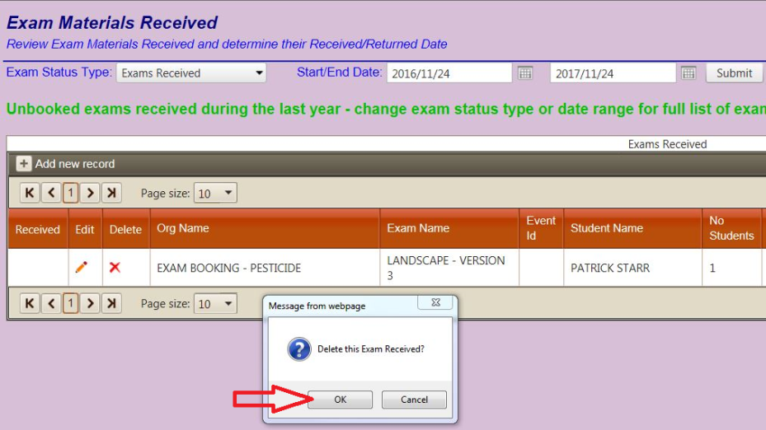

* Select the **OK** button to **delete** the record