ENHANCING RETENTION OF ENGLISH GRAMMAR CONCEPTS IN GRADE 7: AN ACTION RESEARCH STUDY COMPARING ACTIVITY-BASED LEARNING AND THE LECTURE METHOD

SYEDA MINAL NAQVI
(A1-21136089)
SUPERVISED BY
PROF. AOUN ALI
(LECTURER IN EDUCATION)
AN ACTION RESEARCH REPORT SUBMITTED IN PARTIAL FULFILLMENT OF THE REQUIREMENTS FOR THE DEGREE OF B.ED. (HONS.) ELEMENTARY
GOVERNMENT COLLEGE OF EDUCATION
F.B. AREA, KARACHI
(2026–2027)

DECLARATION
I, Syeda Minal Naqvi d/o Syed Nadir Abbas, student of B.Ed. (Hons.) Elementary, hereby declare that no part of the action research report titled “Enhancing Retention of English Grammar Concepts in Grade 7: An Action Research Study Comparing Activity-Based Learning and the Lecture Method” presented by me has been plagiarized from anywhere. Proper references are cited wherever necessary. I understand that the University of Karachi reserves the right to cancel the degree if any of the above declarations are proved false before or even after the award of the degree.

Signature of the Candidate: ______________________
Name of the Candidate: Syeda Minal Naqvi
Seat No.: A1-21136089
Date: ______________________

CERTIFICATE OF APPROVAL
Syeda Minal Naqvi d/o Syed Nadir Abbas, student of B.Ed. (Hons.) Elementary, has completed the action research entitled “Enhancing Retention of English Grammar Concepts in Grade 7: An Action Research Study Comparing Activity-Based Learning and the Lecture Method” as per the scholarly standards set in the research project course guide provided by the University of Karachi.

Signature of the Candidate: ______________________
Name of the Candidate: Syeda Minal Naqvi
Date: ______________________

Signature of the Supervisor: ______________________
Name of the Supervisor: Prof. Aoun Ali
M.Phil. (Education), M.Ed., B.Ed. — Lecturer in Education (BPS-17)
Date: ______________________

ACKNOWLEDGEMENT
All praise and thanks are due to Almighty Allah, the Most Beneficent and the Most Merciful, for granting me the knowledge, strength, and patience to complete this research study.
I would like to express my deepest gratitude to my respected supervisor, Prof. Aoun Ali, whose expert guidance, continuous supervision, and constructive feedback throughout this action research project were invaluable to my academic growth.
Special thanks are due to the respected faculty members of the Government College of Education and the University of Karachi for their support and encouragement during my professional degree programme.
I am also highly indebted to my family, especially my mother and my father, Syed Nadir Abbas Naqvi, for their patience, constant prayers, and understanding during the writing of this report.
Finally, I am thankful to the students of Grade 7 who actively participated in the research intervention and made this comparison of teaching methods possible.
Syeda Minal Naqvi

DEDICATION
I dedicate this work to my beloved parents, whose support and inspiration have been my greatest strength throughout the journey of developing the ideas and concepts in this research project.
Their love and care have been the foundation of this endeavour, without which it would not have been possible.
TABLE OF CONTENTS

(If page numbers do not appear, right-click the table in Word and choose “Update Field”.)
LIST OF TABLES
Table 3.1: Participants and Setting
Table 3.2: Variables of the Study
Table 3.3: Research Timeline
Table 4.1: Demographic Information of Participants
Table 4.2: Individual Pre-Test Scores
Table 4.3: Descriptive Statistics of the Pre-Test
Table 4.4: Frequency Distribution of Pre-Test Scores
Table 4.5: Performance Levels of Students in the Pre-Test
Table 4.6: Post-Test 1 Scores (Phase A – Lecture Method)
Table 4.7: Post-Test 2 Scores (Phase B – Activity-Based Learning)
Table 4.8: Cycle-wise Comparison of Mean Scores
LIST OF FIGURES
Figure 3.1: The Action Research Cycle Followed in the Study
Figure 4.1: Pre-Test Scores of Individual Students
Figure 4.2: Frequency Distribution of Pre-Test Scores
Figure 4.3: Students by Performance Level (Pre-Test)
Figure 4.4: Spread of Pre-Test Scores (Box Plot)
Figure 4.5: Cycle-wise Comparison of Mean Scores

ABSTRACT
This action research study investigated and compared the effectiveness of Activity-Based Learning (ABL) and the traditional Lecture Method in enhancing the retention of English grammar concepts among Grade 7 students. The study was conducted during the teaching practicum of the B.Ed. (Hons.) Elementary programme at the Government College of Education, Karachi, and addressed the common classroom problem of low student engagement and poor retention associated with conventional, teacher-centred instruction.
A single-group repeated-measures (within-subjects) action research design was used with an intact class of 16 Grade 7 students selected through convenience sampling. Over 15 days, the same group was first taught through the traditional Lecture Method (Phase A) and then through multi-strategy ABL techniques — the Human Sentence, the Scavenger Hunt, and the Flashcard Relay Race (Phase B). Data were collected through three teacher-made achievement tests of 20 marks each (Pre-Test, Post-Test 1 and Post-Test 2) and a reflective journal maintained by the researcher. Quantitative data were analysed with descriptive statistics, and qualitative data through thematic analysis.
The diagnostic Pre-Test showed a baseline mean of 13.25 out of 20 (66.25%), with a standard deviation of 2.24, a median and mode of 13, and a range of 10 to 19. More than half of the class (11 of 16 students, 68.8%) scored at or below the “Average” level (13 or less), indicating a moderate but uneven command of the targeted grammar concepts and confirming the need for intervention. [INSERT FINDINGS: Post-Test 1 mean = __ / 20; Post-Test 2 mean = __ / 20; state the gain from Phase A to Phase B.] The study concludes [complete once post-test results are entered] and recommends that elementary English teachers integrate interactive, kinesthetic grammar activities into routine instruction.
Keywords: Action Research, Activity-Based Learning, Lecture Method, English Grammar, Conceptual Retention, Grade 7 Students.

CHAPTER 1: INTRODUCTION

1.1 Background of the Study
In today’s fast-moving world, English is no longer just a subject studied to pass an examination; it is a vital tool for communication, higher education, and future career success. In Pakistan, English is taught as a second language (ESL) from the earliest years of schooling. Grade 7, however, marks an important turning point in a student’s educational journey. At this stage, students are expected to move beyond simple word meanings and begin understanding complex grammatical structures such as tenses, active and passive voice, and sentence patterns.
Grammar works as the foundation, or skeleton, of a language. If a student’s foundation is weak, they struggle to read, write, or speak clearly in English. According to Lijanporna (2017), the main goal of learning English is not merely to obtain good grades but to be able to use the language in everyday, real-life interactions.
Despite the importance of English, the way it is taught in many local classrooms remains largely traditional. Most schools rely heavily on the Lecture Method, in which the teacher stands at the front of the classroom, writes grammar rules on the chalkboard, and students copy them into their notebooks. Anwer (2019) points out that this makes the teacher the only active person in the room, while students become passive listeners. Because the teacher talks and students only listen, the classroom environment can become dull. This leads to a serious problem — a “retention crisis”: students may memorise formulas to obtain marks in an examination, but they do not truly understand the concepts behind the rules.

Why Students Struggle to Retain Grammar Rules
A closer look at Grade 7 classrooms reveals three main reasons why students fail to remember English grammar rules:
- Excessive rote learning (ratta): Because the teacher lectures most of the time, students memorise rules without understanding how and where to use them (Khan & Muhammad, 2015).
- Classroom anxiety: Traditional methods often create a fear of making mistakes. When students are afraid to speak, they do not get the practice they need (Ahmed, 2017).
- Lack of practical connection: Grammar is taught as a mathematical formula rather than as a creative tool for writing and speaking.
Because of these issues, educators and researchers suggest a shift from lecture-based teaching to student-centred methods, particularly Activity-Based Teaching (ABT), which rests on the simple idea of “learning by doing.” When students play a grammar game, take part in role-plays, or work in small groups, they are physically and mentally involved in the lesson. As Dissanayake et al. (2020) explain, activity-based methods make learning enjoyable and help move information from short-term to long-term memory. As a result, students not only remember rules for longer, but their confidence also grows. This action research was therefore designed to test how Activity-Based Learning works in a real classroom in Karachi and whether it helps to address the retention problem.

1.2 Problem Statement
In many elementary classrooms, English grammar instruction relies heavily on conventional, teacher-centred methods such as lectures and rote memorisation. This approach often results in a lack of active student engagement, leading to poor conceptual understanding and low long-term retention of grammar rules. Grade 7 students frequently struggle to apply grammatical concepts in writing and speaking because the material is taught abstractly, without practical application.
This action research study therefore addressed the identified gap by comparing the effectiveness of the traditional Lecture Method with Activity-Based Learning (ABL) strategies. The core problem was to determine whether kinesthetic and interactive learning tasks could improve students’ retention and engagement in the elementary English classroom.

1.3 Purpose of the Study
The purpose of this action research study was to identify, implement, and evaluate the impact of Activity-Based Learning strategies on the retention and conceptual understanding of English grammar among Grade 7 students. Specifically, the study aimed to:
- Compare teaching methodologies: investigate how interactive and kinesthetic techniques (the Human Sentence, Scavenger Hunt, and Flashcard Relay Race) perform when contrasted with the teacher-centred Lecture Method.
- Enhance student engagement: shift the classroom dynamic from passive listening to active participation.
- Improve retention: determine whether practical, activity-based engagement leads to better recall and application of grammar rules.
- Provide actionable pedagogical insights: offer teachers and curriculum planners evidence on how elementary English classrooms can be adapted to foster a more inclusive and effective learning environment.

1.4 Objectives of the Study
- To compare the effectiveness of Activity-Based Learning and the traditional Lecture Method in teaching Grade 7 English grammar.
- To assess the impact of ABL on students’ retention and conceptual understanding of English grammar.
- To identify the role of interactive, kinesthetic tasks in increasing student engagement and active participation during lessons.

1.5 Research Questions
- How does the effectiveness of Activity-Based Learning compare with the traditional Lecture Method in teaching Grade 7 English grammar?
- What is the impact of Activity-Based Learning on students’ retention and conceptual understanding of English grammar concepts?
- To what extent do interactive and kinesthetic tasks increase student engagement and active participation during English grammar lessons?

1.6 Delimitations of the Study
Delimitations establish the boundaries and scope of the research, keeping the project focused and manageable. The delimitations of this study were as follows:
- Participants: The study was limited to one intact class of 16 Grade 7 students. Students of other grade levels were excluded.
- Content area: The research focused exclusively on English grammar concepts such as parts of speech, tenses, and sentence structure. Literature and creative writing were not included in the intervention.
- Geographical and institutional scope: The intervention and data collection were conducted at the teaching practicum site assigned by the Government College of Education, F.B. Area, Karachi.
- Duration: The study was restricted to a 15-day intervention within the timeframe set for the research project course.

1.7 Significance of the Study
This study provides practical insights into improving English language instruction at the elementary level. By examining Activity-Based Learning alongside the traditional Lecture Method, it offers value to the following groups:
- Students: It introduces interactive and kinesthetic techniques that shift students from passive listeners to active participants, helping them retain grammar rules and apply them in daily communication and writing.
- Teachers and educators: It equips teachers with hands-on, low-resource strategies (such as flashcard games and the Human Sentence) that make grammar lessons more interesting and reduce classroom fatigue.
- Curriculum designers and teacher-training institutions: It provides classroom-based evidence that institutions such as the University of Karachi and colleges of education can use when incorporating activity-based methodologies into teacher training and curriculum planning.

1.8 Definition of Key Terms
Action Research: A systematic inquiry conducted by teachers to address practical classroom problems and improve instructional practice (Creswell, 2012).
Activity-Based Learning (ABL): An instructional approach that engages learners in hands-on, interactive tasks to promote meaningful learning and active participation (Bruner, 1966).
Traditional Lecture Method: A teacher-centred method in which the instructor delivers information verbally while students listen passively and take notes (Bligh, 2000).
Conceptual Retention: A learner’s capacity to store, remember, and correctly apply academic concepts over time (Anderson & Krathwohl, 2001).
Disengagement: A lack of attention, interest, and active participation during classroom instruction, which often leads to poor academic performance and low knowledge retention (Fredricks et al., 2004). In this study, disengagement refers to the passive listening and mental fatigue observed when Grade 7 students were taught grammar through the Lecture Method.
Positive Error Management: An instructional strategy that treats student mistakes as valuable learning opportunities rather than failures (Metcalfe, 2017). In this study, it meant guiding students to analyse why a grammatical mistake occurred instead of simply supplying the correct answer, through constructive feedback and a safe, low-anxiety classroom climate.

CHAPTER 2: LITERATURE REVIEW

2.1 Introduction
The pedagogical debate between traditional teacher-centred instruction and interactive, student-centred methodologies has remained a central theme in educational research. As educational standards evolve, teachers are increasingly expected to move from rote memorisation towards active learning techniques that foster long-term conceptual retention. This chapter examines the theoretical frameworks and empirical evidence comparing the Lecture Method with Activity-Based Learning, and analyses how these methodologies influence student engagement, academic achievement, and the retention of English grammar concepts among lower-secondary students.

2.2 Historical and Theoretical Perspectives on Active Learning
The idea of engaging learners actively is not new; its roots lie in the philosophies of early thinkers and modern psychologists. Aristotle used active dialogue and participation to convey knowledge, proposing that learners must interact with material to develop higher-order thinking (Zafar & Akhtar, 2021).
Modern educational psychology confirms that learning by doing builds readiness and motivation. Ahlfeldt et al. (2005) argued that merely transmitting knowledge to passive listeners is an outdated instructional model, and that effective classrooms engage students actively with learning materials and with one another. Benson and Blackman (2003) similarly noted that learning without active engagement is often in vain, and that students respond more positively to physical, interactive experiences than to abstract repetition.

2.3 The Traditional Lecture Method in Grammar Instruction
The traditional technique is an instructor-focused strategy in which the teacher acts as the primary source of information and control. According to Singh (2004), conventional techniques are highly content-focused and leave students in a passive role; the classroom is largely deductive, with the teacher writing rules on the board while students copy them. Behlol (2009) observed that traditional teachers often require students to repeat information without understanding the underlying concepts, so the main tasks of the learner become note-taking and listening.
Studies also show that traditional strategies do not encourage innovation (Khan & Muhammad, 2015). When grammar rules are taught solely through verbal explanation, students are less likely to connect new linguistic concepts to their daily experiences, which leads to short-term memorisation for examinations rather than lasting retention.

2.4 Activity-Based Learning in Language Teaching
Activity-Based Learning shifts the focal point from the instructor to the learner, who is actively involved through physical movement, collaborative games, and hands-on manipulation of concepts. Research by Cakir (2015) shows that activity-based teaching benefits both teachers and learners, including:
- Team bonding and self-esteem: positive peer interaction reduces the anxiety often associated with language learning.
- Higher-order thinking: students compare new knowledge with prior knowledge, analyse sentence patterns, and construct meaning independently.
- Long-term retention: Shah and Rahat (2014) found that the physical involvement of learners produces significantly better results and retention than lecture methods.
Petress (2008) highlighted that active learners are more alert and more willing to ask questions to clarify their understanding, while Fallon et al. (2013) noted that students who are not engaged fail to gain the full benefit of instruction. Locally, Bhalli et al. (2016) and Zafar and Akhtar (2021) reported that activity-oriented methods produced higher achievement in English than traditional methods in Pakistani classrooms.

2.5 Strategies for Implementing Grammar Activities
Scholars recommend several dynamic strategies for integrating activities into grammar lessons. The three used in this study were:
- The Human Sentence: students hold word or tense cards and physically arrange themselves into correct sentences, learning sentence structure through movement.
- The Scavenger Hunt: students search the classroom for hidden grammar clues and identify or correct tenses.
- The Flashcard Relay Race: teams race to the board to write the correct word or tense, which sustains engagement and builds confidence.
McGrath and MacEwan (2011) concluded that learning by doing is more precise and beneficial than conventional techniques because it addresses the needs of students in diverse learning environments.

2.6 Positive Error Management and Student Engagement
The way a classroom handles mistakes is critical to learning. Historically, errors were treated as signs of failed instruction; modern cognitive psychology, however, regards them as stepping stones to deeper processing (Metcalfe, 2017). When students are penalised for mistakes, they tend to withdraw from participation. Reframing errors as learning opportunities reduces anxiety and builds resilience.

2.6.1 Lowering the Affective Filter
Krashen’s (1982) Affective Filter Hypothesis holds that high anxiety acts as a mental barrier that prevents input from reaching the language-acquisition mechanism. Harsh correction raises anxiety and causes disengagement; positive error management lowers the filter so that students feel confident even when they make mistakes, which translates into greater participation.

2.6.2 Metacognition and Mindset
When the teacher immediately supplies the correct answer, students engage only in surface processing. When they are guided to analyse why an error occurred, they engage in metacognitive reflection and become active problem-solvers (Metcalfe, 2017). Dweck’s (2006) Mindset Theory adds that students who view errors as information rather than personal failure develop a growth mindset, showing greater persistence, motivation, and resilience in difficult grammar tasks.

2.6.3 Dimensions of Engagement
Engagement is a multidimensional construct comprising behavioural, emotional, and cognitive components (Fredricks et al., 2004). Positive error management within an ABL classroom supports all three: students volunteer more (behavioural), feel a sense of belonging (emotional), and think critically about underlying rules (cognitive). Practical techniques include think-pair-share on common errors, specific and immediate constructive feedback, and reflective error logs.

2.7 Summary and Research Gap
The literature consistently suggests that activity-based, low-anxiety instruction promotes engagement and retention more effectively than lecture-based teaching. However, most studies have been conducted with larger samples or in different contexts, and few have examined the same group of Grade 7 students in a Karachi classroom experiencing both methods in sequence. The present action research addressed this gap.

CHAPTER 3: RESEARCH METHODOLOGY

3.1 Research Design
The study employed a single-group repeated-measures (within-subjects) action research design to investigate the effectiveness of multi-strategy Activity-Based Learning on Grade 7 students’ English grammar achievement. The same group of students experienced the traditional Lecture Method and Activity-Based Learning in sequence, and performance was measured through a Pre-Test and two Post-Tests. The study followed the cyclical action research model of planning, acting, observing, and reflecting (Figure 3.1).
1. PLAN  Pre-Test; identify retention problem; design lessons | 2. ACT  Phase A: Lecture → Phase B: ABL activities | 3. OBSERVE  Post-Tests 1 & 2; reflective journal | 4. REFLECT  Compare means; identify themes; revise practice ↺
Figure 3.1: The Action Research Cycle Followed in the Study

3.2 Population, Sample and Setting
The population consisted of Grade 7 students at the government school assigned as the researcher’s teaching practicum site. The sample was an intact class of 16 students of mixed academic ability, selected through convenience sampling because the class was assigned to the researcher during the practicum.
Table 3.1: Participants and Setting
Category | Details
Participants | Grade 7 students (N = 16)
Sampling technique | Convenience sampling (intact class)
Research setting | Government school practicum site, Karachi
Researcher | Syeda Minal Naqvi
Supervisor | Prof. Aoun Ali

3.3 Variables of the Study
Table 3.2: Variables of the Study
Variable type | Description
Independent variable | Instructional method (Lecture Method and Activity-Based Learning)
Dependent variable | Students’ achievement and retention in English grammar (test scores out of 20)

3.4 Research Procedure
The study was completed over 15 days in two phases.

Phase A: Traditional Lecture Method
- Day 1: Pre-Test administered (diagnostic baseline).
- Days 2–5: Teacher-centred grammar instruction using the chalkboard and explanation.
- Day 6: Post-Test 1 administered.

Phase B: Multi-Strategy Activity-Based Learning
- Day 7: Orientation to interactive learning and classroom rules for activities.
- Days 8–10: Human Sentence activity.
- Days 11–12: Scavenger Hunt activity.
- Days 13–14: Flashcard Relay Race.
- Day 15: Post-Test 2 administered.
Table 3.3: Research Timeline
Phase | Timeline | Activity | Evaluation
Phase A | Day 1 | Pre-Test | Diagnostic test
Phase A | Days 2–5 | Traditional instruction | —
Phase A | Day 6 | Post-Test 1 | Achievement test
Phase B | Day 7 | Orientation | —
Phase B | Days 8–10 | Human Sentence | Observation
Phase B | Days 11–12 | Scavenger Hunt | Observation
Phase B | Days 13–14 | Flashcard Relay Race | Observation
Phase B | Day 15 | Post-Test 2 | Achievement test

3.5 Research Instruments

3.5.1 Teacher-Made Achievement Tests
Three parallel achievement tests (Pre-Test, Post-Test 1, and Post-Test 2) of 20 marks each were developed to assess grammar identification and sentence construction. The tests were aligned with the Grade 7 English syllabus and reviewed by the supervisor for content validity before administration.

3.5.2 Reflective Journal
The researcher maintained a reflective journal throughout both phases to record student engagement, participation, signs of anxiety, and classroom interaction.

3.6 Data Collection Procedure
After permission was obtained from the school head and the class teacher, the Pre-Test was administered on Day 1 under normal classroom conditions. Each student was assigned a code (S-01 to S-16) to preserve anonymity. Tests were marked by the researcher using a fixed answer key, and journal entries were written at the end of each lesson.

3.7 Data Analysis Procedure
Quantitative data from the achievement tests were analysed using descriptive statistics: mean, median, mode, standard deviation, range, frequency distribution, and percentage. Students were also grouped into performance levels (Excellent 17–20; Good 14–16; Average 12–13; Below Average ≤ 11). Mean scores of the three tests were compared cycle-wise. Qualitative data from the reflective journal were analysed through thematic analysis to evaluate engagement, participation, and classroom behaviour in both phases.

3.8 Ethical Considerations
- Permission was obtained from the school administration and the supervisor before the study began.
- Students were informed of the purpose of the study, and participation did not affect their school grades.
- Student identities were kept confidential through codes (S-01 to S-16).
- Data were used solely for academic purposes and stored securely.

CHAPTER 4: DATA ANALYSIS AND INTERPRETATION
This chapter presents the analysis of the data collected during the study. Section 4.1 describes the participants, Section 4.2 analyses the Pre-Test (diagnostic baseline), and Sections 4.3 to 4.6 present the results of the two intervention cycles, the cycle-wise comparison, and the qualitative findings.

4.1 Demographic Information
Table 4.1: Demographic Information of Participants
Characteristic | Details
Grade | 7
Number of students | 16
Gender | [Boys __ / Girls __]
Age range | [__ to __ years]
School type | Government school (practicum site)
Subject | English (Grammar)

4.2 The Preliminary Stage: Pre-Test Analysis
The Pre-Test was administered on Day 1, before any instruction, to establish the students’ baseline knowledge of the targeted grammar concepts. The test carried 20 marks. Table 4.2 presents each student’s score, percentage, deviation from the class mean, and performance level.
Table 4.2: Individual Pre-Test Scores (N = 16)
Student | Score (/20) | Percentage | Deviation from Mean | Performance Level
S-01 | 13 | 65% | -0.25 | Average
S-02 | 13 | 65% | -0.25 | Average
S-03 | 13 | 65% | -0.25 | Average
S-04 | 12 | 60% | -1.25 | Average
S-05 | 12 | 60% | -1.25 | Average
S-06 | 14 | 70% | +0.75 | Good
S-07 | 15 | 75% | +1.75 | Good
S-08 | 12 | 60% | -1.25 | Average
S-09 | 12 | 60% | -1.25 | Average
S-10 | 16 | 80% | +2.75 | Good
S-11 | 15 | 75% | +1.75 | Good
S-12 | 19 | 95% | +5.75 | Excellent
S-13 | 13 | 65% | -0.25 | Average
S-14 | 10 | 50% | -3.25 | Below Average
S-15 | 10 | 50% | -3.25 | Below Average
S-16 | 13 | 65% | -0.25 | Average
Total / Mean | 212 / 13.25 | 66.25% | — | —
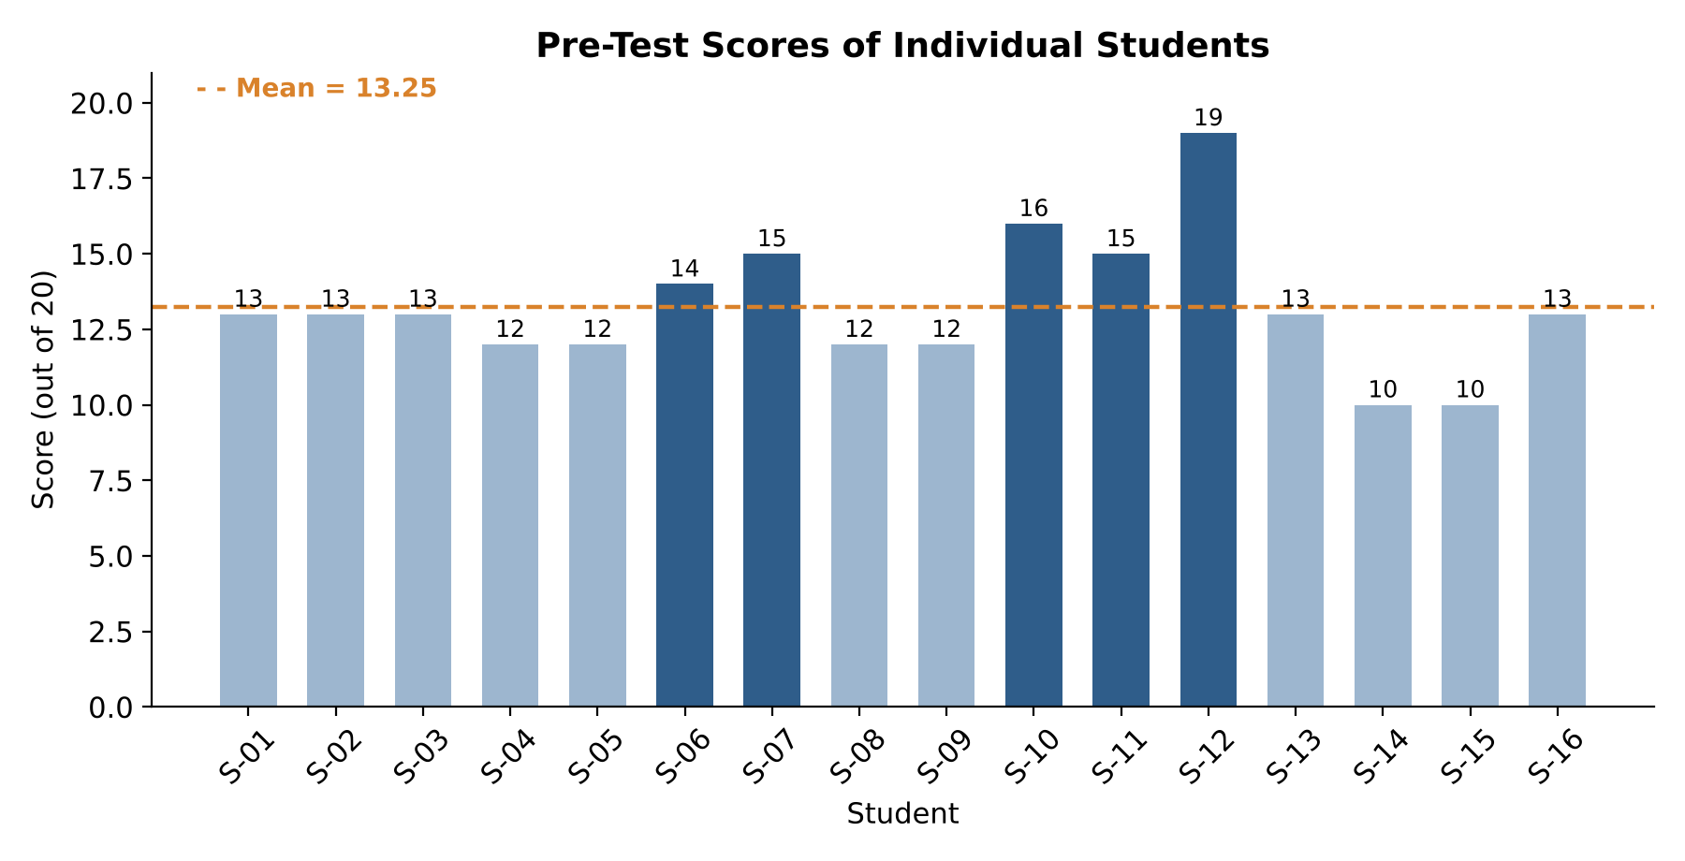
Figure 4.1: Pre-Test Scores of Individual Students
Figure 4.1 shows that scores were concentrated between 12 and 13, close to the class mean of 13.25. Five students (S-06, S-07, S-10, S-11, and S-12) scored above the mean, while eleven students scored below it. S-12 obtained the highest score (19/20), while S-14 and S-15 obtained the lowest (10/20).

4.2.1 Descriptive Statistics
Table 4.3: Descriptive Statistics of the Pre-Test
Statistic | Value
Number of students (N) | 16
Total marks | 20
Sum of scores | 212
Mean | 13.25
Mean percentage | 66.25%
Median | 13
Mode | 13 (5 students)
Standard deviation (sample) | 2.24
Minimum score | 10
Maximum score | 19
Range | 9
First quartile (Q1) | 12
Third quartile (Q3) | 14.25
Students at or above mean | 5 (31.25%)
Students below mean | 11 (68.75%)
The mean score of 13.25 (66.25%) indicates that, before the intervention, students possessed a moderate understanding of the targeted grammar concepts. The median and mode (both 13) are very close to the mean, showing that the distribution was fairly balanced around the centre. The standard deviation of 2.24 indicates moderate variation, which is largely due to one high score (19) at the upper end and two low scores (10) at the lower end. Notably, no student failed the test outright (all scored 50% or above), but only one student reached the “Excellent” band.

4.2.2 Frequency Distribution
Table 4.4: Frequency Distribution of Pre-Test Scores
Score | Frequency (f) | Percentage | Cumulative Frequency
10 | 2 | 12.50% | 2
12 | 4 | 25.00% | 6
13 | 5 | 31.25% | 11
14 | 1 | 6.25% | 12
15 | 2 | 12.50% | 14
16 | 1 | 6.25% | 15
19 | 1 | 6.25% | 16
Total | 16 | 100% | —
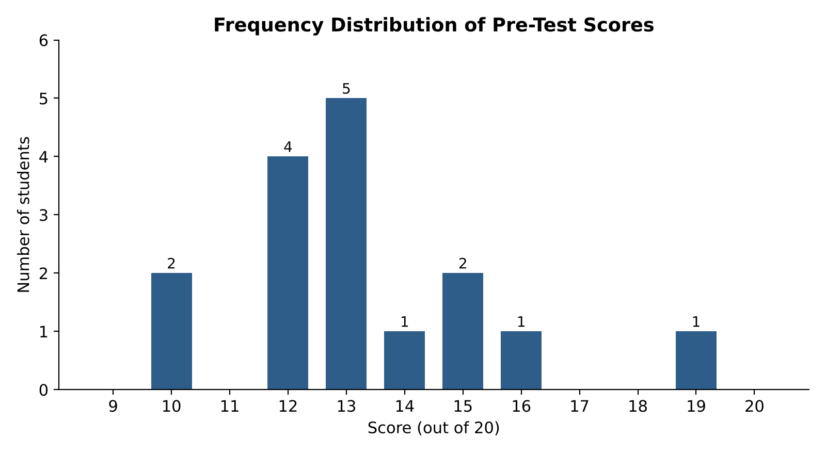
Figure 4.2: Frequency Distribution of Pre-Test Scores
The most frequent score was 13, obtained by five students (31.25%), followed by 12, obtained by four students (25%). Together, these two scores account for more than half the class (56.25%). The distribution is slightly positively skewed because of the single high score of 19, which lies well above the rest of the class.

4.2.3 Performance Levels
Table 4.5: Performance Levels of Students in the Pre-Test
Performance Level | Score Range | No. of Students | Percentage | Students
Excellent | 17–20 (85–100%) | 1 | 6.25% | S-12
Good | 14–16 (70–80%) | 4 | 25.00% | S-06, S-07, S-10, S-11
Average | 12–13 (60–65%) | 9 | 56.25% | S-01–S-05, S-08, S-09, S-13, S-16
Below Average | 10–11 (50–55%) | 2 | 12.50% | S-14, S-15
Total |  | 16 | 100%
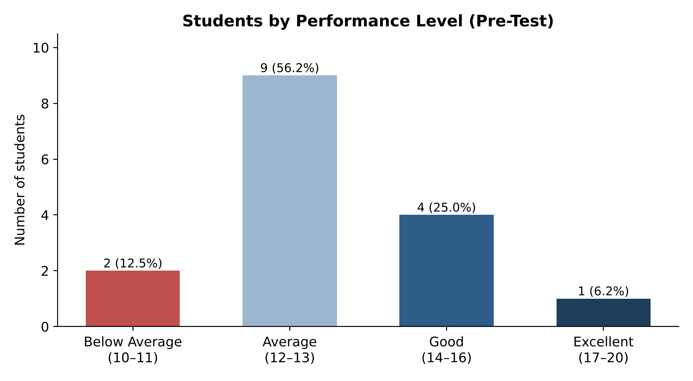
Figure 4.3: Students by Performance Level (Pre-Test)
More than two-thirds of the class (11 students, 68.75%) were in the Average or Below Average categories. This confirms the problem identified in Chapter 1: although students had some prior knowledge of grammar, most had not achieved a secure, applied command of the concepts. Students S-14 and S-15 in particular required additional support.
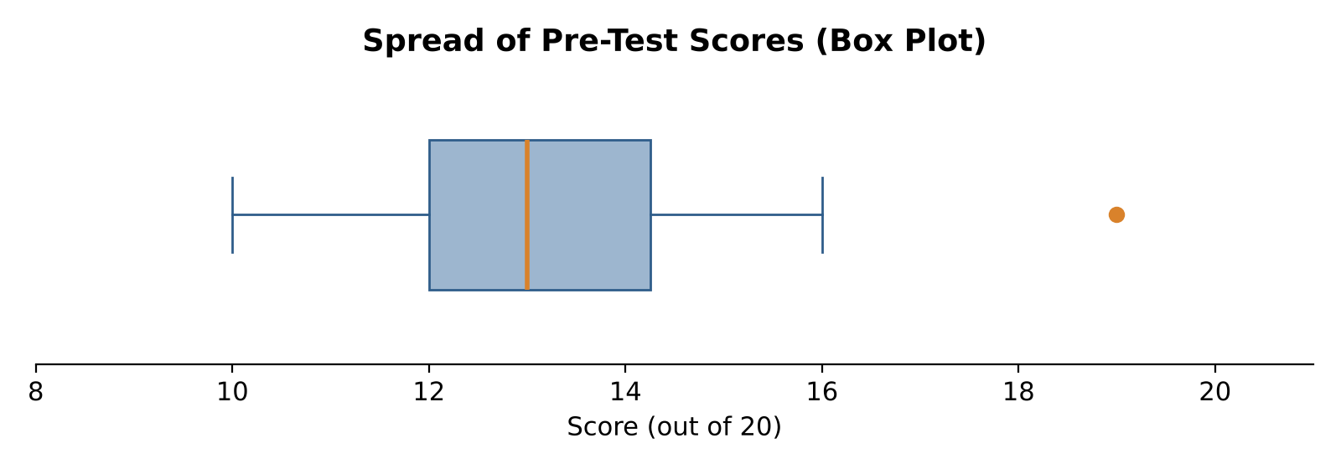
Figure 4.4: Spread of Pre-Test Scores (Box Plot)
The box plot shows that the middle 50% of students scored between 12 and 14.25, a narrow band of just over two marks. The score of 19 (S-12) appears as an outlier, well above the rest of the class, while the lower whisker extends to 10. This suggests a fairly homogeneous class with one exceptionally strong student.

4.2.4 Interpretation of the Pre-Test
The Pre-Test established a clear baseline for the study. With a mean of 13.25/20 and most students clustered in the Average band, the results indicate that students had partially memorised grammar rules but lacked consistent accuracy in identification and sentence construction. This baseline provides the reference point against which improvement after the Lecture Method (Post-Test 1) and after Activity-Based Learning (Post-Test 2) is measured.

4.3 Cycle 1: Lecture Method (Post-Test 1)
[Enter Post-Test 1 scores for S-01 to S-16 in Table 4.6. Then describe the mean, standard deviation and change from the Pre-Test, and note observations from the reflective journal during Phase A.]
Table 4.6: Post-Test 1 Scores (Phase A – Lecture Method)
Student | Pre-Test | Post-Test 1 | Gain
S-01 | 13 | [ ] | [ ]
S-02 | 13 | [ ] | [ ]
S-03 | 13 | [ ] | [ ]
S-04 | 12 | [ ] | [ ]
S-05 | 12 | [ ] | [ ]
S-06 | 14 | [ ] | [ ]
S-07 | 15 | [ ] | [ ]
S-08 | 12 | [ ] | [ ]
S-09 | 12 | [ ] | [ ]
S-10 | 16 | [ ] | [ ]
S-11 | 15 | [ ] | [ ]
S-12 | 19 | [ ] | [ ]
S-13 | 13 | [ ] | [ ]
S-14 | 10 | [ ] | [ ]
S-15 | 10 | [ ] | [ ]
S-16 | 13 | [ ] | [ ]
Mean | 13.25 | [ ] | [ ]

4.4 Cycle 2: Activity-Based Learning (Post-Test 2)
[Enter Post-Test 2 scores in Table 4.7 and describe the mean, standard deviation, and change from the Pre-Test and Post-Test 1. Mention which activities (Human Sentence, Scavenger Hunt, Flashcard Relay Race) appeared most effective.]
Table 4.7: Post-Test 2 Scores (Phase B – Activity-Based Learning)
Student | Pre-Test | Post-Test 1 | Post-Test 2 | Gain (PT1→PT2)
S-01 | 13 | [ ] | [ ] | [ ]
S-02 | 13 | [ ] | [ ] | [ ]
S-03 | 13 | [ ] | [ ] | [ ]
S-04 | 12 | [ ] | [ ] | [ ]
S-05 | 12 | [ ] | [ ] | [ ]
S-06 | 14 | [ ] | [ ] | [ ]
S-07 | 15 | [ ] | [ ] | [ ]
S-08 | 12 | [ ] | [ ] | [ ]
S-09 | 12 | [ ] | [ ] | [ ]
S-10 | 16 | [ ] | [ ] | [ ]
S-11 | 15 | [ ] | [ ] | [ ]
S-12 | 19 | [ ] | [ ] | [ ]
S-13 | 13 | [ ] | [ ] | [ ]
S-14 | 10 | [ ] | [ ] | [ ]
S-15 | 10 | [ ] | [ ] | [ ]
S-16 | 13 | [ ] | [ ] | [ ]
Mean | 13.25 | [ ] | [ ] | [ ]

4.5 Cycle-wise Comparison of Mean Scores
Table 4.8: Cycle-wise Comparison of Mean Scores
Test | Teaching Method | Mean (/20) | Percentage | Std. Deviation
Pre-Test | Baseline (no instruction) | 13.25 | 66.25% | 2.24
Post-Test 1 | Lecture Method | [ ] | [ ] | [ ]
Post-Test 2 | Activity-Based Learning | [ ] | [ ] | [ ]
[Figure 4.5: Cycle-wise Comparison of Mean Scores — a bar chart of the three means will be inserted here once the post-test scores are available.]

4.6 Qualitative Findings: Reflections from the Researcher’s Journal
[Summarise the main themes from the reflective journal, for example: (a) engagement and attention during lectures versus activities; (b) participation of quieter students; (c) anxiety and willingness to make mistakes; (d) peer collaboration. Support each theme with one or two short journal observations.]

CHAPTER 5: DISCUSSION, CONCLUSION AND RECOMMENDATIONS

5.1 Discussion
The diagnostic Pre-Test showed that the Grade 7 students began the study with a moderate level of grammar knowledge (mean = 13.25/20, 66.25%), with more than two-thirds of the class at the Average or Below Average level. This pattern is consistent with the literature, which suggests that lecture-dominated teaching produces partial, memorised knowledge rather than secure conceptual understanding (Behlol, 2009; Khan & Muhammad, 2015). The narrow clustering of scores around 12–13 suggests that students shared similar gaps, most likely in applying rules in sentence construction rather than simply recognising them.
[Discuss Post-Test 1 and Post-Test 2 results here: Did scores rise after the Lecture Method? Did they rise further after ABL? Relate the findings to Cakir (2015), Shah and Rahat (2014), Dissanayake et al. (2020) and Krashen (1982). Answer each research question in turn.]

5.2 Conclusion
[Write 1–2 paragraphs answering the three research questions based on the comparison of mean scores and the journal themes.]

5.3 Recommendations
- English teachers at the elementary level should integrate short, interactive grammar activities such as the Human Sentence and Flashcard Relay Race into routine lessons rather than relying solely on explanation and copying.
- Teachers should use diagnostic pre-tests, as in this study, to identify students who need additional support (e.g., those in the Below Average band) before introducing new grammar topics.
- Mistakes should be handled through positive error management, using constructive feedback and peer discussion to lower anxiety and encourage participation.
- Schools and teacher-training institutions should include activity-based grammar teaching in professional development workshops.

5.4 Implications of the Study
Educational implications: The study highlights the importance of moving from teacher-centred instruction towards student-centred, activity-based pedagogy in English language teaching.
Implications for teachers: Low-cost, easily managed activities can enhance motivation and reduce boredom, creating a supportive environment where students participate rather than passively memorise rules.
Implications for students: Learning grammar through interactive and kinesthetic activities can build confidence, reduce fear of making mistakes, and develop teamwork alongside academic achievement.
Curriculum and policy implications: Curriculum developers, teacher educators, and policymakers may consider incorporating ABL methodologies into curriculum frameworks and teacher-training programmes in Pakistan.

5.5 Limitations of the Study
- The sample was small (N = 16) and drawn from a single class through convenience sampling, so the findings cannot be generalised to all Grade 7 students.
- The single-group design had no separate control group; the order of the two methods (Lecture first, then ABL) means that gains in Phase B may partly reflect cumulative learning from Phase A.
- The intervention lasted only 15 days, which limits conclusions about long-term retention.
- The researcher was also the teacher and the marker, which may introduce bias despite the use of a fixed answer key.
- The achievement tests were teacher-made; their reliability was not statistically established.

5.6 Suggestions for Future Research
- Replicate the study with a larger sample and a separate control group (quasi-experimental design).
- Include a delayed post-test several weeks after the intervention to measure long-term retention more directly.
- Apply inferential statistics (e.g., paired-samples t-test) to test the significance of score differences.
- Examine the effectiveness of ABL in other subjects, grade levels, and in private-school settings.

REFERENCES
Ahlfeldt, S., Mehta, S., & Sellnow, T. (2005). Measurement and analysis of student engagement in university classes where varying levels of PBL methods of instruction are in use. Higher Education Research & Development, 24(1), 5–20.
Ahmed, S. (2017). Valuing activity-based teaching in Pakistan’s education sector. International Journal of Social Sciences, 4(2), 112–118.
Anderson, L. W., & Krathwohl, D. R. (Eds.). (2001). A taxonomy for learning, teaching, and assessing: A revision of Bloom’s taxonomy of educational objectives. Longman.
Anwer, M. (2019). Teaching and learning process in activity-based learning method. Educational Research Journal.
Behlol, M. G. (2009). Conventional teaching techniques and student achievement. Journal of Elementary Education.
Benson, N., & Blackman, S. (2003). Can research methods ever be interesting? Active Learning in Higher Education, 4(1), 39–55.
Bhalli, M., Sattar, A., & Asif, M. (2016). Comparative study of traditional methods with cooperative and activity-oriented learning in teaching of English. Pakistan Journal of Social Research, 2(13), 498–505.
Bligh, D. A. (2000). What’s the use of lectures? Jossey-Bass.
Bruner, J. S. (1966). Toward a theory of instruction. Harvard University Press.
Cakir, I. (2015). The benefits of activity-based teaching for teachers and students. Journal of Language and Linguistic Studies.
Creswell, J. W. (2012). Educational research: Planning, conducting, and evaluating quantitative and qualitative research (4th ed.). Pearson.
Dissanayake, D. M. R. S., Alahakoon, A. M. Y. S., & Wijesinghe, W. A. D. S. K. (2020). Activity based teaching method for effective English language teaching in primary education. SSRN Electronic Journal. https://doi.org/10.2139/ssrn.3730568
Dweck, C. S. (2006). Mindset: The new psychology of success. Random House.
Fallon, M., et al. (2013). The impact of active learning on student involvement. International Journal of Instruction.
Fredricks, J. A., Blumenfeld, P. C., & Paris, A. H. (2004). School engagement: Potential of the concept, state of the evidence. Review of Educational Research, 74(1), 59–109.
Khan, A., & Muhammad, S. (2015). The trade-off between conventional teaching approach and activity-based teaching. PEOPLE: International Journal of Social Sciences, 1(1), 1285–1295.
Krashen, S. D. (1982). Principles and practice in second language acquisition. Pergamon.
Lijanporna, S. (2017). Significance of English language in day-to-day interactions. Education Today.
McGrath, J., & MacEwan, G. (2011). Activity-based teaching techniques. Case Studies Journal.
Metcalfe, J. (2017). Learning from errors. Annual Review of Psychology, 68, 465–489.
Petress, K. (2008). What makes an active learner? Education, 128(4), 566–569.
Planning Commission of Pakistan. (2007). Vision 2030. Government of Pakistan.
Shah, I., & Rahat, S. (2014). Comparative analysis of activity-based learning and lecture methods. Journal of Social Sciences.
Singh, A. (2004). Teaching strategies in elementary classrooms. Journal of Educational Strategies.
UNICEF. (2016). Assessment of activity based teaching methodology. UNICEF Education Reports.
Zafar, H., & Akhtar, S. H. (2021). Analyzing the effectiveness of activity based teaching and traditional teaching method. Language in India, 21(4). http://www.languageinindia.com

APPENDICES

Appendix A: Pre-Test Raw Score Sheet
Code | S-01 | S-02 | S-03 | S-04 | S-05 | S-06 | S-07 | S-08
Score | 13 | 13 | 13 | 12 | 12 | 14 | 15 | 12

Code | S-09 | S-10 | S-11 | S-12 | S-13 | S-14 | S-15 | S-16
Score | 12 | 16 | 15 | 19 | 13 | 10 | 10 | 13
Total = 212; Mean = 13.25; SD = 2.24; Maximum marks = 20.

Appendix B: Permission / Reference Letter
[Attach the reference letter from the Government College of Education and the permission letter from the practicum school.]

Appendix C: Consent Form for Research Participants
I, the undersigned, agree that my child / I may take part in the action research study “Enhancing Retention of English Grammar Concepts in Grade 7.” I understand that participation involves normal classroom lessons and three short grammar tests, that results will be kept confidential using student codes, and that participation will not affect school grades.
Student name: ______________________ Signature: ______________________ Date: __________

Appendix D: Achievement Test (Pre-Test / Post-Tests)
[Attach a copy of the 20-mark Pre-Test, Post-Test 1 and Post-Test 2 question papers with answer keys.]

Appendix E: Reflective Journal Template
Date / Day | Phase & Activity | Engagement Observed | Participation | Anxiety / Errors | Reflection

