## What is a Landing Page?

As defined by [Unbounce](https://unbounce.com/landing-page-articles/what-is-a-landing-page/), “a landing page is a standalone web page, created specifically for the purposes of a marketing or advertising campaign.” Unbounce also mentions landing pages are designed with a single objective in mind, known as a Call to Action or CTA.  
Landing pages are used at various stages throughout the [inbound marketing cycle](https://www.hubspot.com/inbound-marketing). From introducing a user in your target market to your brand to converting a lead into a paying customer, landing pages can help accomplish your goal at each stage of the purchase process.

## What is Homepage?

Homepages are great for what they do, which is provide general information and encourage visitors to *explore.*

As the main gateway to a website, a homepage acts as an introduction to that business’s brand, product, services, values, who and what it’s for, who to contact, you name it. It’s meant to set a “first impression,” encompass *all* that a company has to offer, and direct visitors to learn more throughout different sections of the site.

**The basic components of a landing page :**

1. A main headline and a supporting headline
2. A unique selling proposition
3. The benefits of your offering
4. Images or video showing context of use
5. Social proof
6. A reinforcement statement
7. A closing argument
8. A call to action

## WHAT MAKES FOR A GOOD HOMEPAGE?

Aside from giving you a small ideal of how a homepage differs structurally from a landing page, let’s discuss what it should accomplish:

#### **Occupy your root domain (i.e. www.digitalstrike.com) It’s the central hub of your website.**

It’s where the link in your company logo links, and it’s where site visitors can easily find navigation to the rest of your site

#### **Give a comprehensive overview of what your business does**

When looking at your homepage, a visitor should definitively know what your company does but also feel compelled to venture within the site for more detailed info

#### **Link to every other crucial permanent page of your website**

People who land on your homepage should be able to easily access all valuable web pages, including all service pages, your blog, the contact page, etc.

#### **Tell visitors how to connect with you in different ways**

Make sure your phone number is prominently displayed and that people can find you on social media….

## WHAT MAKES FOR A GOOD LANDING PAGE?

Conversely, let discuss what an effective landing page should accomplish:

#### **Feature design elements to receive traffic from one or several specific sources**

A landing page is designed to welcome traffic from a click on an ad on Google or a link inside an email; the info on the page should expand on what’s found in the ad/email

#### **Prompt visitors to accomplish a goal through a strong call-to-action (CTA)**

A landing page funnels visitors in the direction of accomplishing on central goal, such as signing up for a newsletter, requesting a free quote, registering for a webinar, etc.

#### **Stay focused on a single topic or offer throughout the page**

A landing page should never say or do too much; anything above and beyond a single topic distracts the visitor from the main goal

#### **Omit or downplay navigation options**

Unlike your homepage, a landing page should not include a navigation bar; this allows visitors to click out of the page, lessening any chance for meaningful action

#### **Not necessarily intended to be a permanent part of your website**

Your homepage is the face of your website, but a landing page is more of a temporary microsite, meant only for use in conjunction with marketing campaigns

### **Homepage Example**

You have probably seen a million homepages, so we’re just going to share one.

Our favorite example is our own homepage. [It didn’t always look this good](https://www.digitalstrike.com/blog/marketings-guide-to-website-redesign/), but right now we’re pretty damn proud of it. As you can see, we give an overview of the solutions and services we offer with a couple of calls-to-action sprinkled throughout the page. We have a “sticky header,” which means our header stays at the top even when you scroll down – and our phone number stays prominently displayed.

But we also have a navigation menu that lets you explore the rest of our site depending on what you want to know.

Look how pretty it is.

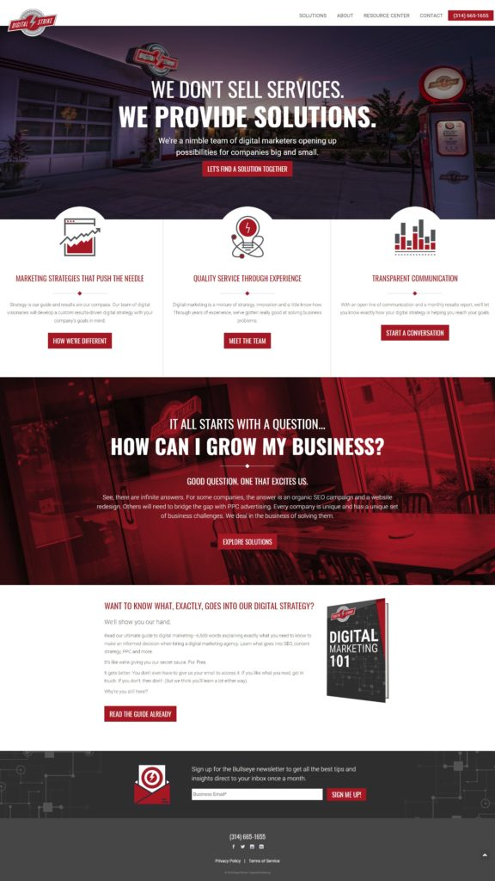

### **Landing Page Example**

Here is an example of a landing page we designed for a client. We specifically designed it for a campaign to promote the company’s fire damage restoration services. The call-to-action is to schedule a free estimate, and as you can see below, the phone number is prominently displayed three times. And there’s a form you can fill out.

It gives you just enough information that makes you want to call this company and see how they can restore your home.

Singular call-to-action!

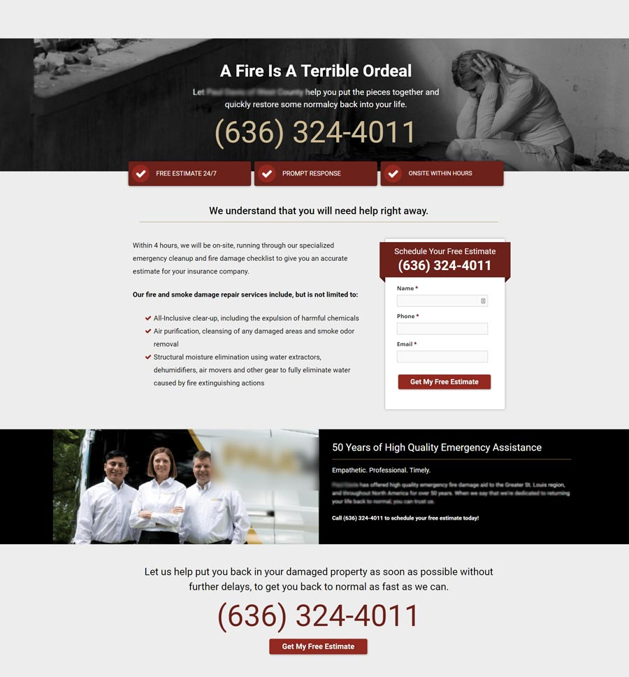

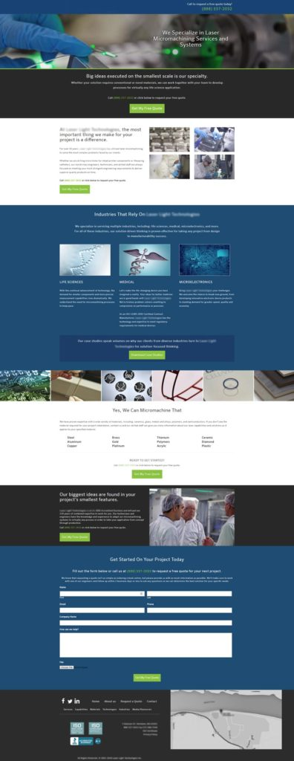

·        les éléments qui les constituent ainsi que les tendances modernes dans la conception de telles pages.

**How to make the landing page modern**

### 1. Get Faster Load Speed for Your Landing Page

According to a study conducted by [Unbounce](https://unbounce.com/page-speed-report/), nearly 70% of consumers admitted that page loading speeds affected their purchase decisions. Furthermore, the study found that over half the responders would hit the back button if the page took **more than 6 seconds to load**.

### 2. KISS – Keep It Short and Simple

Our attention span, when it comes to marketing messages, is rather short. It’s not a surprise considering all the billboards, ads, email promotions, and more we’re getting bombarded with each day. However, this shows a clear direction that your landing page needs to be straight to the point and as simple as possible.

### Optimize Your Landing Page for Mobile

It’s no secret that smartphone usage is growing each year. According to research by [Statista](https://www.statista.com/statistics/330695/number-of-smartphone-users-worldwide/), there will be 3.5 billion smartphone users this year, with this number increasing to 3.8 billion next year. This is a huge indication of where the information consumption is heading.

### 4. Create Trust in Your Landing Page

It’s difficult to convert someone who doesn’t trust you or your website. You could have the best product or service out there but still won’t see the conversion rates you should be seeing. Consider adding elements to your landing page that create trust and show other people being satisfied with their purchase.

### 5. Add a Clear CTA

Make sure your CTA “call to action” is visible and describing the action the customer will take when clicking on it. It’s also better to become creative with the copy part of the button and not just writing “Submit”. Think of the CTA as your punchline that gives the potential customer a strong reason to click on it.