Pseudocode

Declare temp
Declare distance
Declare weight
Declare country
Declare choice
print “enter country”
Ask/getline country store in country
Print converter toolkit
Print “1. Temp”
Print “2. distance”
Print “3. weight”
Print “4. quit”
Ask number 1-4
Check if valid
If yes
Switch
In case 1 Ask temp, Convert temp, Print temp
In case 2 Ask distance, Convert distance,Print distance
In case 3, Ask weight, Convert weight, print weight
In case 4, read you quit
If no
Print invalid input
Print country
Print outro

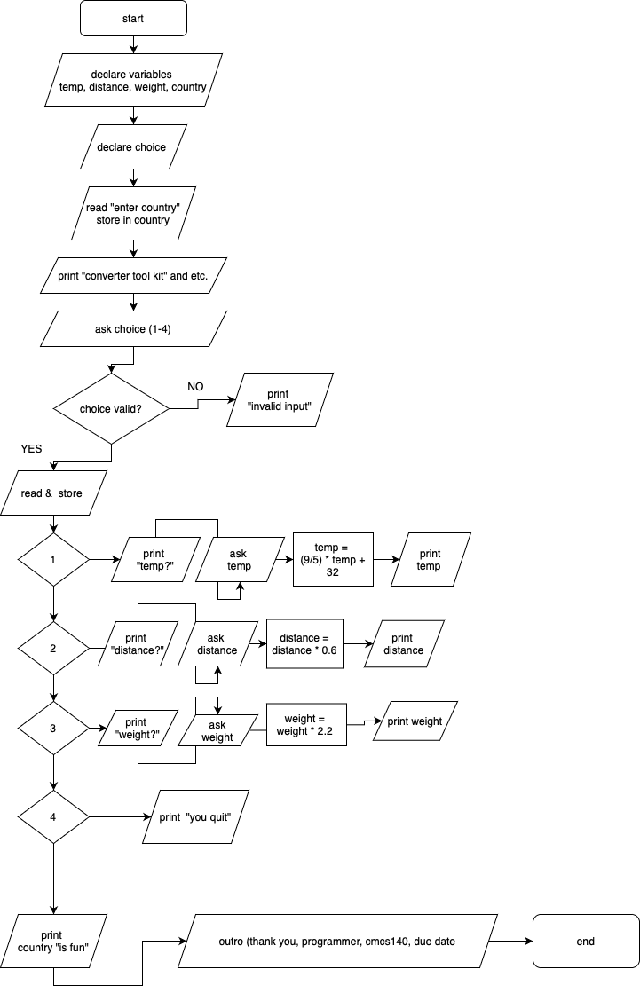

Test Case # | Input | Actual Input | Expected Output | Actual Output | Did the test pass?
1 | Choice 1  Temp 20 | 68 | 68 | 68 | yes
2 | Choice 2  Distance -8 | !!! Program does not convert negative weight !!! | Error message | !!! Program does not convert negative weight !!! | yes
3 | Choice 3 | 0 | error | !!! Program does not convert negative weight !!! | yes
4 | Choice 4 | You quit :( | quit | You quit :( | yes

Screenshot:

Valid input
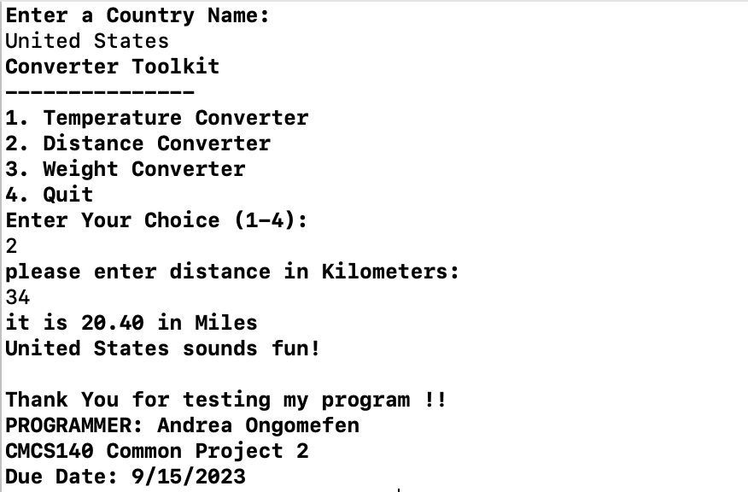
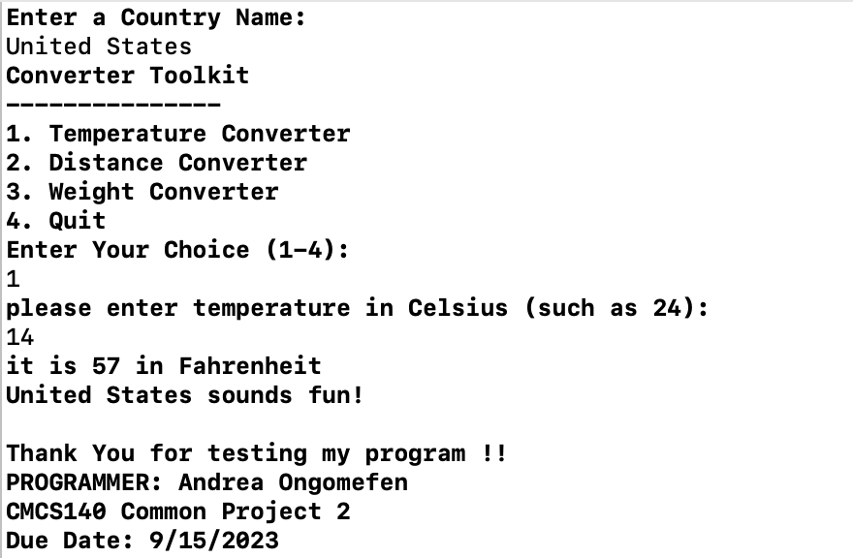
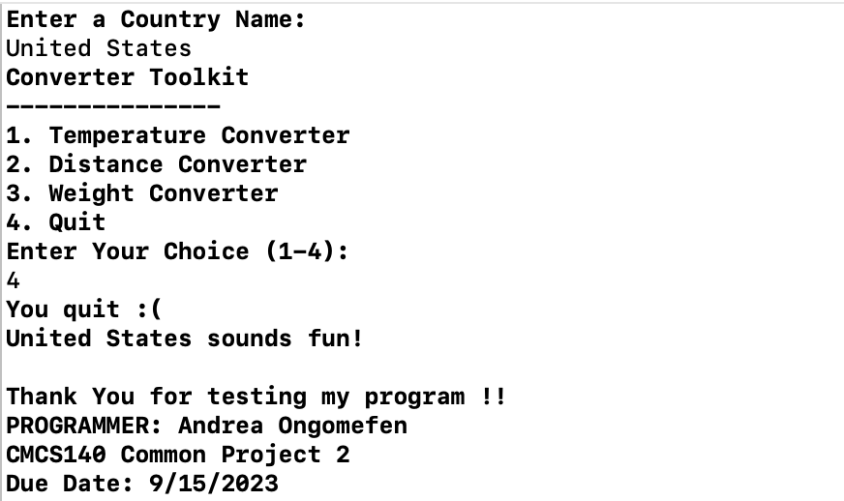
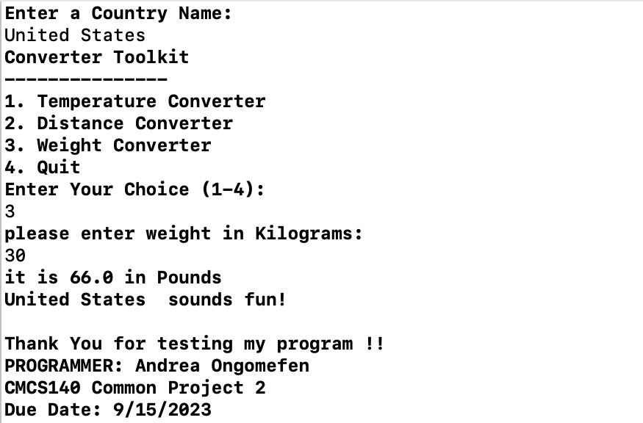

Invalid input
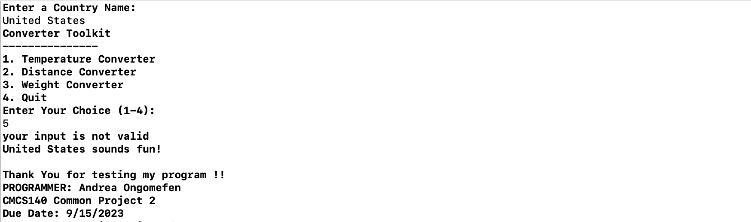

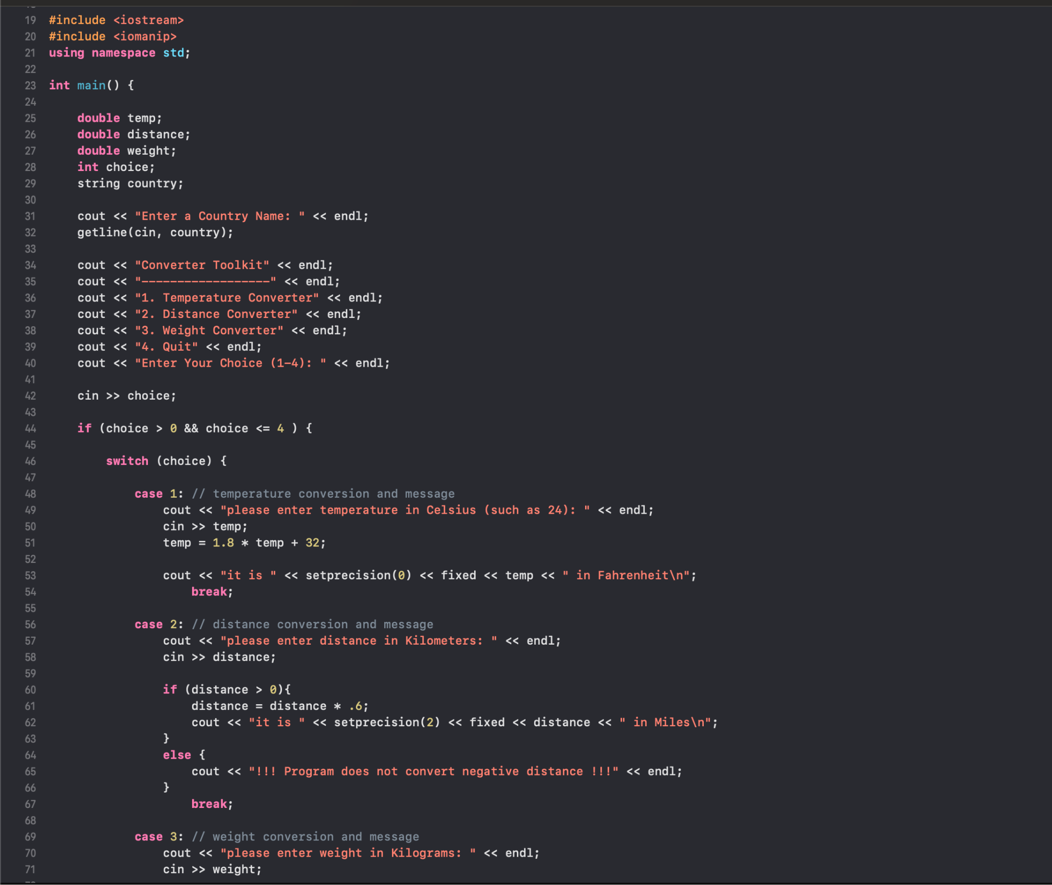

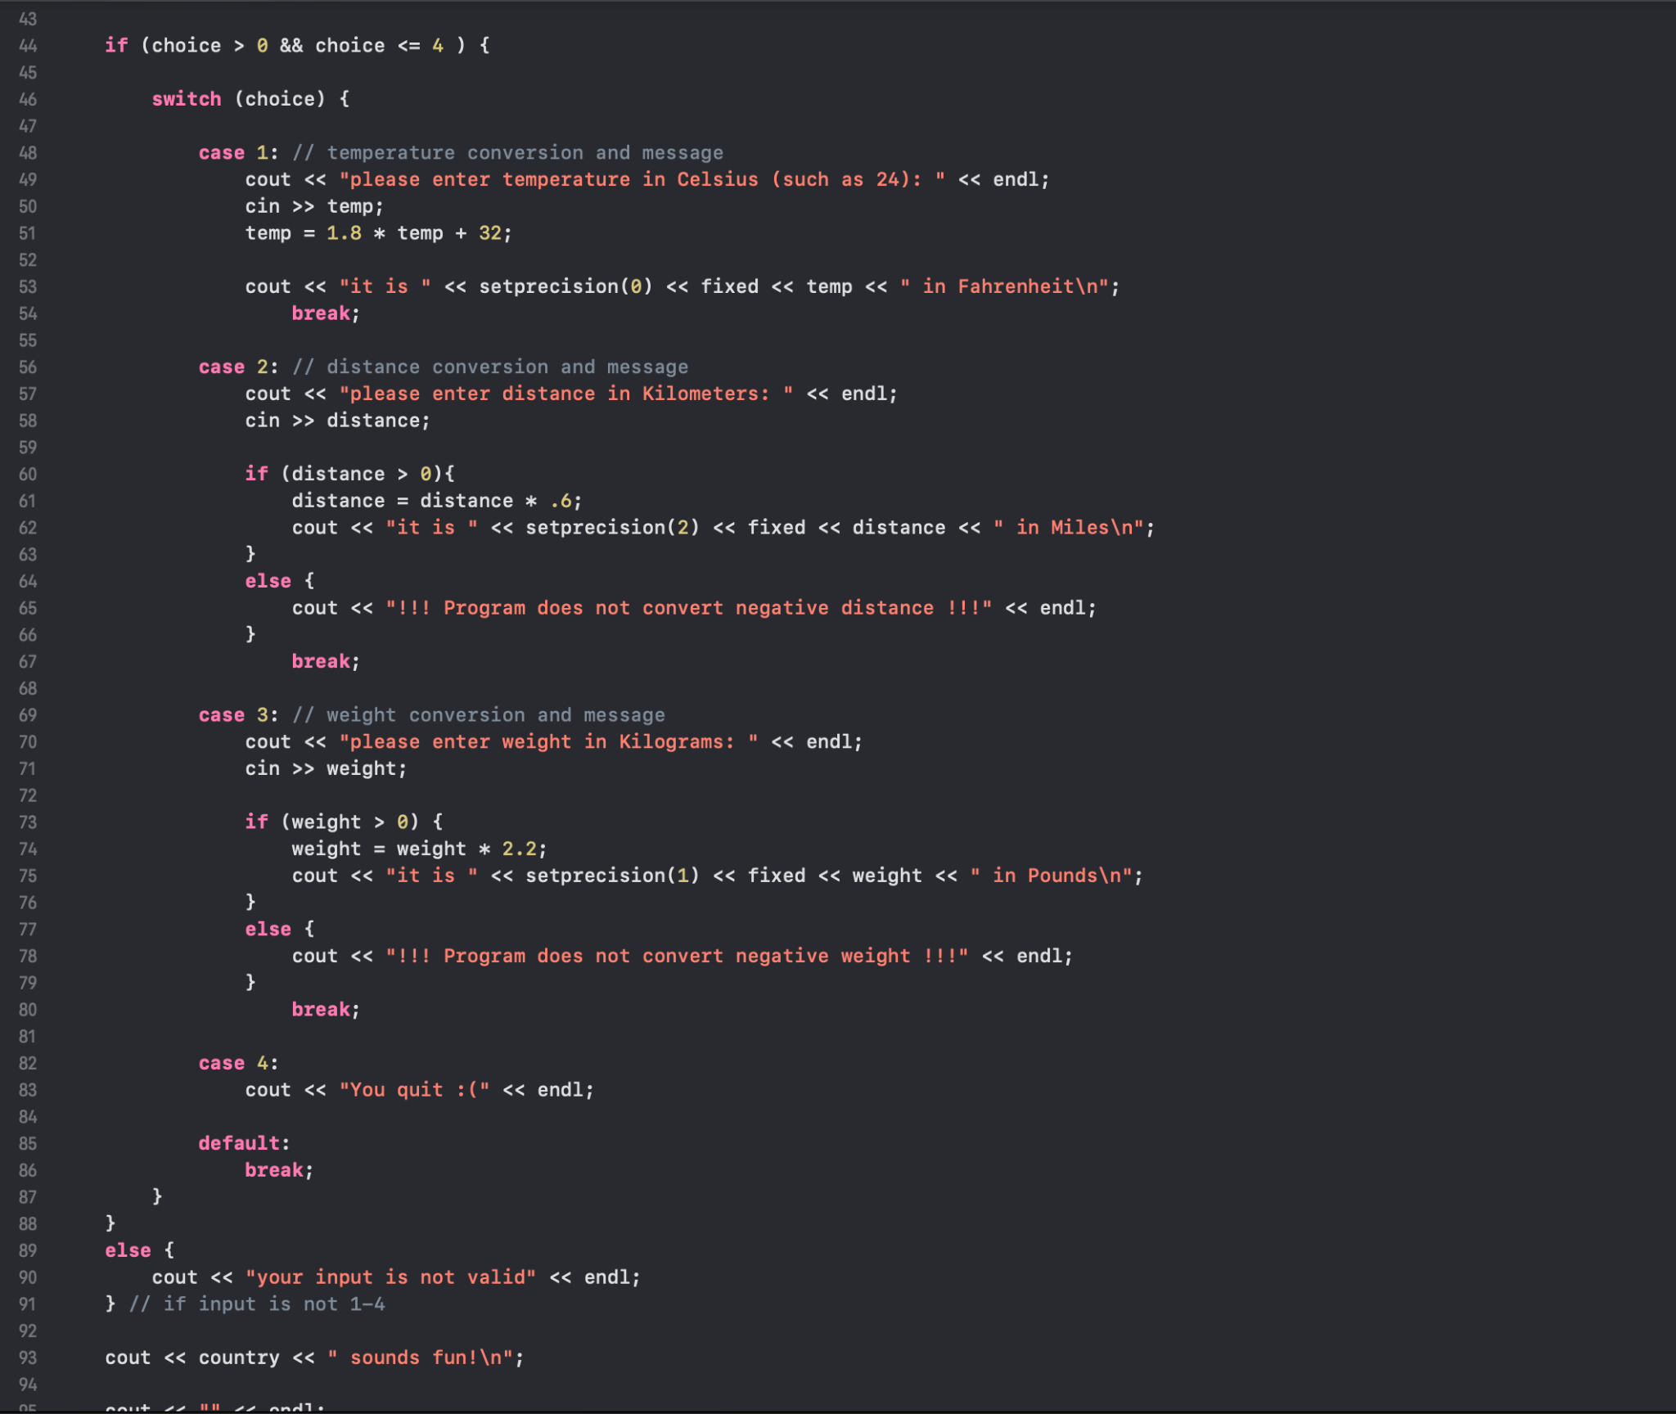

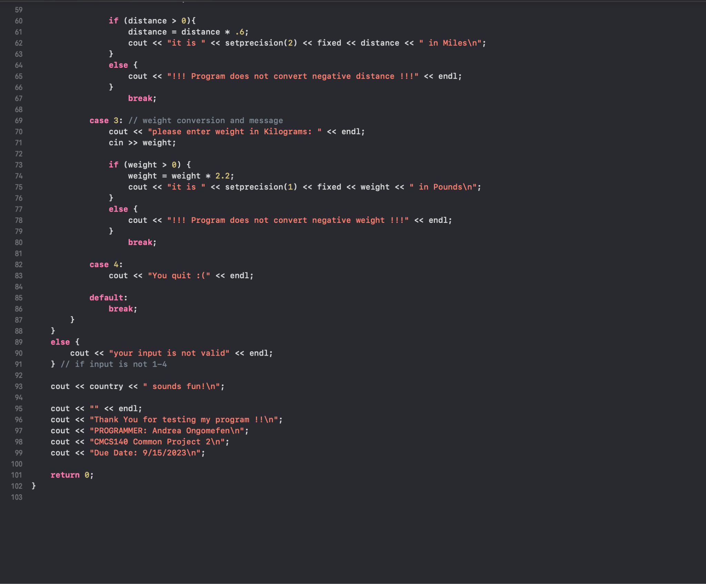

Lessons Learned

Write about your Learning Experience, highlighting your lessons learned and learning experience from working on this project.
What have you learned? I learned about how initialization works within a switch statement
What did you struggle with? Fahrenheit conversion because the fraction was input as a whole creating a problem in the solution
What would you do differently on your next project? Write more comments in my code
What parts of this assignment were you successful with, and what parts (if any) were you not successful with? Everything except multiplying fractions with int instead of double
Provide any additional resources/links/videos you used to while working on this assignment/project.
https://www.tenouk.com/clabworksheet/labworksheet8b.html

