**Getting started with the DigiGlove Application**

Step 1: Download the software

In order to be able to use the DigiGlove application, you need to download the software. You can clone the directory with the belonging files on Github, following the next link1

Link1: <https://github.com/AP-Elektronica-ICT/intprojectrepo-digi-glove>

Step 2: Run the software

After successfully cloning the software you are able to run de DigiGlove Application.

Open the cloned software with Visual Studio 2019.

Open the folder ‘Digi-Glove-Application’ and double click on ‘Digi-Glove-Application.sln’.

A new solution will open.

This application enables you to run the application.

Press the Start button and the solution will start debugging.

Now you can see the home screen of the DigiGlove Application:

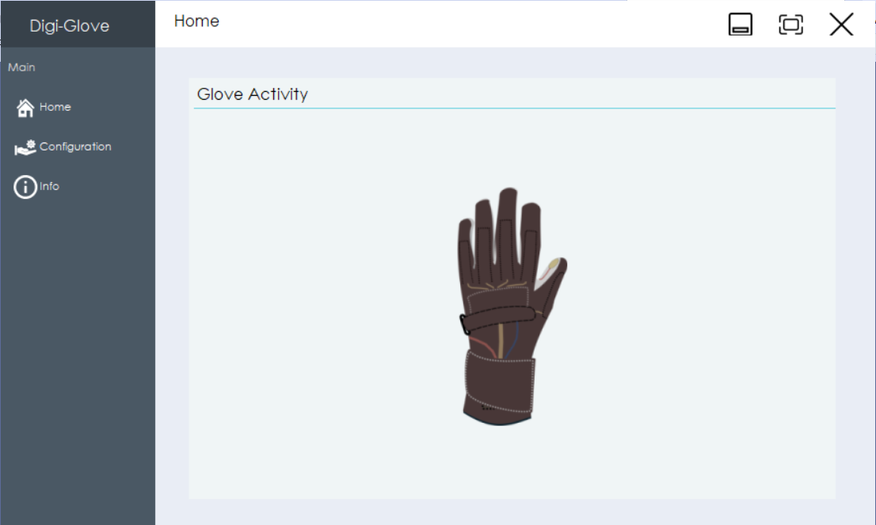

Step 3: The Main folder

You can switch between three different windows: Home, Configuration and Info

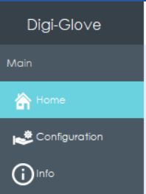

**- Home**

This window will show you the activity of the glove

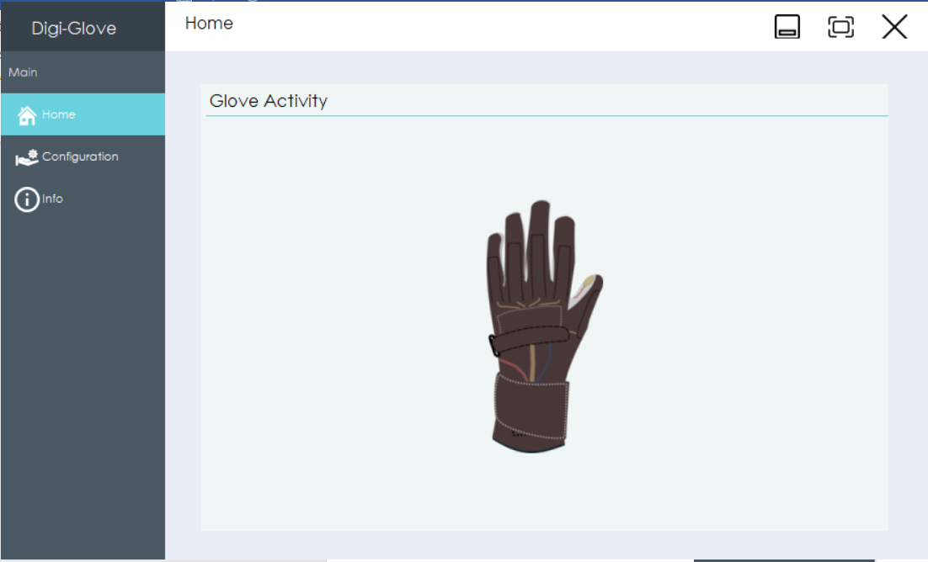

**- Configuration**

This window will give you an overview of all macro’s, the controls and the calibration

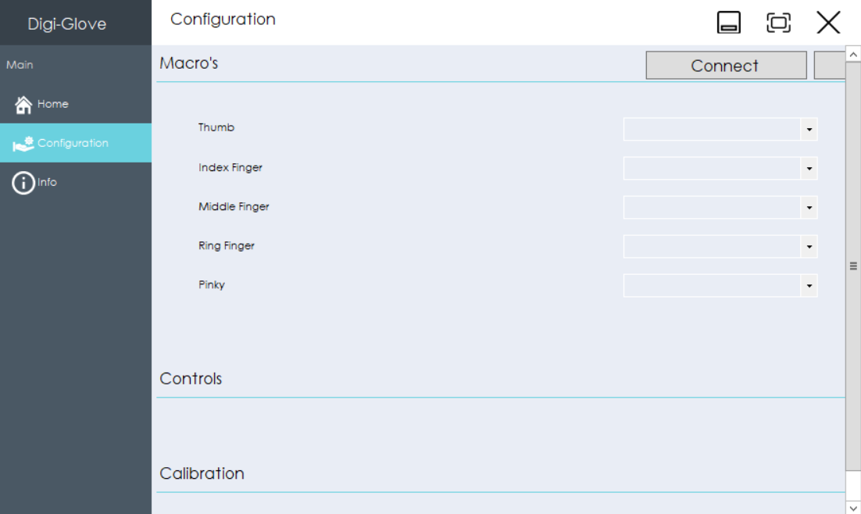

**- Info**

Here you can find more info about the Glove and the application itself

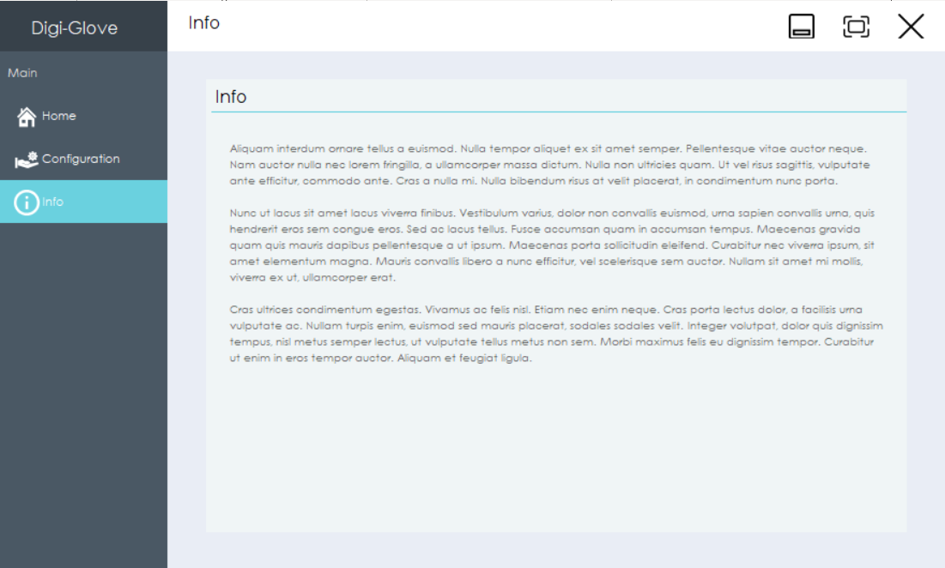

Step 4: Assigning macro’s to a finger

Go to the **configuration folder.**

Here you will see a subfolder called Macro’s.

The left side represents the **5** **fingers** of the glove.

On the right you see lists which are filled with possible macro’s.

Each **one** **of the five** **fingers** can get **one** **macro** assigned to it.

You can **choose** which **macro** you want to assign to each finger.

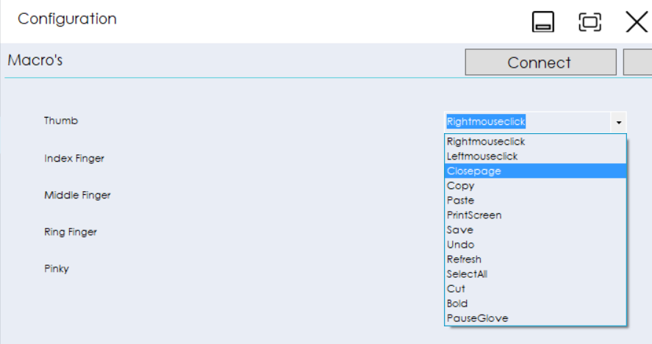

Step 5: Make a connection with the glove

When the **glove** is **turned** **on**, you can make a connection.

Press ‘**Connect’** to make a connection.

You have now made a connection through which data can be transferred to the glove.

Step 6: Save the configuration

**After** **assigning** macro’s to the fingers you can save the configuration.

Press ‘**Save’** next to the connect button.

You configuration has been sent to the glove.

Step 7: Ready to go!

Now you are **ready**.

You can **use** the glove.

Step 8: Change the configuration

Go to the **configuration** **folder**.

**Change** the configuration to the configuration you want.

Press ‘**Save’** again.

The configuration has been updated.