**Getting started with the DigiGlove Glove (hardware)**

Step 1: Put the glove on your hand

In order to be able to use the DigiGlove’s functionality, you need to put on the glove.

Step 2: Pair the device through Bluetooth

After successfully putting on the glove you need to pair the device with the application.

The connection gets provided by a Bluetooth connection.

Make sure to enable Bluetooth on your computer.

Wait a couple of seconds.

Step 3: Open the manual “ManualDigiGloveApplication.docx”

Read the instructions of this file.

Step 4 shows you how to assign the a macro.

Step 5 shows you how to make a connection between the application and the glove.

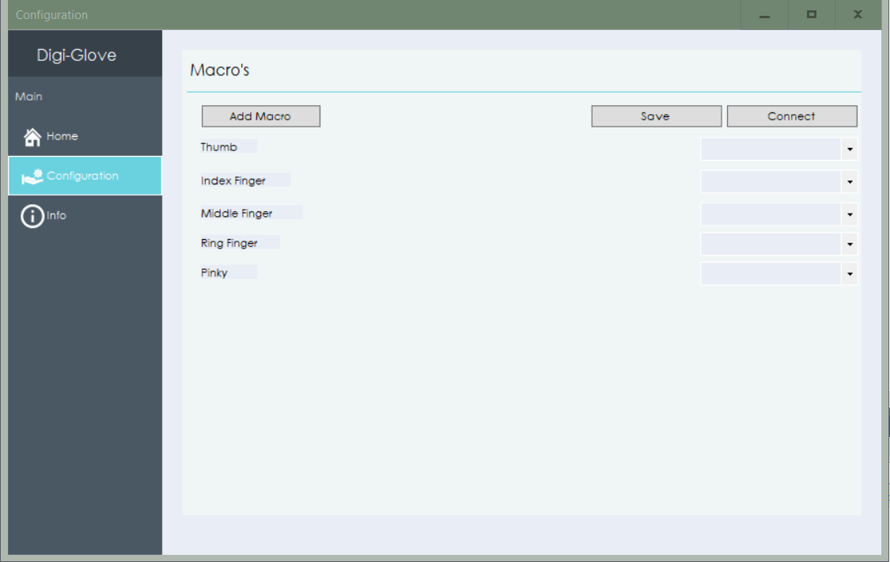

Funtions of the glove

**- Fingers**

The glove has 5 fingers. They are all provided with flex-strips. When you bend your finger the movement is registered.

**- Gyroscope**

The gyroscope provides a manner to register movement based on X and Y movement.   
This movement is used to hover with your mouse on the screen.

**- Touch sensors**

The glove has 2 touch sensors. These sensors continuously send data to the application to let us know when a touch movement has been made