Project name: Digiglove

# Team name: Charlie’s angels

* Flex sensor to measure bending amount of each finger
* Force sensors to fingertips if needed
* Gyroscope and an accelerator sensor to measure hand orientation

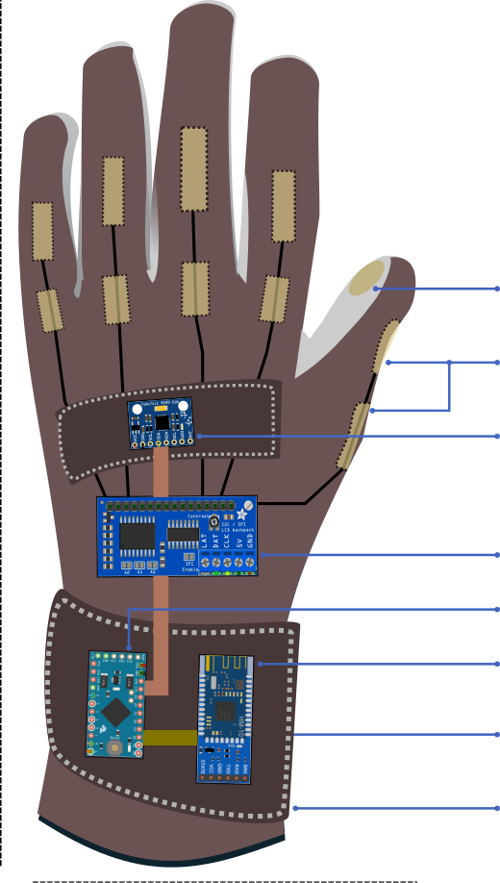

Api => translator  
 -bluethoot output communication

# Fucos:

-rotation (°)

-Flex sensor (registered in %)

# Possible extras:

-Accalerometer

## Programmable gestures

* scripting engine
* Usinng an existing gesture library (bv. Leap motion)
* Search open gesture inputs like VR/AR (github)

# Hardware

-Figuring out accuratie off flex sensors

-Technical Drawing:

* Power consumption
* connection requirements
* placement of parts for user confortability

-Finding a propper glove.

# THE PROJECT

## WHY?

We want to realise the future. Today IS, no SHOULD be what we imaged the future to be. We exist to create that future we imaged.

## HOW?

We look to our past and look what we desired the future to be.

## WHAT?

We are creating a glove which you will be able to digitally represent your hand in your desired software. You’ll be able to control your mouse, create macro’s with hand gesturers and even use it with software that uses hand gesturers to control it’s functionality.

## WHO?

Everyone that uses a computers.