CC

# Chiro Connect:

Doel van deze dashboard?

* Is een dashboard waarop alle chiro-netwerkapparaten worden verzameld en dat de activering van het netwerk weergeeft

Wat voor impact heeft deze project?

* Centraalpunt voor netwerk activiteit
* Opvolging van netwerk
* Handige tool voor IT-team Waarom chiro?
* Is mijn werk plaats, als ICT-medewerker

# Websites voorbeelden:

Link: <https://retool.com/templates/cyber-security-dashboard> Note: moet een account hebben voor dashboard te krijgen.

Inspiratie stijl:

* Simple dashboard
* Tabel
* Indicators

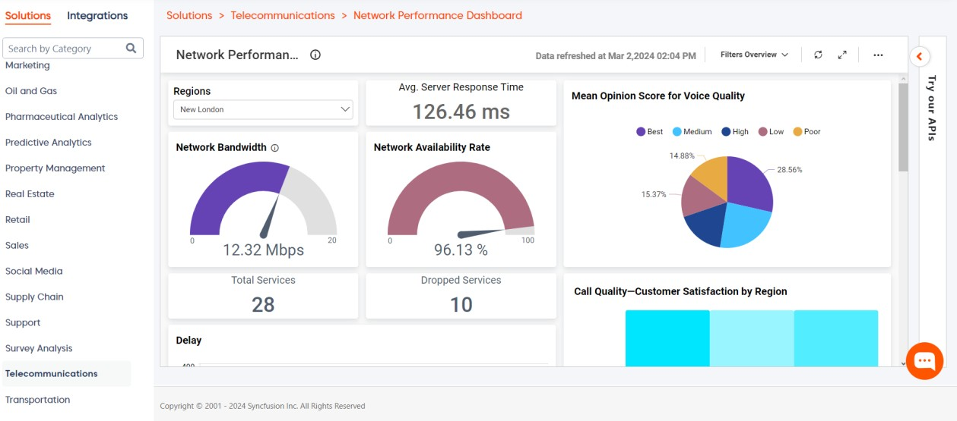

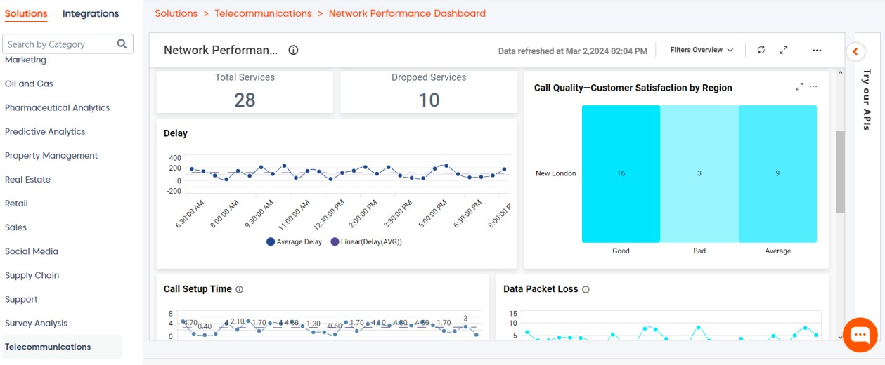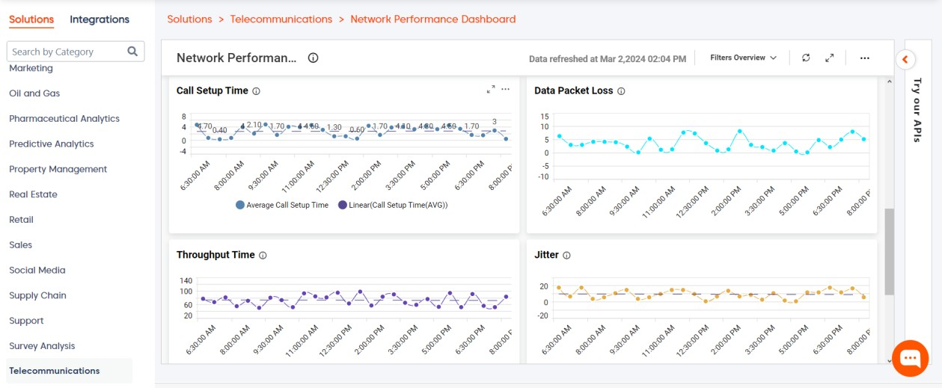

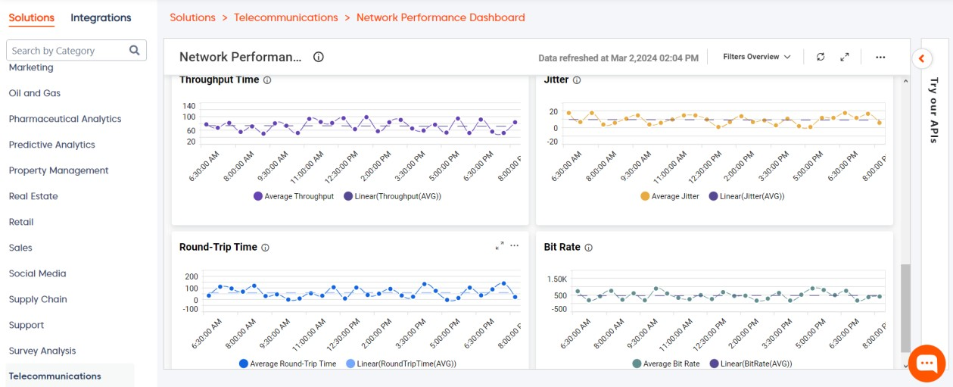

Link: [https://samples.boldbi.com/solutions/telecommunications/network-performance-](https://samples.boldbi.com/solutions/telecommunications/network-performance-monitoring-dashboard) [monitoring-dashboard](https://samples.boldbi.com/solutions/telecommunications/network-performance-monitoring-dashboard)

Inspiratie stijl:

* Geavanceerd opmaak van dashboard
* Veel details

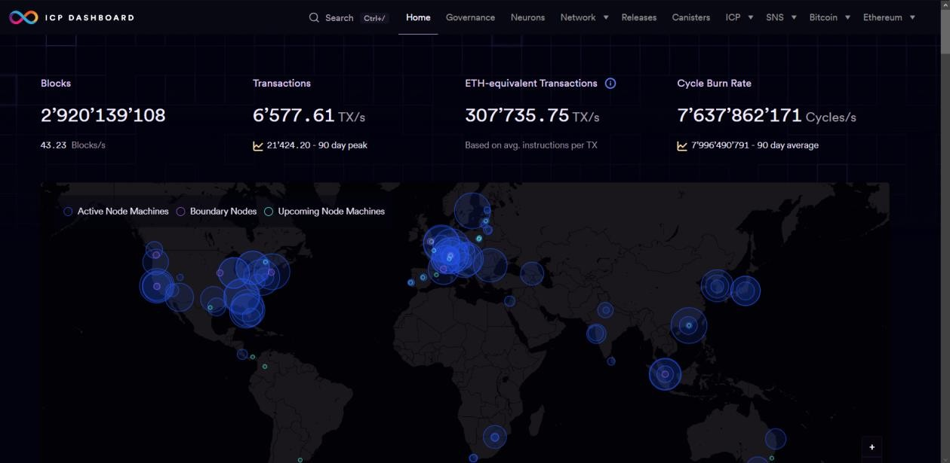

Link: [https://dashboard.internetcomputer.org](https://dashboard.internetcomputer.org/)

Inspiratie stijl:

* map dashboard
* Dark-mode screen
* Simple

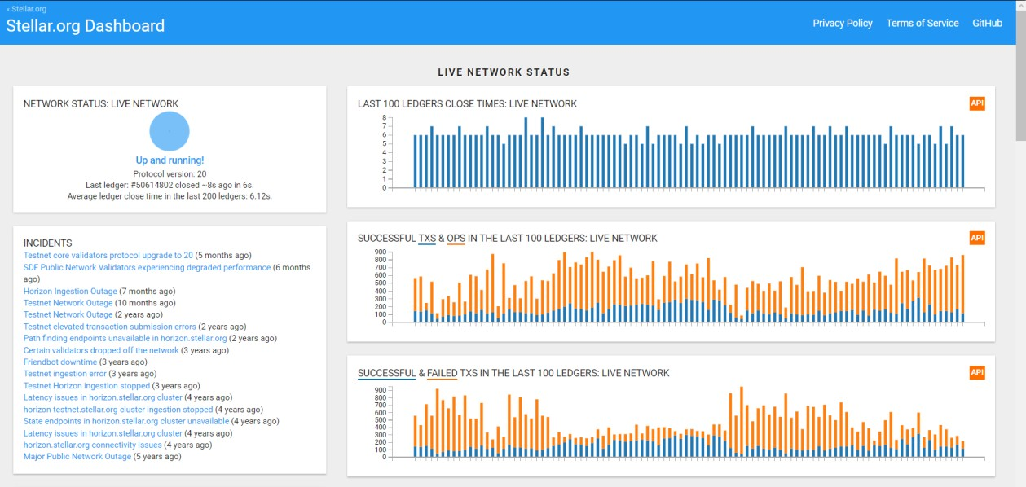

Link: [https://dashboard.stellar.org](https://dashboard.stellar.org/)

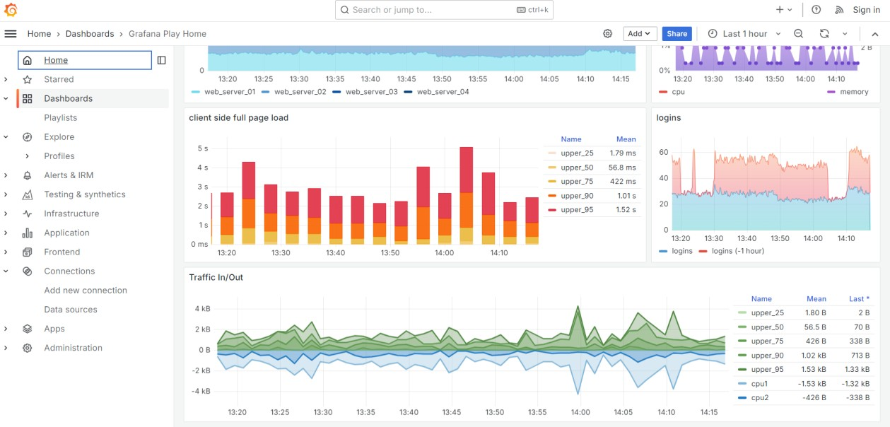

Link: <https://play.grafana.org/d/000000012/grafana-play-home?orgId=1>

Inspiratie stijl:

* Grafieken
* Charts
* Kleuren

# Visueel

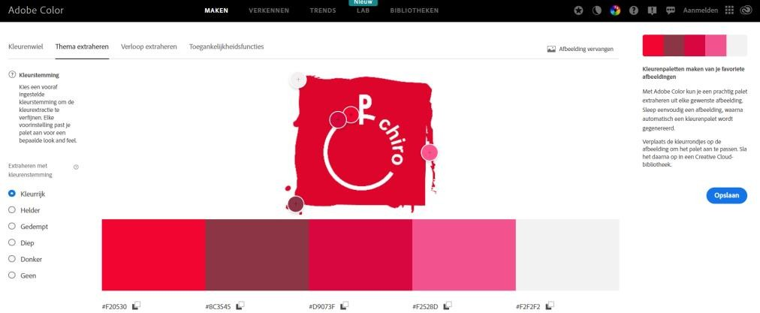

## Kleuren

* #F2053
* #8C3545
* #D9073F
* #F2528D
* #F2F2F2

## Logo



Kleuren gebruikt voor logo Web:

* #f2528d
* #d9073f Naam:
* #f20530

Home pagena

|  |  |  |
| --- | --- | --- |
| Home | About | Contact |

Logo



To Dashboard

Log in



Home Tekst

Footer

To dashboard pagena

|  |  |  |
| --- | --- | --- |
| Home | About | Contact |

Logo

To Dashboard

Log in

Task

Task

Footer



About pagena

Logo



To Dashboard



Log in

About Chiro

|  |  |  |
| --- | --- | --- |
| Home | About | Contact |

About ChiroConnect

Why ChiroConnect

Footer



Logo



To Dashboard



Log in

Contact Us

Contact Web developver Name:

Phone: Mail:

Contact Network Administrator Name:

Phone: Mail:

Contact Chiro Phone:

Mail:

|  |  |  |
| --- | --- | --- |
| Home | About | Contact |

Contact pagena

Where To find Us

Footer



Logo

To Dashboard

Welcome

Home Tekst

12:37

Home pagena

|  |  |  |
| --- | --- | --- |
| Home | About | Contact |



Logo

To Dashboard

Task

Task

12:37

To dashboard pagena

|  |  |  |
| --- | --- | --- |
| Home | About | Contact |



Logo

To Dashboard

About Chiro

About Chiro

About Chiro

12:37

About pagena

|  |  |  |
| --- | --- | --- |
| Home | About | Contact |



Logo

To Dashboard

Contact Us

Contact Web developver Name:

Phone: Mail:

Contact Network Administrator Name:

Phone: Mail:

Where To find Us

12:37

Contact pagena

|  |  |  |
| --- | --- | --- |
| Home | About | Contact |