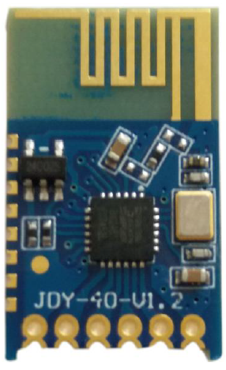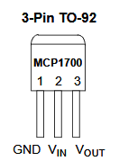
(16) PB2
(15) PB1
(6) PD4
(5) PD3
MCP1700
Vin 2

3 Vout

GND
1

ATMega328P
1µF
1µF
JDY40 connections to the ATMega328P.
3.3V
5V
5V
5V
All resistors 1kΩ

