Venturi - Induced Diaphragm Strain Gauge Architecture for Mass Air- Flow Measurement
Aditeya Sarkar, Aitijhya Sahoo, Shrirang Pai, Subhendu Karmakar
R V College Of Engineering, Bengaluru 560059
Abstract:
Reliable mass-flow measurement is critical for various applications, including Environment Control Systems (ECS) in aircraft. Traditionally used Thermal mass-flow sensors suffer from high-temperature range limits, contamination sensitivity, drift, and Invasiveness. This paper presents the design and development of a compact Venturi-based diaphragm strain-gauge sensor optimized for compressor bleed air in an aircraft ECS. The venturi produces a deterministic differential pressure, a thin metallic diaphragm instrumented with foil strain gauges transducers the pressure differential into voltage, and a low-noise analog front end conditions the signal for digital conversion and calibration. The paper covers Venturi sizing for compressible, high-temperature flows, diaphragm mechanics and fatigue constraints, analog front-end design, and an outline of CFD/FEA validation and calibration procedures for aircraft qualification. Simulation results and calibration methodology are included.
Index Terms: Aircraft ECS, Diaphragm Deflection, Mass Air Flow Sensor, Sensor Design, Strain Gauge, Instrumentation, Venturi Meter

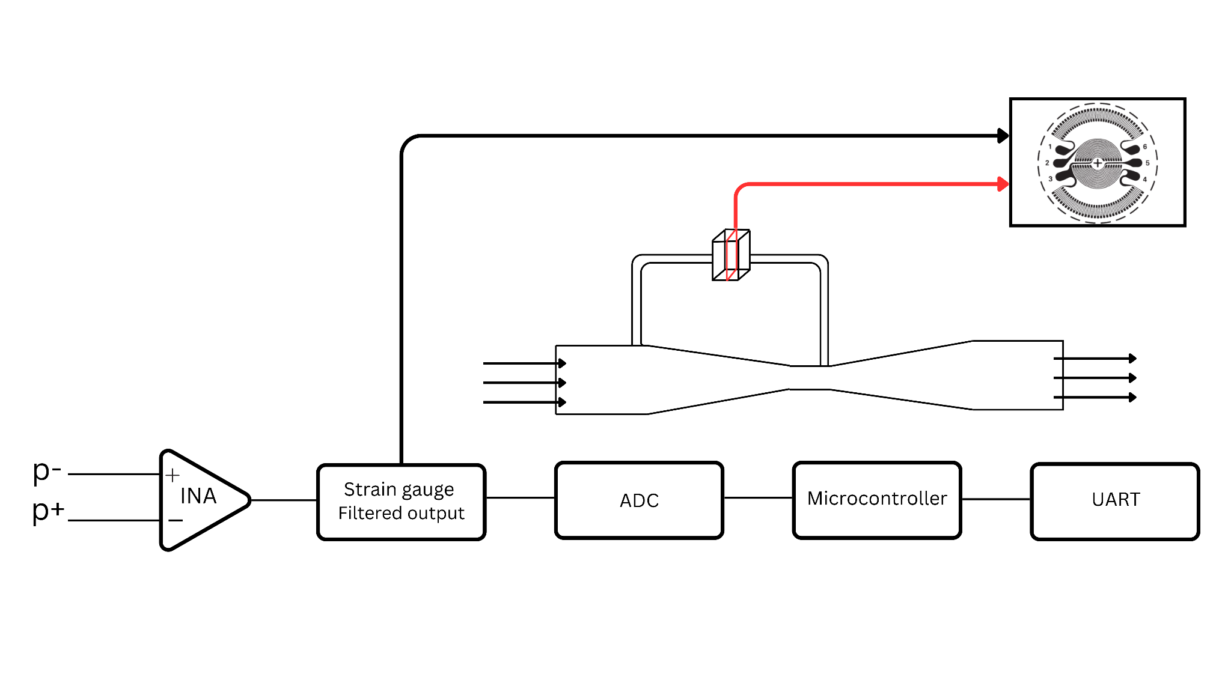
I. INTRODUCTION
Mass air flow sensors are crucial for various applications, including the Aircraft Environment Control System (ECS), which requires accurate measurement of mass flow through the bleed air duct. Most current installations use thermal mass-flow sensors based on hot-wire or MEMS heated elements. These technologies are costly and face significant limitations in bleed-air environments, notably restricted high-temperature capability, sensor drift under sustained thermal loads, sensitivity to contamination, and reduced accuracy when measuring highly compressible, high-temperature flows.
Thermal sensors are also inherently invasive; they alter the thermodynamic properties of the sampled air during the sensing process. Non-invasive alternatives, such as ultrasonic flow meters, avoid thermal intrusion but are prohibitively expensive and insufficiently robust to withstand the vibration and structural disturbances typical of aircraft installations.
This creates a clear operational gap for a low-cost, high-temperature-capable, vibration-resistant mass-flow sensor that can operate reliably with compressed bleed air while remaining effectively non-invasive. [2]

To address this gap, we propose a Venturi-based diaphragm strain-gauge sensor. A calibrated venturi meter generates a deterministic differential pressure between two stations, and this pressure difference is transduced by a thin metallic diaphragm that deflects proportionally to the applied load. A circular strain gauge bonded to the diaphragm responds to this deflection and produces a corresponding voltage when driven by a constant excitation source. The resulting electrical output is used to compute differential pressure, and the mass flow rate is derived using the continuity equation and Bernoulli’s principle, with corrections applied for absolute pressure and
temperature at the venturi throat.

Figure 1

This paper gives an overview over of the complete sensor development methodology, including venturi meter design principles, diaphragm deflection analysis, vibration-isolation considerations, analog front-end design for constant-current excitation, common-mode noise rejection using instrumentation amplifiers, and selection criteria for analog-to-digital conversion and data acquisition required for accurate evaluation of sensor data.

II. SYSTEM OVERVIEW
Figure [1] shows a simplified block diagram of the sensor design.
The venturi meter produces a differential pressure between the upstream and the throat. The two are connected to a diaphragm housing chamber. This causes a deflection in the diaphragm, which is transduced by a strain gauge. The voltage signal from the strain gauge is amplified and processed to provide an output voltage proportional to the pressure difference. This value is used to then derive the mass flow rate.

Primary design goals:
- Obtain mass flow rate from pressure difference.
- Determine dimensions for the venturi meter ensuring flow stability and obtaining the desired differential pressure values.
- Determine dimensions for the diaphragm ensuring linear range deflection.
- Developing a design for diaphragm housing and sealing.
- Developing a vibration noise isolation system.
The following are the constraints assumed for the design process:

Parameter | Value
Minimum Mass Flow Rate | 3 kg/min
Maximum Mass Flow Rate | 6 kg/min
Inlet (upstream) Diameter | 2 inch

III. OBTAINING MASS FLOW RATE FROM PRESSURE DIFFERENCE
The Strain Gauge provides differential pressure values; however, the final required output is Mass Flow Rate. This requires an expression for calculating the mass flow rate from the differential pressure.

Using the continuity relation,
 , we get 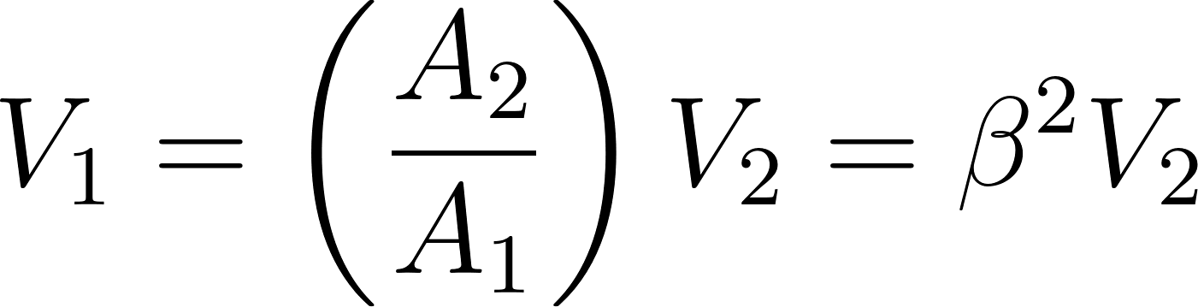
Where, 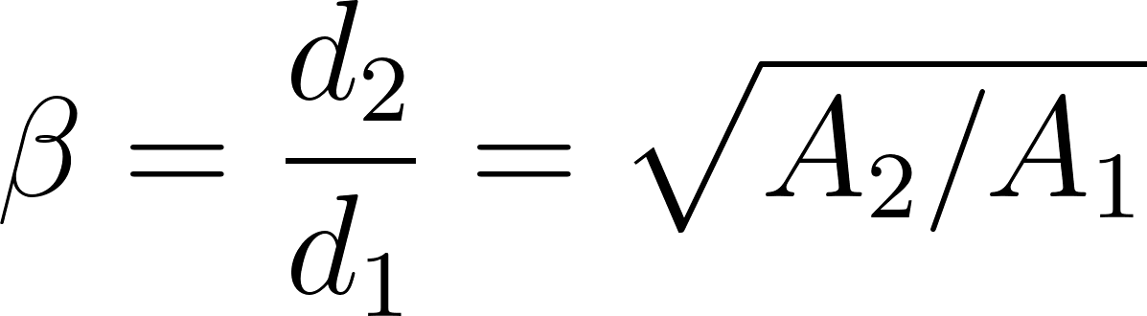
Assume steady, one-dimensional flow and neglect elevation change; invoking Bernoulli's equation between section 1 (upstream) and the throat (section 2) and taking ρ₁=ρ₂ for the algebraic manipulation gives:
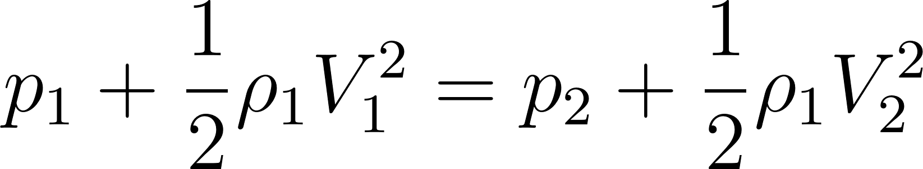
so that the static pressure difference may be written as
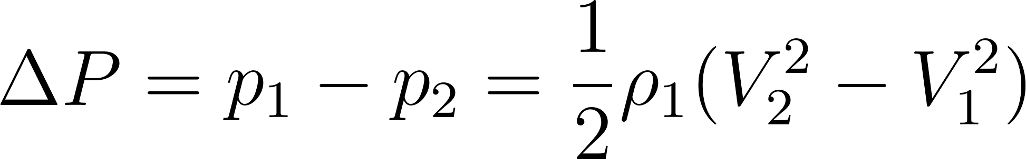
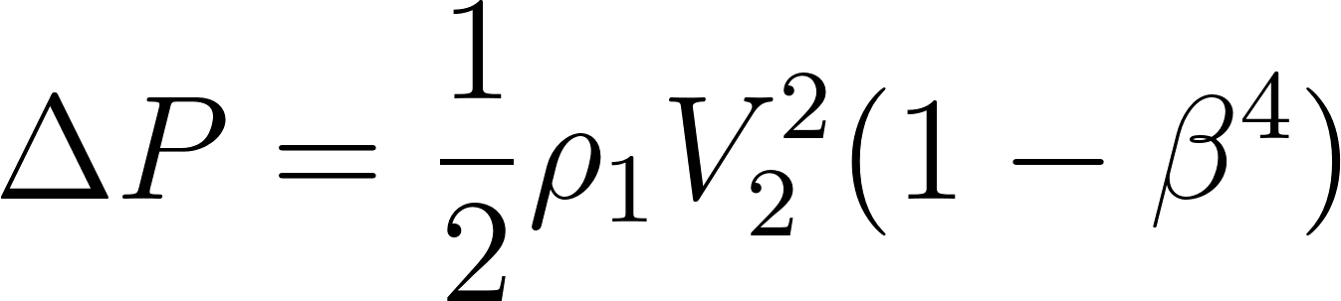
Solving for the throat velocity V₂ yields:

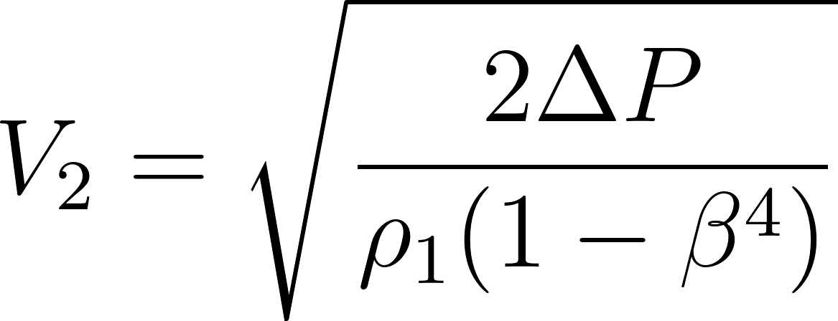
Now,

Substituting the equation for V₂,
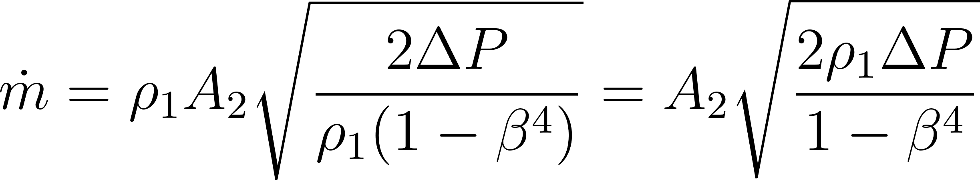
To account for (i) viscous losses, boundary-layer and profile effects and (ii) gas compressibility in practical Venturi metering, introduce an empirical discharge coefficient C (dimensionless, obtained by calibration for the particular geometry and Reynolds-number range) and an expansibility correction factor ε is used. The equation becomes:

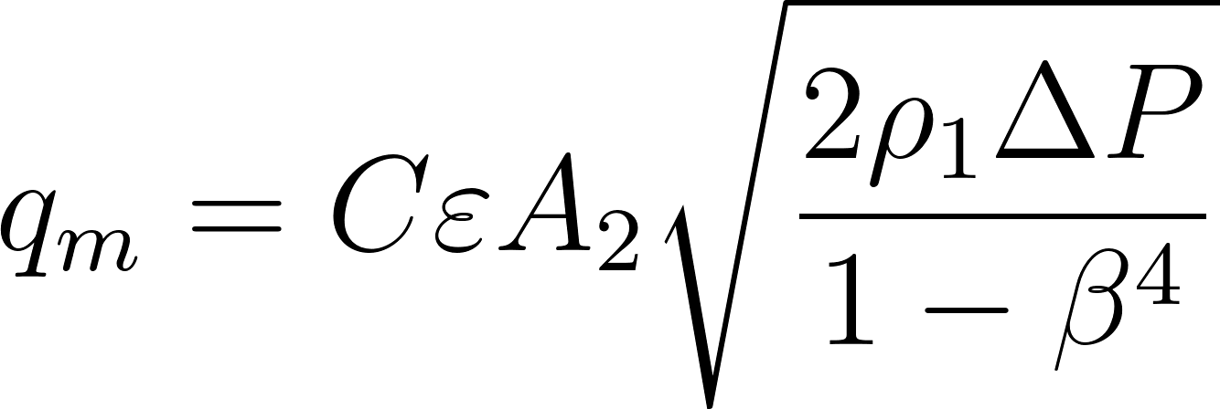

IV. DIAPHRAGM DEFLECTION STUDIES [3]
We perform a diaphragm deflection research and study to understand the equations behind the deflection values of the diaphragm. This becomes crucial for the material selection and dimension determination of the diaphragm.
The formulas included here are based on the following
assumptions:
- Uniform diaphragm thickness
- Small deflections
- Infinitely rigid clamping around the diaphragm
- periphery
- Perfectly elastic behavior
- Negligible stiffening and mass effects due to the
- presence of the strain gauge on the diaphragm.

To the degree that the actual transducer fails to satisfy all of the above assumptions, the formulas will be inaccurate. Because of this, the formulas should be used only in the initial stages of transducer development to determine the approximate proportions of the transducer.

Sensitivity
The strain distribution in a rigidly clamped diaphragm under a uniform pressure is shown in Figure [2]. The radial and tangential strains at the center of the diaphragm are identical and they can be expressed as:

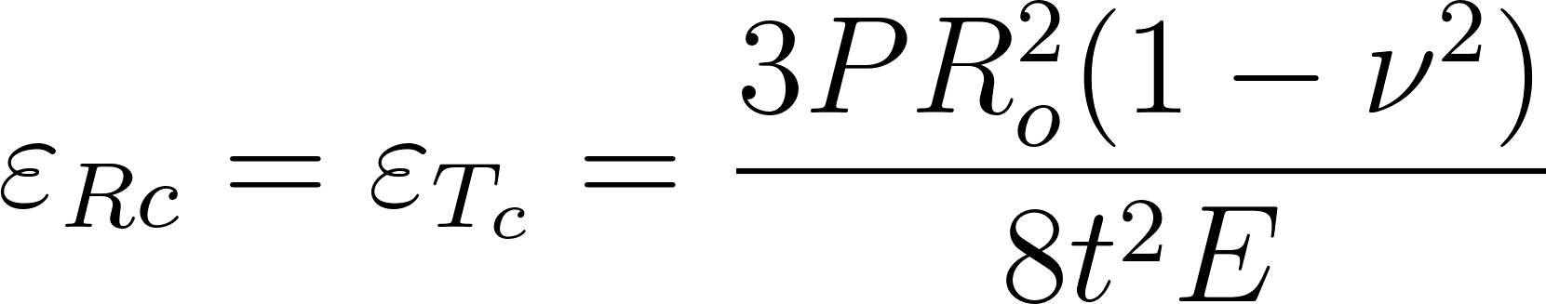 (1)
Where,
P = Pressure
Ro = Radius of Diaphragm
t = Thickness of Diaphragm
ν=Poisson’s ratio
E = Modulus of elasticity
The radial strain decreases rapidly as the radius increases, becoming negative, and (at the edge) equal to twice the center strain. The tangential strain decreases to zero at the periphery of the diaphragm. Thus,
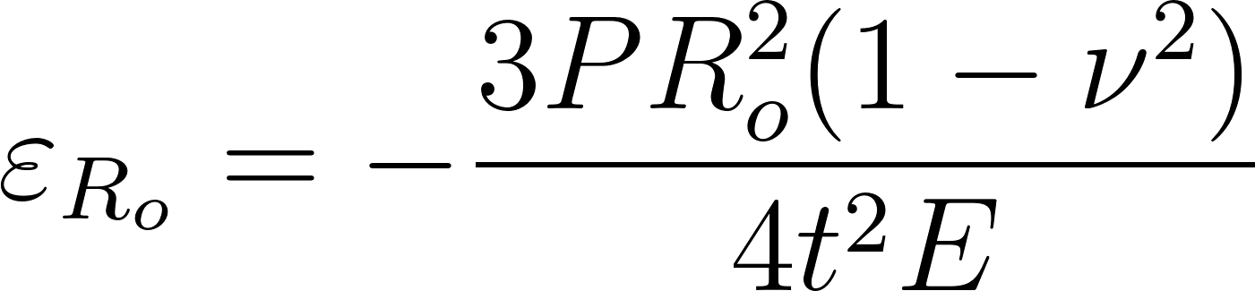 (2)

 (3)
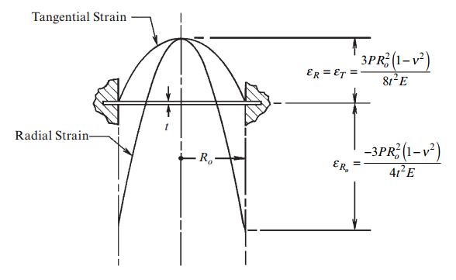
Fig 2

Linearity

The preceding equations for diaphragm strain and output indicate that the output is proportional to the applied pressure. This precise linearity applies, however, only for vanishingly small deflections. In the case of finite deflections,the diaphragm pressure transducer is inherently nonlinear, and becomes more so, as deflection increases. As a general rule, the deflection of the diaphragm at the center must be no greater than the diaphragm thickness; and, for linearity in the order of 0.3%, should be limited to one quarter the diaphragm thickness.
The following is the formula for diaphragm deflection, based
upon small-deflection theory:

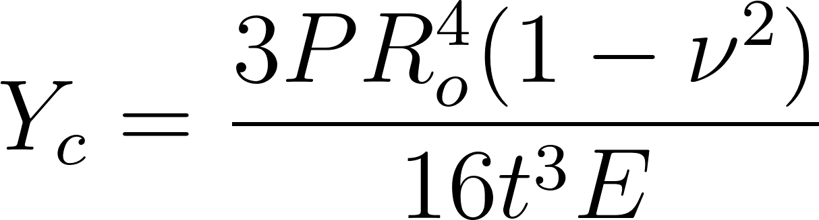 (4)

where: Yc = Center deflection, in (mm)

Diaphragm Strain Gauges
Micro-Measurements manufactures two different strain gauge configurations (Figure 2a and b) for use on diaphragm pressure transducers. The traditional circular pattern as shown in Figure 2a has been designed to take advantage of the orientation of the tangential and radial strain fields described above.

Taking account of the sign difference in the strains sensed by the radial and tangential grid elements, and dividing the elements into symmetrical pairs, permits incorporating a full bridge into a single strain gauge. In terms of optimizing the strain gauge design, the solder tabs have been located in a region of low strain. The linear gauge configuration shown in Figure 2b functions in the same manner as the circular version, with only minor differences in total gauge output.

The main advantage of a full bridge circular strain gauge is internal temperature compensation within the circuit itself. For either the circular or linear patterns, averaging the strain over the region covered by each sensing element (assuming a gage factor of 2.0), and averaging the outputs of all sensing elements, the total gage output (eo) in millivolts per volt can be expressed approximately by the following formula:

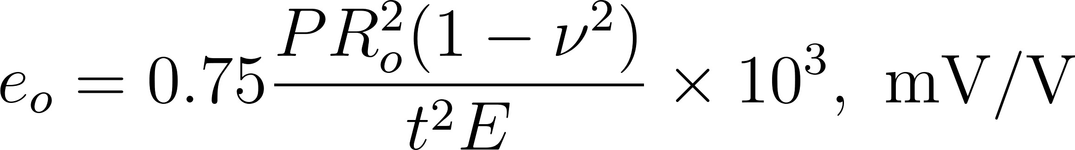 (5)

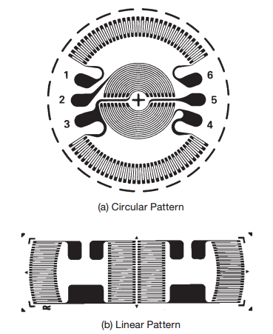

An Excel Calculator has been prepared for ease of calculation of diaphragm parameters. This calculator also serves as a validation of the FEA simulation results of the diaphragm deflection.
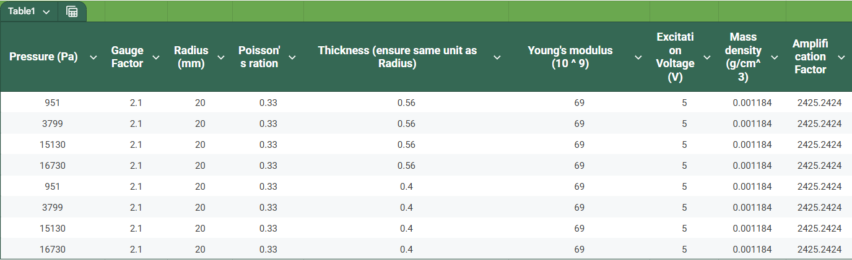
Input Values
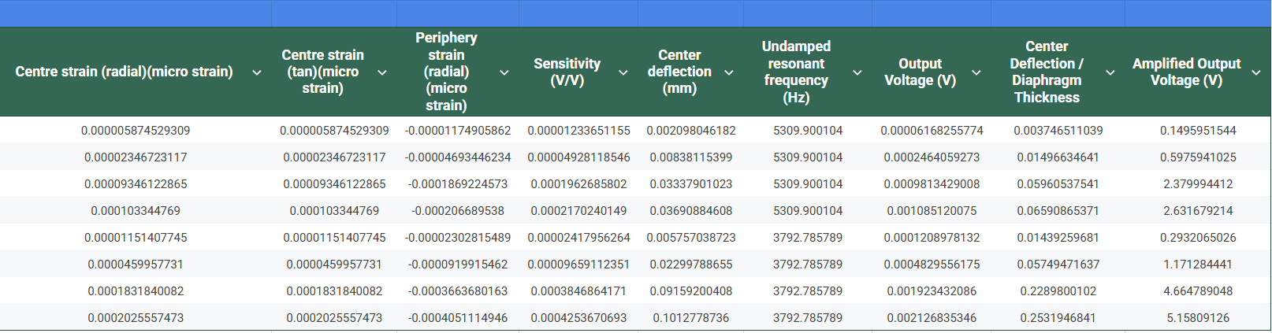
Output Results

- Material and Dimension Selection
Aluminium 2 Series is selected as the diaphragm material due to its low Young's Modulus of 69GPa, allowing the diaphragm to be of an easily procurable thickness of 0.3-0.5mm.At the same time, a high yield strength allows a larger elastic limit for the diaphragm, increasing its factor of safety and life cycle.
2 Series Aluminium is preferred due to its high fatigue life and ability to withstand cyclic loads.

We used ‘hit and try’ analysis to determine the diameter and thickness of the diaphragm based on the readability of the output voltage and the linearity of the readings.

The following dimensions are selected:
Parameter | Values
Diameter | 40mm
Thickness | 0.56mm

V. DETERMINING VENTURIMETER DIMENSIONS
A venturimeter has a major and a minor diameter. The values of these two diameters determine the pressure difference created and hence the diaphragm deflection. The major and minor diameters are set such that the pressure difference yields a readable voltage difference after amplification of the signal.

The other dimensions include the converging and diverging angles. These are set according to ISO Standards to ensure smooth contour of properties such as pressure and velocity of the flow and to ensure maximum possible recovery of the flow parameters.

The design, manufacturing, installation, and performance calculations will strictly follow the guidelines of ISO 5167, specifically Part 4: Venturi tubes. [5]

ISO 5167-4 describes three types of classical Venturi tubes: "as cast," "machined," and "fabricated". For this application, which involves a relatively small pipe diameter and a need for high accuracy, the Classical Venturi Tube with a Machined Convergent Section is the most appropriate choice.

This type offers the highest discharge coefficient and the lowest uncertainty among the standard types.

Let’s assume β=0.5 (within the range of ISO standard values for β values)

For minimum flow rate 0.025 kg/sec
Mass Flow rate:
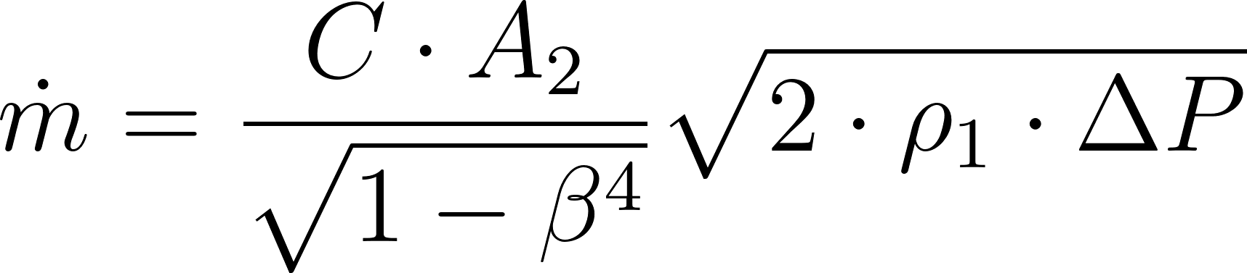
Rearranging to solve for ΔP
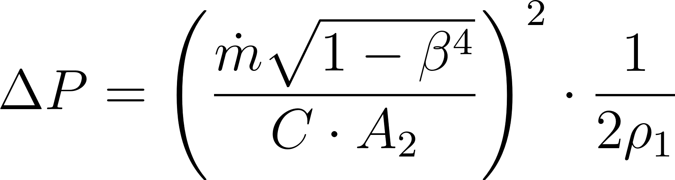
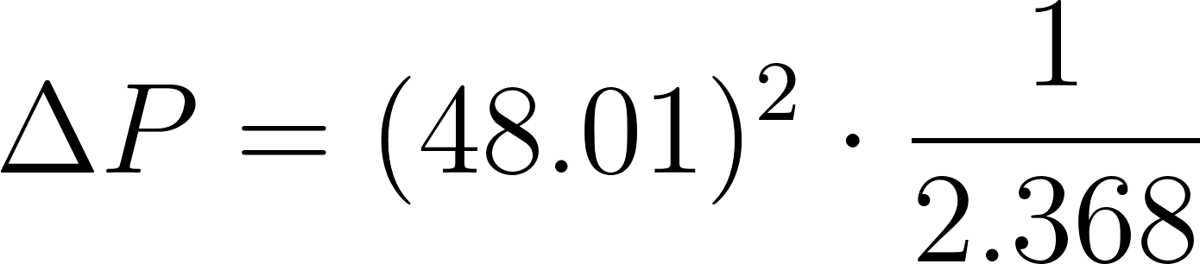


Inputting this pressure value in the calculator, we get:
Output voltage= 77 uv

For maximum flow rate= 0.105 kg/sec
Repeating same calculation,
ΔP= 17,170 Pa
Inputting this pressure value in the calculator, we get:
Output voltage= 1.36 mv

Both the voltage values can be used under a proper amplification to get clean readable outputs.
Thus β=0.5 is finalised.
The Major Diameter is obtained from the assumed constraint of 2 inch, and the converging and diverging angles are determined from ISO 5167 recommendations.

The final Venturi Meter Dimensions are as follows:
Parameter | Values
Major Diameter | 55.8mm
Minor Diameter | 27.9mm
Upstream Length | 254.37mm
Throat Length | 24.91mm
Converging Angle | 21°
Diverging Angle | 7°
Downstream Length | 76.32mm

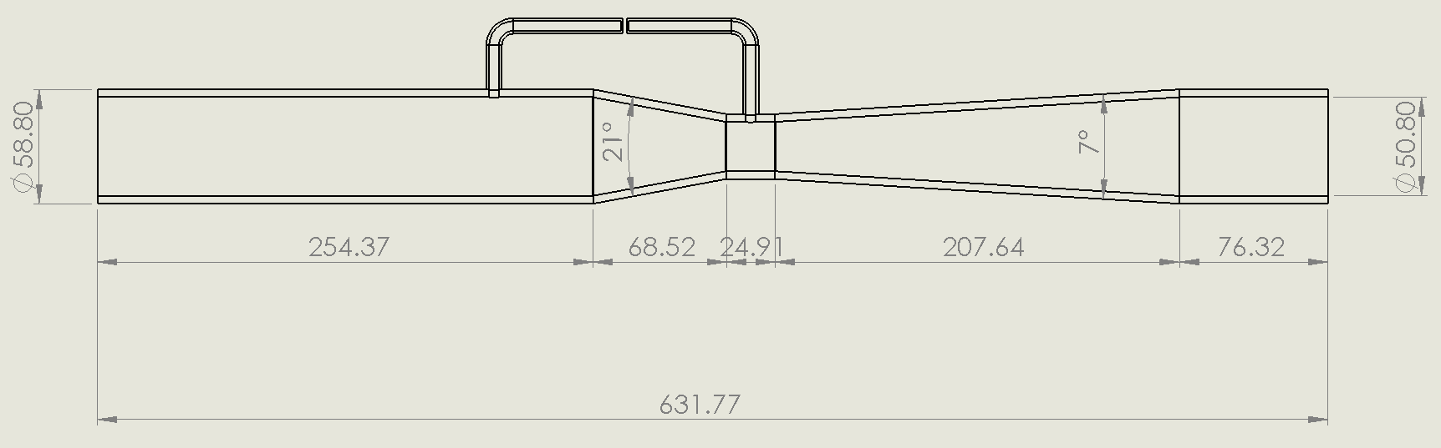
Fig [3]

VI. DETERMINING DIAPHRAGM HOUSING DIMENSIONS
The diaphragm housing consists of two hollow flanges with two O-rings, sandwiching the diaphragm between them, ensuring a proper seal.

The following are the basic features for the housing flanges:
- Flange type diaphragm housing
- 40mm hollow depression for diaphragm deflection
- Flat plain clamp land
- Grooves for O Ring
- Raised Stopper
- Flange extrusion with bolting holes
- Wiring holes in one of the flanges [6]

O - Ring Selection
Material and dimensions are the two factors taken into consideration for O Ring selection. A diameter larger than the working diameter of the diaphragm is taken into account.

NBR (Buna-N) 70A is selected as a suitable case for a static seal type application.

Parameter | Values
Internal Diameter | 50mm
Cross Sectional Area | 2.5mm

Groove Dimension [7]
Grooves are made on the flanges for the O Rings to sit on. The dimensions for the groove depend on several factors such as percentage stretch, percentage squeeze, and percentage gland fill of the O Ring during installation.
These values are determined based on static or dynamic sealing applications and are referenced from the Standard Parker O Ring Handbook.
The dimensions set for the groove are as follows:

Parameter | Values
Internal Diameter | 50mm
Cross-sectional Area | 2.5mm

Installation Stretch Calculation:

Squeeze Calculation:

Gland Fill Calculation: 

Final Dimensions of the flange design are shown in the cross-section diagram below.
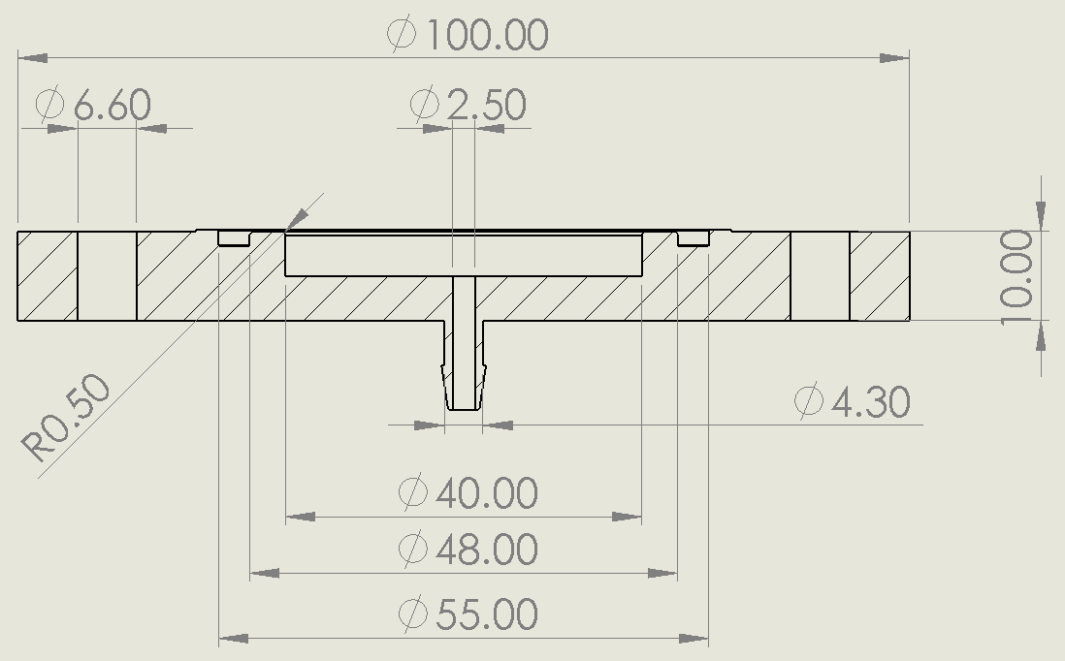
Fig [4]

VII. CAD MODELS
Based on the obtained dimensions of the venturi meter and diaphragm, CAD Models are prepared using SolidWorks software. Two sets of designs are made, one for the actual machining and another simplified twin, used for simulation purposes.

Venturi Meter CAD Models[4]
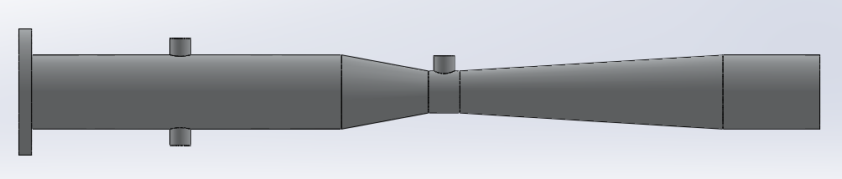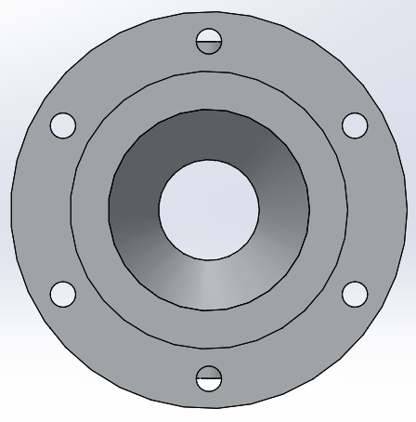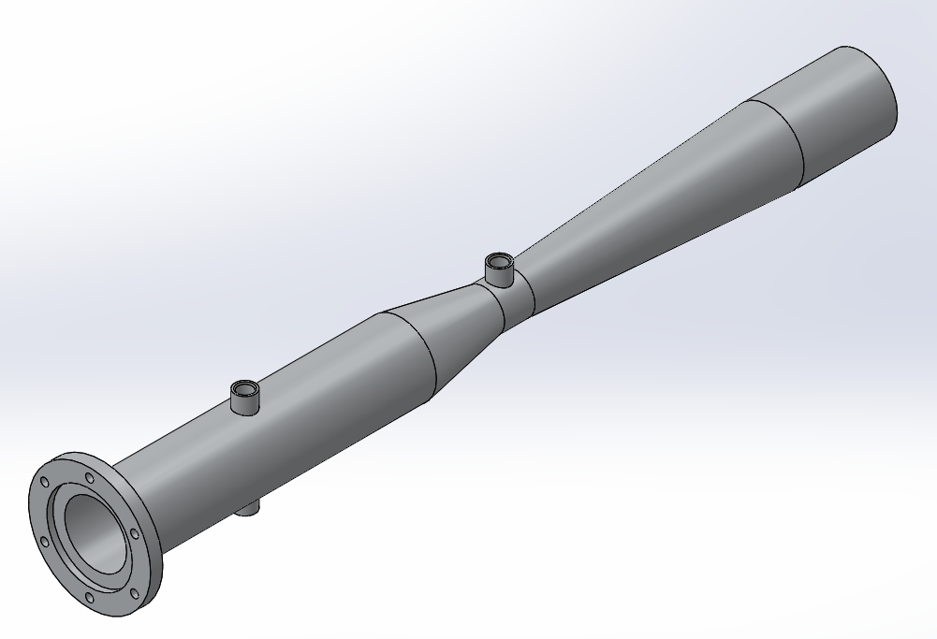
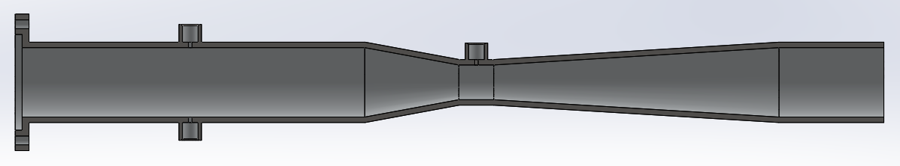
Fig [5]

Diaphragm CAD Models
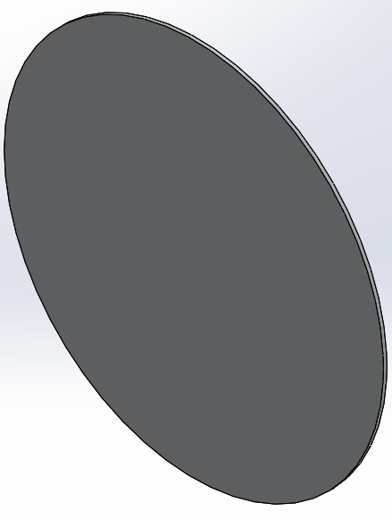
Fig [6]

Flange Housing CAD Models

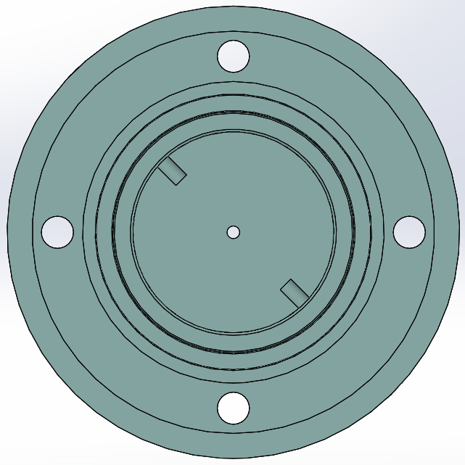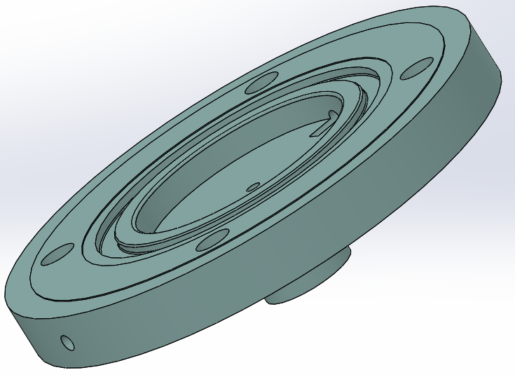

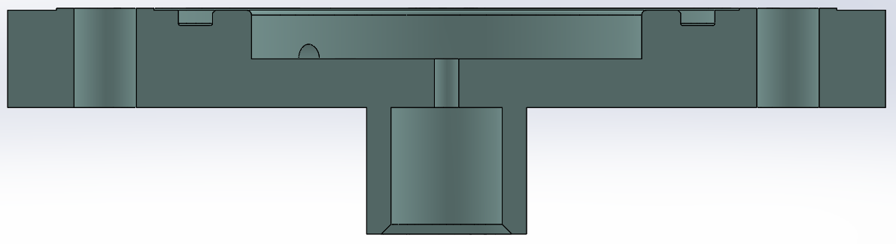
Fig [7]

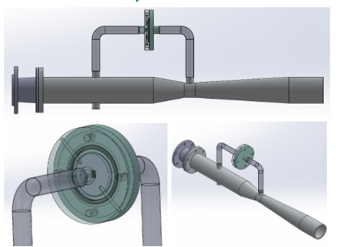
Final Assembly

Fig[8]

VIII. SIMULATION RESULTS

Diaphragm Deflection Results
A FEA simulation of the diaphragm is done to determine the amount of deflection, stress induced, factor of safety and life cycle of the diaphragm.

The pressure values for the boundary conditions are taken from the output values of the CFD Pressure Simulations for the Venturi Meter.

Boundary Conditions:
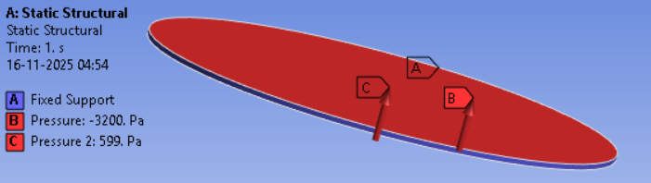

- MFR= 0.025 kg/sec
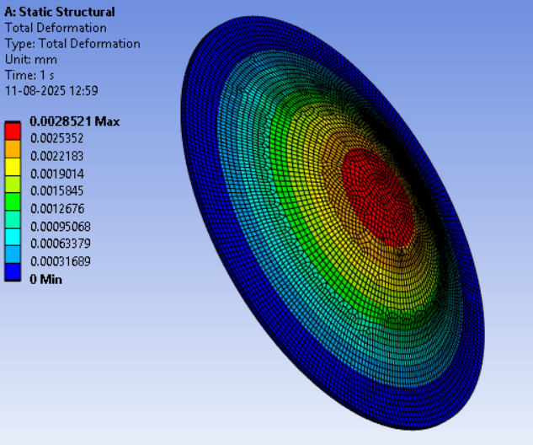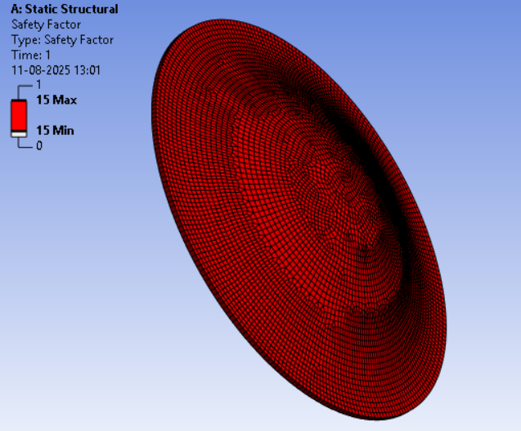
Total Deformation FOS

- MFR= 0.05 kg/sec
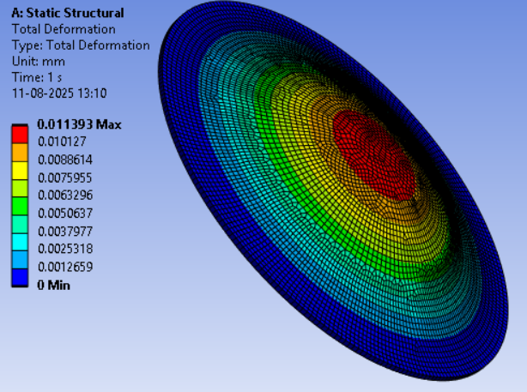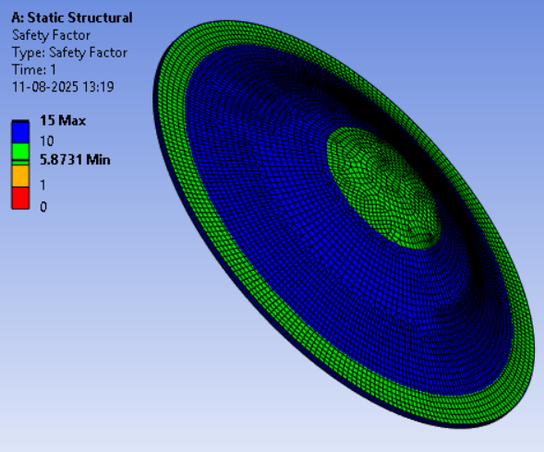
Total Deformation FOS

- MFR=0.1 Kg/sec
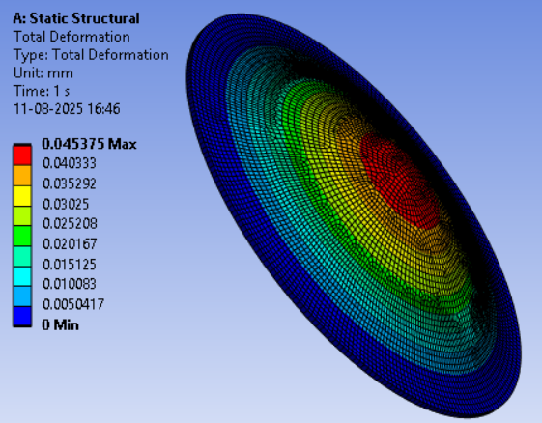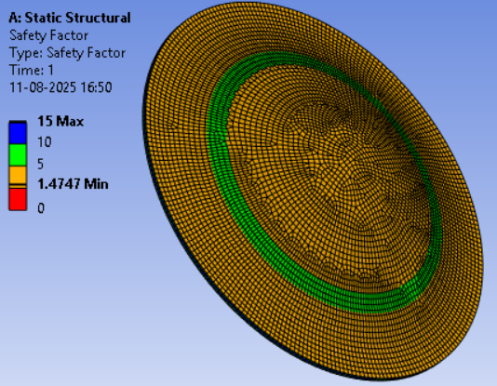
Total Deformation FOS

- MFR=0.105 kg/sec
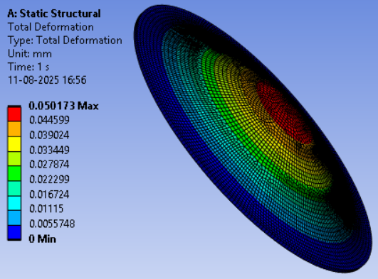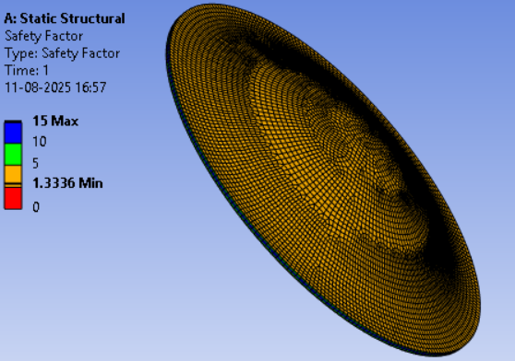
Total Deformation FOS

The graph for Mass Flow Rate vs Total Deformation is given below:
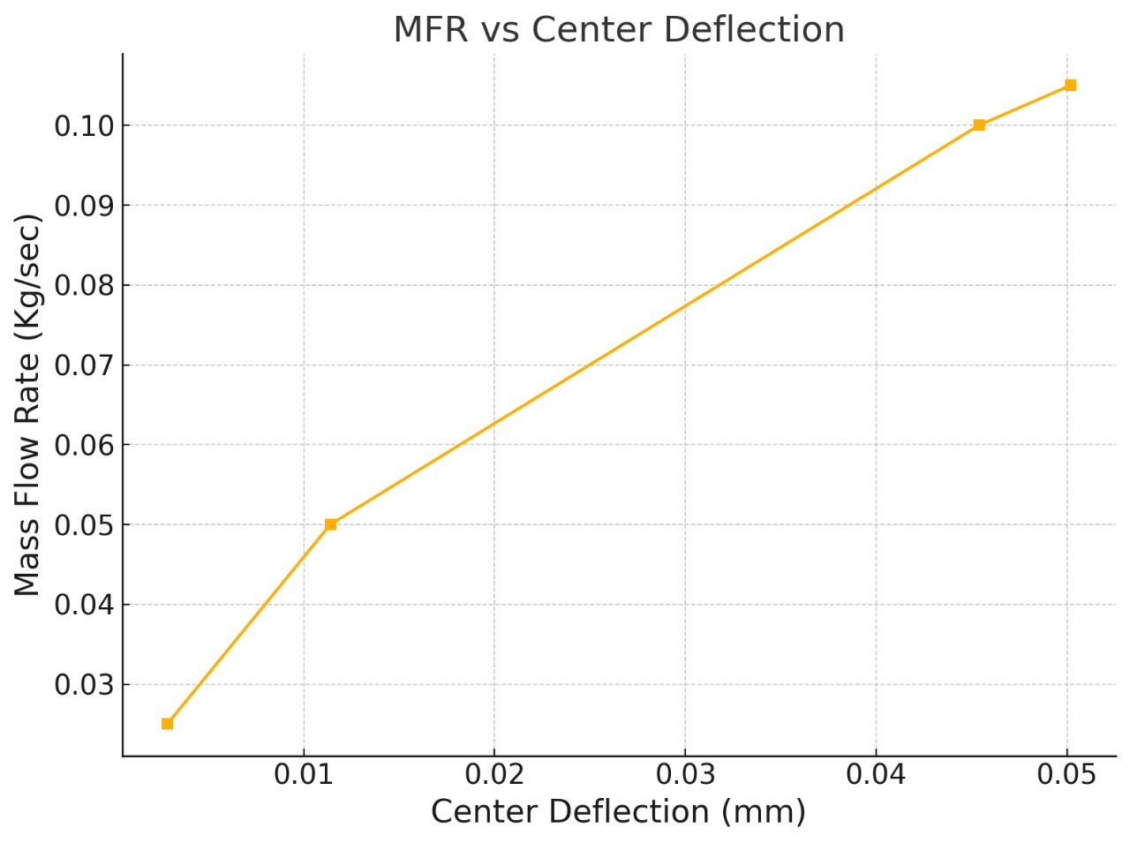
Fig [8]

The results of the FEA simulation are validated by comparing the results from the hand calculator.
B. Venturi Meter Pressure Distribution Simulation Results

A CFD simulation for different mass flow rates is conducted to obtain the pressure distribution across the venturi meter at different flow rates. This is used to obtain the differential pressure values between the major and the minor diameters of the venturi.

- MFR= 0.025 kg/sec
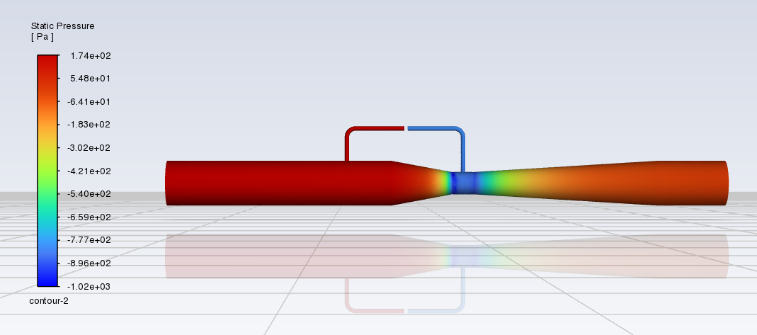

- MFR= 0.05 kg/sec
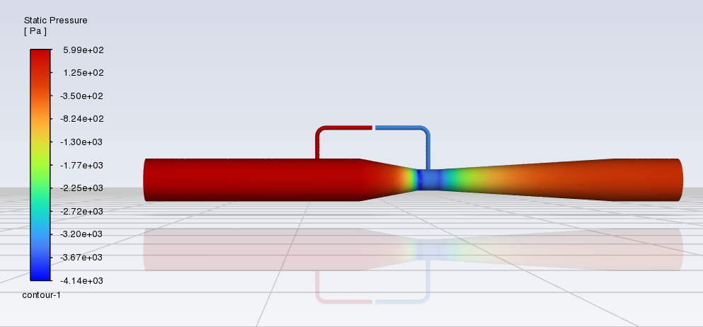

- MFR=0.1 Kg/sec
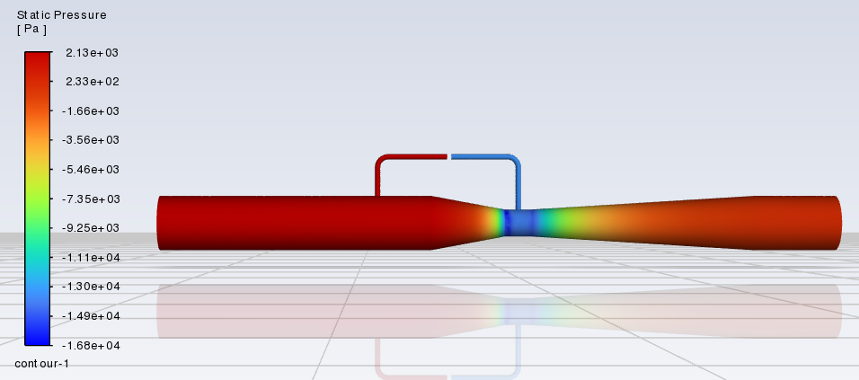

- MFR=0.105 kg/sec
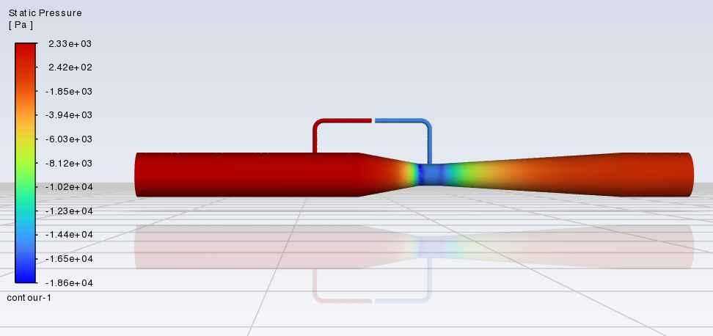

The difference in pressure values between the two probes from the major and minor diameters give us the differential pressure for each Mass Flow Rate.

The graph for Mass Flow Rate vs Differential Pressure is given below:

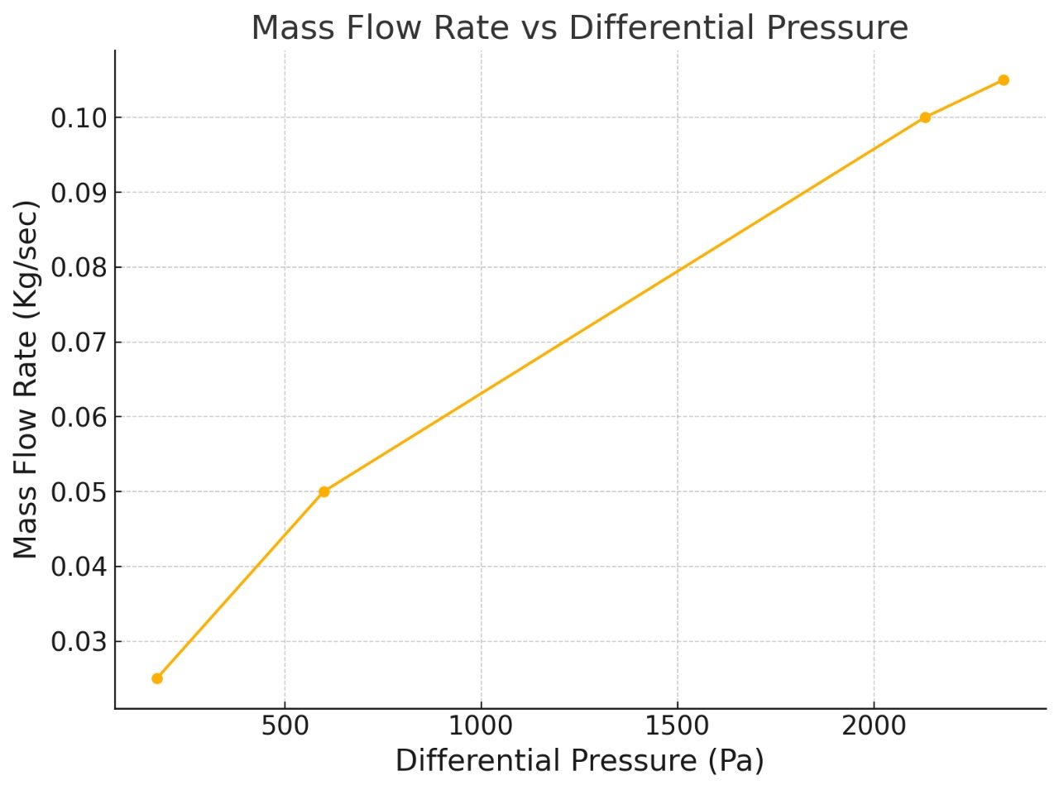
Fig [9]

Fig [8] and Fig [9] graphs have the same slope with respect to mass flow rate. This validates that this methodology can be used to derive the mass flow rate.

IX. ELECTRONIC SYSTEM DESIGN
This section outlines the design process, rationale, and component selection for the analog front-end (AFE) developed to capture and prepare microvolt-level signals from a strain gauge sensor for effective digital conversion by the STM32 Microcontroller (MCU).

Wheatstone bridge(Input Stage):
In strain measurement applications, strain gauges detect small changes in resistance when subjected to mechanical stress. To accurately identify and measure these slight changes, a Wheatstone bridge configuration is typically used. It consists of four resistors, each with nominal values of about 350 Ω. The bridge is powered by a stable +5 V excitation source to maintain consistent bias conditions. When the strain gauge is mechanically deformed, it creates an imbalance in the bridge, mainly between the R3 and R4 arms. This imbalance produces a differential output voltage.The voltage signal difference, usually in tens-of-millivolt range, represents the applied strain.

Instrumentational Amplifier (INA) Stage:
A precision instrumentation amplifier (AD8220 model for simulation; AD8230G80 intended for PCB implementation) was selected for its:
- High input impedance, which minimizes loading on the bridge.
- Excellent common-mode rejection, essential for microvolt-level signals, with an inbuilt 500Hz filter
- Fixed gain setting of 80, reducing need of passives for biasing the gain.

A target gain of about 80 as the initial stage so the amplified signal uses a significant portion of the STM32’s 3.3 V ADC input range.

To remove high-frequency noise and limit bandwidth to the strain-gauge operating range, the AD8230G80 has inbuilt 2nd order low pass filters with fc of 100Hz and 500Hz (simulated using the AD628 2nd order low pass filter).

Design Considerations when choosing the AD8230G80 :
- Strain-gauge signals change slowly, typically <100 Hz.
- The filter was composed of two cascaded 2nd-order sections using precision R–C components.

Outcome: Microvolt-level bridge signals are amplified to a few hundred millivolts (V_80 in simulation). However, the output still needs a further gain of 20-30 to reach the full scale range of the ADC. The filtered output (V_80_filtered) exhibits significantly reduced noise while maintaining the waveform integrity of the underlying strain signal.
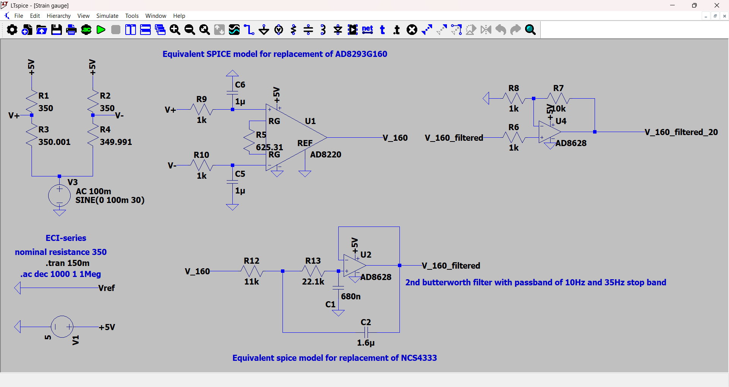

Post Gain Stage:
A final gain stage is implemented using an additional NCS21871 amplifier, and was incorporated to maximize ADC dynamic range usage. We selected a gain of approximately 30, which can be changed on the fly using potentiometers.
Purpose
- To compensate for residual attenuation after filtering.
- To ensure the final signal spans the 0–3.3 V ADC input range without clipping.
Outcome: The post-amplified waveform (V_80_filtered_30) shows strong, stable amplification with minimal offset drift—suitable for high-resolution STM32 ADC sampling.

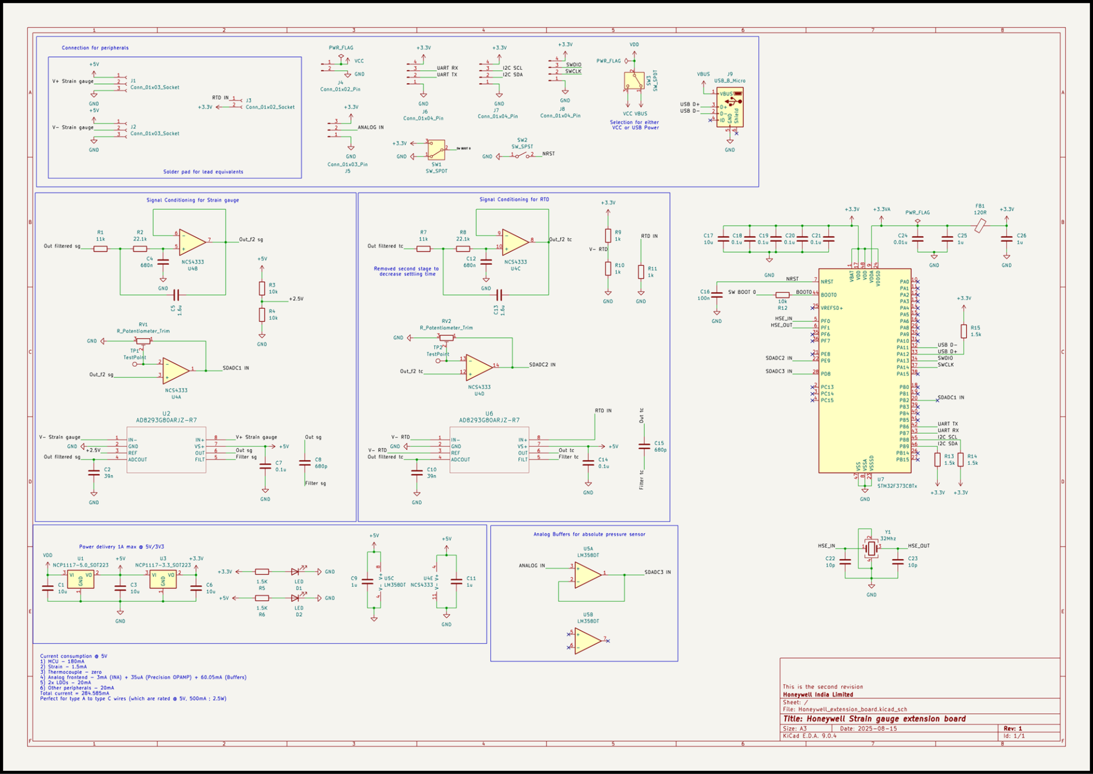
Fig [11]

X. ELECTRONIC SIMULATION RESULTS

Time Domain Analysis:
The waveforms demonstrates the progressive improvement across processing stages:
- Green (V_80): INA output has higher amplitude but significant ripple and noise.
- Cyan (V_80_filtered): represent the noise removed by the low pass filter baseline stabilized.
- Red (V_80_filtered_30): Post-gain output , we scaled the output near full ADC range (0–3.3 V).

Interpretation: The signal chain effectively suppresses noise while preserving the strain-induced low-frequency waveform.
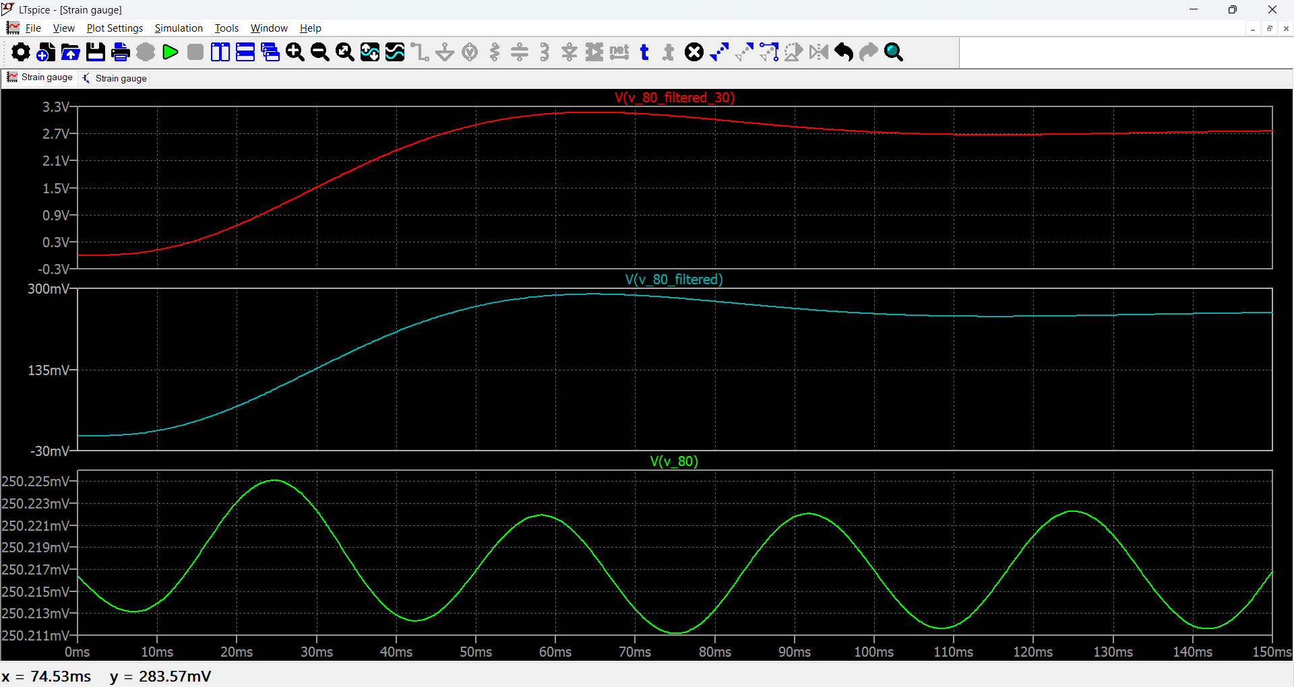

Frequency Response:
- V_80 (Green): Wideband characteristics of the INA output.
- V_80_filtered (Cyan): Sharp roll-off beyond ~35 Hz, validating Butterworth filter performance.
- V_80_filtered_30 (Red): Identical frequency shaping, scaled in amplitude by the post-gain stage.
Interpretation: The filtering stage effectively confines bandwidth, preventing aliasing and improving SNR. The gain structure ensures optimal utilization of the 12-bit MCU ADC.
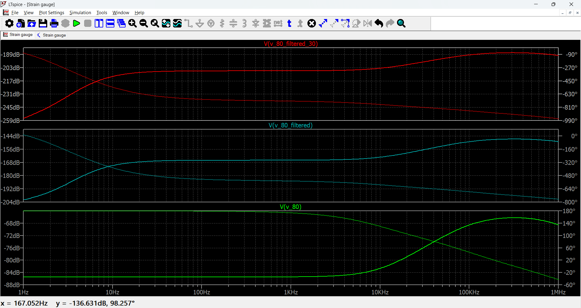

XI. KEY ELECTRONIC DESIGN DECISIONS

- Instrumentation Amplifier with High Gain: Necessary to lift microvolt-level bridge signals into a usable range.
- 4th-Order Butterworth Low-Pass Filtering: Provides smooth passband response with strong stopband attenuation, minimizing noise and aliasing.
- Precision, Low-Offset Op-Amps: Reduce drift and offset errors, particularly important at low frequencies.
- ADC-Oriented Output Scaling: Ensures maximum resolution and SNR by driving the ADC near its full-scale input range.
The system evolved from a direct INA-to-ADC approach into a refined signal chain incorporating optimized gain distribution, precision filtering, and full ADC dynamic range utilization.

XII. VIBRATION AND MECHANICAL NOISE ISOLATION METHODOLOGY
The diaphragm of the sensor is constantly exposed to aircraft vibration coming from the engine and airframe. Fighter/jet aircraft typically transmit vibration in the range of 10–500 Hz, with engine-related peaks sometimes reaching 0.5–5 g at specific frequencies, while the general broadband background vibration is usually around 0.1–1 g RMS. During manoeuvres, the diaphragm also feels inertial loads from 3–9 g in normal fighter operations and even higher g-loads during extreme manoeuvres. It may also experience sudden pressure transients, such as 10–50 kPa jumps during rapid throttle changes or pneumatic line switching. Acoustic pressure from engines can add small but fast changes, often in the range of 100–150 dB SPL, which corresponds to fluctuating pressures of 50–200 Pa. Temperature changes, which in aircraft can swing from −50°C to +100°C depending on location, cause thermal expansion that can bend the diaphragm slightly and shift its baseline.

This problem is traditionally dealt with using a twin diaphragm setup. When two diaphragms with closely matched mechanical and electrical characteristics are used in a differential (common-mode-rejecting) arrangement, the residual disturbance after subtraction is determined by the mismatch factor ε. The residual acceleration or pressure disturbance is approximately ε times the original input, meaning that realistic mismatch levels of 10%, 1%, and 0.1% correspond to disturbance reductions of approximately 20 dB, 40 dB, and 60 dB, respectively.

Thus, a well-matched twin-diaphragm system can reduce common-mode vibration, inertial loading, and acoustic fluctuations by 10 to 1000 times, greatly improving measurement stability in high-vibration aerospace environments, while preserving the differential pressure signal of interest.[8]

XIII. CONCLUSION
The project delivers a complete and well-tested design for a mass‑flow sensor. It uses a Venturi tube to create a pressure difference, which is captured by a metallic diaphragm with a full‑bridge strain gauge. By choosing the Venturi dimensions within ISO 5167 standards, the sensor produces a predictable and consistent pressure drop across the required flow range. The diaphragm’s geometry was worked out through analytical methods and then verified with finite element analysis, confirming linear response, safe stress levels, and long fatigue life.

Computational fluid dynamics confirmed the pressure distribution inside the Venturi and showed a direct proportionality between flow rate and pressure difference. This same proportionality was reflected in the diaphragm’s deformation, tying together the fluid behavior, structural response, and sensor output. CAD modeling of the Venturi, diaphragm, and housing ensured the design could be manufactured with proper sealing, precise clamping, and repeatable boundary conditions.

On the electronics side, the sensor’s bridge output—at the microvolt level—was conditioned into a stable, ADC‑ready signal. This was achieved through a high‑gain instrumentation amplifier, a fourth‑order low‑pass filter, and a final gain stage tuned for full dynamic range use. Simulations confirme that the signal chain suppressed noise, controlled bandwidth, and maintained stability.

Together, the mechanical, fluid, and electronic validations show that this sensor can reliably translate differential pressure into mass‑flow rate with high repeatability. The approach lays the groundwork for a compact, high‑temperature, low‑intrusion sensor suitable for aircraft bleed‑air systems, with a clear path toward qualification testing and hardware deployment.

XIV. REFERENCES
- C. H. Stephan and M. Zanini, "A micromachined, silicon mass-air-flow sensor for automotive applications," TRANSDUCERS '91: 1991 International Conference on Solid-State Sensors and Actuators. Digest of Technical Papers, San Francisco, CA, USA, 1991, pp. 30-33, doi: 10.1109/SENSOR.1991.148790. keywords: {Silicon;Automotive applications;Resistors;Engines;Wire;Sensor phenomena and characterization;Fluid flow measurement;Fabrication;Temperature sensors;Circuits},

- Han, X., Huang, M., Wu, Z. et al. Advances in high-performance MEMS pressure sensors: design, fabrication, and packaging. Microsyst Nanoeng 9, 156(2023). https://doi.org/10.1038/s41378-023-00620-1

- Design Considerations for Diaphragm Pressure Transducers: Technical Paper by Vishay Microsystems
TN-510.pdf

- W. Zhou, L. Xu and X. Li, "Wet gas flow modeling for the straight section of throat-extended Venturi meter," 2010 IEEE Instrumentation & Measurement Technology Conference Proceedings, Austin, TX, USA, 2010, pp. 229-233, doi: 10.1109/IMTC.2010.5488011. keywords: {Fluid flow;Fluid flow measurement;Acceleration;Equations;Instruments;Chemistry;Root mean square;Design optimization;Geometry;Power measurement;wet gas metering;Throat-Extended Venturi Meter (TEVM);straight section;flow modeling;Differential Pressure (DP)},

- International Organization for Standardization, ISO 5167-4:2022 Measurement of fluid flow by means of pressure differential devices inserted in circular cross-section conduits running full — Part 4: Venturi tubes, 2nd ed., Geneva: ISO, Jun. 2022.

- P. Thawornsathit, “Mechanical Diaphragm Structure Design of a MEMS-Based Piezoresistive Pressure Sensor for Sensitivity and Linearity Enhancement”, Eng. J., vol. 26, no. 5, pp. 43-57, May 2022.

- Parker O-Ring Handbook ORD 5700
ORD-5700.pdf

- Lu, Y.; Zhang, S.; Yan, P.; Li, Y.; Yu, J.; Chen, D.; Wang, J.; Xie, B.; Chen, J. Resonant Pressure Micro Sensors Based on Dual Double Ended Tuning Fork Resonators. Micromachines 2019, 10, 560. https://doi.org/10.3390/mi10090560

