CM2113 Design Documentation

Project Description 1

Project Plan 1

Game Mechanics 1

Functional Requirements 1

Non-Functional Requirements 2

Moodboard 2

Objects for scanning 2

## Project Description

The following project is an attempt to create a 3D game. The game is set in a house’s backgarden and will allow users to control a small garden gnome. The gnome is responsible for organising and cleaning the garden when the house owners are away. This time, the owners had to leave in the middle of putting new plants in the garden and have left three plant pots outside. The gnome’s job is to put them by the shed, as the shed door has been locked. The objects that are to be picked up will have an effect applied to them so that they can be seen by user. The place where each object should be placed will also have an effect applied.

## Project Plan

The game file had to be restarted as it was saved in a different format. Some objects were scanned before and reused in the new game file.

|  |  |
| --- | --- |
| Week 1 (20/3/23 - 26/3/23) | Creation of game file  Adding pre-scanned objects to game |
| Week 2 (27/3/23 - 2/4/23) | Adding character animation for movement – DID NOT WORK  Adding character movement as a replacement for animation  Adding pick up functionality to game |
| Week 3 (3/4/23 - 9/4/23) | Creating particle effect system for object placement |
| Week 4 (10/4/23 - 16/4/23) | OTHER DEADLINES |
| Week 5 (17/4/23 - 23/4/23) | OTHER DEADLINES |
| Week 6 (24/4/23 - 30/4/23) | Scanning more objects to populate game  Scan clean-up using blender  Adding animation to objects  Creating new particle system for objects to be picked up |
| Week 7 (1/5/23 - 4/5/23) | Making corrections to effects  Testing Report (by non-developers)  SUBMISSION |

## Game Mechanics

The character must be able to walk, with the users able to WASD to move.

The character must be able to look through the scene, with mouse movement

The character must be able to pick up objects.

## Functional Requirements

Animations must be used x 2

Particle effect system must be used

A character must be present in the game

There must be one level with 3d objects.

In game objects must be scanned.

## Non-Functional Requirements

Unity 3D - I have prior experience with using unity to create a project, however I have little experience in creating a project in 3D

Deadline – 05/05/23

## Moodboard

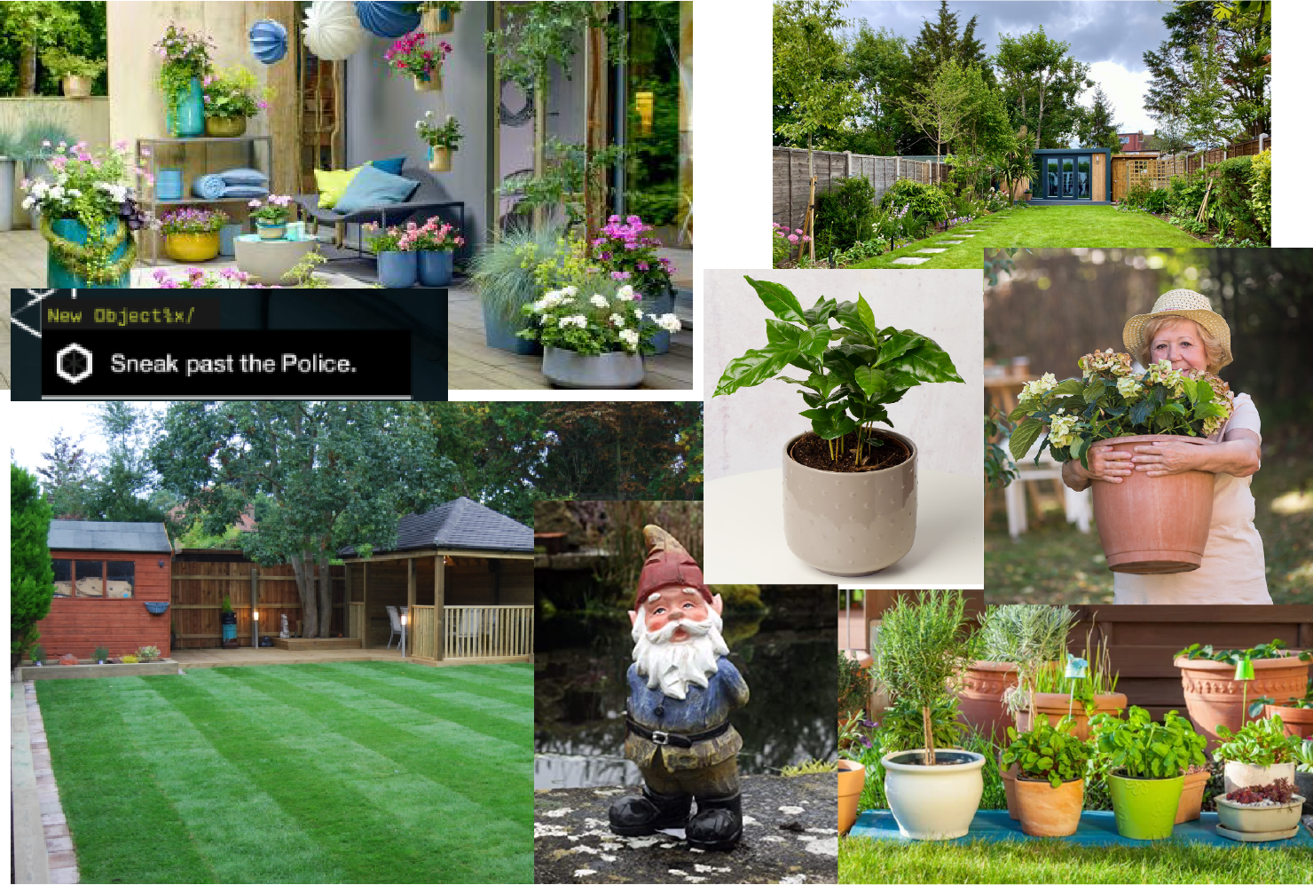

## Objects for scanning

Garden gnome – This object would have to be handmade. When scanning a biped, it is important that they are in a T or A pose position (T pose – legs are together, and arms are horizontal and parallel to the ground, A pose – legs are apart, arms are horizontal and parallel to the ground) for them to be animated properly and used in a project.

Garden – This object will be an exterior scan of my back garden. It easily accessible, so no consent form is needed to be signed.

Flower pots – Three individual plant pots need to be scanned for this project; a blue plant pot, a black plant pot and a dog-shaped plant pot. These objects will be interactive with the player character.