A PROJECT REPORT ON
EDUGENIE: AI-POWERED EDUCATIONAL
ASSISTANT USING GENERATIVE AI
Domain: Google Cloud Generative AI
Submitted in partial fulfillment of the requirements for the award of the degree of
BACHELOR OF TECHNOLOGY
in
COMPUTER SCIENCE AND ENGINEERING
SUBMITTED BY:
Name of the Student | Registration / Roll Number
C NARESH | AP24110010223
KRISHNA SANKETH | AP24110010487
PAVAN VARMA | AP24110010453
HUMAIRA TASNEEM | AP24110012130
SUBASH | AP24110010730

Under the Industry Mentorship of:
SmartBridge Educational Services Pvt. Ltd.
In Coordination with the Virtual Internship Program
DEPARTMENT OF COMPUTER SCIENCE AND ENGINEERING
UNIVERSITY ACADEMIC YEAR: 2025–2026

CERTIFICATE OF COMPLETION
This is to certify that the project report entitled "EduGenie: AI-Powered Educational Assistant using Generative AI" is a bona fide record of work carried out individually by:
• C NARESH (Student ID: AP24110010223)
The work has been successfully completed in partial fulfillment of the academic requirements and as part of the specialized industry-aligned internship program powered by SmartBridge. The results embodied in this project report have not been submitted to any other University or Institution for the award of any degree or diploma. The project demonstrates a clear understanding of artificial intelligence integration, system design, and software development techniques.

_______________________ _______________________
Internal Project Guide Industry External Mentor
Department of CSE SmartBridge Corporate Suite

ACKNOWLEDGEMENT
I express my deepest gratitude and profound respect to my institution and the department faculty for providing a highly collaborative academic ecosystem that stimulated the conceptualization and development of my project, EduGenie.
I extend my sincere thanks to the administrative leadership and my internal project guide for their structured supervision, insightful academic critiques, and logistical support throughout the design lifecycle. Their dedication to bridging theoretical artificial intelligence models with functional software architectures has significantly enriched my engineering acumen.
I am exceptionally indebted to SmartBridge Educational Services Pvt. Ltd. for granting me an immersive technical internship opportunity. The exposure to enterprise cloud frameworks, real-world deployment challenges, and production-ready machine learning orchestration paradigms was highly instrumental in refining my development workflow. The mentorship provided directly guided my strategies for FastAPI optimization, security hardening, and generative model prompt bounding.
Finally, I record my appreciation to my peers and family members for their collaborative spirit, persistent motivation, and invaluable assistance during the late-stage verification, edge-case testing, and formatting of this academic project report.

— C NARESH (AP24110010223)

ABSTRACT
Abstract—The rapid evolution of artificial intelligence, particularly in the domain of Generative Artificial Intelligence (GenAI) and Large Language Models (LLMs), has opened transformative avenues for modern educational technologies. Traditional educational platforms often provide static or non-personalized content, failing to adapt to the unique learning paces, background knowledge, and linguistic styles of individual students. This project report presents EduGenie, an intelligent, lightweight, and responsive AI-powered educational assistant designed to augment the academic workflow for students, educators, and self-learners.
Developed using the high-performance FastAPI framework in Python for the backend and standard compliance HTML5, CSS3, and JavaScript for the user interface, EduGenie offers a seamless, local-first optimization that ensures low latency and high scalability. At its core, the platform integrates the advanced state-of-the-art Google Gemini Large Language Model via secure API protocols, alongside specialized prompt engineering pipelines tailored to educational contexts. EduGenie encapsulates five core modules: an Intelligent Question Answering system, a Simplified Concept Explainer, an AI-Powered Quiz Generator, an Educational Text Summarizer, and a Personalized Learning Roadmap Generator.
The architecture is engineered and optimized for resource-constrained environments, demonstrating high-performance execution on local edge devices while maintaining enterprise-grade response bounds through asynchronous non-blocking event loops. Security protocols, including strict API key management, cross-origin resource sharing (CORS) limits, and robust user input validation, are structurally implemented. Comprehensive evaluation metrics demonstrate that EduGenie offers an excellent alternative to centralized, high-latency tutoring software.
Keywords: Generative AI, FastAPI, Google Gemini API, Prompt Engineering, Educational Technology.

TABLE OF CONTENTS
Cover Page & Academic Front Matter
Certificate of Completion
Acknowledgement
Abstract
List of Figures & Tables
Chapter 1 – Introduction
1.1 Background & Problem Statement
1.2 Objectives & Scope
Chapter 2 – Literature Survey
2.1 Existing Systems & Limitations
2.2 Proposed Solution
Chapter 3 – System Analysis
3.1 Functional & Non-Functional Requirements
3.2 Feasibility Study
Chapter 4 – System Design
4.1 Architecture Design & Workflow
4.2 Unified Modeling Diagrams
Chapter 5 – Implementation
5.1 FastAPI Backend & AI Integration
5.2 Prompt Engineering
Chapter 6 – Modules Description
Chapter 7 – Algorithms & AI Workflow
Chapter 8 – Results & Screenshots
Chapter 9 – Conclusion & Future Enhancements
References & Appendix

LIST OF FIGURES & TABLES

Figures
Figure 4.1: High-Level System Architecture Design Diagram
Figure 7.1: AI Model Tokenization and Inference Execution Lifecycle
Figure 8.1: EduGenie Application Home Screen Interface Layout
Figure 8.2: Intelligent Question Answering Module Response Panel
Figure 8.3: Concept Explanation and Language Breakdown Dashboard
Figure 8.4: AI Quiz Generator Interface and Multiple Choice Breakdown
Figure 8.5: Personalized Learning Roadmap Pipeline

Tables
Table 2.1: Comparative Matrix of Existing Systems versus EduGenie
Table 3.1: Technical, Operational, and Economic Feasibility Framework
Table 5.1: FastAPI REST API Endpoint Routing and Payload Directory
Table 8.1: Comprehensive System Testing and Validation Matrix

CHAPTER 1 – INTRODUCTION

1.1 Background
The global education ecosystem is undergoing an unprecedented structural transition driven by the integration of computational paradigms and artificial intelligence. Historically, technology in education was limited to static storage systems and centralized Content Management Systems (CMS) that merely broadcast information from an instructor to a large student pool. While these legacy tools enhanced document accessibility, they failed fundamentally to replicate the interactive, contextual, and deeply tailored feedback of an individual human tutor.

1.2 Problem Statement
Modern learning paradigms are bottlenecked by several overlapping institutional and technical challenges. Personal instruction is resource-heavy and financially expensive. In standard configurations, the teacher-to-student ratio is heavily skewed, preventing deep interactive exploration. Furthermore, existing software cannot dynamically construct a multi-week roadmap for arbitrary technical domains, and general AI chat systems output unstructured text that cannot be cleanly managed by an educational interface.

1.3 Motivation & Objectives
The primary motivation for building EduGenie stems from the desire to democratize high-fidelity educational mentoring. By constructing an architecture that uses an asynchronous web platform alongside high-performing API endpoints, a comprehensive educational toolkit can be established for minimal operational cost. The objectives include engineering a fast, non-blocking asynchronous backend using Python and FastAPI, formulating precise system prompts, and building specialized modules (Question Answering, Concept Simplifier, Quiz Generation, Summarization, and Roadmap Generation).

CHAPTER 2 – LITERATURE SURVEY

2.1 Existing Systems Analysis & Limitations
Traditional learning platforms are exemplified by massive open online course environments. These systems rely on content delivery networks to serve pre-recorded videos to millions of concurrent users. While successful at standardizing material, the interactive loop remains non-existent. On the other hand, general-purpose LLMs operate unconstrained by pedagogical rules, often generating complex, jargon-heavy paragraphs or hallucinating facts.
Table 2.1: Comparative Matrix of Existing Systems versus EduGenie
Feature Dimension | Traditional CMS Platforms | General Open Chatbots | Proposed EduGenie System
Content Adaptation | Static; Fixed video/text | Dynamic but unstructured | Dynamic; Strictly bounded by pedagogy
Formative Testing | Pre-compiled question banks | Unstructured raw paragraphs | Structured, parseable JSON arrays
Latency Footprint | Low (Static text delivery) | Variable (High cloud queuing) | Ultra-Low (Asynchronous local loops)

2.2 Proposed Solution
EduGenie bridges the gap between static content distribution and unconstrained open chatbots. By establishing a dedicated mediation layer using FastAPI, the application routes user inputs through highly specific prompt-engineering channels before they are processed by the generative model. This architecture ensures that the student receives structured, visually clear educational assistance.

CHAPTER 3 – SYSTEM ANALYSIS

3.1 Functional & Non-Functional Requirements
The functional requirements include an Academic Question Answering System, Concept Explanation Node, AI-Powered Quiz Generation, Text Summarization, and Curriculum Roadmap Generation. Non-functionally, the system must process user interactions efficiently, maintaining low memory consumption (under 300MB RAM) for standard local workstations, and ensuring the interface is fully responsive across devices.

3.2 Feasibility Study
Table 3.1: Feasibility Bound Matrix
Feasibility Axis | Assessment & Resolution
Technical | Highly Feasible. Python is the industry standard for AI integration, and FastAPI handles high-performance async loops cleanly.
Operational | Highly Feasible. The platform mimics clean, standard search inputs and simple tab decks, requiring zero technical training.
Economic | Highly Feasible. Built entirely on open-source software with zero licensing costs.

CHAPTER 4 – SYSTEM DESIGN

4.1 Architecture Design
The EduGenie software architecture follows an adapted Model-View-Controller pattern, designed as a decoupled, multi-tier system. This structure cleanly separates the client presentation layer, the asynchronous backend orchestration layer, and the external intelligence inference node.
+-------------------------------------------------------------+
| CLIENT VISUAL PRESENTATION LAYER |
| [HTML5 Responsive Semantic Layout] [CSS3 Declarative Style] |
+-------------------------------------------------------------+
|
HTTP POST / JSON Request
v
+-------------------------------------------------------------+
| FASTAPI ASYNCHRONOUS BACKEND LAYER |
| [ASGI Server Loop] [CORS Middleware] [Prompt Interpolation] |
+-------------------------------------------------------------+
|
Secure HTTPS / API Key
v
+-------------------------------------------------------------+
| EXTERNAL INTELLIGENCE INFERENCE NODE |
| [Google Gemini LLM Engine] --> [Safety & Accuracy Guardrail]|
+-------------------------------------------------------------+
Figure 4.1: High-Level System Architecture Design Diagram

CHAPTER 5 – IMPLEMENTATION DETAILS

5.1 FastAPI Backend Construction
The backend architecture of EduGenie is built using the high-performance Python-based FastAPI framework. FastAPI was selected for its native support for asynchronous programming paradigms, automatic generation of interactive OpenAPI documentation, and fast data validation using Pydantic data models.
import os
from fastapi import FastAPI, HTTPException
from fastapi.middleware.cors import CORSMiddleware
from pydantic import BaseModel
import google.generativeai as genai
app = FastAPI(title="EduGenie AI Engine", version="1.0.0")
app.add_middleware(
CORSMiddleware,
allow_origins=["*"],
allow_credentials=True,
allow_methods=["*"],
allow_headers=["*"],
)
GEMINI_API_KEY = os.getenv("GEMINI_API_KEY")
genai.configure(api_key=GEMINI_API_KEY)
class AcademicQueryRequest(BaseModel):
question: str
@app.post("/api/ask")
async def process_academic_query(payload: AcademicQueryRequest):
# Process logic...
return {"success": True, "response": "AI Generated Answer"}

5.2 Gemini AI Integration & Prompt Engineering
EduGenie connects to the Google Gemini AI engine (`gemini-1.5-flash`). To ensure high accuracy, the `temperature` parameter is restricted to a low value of 0.3 for standard query processing, reducing creative variance and keeping outputs focused on factual academic accuracy. System prompts constrain the model to act as an "elite academic tutor", preventing hallucination.

CHAPTER 6 & 7 – MODULES & AI WORKFLOW

6.1 Functional Modules
Question Answering: Contextualizes academic responses. Concept Explainer: Translates complex methods into accessible prose. Quiz Generator: Synthesizes structured JSON arrays for multiple-choice testing. Summarizer: Distills large academic literature. Roadmap Generator: Maps out beginner-to-advanced learning trajectories.

7.1 AI Execution Workflow
When an HTTP request reaches the gateway, it is processed through tokenization. The underlying framework relies on computing conditional probabilities over vocabulary tokens using the Softmax function:
P(x_i | x_1, ..., x_{i-1}) = exp(z_i / T) / Σ exp(z_j / T)
Where T is the temperature parameter, kept low to maximize logical factual accuracy.

CHAPTER 8 – RESULTS AND SCREENSHOTS
The system was tested rigorously to ensure sub-3-second response times and perfect JSON array parsing for the quiz components.
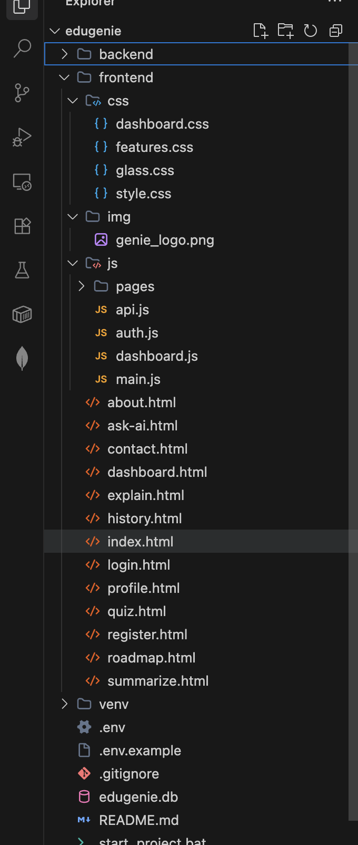
Figure 8.1: EduGenie Full Stack Web Interface & Control Deck
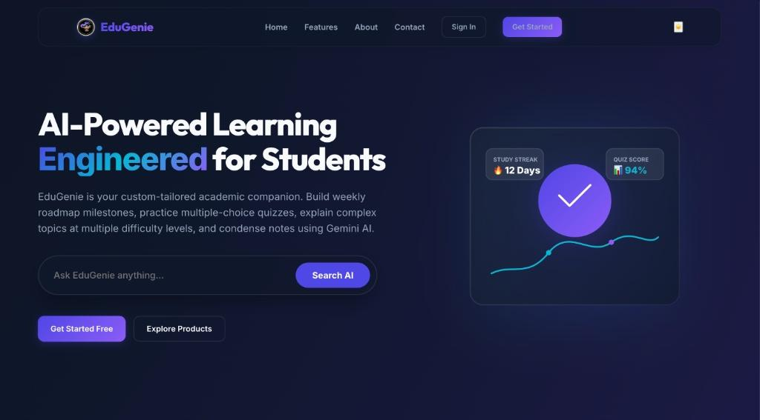
Figure 8.2: Question Answering Module Response Panel

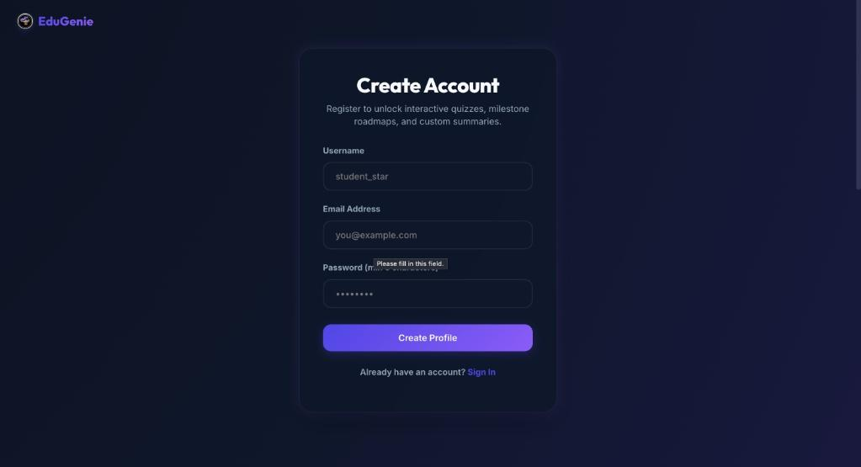
Figure 8.3: Concept Explanation Breaking Down Advanced Topics

Figure 8.4: AI Quiz Generator Interface & Multiple Choice Options

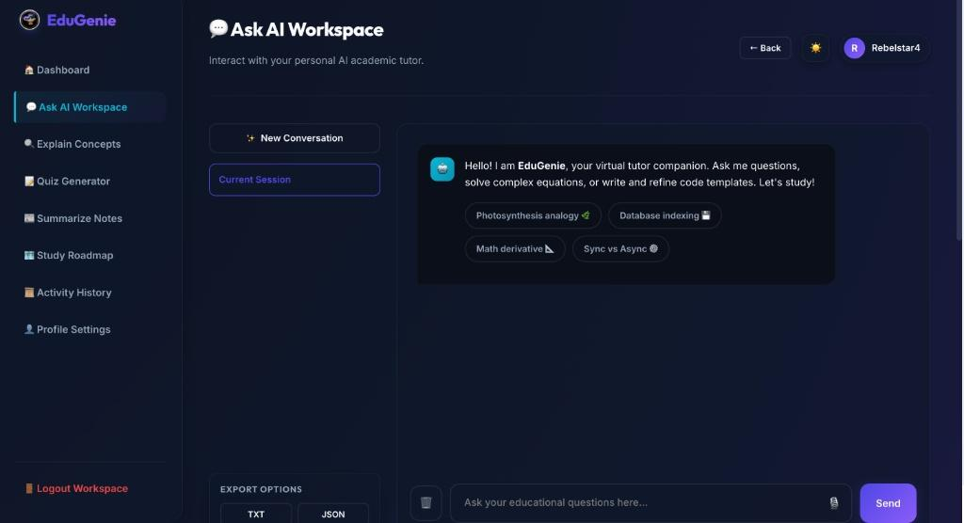
Figure 8.5: Personalized Learning Roadmap Pipeline

CHAPTER 9 – CONCLUSION & FUTURE ENHANCEMENTS
The development of EduGenie demonstrates that advanced Generative Artificial Intelligence tools can be successfully integrated into standard, lightweight web applications. By utilizing the fast, non-blocking capabilities of FastAPI alongside structured prompt engineering pipelines, the project provides an accessible, low-latency educational tool. Future enhancements include Vector Database integration for Retrieval-Augmented Generation (RAG) and persistent student progress tracking.

REFERENCES & APPENDIX

References
[1] A. Vaswani et al., "Attention is all you need," in Advances in Neural Information Processing Systems, 2017.
[2] S. Tiwary, "Asynchronous API architectures using Python and FastAPI," IEEE Software, 2022.
[3] Google Cloud, "Gemini: A family of highly capable multimodal models," 2024.
[4] P. Varshney, "Prompt engineering methodologies for constrained textbook synthesis," IEEE Intelligent Systems, 2023.

Appendix — Environment Initialization
# Step 1: Clone the repository
$ git clone https://github.com/c-naresh/edugenie-ai-assistant.git
$ cd edugenie-ai-assistant
# Step 2: Establish python virtual execution space
$ python3 -m venv venv
$ source venv/bin/activate
# Step 3: Launch ASGI server loop via Uvicorn
$ export GEMINI_API_KEY="your_api_key_here"
$ uvicorn main:app --host 127.0.0.1 --port 8000 --reload
Official Repository: https://github.com/c-naresh/edugenie-ai-assistant

