CLA-3 – Case Study
Case study title | Diabetes Onset Prediction Using the Pima Indians Dataset
Base paper | J. W. Smith, J. E. Everhart, W. C. Dickson, W. C. Knowler and R. S. Johannes, “Using the ADAP learning algorithm to forecast the onset of diabetes mellitus,” Proc. Annu. Symp. Comput. Appl. Med. Care, 1988, pp. 261–265.
Date of submission | 07-11-2026

Roll No. | Name
[Roll No.] | Bhuvana

1. Introduction and Problem Statement
Diabetes mellitus affects hundreds of millions of people worldwide, and many cases stay undiagnosed for years. Early identification allows lifestyle change and treatment before complications such as kidney disease, nerve damage and heart disease develop. A model that flags high-risk patients from a few routine measurements could help clinics decide who should receive a full diagnostic test first.
This case study asks: can routine clinical measurements (glucose, BMI, age, pregnancies and similar) predict whether a woman in the Pima Indian population develops diabetes within five years, and how well does a simple, interpretable model such as logistic regression do compared with more flexible classifiers? It is a binary classification problem (Outcome = 1 means diabetes onset, 0 means no onset).

2. Base Paper Summary
Smith et al. [1] introduced the ADAP (adaptive learning) algorithm, an early neural-network-style model that adjusts connection weights incrementally and produces a continuous output between 0 and 1 that is thresholded to give a diabetes forecast. The key idea was to learn from patient records collected by the National Institute of Diabetes and Digestive and Kidney Diseases from Pima Indian women aged 21 or more living near Phoenix, Arizona, and to forecast onset of diabetes within five years from eight measured variables.
In the paper, the model was trained on 576 cases and tested on the remaining 192; it reported a sensitivity and specificity of about 76% on the test set. The dataset later became one of the most widely used benchmarks in the UCI repository [2]. This case study does not re-implement ADAP. It uses the same dataset, a split of the same size (576/192), and standard scikit-learn classifiers, and compares the outcomes to the paper’s reported figure.

3. Method / Model Explanation
Logistic regression is the main model. It is linear in the features but passes the result through a sigmoid so that the output is a probability. The steps are: (1) impute missing values and standardise every feature; (2) compute a weighted sum of the features; (3) convert it to a probability; (4) predict diabetes if the probability is at least 50%; (5) learn the weights by minimising the log-loss on the training data (with L2 regularisation).
z = b + w₁x₁ + w₂x₂ + … + w₈x₈, p = P(y = 1 | x) = 1 / (1 + e^(−z))
Here xᵢ is the i-th standardised feature (Pregnancies, Glucose, BloodPressure, SkinThickness, Insulin, BMI, DiabetesPedigreeFunction, Age), wᵢ is its learned weight, b is the intercept (−0.864 in our fit), z is the log-odds of diabetes, and p is the predicted probability. A positive weight means the feature raises the predicted risk. As a comparison, a Random Forest (300 trees voting, each trained on a random sample of rows and features) and k-Nearest Neighbours (k = 7, majority vote of the seven most similar patients) were also trained.
Worked example (test patient #445). After standardising, the model’s contributions (wᵢ × xᵢ) are: Glucose 180 mg/dL gives +2.25, BMI 59.4 gives +2.88, DiabetesPedigreeFunction 2.42 gives +1.24, Pregnancies 0 gives −0.51, and the remaining four features sum to about −0.29. Adding the intercept: z = −0.864 + 5.57 ≈ 4.71 (4.706 unrounded). Then p = 1/(1 + e^−4.706) = 99.1%, which is above 50%, so the model predicts diabetes.

4. Implementation
Tools. Python 3, pandas, NumPy, scikit-learn 1.9 and matplotlib. Models come from scikit-learn (LogisticRegression, RandomForestClassifier, KNeighborsClassifier) [3]. All code is in my GitHub repository: [GitHub link here] (file diabetes_prediction.py).
Dataset. The Pima Indians Diabetes dataset [2] has 768 examples and 8 numeric features; 268 (34.9%) are positive and 500 (65.1%) negative. It was loaded from the public CSV copy at github.com/plotly/datasets (diabetes.csv). The data was split 75/25 with stratification (random_state = 42): 576 training and 192 test examples.
Steps and settings. (1) Replace physiologically impossible zeros in Glucose, BloodPressure, SkinThickness, Insulin and BMI with missing values; (2) median imputation, fitted on training data only; (3) standardisation for logistic regression and k-NN; (4) train the three models (LogisticRegression max_iter = 1000; RandomForest 300 trees; k-NN k = 7); (5) 5-fold stratified cross-validation on the training set (ROC-AUC) and final evaluation on the untouched test set. Imputation and scaling sit inside a scikit-learn Pipeline so no test information leaks into training.
Problems faced. The main problem was hidden missing data: 5 Glucose, 35 BloodPressure, 227 SkinThickness, 374 Insulin and 11 BMI readings are recorded as 0, which is impossible. Treating zeros as real values would distort the scaling, so they were converted to missing and imputed with the median. A second issue was class imbalance (about 2:1), which is why accuracy alone is not reported; precision, recall, specificity, F1 and ROC-AUC are included.

5. Results and Discussion
Table 1. Test-set results (192 patients) and 5-fold cross-validation AUC on the training set.
Model | Accuracy | Precision | Recall | Specificity | F1 | Test AUC | CV AUC (mean ± sd)
Logistic Regression | 72.4% | 63.0% | 50.7% | 84.0% | 56.2% | 82.4% | 83.1 ± 2.3%
Random Forest | 74.5% | 66.1% | 55.2% | 84.8% | 60.2% | 81.1% | 81.8 ± 1.4%
k-NN (k = 7) | 72.4% | 62.5% | 52.2% | 83.2% | 56.9% | 78.2% | 80.2 ± 2.5%

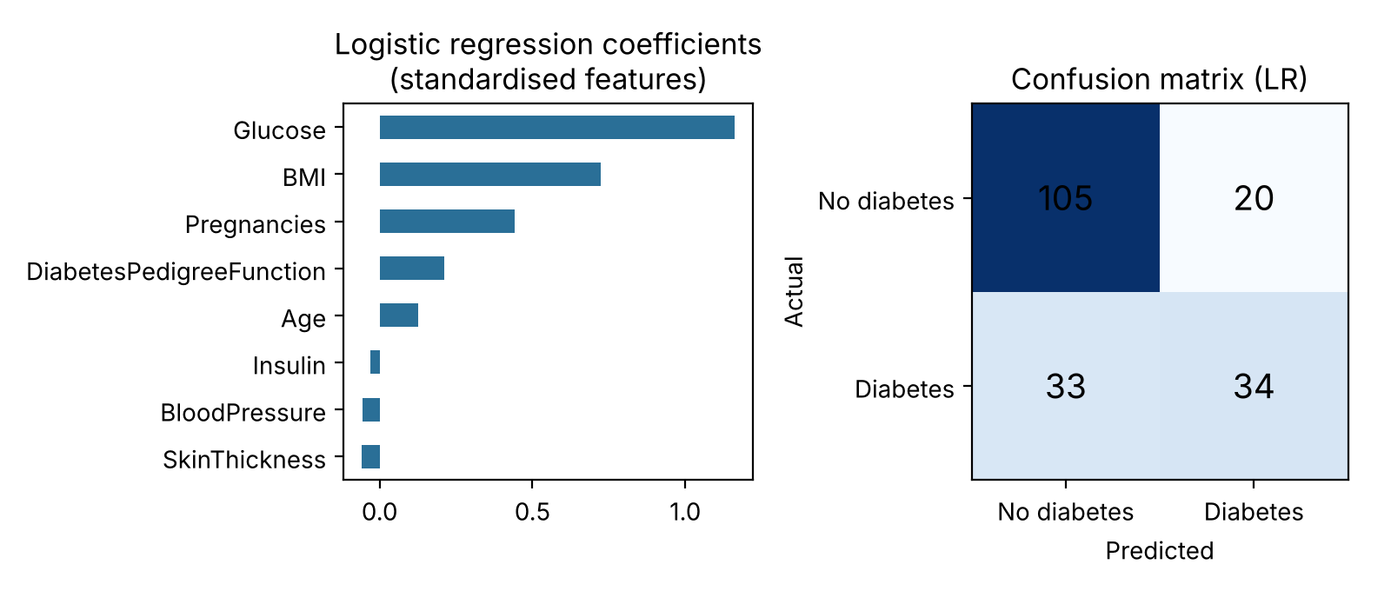
Figure 1. Logistic regression: standardised coefficients (left) and test confusion matrix (right: 105 TN, 20 FP, 33 FN, 34 TP).
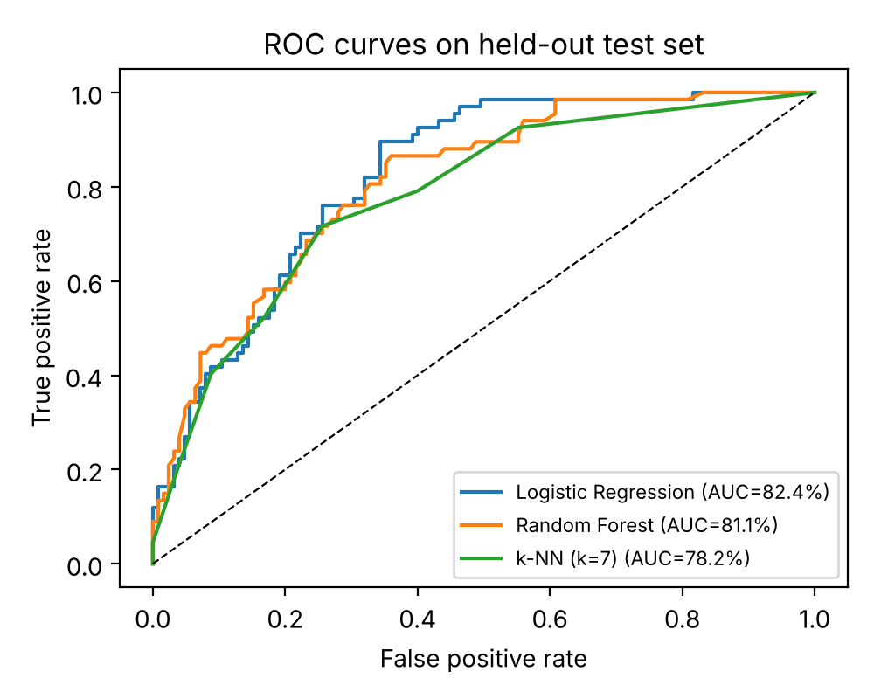
Correct output. Test patient #445 (Glucose 180, BMI 59.4, DiabetesPedigreeFunction 2.42) was predicted diabetic with probability 99.1% and was actually diabetic. High glucose and high BMI, the two strongest coefficients, pushed the score far above the threshold.
Incorrect output. Test patient #6 (Glucose 78, BMI 31.0, age 26) was predicted non-diabetic with probability 5% (z ≈ −2.95), but developed diabetes (a false negative). Her glucose was well below average, which alone contributed −1.68 to z, and the other features did not signal risk, so the model had nothing to separate her from healthy patients.
Discussion. Glucose is by far the strongest predictor (coefficient 1.16), followed by BMI (0.72) and pregnancies (0.44); BloodPressure, SkinThickness and Insulin contribute almost nothing, partly because so many of their values were missing. Logistic regression had the best AUC (82.4% on the test set, 83.1% cross-validated), and the Random Forest had the best accuracy (74.5%) and recall, but the differences are small and within the cross-validation spread, so no model is clearly superior. Accuracies of 72–75% are lower than the 76% sensitivity and specificity reported in [1]; here specificity (83–85%) is high but sensitivity (51–55%) is low, meaning roughly half of the diabetic patients are missed at the default 50% threshold. Replacing zeros with the median did not improve accuracy on this split (73.4% for a logistic model on the raw zeros versus 72.4% after cleaning), so the cleaning is justified mainly on medical grounds, not by a score gain.
Limitations. The dataset is small (768 patients, 192 in the test set, so each metric has a wide confidence interval), covers only women of one population, and the label is five-year onset from a single study. The threshold was not tuned and no hyperparameter search was run. Results come from one train/test split. These models should be seen as a screening aid and not as a diagnostic tool.

6. Conclusion
Using routine clinical measurements, logistic regression predicted five-year diabetes onset in Pima Indian women with a test ROC-AUC of 82.4% (cross-validated 83.1%), accuracy of 72.4% and specificity of 84%. The simple, interpretable model performed about as well as the Random Forest (AUC 81.1%) and k-NN (78.2%), and glucose, BMI and number of pregnancies were the most influential factors. However, sensitivity was only about 51%, so the default model misses many true cases, and the threshold would have to be lowered before real screening use. Overall, the answer to the question in Section 1 is yes, partially: the measurements carry useful predictive signal, but the achieved performance is modest.

7. References
[1] J. W. Smith, J. E. Everhart, W. C. Dickson, W. C. Knowler and R. S. Johannes, “Using the ADAP learning algorithm to forecast the onset of diabetes mellitus,” in Proc. Annu. Symp. Comput. Appl. Med. Care, 1988, pp. 261–265.
[2] D. Dua and C. Graff, “UCI Machine Learning Repository: Pima Indians Diabetes Database,” Univ. of California, Irvine, 2019. Data copy used: https://github.com/plotly/datasets/blob/master/diabetes.csv
[3] F. Pedregosa et al., “Scikit-learn: Machine learning in Python,” J. Mach. Learn. Res., vol. 12, pp. 2825–2830, 2011.

8. Declaration
I confirm that this case study is my own work and that all results reported were obtained by me.

Signature:
Roll No.: [Roll No.]
Name: Bhuvana

