PROJECT REPORT
Personalized Networking Assistant
AI-Powered Conversation Starter Generator for Professional & Social Networking Events
Prepared by
Team: Personalized Networking Assistant

Team Members
The project was executed collaboratively by a five-member team, with responsibilities distributed across five epics to ensure balanced ownership of design, development, and delivery.
Team Member | Role | Responsibility
Sruthi Vandavasi | Team Lead | Epic 4, Epic 5, Conclusion
Manyam Devi Dhatri | Member | Epic 1, Description of ER Diagram
Jaswanth Badeti | Member | Epic 2, Pre-requisites
Roshan Ap24110010332 | Member | Epic 3, Project Flow
Nissankararao Krishna Vamsi | Member | —

Project Overview
The Personalized Networking Assistant is an AI-powered web application designed to help users generate smart, tailored conversation starters for professional or social networking events. Attending conferences, meetups, and industry events can be daunting, especially when trying to strike up meaningful conversations with strangers who share overlapping professional interests. This application solves that problem by using natural language processing to analyze event context and user interests, then producing relevant, engaging conversation openers in real time.
At its core, the system combines two transformer-based models: DistilBERT, a lightweight distilled version of BERT, is used to extract key themes and topics from event descriptions, while GPT-2 is used to generate context-aware, natural-sounding conversation prompts based on those extracted themes and the user's stated interests. To ensure that users are not just making conversation but making informed conversation, the platform integrates the Wikipedia API for on-demand fact verification, allowing users to quickly confirm or expand upon a topic before bringing it up. A history and feedback module rounds out the experience, letting users track previously generated suggestions, mark which ones worked well, and allow the system to refine its personalization over time.
The system is built using FastAPI for the backend REST services and Streamlit for the interactive frontend, resulting in a lightweight, modular, and responsive application. All backend logic — including model inference, fact-checking, and history management — is thoroughly unit-tested using pytest, ensuring reliability across releases.

Description of the ER Diagram
Assigned to: Manyam Devi Dhatri
The Entity-Relationship (ER) diagram forms the structural backbone of the Personalized Networking Assistant, defining how user data, event data, and generated content relate to one another within the persistence layer. The schema is designed to be lightweight yet extensible, supporting the core features of theme extraction, starter generation, fact-checking, and history tracking without unnecessary complexity.

Core Entities
- User — stores basic identifying information for each user of the application, including a unique user ID, name, and preferences such as commonly stated interests. This entity anchors all personalization logic.
- Event — represents a networking event or context entered by the user, capturing the event description, extracted themes, and timestamp of creation. Each event can be linked to multiple generated conversation starters.
- ConversationStarter — stores each AI-generated conversation prompt, including the source event it was generated from, the text of the starter, the model version used, and a foreign key reference to the associated user.
- Feedback — captures user ratings (thumbs up/down) on individual conversation starters, enabling the application to learn which types of prompts are most effective for a given user or theme.
- FactCheck — logs topics that were searched via the Wikipedia API, along with the summarized result returned, so that previously fact-checked topics can be retrieved quickly without repeat API calls.
- History — a derived or join entity that aggregates a user's past events, starters, and feedback into a single retrievable timeline for the 'Reviewing Past Strategies' feature.

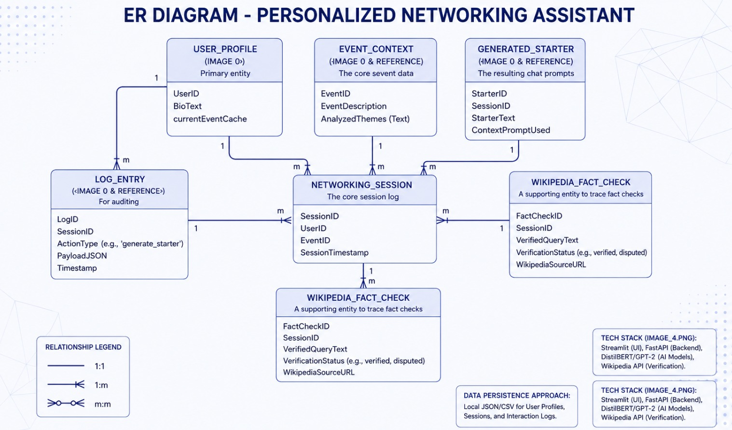

Relationships
- A User can create multiple Events (one-to-many), reflecting that a single user may attend and prepare for several networking occasions over time.
- An Event can generate multiple ConversationStarters (one-to-many), since the system typically produces 2–3 starters per request.
- Each ConversationStarter has at most one Feedback entry per user (one-to-one), representing the thumbs up/down rating.
- A User can perform multiple FactCheck queries (one-to-many), independent of any specific event, since fact-checking can be used standalone.
- The History view is effectively a many-to-many aggregation across Users, Events, and ConversationStarters, joined through Feedback to surface which strategies were most useful.
This relational structure ensures referential integrity between generated content and the user who requested it, while keeping the schema normalized enough to avoid data duplication. It also allows the analytics layer (used for personalization improvements) to efficiently query feedback trends across themes and event types.

Pre-requisites
Assigned to: Jaswanth Badeti
Before development and deployment of the Personalized Networking Assistant, the following technical and environmental prerequisites must be in place. These ensure a consistent development experience across all team members and prevent environment-related integration issues.

Software & Environment
- Python 3.9 or higher, with pip and virtualenv (or conda) for dependency isolation.
- FastAPI and Uvicorn for building and serving the backend REST API.
- Streamlit for building the interactive frontend application.
- Hugging Face Transformers library, providing access to pre-trained DistilBERT and GPT-2 model checkpoints.
- PyTorch (or TensorFlow, depending on the chosen backend for Transformers) for running model inference.
- Requests library for interfacing with the Wikipedia REST API.
- SQLite or PostgreSQL for persisting user history, feedback, and event data, along with SQLAlchemy as the ORM layer.
- pytest and pytest-asyncio for unit and integration testing of backend services and routes.
- Git and a shared repository (e.g., GitHub) for version control and collaborative development.

Knowledge Prerequisites
- Basic understanding of transformer-based NLP models, particularly how BERT-family models perform feature/theme extraction and how GPT-style models perform text generation.
- Familiarity with REST API design principles and asynchronous programming in Python (async/await) for FastAPI routes.
- Understanding of Streamlit's session state and component model for building interactive, stateful frontends.
- Basic knowledge of relational database design, given the ER schema underpinning history and feedback storage.
- Familiarity with unit testing practices and mocking external API calls (e.g., Wikipedia) for reliable, deterministic tests.

Hardware Considerations
- A machine with at least 8GB RAM is recommended for running DistilBERT and GPT-2 inference locally; a GPU is optional but improves generation latency significantly.
- Sufficient disk space (2–3 GB) to store downloaded pre-trained model weights for both DistilBERT and GPT-2.

Project Flow
Assigned to: Roshan Ap24110010332
The Personalized Networking Assistant follows a clear, linear flow from user input to personalized output, with feedback looping back into the system to improve future recommendations. The overall flow can be broken down into the following stages:

1. Input Collection
The user begins by entering an event description (e.g., "AI for Sustainable Cities") along with a set of personal interests (e.g., "climate change", "urban planning") through the Streamlit frontend. This input is sent to the FastAPI backend via a REST call.

2. Theme Extraction
The backend passes the event description to the DistilBERT-based theme extraction service, which identifies the most salient topics and concepts embedded in the text (e.g., AI, sustainability, infrastructure). These extracted themes are combined with the user's stated interests to form a generation context.

3. Conversation Starter Generation
The combined context is passed to the GPT-2 generation service, which produces 2–3 natural-language conversation starters tailored to both the event's themes and the user's personal interests. The generated text is post-processed for coherence and length before being returned to the frontend.

4. Optional Fact Verification
If the user wants to verify a topic before their event (e.g., "blockchain in healthcare"), they can trigger a fact-check request. The backend queries the Wikipedia API, retrieves a concise, reliable summary, and returns it to the frontend for quick reference.

5. History Logging & Feedback
Every generated set of conversation starters is logged to the History module, along with the associated event and timestamp. Users can revisit this history at any time and mark individual starters with a thumbs up or thumbs down, indicating how useful the suggestion was in practice.

6. Continuous Personalization
Feedback signals are stored and can be used to bias future generations — for example, favoring themes or phrasing styles that a user has previously rated positively. This creates a lightweight feedback loop that makes the assistant increasingly personalized with continued use.
This flow ensures that the application remains responsive at every stage: users get near-instant theme extraction, quick generation results, and fast fact-check lookups, all while contributing data that improves the system's future recommendations.

Epic 1: Model Selection and Architecture
Assigned to: Manyam Devi Dhatri
This epic focused on selecting the right combination of pre-trained NLP models and defining the overall system architecture that would support both real-time inference and modular scalability.

Key Activities
- Evaluated multiple transformer models for theme/topic extraction, ultimately selecting DistilBERT for its balance of accuracy and inference speed — roughly 60% faster and 40% smaller than full BERT while retaining over 95% of its language understanding performance.
- Selected GPT-2 as the generative model for conversation starters due to its strong performance on open-ended, fluent text generation without requiring paid API access, making it suitable for local or self-hosted deployment.
- Designed a modular service-oriented architecture separating concerns into distinct backend services: Theme Extraction Service, Generation Service, Fact-Check Service, and History/Feedback Service.
- Defined the interaction pattern between FastAPI (serving as the orchestration and API layer) and the underlying Hugging Face model pipelines, including how models are loaded once at startup to minimize per-request latency.
- Established the ER diagram and database schema to support persistence of events, starters, feedback, and fact-check history.

Outcome
The result of this epic was a clearly documented technical architecture diagram and model selection rationale, giving the rest of the team a stable foundation to build backend services, frontend components, and tests against.

Epic 2: Core Functionalities Development
Assigned to: Jaswanth Badeti
This epic covered the implementation of the core AI-driven functionalities that power the application: theme extraction, conversation starter generation, and Wikipedia-based fact-checking.

Key Activities
- Implemented the DistilBERT-based theme extraction pipeline, including tokenization, inference, and post-processing to convert raw model output into clean, human-readable theme keywords.
- Implemented the GPT-2 text generation pipeline, including prompt engineering to steer the model toward producing natural, non-repetitive conversation starters, and applied truncation/length controls to keep outputs concise (2–3 starters per request).
- Integrated the Wikipedia REST API for fact verification, including query normalization, summary extraction, and graceful error handling for topics with no direct Wikipedia match (using search-based fallback suggestions).
- Implemented caching for repeated fact-check queries to reduce redundant external API calls and improve response times.
- Wrote isolated unit tests for each core function using pytest, including mocked responses for the Wikipedia API to ensure tests remain fast and independent of network availability.

Outcome
By the end of this epic, all three core AI functionalities — theme extraction, starter generation, and fact-checking — were fully implemented, independently testable, and ready to be wired into the main application logic.

Epic 3: Main Application Logic
Assigned to: Roshan Ap24110010332
This epic focused on orchestrating the core functionalities into a coherent backend application using FastAPI, exposing clean REST endpoints that the frontend and other clients could consume.

Key Activities
- Designed and implemented FastAPI routes for the three primary use cases: generating conversation starters, performing fact-checks, and retrieving/updating user history and feedback.
- Defined Pydantic request/response models to enforce strict input validation (e.g., ensuring event descriptions and interests are non-empty, and feedback values are constrained to valid options).
- Implemented the orchestration layer that ties together theme extraction and generation services into a single '/generate-starters' endpoint, so the frontend only needs to make one call per user request.
- Built the database access layer using SQLAlchemy, including CRUD operations for events, conversation starters, and feedback records, aligned with the ER diagram from Epic 1.
- Added centralized error handling and logging middleware to gracefully manage model inference failures, invalid input, and external API timeouts.
- Wrote integration tests using pytest and FastAPI's TestClient to validate end-to-end route behavior, including success and failure scenarios.

Outcome
This epic delivered a fully functional, tested backend API capable of handling all three scenarios described in the project brief — smart starter generation, fact verification, and history review — ready for frontend integration.

Epic 4: Frontend UI Using Streamlit
Assigned to: Sruthi Vandavasi
This epic delivered the user-facing interface of the application, built using Streamlit to provide a responsive and interactive experience without the overhead of a full JavaScript frontend framework.

Key Activities
- Designed the main input form allowing users to enter an event description and a list of personal interests, with real-time input validation and helpful placeholder text.
- Built the conversation starter results view, displaying generated starters as clean, readable cards with thumbs up/down feedback buttons attached to each suggestion.
- Implemented the Quick Fact Verification page, allowing users to search a topic and view a concise Wikipedia-sourced summary, along with a link to the full article for further reading.
- Built the History page, allowing users to browse past events and generated starters, filter by feedback rating, and revisit previously useful suggestions.
- Used Streamlit's session state to maintain a smooth, multi-step user experience across page interactions (e.g., preserving the last generated results when navigating to the fact-check page and back).
- Connected the frontend to the FastAPI backend via HTTP requests, with loading indicators and error messages to keep the UI responsive during model inference calls.

Outcome
The result was a clean, intuitive three-page application (Generate, Fact-Check, History) that made the underlying AI functionality accessible to non-technical users through a simple, guided interface.

Epic 5: Testing and Local Deployment
Assigned to: Sruthi Vandavasi
The final epic focused on ensuring the reliability of the full system through comprehensive testing, and on packaging the application for local deployment and demonstration.

Key Activities
- Achieved unit test coverage across all backend services (theme extraction, generation, fact-checking, and history/feedback), using pytest fixtures to isolate model calls and database state between tests.
- Wrote integration tests covering full request/response cycles through FastAPI's TestClient, validating that the orchestration layer correctly combines outputs from multiple services.
- Performed manual end-to-end testing of the Streamlit frontend against the running FastAPI backend, covering all three core scenarios described in the project brief.
- Set up a local deployment workflow using Uvicorn to serve the FastAPI backend and Streamlit's built-in server for the frontend, documented with clear setup and run instructions for future contributors.
- Conducted basic performance checks on model inference latency, adjusting batch sizes and generation length parameters to keep response times acceptable for interactive use.
- Reviewed and resolved edge cases, including empty inputs, unavailable Wikipedia topics, and repeated feedback submissions.

Outcome
This epic confirmed that the application functions reliably as a cohesive whole, with all critical paths covered by automated tests and a working local deployment ready for demonstration or further cloud deployment.

Conclusion
Assigned to: Sruthi Vandavasi
This project was executed collaboratively across five epics — from model selection and core functionality development to main application logic, frontend design, and testing — with each team member contributing a critical piece toward the final working system.
The Personalized Networking Assistant successfully demonstrates how modern NLP techniques can be applied to solve a practical, everyday problem: helping individuals navigate professional and social networking events with more confidence and relevance. By combining DistilBERT for theme extraction and GPT-2 for generating context-aware conversation starters, the application bridges the gap between raw event information and meaningful, personalized human interaction.
The integration of Wikipedia-based fact-checking adds a layer of reliability, ensuring users walk into conversations well-informed rather than relying on guesswork. The history and feedback logging feature closes the loop by allowing the system to learn from user preferences over time, laying the groundwork for more adaptive personalization in future iterations.
From an engineering standpoint, the use of FastAPI for the backend and Streamlit for the frontend enabled a clean separation of concerns, resulting in a modular, maintainable, and testable architecture. Comprehensive unit testing with pytest across backend services and routes ensured that each component functioned reliably both independently and as part of the integrated system.
Overall, this project met its stated goals — generating smart conversation starters, verifying facts, and tracking user interaction history — while also serving as a strong learning experience in applying transformer-based NLP models within a full-stack, production-style application. Potential future enhancements include upgrading to more advanced personalization models that learn directly from feedback history, expanding fact-checking to additional trusted sources beyond Wikipedia, adding multi-language support for global networking events, and deploying the application to a cloud environment to support real-world, multi-user usage at live events.

