CropAI
AI-Based Crop Disease Detection System
Project Report

Prepared from the project interface screenshots supplied
Project repository: https://github.com/AP24110011282/CropAI-AI-Based-Crop-Disease-Detection
Submitted by: J VAMSI
University: SRM University-AP
Degree: B.Tech
Department: Computer Science and Engineering (CSE)
Academic Year: 3rd Year

1. Abstract
CropAI is a web-based, AI-assisted crop health screening application. It allows a user to create an account, sign in, upload a photograph of a plant leaf, and receive a model-generated crop disease prediction. The result interface presents the predicted class, a confidence score, alternative high-scoring classes, and educational information about visible symptoms and general crop-management practices. An administrator dashboard provides an overview of prediction activity, class distribution, and prediction history.
This report is based on the supplied screenshots and the project details already shared. The screenshots demonstrate the application interface and example records; they do not independently prove the model's real-world diagnostic accuracy.

2. Introduction
Plant diseases can affect crop health and agricultural productivity. CropAI aims to make an initial, image-based screening workflow accessible through a browser. The user submits a leaf image and the application uses a trained deep-learning image-classification model to produce a possible disease class. The application is intended as an educational decision-support aid rather than a replacement for an agricultural expert.

3. Objectives
- Provide a simple account registration and sign-in experience.
- Allow users to upload a plant leaf image for AI-based analysis.
- Display the predicted disease class and model confidence.
- Show the top three model predictions to communicate alternative classes.
- Provide educational symptom indicators and prevention/management guidance.
- Maintain prediction records and provide administrative summaries and export options.

4. System Overview and Technologies
The project context identifies a Flask-based Python application, a TensorFlow/Keras image-classification model using MobileNetV2, and SQLite for storing application records. The screenshots show the browser-facing registration, login, upload, result, and administrator interfaces.
- Backend: Python with Flask.
- Machine learning: TensorFlow/Keras; MobileNetV2-based image classification.
- Database: SQLite for user and prediction-related records.
- Frontend: HTML, CSS, and JavaScript templates and interface components.
- Model artifacts: Keras model files and a class-name mapping file, as included in the project repository.
The screenshots do not show exact package versions, database schema, training configuration, or the full deployment architecture; these details are therefore not specified in this report.

5. Main Application Modules

5.1 User registration and authentication
The registration page collects a username, email address, password, and password confirmation. The sign-in page accepts an email address and password. The interface also provides navigation between registration and sign-in.

5.2 Home page and leaf image upload
The home page introduces CropAI and presents a Leaf Health Scanner panel. Users are prompted to choose a leaf photograph in JPG, JPEG, or PNG format and start disease detection. The page describes a three-step workflow: upload an image, run AI analysis, and view results.

5.3 AI prediction and assessment report
The assessment page displays the predicted disease class, crop label, model confidence, and the top three model predictions. The supplied example shows Tomato_Early_blight as the leading class with a displayed score of 49.98%; Pepper Bell Bacterial Spot is shown as the second class at 49.72%, followed by Tomato Late Blight at 0.29%. The interface labels this example as low model confidence and warns that the scores are model outputs, not independently confirmed disease probabilities.

5.4 Educational disease information
The result page includes symptom and visual-indicator notes, prevention and management suggestions, affected plant parts, favorable conditions, monitoring advice, and treatment precautions. It also displays an important note that the output is an AI-generated prediction and that users should consult an agricultural expert before applying treatments.

5.5 Administrator dashboard and prediction history
The administrator dashboard summarizes total predictions, disease categories, healthy predictions, and average confidence. It also visualizes disease distribution, healthy-versus-diseased predictions, daily prediction activity, and the most detected classes. The history interface provides a search field, prediction type filter, date filter, apply/clear controls, record details, and delete actions. An export-data option and Export CSV control are visible.

6. Interface Evidence and Screenshots
The following figures are the screenshots supplied for this report. They document the visible application workflow and dashboard features.
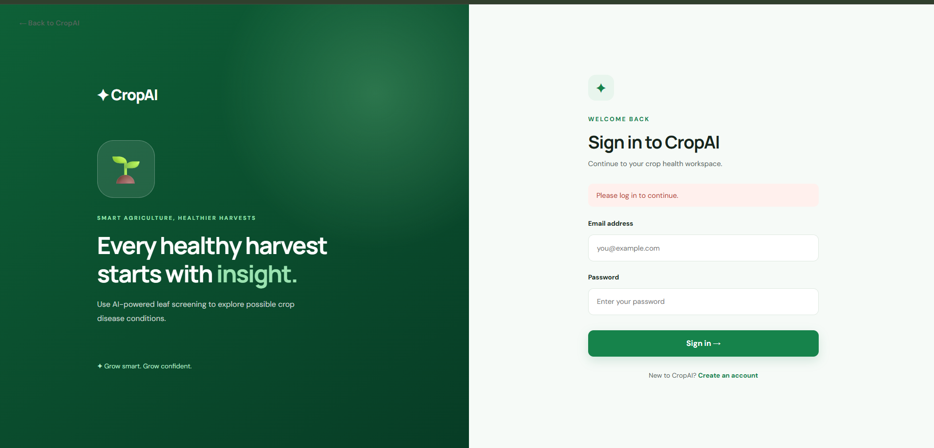
Figure 1. CropAI sign-in page
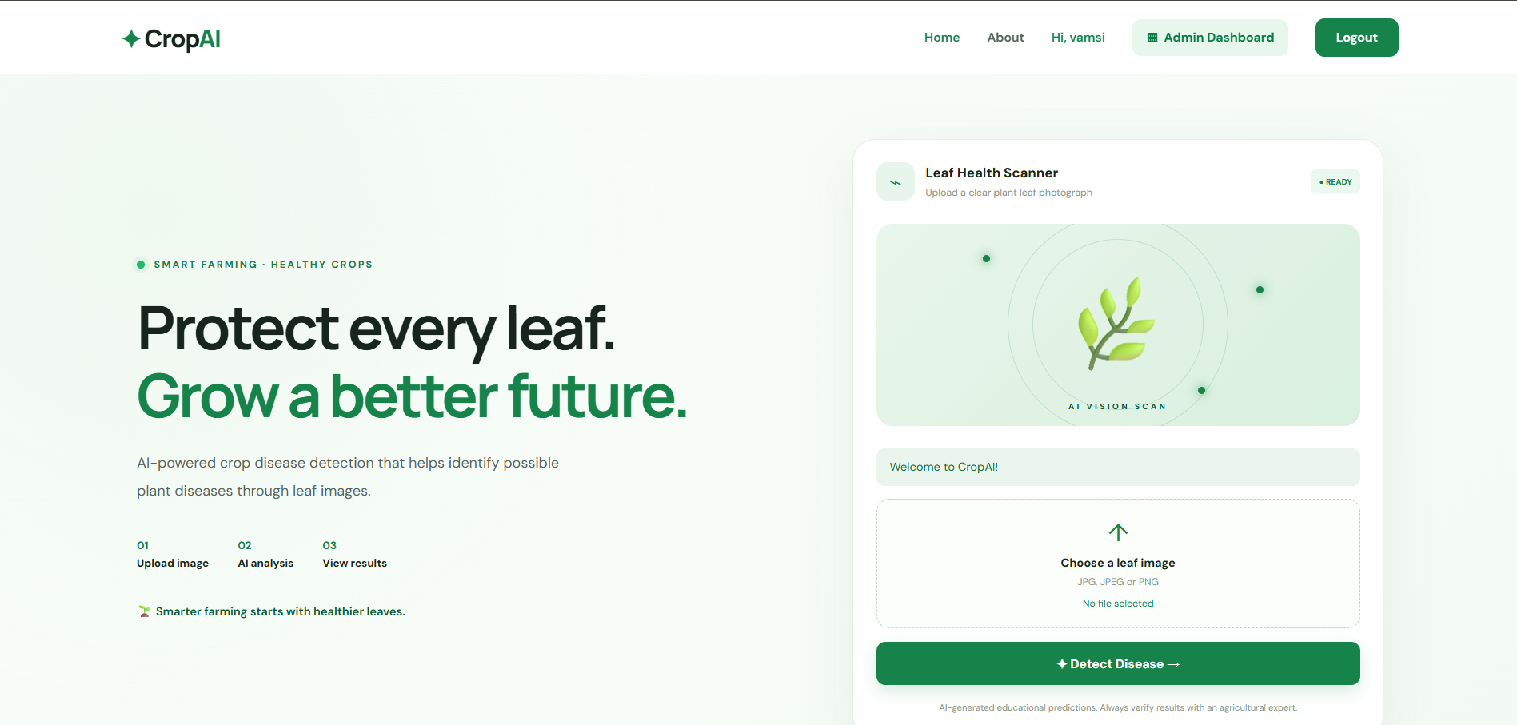
Figure 2. CropAI home page and leaf image upload interface
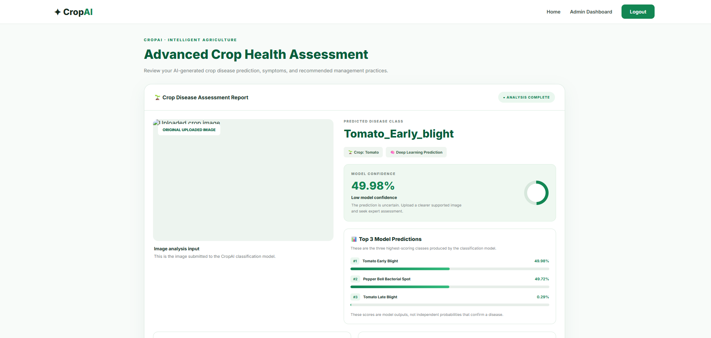
Figure 3. Crop disease assessment result page
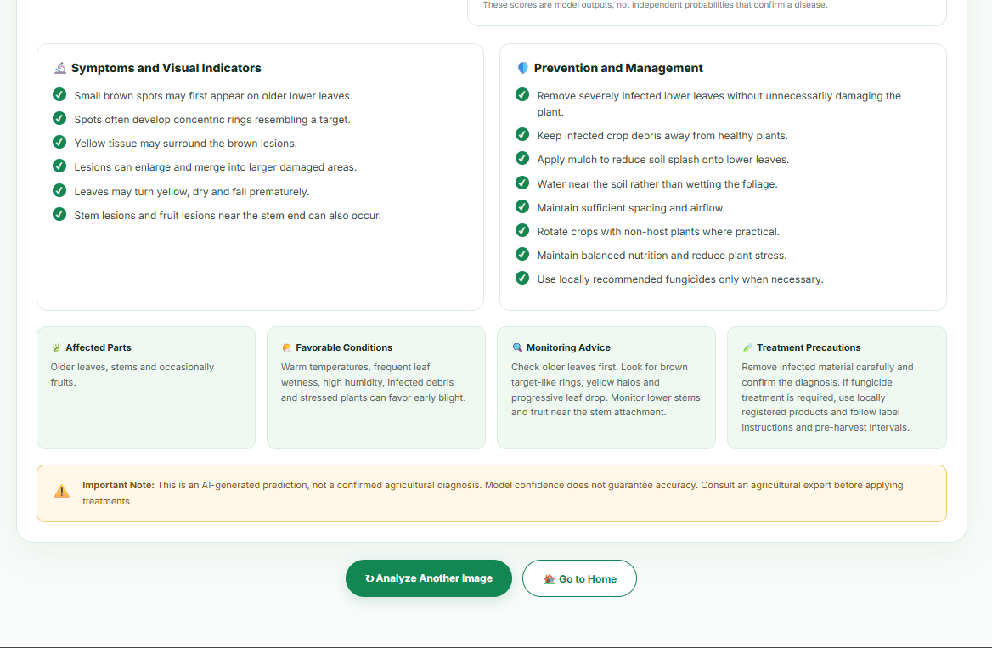
Figure 4. Disease symptoms, prevention, and treatment precautions
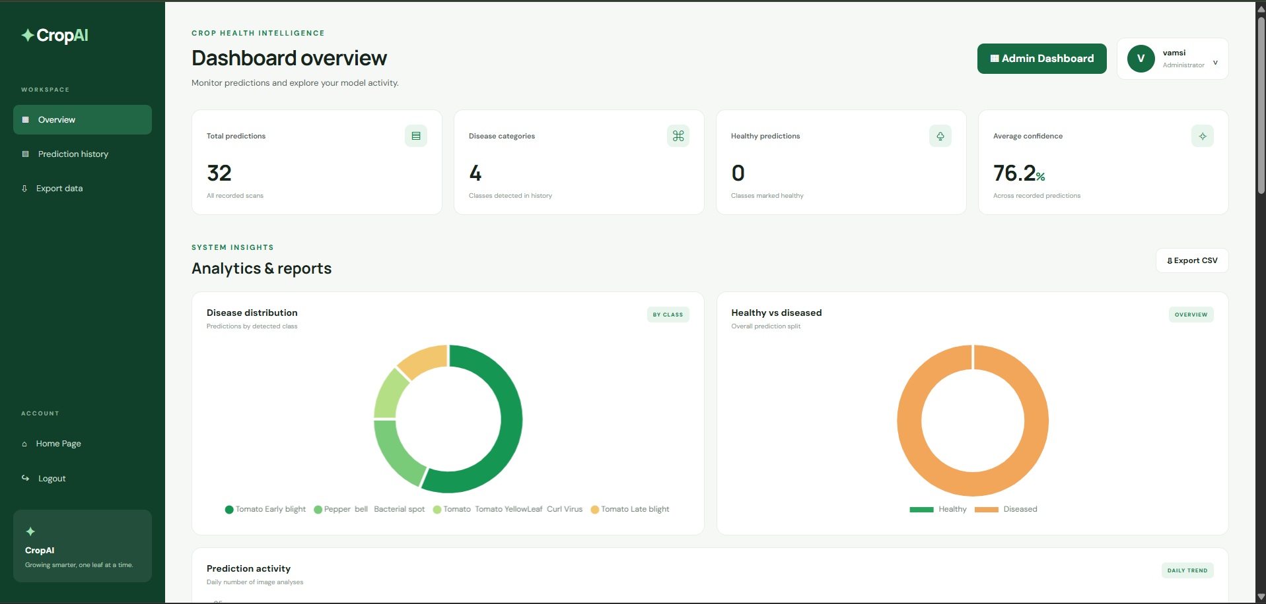
Figure 5. Administrator dashboard overview and analytics
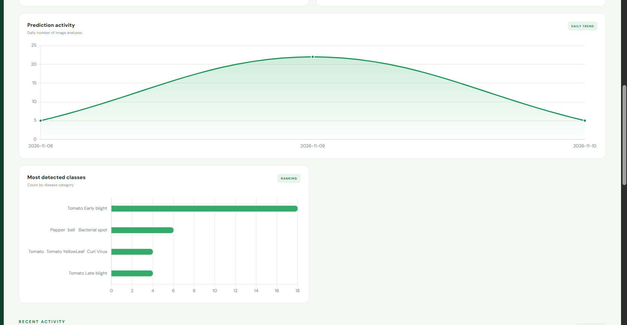
Figure 6. Prediction activity trend and most-detected classes
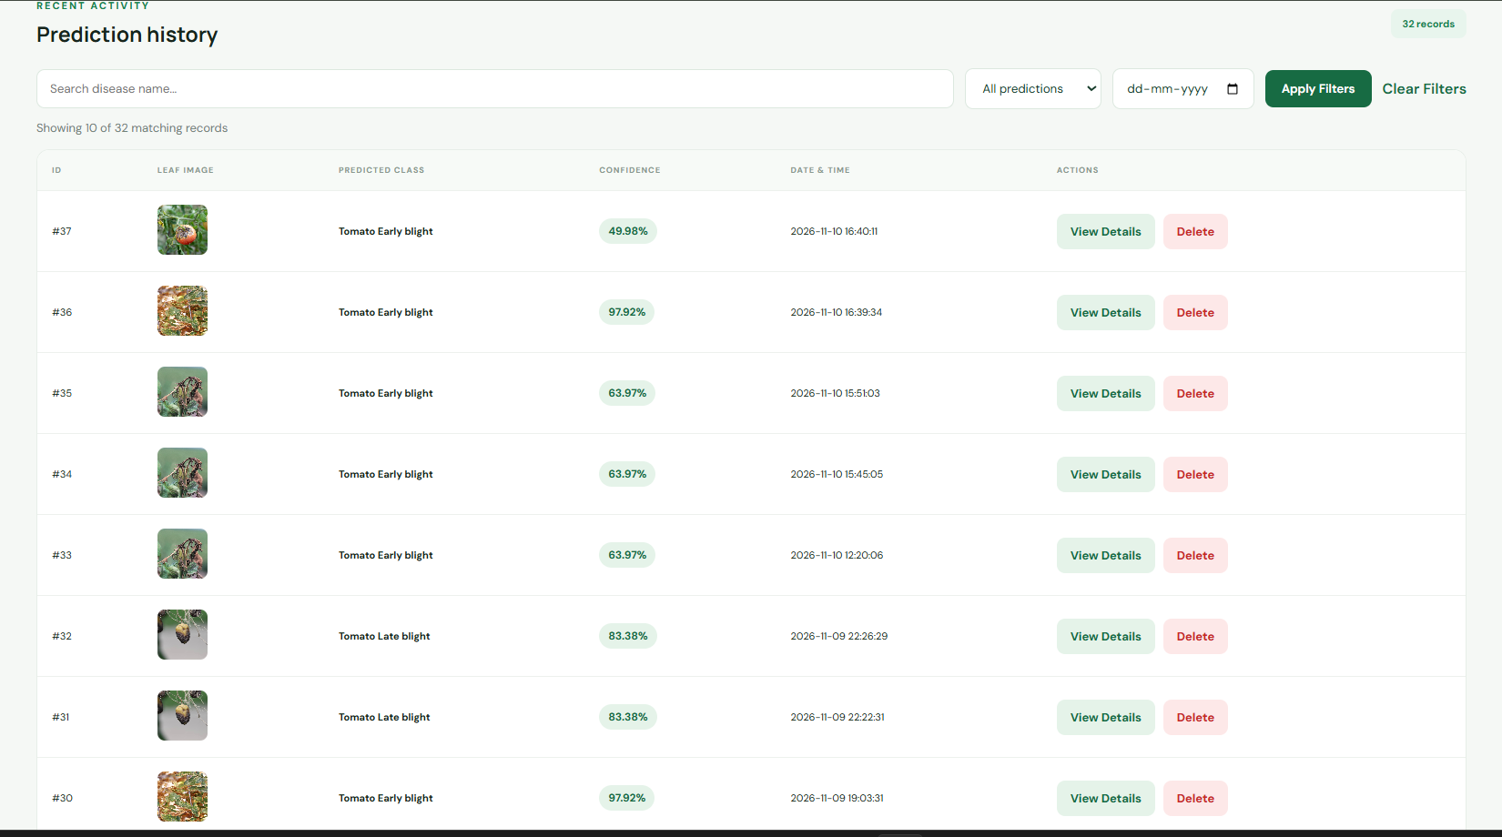
Figure 7. Prediction history with search, filters, and record actions
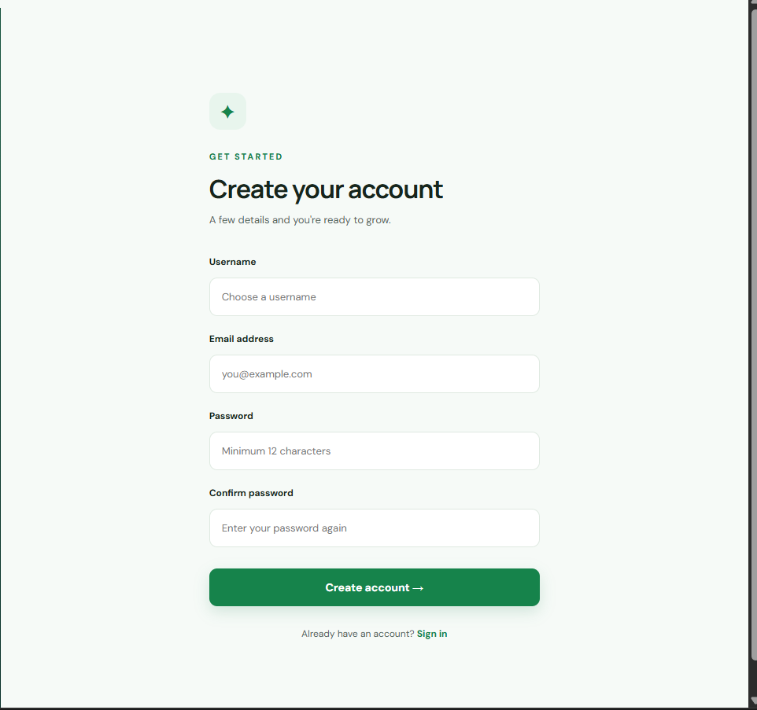
Figure 8. New user registration page

7. Example Dashboard Observations
One supplied dashboard screenshot displays 32 total predictions, 4 disease categories, 0 healthy predictions, and an average confidence of 76.2%. The visible class ranking shows Tomato Early blight as the most frequent class, followed by Pepper bell Bacterial spot, Tomato Tomato YellowLeaf Curl Virus, and Tomato Late blight. These are example application records shown in the screenshot, not a controlled model evaluation.
The result screenshot also shows why confidence communication matters: the example prediction has a score of 49.98% and is explicitly marked low confidence. A user should not interpret this output as a confirmed diagnosis.

8. Limitations and Improvements
- The example assessment screenshot shows a broken/missing preview for the original uploaded image. The upload storage path and image-serving route should be checked so the submitted image displays correctly.
- The displayed example has low confidence and two leading classes with very similar scores. The interface should continue to communicate uncertainty clearly and encourage expert verification.
- Model performance should be reported using a separate held-out test set, including accuracy, precision, recall, F1-score, and a confusion matrix. Dashboard prediction counts are not substitutes for these metrics.
- Test the model with clear images from different devices, lighting conditions, backgrounds, and field environments.
- Add clear validation messages for unsupported file types, oversized files, empty uploads, and failed predictions.
- Review authentication, password hashing, upload validation, access control, and protection of user data before any public deployment.

9. Conclusion
CropAI demonstrates an end-to-end web interface for image-based crop disease screening, from user registration and leaf upload to prediction reporting and administrative monitoring. Its result page combines a predicted class with confidence information and educational guidance, while the dashboard supports review of stored prediction activity. The system should be presented as an educational screening prototype. Reliable field use would require rigorous independent evaluation, robust image handling, and validation by agricultural experts.

10. Project Repository
GitHub: https://github.com/AP24110011282/CropAI-AI-Based-Crop-Disease-Detection
The dataset was kept outside the GitHub repository because of its size. The report therefore describes the visible application and known project configuration, not a fresh audit of the complete local dataset.

