SRM University, Andhra Pradesh
Department of Computer Science and Engineering

Hospital Patient Management System
A Python-Based Terminal Application Using Core Data Structures

A Project Report Submitted in Partial Fulfillment
of the Requirements for the Course
Data Structures and Algorithms / CSE-204
Submitted by:
Name | Roll Number
Dinesh CH | AP24110011504
Charan Koya | AP24110011508
Ranjith Vijay Raavi | AP24110011505
Sai Chaturvedi Nallana | AP24110011463
B. Shashank | AP24110011496

Academic Year: 2025–26

Abstract
This project presents the design and implementation of a Hospital Patient Management System developed in Python. The system simulates real-world hospital workflows by integrating six core data structures — Linked List, Stack, Queue, Priority Queue, Hash Map, and Arrays — each applied to specific operational requirements of a hospital environment.

The system provides a complete terminal-based interface for registering patients, tracking symptoms, managing emergency and routine queues, assigning doctors, and generating hospital-wide reports. Emergency patients are triaged using a Min-Heap Priority Queue, ensuring that critical cases are always processed first. Patient medical histories are maintained using a Stack, allowing O(1) access to the most recent visit. Symptoms are tracked dynamically using a custom Linked List, and routine checkup patients are served in FIFO order using a Queue backed by Python's deque.

The project demonstrates how theoretical data structures translate directly into practical software solutions, addressing real challenges in patient management, doctor assignment, and hospital reporting.

1. Introduction
Hospital management is a domain that demands precise, efficient, and real-time handling of information. From emergency triage to routine checkups, every operation has its own priority, ordering, and access pattern — making it an ideal context to apply and demonstrate the value of different data structures.

This project implements a Hospital Patient Management System as a Python terminal application. Rather than using generic databases or external libraries, the system manually implements core data structures to handle each specific task: a priority queue for emergencies, a stack for medical history, a linked list for symptoms, and hash maps for fast patient and doctor lookups.

The objective is twofold: to simulate realistic hospital operations through software, and to demonstrate the practical advantage of selecting the right data structure for each problem. The result is a modular, extensible system that handles patient registration, symptom tracking, queue management, treatment processing, and reporting.

2. Objectives
- Design a terminal-based hospital management system using Python
- Apply six distinct data structures to real operational use cases
- Implement priority-based emergency triage using a Min-Heap
- Maintain FIFO fairness for routine checkups using a Queue
- Track patient symptom history dynamically using a Linked List
- Store and retrieve medical visit history using a Stack
- Enable O(1) patient and doctor lookup using Hash Maps
- Generate a full hospital summary report from aggregated data

3. Data Structures Used

3.1 Linked List — Symptom Tracking
Each patient's symptoms are stored in a custom singly linked list (SymptomLinkedList). Each node (SymptomNode) holds the symptom name, a severity rating from 1 to 10, and a timestamp. New symptoms are appended to the tail in O(n), and the entire list is traversed to find the most severe symptom or compute average severity. This structure allows unlimited symptom entries without pre-allocating memory.

3.2 Stack — Medical History (LIFO)
Patient visit records are managed using a Stack (MedicalHistoryStack) backed by a Python list. Each completed treatment pushes a new record onto the stack, storing the diagnosis, prescription, doctor name, and timestamp. The most recent visit is accessible in O(1) via peek. This LIFO structure naturally reflects how clinicians review patient history — most recent first.

3.3 Queue — Routine Checkups (FIFO)
Routine checkup patients are managed in a FIFO queue (RoutineCheckupQueue) using Python's collections.deque. Patients are enqueued on arrival and dequeued for processing in order, ensuring fairness. The deque provides O(1) enqueue and dequeue operations at both ends.

3.4 Priority Queue — Emergency Triage (Min-Heap)
Emergency patients are managed using a Min-Heap Priority Queue (EmergencyPriorityQueue) via Python's heapq module. Priority level 1 (Critical) is treated with the highest urgency, followed by level 2 (Serious) and level 3 (Moderate). A monotonic counter resolves ties, ensuring stable insertion ordering when priorities are equal. This guarantees that the most critical patient is always processed next in O(log n).

3.5 Hash Map — Patient and Doctor Lookup
All patients and doctors are stored in Python dictionaries keyed by their unique IDs. This enables O(1) average-case lookup, insertion, and existence checks regardless of the number of registered entries — a critical requirement for a real-time hospital system.

3.6 Arrays — Department Statistics
Department-level patient counts are tracked in a fixed-size Python list indexed by department position. Each time a treatment is completed, the corresponding index is incremented in O(1). This array is used to generate the department summary in the full hospital report.

Data Structure | Class | Operation | Time Complexity
Linked List | SymptomLinkedList | Add Symptom | O(n)
Stack | MedicalHistoryStack | Push / Peek | O(1)
Queue (deque) | RoutineCheckupQueue | Enqueue / Dequeue | O(1)
Min-Heap | EmergencyPriorityQueue | Insert / Pop | O(log n)
Hash Map (dict) | patients / doctors | Lookup / Insert | O(1) avg
Array (list) | department_stats | Index Update | O(1)

4. System Design
The system follows a modular class-based architecture. Each data structure is encapsulated in its own class, and higher-level entities (Patient, Doctor, HospitalManagementSystem) compose these structures to build the complete application.

4.1 Class Architecture
- SymptomNode / SymptomLinkedList — Custom linked list for symptom tracking
- MedicalHistoryStack — Stack for visit history
- RoutineCheckupQueue — FIFO deque for routine patients
- EmergencyPriorityQueue — Min-heap for emergency triage
- Patient — Composes SymptomLinkedList and MedicalHistoryStack
- Doctor — Tracks specialty, availability, and treatment count
- HospitalManagementSystem — Orchestrates all structures and exposes the menu interface

4.2 Patient Flow
- Patient is registered and stored in the Hash Map
- Symptoms are added to the patient's Linked List
- Patient is placed in either the Emergency Priority Queue or Routine Queue
- An available doctor is located via Hash Map iteration
- Doctor completes treatment; a record is pushed onto the patient's Stack
- Department stats array is incremented; treatment log is appended

5. Implementation Details

5.1 Technology Stack
- Language: Python 3.x
- Standard Libraries: heapq, collections.deque, datetime, typing
- Interface: Text-Based User Interface (TUI) via terminal
- No external dependencies required

5.2 Key Implementation Highlights
The EmergencyPriorityQueue uses a (priority, counter, patient_id, name, condition) tuple for heap entries. The counter field ensures that two patients with the same priority level are served in insertion order, making the queue stable.

The MedicalHistoryStack uses Python's list with append() and pop() as push/pop operations, and index [-1] as a O(1) peek. This avoids any overhead from linked-node implementations while preserving LIFO semantics.

The SymptomLinkedList traverses the full list to compute average severity and find the maximum, giving O(n) complexity — acceptable given that individual patients rarely have more than a few dozen symptoms.

The HospitalManagementSystem.get_available_doctor() method iterates over the doctors dict and returns the first available doctor matching the requested specialty. This is O(d) where d is the number of doctors.

6. System Interface — Screenshots

6.1 Main Menu
The main menu provides access to all 12 system functions through a numbered terminal interface.

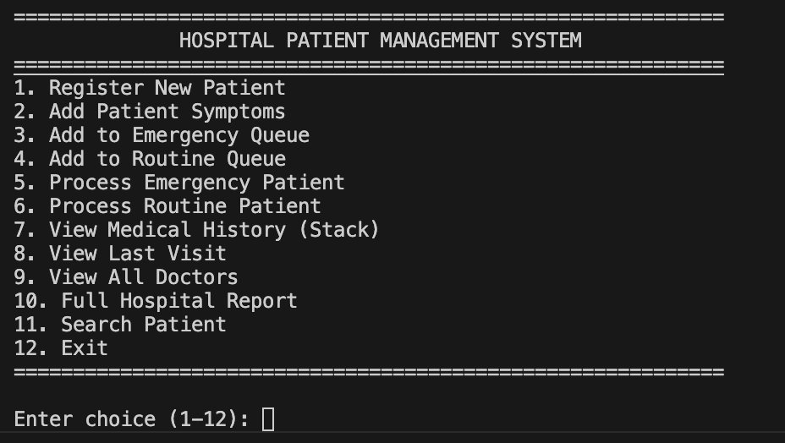
Figure 1: Hospital Patient Management System — Main Menu

6.2 Patient Registration
New patients are registered by entering their ID, full name, age, blood group, and contact number. The patient is immediately stored in the Hash Map for O(1) future lookups.

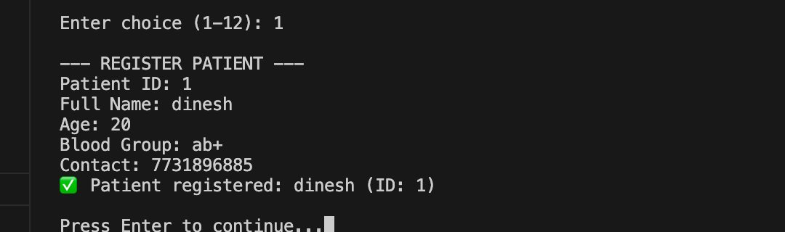
Figure 2: Patient Registration — New Patient Added Successfully

6.3 Doctor Directory
The Doctor Directory displays all registered doctors with their specialties, availability status, and the number of patients treated in the current session.

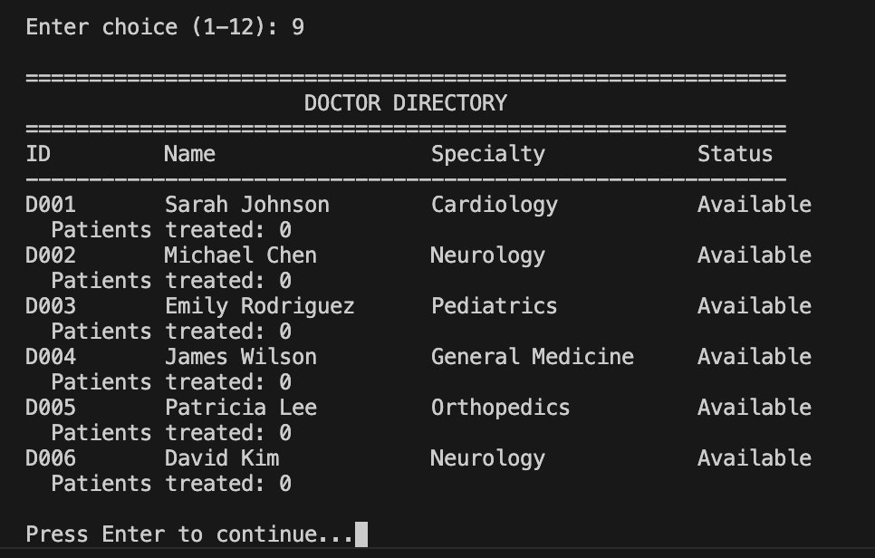
Figure 3: Doctor Directory — All Doctors with Specialty and Status

6.4 Medical History (Stack)
Patient medical history is retrieved from the Stack and displayed in reverse chronological order. The symptom history from the Linked List is shown below the visit records.

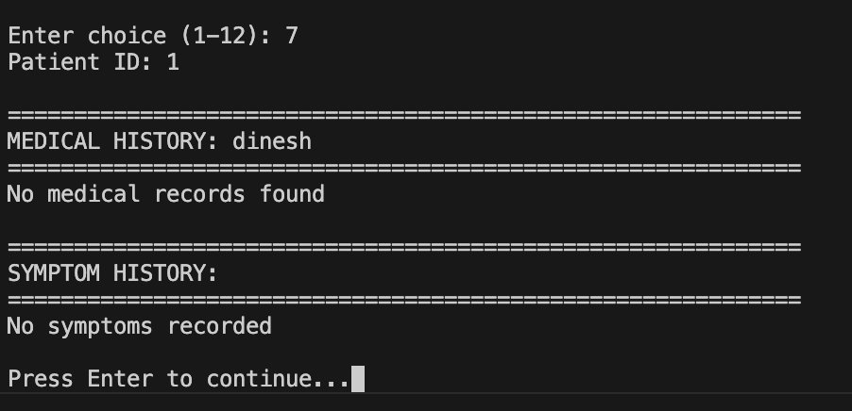
Figure 4: Medical History View — Stack-Based Visit Records and Symptom History

6.5 Full Hospital Report
The Full Report aggregates data from all structures: patient count from the Hash Map, queue sizes from the Priority Queue and deque, department stats from the Array, and doctor status from the doctors Hash Map.

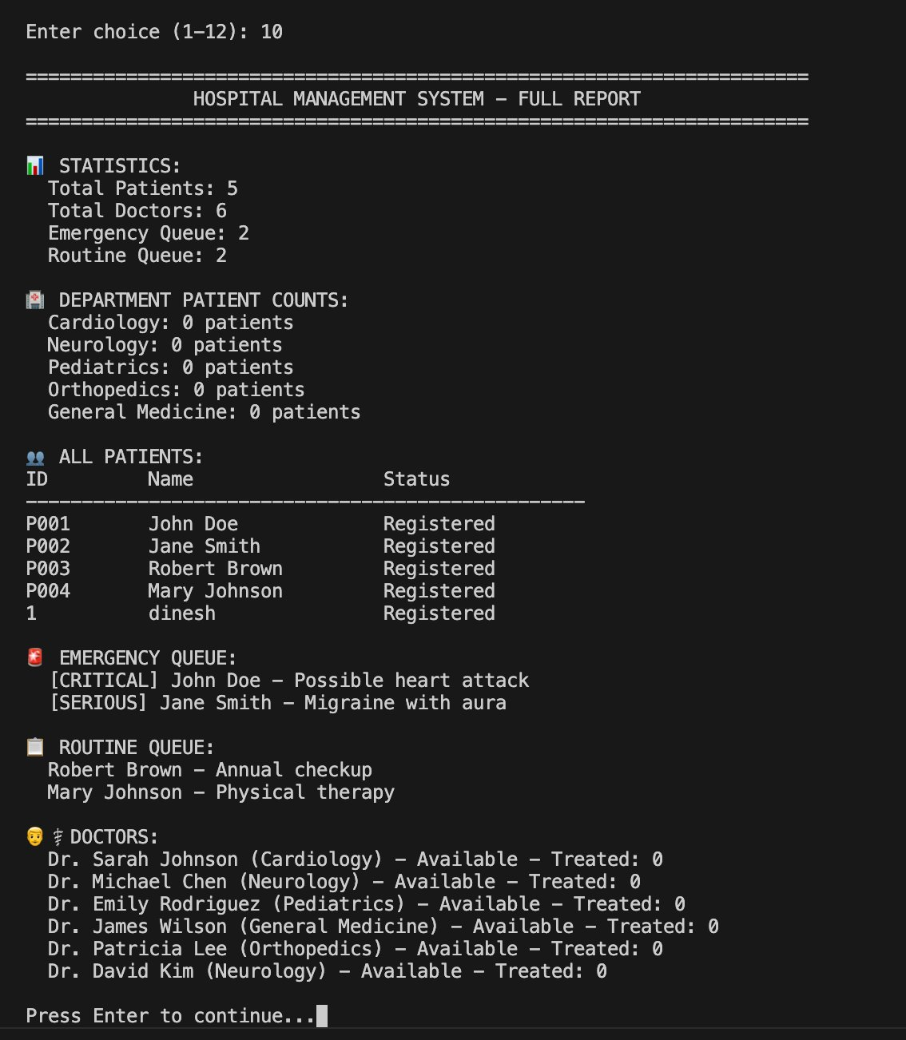
Figure 5: Full Hospital Report — Statistics, Queues, Patients, and Doctors

7. Results
The system successfully demonstrates all planned features with stable performance across all menu operations. The following results were observed during testing:

Feature | Result
Patient Registration | Registers and stores patient in O(1) via Hash Map
Emergency Triage | Critical patients always processed before Serious/Moderate
Routine Queue | Strict FIFO order maintained across all sessions
Medical History | Most recent visit accessible instantly via Stack peek
Symptom Tracking | Unlimited symptoms per patient; severity analytics computed
Hospital Report | Full system state rendered from aggregated data structures
Doctor Assignment | Available doctor located and assigned in real time

8. Conclusion
The Hospital Patient Management System successfully demonstrates the practical application of six core data structures within a single cohesive application. Each structure was chosen to match the access pattern of its use case: the heap for priority-ordered emergency triage, the stack for LIFO medical history, the deque for fair FIFO queue management, the linked list for dynamic symptom storage, and hash maps for constant-time lookups.

The project reinforces a fundamental principle of software design: the right data structure for the right problem leads to cleaner code, better performance, and more maintainable systems. By building each structure from first principles and integrating them into a real domain, the team gained hands-on understanding of the trade-offs involved in each choice.

9. Future Work
- Build a graphical user interface (GUI) using Tkinter or PyQt
- Persist patient data using SQLite or a file-based database
- Add authentication for doctors and administrative staff
- Implement a billing and invoice module
- Extend to a web-based application using Flask or Django
- Add real-time notifications for high-severity symptom entries
- Support multi-department queue routing based on doctor specialty

10. References
- Cormen, T. H., Leiserson, C. E., Rivest, R. L., & Stein, C. (2009). Introduction to Algorithms (3rd ed.). MIT Press.
- Python Software Foundation. (2024). Python 3 Documentation — collections.deque. https://docs.python.org/3/library/collections.html
- Python Software Foundation. (2024). Python 3 Documentation — heapq. https://docs.python.org/3/library/heapq.html
- Goodrich, M. T., Tamassia, R., & Goldwasser, M. H. (2013). Data Structures and Algorithms in Python. Wiley.
- GeeksforGeeks. (2024). Priority Queue using Python heapq. https://www.geeksforgeeks.org/heap-queue-or-heapq-in-python/

