L3 Agentic AI Foundry – June 2026 - Assignment
Enterprise Knowledge Assistant – using LangGraph, RAGAs and MCP

- Executive Summary:
Enterprise Knowledge Assistant is a document Q&A system that ingests organizational documents from a configurable location, stores them in a hybrid search index and answers user questions with citations. It uses client-server architecture built on the Model Context Protocol (MCP), with full observability tracing (Opik) and response quality evaluation (RAGAS).
Key Capabilities:
- Multi-format document ingestion (PDF, DOCX, TXT, CSV, XLSX, XML, images)
- Automatic PII redaction during ingestion
- Hybrid retrieval (semantic + keyword search with reranking)
- Answer generation with document-name citations
- Automated RAGAS evaluation (faithfulness, relevancy, precision, recall)
- Streamlit conversational UI
- Opik observability tracing

- Architecture:
  - Data Flow:
- Ingestion (at server startup): Documents → Load → PII Redact → Chunk → Embed → Store (ChromaDB + BM25)
- Query (Streamlit UI-client): User question → Hybrid Retrieval → LLM Generation → Cited Answer
- Evaluation: Question + Answer + Contexts + Ground Truth → RAGAS Scores (LLM-as-a-judge)

  - Application Design:
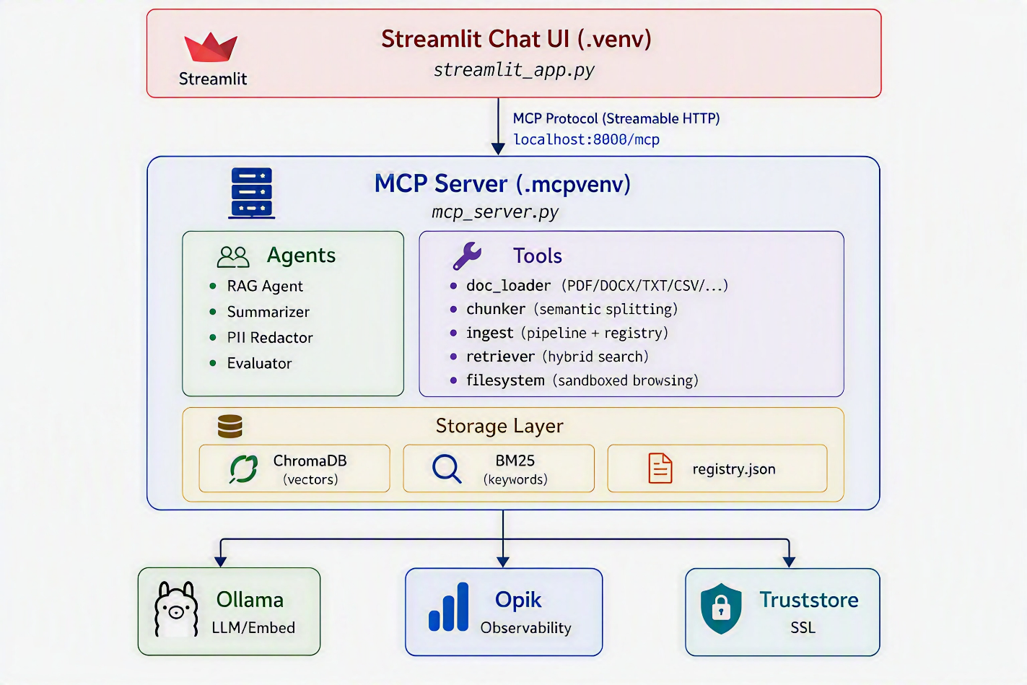

  - Tech Stack:
- Language: Python 3.12
- LLM via Ollama:
  - gpt-oss:120b-cloud: For Chat, Inference & decisions. Cloud-hosted.
  - nomic-embed-text: For vector embeddings. Local-hosted.
  - Llava/Llava:13b: For vision/OCR capabilities. Local-hosted.
- Agent Framework: LangChain + LangGraph for stateful agent orchestration.
- Vector Store: ChromaDB (persistent) for Semantic similarity search.
- Keyword Search: rank-bm25 (BM25-Okapi) for Term-frequency retrieval.
- MCP Server: FastMCP with Streamable HTTP tool/agent exposure.
- UI: Streamlit for Conversational chat interface.
- Observability: Opik (by Comet) for LLM call tracing and monitoring.
- Evaluation: LLM-as-Judge (RAGAS) for faithfulness, relevancy, context-precision, context-recall scores scaled 1-5.
- SSL: truststore for corporate proxy certificate injection.
- Config: python-dotenv for Secret management.
  - Components:
    - Document Loader: (tools/doc_loader.py)
Ingest documents from 8+ formats and extracts text content. Reads PDFs/JPGs using tesseract, with fallback on llava vision llm for OCR.
    - PII Redactor: (agents/pii_redactor.py)
Detects and redacts personally identifiable information like email, phone, ID numbers, financial details, etc. (regex, python-libraries with option for LLM configurable flags.
    - Chunker: (tools/chunker.py)
Split documents into semantically coherent chunks.
- Splits at paragraph → sentence → word boundaries.
- Configurable chunk size and overlap.
- Attaches metadata: source path, chunk index, total chunks, document title.
- Generates contextual summary headers.
    - Ingest Pipeline: (tools/ingest.py)
Orchestrates the full ingestion workflow on server startup.
      - Auto-ingest on server startup: Scans folder location ‘knowledge_source/’, ingests new/modified items, skips unchanged items.
      - Change detection: SHA-256 content hashing, compared against ‘registry.json’
      - Fault tolerant: Single file failures don't stop batch processing
      - Manual tools: ingest_file, ingest_all, list_document, delete_document
    - Hybrid Retriever: (tools/retriever.py)
Combines semantic and keyword search for robust retrieval.
      - Embed query → ChromaDB semantic search (top 2K results)
      - Tokenize query → BM25 keyword search (top 2K results)
      - Normalize scores to [0, 1] (min-max)
      - Combine: final = (0.7 × semantic) + (0.3 × keyword)
      - Deduplicate by chunk ID
      - Rerank top candidates
      - Return top-K results (default 5, configurable)

    - RAG Agent:
LangGraph-based retrieval-augmented generation with citations.

Start → Retrieve → Has Context? → Yes → Generate Answer → End
→ No → "No relevant info" → End

- Instructs LLM to cite by document name.
- Respects MAX_TOKENS and TEMPERATURE config.
- Falls back gracefully when no context is found.
    - Summarizer Agent: (agents/summarizer_agent.py)
Generates document summaries using iterative refinement.
- Summarizes chunk-by-chunk with progressive refinement.
- Caches results by content hash in ‘MCP_Stack/cache’.
- Returns cached summary for unchanged documents.
    - Evaluator Agent: (agents/evaluator_agent.py)
LLM-as-Judge Evaluation: (RAGAS-style)
  - Faithfulness (0–5): Is the answer supported by contexts?
  - Answer Relevancy (0–5): Does it address the question?
  - Context Precision (0–5): Are retrieved contexts relevant?
  - Context Recall (0–5): Do contexts cover the ground truth?
Ground-Truth Generation: (addional tool-assist for users)
  - Reads a document from ’knowledge_source/’ and generates 3-10 Q&A pairs with context, written to ‘ground_truth_docs/’.
    - Filesystem Tools: (tools/filesystem.py)
Sandboxed file browsing within ‘knowledge_source/’ only.
  - list_directory, read_file, search_files, get_file_info.
  - Path traversal attacks (‘../’) are blocked with access denied.
    - MCP Server: (mcp_server.py)
FastMCP server with Streamable HTTP transport.
  - Registers all tools and agents as MCP tools
  - Runs startup ingestion before accepting connections
  - Returns structured errors without crashing on tool failures
  - Logs to ‘Server_Logs/’ as JSONL
    - Streamlit Chat UI: (streamlit_app.py)
Conversational interface for the knowledge base.
  - Handles greetings locally (no unnecessary knowledge base calls)
  - Displays citations as document names
  - Shows ingested documents in collapsible sidebar (folder-structured)
  - Maintains session state with conversation history
  - Logs to ‘Client_Logs/’ as JSONL

- Project Structure:
L3June26_Assignment/
│
├── MCP_Stack/ # Server-side (run as a MCP server Virtual env)
│ ├── agents/
│ │ ├── rag_agent.py # LangGraph RAG agent (retrieve → generate)
│ │ ├── summarizer_agent.py # Iterative doc summarization with caching
│ │ ├── pii_redactor.py # Regex + LLM-based PII detection
│ │ └── evaluator_agent.py # RAGAS evaluation + ground-truth generation
│ ├── tools/
│ │ ├── doc_loader.py # Multi-format document loading
│ │ ├── chunker.py # Semantic chunking with metadata
│ │ ├── ingest.py # Ingestion pipeline + document registry
│ │ ├── retriever.py # Hybrid search (ChromaDB + BM25 + rerank)
│ │ ├── filesystem.py # Sandboxed file browsing
│ │ └── tracing.py # Opik tracing utilities
│ ├── mcp_server.py # FastMCP server entry point
│ ├── server_config.py # Server configuration (models, params, flags)
│ ├── .env / .env.example # Server secrets
│ ├── requirements_mcp.txt # Server dependencies (pip freeze)
│ ├── knowledge_source/ # Drop documents here for ingestion
│ ├── knowledge_base/ # ChromaDB + BM25 index + registry.json
│ ├── ground_truth_docs/ # RAGAS ground-truth JSON + eval results
│ ├── Server_Logs/ # Per-session JSONL logs
│ └── cache/ # Summarizer cache (by content hash)
│
├── streamlit_app.py # Streamlit chat UI (runs as a MCP client virtual env)
├── client_config.py # Client configuration
├── generate_ground_truth.py # Standalone ground-truth generation script
├── run_ragas_eval.py # Batch RAGAS evaluation script
├── requirements.txt # Client dependencies (pip freeze)
├── .env / .env.example # Client secrets
├── README.md # Setup and usage guide
├── command_list.md # All commands to be run
├── RAGAS_README.md # RAGAS evaluation guide
└── Client_Logs/ # Client session JSONL logs

- Configurations:
  - Server Configs: (MCP_Stack/server_config.py)
Parameter | Default | Description
OLLAMA_BASE_URL | http://localhost:11434 | Ollama API endpoint
DEFAULT_MODEL | gpt-oss:120b-cloud | Chat/generation model
EMBEDDING_MODEL | nomic-embed-text | Embedding model
VISION_MODEL | Llava/Llava:13b | Cloud vision model (OCR fallback)
MAX_TOKENS | 2048 | Max generated tokens
TEMPERATURE | 0.7 | LLM temperature
CHUNK_SIZE | 2000 | Characters per chunk
CHUNK_OVERLAP | 200 | Overlap between chunks
RETRIEVAL_TOP_K | 5 | Results to retrieve
SEMANTIC_WEIGHT | 0.7 | Semantic vs keyword balance
PII_USE_LLM | True | LLM-based PII detection
ENABLE_RAGAS_EVAL | True | Auto-evaluate responses
GROUND_TRUTH_MIN_QUESTIONS | 3 | Min Q&A pairs per doc
GROUND_TRUTH_MAX_QUESTIONS | 10 | Max Q&A pairs per doc
MCP_SERVER_PORT | 8000 | Server port

  - Client Configs: (client_config.py)
Parameter | Default | Description
OLLAMA_BASE_URL | http://localhost:11434 | Ollama API endpoint
ORCHESTRATOR_MODEL | gpt-oss:120b-cloud | Client model
MCP_SERVER_URL | http://localhost:8000/mcp | MCP server endpoint
ENABLE_OPIK_TRACING | True | Opik observability

  - Secrets: (dedicated .env files for client and server)
- OPIK_API_KEY – Opik platform API key
- OPIK_WORKSPACE – Opik workspace name
- OPIK_PROJECT_NAME – Opik project name

- Guardrails:
Category | Implementation
Anti-hallucination | Answer ONLY from context. If not found, say so.
No-context fallback | Returns fallback response when retrieval is empty
Filesystem sandbox | knowledge_source root validation
PII protection | Automatic redaction
Timeout protection | 120-second timeout

- RAGAs Metrics: (LLM-as-a-Judge)
Metric | Measure
Faithfulness | Supported by retrieved context
Answer Relevancy | Addresses the question
Context Precision | Retrieved context relevance
Context Recall | Ground truth coverage

