**Product Module Design:**

Based on the BRD, I have broken down the Product platform into specific functional modules in sequence of build requirement.

* HM/TA portal – UI/UX
* SRF Creation (with real-time AI recommendations)
* JD optimization – AI module
* JD publishing – Internal/External
* Talent-Pool Management
* Candidate Sourcing – Direct/Internal/External
* Candidate Screening – AI module
* Candidate Scoring (matching to SRF) – AI module with dynamic weightage selection.
* Candidate Portal – UI/UX
* AI-Assessment – Create questionnaire
* AI-Assessment – MCQ/subjective with support for code writing etc.
* SRF Status updates and Dashboard
* Candidate Status updates and Dashboard
* Communication and notifications – template and AI driven
* Interview scheduling – AI driven
* Interview Panel management
* Dashboard views and extracts
* Logging and event management

**Flow starts with SRF Creation:  -** Module A – Job Description/SRF Creation:

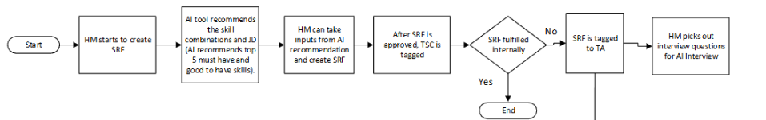

The above flow indicates a Real-time integration of AI module to the user-interface, for AI-driven skill recommendations and setup Assessment questions for the SRF, which is not possible in ORC.

Based on Discussion on 23rd June 2025 -

Module A – Job Description/SRF Creation:

* SRF creation to be done wholly on the new HA Platform with AI features.

All User actions, related to flows will be verified and tracked with timestamps; which can be used for audits latter on.

After setting up the SRF, Hiring Manager (HM) will then be able to either

* 'Cancel’ it, if required.

Or

* mark it as ‘Fulfilled Internally’ and ‘Closed’.

Or

* ‘Tagged to TA’ for further actions.

HM / User, can view all SRFs created by them – edit their status to previous stage or next stage based on their requirements.

Like New -> pending Approval -> Approved -> tagged-to-TA/TSC -> ... etc.

 After SRF has passed the Approved state;

HM adds/selects Question-set for AI Interview from AI-generated/user input List for specific Job-Role requirement.

**Flow continues with SRF ‘Tagged to TA’:**

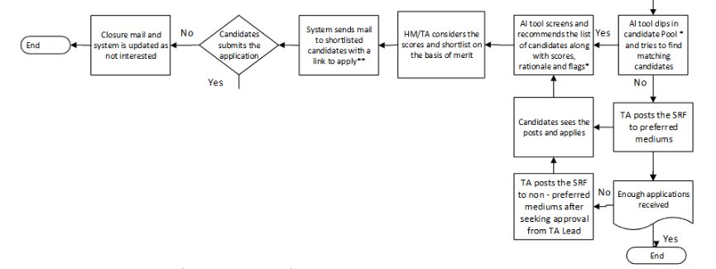

For each SRF tagged to TA:

* User can view AI-recommended candidates, from the Internal Talent Pool consisting of previously Screened candidates who are not currently tagged to any SRFs.
* HA-Platform users (TA team) can view the AI- recommended candidate list and tag them to this SRF individually or as a whole, and mark them as ‘Ready for Scoring’.
* TA team can choose to publish the SRF to identified channels to allow candidates to apply directly on Zensar-Careers or via 3rd party channels.
* This recommended candidate list will grow, as newer candidates apply or are sourced from 3rd party to the system.
* TA team can decide to close the SRF to new application, once they are satisfied with the number of candidate applications tagged for the SRF. This will mark the SRF as ‘Shortlisting in progress / Closed to new application’.
* TA team can decide to Score the list of candidates tagged to an SRF, before or after closing the SRF for new candidate applications and view/download and action on the Scored list of candidates.
* TA team can select individual scored candidates (or multiple) and mark them as
  + Either ‘Shortlisted’.
  + Or ‘Not-Taken-Forward’.
* On being shortlisted, system will trigger email notifications to candidate to ‘Apply’ within a specific date-range.
* If Candidate applies within the date-range, then the process moves forward, and the Candidate is locked with ‘Application in progress’ status for the tagged SRF.
* If no apply is registered for the date range; system will mark the candidate as ‘Not-interested’ for the tagged SRF.

Internal Talent pool –

* All candidates will be screened at the point of inception.
* If candidate sourced directly or via 3rd party, for an SRF, they will be tagged to that SRF in the Talent Pool.
* If candidate who registers or sourced for talent pool then they will not be tagged to any SRF at inception.
* Any Candidates who have previous applied or sourced into Zensar will be part of the Talent Pool.
* If Candidate directly applied for a SRF from Zensar-Careers or Zensar-Internal or 3rd party will be auto-tagged for the SRF with status ‘Ready for Scoring’.
* One candidate can only be tagged to One SRF with ‘Application in progress’ or ‘Ready for Scoring’ status at a time.
* If Candidate is already tagged to an Open SRF with status set to ‘Application in progress’ or ‘Ready for Scoring’, then he will be excluded from recommendations for any other SRF until:
  + The previous SRF is Closed.
  + The candidate is ‘not-selected’ and so untagged from the SRF.

*This Talent Pool is feasible to be built independently on HA platform. Not sure if something similar already exists on ORC.

**Flow continues with Candidates who are interested and ‘Applied’:**

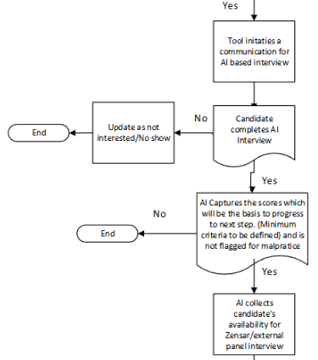

Once Shortlisted candidate responds to email notification ‘Apply’ Link.

* They will be taken to the Candidate portal to verify/update contact details.
* Generate/update password for logging into the portal.
* Mark Candidate as ‘Assessment in progress’.
* Prompt Candidate to take the ‘AI Assessment’ test within the specific date-range.
* If candidate misses the deadline, then mark candidate as ‘No Show’.
* If candidate completes the AI assessment, check if they meet Assessment minimum criteria:
  + If No; mark candidate as ‘Assessed Rejected’.
  + If Yes;
    - mark candidate as ‘Assessed Proceed’.
    - Collect candidate details for Panel Interview.
      * Email-ID for interview invite (outlook/external)
      * Availability-slot for interview – date/time.
    - Mark candidate as ‘Ready for Panel Interview’.
    - Trigger a notification the HA and COE to assign Interview panel for selected availability slots.
    - Allow for ‘Reschedule Availability-slot’, if trigger email notification to candidate, HM and COE if reschedule requested.

System will add the assessment details to the candidate score view, available to be viewed/downloaded by the TA team.

*This is feasible to be built independently on HA platform. Not sure if something similar already exists on ORC.

**Flow continues with Candidate ‘Ready for Panel Interview’:**

HM and TA users can see the list of candidates tagged to the SRF, with their current status.

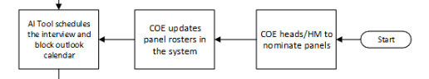

* HM and COE will have an email notification to nominate/assign interview panellist for the candidate for the selected interview slots.
* TA team can initiate reminder-emails to HA and COE, if this is not actioned.
* Once panel availability and the outlook email IDs is updated, system will create a meeting invite and send it out to the Panel, Candidate, with HM/HR in cc.
* Mark Candidate as ‘Interview Scheduled’
* If candidate initiates a reschedule from the portal – send notification to the HM, COE to update available slots and panellists. Mark the candidate as ‘Reschedule requested’.
* If candidate No-Show/Un-responsive to meeting invite, HM/TA team can mark the candidate as No-Show or Reschedule requested.

*This is feasible to be built independently on HA platform. Not sure if something similar already exists on ORC.

**Flow continues after Candidate marked as Interview Scheduled:**

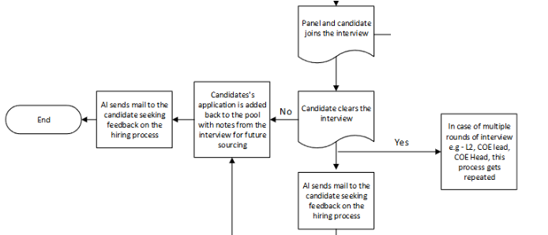

After Interview is conducted, Panellist/HM can mark the Candidate as ‘L1 Selected’ or ‘L1 rejected’ on the portal.

If rejected, trigger email to candidate informing of the status and letting them know that their profile will be stored in the Talent pool for any future requirements.

If ‘L1 Selected’,

* HM can select options to initiate additional interview rounds (L2/L3/HR etc)
* Once initiated, system will follow the standard process to
  + Mark candidate as ‘L2/L3 Initiated’
  + Send email to candidate to select preferred interview slots
  + Trigger email to HM, COE to update panel details
  + Setup and trigger interview invite emails to candidate, HM, HR, COE, panel etc.
  + Update candidate status to ‘L2/L3 interview scheduled’.
* If candidate No-Show/reschedule requested, HM can update the candidate status appropriately.

After each round of L2/L3/HR interviews conducted;

* the candidate can be marked as either ‘Rejected’ which will trigger the email to candidate informing of the status and letting them know that their profile will be stored in the Talent pool for any future requirements.
* If Selected, Move to the next stage in the interview or ahead in the flow after successful HR rounds.

After Selected, the candidate will remain parked in this status – until HM, TA team etc are finished assessing all candidates lined up and manually mark the candidate as ‘Selected for BGV’.

**Flow continues after candidate status changes to ‘Selected for BGV’:**

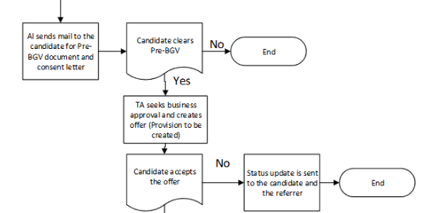

Once HM marks candidate as ‘Selected for BGV’, email notifications are sent to candidate to complete the BGV process.

* If No-response from candidate or if BGV fails, HM/System can mark the candidate as ‘Not Interested’ / ‘BGV failed’ on the system which will trigger email notification to candidate and put his profile back into the Talent pool.
* Once candidate completes the BGV pre-requisites, status will update to ‘BGV in-progress’, which will initiate the BGV process until HM marks and approves the candidate on the portal as ‘BGV Passed’.

This will send email notification to respective teams to generate Offer.

Once offer generated, send email notification to candidate with the Offer and link to ‘Accept’/’Reject’ offer.

* If candidate rejects offer, send notification to HM, Candidate and relevant teams and mark status to ‘Offer rejected’.
  + HM will have the option to ‘re-initiate Offer’, to send new offer.
  + or ‘Rescind Offer’ to reject candidate and send him back to talent pool.
* If candidate accepts the offer;
  + send notification to HM, Candidate and relevant teams
  + mark candidate status as ‘Onboarding in progress’.

HM can mark the SRF as ‘Fulfilled and closed’, which will –

* update all candidates tagged to the SRF, to ‘Requirement closed’ status, which will move them back into the talent pool.