🛒 Purchase Intent Scorer — Dashboard Workflow
How a browsing session becomes a live buy/no-buy recommendation
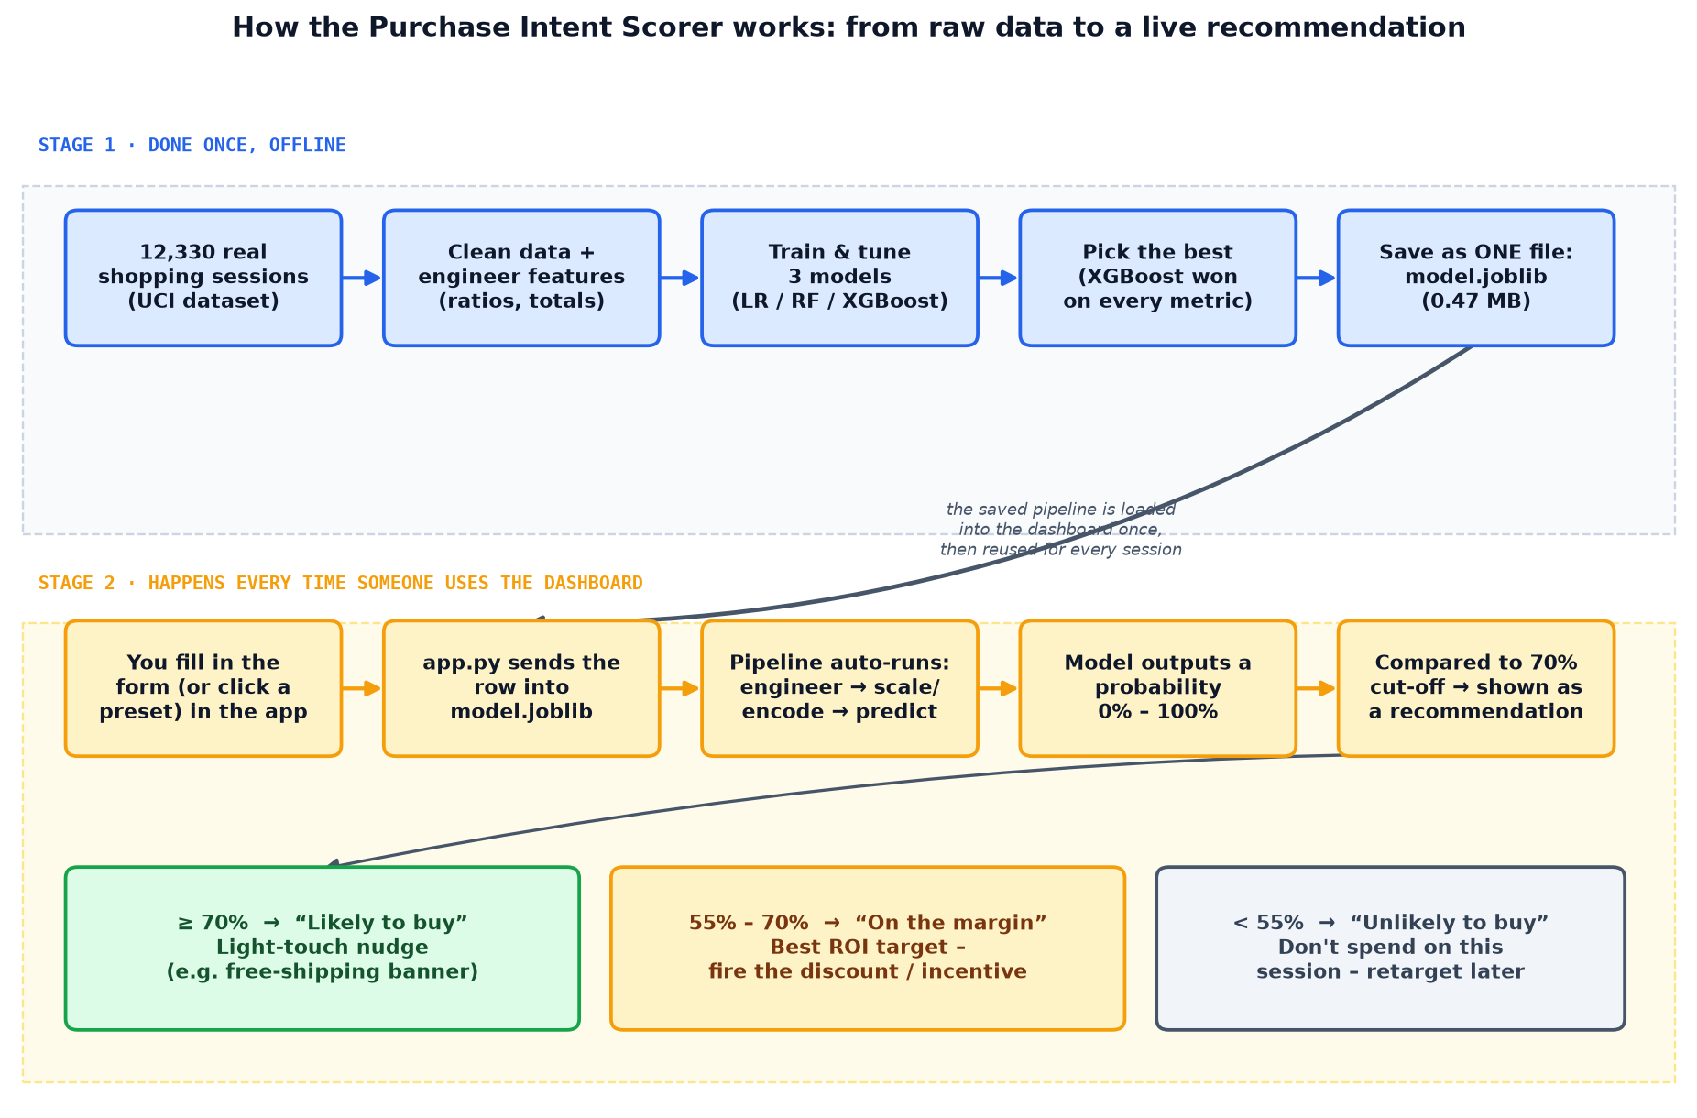
Stage 1 (top) runs once, offline, to produce model.joblib. Stage 2 (bottom) runs every time a session is scored in the live app.

