Dear Microsoft Quantum (Sydney) Team,

Based on our discussions, please find below an offer for two Solutions Lab modules.

1. Image denoising module

2. Guided acquisition (center line detection and navigation)

The total price for the two modules is 15,000 Euros.

Please don’t hesitate to contact us in case of any questions.

Best Regards,

Manoj Mathew

# Offer for custom solutions

**Overview**

Microsoft Quantum, Australia acquires Light Microscopy (LM) images to inspect and detect breakage points in semiconductor wafers. Their interest also lies in guided acquisition to automatically detect and navigate to the center line feature in the wafer image as well as in image denoising.

**Description of Software Modules:**

**Software Module 1 [Image Denoising]**

Image Denoising module is an advanced image processing cum machine learning module that removes the tiny blue background speckles from the wafer images resulting in cleaner-looking wafer images. It encapsulates custom machine learning based denoising algorithm followed by processing and segmentation. The segmentation mask is then used to extract the object of interest and mask out the blue speckles. A pictorial representation of the proposed workflow is depicted below.

Cleaner Output Image

Input Image

**Software Module 2 [Guided Acquisition (center line detection and navigation)]**

The Guided Acquisition Module is utilized to detect the center line feature in the wafer images and navigate the system to the detected feature in the image. High resolution images of the detected feature can then be acquired by the software for further processing and analysis. A typical guided acquisition workflow is shown below.

System automatically moves to the detected feature, acquire, and analyze high resolution image at detected feature

**Pricing Information**

Estimated delivery time is 4 months from the placement of the purchase order:

|  |  |  |  |  |  |
| --- | --- | --- | --- | --- | --- |
| Sl. No: | Description | Catalog Number | Unit Price (Euro) | Unit Nos | Total Price (Euros) |
| 1 | Image Denoising | 410190-0105-005 | 5000 | 1 | **5000** |
| 2 | Guided Acquisition (center line detection and navigation) | 410190-0105-010 | 10000 | 1 | **10000** |
|  | Total |  |  |  | **15000** |

This offer is valid until the xxxxx.

We hope this offer corresponds to your requirements.

Carl Zeiss Microscopy GmbH

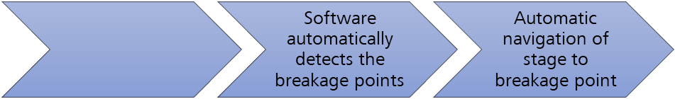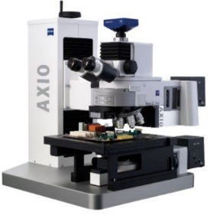

Acquire overview image

System automatically moves to the breakage point, acquire and analyze high resolution image at the breakage point