Dear Dr. Esther Koh, Advanced Imaging Laboratory (AIL), National University of Singapore,

Please find below an offer for a Multichannel Combination Viewer and Image Export Solutions Lab module in ZEN Blue.

The total price for the module is 1,600 Euros.

Please don’t hesitate to contact us in case of any questions.

Best Regards,

Dr. Manoj Mathew

# Offer for custom solutions

**Overview**

Advanced Imaging Laboratory (AIL), National University of Singapore acquires Light Microscopy (LM) images and visualizes them in ZEN Blue. They aim to replicate the AxioVision software functionality of displaying multiple channel combinations of an input image. Their interest also lies in exporting the desired channel combinations from ZEN Blue.

**Description of Software Modules:**

**Software Module [Multichannel Combination Viewer and Image Export]**

The Multichannel Combination Viewer and Image Export module enables the user to input a multichannel image and visualize different channel combination outputs on the ZEN Blue documents pane. It also facilitates the user to export the required channel combination images in the desired format to a user-defined directory.

The pictorial representation of the proposed workflow is depicted below.

**Multichannel Image Combination Viewer OAD with Export Options**

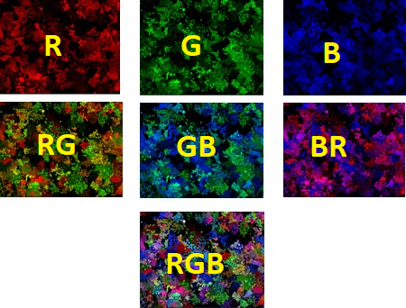

Input in ZEN Blue

Image Export Functionality

GUI to select desired channel combinations

**Pricing Information**

Estimated delivery time is 1 month from the placement of the purchase order:

|  |  |  |  |  |  |
| --- | --- | --- | --- | --- | --- |
| Sl. No: | Description | Catalog Number | Unit Price (Euro) | Unit Nos | Total Price (Euros) |
| 1 | Multichannel Combination Viewer and Image Export | 410190-0105-000 | 1 | 1 | **1,600** |
|  | Total |  |  |  | **1,600** |

This offer is valid until the xxxxx.

We hope this offer corresponds to your requirements.

Carl Zeiss Microscopy GmbH