DIANN analysis for DIA - report - created on 2026-10-23 17:43:54
Prepared with MultiScholaR; analyst: [to be completed]
2026-10-23

Sample Details
SAMPLE DETAILS
There are 8 samples in total which consists of:
• 8 biological samples with no technical replicates.
• Sample identification, conditions upon receipt and any non-compliance notes: [to be completed by the analyst]

Method Details
METHOD DETAILS
Data analyses were performed with MultiScholaR; the software version and build are listed under ‘Software and build’. SOP reference: [to be completed by the analyst].
Data import, filtering and quantification
Precursor-level identifications and quantities were imported from the DIA-NN main report (one row per precursor and run). Low-confidence peptide identifications were removed using q-value and proteotypic peptide filtering, retaining only peptides with a q-value threshold of 0.01 and only those that are proteotypic. Precursor ion intensities were then aggregated into peptide-level quantification values, combining all charge states of the same peptide sequence while keeping different modified peptides (peptidoforms) as separate entries. The peptide quantities were arranged as a peptide-by-sample matrix and log2 transformed (values at or below zero treated as missing); one protein accession was chosen per protein group from the FASTA metadata and duplicate peptides of a resolved group were aggregated.
Protein-level quantification was performed with the limpa package’s Detection Probability Curve method, DPC-Quant (Li et al., 2025), on the ‘limpa’ engine (version 1.4.2). Unlike roll-up approaches that first aggregate peptides to proteins and then impute missing values, DPC-Quant quantifies proteins and handles missing values in one statistical model: a detection probability curve fitted on the peptide matrix (fitted intercept 0.264, slope 0.012: nearly random missing) relates peptide intensity to the probability of detection, and maximum posterior estimates with standard errors are returned for every protein in every sample. Proteins were required to have at least 1 unique peptide(s) and 2 peptidoform(s) to be considered for further analysis. No protein-level missing-value filter applies: the quantified matrix is complete. No between-sample normalisation was applied to the quantified log2 matrix (the limpa workflow’s default).
To account for unwanted variation, RUV-III (Molania et al., 2019) was fitted on the quantified protein matrix using a set of endogenous negative control proteins chosen by a negative-control sweep (4% of proteins, 100 controls; replicate structure: group). The 1 estimated factor(s) of unwanted variation (W) were appended to the design as covariates of the differential abundance model; the protein matrix itself was not corrected (the RUV-adjusted matrix is used for quality-control plots only).
At each stage, the samples were checked for batch effects using principal component analysis (PCA) plots, density boxplots, relative log-expression (RLE) plots and the distribution of the Pearson correlation between replicate samples within groups; samples whose correlation with their group fell below the configured threshold were removed.
Test conditions, deviations from the method and critical reagent details: [to be completed by the analyst].

Results
Quality Control
Figure 1 shows four quality-control views at three stages of processing: after log2 transformation (left column: panels a, d, g, j), after between-sample normalisation (centre column: b, e, h, k) and for the RUV-III-adjusted matrix (drawn for quality control only; the differential abundance model carried the RUV-III factors as covariates) (right column: c, f, i, l).
• Principal component analysis (panels a-c): samples plotted on the first two principal components, coloured by experimental group.
• Density plots (panels d-f): the distribution of protein intensities per sample.
• Relative log expression (panels g-i): per-sample deviations from the protein-wise median.
• Pearson correlation (panels j-l): the distribution of between-sample correlations within groups.
Whether technical variation was reduced and biological signal retained is assessed from these panels by the analyst; this report draws no automated conclusion from them.

Differential Abundance Analysis
DIFFERENTIAL ABUNDANCE ANALYSIS
Differential abundance analysis of proteins was performed on the DPC-quantified protein abundances for the comparisons defined in the contrast table. The limpa R package’s ‘dpcDE’ function (Li et al., 2025) fitted a linear model using the formula ‘~ 0 + group + W1’, weighting each observation by the uncertainty of its DPC-Quant estimate (imputed values down-weighted), with the ‘limma’ R package (Ritchie et al., 2015) underneath. The 1 RUV-III factor(s) of unwanted variation (W) entered the model as covariates. Contrasts were applied with ‘contrasts.fit’ and p-values were calculated using the ‘eBayes’ function. A trended and robust empirical Bayes analysis was performed. The false discovery rate correction was applied to the moderated p-values by calculating the q-values (Storey, 2002). No log-fold-change threshold (TREAT) applies on this model. Significant differentially expressed proteins were defined as those with q-values less than 0.05.
Volcano plots of differentially expressed proteins across all groups are shown in Figure 2, with a threshold of q-value < 0.05 and no log fold-change threshold. Full details of all proteins are provided in the supplementary results table DA_results_proteomics.xlsx within the Publication_tables folder.
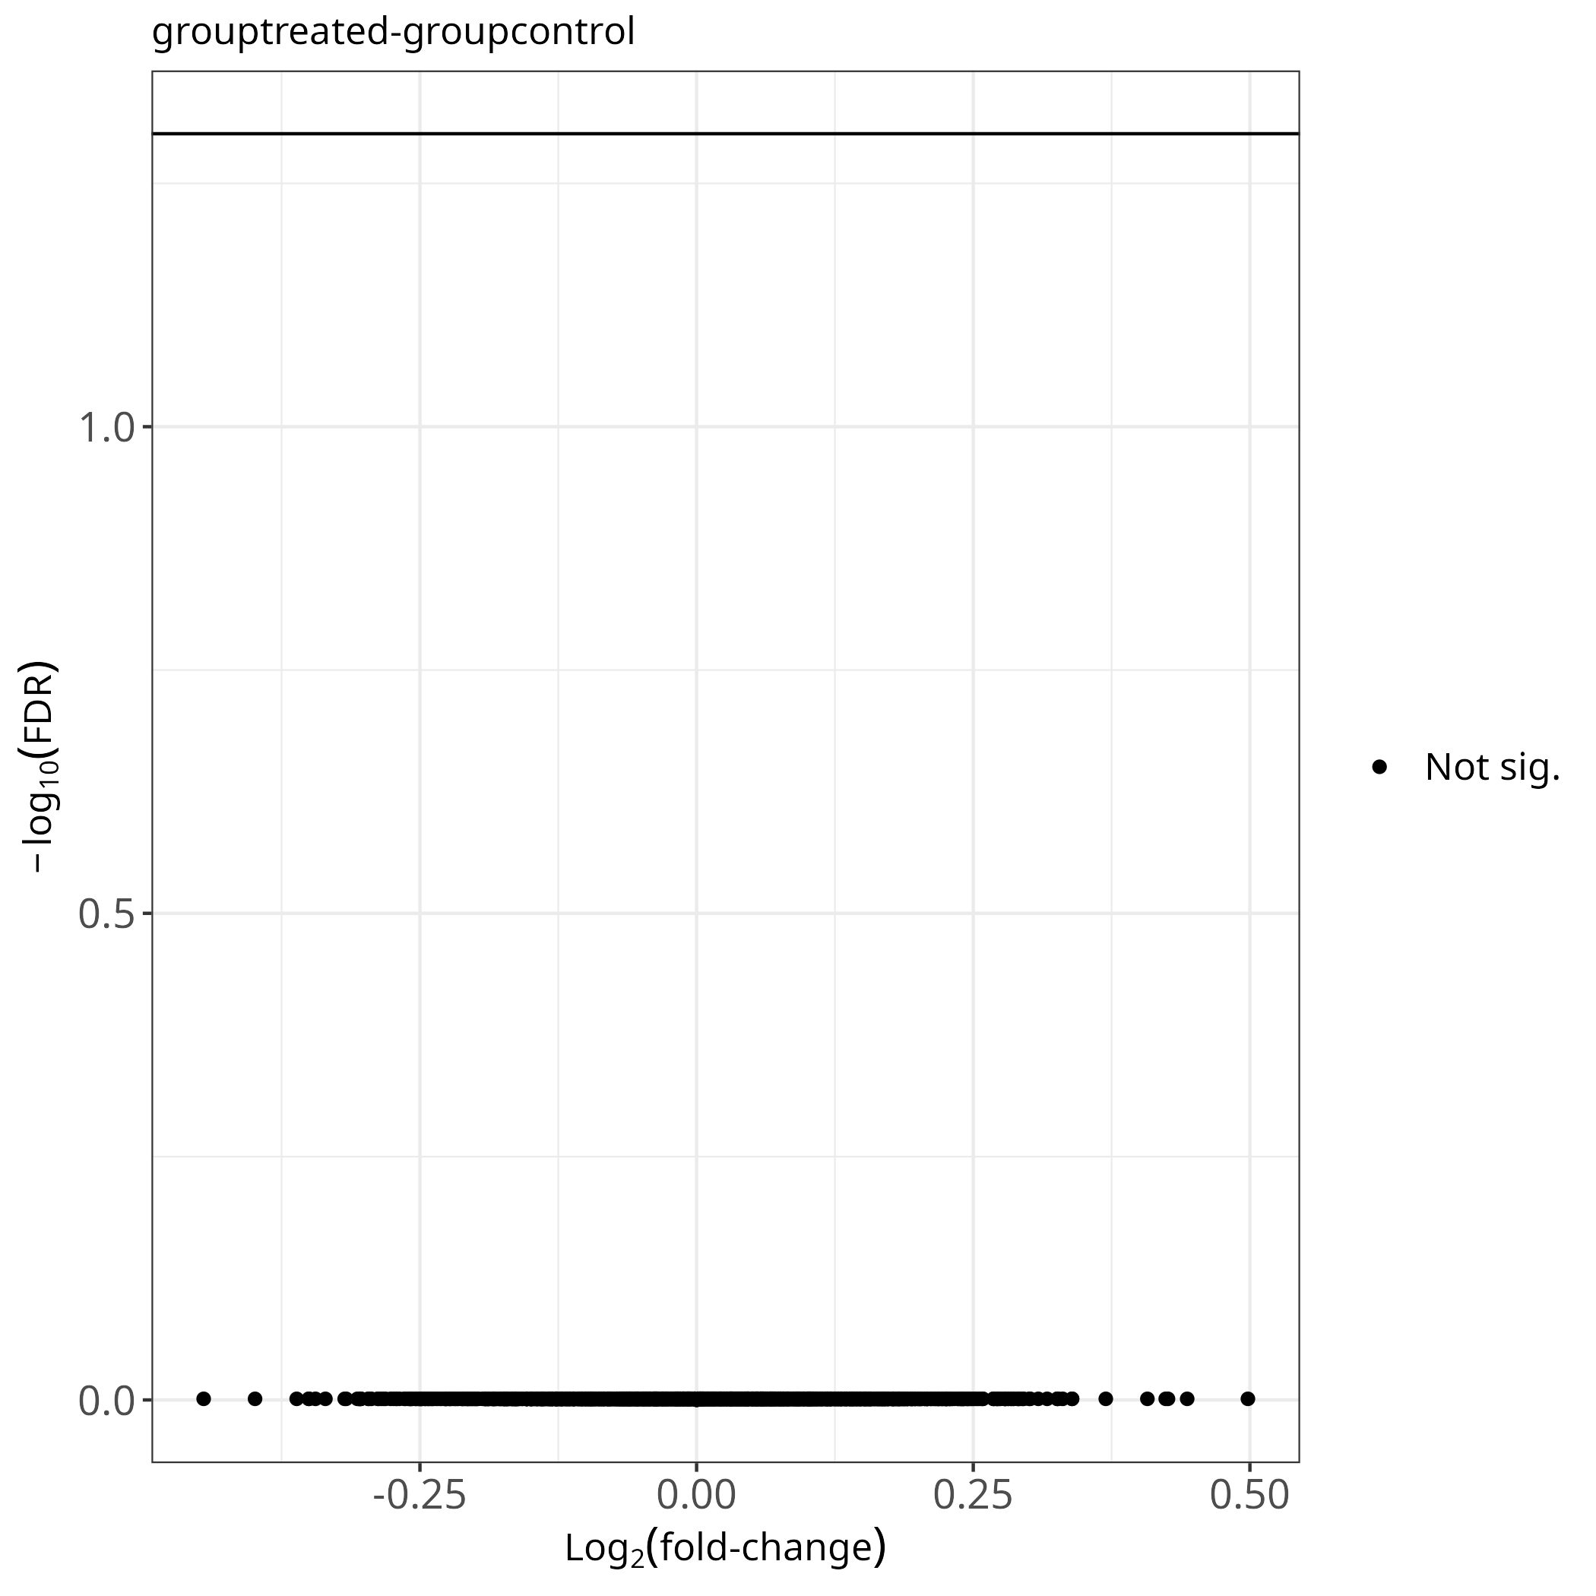
Figure 2: Volcano plots of differentially expressed proteins one per comparison.

Analyst interpretation
ANALYST INTERPRETATION
[To be completed by the analyst: quality-control assessment from Figure 1, technical performance, limitations of this dataset, and recommendations for downstream analysis. Nothing in this section is generated automatically.]

GO Enrichment Analysis
No enrichment analysis was run for this project.

Software and build
MultiScholaR version: 0.5.0
Source commit: 81a69944b832d2aed460a96ad381dd5b1ff4dc25
Build: fc6d8f66a7104c5bfe2ddd469c748c87c3368a6f9800919ea8d0f1a962fcff83
R: R version 4.6.1 (2026-06-24)
BLAS: /usr/lib/libblas.so.3.12.0

