**CHATBOT DEPLOYMENT WITH IBM CLOUD**

**WATSON ASSISTANT**

**PHASE-3**

**In this phase, we will begin developing a chatbot using IBM Watson Assistant. IBM Watson Assistant is a sophisticated cloud-based platform for building conversational AI solutions. It leverages three fundamental components to create and train chatbots or virtual assistants.**

**Description:**

**Entities categorize information, aiding data extraction, while intents define user purposes, enabling contextually relevant conversations. Dialogs control the chatbot's responses, using nodes to guide users based on identified intents and entities.**

**The steps involved in deploying a chatbot using IBM Watson Assistant:**

1. **Firstly, Sign in to your IBM account and navigate to the IBM Cloud Catalog and use the catalog's search function to find "Watson Assistant," then select it.**

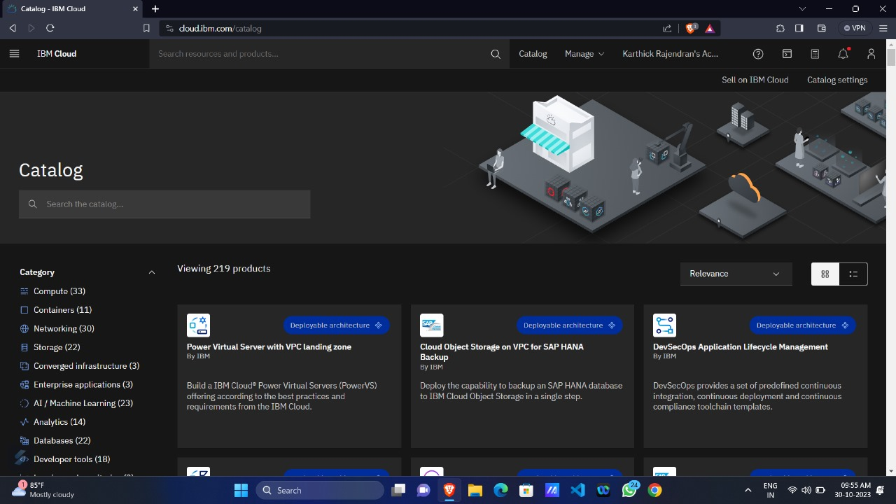

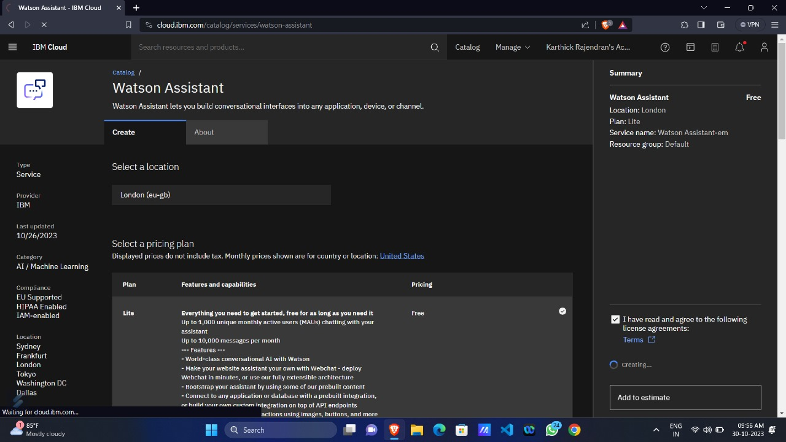**2.Instantiate a fresh Watson Assistant instance, specifying the preferred location and plan, such as “Lite.”**

**3.Log into the Watson Assistant tool and initiate the creation of a new assistant, providing it with a name and an optional description.**

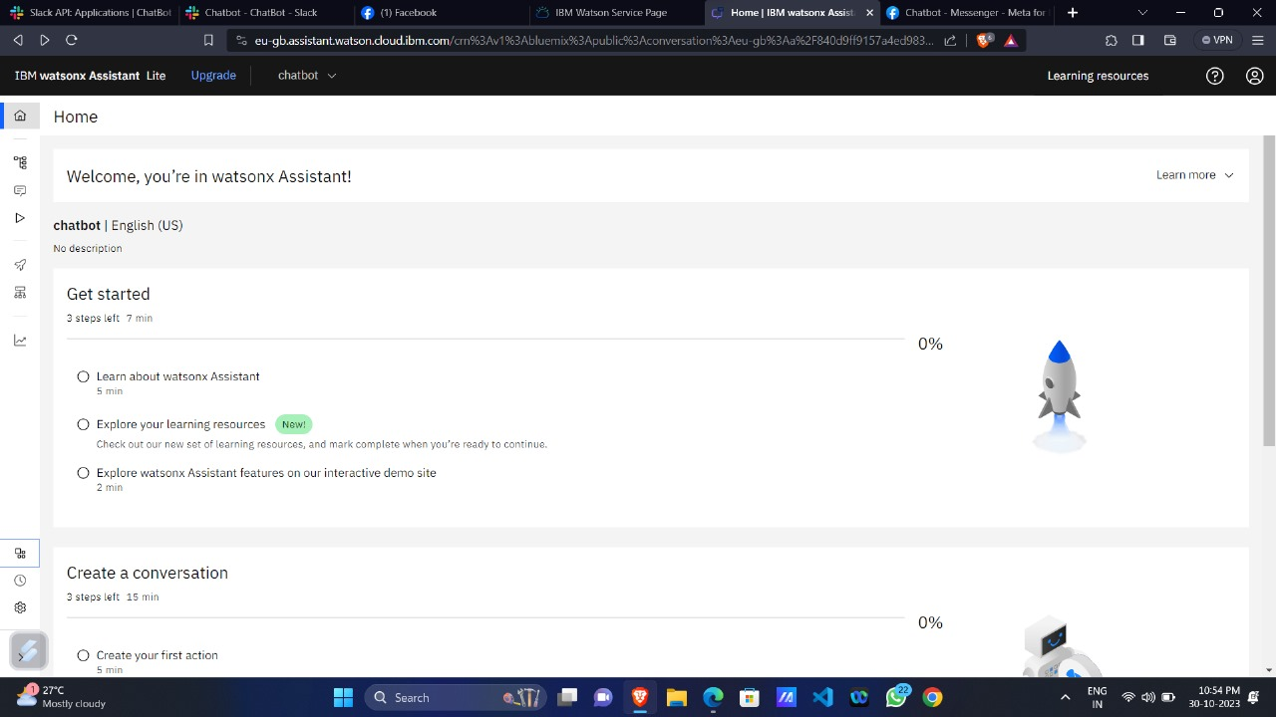

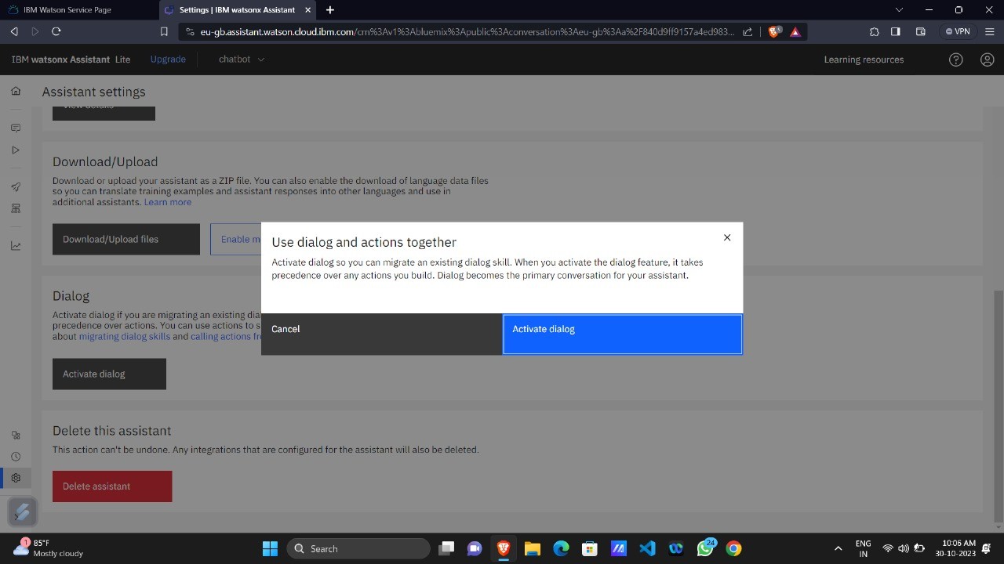**4.Initiate the process by establishing entities, defining pertinent details (like cuisine types, genres), and associating variables with them.**

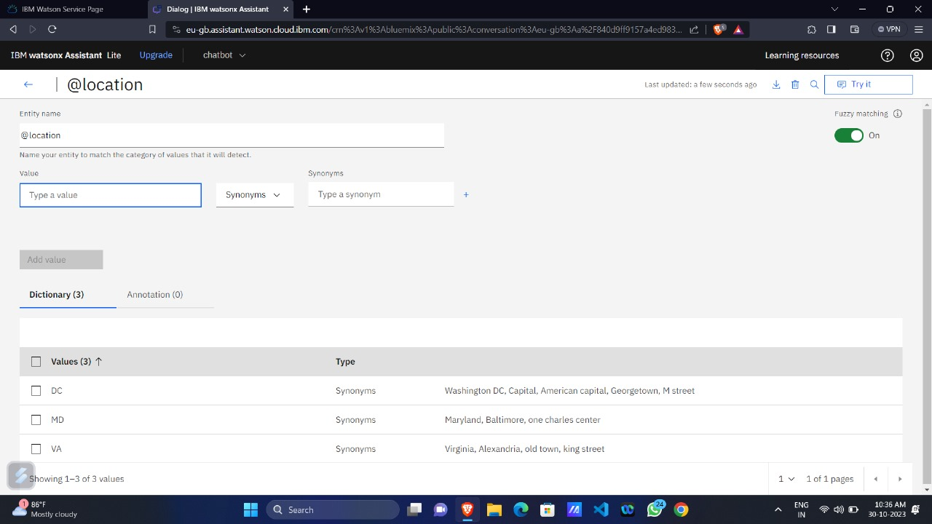

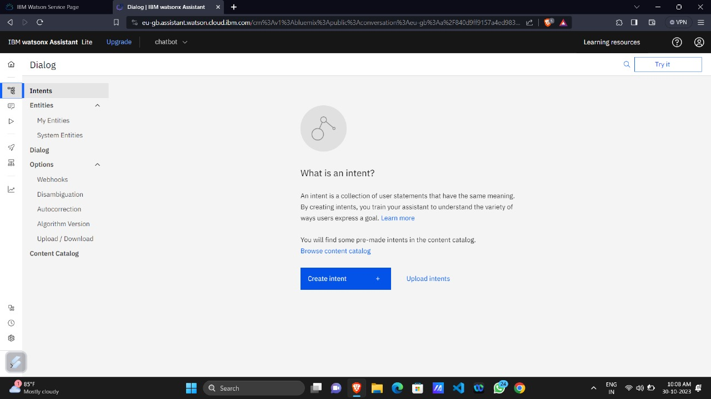**5.Construct intents to embody the diverse objectives or intentions conveyed in user messages, such as “check account balance” or “transfer funds.”**

1. **Construct a dialogue flow by generating nodes for every intent and specifying suitable responses for various user inputs.**

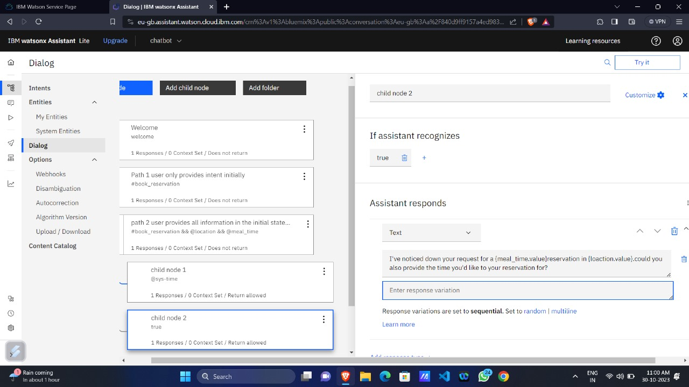

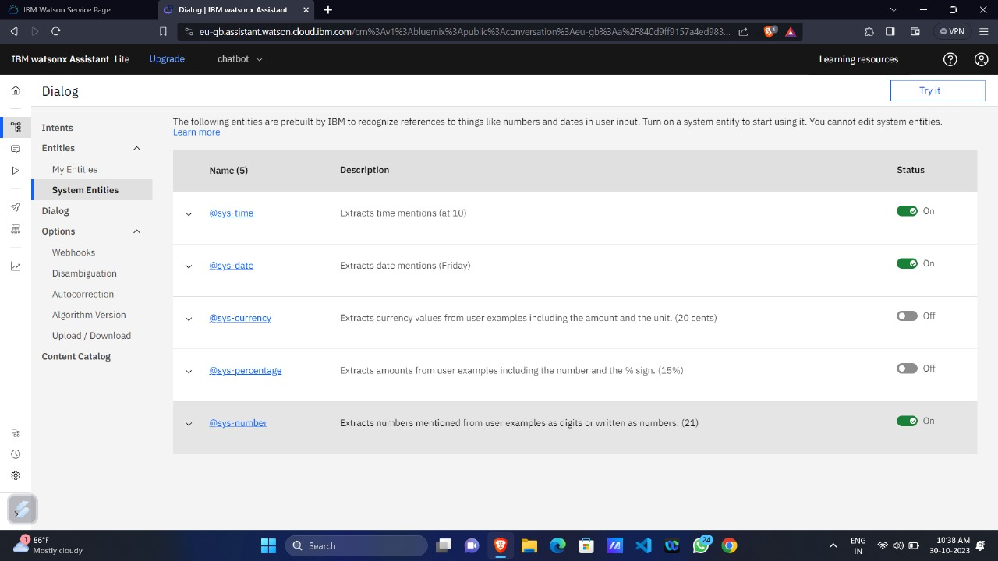

1. **Verify the chatbot’s functionality by testing it with sample queries and confirming the responses within the Watson Assistant interface.**

