**CHATBOT DEPLOYMENT WITH IBM WATSON ASSISTANT**

**PHASE - 4**

In this stage, our focus remains on the development of our project through IBM Cloud Foundry. we plan to seamlessly integrate our chatbot across multiple platforms, including Facebook Messenger and Slack. Our foremost priority is to guarantee a smooth and natural flow of conversation, accompanied by informative and precise responses from the chatbot.

**Chatbot using IBM Watson Assistant into facebook messenger:**

1. 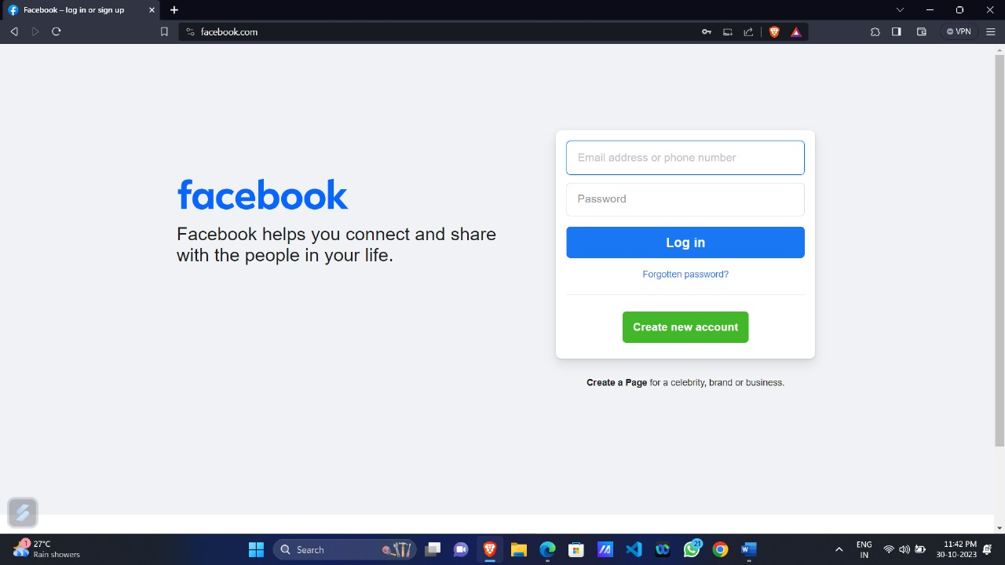Start the process by registering for a Facebook account in case you aren't already a member.
2. After that, create a Facebook page that corresponds to your chatbot

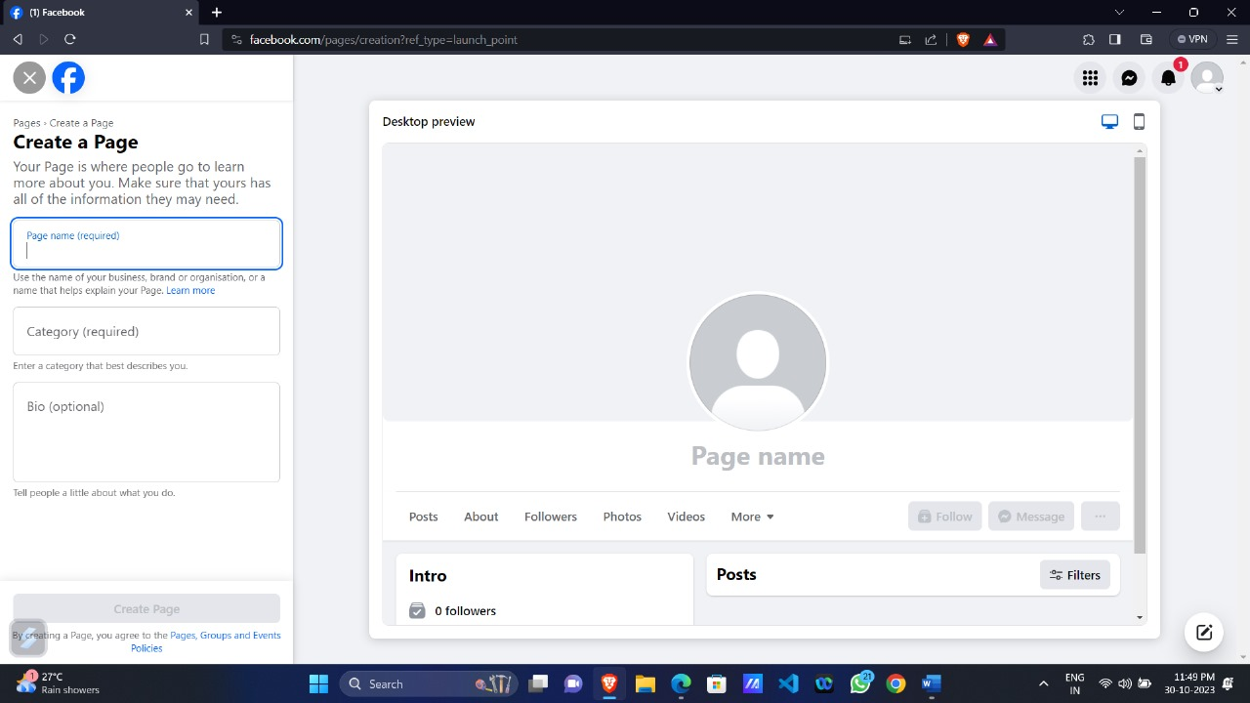

Subsequently, establish a Facebook developer account or log into an existing one if you already have one and create a Facebook app specifically for your chatbot.

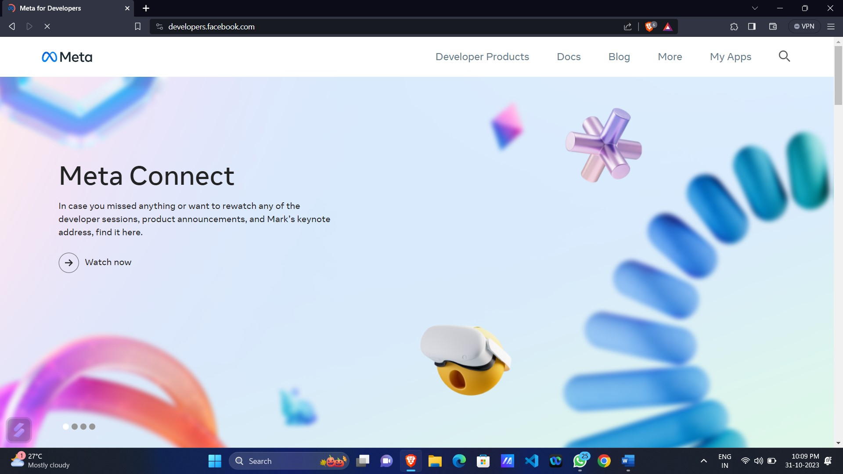

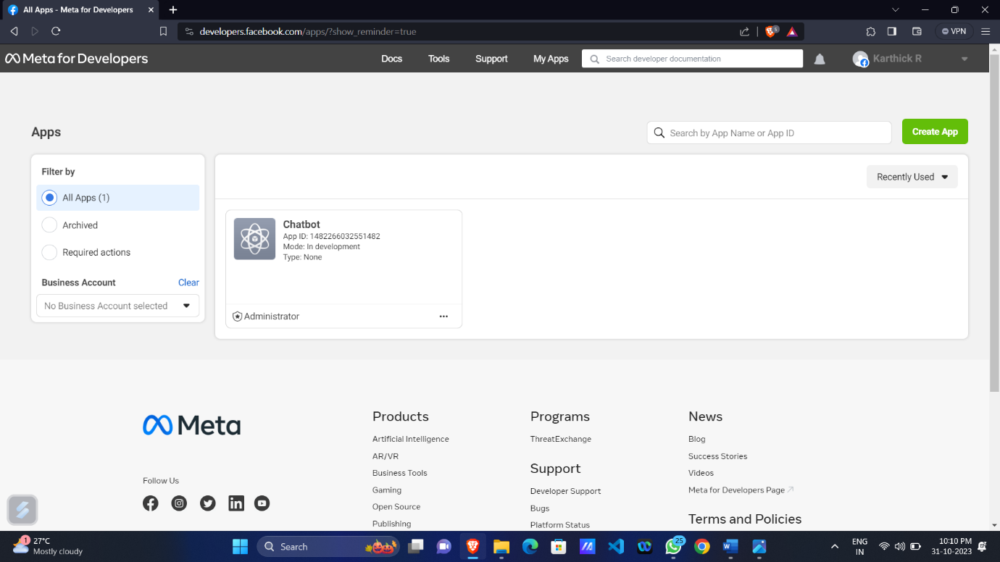

1. Link your chatbot to your Facebook page by generating a page access token. Make sure to save this token for future use.

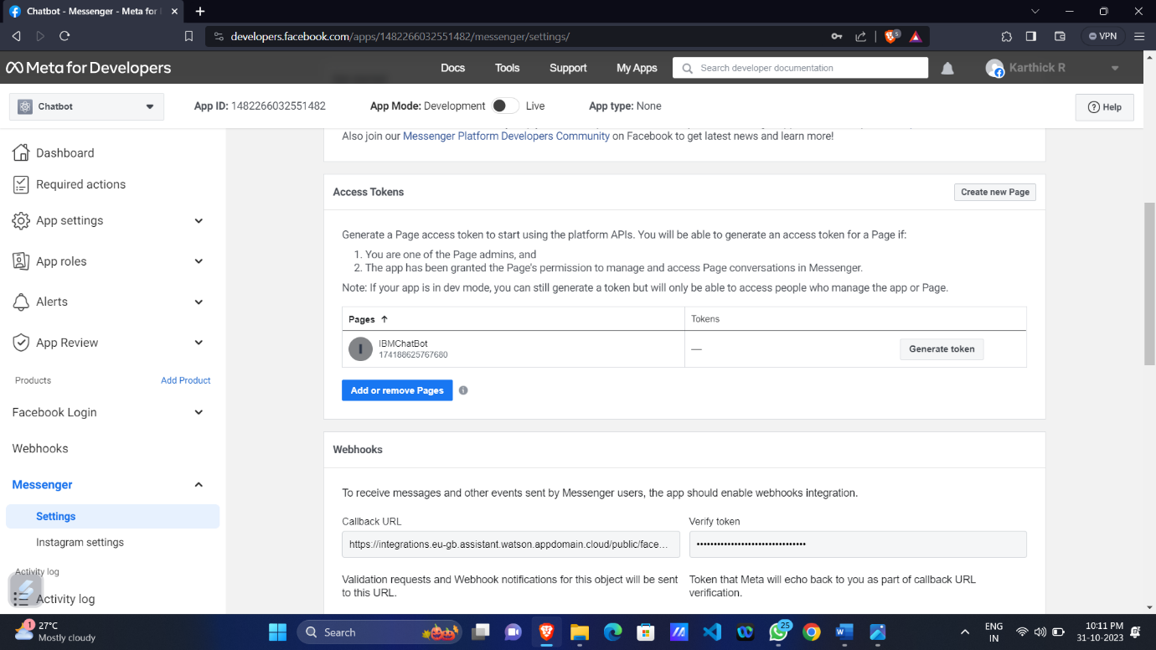

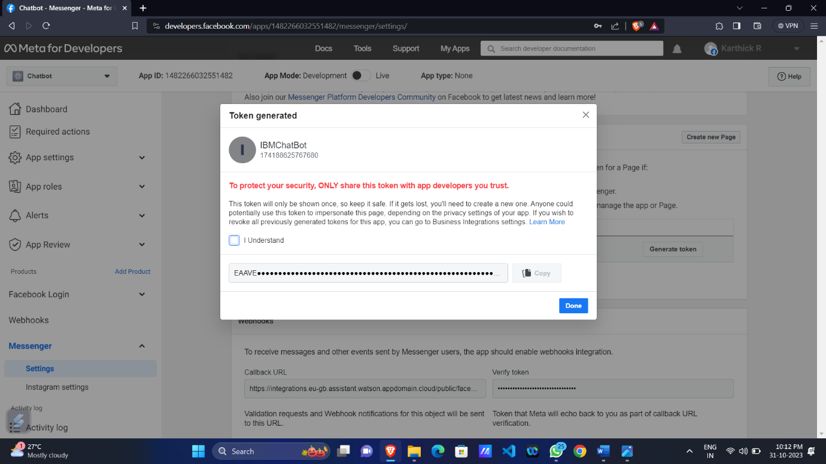

1. To get started, initiate your chatbot assistant instance and select the particular chatbot you want to link with your web page.

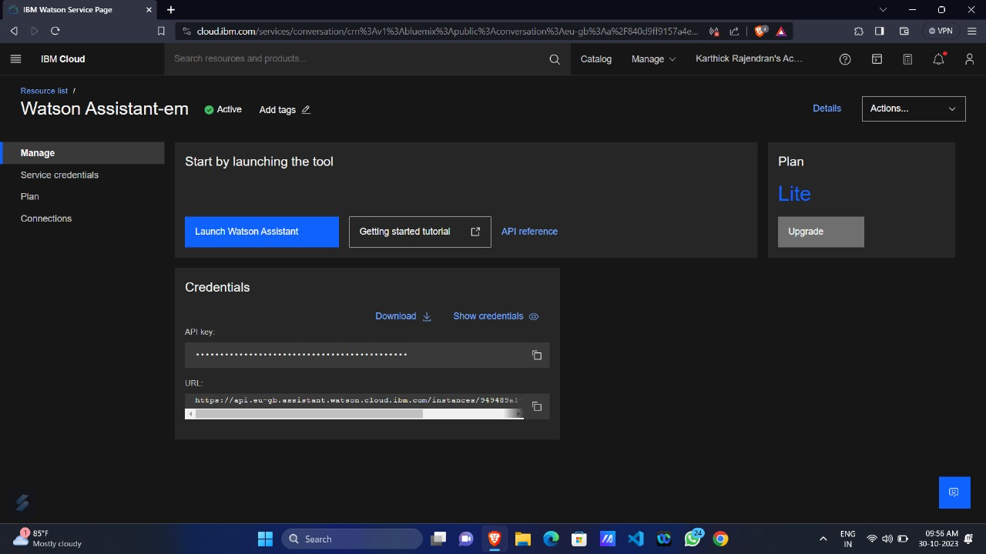

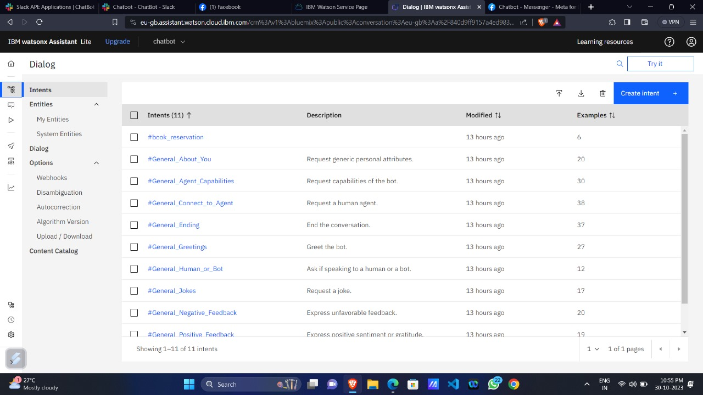

1. Incorporate the Facebook Messenger integration and input the necessary credentials. Be sure to validate the callback URL and save it accordingly.

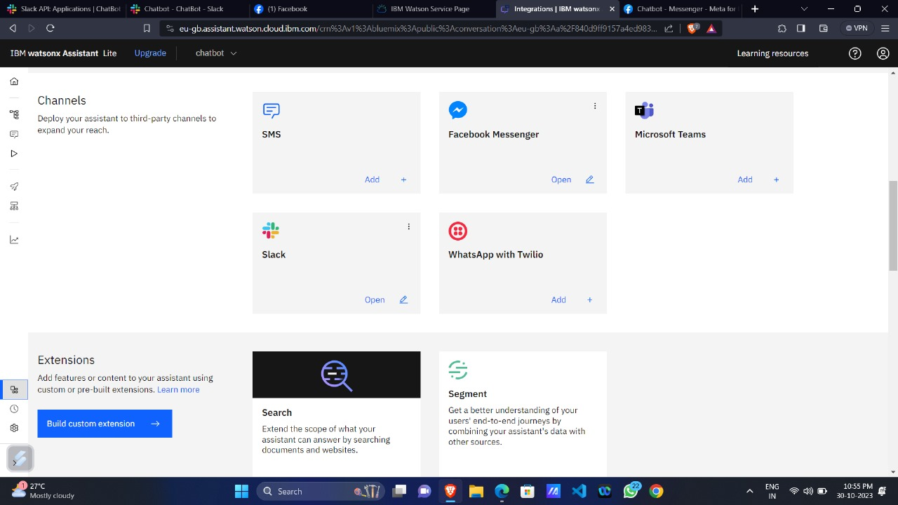

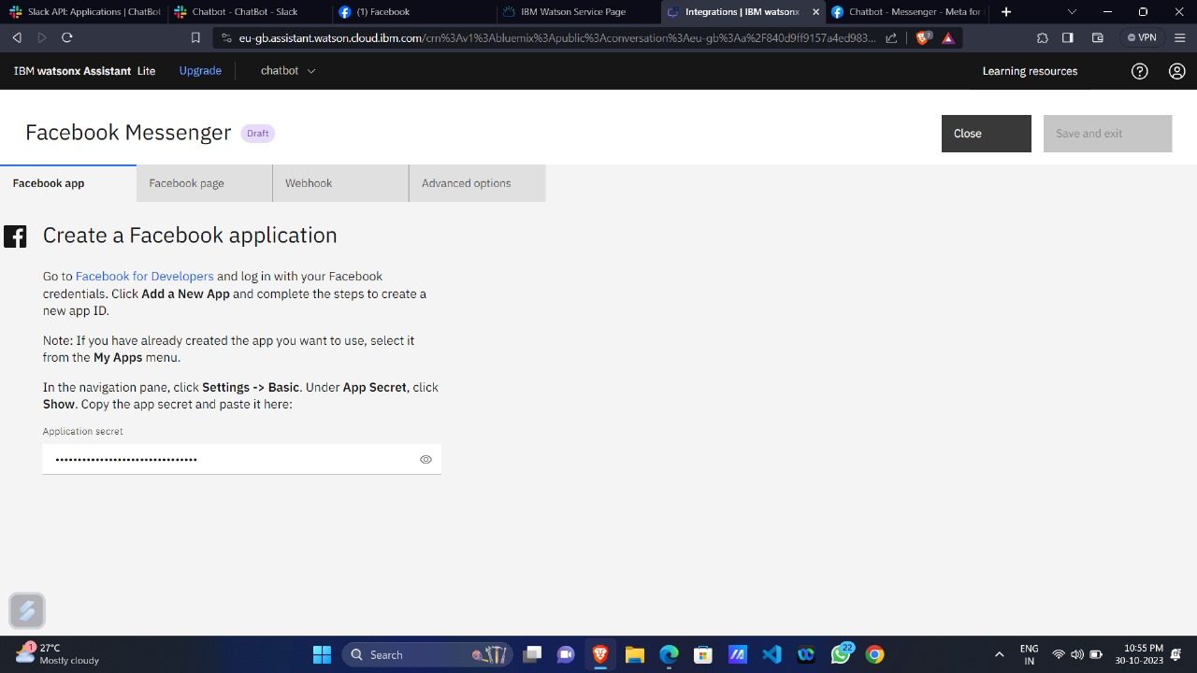

1. Furthermore, include a subscription for messages and messaging postbacks to ensure seamless communication.

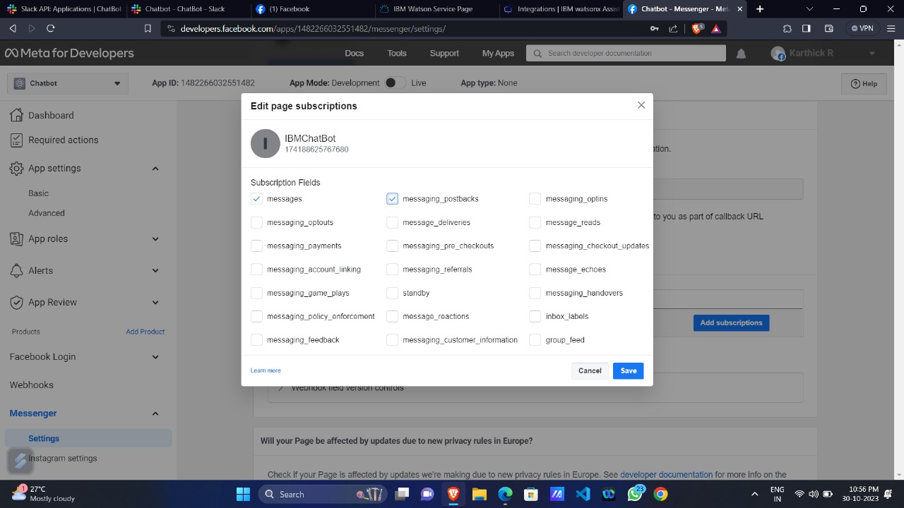

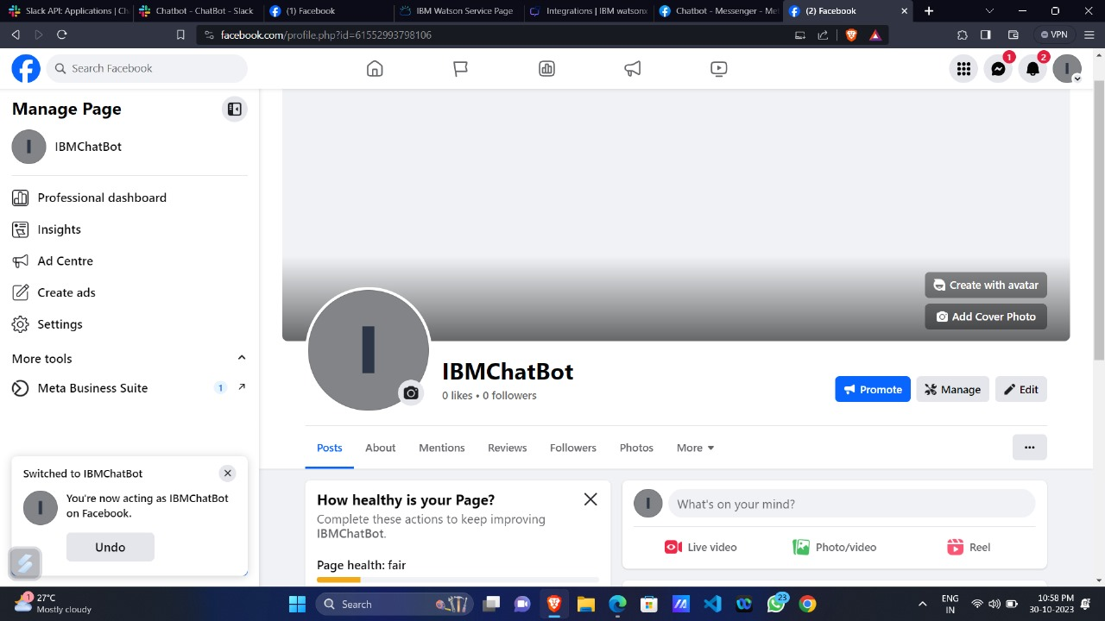

For a successful integration of the IBM Watson Assistant chatbot into Slack, Follow the step-by-step guidelines provided below:

1. If you haven't signed up for a Slack account yet, you should start by creating one and to Create a Workspace that corresponds to your chatbot.

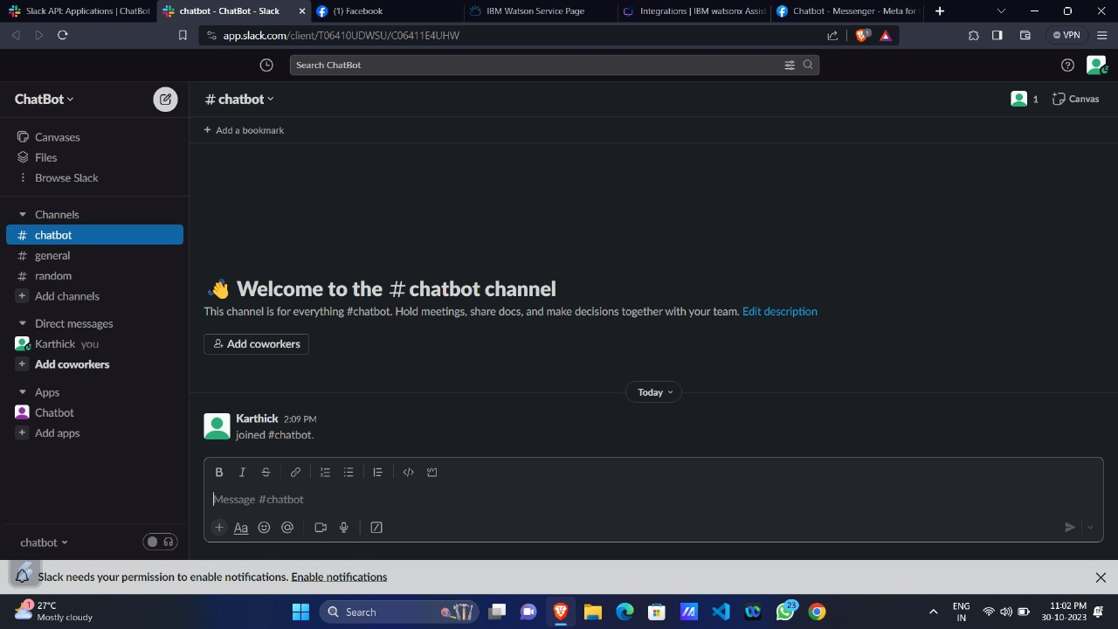

1. Next, navigate to the Slack API website and create a dedicated Slack app for your chatbot. 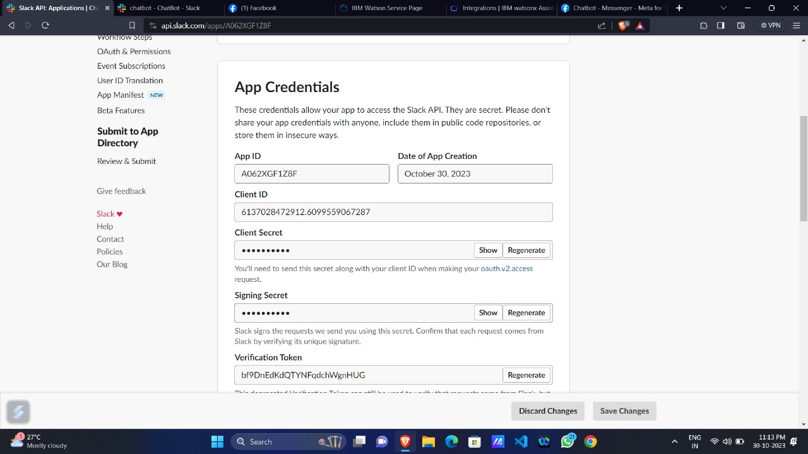

3. Locate the App Credentials section and copy your verification token

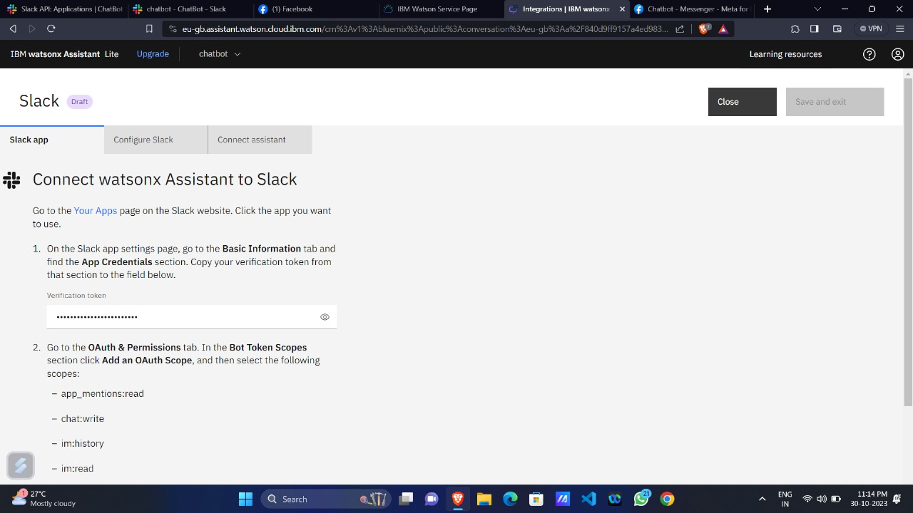

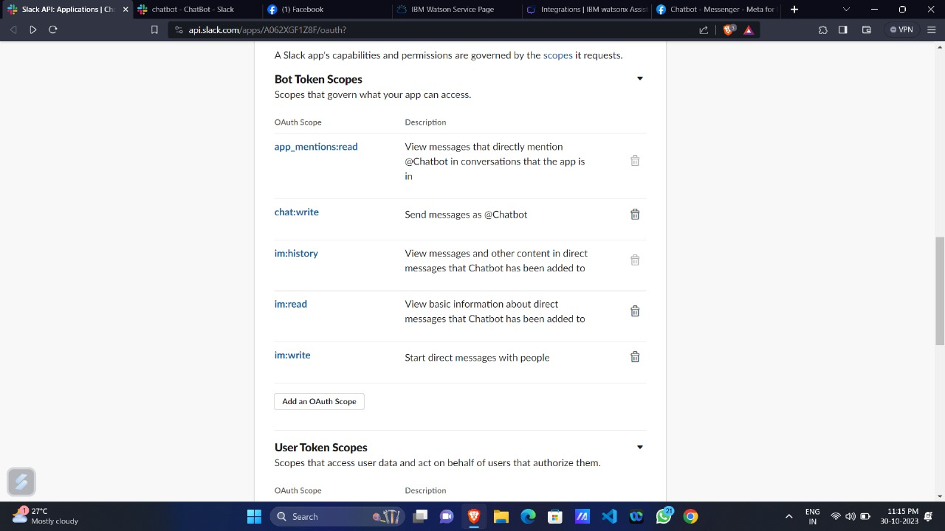4. Go to the OAuth & Permissions tab. In the Bot Token Scopes section, click on "Add an OAuth Scope,"

5. On the OAuth & Permissions tab, click "Install App to Workspace," and grant the required permissions by selecting "Allow." Once completed, you'll be redirected back to the OAuth & Permissions page, where you should copy and paste your Bot user OAuth access token.

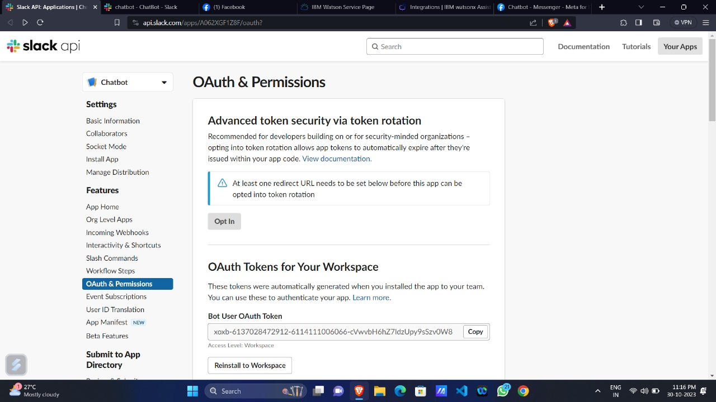

6. Go back to the Slack app settings page and navigate to the Event Subscriptions tab. Turn on the Events toggle by switching it to the "On" position. Next, paste your request URL into the provided text field.

7. While in the Event Subscriptions tab, find the "Subscribe to Bot Events" section. Click on "Add Bot User Event" and choose the specific event types you want to subscribe to.

You must select at least one of the following types:

- message.im: Monitors message events in direct message channels.

- app_mention: Monitors message events that mention your app or bot.

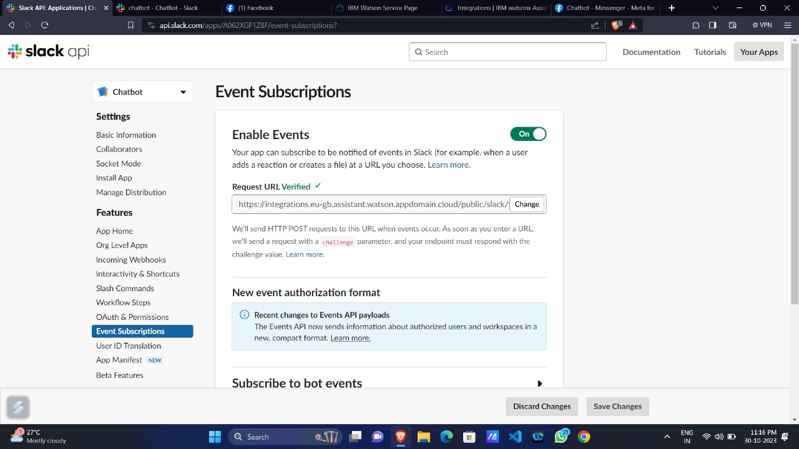

1. Go to the App Home tab, click on "Edit," and enter a display name and default username for your virtual assistant. Afterward, save your modifications and enable the "Always Show My Bot as Online" toggle.
2. In the App Home tab, find the Show Tabs section. Turn on the Messages Tab toggle and ensure that you mark the checkbox for "Allow users to send Slash commands and messages from the messages tab."

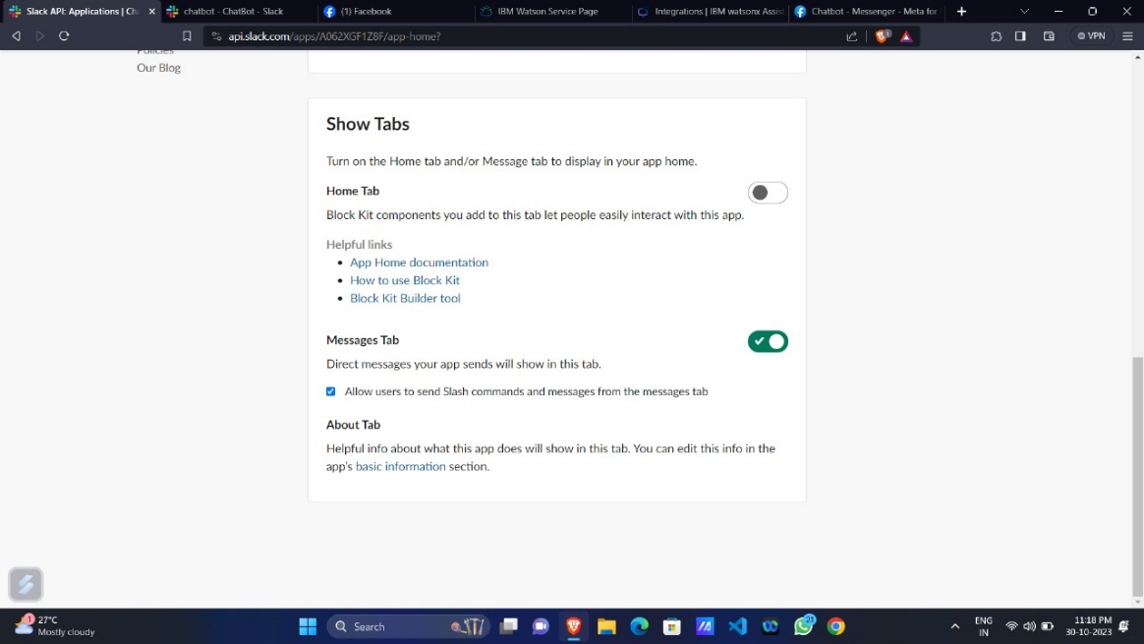

Lastly, it's crucial to conduct comprehensive testing of your chatbot application on Messenger to guarantee its smooth and trouble-free operation.