**CHATBOT DEPLOYMENT WITH IBM WATSON ASSISTANT PHASE 5**

**Problem definition using design thinking:**

**Empathize:**

To fully understand the problem, we must empathize with the users. Users need a virtual guide that provides assistance on messaging platforms. They seek helpful information, quick answers to FAQs, and a pleasant conversational experience. The objective is to institute an interactive and streamlined conversational interface capable of automating routine tasks, furnishing prompt responses, and elevating overall customer satisfaction.

**Define:**

The problem is to create a chatbot using IBM Cloud Watson Assistant that serves as a virtual guide for users on messaging platforms, offering information, addressing FAQs, and ensuring a friendly user experience.

**Ideate:**

* Create a relatable and engaging persona for the chatbot to connect with users or develop a knowledge base for the chatbot to access and retrieve information, Train the chatbot to respond effectively to common user questions and to Configure Watson Assistant for natural language understanding.
* Continuously test and improve the chatbot's user experience and integrate the chatbot with messaging platforms for seamless access. Through Monitoring and Analytics, to Implement tools for tracking and analysing user interactions and to ensure ongoing maintenance and support for the chatbot.

**Prototype:**

To Configure Watson Assistant for natural language understanding and to train the chatbot to response to FAQs and Creating a robust chatbot prototype is a practical step to visualize and test your ideas. Designing conversational flows aligned with use cases and iteratively refining the prototype based on feedback ensures a user-friendly interface and to ensure regular updates and support for the chatbot.

**Testing:**

Continuously testing the chatbot to validate its effectiveness in providing information, addressing FAQs, and delivering a friendly conversational experience and to check iterative process helps continuously improves the design.

**Implementation:**

To Execute the proposed approach step by step, until the chatbot is fully functional from the train the chatbot to response accurately, by conducting the extensive testing to optimize user experience and to train users with guides for effective interaction, by maintaining the updates and support required by the user for the chatbot and mainly to monitor the tools to analyse user interactions.

**Development Phases:**

1. **Environment Setup:** Install and configure IBM Watson Assistant, ensuring the inclusion of necessary intents, entities, and responses.

1. **Persona Design:** Define the chatbot's persona, which can be friendly, professional, or tailored to the specific use case.

1. **Conversation Flow Design:** Create a conversational tree that encompasses the branching logic for various user queries.

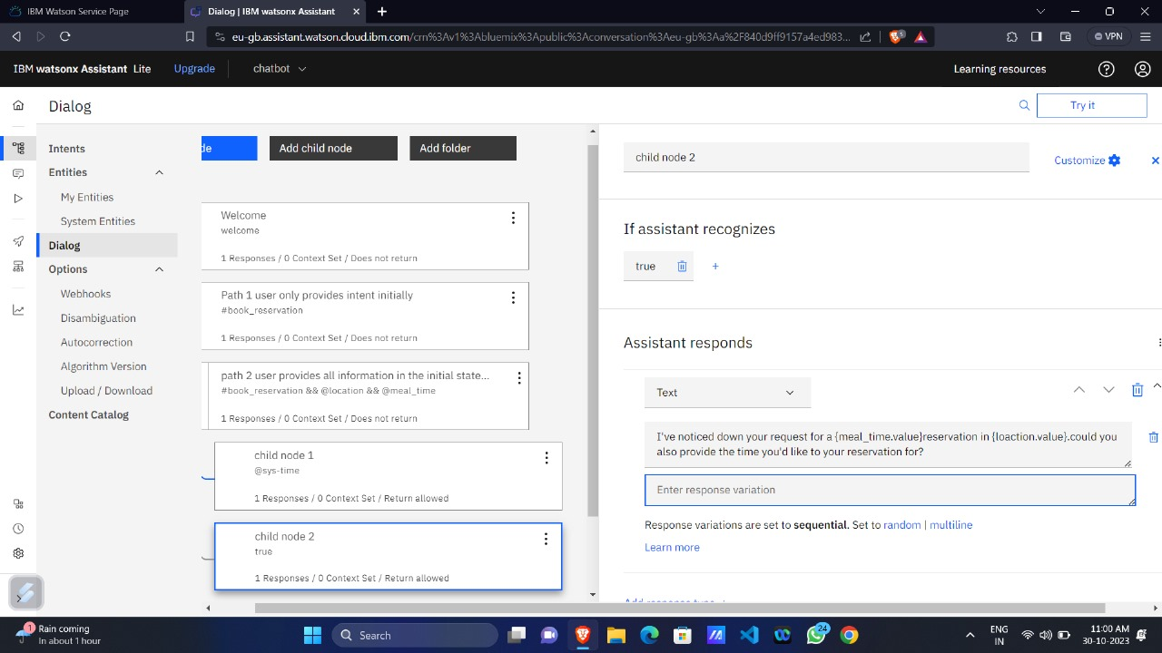

1. **Technical Implementation:**

* **Configure Intents:** Define user intents, such as "greeting," "help," or domain-related queries.
* **Entities:** Identify key entities within user queries, such as product names or dates.
* **Dialog Nodes:** Establish dialog nodes that contain responses for different intents and entities
* **System Integration:** If required, integrate Watson Assistant with external systems or Facebook Messenger App or Slack App or Any Messenger App.

1. **Testing and Training:** Enhance the chatbot's accuracy by training it with example user queries and responses.

1. **User Acceptance Testing (UAT):** Involve actual users in UAT to gather feedback and refine the chatbot's responses and conversation flow.

1. **Deployment:** Deploy the chatbot on the desired platform, such as a website or messaging app.

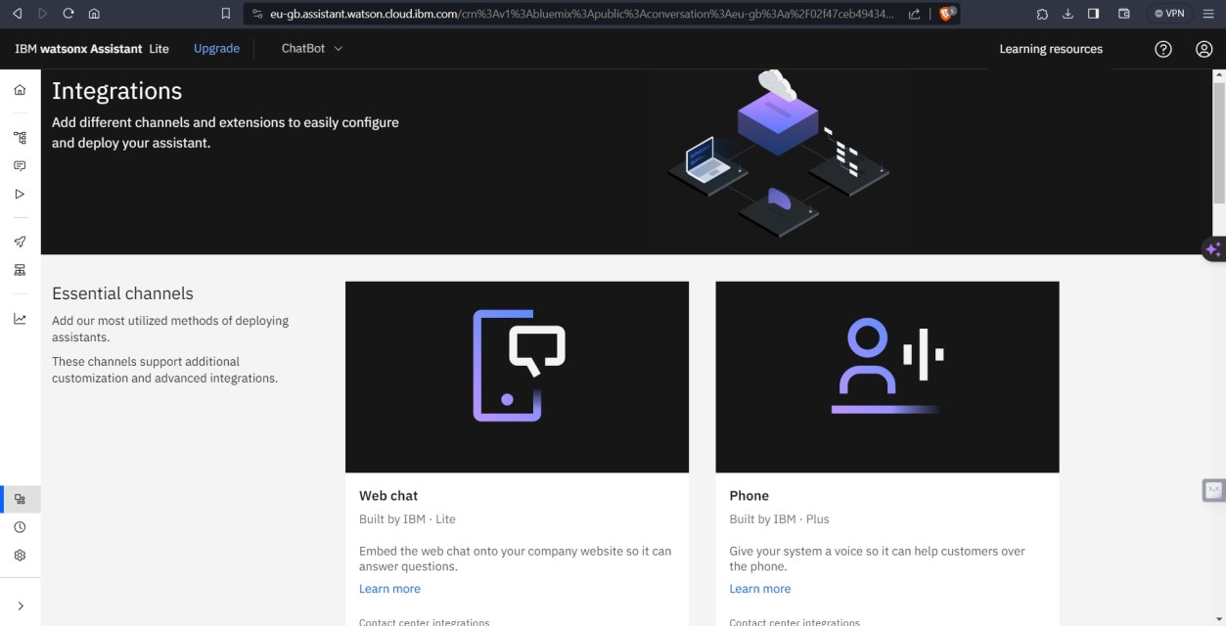

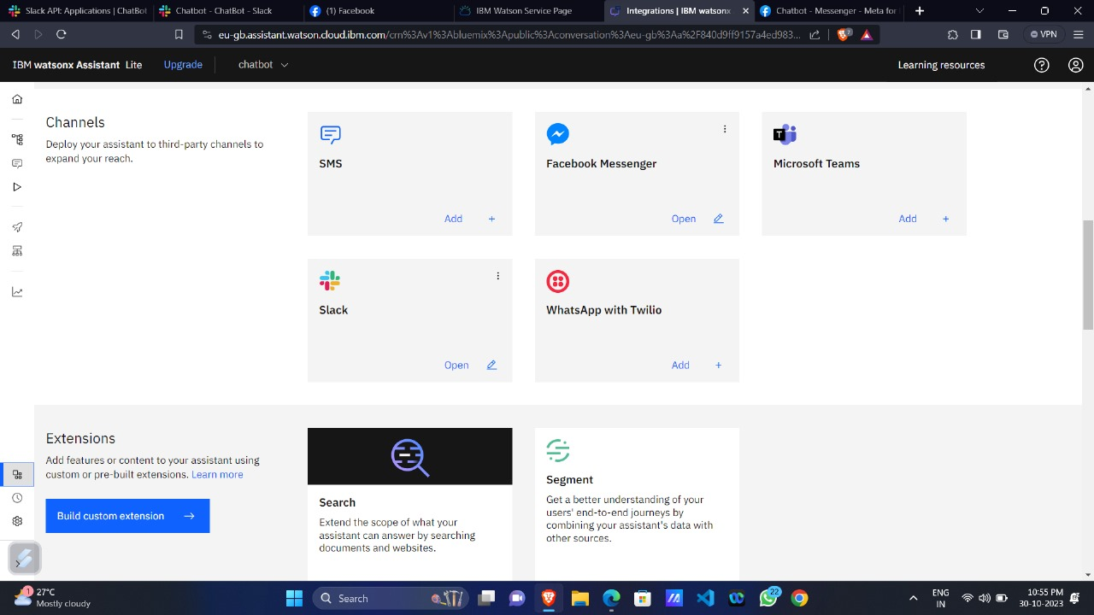

1. **Monitoring and Maintenance:** Continuously monitor the chatbot's performance, analyze user interactions, and implement updates as necessary to enhance its capabilities.

**Chatbot Persona:**

For this project, the chatbot persona will be professional and helpful, maintaining a polite and informative tone.

**Conversation Flow:**

**The conversation flow structure:**

1. Greeting and welcoming the user.
2. Understanding the user's intent.
3. Providing relevant responses or directing the user to relevant information.
4. Handling common queries.
5. Offering assistance or escalating to human support when required.

**Technical Implementation using Watson Assistant:**

1. **Intents:** Define intents such as "greeting," "FAQs," "product information," etc.

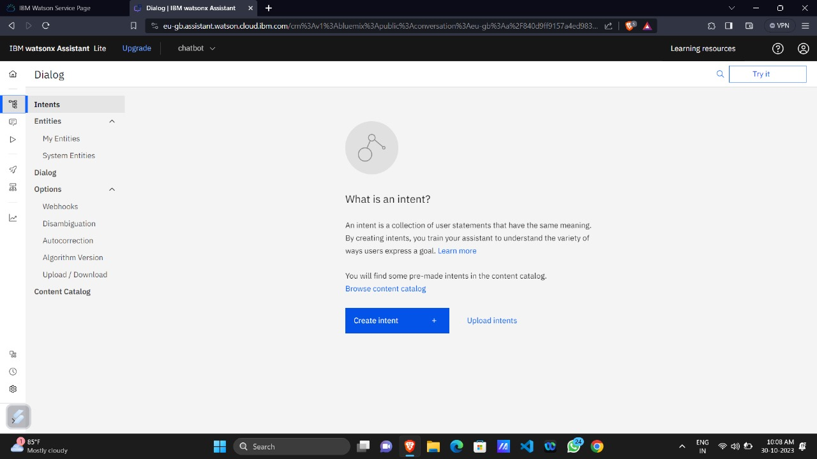

1. **Entities**: Identify entities such as product names, dates, or locations.

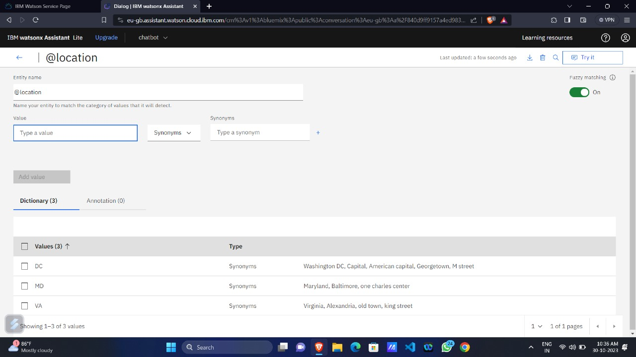

1. **Dialog Nodes:** Create nodes to handle each intent, providing responses and guiding the conversation.



1. **Integrations:** Integrate with Facebook Messenger App or Slack App or APIs for dynamic information retrieval.

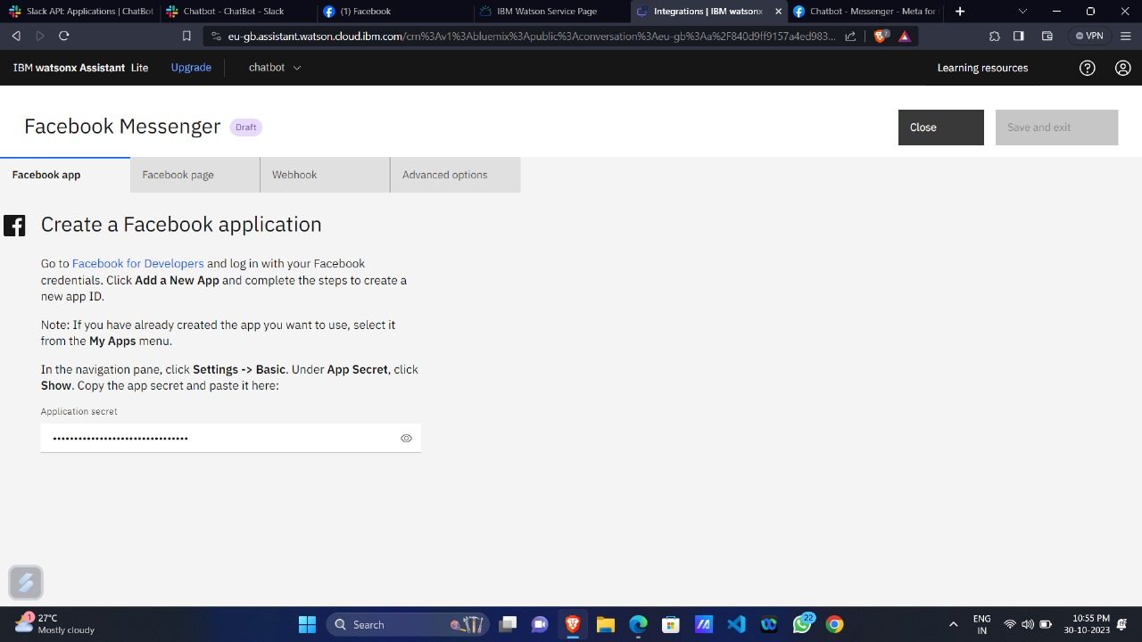

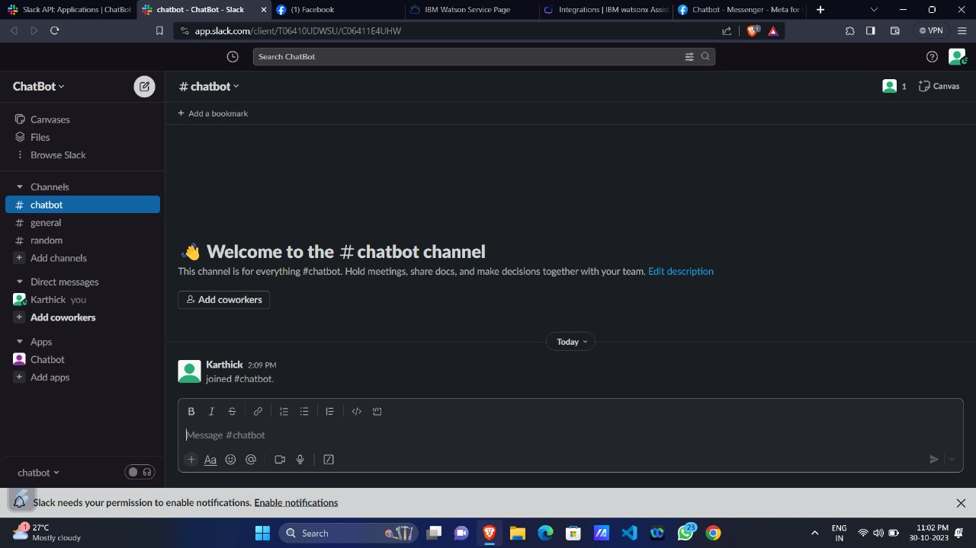

**Examples of User Queries and Chatbot Responses:**

**Chatbot Integrated in Facebook Messenger App**

