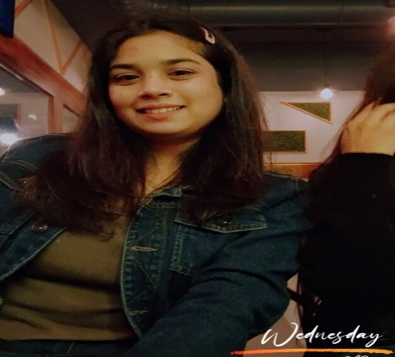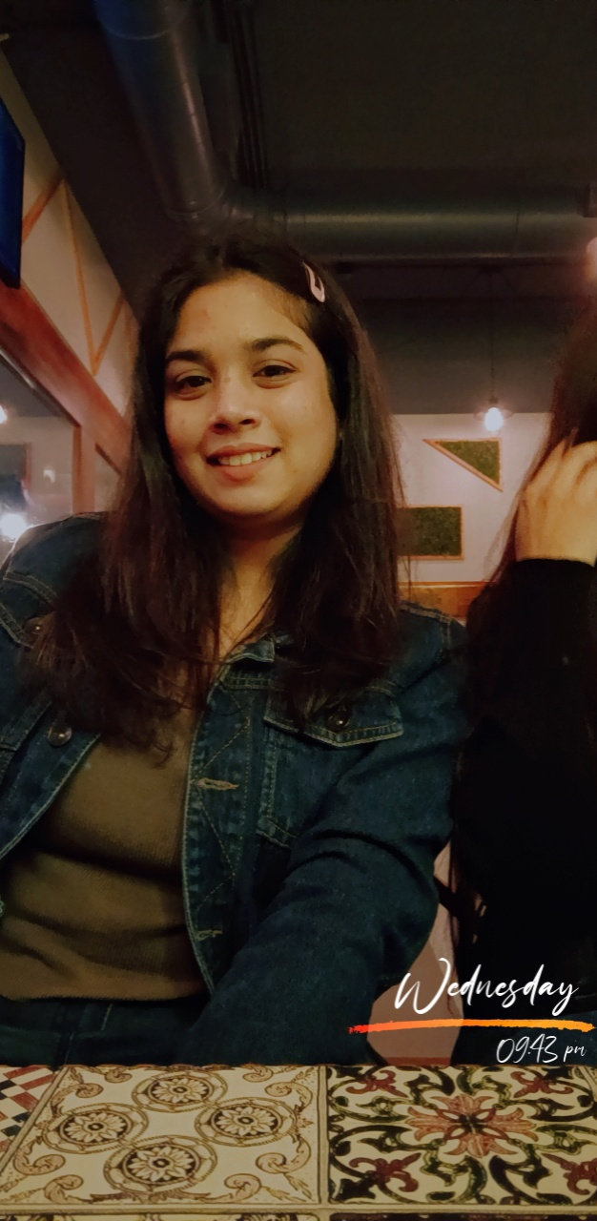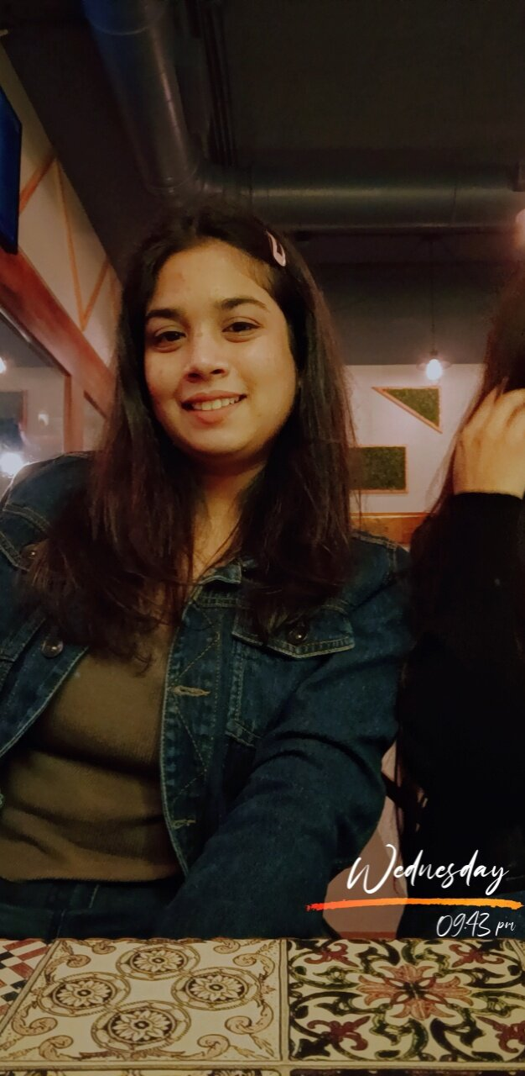

1

© Capgemini 2017. All rights reserved

|

Presentation Title | Author | Date



**Strengths**

**Achievement**

**Education and certificates**

**Base Location:**

**Email ID:**

**Mobile No:**

**Grade:**



**Online RollOff form project**

Case study of RollOff form project System along with API,

Swagger, responsive UI with HTML5, CSS, Bootstrap and

Angular used as User Interface.

**Experience**

PVH Data Streaming Project

Contributed to the creation of an application using Angular for frontend, Web Api for backend , SQL server , HTML 5, CSS 3

Mumbai,

Airoli

aishwarya-dilip.patil@capgemini.com

+919049237802

**Full Stack Developer**

•

Full Stack developer with Angular and .NET.

•

Hands on experience on

**C#,ADO.NET, Entity**

**framework , SQL Server , ASP.NET MVC5 with WEB API**

**and**

in creating

**services**

with

**.NET Framework.**

•

Experience in creating

**Single page Web**

Application in

**Angular**

Experience in creating documentation and swagger

**Aishwarya Patil**



A4

Bachelor of Technology , Computer

Science Engineering : 2018

-

2022

**Skills**



Analyst

Trained

under:

i

-

Transform

C#

Basics, OOPS concept

.NET

ADO.NET,ASP.NET with MVC5

and WEB API , Entity

Framework

Angular

Components, Services,

Modules, Routing, Forms &

Validation

Database

MSSMS SQL

UI Tech

HTML 5 & CSS 3,JavaScript,

ES6 & TypeScript ,UI,

Bootstrap

Tools

Swagger

Add-on Skills

Peer learning,Team Management Communication skills

ss