EX: 1 ESTIMATION OF PROJECT COST AND CONTROL ACTIVITY USING OPEN-SOURCE TOOLS

AIM
To perform cost estimation, duration scheduling, resource allocation, and project control activity tracking for the project "resume builder1" using an open-source project management software tool.

PROCEDURE

Step 1: Project Initialization & Task Identification
Launch the open-source project management tool and create a new project named 'resume builder1'. Define the complete Work Breakdown Structure (WBS) consisting of key task activities: Requirement Analysis, Market Analysis, System Design, Database Design, Coding, Testing, Bug Fixing, and Deployment.

Step 2: Activity Duration & Predecessor Linking
Set individual task durations and specify predecessor dependencies to establish logical task workflow:
• Requirement Analysis: 5 days (Start: 13/07/26, 8:00 AM)
• Market Analysis: 2 days (Start: 13/07/26, 8:00 AM)
• System Design: 4 days (Predecessors: 1, 2)
• Database Design: 3 days (Predecessor: 3)
• Coding: 5 days (Predecessor: 4)
• Testing: 2 days (Predecessor: 5)
• Bug Fixing: 2 days (Predecessor: 6)
• Deployment: 1 day (Predecessor: 7)

Step 3: Resource Creation & Task Assignment
Add project resources (Ram, Vijaya, Pooja, Raja, Arun) into the system and assign appropriate hourly/standard cost rates. Link human resources to their respective activities (e.g., Ram to Requirement Analysis, Arun & Vijaya to Coding, Pooja & Raja to Database Design).

Step 4: Resource Chart & Availability Tracking
Utilize the Resource Utilization / Availability views to monitor individual workload percentages across the schedule timeline to ensure no team member is over-allocated.

Step 5: Project Cost Analysis & Summary Generation
Generate the comprehensive project summary report to review key project baselines, overall schedule duration (22 days), effort hours (160 hours), and calculated project cost (₹8,373.00).

OUTPUT
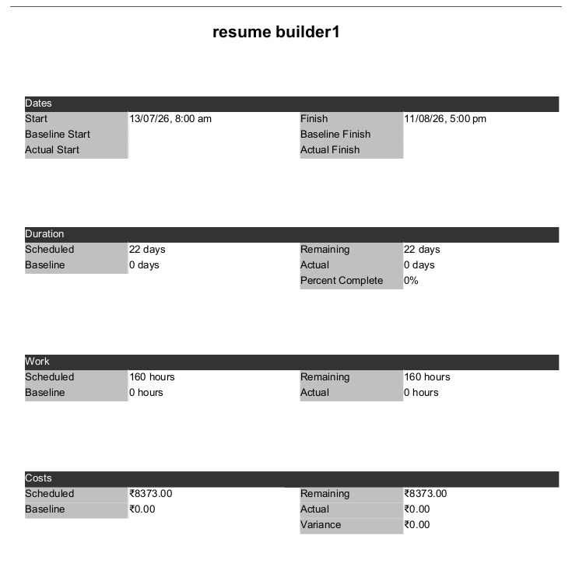

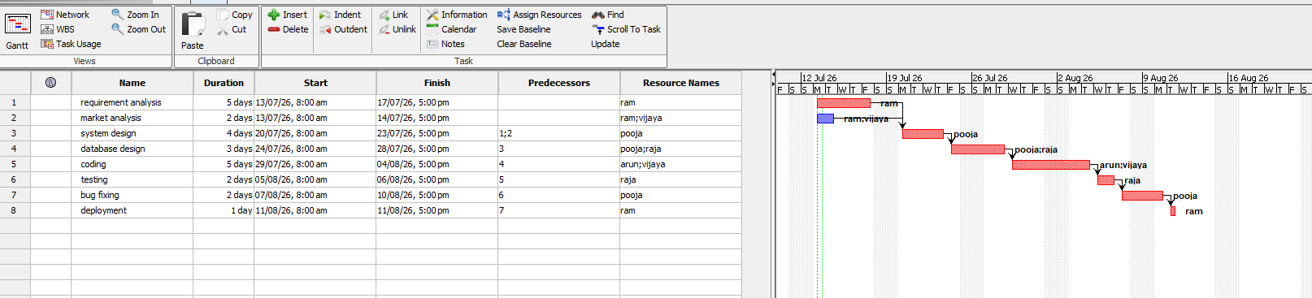
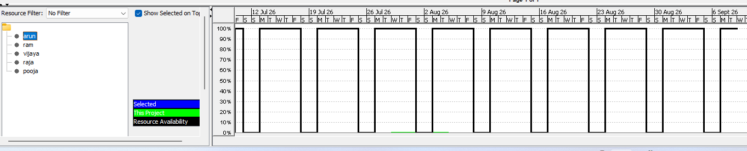
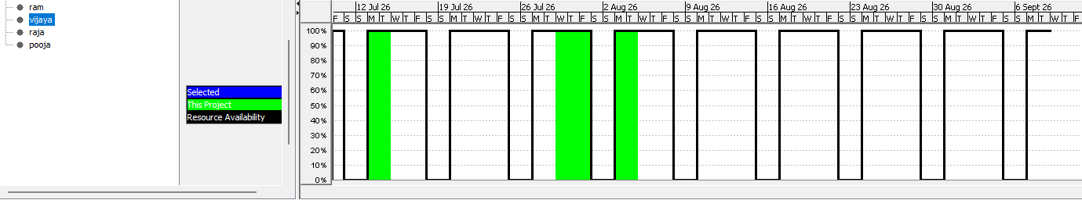

RESULT
The estimation of project cost and control activity for 'resume builder1' was successfully executed using the open-source project management software. The final baseline parameters and cost estimates obtained from the simulation are tabulated below:
Parameter / Feature | Obtained Value / Status
Project Start Date | 13/07/26, 8:00 AM
Project Finish Date | 11/08/26, 5:00 PM
Scheduled Duration | 22 Days
Total Planned Effort Hours | 160 Hours
Total Estimated Project Cost | ₹ 8,373.00
Conclusion: The open-source project management software efficiently streamlined task planning, workload distribution, resource tracking, and cost calculation. The total project expenditure was computed to be ₹8,373.00 with a total timeline of 22 days.

