

*Developing an Anti-Delay Assistance System with Cost Distribution and Virtual Assistant Integration.*

Project Documentation Submitted to the Faculty of the

School of Computing and Information Technologies

Asia Pacific College

In Partial Fulfillment of the Requirements for

Systems Analysis & Detailed Design for CS/IT students

SYSADD1/MSYADD1

By

|  |  |
| --- | --- |
| Mandal, Krishna Kumar R. | Nerez, Marc Angelo A. |
| Sabanal, Alexus Norsaid D. | Subedi, Jeho Ram B. |

2024

TABLE OF CONTENTS

Executive Summary 3

I. Introduction 4

1.1 Project Context 5

1.2 Statement of the Problem 5

1.3 Objectives 7

1.4 Significance of the Project 7

1.5 Scope and Limitations 8

II. Review of Related Literature / Systems 8

III. Current Systems 14

3.1 Current System 15

3.2 Technical Background 19

3.3 List of Processes 20

3.4 SWOT Analysis 22

IV. Proposed Solution 22

4.2 Lean Canvas 23

4.3 Product Vision 25

4.4 Technology Specifications 26

4.5 Feasibility 26

4.6 Data Flow Diagrams 35

V. Requirements Analysis 38

5.1 Product Backlog / User Stories 38

5.2 Use Case Diagram 42

5.3 Fully Dressed Use Cases 43

5.4 Test Cases for Fully Dressed Use Cases 55

5.5 Activity Diagrams with Swimlane 60

5.6 Entity Relationship Diagram and Data Dictionary 71

5.7 Prototype 80

References 83

# Executive Summary

Saint Michael Guard Watch Security Services Inc. (SMGWSSI) faces significant operational challenges, including limited information accessibility, inefficient hiring processes, delays in delivering documents to customers, and single-point inquiry. To address these issues, our development team is creating a Security Agency Service System, designed to enhance SMGWSSI’s operational effectiveness and efficiency. This user-friendly platform will significantly improve information accessibility, enhance hiring processes, speed up the delivery of documents, and enhance communication capabilities. By integrating these features, we aim to transform SMGWSSI’s operations and provide a seamless experience for potential customers, job seekers, current employees, and managerial admin.

Our solution will deliver real-time access to general and critical information, improving decision-making and transparency on the part of the customer and client. It will implement efficient, automated hiring process to attract and filter qualified talent swiftly and develop an algorithm to accurately compute quotations, reducing human errors and simplifying the process and make it easy to learn and teach to new and current employees, which in turn will save time. Additionally, we will integrate a virtual assistant to facilitate instant communication and support, that can handle general inquiries, ensuring better user engagement and satisfaction. To ensure optimization of the system, the project will utilize modern development tools, a secure database, and reliable server infrastructure.

The primary audience includes potential customers, job seekers, current admin employees, and the managerial admin. The content and functionalities of the system are tailored to meet the needs and expectations of these stakeholders, ensuring a user-friendly experience and efficient interaction with the platform. The developers also identified the need for training sessions for administrative and HR staff on using the new system, and monitoring for users to navigate the portal and its features to fully capitalize on the functionalities of the system. The developers believe that by addressing the operational challenges faced by SMGWSSI, this project will significantly enhance the organization’s efficiency, customer satisfaction, and overall service delivery, positioning the company for future growth and success.

# Introduction

## 1.1 Project Context

Saint Michael Guard Watch Security System Inc. (SMGWSSI) operates as a premier security agency, specializing in the deployment of highly trained security guards and officers to a diverse range of environments. From commercial establishments and residential areas to vacant lots and various other locations requiring vigilant security, they provide comprehensive protection tailored to the unique needs of each client. It was founded by high-ranking retirees of the Philippine Military Academy and the Philippine National Police. It emerged from their collective expertise and shared vision, birthing an agency with a steadfast focus on professionalism, discipline, and faith. Their vision extended beyond mere security provision; it aimed to imbue the industry with a sense of honor and dignity, elevating the image of security guards, security officers, and bodyguards alike. The company was established on September 29, 2015.

Despite their extensive expertise in discipline, physical security, professionalism, and operations, Saint Michael Guard Watch Security Services Inc. (SMGWSSI) has acknowledged pain points that persist within their operations. These challenges, that use outdated methods, have prompted the recognition that technology holds the key to resolution. However, the company acknowledges its limited familiarity with technological solutions. With the help of the developers, SMGWSSI aims to address these issues through the implementation of a technological solution. This project is designed to mitigate existing inefficiencies and harness the transformative power of technology to elevate operational efficacy and redefine industry standards within the security services sector.

## 1.2 Statement of the Problem

Saint Michael Guard Watch Security System Inc. has identified several pain points in its operations and wants to capitalize on technology to address these.

1. **Overburdened single-point inquiry management.**

The current system, where only one individual handles inquiries presents significant operational inefficiencies and missed responses. Although, 60% of the inquiries are FAQ according to the secretary, there are days wherein This setup not only overwhelms the branch secretary but also leads to delayed responses, increased stress, and the potential for missed inquiries. Moreover, inquiries that are outside business hours are not responded to promptly, leading to a potential loss in sales. The client advised us that hiring a dedicated person solely to handle inquiries is not cost-efficient because, although being overburdened doesn't happen constantly, it occurs often enough to result in missed and delayed responses.

1. **Delays in hiring process.**

The current method of managing employment applications from three channels (FB Messenger, Viber, and Email) proves to be inefficient for several reasons;

* The channels lack a system to segregate inquiries from different stakeholders, such as applicants, employees, and potential customers. Without clear differentiation, there is a risk of confusion and miscommunication, as HR may inadvertently prioritize applicant inquiries over customer queries or employee concerns.
* Instead of organizing applications chronologically or by relevance, this system often results in important messages getting buried under newer ones, making it challenging for HR to keep track of applicants and their respective statuses.
* Their record keeping involves making a folder for each applicant and downloading the applicant’s requirements to each folder (see Fig. 1). They download the images sent by the applicant from their different channels (Messenger, Gmail, Viber). There were instances where documents were downloaded in the wrong folder or misplaced due to human error.
* They have provided us with their hiring process and want to know what steps can be taken to shorten the process and make the process faster. The applicant's folder structure can be seen in Table I, section P001. The timeframe for their current hiring process depends on the number of applicants. However, they informed us that it now takes approximately seven days to hire each employee.

1. **Delays in approval of cost distributions.**

Though our client has a system in place for computing cost distributions, they have seen significant delays in their process when there are two to five proposals handled in the same period. This is due to the manual checking of the cost distribution handled by three departments (The Branch secretary, The General Manager, and the Finance Department).

* Delays in checking by the General Manager or the Finance department due to other duties. Some approvals take 4 to 6 days due to other priorities. The process for cost distribution approval can be seen in Table I, section P002. A proposal with a cost distribution should be sent to the client on the same day or the day after.
* The branch secretary is responsible for manually entering and manipulating the cost distribution in Microsoft Excel based on client details. This process is prone to human error and can be time-consuming, especially with a high volume of inquiries or complex client requirements (see Fig. 2).

## 1.3 Objectives

**1.3.1 Main Objective**

This project's main objective is to address operational challenges in terms of response times to customers and applicants to enhance organizational effectiveness of Saint Michael Guard Watch Security Services Inc. (SMGWSSI).

**1.3.2 Specific Objectives**

1. To reduce the volume of inquiries handled by branch secretaries by 60%, providing instant answers to common questions from customers and applicants."
2. To find a way to shorten the hiring process by 25% and find a better way to improve record keeping by eliminating human error.
3. To reduce the manual cost distributions approval process from 6 steps to 5 steps.

## 1.4 Significance of the Project

The development and implementation of a system for Saint Michael Guard Watch Security Services Inc. (SMGWSSI) is significant for both the organization and its stakeholders. Firstly, the project signifies a strategic shift towards modernizing operational practices, leveraging technology to enhance efficiency, and ensuring competitiveness in the rapidly evolving era.

The project also holds significance for future web developers, serving as a practical case study in the integration of advanced functionalities and user-centric design principles into web development projects, thereby offering valuable insights and learning opportunities for aspiring developers.

## 1.5 Scope and Limitations

The project's scope is limited to the creation and implementation of the new system, without altering, addressing the current content, or existing issues unrelated to the new functionalities. Automated systems will operate strictly within the parameters provided by SMGWSSI. Focusing on web development and automated functionalities, the system will feature a user-friendly interface, capabilities for automatically processing and simplifying applications, and a Virtual assistant to handle cost distribution computations and general inquiries. All solutions will be integrated into a single, cohesive web system, delivered as a complete prototype to address identified pain points.

As the project only aims to directly confront the pain points as presented, it will not touch on any of the existing issues that are not relevant to the system's design. The automated systems will also only work with the parameters given by Saint Michael Guard Watch Security Services Inc. (SMGWSSI).

# Review of Related Literature / Systems

This part of the study provides a complete review of the relevant literature and systems. The goal of this chapter is to give the study a strong theoretical basis by reviewing previous research and other relevant resources, examining similar systems that provide direction for the project's progress, and analyzing them. This chapter aims to present the current state of knowledge gaps and provide the framework for the current activity by critically assessing and summarizing the systems and literature that are currently in use.

**Automation of company processes**

When equipped with the appropriate tools, automating computer operations become remarkably straightforward and can yield significant advantages. Recognizing these benefits, as well as potential hurdles, is crucial in garnering support for an operations automation initiative. A recent inquiry by a prominent trade journal sought to uncover the chief advantages of an automated or unattended computer center. The findings underscored several primary benefits consistently cited by respondents. These include cost reduction, heightened productivity, improved availability, enhanced reliability, and optimized performance. Such advantages underscore the transformative potential of operations automation, making it a compelling proposition for organizations seeking efficiency gains and competitive advantages in today's digital landscape [5].

**MERN stack as a database**

The swift expansion of the digital marketing industry has led to an increase in customer expectations. As a result, developers work around the clock to build systems that are more user-friendly, faster to load, and mobile-friendly. Continue reading to learn about the many benefits of the MERN stack. The MERN stack is a combination of state-of-the-art and tried-and-true techniques for developing scalable master software applications for the front-end, back-end, and data systems. Given that only JavaScript-based platforms can generate dynamic web pages and applications, businesses specifically seek to use them as a platform [6].

**Enhancing Customer Service with a virtual assistant**

Driven by advanced artificial intelligence (AI), these chatbots perform a variety of tasks, each designed to enhance the customer experience and enhance operations. Chatbots for customer service are quickly becoming integral parts of successful customer service strategies. These chatbots pull information directly from the company's FAQ pages, eliminating the need for customers to search through the portal or wait for a response from a live agent. This improves service efficiency and empowers customers by giving them immediate access to the information they need. Chatbots that share knowledge from FAQ pages serve as an automated knowledge base, providing instant answers to common customer queries.

Consumer questions can come in at any time of day or night. If your company does not have the workforce to handle live agent support around-the-clock, chatbots can cover this gap. Chatbots are always on hand and can respond to questions from customers instantly, no matter when they are raised [9]. Moreover, this immediacy helps in converting inquiries into sales by giving customers the information they need to make whether the price is agreeable. The convenience of having price information readily available at any time enhances the overall customer experience and satisfaction. Virtual assistants can provide instant price calculations and comparisons, which significantly reduces the waiting time for customers [8] This is one of the reasons the developers decided to integrate this since it is an integral tool in solving the lack of communication channels of SMGWSSI during the out of office period. It is important to note that while a chatbot is a powerful tool, they will not replace live agents.

**Online Job Application System**

According to article [1], the usage of Online Job Application Systems contains many different advantages over regular recruitment methods which therefore highlights their increased efficiency in comparison. With these advantages being, The ability to allow you to Publish Jobs to numerous Job Boards with one click, Manage your career board, Acknowledge job applications, Process Job Application using customized workflows, Build a candidate database, enhance communication via email templates, Easily track and add recruitment notes, And Increasing candidate experience by keeping them in the loop throughout the hiring process. And of course. these capabilities that the usage of online job application systems also lead to the benefits Saving Time, Saving Money, and being able to make better hiring decisions.

Furthermore, the article also provides a detailed overview of the disadvantages regular recruitment methods possess. With them being the following  The inability to access all the recruitment data easily.   The loss of the opportunity to build a candidate database.   The loss of time doing things manually.   A lackluster candidate experience brought forth by communication cohesion, strategy, and mechanism issues  And the possibility of leaving stale jobs on the job boards if one forgets to remove the job advertisements.

One would consider this article agreeable because the points it provides regarding the topic can be validated from personal experience. Especially considering how the usage of analog process is considered a lot slower compared to the usage of digital in many other different fields aside from the field of business  But with that being. The relevance of the article comes from its relation to the main goal of this project which is to create a web-related service for the company named SGWSSI. And this article provides just the key points needed to serve as good reasons for this project to be even done in the first place.

**APC enrollment process**

Inspired by the APC enrollment process [2], where students select subjects that are then verified by the dean before receiving a detailed tuition fee breakdown, the proposed system for SMGWSSI will follow a similar enhanced approach. In our system, the secretary answers four questions, which are then reviewed and verified by the general manager. This single-point verification ensures accuracy while maintaining efficiency.

Once the general manager approves the inputs, the system automatically calculates the total cost of hiring security guards. This cost breakdown is displayed clearly and accurately based on the input provided. The benefits of this system include increased efficiency by reducing the time required for manual calculations and minimizing errors, improved accuracy through a single verification step, and enhanced transparency with a detailed cost breakdown provided to clients.

**The Republic of the Philippines Social Security System Official Website**

The Official Website of The Republic of the Philippines Social Security System (SSS) includes an online registration/application form just like what the groups’ proposed portal will offer [3].

With facial scanning software, One Time Passwords (OTPs) sent via email, and the requirement of presenting hard copies of birth certificates and IDs in person at SSS branches, the website ensures that only non-fraudulent information is accepted. This includes verifying name, age, sex, address, phone number, email address, etc. Such verification is essential not only for job applications but for any transactional application in general.

This system is relevant to the study as it exemplifies an online application system that incorporates features such as the sending of necessary files and documents online which was also promised in this project. Therefore, making it a valuable reference for developing the proposed website. However, due to the process of verification being done via in person. Some features present on this website would need to be changed.

**Gaming Library Virtual Assistant**

The Website named Gaming Library includes an online virtual assistant just like what the groups’ proposed portal will offer [4].

With the ability to answer broad questions such as pricing, availability, and details about the product. The virtual assistant present on this website would serve already as a decent point of reference for the developers of this project to base their output upon. However, what solidifies its position as a point of reference would be its capability to redirect the user (customer or applicant) to a Customer Service Representative if they require more clarification or specific inquiries about their services.

This system is relevant to the study as it provides a firsthand look and a source of basis for what otherwise may be a very vital feature of the project. Therefore, making it a valuable reference for developing the proposed website.

That said, however. Due to how the virtual assistant present on this website is focused more on the sale of board games. Some necessary changes and modifications would have to be made for the sake of the product.

**Security Measures to Prevent Authentication Attacks**

The web article titled "What Are the Security Measures to Prevent Authentication Attacks" provides developers with help insights on some of the most effective security measures to use when ensuring a websites authentication is safe, trustworthy, and not so easily compromised, focusing on authentication methods such as 2FA, Password Strength Validation, Secure Password Storing, Compromised Attack Detection, Roles and Permission Handling, and Device Policy Enforcement to name a few.[10].

This article is relevant to the project as it provides examples of security measures that developers can use to make their website more secure, especially if it is the type of website that handles multiple accounts of important data.

That said, more tips would be desirable due to the specific details about the project. Each of the necessary parties have different types of accounts depending on their position. And each of these different accounts handles different sorts of important data.

**The Corinthians Group of Companies web interface**

a leading security agency in the Philippines, excels in providing highly trained security guards and comprehensive security training programs for various sectors, including commercial, residential, industrial, and institutional. They emphasize continuous education and use of advanced security technologies, ensuring their personnel are well-prepared for any situation. Their integrated security solutions combine manpower with advanced surveillance, access control, and alarm systems for a layered security strategy. Specializing in event security management, they conduct thorough risk assessments and develop customized plans for large gatherings, corporate events, and private functions. Additionally, Corinthians offers consultancy services, conducting security audits and risk assessments to help organizations enhance their security infrastructure. This holistic approach, blending expert personnel and cutting-edge technology, positions Corinthians Group as a top security provider in the region.

**Dark Horse Security Agency comprehensive security content**

Based in Quezon City, Metro Manila, is a renowned security provider known for its comprehensive and tailored security solutions. The agency excels in deploying well-trained security personnel for various sectors, including commercial, residential, and industrial environments. Their guards are selected through a rigorous vetting process and receive continuous training to stay updated with the latest security practices and technologies. Dark Horse Security Agency also offers advanced surveillance and monitoring systems, integrating CCTV cameras, alarm systems, and access control systems to create a robust security infrastructure. They specialize in event security management, providing meticulous planning and on-site coordination to ensure the safety and success of large-scale events. Additionally, the agency offers consultancy services, conducting thorough security assessments and providing strategic recommendations to enhance overall security measures. Their commitment to excellence and customer satisfaction makes Dark Horse Security Agency a leading choice for reliable and effective security solutions in Metro Manila.

**Philippine National Guard Security Agency, Inc. Web= interactivity**

is a distinguished security service provider in the Philippines, offering a wide range of security solutions tailored to meet the needs of various industries. Their core services include the deployment of highly trained security guards, who undergo rigorous selection and continuous training to ensure top-notch performance. PNGSA emphasizes the integration of advanced security technologies, including state-of-the-art surveillance systems, access control, and alarm systems, to bolster physical security measures. The agency is also proficient in event security management, providing meticulous planning and execution to safeguard high-profile events and large gatherings. Additionally, PNGSA offers specialized consultancy services, conducting comprehensive security audits and risk assessments to help clients enhance their security infrastructure proactively. Their commitment to excellence and adaptive security strategies positions Philippine National Guard Security Agency, Inc. as a leading and reliable security partner in the region.

# Current Systems

## 3.1 Current System

Saint Michael Guard Watch Security Services Inc. (SMGWSSI) is leveraging its Facebook page, company phone lines (Viber), and Gmail accounts as channels to receive inquiries and SG (Security Guard) applications. For inquiries, the branch secretary handles it. She checks all the channels to make sure that all inquiries are addressed. However, there are certain times that Inquiry messages, applicant messages, and employee concerns simultaneously flood the channels, making it difficult for her to respond promptly and effectively to each one.

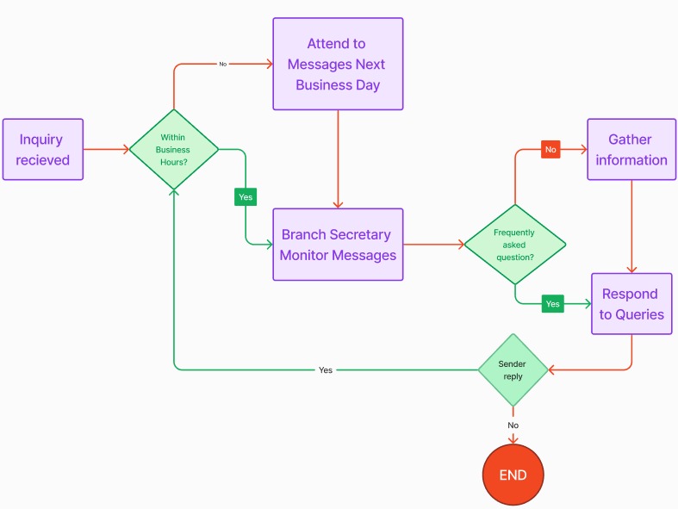*Figure 1. Inquiry Flowchart*

For applicants, their process involves HR checking the same channels to download each of the application documents. This process has an elevated risk of human errors. Due to the manual downloading of each document to the specific folder of the applicant, there are several times wherein the document has been saved to another applicant's folder or got completely lost that resulted in delays in interviews or overlooked qualified applicants. Please refer to the image below regarding the sample of how they record keep applicants.

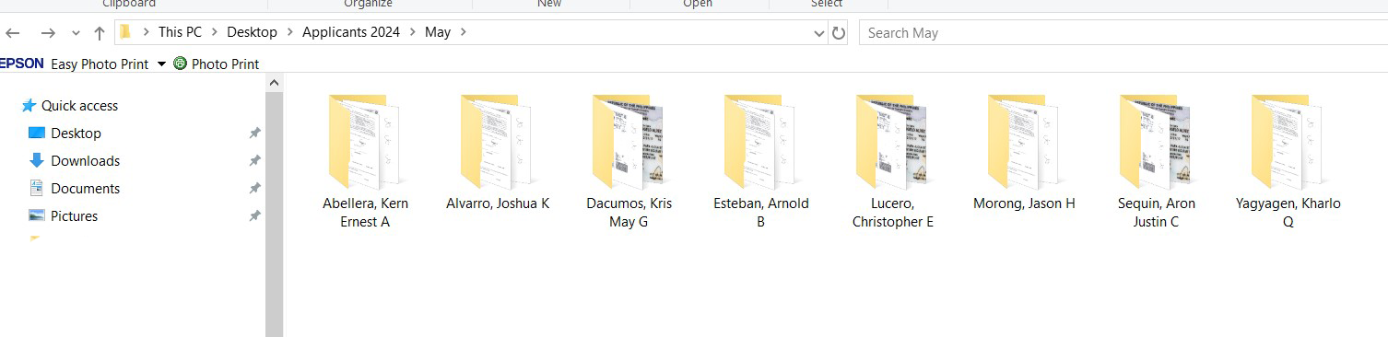*Figure 2. Record keeping sample folders*

As seen in Figure 1., each applicant has their own folder under the date they applied. This manual update of putting files of people in folders. This process has a lot of potential for human errors due to the manual copy and paste to specific folders. This has caused significant delay as well when handling 30+ applicants on the same day for three channels (Viber, email, FB messenger) that have 5-6 documents each.

After the record keeping, the HR calls each applicant that has completed documents for the initial interview. The interview questions are;

* How many years they have been in the Security Profession
* What agency were they a part of before applying to SMGWSSI
* Current location and areas that he/she will be willing to be posted
* Posting he/she is applying to
* Types and number of uniforms
* Training center that he/she attended

This causes an additional delay in the process due to some applicants not answering on the 1st call. HR is advised to try two times with a significant gap each before they deem the applicant uncontactable. This has been another cause for delay in the hiring process.

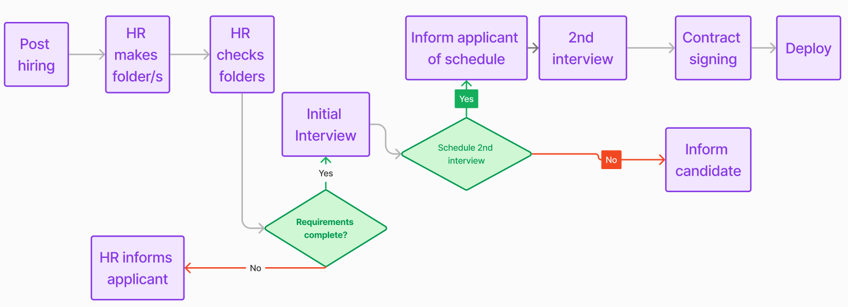*Figure 3. Hiring process flowchart*

For the dissemination of proposals and cost distributions to customers. To facilitate efficient cost calculations, the company made an Excel file that automates computation, to somehow enhance the process. However, this process is susceptible to human error. Below is a sample of their cost distribution they use

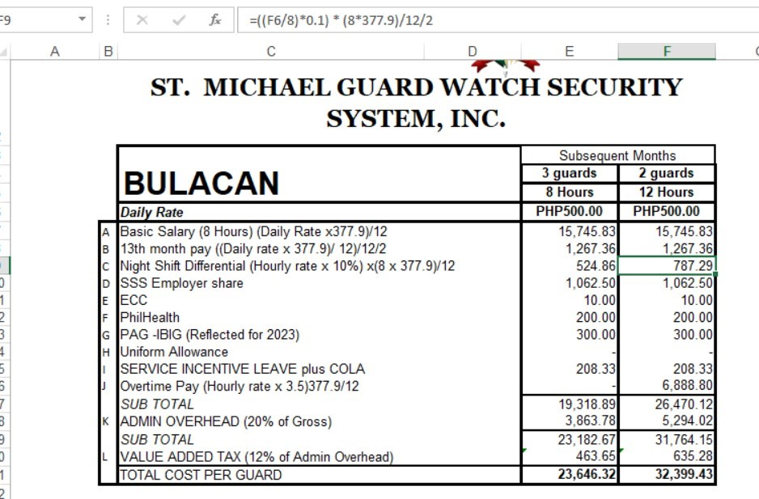*Figure 4. Cost distribution excel sheet sample*

As seen in this sample, the formula for certain variables is already there. Every time a customer inquiries about pricing, this is the method they use to manipulate the price. To check whether the amount is correct, it goes to three departments. The branch secretary gets the details from the client first. The details that are required are;

* The location of the posting
* Type of posting (School, residential, Hotel, Etc)
* Number of security guards needed
* How many hours per shift (8 or 12)
* How many days per week (5-7)
* Type of firearms needed
* How many Firearms and radios are needed

The secretary then manipulates the cost distribution to match the clients' details. After this, he will submit the cost distribution to the General Manager to check whether the details are correct, then the General Manager will send it to the Finance Department for final approval. This method has seen delays due to the General Manager and Finance Department having other duties on certain dates.

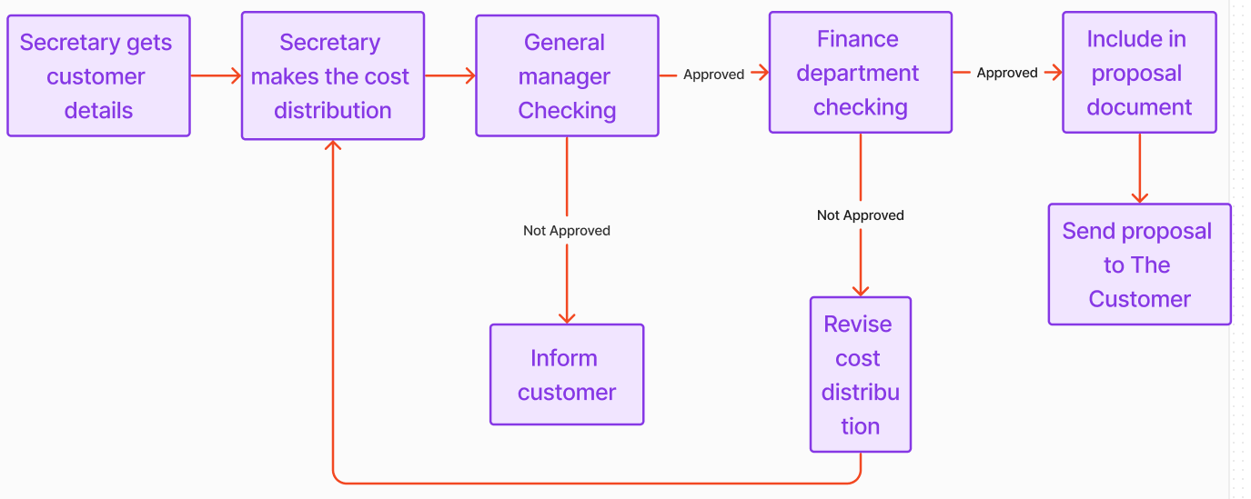*Figure 5. Cost Distribution flowchart*

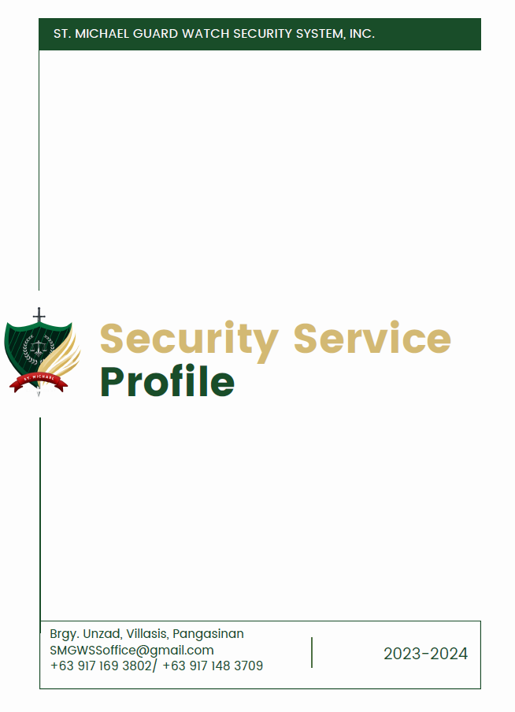

*Figure 6. First page of the Security Service profile*

## 3.2 Technical Background

The current system used by SMGWSSI for receiving inquiries are the three channels they currently have (Company phone, Gmail Account and FB Messenger). The image below shows the interface in FB messenger. The company can receive applications from any of these channels, which are manually sorted and reviewed. Most of the soft copies of their applicants come through their Facebook page.

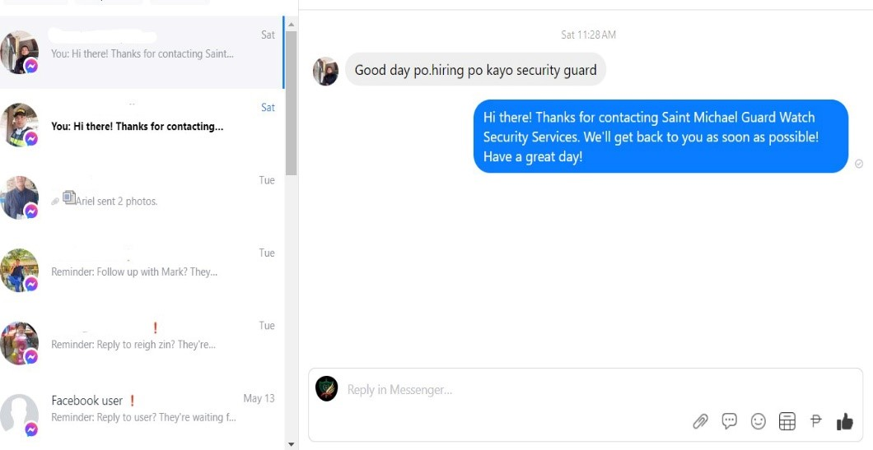 *Figure 7. FB Messenger interface*

As for its cost calculation, it is done manually in Microsoft Excel (see Figure 4 for reference).

## 3.3 List of Processes

*Table 1 contains the list of current processes being performed by the customer*.

*Table 1 List of Processes*

|  |  |  |
| --- | --- | --- |
| Process ID | Process  Name | Process  Details |
| P001 | Hiring Process | 1. If there is an available position, SGWSSI will post a Facebook post, or send an SMS to previous applicants. 2. HR will make folder/s in the computer wherein he/she will download the requirements submitted by the applicant. 3. HR checks each folder if requirement is complete 4. If requirements are complete. The Applicant’s initial Interview is done via a phone call. 5. If the applicant passes the initial interview, they will be scheduled for second Interview. It is done via messenger Or Face to Face if the applicant is close enough to the vicinity of the main offices in Pangasinan or Baguio 6. 2nd interview is done by the operations manager or general manager. 7. If within the vicinity of Pangasinan or Baguio. The Applicant will be made to sign a contract in the office before deployment. If otherwise. The applicant must go to their posting area on the day of deployment where he/she will sign the contract on the posting location. 8. Operations Manager endorses The Applicant to The Customer |
| P002 | Customer Proposal Process | 1. If there is a potential customer inquiry, The Secretary asks their location, type of posting, number of days of duty (6 or 7 days a week), and how many guards are needed. 2. The admin then computes the cost distribution data by manipulating the details in Microsoft Excel (Includes Night differential, Minimum Wage, 13th month pay, overtime pay) 3. It is then sent via email to the General Manager for 2nd checking to make sure the details are correct 4. It is then sent via email to the head of Finance department for 2nd checking to make sure the computation is correct 5. If the computation is correct, It will be sent back to the secretary to include in proposal document 6. The Proposal is to be sent to The Customer via in person, Email or Viber. |
| P003 | General Inquiry Process | 1. A message is received through Facebook Messenger, company phone or company email 2. If it’s within business hours, It will be assisted by the branch secretary. If not, it will be attended the next business day. 3. If it is a FAQ, it will be answered immediately. However, if it is not, the branch secretary will gather the necessary information first. 4. The branch secretary will respond after it gathered the necessary information. 5. If the sender replies, the process will restart. |

*Table 1 List of Processes*

## 3.4 SWOT Analysis

|  |  |
| --- | --- |
| STRENGTHS | OPPORTUNITIES |
| * Provides a singular point of access for multiple operations. * Allows reach for the company that was otherwise impossible. * Automates the process and hastens it compared to the previous protocol. * Reduces potential human error. | * An enhanced brand image due to a professional system has the potential to attract new customers. * Easier record keeping for potential customers due to the admin dashboard. * The portal can have additional functionalities in the future if needed. |
| WEAKNESSES | THREATS |
| * Requires upkeep and maintenance of an entire system. * Cannot guarantee an increase in quality for applications. * Relies on an internet connection for the functionalities to work. | * Other security agencies may copy or imitate functionalities. * There may be data security and privacy concerns over database handling. |

*Table 2 SWOT Analysis*

# Proposed Solution

## 4.2 Lean Canvas

***Problem***

* + **Overburdened Single-Point Inquiry Management** - The current system, wherein a single individual is responsible for managing all inquiries through the company phone, Facebook, and Gmail account, presents significant operational inefficiencies and missed responses.
  + **Delay in hiring Process of Employees and Applicants and outdated record keeping** - FB messenger lacks a system to segregate inquiries from different stakeholders, such as applicants, employees, and potential clients.
  + **Delayed Delivering of Cost Distributions** - The manual computation of cost distribution and prolonged approval process presents a significant challenge for SMGWSSI to meet the targets in delivering cost distributions.

***Solution***

* + **Virtual Assistant** - Adding a communication channel to make it easier for the customers and applicants to inquire about more details that can also have an option to chat with an agent.
  + **Dedicated Employment Portal** - Adding an applicant form to enhance the process for the HR to view and process. To track the records to make it easier and more efficient.
  + **Cost Distribution Calculator**- Instead of using their current system, which is using a Microsoft Excel sheet with multiple approvals, the developers want to create an automated cost distribution that is accurate, reliable and will shorten the approval process.

***Key Metrics***

* + Response time for inquiries will be greatly improved due to the Virtual assistant.
  + Information will be more reliable and viewing and record keeping will be easier and faster.
  + It will provide a secure way of sharing documents for applicants that will make applying convenient.
  + The response time for both applicants and customers from the agency will be faster.
  + A faster way and easier to understand cost distribution calculator process.

***Unique Value Proposition***

* + **Consolidated Application Process** - A more systematic hiring system that assists the HR/recruitment department. by using an AI pdf conversion making it easier to the HR when an applicant is filling out the form and will be delivered to the HR with the PDF version.
  + **Virtual Assistant** - a virtual assistant can provide real time data to the customer. With the use of asking questions to provide more details about the company’s services with the option to talk to an agent.
  + **Improved Cost Distribution System** - a better way of computing cost distribution that simplifies the process, making it more accessible to employees and enabling faster delivery of cost distributions to customers.

***Customer Segment***

* + *Security Agencies.*
  + *Establishments without dedicated web-systems.*

***Channels***

* + FB Messenger.
  + Email.
  + Mobile Number.

***Revenue Streams***

* + The time to modify cost distributions and proposals are shortened. Therefore, maximizing the number of customers that can be accommodated by the customer.
  + The website will also function as a marketing tool for the agency. This will provide a wider reach to their current medium and may attract more customers due to this.

***Cost Structure***

* + Subscriptions of Paid Frameworks that are being used in the development process.
  + Hosting and Deployments for deploying the that can be access publicly.
  + Costing of API Services can be used to assist with the functionalities.
  + Costing of Required Desktop to run the system.
  + IT Personnel for troubleshooting and maintenance.
  + Training or Orientation for the use of the new system.
  + Internet Services to access the system.

***Unfair Advantage***

* + The members each possess the necessary knowledge and prior experience to be able to handle the project and this is proven by their completion of the subjects WEBPROG, MODESIM, DATAMA, and USERDES to name a few.
  + The members have access to connections that the other groups do not such as Connections with potential customers and other beneficial parties.
  + The members each come from different but interconnected educational fields in relation to the project. With one member being a Marketing course graduate, two members being sophomores in the field of Cybersecurity, and one member who is a sophomore in the field of Mobile Internet.

## 4.3 Product Vision

FOR Saint Michael Guard Watch Security Services Inc. (SMGWSSI),

WHO needs a simplified channel for customer inquiries, a method to enhance the hiring process with concise and reliable recordkeeping, and a more efficient cost distribution calculation process.

THE Anti-Delay Assistance System (ADAS) IS A web-based portal

THAT aims to centralize customer inquiries, improve the hiring process record keeping, provide automatic cost distribution calculation, and a collection of company information, all within one platform.

UNLIKE other security agencies, that still manually respond to inquiries, use traditional application processes, and only contain basic information on their websites,

THE ADAS includes a virtual assistant which can both promptly respond to customer inquiries, provide automated cost distribution calculations and an employment portal connected to a web-integrated database.

## 4.4 Technology Specifications

For the proposed system, the hardware requirements should be either Intel i5 or AMD Ryzen 3 as their processors to run the system smoothly. With the use of these recommendations, it can provide more mid-range quality for them to use that have good performances. These processors, manufactured by Intel and AMD respectively, given that the Human Resource will be working as administrators of the site, it is highly recommended for them to utilize desktops as it provides with better performance, quality, and specifications.

For the software development, it will be based on the relevant tech stack. Called as MERN Stack that consists of MongoDB for handling databases, Express.js for API frameworks, React for system design, and Node for server-side scripting. With the use of [11] MERN Stack this can be implemented using only a single programming language called JavaScript that can handle both the front-end and back-end. It provides more scalability, consistent, open-source user experience that the development process is suitable with the adding more enhanced security, efficient workflow, built-in tools, libraries, flexibility, and customizability. It also uses a collection of relevant cloud technologies that can support the system’s functionality. Additionally, ensuring a user-friendly design comes with dynamic, responsiveness, and has the variety of different CSS Libraries, such as Shadcn, Bootstrap. Framer and Tailwind. As for our front-end design we specifically chose to use Bootstrap as our framework as this gives more dynamic designs for content views. In the meantime, the database is planned to be used with MongoDB. As it uses a database that is serverless as it is more flexible when it comes to formatting.

The peopleware will consist of admins, customers and applicants. Each of them has their own role, which is that they have limited access to the system and its functionalities. The admin role is the people that have access to manage and moderate the portal’s contents and have the most access level. The HR, Branch secretary and IT admin have this access. The customers and applicants have access to see all the available services SMGWSSI offers and inquire. The applicants have access to the employment portal. Wherein they can answer the questionnaire for employment and send documents to apply for a position.

For the network it requires a stable internet connection and a database that is connected to the cloud for storing data and data recovery, whereas during the development process the portal and its database will be temporarily hosted locally using MongoDB to test and run the system before its hosting and deployment. The portal is planned to be hosted and deployed using Hostinger.

## 4.5 Feasibility

Operational Feasibility

|  |  |
| --- | --- |
| Factor | Evaluation |
| Resources | MongoDB - Database Express Js - Server Side React - Frontend Framework Node Js - Backend Framework  Bootstrap - Css Framework |
| Skills | * Proficiency in HTML and CSS. * Proficiency in JavaScript, including asynchronous programming and event-driven architecture. * Strong understanding of React components, state management, and lifecycle methods. * Proficiency in MongoDB query language (MongoDB Query Language - MQL). |
| Impact on existing processes | * An application portal will enhance the application process by organizing applicants based on their submission date. Additionally, it will shorten the application process, as developers have incorporated a questionnaire to replace the initial interview * The required documents will be viewed by the HR in a PDF file wherein all the documents of the applicant are inside the file, instead of manually downloading each file in messenger. This adjustment accelerates the application process, making it more efficient and improves their record keeping as well. * A simplified and accurate cost distribution calculator will enhance the efficiency of assisting potential customers. By automating the calculation of cost distribution, this tool will expedite the process, allowing staff to quickly provide accurate estimates to customers. This will make the process faster and enable the agency to handle more customers compared to the system in place. * Training new employees to master the hiring process and the cost distribution will be easier. making the transition for new hires smoother and less prone to mistakes. * The integration of Virtual assistant will also add a communication channel for their operations. The Virtual assistant can assist customers, applicants and employees regarding frequently asked questions and can assist customers 24/7. |

*Table 3 Operational Feasibility*

**Economic Feasibility**

COST ANALYSIS

The developers have identified the applicable Software, hardware, service, and personnel needed to be able to make the system effective. costs were gathered through researching pricing plans and making necessary assumptions. The breakdown of cost components includes subscriptions for MongoDB Atlas, encompassing storage, security, backups, and serverless features; Hostinger fees for hosting, including storage, domain, Managed WordPress, DDos protection, and automatic migration; API services such as Jotform and chatbot services, with data security measures; costs for IT personnel, covering training, orientation, and monitoring; internet service provider charges; and the cost of desktop computers. Estimated costs encompass both recurring subscriptions and one-time expenses.

BENEFIT ANALYSIS

Our proposed project offers many benefits, particularly in reducing human error and streamlining processes for applicants and potential customers. By focusing on efficiency improvements, we aim to minimize errors while shortening the process duration. This approach not only enhances operational effectiveness but also cultivates a more seamless experience. These improvements will lead to cost savings through reduced errors and increased productivity.

INITIAL INVESTMENT

The initial investment for the ADAS is PHP 113,446.00. The total cost does not necessarily mean that this is the overall cost the client needs to pay. The two branches already have 2 desktop computers and 2 internet service providers. It is just to show the detailed requirements needed for the system. This was derived from the hardware and software requirements to run the system. It includes all the necessary elements to ensure that the implementation is effective.

OPERATING COST

|  |  |  |  |
| --- | --- | --- | --- |
| Description | Quantity/  Duration | Cost | Total |
| Subscriptions of Paid Frameworks  MongoDB Atlas   * Up to 1tb storage * Security and backups * serverless | 1 year | FPHP 660.00 | 660.00 |
| Hostinger fees   * 200 GB NVMe Storage * Domain * Managed WordPress * Enhanced DDos Protection * Automatic Website Migration | 1 year | PHP 2,028.00 | 2,028.00 |
| Cost of API Services  Jotform   * 25 forms * 1,000 monthly submissions * 1GB available space * 10,000 monthly form views | 1 year | PHP 22,440.00 | 22,440.00 |
| Chatbot   * 1 active chatbot * 1,000 valid chats/mo * Data Security | 1 year | PHP 34,320.00 | 34,320.00 |
| IT Personnel | 1 | PHP 10,000.00 | 10,000.00 |
| Training, Orientation, and monitoring   * 2-day Face to face training * 5 online training sessions (Management, HR, Branch secretaries, Marketing, IT personell) * 1-month weekly monitoring * 3 months consultations | 1 | PHP 20,000.00 | 20,000.00 |
| Internet Service provider | 2 (for two branches) | PHP 999.00 | 1,998.00 |
| Desktop computer | 2 (for two branches) | PHP 16,000.00 | 32,000.00 |
| Total |  |  | 123,446.00 |

*Table 4 Operating cost*

COST SAVINGS

Automating repetitive tasks and minimizing manual intervention allows organizations to cut labor costs tied to employee time spent on routine operations. An example of this is the cost of hiring a new employee and using the Chatbot program. The monthly salary of an employee in Pangasinan is PHP11,310.00 (435 x 26). The chatbot only costs PHP34,320.00 for the whole year. Moreover, this enables personnel to channel their efforts toward higher-value tasks, thereby maximizing workforce productivity without necessitating additional hires. Although the cost savings from operations automation might not always manifest into a specific amount immediately, the time conserved through automation contributes to overall cost reduction.

REVENUE GENERATION

By providing a dedicated website equipped to accommodate customer inquiries and transactions, businesses can significantly enhance the assistance process. This enhanced efficiency translates to quicker responses to customer needs and inquiries. As a result, our customers can expect to generate more revenue as the shortened assistance time allows for increased throughput and smoother transactions.

**Technical Feasibility**

INFRASTRUCTURE ASSESSMENT

SMGWSSI currently relies on manual processes for hiring security guards and computing cost distributions. The agency operates with an outdated system that involves manually downloading the applicant's documents and an excel sheet for the cost distribution that has a high risk of human error, paired with a checking system in place that further delays the completion of proposals. This manual approach has led to inefficiencies and errors, including delays in processing applications and prolonged hiring durations. The current system underscores the critical need for modernization and automation within SMGWSSI. By adopting an innovative technology, automating manual processes, and enhancing the user experience through a modern web-based portal, SMGWSSI can improve operational efficiency, reduce errors, and enhance its competitive advantage in the security services market. The proposed infrastructure enhancements represent a strategic investment in the agency's future success

RESOURCE AVAILABILITY

To implement the infrastructure enhancements effectively, it is crucial to assess human resources alongside hardware and software availability. We will evaluate personnel expertise in software development, database management, and project management, addressing any skill gaps through training or hiring. Simultaneously, we will review existing hardware capabilities for hosting the web portal and database servers, considering upgrades if necessary. An inventory of required software tools and licenses will ensure smooth development, deployment, and maintenance of the solution. By aligning human resources with hardware and software availability, we aim to optimize resource allocation and meet project objectives within the designated period.

HARDWARE

For optimal results in web development, you can begin with any computer compatible with Windows, macOS, or Linux. The recommended specifications for programming include:  
- Intel i5/i7 processor or Apple Silicon processor for newer Macs  
- Full HD monitor or built-in laptop screen, ideally 1920×1080 resolution  
- 8GB of RAM  
- 500GB HDD  
These specifications ensure smooth performance and efficiency during the development process.

SOFTWARE

The proposed system will leverage a combination of powerful software tools to deliver robust functionality and a seamless user experience. MongoDB will serve as the database management system, providing a scalable and flexible storage solution for managing data efficiently. Express.js will handle server-side operations, facilitating the development of RESTful APIs and enabling smooth communication between the front-end and back-end components. On the front end, React will be utilized as the framework of choice, empowering developers to create dynamic and interactive user interfaces with ease. Meanwhile, Node.js will power the backend, offering a non-blocking, event-driven architecture that ensures high performance and scalability. To enhance the visual presentation and ensure a responsive design, Bootstrap will be employed as the CSS framework, streamlining the development process, and optimizing compatibility across various devices and screen sizes. Together, these software tools form a cohesive ecosystem that enables the creation of a modern, efficient, and user-friendly web application for SMGWSSI.

PERSONNEL

Following deployment and integration, the ongoing maintenance and management of the proposed project will require dedicated IT personnel. These individual/s will be responsible for tasks such as database management, system security, and administrative duties to ensure the continuous operation and optimal performance of the SMGWSSI web system. Additionally, the office administrators, primarily the branch secretaries, will play a crucial role as they will be responsible for receiving data from the website regarding applications and customer inquiries. Their involvement ensures seamless communication between the web system and internal stakeholders, facilitating timely responses to inquiries and efficient processing of applications. Together, the collaboration between IT personnel and office administrators will contribute to the smooth operation and effectiveness of the SMGWSSI web system.

TRAINING

The IT personnel, aside from having knowledge of the said tools the developers are using, must also be knowledgeable in Database Management, System Security and System Administration to easily understand, maintain and troubleshoot the Web system.   
  
The HR department, Marketing department and branch secretaries, and IT personell which will be the main users of the system must attend a 2-day face-to-face training. This is done to divide the departments' availability and not hinder their daily operations. This training is to familiarize administrators with system navigation, data entry procedures, and application processing workflows, and how the simplified cost distribution works. The developers also included a 5-session online orientation which will focus on how the website will help the company and show them how the system works. The 5-session was put in place to accommodate employees who are not available on the same day. There will also be a weekly monitoring for the 1st month of he system’s implementation to ensure that the employees have adapted to it. It also includes 3-month consultation services.

# 4.6 Data Flow Diagrams

Level 0 Diagram:

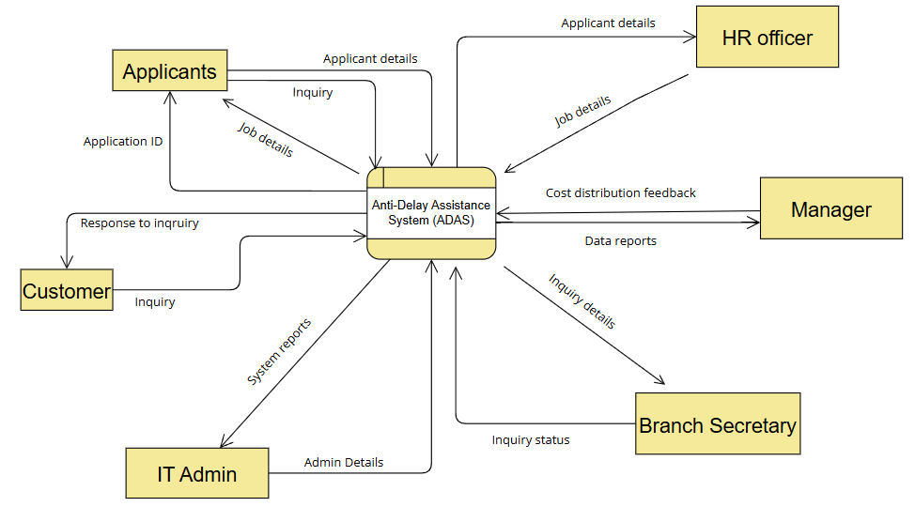

*Figure 8. Level 0 Diagram*

Level 1 Diagram:

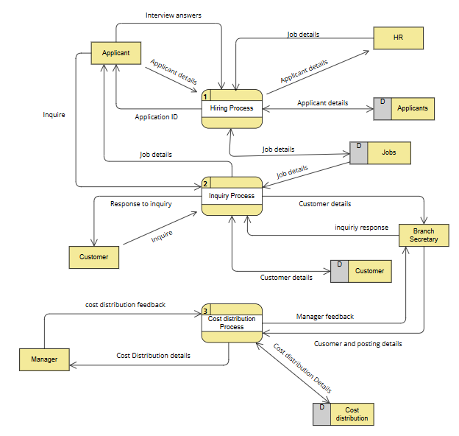

*Figure 9. Level 1 Diagram*

Level 2.1 Diagram (Hiring System):

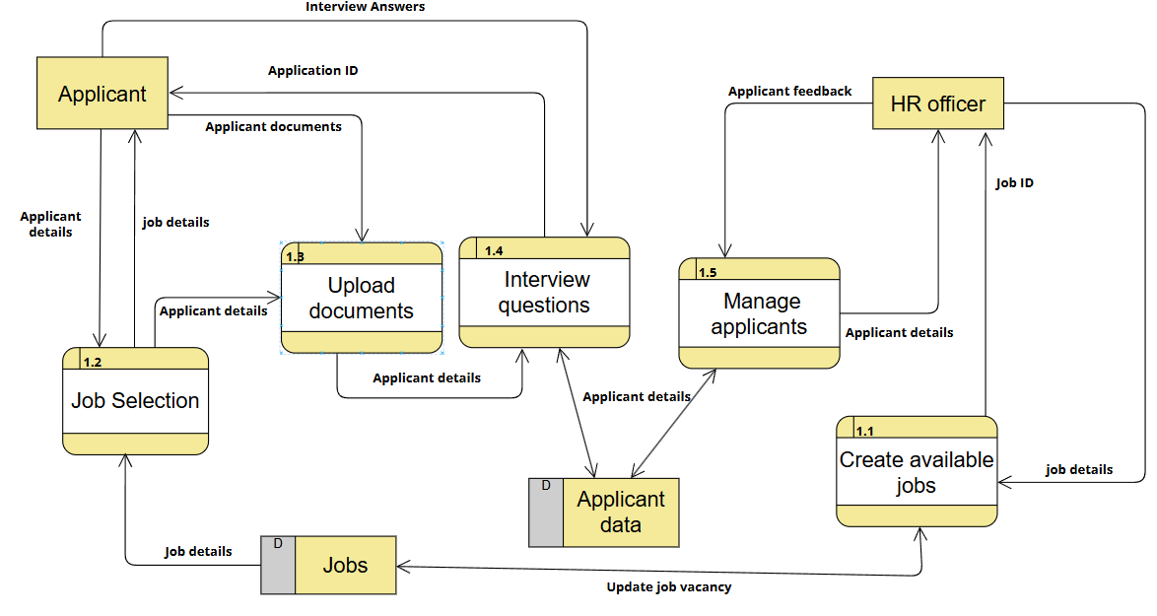

*Figure 10. Level 2.1 Diagram*

Level 2.2 Diagram (Inquiry System)

*Figure 11. Level 2.2 Diagram*

Level 2.3 Diagram (Cost Distribution System)

*Figure 12. Level 2.3 Diagram*

# Requirements Analysis

## 5.1 Product Backlog / User Stories

|  |  |  |  |  |  |  |
| --- | --- | --- | --- | --- | --- | --- |
| **ID** | **As a..** | **I want to be able to...** | **So that...** | **Priority** | **Sprint** | **Status** |
| 1 | Customer | Check for any potential job openings the company may have in my area and as well as their necessary requirements | I can be able to apply once I have the proper requirements and be able to know what these necessary requirements are | Should | 1 | Not Started |
| 2 | Applicant | Check for any potential job openings the company may have in my area and as well as their necessary requirements | I can be able to apply once I have the proper requirements and be able to know what these necessary requirements are | Should | 1 | Not Started |
| 3 | Applicant | To be able to fill out an application form online whilst also providing the necessary documents via an online method as well | I would still be able to apply for a job if I am not available to directly go into the necessary offices. | Should | 1 | Not Started |
| 4 | Customer | Get a clear idea of the company’s costing metrics | I can determine what kind of service I will avail from them | Would | 1 | Not Started |
| 5 | Customer | Gain inquiries at a rapid pace with minimum wait time | I can be able to gain further clarification if there are specific details I would need to be addressed | Should | 1 | Not Started |
| 6 | HR Officer | View the lists of current pending applicants/current pending customers without the risk of them being unprioritized in a messaging queue of sorts | I can easily be able to assess, keep track, and accommodate each one in time without the risk of having forgotten one. | Should | 2 | Not Started |
| 7 | Branch Secretary | More easily calculate the cost distributions for the sake of the customer proposal | I would be able to save time in making the document to be sent to the potential customer | Would | 2 | Not Started |
| 8 | IT Admin | Be able to be immediately notified if something goes wrong for either the website or the chatbot | I would be able to quickly begin making the necessary software repairs and other maintenance related measures | Would | 1 | Not Started |
| 9 | IT Admin | Make, edit, and delete an account | I would be able to differentiate myself from applicants and customers, make the necessary changes to my account once a situation that warrants that change comes, and secure my data permanently if my tenure within the company is over | Should | 2 | Not Started |
| 10 | IT Admin | Login/Logout | So that I would be able to access my account at any time and be able to secure my data | Would | 1 | Not Started |
| 11 | Branch Secretary | Make, Edit, and Delete an account | I would be able to differentiate myself from applicants/customers, make the necessary changes to my account once a situation that causes confusion comes and secure my data permanently if I no longer work for the company | Should | 2 | Not Started |
| 12 | Branch Secretary | Login/Logout | So that I would be able to access my account whenever it is necessary and secure my data once my shift is over or when I am not at work | Would | 1 | Not Started |
| 13 | HR Officer | Make/Edit/Delete an account | I would be able to differentiate myself from applicants/potential customers, make the necessary changes to my account once a situation that warrants that change comes, and secure my data permanently if I no longer work for the company | Should | 2 | Not Started |
| 14 | HR Officer | Login/Logout | So that I would be able to access my account at any time whenever it is necessary. And in any device that I can be contacted through as well as be able to secure my data and as well as the data of potential applicants | Would | 1 | Not Started |
| 15 | General Manager | Approve/Deny Cost Distributions | So that I can check the validity, and the feasibility of a customer’s demands based on the details of the cost distribution that has been made by the branch secretary | Should | 1 | Not Started |
| 16 | General Manager | Analyze Reports | So that I can track the number of applicants, job openings, cost distribution requests, and reports recorded in the system | Would | 1 | Not Started |
| 17 | General Manager | Make/Edit/Delete an account | I would be able to differentiate myself from applicants/potential customers, make the necessary changes to my account once a situation that warrants that change comes, and secure my data permanently if I no longer work for the company | Should | 2 | Not Started |
| 18 | General Manager | Login/Logout | So that I would be able to access my account at any time whenever it is necessary. And in any device that I can be contacted through as well as be able to secure my data and as well as the data of potential applicants | Would | 1 | Not Started |

*Table 5 Product Backlog*

## 5.2 Use Case Diagram

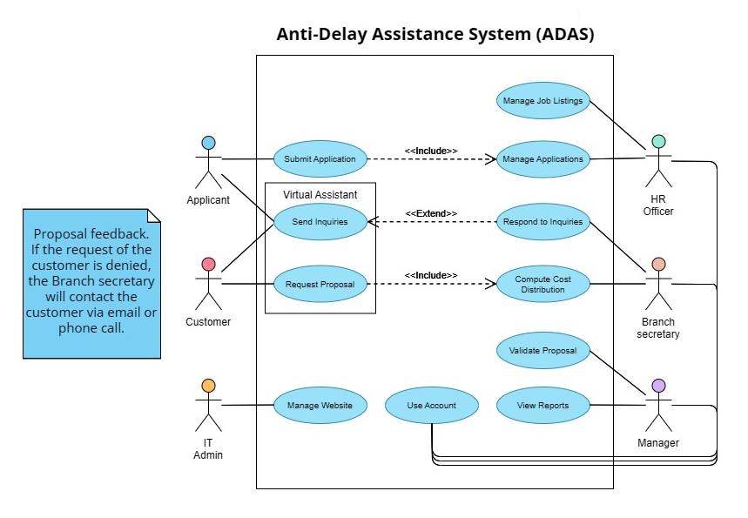*Figure 13. Use Case Diagram*

## 5.3 Fully Dressed Use Cases

Inquiry Process:

|  |  |
| --- | --- |
| Use Case ID: | UCC-001 |
| Use Case Name: | Send Inquiry |
| Author: | Alexus Sabanal |
| Date Created: | 2024/08/27 |
| Description | This is the process wherein the customer/applicant asks an inquiry through a virtual assistant. The virtual assistant processes the inquiry, and if it is not included in the FAQ (Frequently Asked Questions), it redirects the inquiry to the Branch Secretary for further action. |
| Primary Actor | Customer/Applicant |
| Secondary Actor | Branch Secretary/HR Officer |
| Extends Use Case | Respond to Inquiries  Submit Application |
| Precondition | 1. The virtual assistant must be available and fully functioning |
| Postcondition | 1. The Customer/Applicant receives an appropriate response to their inquiry. 2. The Customer’s inquiry is forwarded to the Branch Secretary. 3. The Applicant’s inquiry is forwarded to the HR Officer. |
| Main Flow: | 1. The Customer/Applicant initiates an inquiry via the virtual assistant (e.g., asking about branch hours). 2. The virtual assistant receives the inquiry and analyzes the content. 3. If the inquiry is general: The virtual assistant answers it directly. 4. If the inquiry is not within the FAQ: The virtual assistant asks for the Customer or Applicant’s details (Name, Phone Number/Email Address) and the nature of the inquiry. (Extends use case point: Inquiry Answering) 5. If the inquiry is about Job Applications: The virtual assistant tells the Applicant about what Job Openings are available.  * If they would want to apply: Proceed to the Applicant Form (Extends use case point: Submit Application) * If not, The Process would end. |

*Table 6 Inquiry Process*

Application process:

|  |  |
| --- | --- |
| Use Case ID: | UCC-002 |
| Use Case Name: | Submit Application |
| Author: | Alexus Sabanal |
| Date Created: | 2024/08/27 |
| Description | This is the process where the Applicant submits the documents to the system for the HR Officer to view. |
| Primary Actor | Applicant |
| Secondary Actor | N/A |
| Include Use Case | N/A |
| Precondition | 1. A job opening must be available and posted on the website |
| Post condition | 1. The Applicant receives an Application ID |
| Main Flow: | 1. The Applicant clicks Apply Now 2. The System shows the available Job Details. 3. The Applicant is given the option to choose which job opening he will apply to. 4. The system prompts the Applicant to submit the required documents for the position 5. The Applicant uploads the required documents.    1. **If the documents submitted are complete:** The Applicant proceeds to the next step    2. **If not complete:** The Applicant cannot proceed. End Use Case. 6. The system prompts the Applicant to then answer a series of Interview Questions. 7. The Applicant answers the interview questions    1. **If the Applicant answers all the questions:** They can proceed to the next step.    2. **If not:** The Applicant cannot proceed. End Use Case. 8. The system generates an application ID to the applicant. Signaling to them that the Application has been submitted. 9. The Applicant receives the Application ID. End Use Case. |

*Table 7 Application Process*

Cost Distribution Inquiry:

|  |  |
| --- | --- |
| Use Case ID: | UCC-003 |
| Use Case Name: | Request Proposal |
| Author: | Alexus Sabanal |
| Date Created: | 2024/08/27 |
| Description | This is the process where the Customer inquiries about the Cost Distribution Sheet through the virtual assistant, with the virtual assistant relaying any more specific inquiry to the Branch Secretary. |
| Primary Actor | Customer |
| Secondary Actor | Branch Secretary, Manager |
| Include Use Case | Compute Cost Distribution |
| Precondition | 1. The Branch Secretary must be available 2. The Virtual Assistant must be available and fully functioning |
| Postcondition | 1. The Customer receives a reference number for their proposal. |
| Main Flow: | 1. The Customer initiates an inquiry related to the Cost Distribution of a certain plan the company offers. 2. The virtual assistant receives the inquiry and asks for the customer’s details (Name, Phone Number/Email Address) as well as necessary details for calculating the Cost Distribution (Location, Amount, Hours). 3. The Customer receives a reference number as the Branch Secretary triggers use case Compute Cost Distribution. |

*Table 8 Cost Distribution Inquiry*

Access Profiles:

|  |  |
| --- | --- |
| Use Case ID: | UCC-004 |
| Use Case Name: | Use Account |
| Author: | Krishna Mandal |
| Date Created: | 2024/08/27 |
| Description | This is the process where the Primary Actor accesses their designated dashboard through the creation or access of an account. |
| Primary Actor | HR Officer/Branch Secretary/Manager |
| Secondary Actor | None |
| Precondition | None |
| Postcondition | The admin accesses their dashboard so that they can fulfill other use cases. |
| Main Flow: | 1. The employee enters the Login portal. 2. If the employee does not have an account, the employee inputs their Employee ID, other credentials, and department into the Registration and hits submit. 3. The employee inputs their Employee ID. 4. The employee inputs their password.  * If the password is correct: Proceed to employee dashboard. End Use Case. * If the password is wrong: Repeat Step 3. * If they cannot remember their password, they can enter their e-mail to request a password reset. |

*Table 9 Access Profiles*

Manage Website:

|  |  |
| --- | --- |
| Use Case ID: | UCC-005 |
| Use Case Name: | Manage Website |
| Author: | Krishna Mandal |
| Date Created: | 2024/08/27 |
| Description | This is the process where the IT Admin accesses the website’s administrative panel to fix site problems or change data. |
| Primary Actor | IT Admin |
| Secondary Actor | None |
| Generalization | Log In |
| Precondition | The dashboard must have a valid username and password. |
| Postcondition | The IT Admin can use the admin dashboard tools to create, update, and delete accounts, as well as conduct general site maintenance. |
| Main Flow: | 1. The IT Admin accesses the dashboard page. 2. The IT Admin enters an admin username. 3. The IT Admin enters the password.  * If the password is correct: Proceed to SQL dashboard. End Use Case. * If the password is wrong: Repeat Step 3. |

*Table 10 Manage Website*

Job Creation:

|  |  |
| --- | --- |
| Use Case ID: | UCC-006 |
| Use Case Name: | Manage Job Details |
| Author: | Marc Angelo Nerez |
| Date Created: | 2024/08/27 |
| Description | This process involves the HR Officer posting an available job through the dashboard. The job will be stored and recognized by the virtual assistant, making it available for applicants to apply. |
| Primary Actor | HR Officer |
| Secondary Actor | None |
| Precondition | 1. HR account must be logged in. |
| Postcondition | 1. The job posting is stored in the system and is available for applicants to apply to through the virtual assistant. |
| Main Flow: | 1. The HR Officer logs into the admin dashboard. 2. The HR Officer navigates to the job posting section. 3. HR either deletes or creates a job vacancy post. 4. The HR Officer inputs the job details (title, description, requirements, etc.). 5. The job vacancy is updated. 6. The virtual assistant’s postings and responses are updated to reflect the new vacancies. |

*Table 11 Job Creation*

Checking of applicants:

|  |  |
| --- | --- |
| Use Case ID: | UCC-007 |
| Use Case Name: | Manage Applications |
| Author: | Marc Angelo A. Nerez |
| Date Created: | 2024/08/27 |
| Description | The HR Officer reviews applications submitted by candidates through the dashboard. The system indicates what position or job details they are applying for. Applications are downloadable in PDF format. |
| Primary Actor | HR Officer |
| Secondary Actor | None |
| Precondition | 1. The HR Officer must be logged into the admin dashboard. 2. There must be available applications submitted by candidates. |
| Postcondition | 1. The HR Officer downloads and reviews the application(s) in PDF format. |
| Main Flow: | 1. The HR Officer logs into the admin dashboard. 2. The HR Officer navigates to the applicants' section. 3. The HR Officer views the list of applicants. 4. The system displays the applicants by date of application.  * If the applicant is qualified: The HR officer downloads the applicant’s details in PDF format. * If the applicant is not qualified: The HR officer can archive applications for future referral. |

*Table 12 Checking of Applicants*

Customer inquiries not handled by Virtual Assistant:

|  |  |
| --- | --- |
| Use Case ID: | UCC-008 |
| Use Case Name: | Respond to Inquiries |
| Author: | Marc Angelo A. Nerez |
| Date Created: | 2024/08/27 |
| Description | The Branch Secretary (or other employee) checks inquiries or requests made by customers via virtual assistant, which are not FAQ-related. This includes requests to speak with an agent or a request for a cost distribution. If the customer wishes to speak with an agent, their contact information (email or phone number) is provided, and if they want to request for a cost distribution, they will be required to give more information about the posting (number of guards, location, number of shifts per week, etc.) |
| Primary Actor | Branch Secretary |
| Precondition | 1. The customer has made an inquiry or request via the virtual assistant that is confirmed to be not FAQ-related. 2. The Branch Secretary is logged into the admin dashboard. |
| Postcondition | 1. The Branch Secretary responds to the inquiry. |
| Main Flow: | 1. The system notifies the Branch secretary of inquiries not yet handled. 2. The Branch Secretary checks for flagged inquiries. 3. The Branch Secretary sends a response to the inquiry. |

*Table 13 Customer Inquiries not handled by the Virtual Assistant*

Computation of cost distribution:

|  |  |
| --- | --- |
| Use Case ID: | UCC-009 |
| Use Case Name: | Compute Cost Distribution |
| Author: | Marc Angelo Nerez |
| Date Created: | 2024/08/27 |
| Description | The Branch Secretary computes a cost distribution using the cost distribution calculator and sends it to the General Manager for approval. |
| Primary Actor | Branch Secretary |
| Secondary Actor | General Manager |
| Precondition | 1. A customer has requested a cost distribution calculation. 2. The Branch Secretary is logged into the dashboard. |
| Postcondition | 1. The Cost distribution is stored on the system. 2. The manager has been notified about the new cost distribution. |
| Main Flow: | 1. The Branch Secretary logs into their dashboard and is notified about a cost distribution request. 2. The Branch Secretary sees the details of the customer.  * If the agency is unable to provide services: the Branch Secretary notifies the Customer and explains the reasons. * If the agency can provide services: the Branch Secretary computes the cost distribution based on the post details (e.g., number of guards, location, etc.).  1. The Branch Secretary inputs the customer-provided data into the cost distribution calculator. 2. The Branch Secretary finalizes and saves the cost distribution. |

*Table 14 Computation of Cost Distribution*

Cost distribution approval:

|  |  |
| --- | --- |
| Use Case ID: | UCC-010 |
| Use Case Name: | Validate Proposal |
| Author: | Marc Angelo Nerez |
| Date Created: | 2024/08/27 |
| Description | The Manager checks the cost distribution saved by the branch secretary and approves or disapproves of it. |
| Primary Actor | Manager |
| Secondary Actor | Branch Secretary |
| Precondition | 1. A cost distribution calculation has been created. 2. The Manager is logged into the admin dashboard. |
| Postcondition | 1. The Branch Secretary receives feedback from the Manager. |
| Main Flow: | 1. The Manager logs into the system using their credentials to access the admin dashboard. 2. The Manager receives notification that a new proposal has been submitted. 3. The Manager navigates to the cost distribution proposal section and reviews the submitted proposal. 4. The Manager gives their feedback.  * If Approved: The system updates the status of the proposal as "Approved." * If Disapproved: The Manager is required to provide reasons for the disapproval.  1. The system sends a notification to the Branch Secretary, informing them of the Manager's decision along with any accompanying feedback or reasons. |

*Table 15 Cost Distribution Approval*

Manager Views Reports:

|  |  |
| --- | --- |
| Use Case ID: | UCC-011 |
| Use Case Name: | Manager Views Reports |
| Author: | Marc Angelo Nerez |
| Date Created: | 2024/09/27 |
| Description | This user case describes how a manager receives various reports from the dashboard, including the number of applicants, customer requests for proposals, and jobs created for hiring |
| Primary Actor | Manager |
| Secondary Actor | N/A |
| Precondition | 1. The Manager is logged into the admin dashboard. |
| Postcondition | 1. The Manager Successfully views he reports on their dashboard 2. The Manager can download or print the reports if necessary |
| Main Flow: | 1. The Manager logs into the system using their credentials to access the admin dashboard. 2. The Manager navigates to the reports system of the dashboard 3. The Manager selects the “View Reports” tab. 4. The Manager chooses the month of the report they want generated 5. The system generates the selected report based on the latest data 6. The Manager reviews the report in full detail  * The Manager has the option to download or print the report for further analysis and record keeping |

*Table 16 Manage Views Reports*

5.4 User Classes and Characteristics

|  |  |
| --- | --- |
| ROLES | DESCRIPTION |
| Human Resource Management | These are the HR staff of SMGWSSI that will receive data regarding the applicant's files and are also responsible for ensuring the hiring process is followed. |
| Branch Secretary | They are the ones that handle the details of cost distributions and delivery of proposals to customers. They are also responsible for responding to inquiries through the company’s phone or social media. |
| IT Administrator | These are the IT Admins that handle the portals data that can also be used to troubleshoot if it occurs. They are also responsible for responding to the issues that are on the system. |
| Potential Customers | These are users that are potential customers of SMGWSSI. They visit the website to know more about SMGWSSI or inquire regarding pricing, availability in their location or request a proposal for their security needs. |
| Applicants | The applicants can be any user who applies for a security guard, security officer, or any office admin position. |

*Table 17 User Classes and Characteristics*

## 5.4 Test Cases for Fully Dressed Use Cases

Inquiry_001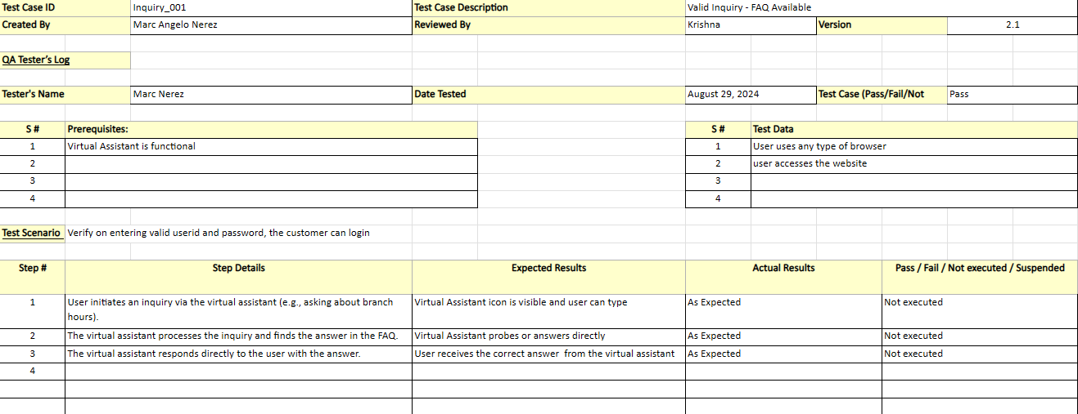

*Figure 14. Inquiry_001 Test Case*

Inquiry_002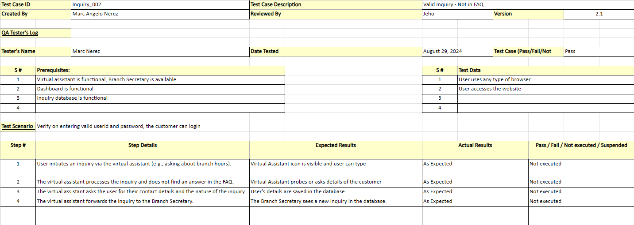

*Figure 15. Inquiry_002 Test Case*

Inquiry_003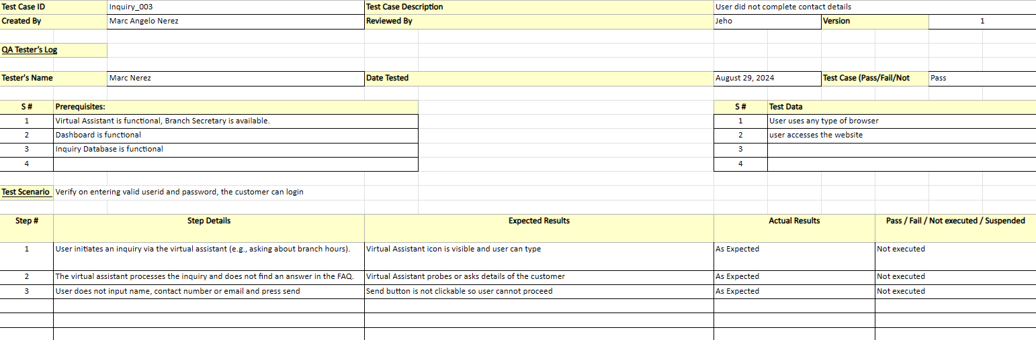

*Figure 16. Inquiry_003 Test Case*

Jobmanagement_001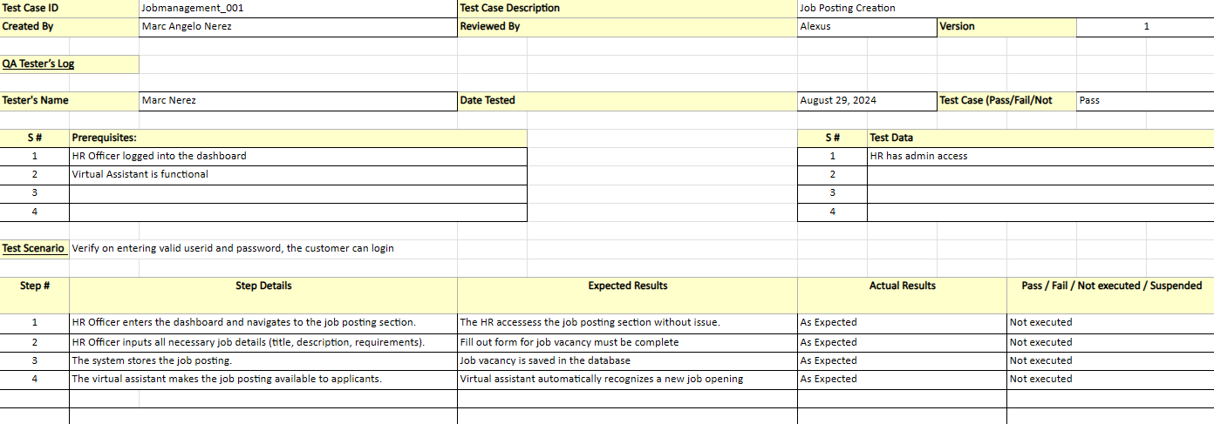

*Figure 17. Jobmanagement_001 Test Case*

Jobmanagement_002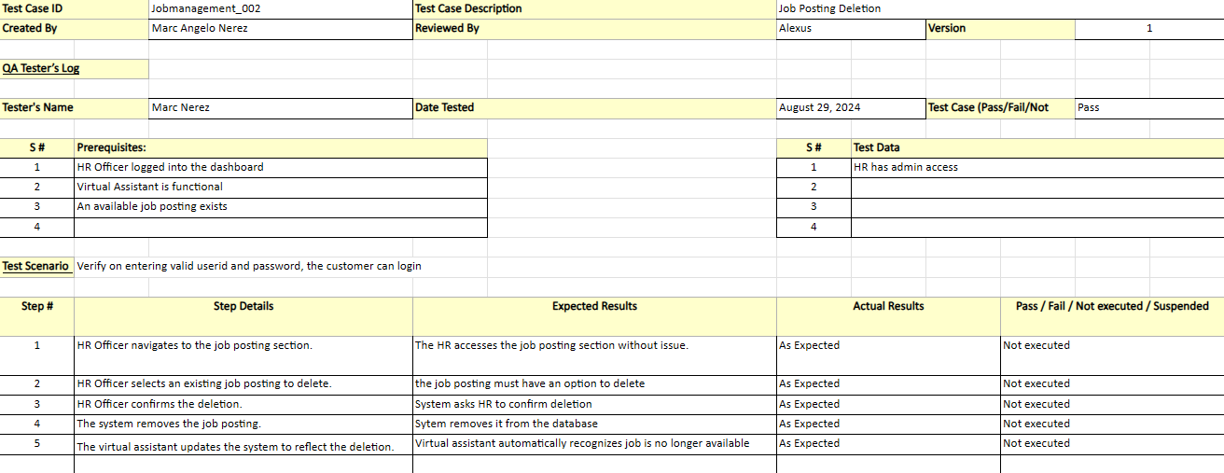

*Figure 18. Jobmanagement_002 Test Case*

Jobmanagement_003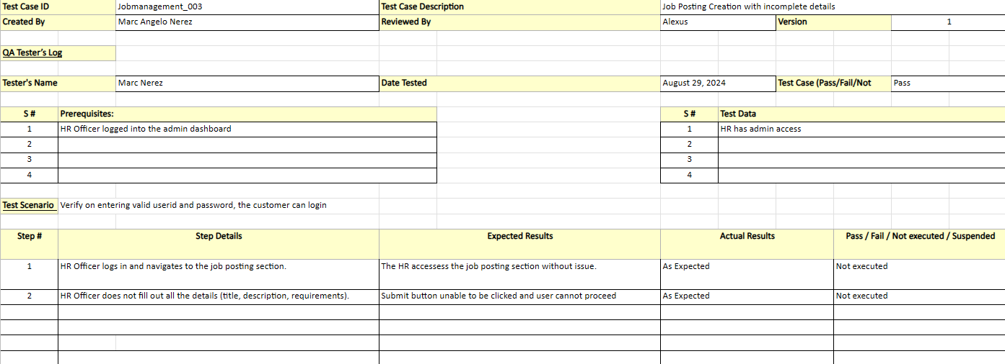

*Figure 19. Jobmanagement_003 Test Case*

Hiring_001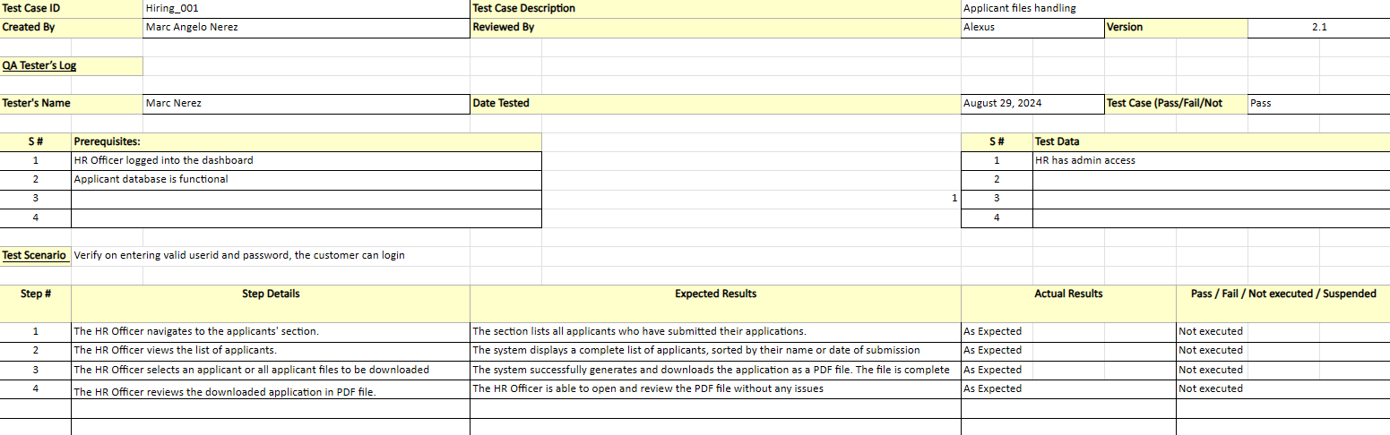

*Figure 20. Hiring_001 Test Case*

Application_001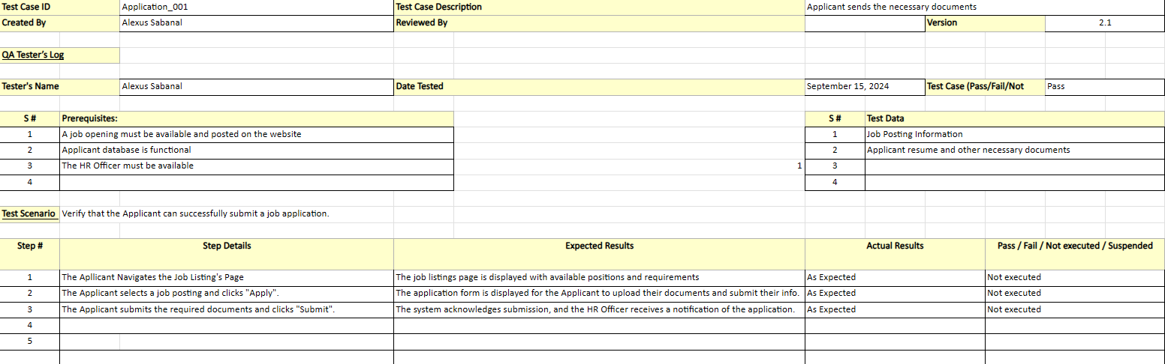

*Figure 21. Application_001 Test Case*

Application_002

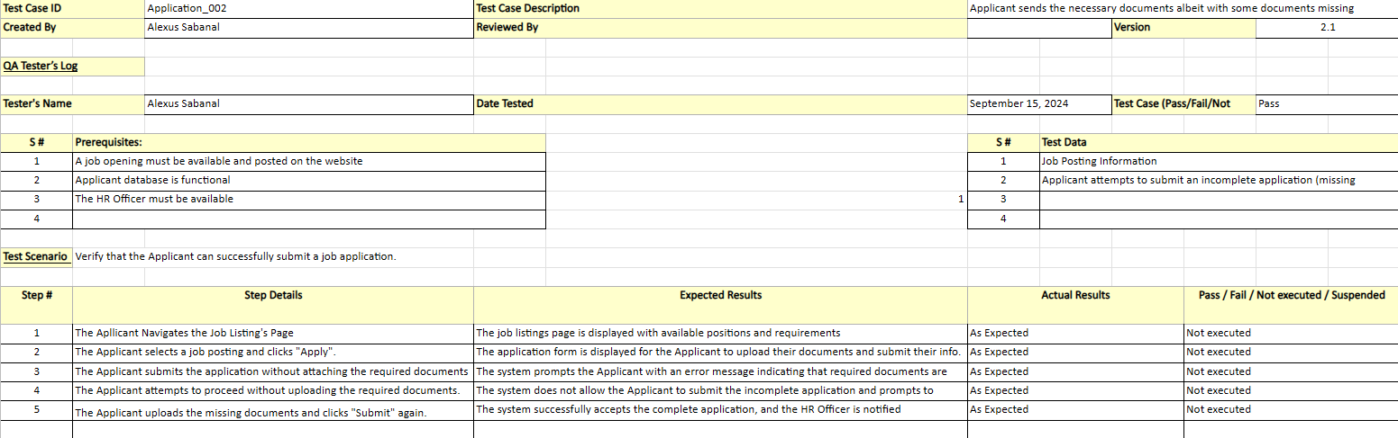

*Figure 22. Application_002 Test Case*

Cost_Distribution_001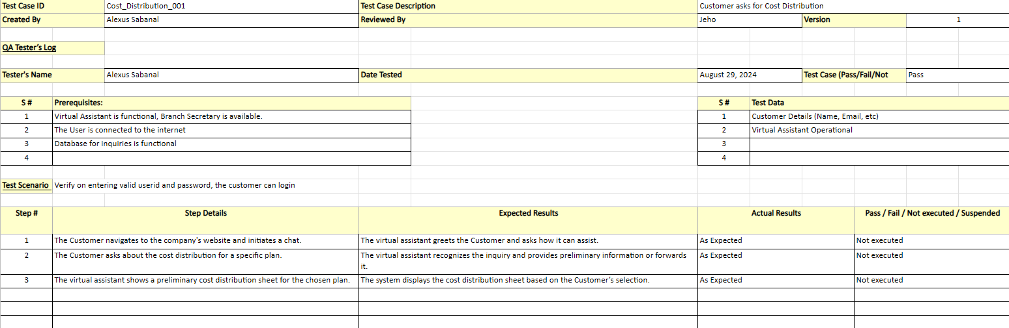

*Figure 23. Cost_Distribution_001 Test Case*

Cost_Distribution_002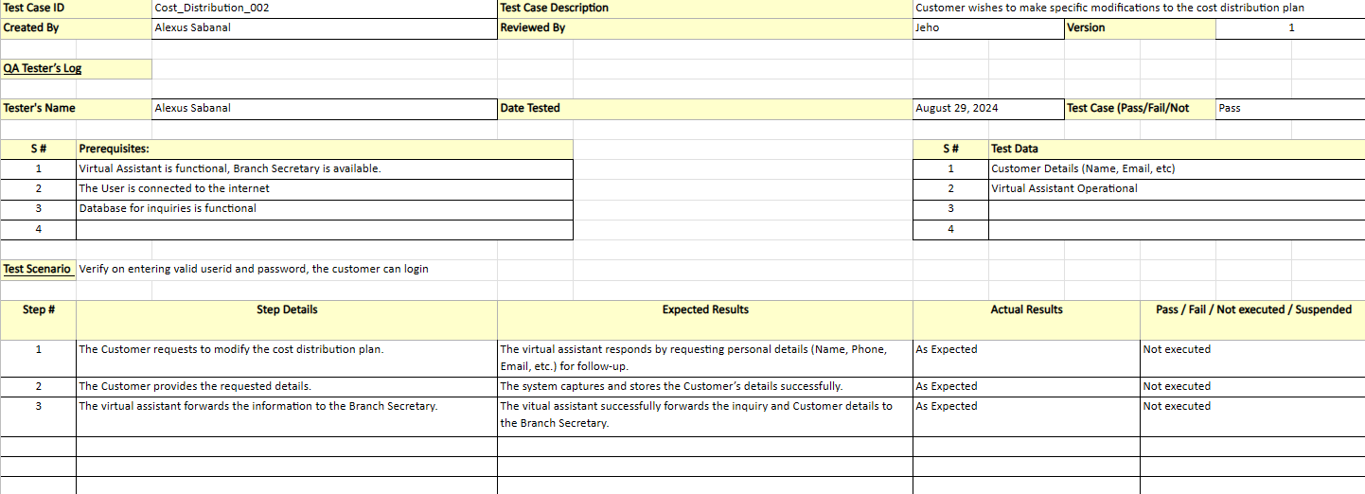

*Figure 24. Cost_Distribution_002 Test Case*

Cost_Distribution_003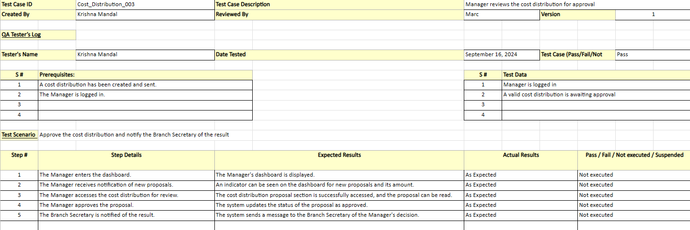

*Figure 25. Cost_Distribution_003 Test Case*

## 5.5 Activity Diagrams with Swimlane

UCC-001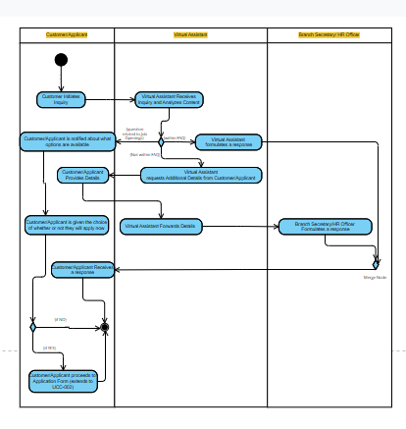

*Figure 27. UCC-001 Activity Diagram*

UCC-002

*Figure 28. UCC-002 Activity Diagram*

UCC-003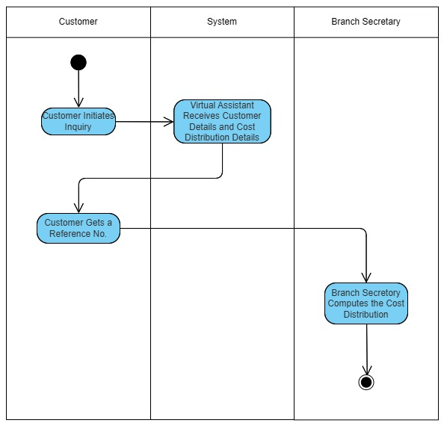

*Figure 29. UCC-003 Activity Diagram*

UCC-004  
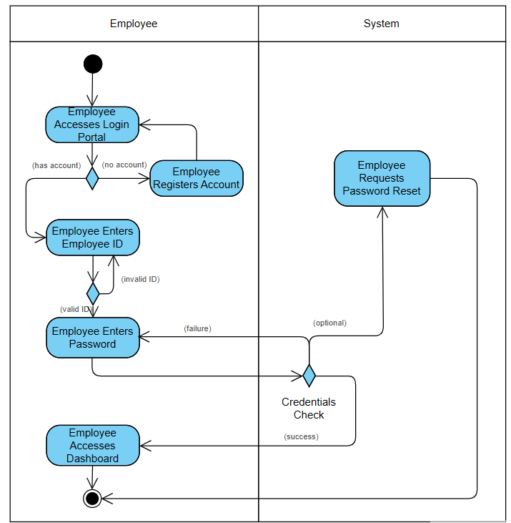

*Figure 30. UCC-004 Activity Diagram*

UCC-005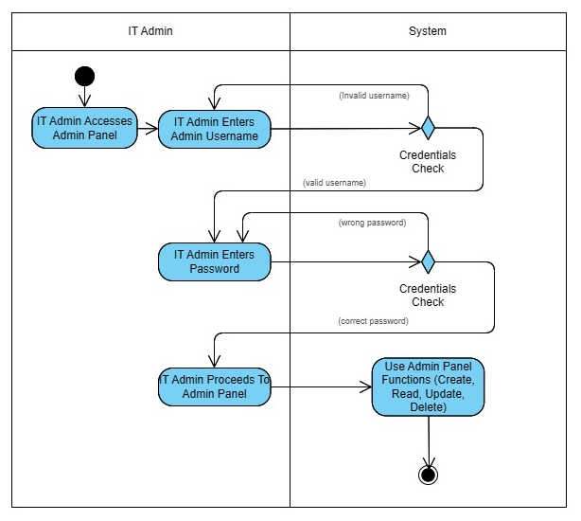

*Figure 31. UCC-005 Activity Diagram*

UCC-006

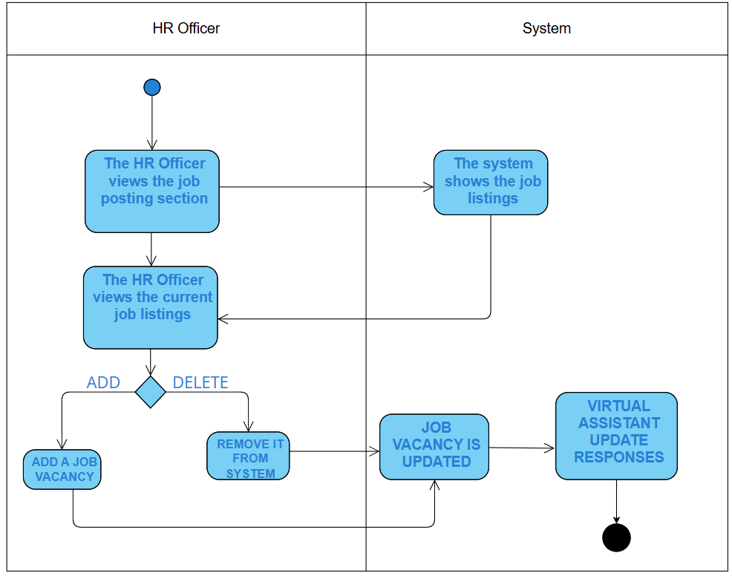

*Figure 32. UCC-006 Activity Diagram*

UCC-007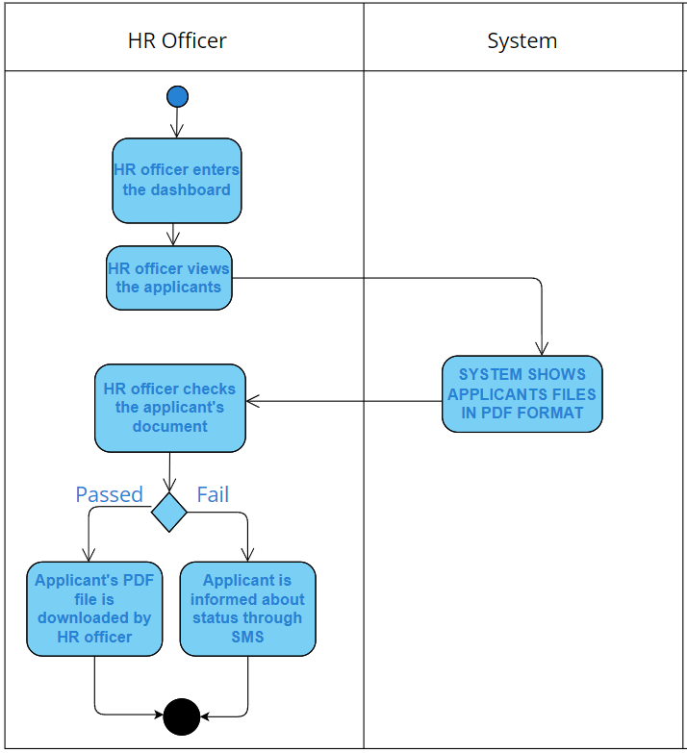

*Figure 33. UCC-007 Activity Diagram*

UCC-008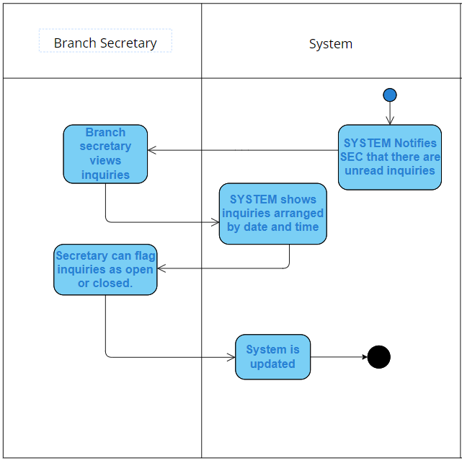

*Figure 34. UCC-008 Activity Diagram*

UCC-009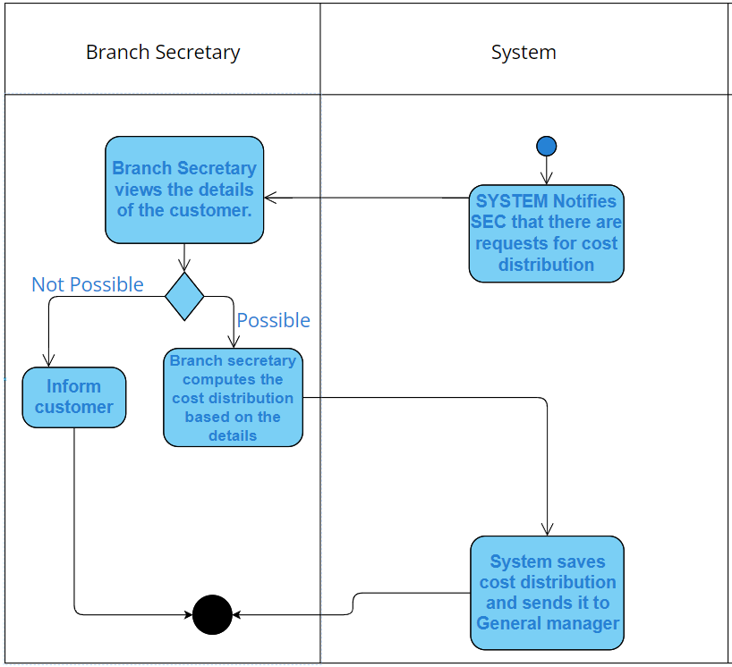

*Figure 35. UCC-009 Activity Diagram*

UCC-010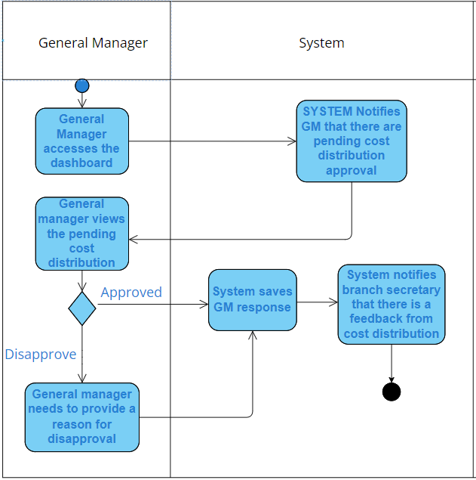

*Figure 36. UCC-010 Activity Diagram*

UCC-011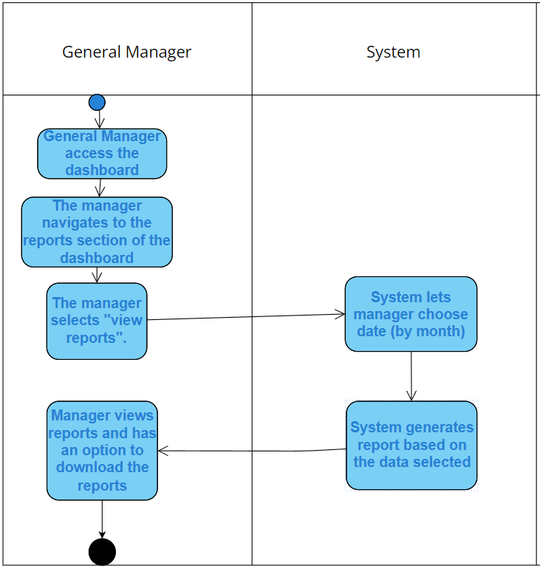

*Figure 37. UCC-011 Activity Diagram*

## 5.6 Entity Relationship Diagram and Data Dictionary

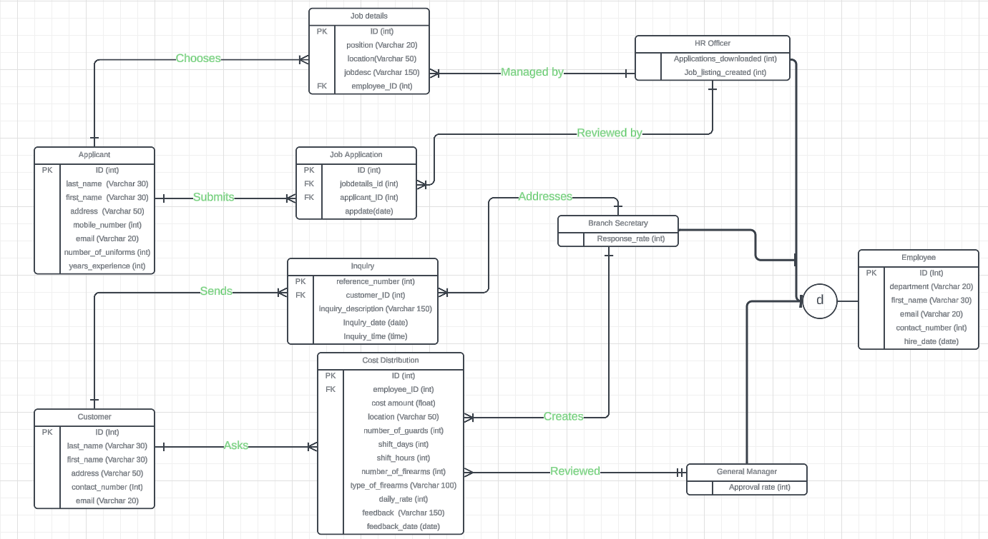

*Figure 38. Entity Relationship Diagram*

**Data Dictionary:**

**1. Linking "Applicant" to "Job Details":**

* **Applicant (PK: Applicant_ID)**:
  + Each applicant chooses a job from the job details. There is a one-to-many relationship between "Applicant" and "Job Details" (i.e., one applicant can apply to multiple job details).
  + The relationship between "Applicant" and "Job Details" should be represented with a Job_Application entity, which would act as a joining table.

**Job_Application:**

* + Application_ID (PK)
  + Applicant_ID (FK from Applicant)
  + Job_ID (FK from Job Details)
  + Application_Date (Date the applicant applied for the job)

This table captures which job the applicant applied to and the application date.

**2. Connecting "HR Officer" to "Job Details" and "Requirements":**

* **HR Officer (PK: Employee_ID)**:
  + An HR officer can create job details and review requirements submitted by applicants.
  + The relationship between "HR Officer" and "Job Details" should be one-to-many (one HR Officer can create many job details).
  + You should add a Created_By field in "Job Details" that references Employee_ID from "HR Officer".

**Job Details (PK: Job_ID)**:

* + Job_ID (PK)
  + Position
  + Location
  + Job_Description
  + Created_By (FK from HR Officer, Employee_ID)

**Requirements (PK: Document_ID)**: - Add a relationship where "HR Officer" reviews and filters the requirements submitted by applicants. A new field can be added in the "Requirements" entity: - Reviewed_By (FK from HR Officer, Employee_ID)

**3. Linking "Customer" to "Inquiry" and "Business Proposal":**

* **Customer (PK: Customer_ID)**:
  + A customer initiates an inquiry, which can later lead to a business proposal. The relationship between "Customer" and "Inquiry" should be one-to-many.
  + The "Customer" entity is already connected to "Inquiry", but the proposal stage should also be connected.

**Inquiry (PK: Reference_Number)**:

* + Reference_Number (PK)
  + Customer_ID (FK from Customer)
  + Inquiry_Description
  + Inquiry_Date
  + Inquiry_Time

**Business Proposal (PK: Proposal_ID)**:

* + A business proposal is created based on the inquiry.
  + Link the "Inquiry" table to the "Business Proposal" using an Inquiry_ID field in "Business Proposal". This shows that a business proposal originates from an inquiry.

**Business Proposal:**

* + Proposal_ID (PK)
  + Customer_ID (FK from Customer)
  + Inquiry_ID (FK from Inquiry)
  + Proposal_Description
  + Required_Quantity
  + Shift_Hours
  + Posting_Date
  + Employee_ID (FK from HR Officer or Branch Secretary)

**4. Cost Distribution and Manager Approval:**

* **Cost Distribution (PK: CostID)**:
  + The "Cost Distribution" entity represents the calculated costs for a business proposal and needs approval from a manager. The relationship should be:
    - Many proposals can have cost distributions, but a proposal can have only one cost distribution.
    - A manager approves each cost distribution.

**Cost Distribution:**

* + CostID (PK)
  + Proposal_ID (FK from Business Proposal)
  + Customer_ID (FK from Customer)
  + Employee_ID (FK from Employee – could be HR Officer or Branch Secretary)
  + Cost_Amount
  + Approved_By (FK from Manager, Employee_ID)
* **Manager (PK: Employee_ID)**:
  + The "Manager" approves the cost distribution.
  + A Decision_Date field can be added to track when the cost was approved or rejected.

**5. Branch Secretary Involvement:**

* **Branch Secretary (PK: Employee_ID)**:
  + A branch secretary also plays a role in managing inquiries and proposals. You can have the secretary assist in creating proposals or managing inquiries.

**Branch Secretary Role:**

* + Can check or review inquiries.
  + Can assist in preparing a business proposal.

In the "Business Proposal" table, you can have an additional field Prepared_By to indicate whether the proposal was prepared by the HR Officer or the Branch Secretary.

**6. Connecting All Entities:**

The relationships between all entities can be summarized as:

* **Applicant** applies to a **Job Details** (via Job_Application).
* **Customer** creates an **Inquiry**, which leads to a **Business Proposal**.
* A **HR Officer** or **Branch Secretary** can be responsible for creating the business proposal.
* **Cost Distribution** calculates the cost of the proposal, and a **Manager** approves it.

**Updated Table Structures:**

Applicant

|  |  |  |  |  |  |  |
| --- | --- | --- | --- | --- | --- | --- |
| **Attribute Name** | **Contents/Description** | **Data Type** | **Format/Range** | **Required** | **PK or FK** | **FK Reference** |
| applicant_ID | Unique identifier for each applicant | Int | Auto-Increment | Yes | PK |  |
| last_name | Applicant's last name | Varchar(50) | Text | Yes |  |  |
| first_name | Applicant's first name | Varchar(50) | Text | Yes |  |  |
| address | Applicant's address | Varchar(100) | Text | No |  |  |
| mobile_number | Applicant's mobile phone number | Varchar(20) | Numeric String | No |  |  |
| email | Applicant's email | Varchar(50) | Email format | No |  |  |

*Table 18 Applicant Table*

Job Details

|  |  |  |  |  |  |  |
| --- | --- | --- | --- | --- | --- | --- |
| **Attribute Name** | **Contents/Description** | **Data Type** | **Format/Range** | **Required** | **PK or FK** | **FK Reference** |
| jobdetails_ID | Unique identifier for each job details | Int | Auto-Increment | Yes | PK |  |
| position | Job position being advertised | Varchar(50) | Text | Yes |  |  |
| location | Location of the job | Varchar(50) | Text | Yes |  |  |
| jobdesc | Description of the job | Varchar(255) | Text | No |  |  |
| employee_ID | Reference to the HR Officer who created the job | Int | Foreign Key | Yes | FK | Employee.employee_ID |

*Table 19 Job Details Table*

Job Application

|  |  |  |  |  |  |  |
| --- | --- | --- | --- | --- | --- | --- |
| **Attribute Name** | **Contents/Description** | **Data Type** | **Format/Range** | **Required** | **PK or FK** | **FK Reference** |
| jobapplication_ID | Unique identifier for each job application | Int | Auto-Increment | Yes | PK |  |
| jobdetails_ID | Reference to the applied job details | Int | Foreign Key | Yes | FK | Job Details.jobdetails_ID |
| applicant_ID | Reference to the applicant applying for the job | Int | Foreign Key | Yes | FK | Applicant.applicant_ID |
| appdate | Date when the applicant applied | Date | YYYY-MM-DD | Yes |  |  |

*Table 20 Job Application Table*

Customer Table

|  |  |  |  |  |  |  |
| --- | --- | --- | --- | --- | --- | --- |
| **Attribute Name** | **Contents/Description** | **Data Type** | **Format/Range** | **Required** | **PK or FK** | **FK Reference** |
| customer_ID | Unique identifier for each customer | Int | Auto-Increment | Yes | PK |  |
| last_name | Customer's last name | Varchar(50) | Text | Yes |  |  |
| first_name | Customer's first name | Varchar(50) | Text | Yes |  |  |
| address | Customer's address | Varchar(100) | Text | No |  |  |
| contact_number | Customer's contact number | Varchar(20) | Numeric String | No |  |  |
| email | Customer's email address | Varchar(50) | Email format | No |  |  |

*Table 21 Customer Table*

Inquiry Table

|  |  |  |  |  |  |  |
| --- | --- | --- | --- | --- | --- | --- |
| **Attribute Name** | **Contents/Description** | **Data Type** | **Format/Range** | **Required** | **PK or FK** | **FK Reference** |
| reference_number | Unique identifier for each inquiry | Int | Auto-Increment | Yes | PK |  |
| customer_ID | Reference to the customer making the inquiry | Int | Foreign Key | Yes | FK | Customer.customer_ID |
| inquiry_description | Description of the inquiry | Varchar(255) | Text | Yes |  |  |
| inquiry_date | Date the inquiry was made | Date | YYYY-MM-DD | Yes |  |  |
| inquiry_time | Time the inquiry was made | Time | HH:MM | Yes |  |  |

*Table 22 Inquiry Table*

Business Proposal

|  |  |  |  |  |  |  |
| --- | --- | --- | --- | --- | --- | --- |
| **Attribute Name** | **Contents/Description** | **Data Type** | **Format/Range** | **Required** | **PK or FK** | **FK Reference** |
| proposal_ID | Unique identifier for each proposal | Int | Auto-Increment | Yes | PK |  |
| customer_ID | Reference to the customer receiving the proposal | Int | Foreign Key | Yes | FK | Customer.customer_ID |
| inquiry_ID | Reference to the inquiry related to the proposal | Int | Foreign Key | Yes | FK | Inquiry.reference_number |
| proposal_description | Detailed description of the proposal | Varchar(255) | Text | No |  |  |
| required_quantity | Quantity of service or product requested | Int | Numeric | Yes |  |  |
| posting_date | Date the proposal was posted | Date | YYYY-MM-DD | Yes |  |  |
| employee_ID | Reference to the employee who prepared the proposal | Int | Foreign Key | Yes | FK | Employee.employee_ID |

*Table 23 Business Proposal Table*

Employee Table

|  |  |  |  |  |  |  |
| --- | --- | --- | --- | --- | --- | --- |
| **Attribute Name** | **Contents/Description** | **Data Type** | **Format/Range** | **Required** | **PK or FK** | **FK Reference** |
| employee_ID | Unique identifier for each employee | Int | Auto-Increment | Yes | PK |  |
| department | Department in which the employee works | Varchar(50) | Text | Yes |  |  |
| first_name | Employee's first name | Varchar(50) | Text | Yes |  |  |
| last_name | Employee's last name | Varchar(50) | Text | Yes |  |  |
| email | Employee's email address | Varchar(50) | Email format | Yes |  |  |
| contact_number | Employee's phone number | Varchar(20) | Numeric String | No |  |  |
| hire_date | Date the employee was hired | Date | YYYY-MM-DD | Yes |  |  |

*Table 24 Employee Table*

Cost Distribution

|  |  |  |  |  |  |  |
| --- | --- | --- | --- | --- | --- | --- |
| **Attribute Name** | **Contents/Description** | **Data Type** | **Format/Range** | **Required** | **PK or FK** | **FK Reference** |
| cost_ID | Unique identifier for cost distribution | Int | Auto-Increment | Yes | PK |  |
| employee_ID | Reference to the employee handling cost calculation | Int | Foreign Key | Yes | FK | Employee.employee_ID |
| cost_amount | The calculated cost for the proposal | Int | Numeric | Yes |  |  |
| location | Location of the cost distribution | Varchar(50) | Text | Yes |  |  |
| number_of_guards | Number of guards required | Int | Numeric | No |  |  |
| shift_days | Number of working days for the guards | Int | Numeric | No |  |  |
| shift_hours | Number of working hours per day | Int | Numeric | No |  |  |
| feedback | Customer feedback regarding the cost distribution | Varchar(255) | Text | No |  |  |
| feedback_date | Date when the feedback was provided | Date | YYYY-MM-DD | No |  |  |

*Table 25 Cost Distribution Table*

General Manager Table

|  |  |  |  |  |  |  |
| --- | --- | --- | --- | --- | --- | --- |
| **Attribute Name** | **Contents/Description** | **Data Type** | **Format/Range** | **Required** | **PK or FK** | **FK Reference** |
| employee_ID | Reference to the employee who is a general manager | Int | Foreign Key | Yes | FK | Employee.employee_ID |
| department | Department in which the general manager works | Varchar(50) | Text | Yes |  |  |
| first_name | General manager's first name | Varchar(50) | Text | Yes |  |  |
| last_name | General manager's last name | Varchar(50) | Text | Yes |  |  |
| contact_number | General manager's contact number | Varchar(20) | Numeric String | No |  |  |
| email | General manager's email address | Varchar(50) | Email format | No |  |  |
| hire_date | Date the general manager was hired | Date | YYYY-MM-DD | Yes |  |  |

*Table 26 General Manager Table*

## 5.7 Prototype

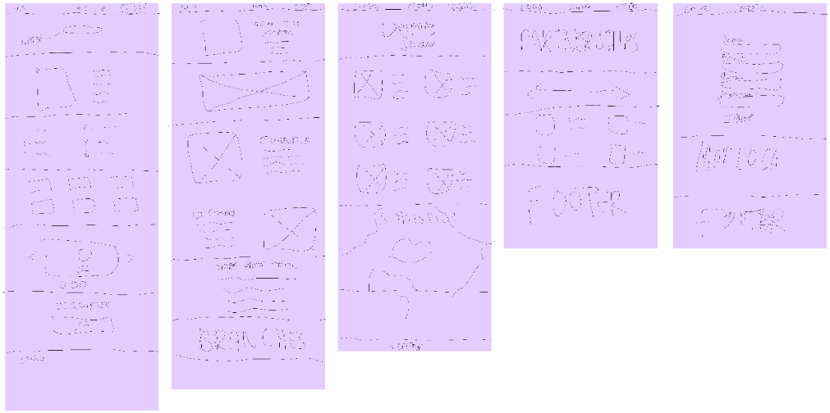

*Figure 39. Prototype Mock Flow*

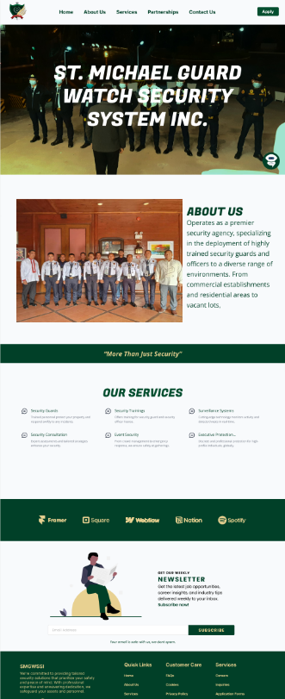

*Figure 40. Project Wireframe Screenshots*

# References

[1] 1M. Takalpati, “Online job application system: Why you need one,” Recruiteze, <https://recruiteze.com/online-job-application-system-why-you-need-one> (accessed Apr. 26, 2024).

[2] “Asia Pacific College RAMS page” <https://rams.apc.edu.ph/home> (accessed Apr. 26, 2024).

[3] Republic of the Philippines Social Security System, <https://www.sss.gov.ph/> (accessed Apr. 28, 2024).

[4] E. Pabellano, Jk. Valdes, and D. L. Galang, “The Ultimate Board Game Store,” Gaming Library, <https://www.gaminglib.com/> (accessed May 23, 2024).

[5] P. Cameron, “5 Benefits of automation: The advantages of automation.” [h](https://www.fortra.com/resources/guides/automation-advantages-5-benefits-automation) ttps://www.fortra.com/resources/guides/automation-advantages-5-benefits- automation

[6] GraffersID, “Advantages of MERN Stack Development,” *Graffersid*, Dec. 07, 2023. <https://graffersid.com/advantages-of-using-mern-stack/>

[7] C. Cerdeira, “Customer service chatbots: Benefits and examples,” Talkdesk, Jan. 09, 2024. <https://www.talkdesk.com/blog/chatbots-customer-service/>

[8] “Top 22 benefits of chatbots for businesses and customers,” *Zendesk*, May 08, 2024. [https://www.zendesk.com/blog/5-benefits-using-ai-bots-customer-](https://www.zendesk.com/blog/5-benefits-using-ai-bots-customer-service/) service/

[9] J. Erickson, “What is the MERN stack?,” Jan. 30, 2024.

<https://www.oracle.com/ph/database/mern-stack/#:~:text=Key%20Takeaways,js>.

[10] S. Rodin, “What are the security measures to prevent authentication attacks,”

Frontegg, [https://frontegg.com/blog/what-are-the-security-measures-to-prevent -](https://frontegg.com/blog/what-are-the-security-measures-to-prevent-authentication-) authentication- attacks (accessed May 23, 2024).

[11] Corinthians Group of Companies, “Top security agency in the Philippines - Security

guard, security training,” Corinthians Group of Companies, Sep. 08, 2023.

<https://www.corinthiansgroup.com/>

[12] “Dark horse Security Agency in Quezon City, Metro Manila,” Dark Horse Security

Agency. <https://www.darkhorsesecurity.com.ph/>

[13] “Philippine National Guard Security Agency, Inc. (PNGSA),” Philippine National Guard Security Agency, Inc. (PNGSA). <https://pngsa.com/>