*OptiTrack: Optimized Time Tracking with Productivity Insights*

Project Documentation Submitted to the Faculty of the

School of Computing and Information Technologies

Asia Pacific College

In Partial Fulfillment of the Requirements for

Introduction to Systems and Design for IT

MNTSDEV

By

|  |  |
| --- | --- |
| Robyn Dominique Fruto | Sondrick Frondrozo |
| Rick Laurence Cruz |  |
|  |  |

Table of Contents

List of Figures iv

List of Tables v

Introduction 1

Project Context 1

Statement of the Problem 1

Objectives 1

Significance of the Project 2

Scope and Limitations 2

Review of Related Literature / Systems 3

Current System 4

Technical Background 4

List of Processes 4

SWOT Analysis 5

Proposed Solution 5

Technical Background 5

Feasibility 5

Operational Feasibility 5

Economic Feasibility 5

Technical Feasibility 5

Schedule Feasibility 5

Requirements Analysis 5

Project Vision 5

Prototype (Mock Flow / Wireframe) 5

Project Lean Canvas 6

User Classes and Characteristics 6

Product Backlog 7

Product Roadmap 7

Release Plan 7

Use Case Diagram 7

Use Case Full Description 7

Conclusion 8

References 9

Appendices 10

Appendix A: Roles and Responsibilities 10

Appendix B: Minutes of the Meetings 11

Appendix C: Methodology 12

Appendix D: Project Sharepoint Link 13

# List of Figures

Figure 1 List of Processes Flowchart 9

Figure SWOT Analysis of the Current System 9

Figure Sign in Wireframe 13

Figure Employee Account 14

Figure OT Request Page Wireframe 14

Figure Analytics Page Wireframe 15

Figure Manage Employee Account - Manager Side 15

Figure Manage Recommendation - Manager Side Wireframe 16

Figure Use Case Diagram 21

# List of Tables

Table 1 List of Processes in the Current System 8

Table 2 Target Users and Their detailed needs 13

Table 3 Lean Canvas 16

Table 4 User and Characteristics Table 18

Table 5 Product Backlog Table 19

Table 6 Release Plan Table 20

Table 7 Manage Employee Account Use Case Description 22

Table 8 Manage Task Use Case Description 23

Table 9 Manage OT Use Case Description Table 25

Table 10 Manage Performance Use Case Description Table 27

Table 11 Manage Recommendations Use Case Description Table 28

Table 12 OT Approval Use Case Description Table 29

Table 13 View Reports Use Case Description Table 31

# Introduction

Overtime (OT) management plays a crucial role in workforce efficiency, ensuring fair compensation while optimizing operational productivity. However, the Capgemini Collections team faces significant challenges due to inefficiencies in the existing OT tracking and approval process. The reliance on third-party software such as Replicon has resulted in a lack of transparency, manual data retrieval inefficiencies, and approval delays. Employees struggle to track their OT balance, team leaders encounter bottlenecks in approvals, and operations managers lack real-time visibility into OT data, leading to inefficiencies and potential unnecessary costs.

To address these issues, this project focuses on the development and implementation of an advanced OT tracker integrated with productivity insights. The new system aims to enhance transparency, streamline approvals, and provide actionable workforce analytics. By automating OT approvals and improving data visibility, the system will facilitate better resource allocation and data-driven decision-making. Employees will gain instant access to their OT balance, team leaders will benefit from an organized and structured approval workflow, and operations managers will have a comprehensive view of OT trends for improved workforce planning.

[1] Aligned with Capgemini’s mission of driving operational transformation, this project integrates seamlessly with existing workflows while introducing automated approval processes and real-time analytics. The primary objectives include the creation of a real-time dashboard for tracking OT requests, the automation of approval workflows to expedite decision-making, and the generation of detailed reports to assess productivity and OT utilization. The expected outcomes include reduced operational costs, improved employee morale, enhanced productivity, and strengthened client relationships.

By implementing this advanced OT tracking system, Capgemini’s Collections team will achieve a more transparent, efficient, and optimized approach to overtime management, ensuring long-term business success and continuous operational improvement.

## Project Context

Capgemini, [2] a global leader in business and technology consulting, is committed to empowering clients to achieve organizational transformation and performance improvement through a human-centered approach to technology. This commitment is exemplified in their strategic partnerships with key clients, such as Selecta, where operational efficiency is paramount. Within Capgemini's Collections team, a critical function supporting these client relationships, an operational inefficiency was identified regarding overtime (OT) management. Specifically, Ms. Rochelle, a key stakeholder, observed significant challenges associated with the existing OT process, which relies on the third-party software, Replicon.

The current system is characterized by a lack of transparency and an inefficient approval workflow. Employees submit OT requests directly to Replicon, which are then routed to the Operations Manager for approval. This process lacks critical contextual information, resulting in approvals often being granted without proper justification. Furthermore, Ms. Rochelle, Team Managers and team leaders are required to engage in time-consuming information retrieval to ascertain the necessity of OT requests, creating significant bottlenecks and delays. This lack of visibility impedes effective resource allocation and potentially incurs unnecessary operational costs.

To address these challenges, the project aims to develop and implement an OT tracker with integrated productivity insights. This initiative is strategically aligned with Capgemini's mission to enable client transformation and performance improvement by optimizing internal operational processes. The project goal is to streamline and automate the OT management process, thereby enhancing transparency, efficiency, and productivity within the Collections team. This will be achieved through the development of a software solution that provides real-time visibility into OT requests, automates the approval workflow, and generates actionable productivity insights. The expected outcomes include reduced operational costs, improved employee morale, enhanced productivity, and strengthened client relationships, all of which contribute to Capgemini's continued success in delivering exceptional value to its clients.

## Statement of the Problem

The Capgemini Collections team, a crucial component in maintaining strong client relationships, currently operates within an overtime (OT) management framework that presents significant challenges. The existing process, heavily reliant on manual data entry and disjointed communication, has revealed critical inefficiencies that hinder operational effectiveness and potentially impact client service. Recognizing the need for a more robust and transparent system, this research aims to address the following core problems:

* Lack of Comprehensive Team Visibility
* Inefficient and Un streamlined Approval Process
* Limited Access to Actionable Productivity Insights

Addressing these challenges is critical to optimizing the Collections team's performance, reducing operational costs, and reinforcing Capgemini's commitment to delivering exceptional client service.

## Objectives

This system aims to enhance visibility, streamline approvals, ensure justified OT usage, and provide actionable productivity insights. The following objectives will guide the development and implementation process:

* Develop and deploy a real-time dashboard displaying all OT requests with filters for status, team, and date range, accessible to all team members, reducing visibility issues, and communication bottlenecks by 100%
* Implement an automated OT approval workflow with customizable approval levels based on employee role and OT volume, reducing average OT approval time by 90%.
* Implement an AI system to generate automated weekly reports on team productivity and OT utilization.

**Significance of the Project**

Capgemini is deploying an OT time tracker with embedded AI productivity insights to better manage overtime. Automation of approval workflow reduces intervention, enabling good decision-making. It also helps the employees by granting them real-time visibility into the OT allocation and approvals.

**Who Benefits and How?**

* **Employees** – Gain improved transparency and control over their overtime (OT) requests. The new system provides real-time access to OT balances, request statuses, and approval updates, ensuring a fair and efficient process. Employees can also justify their OT usage, fostering accountability and work-life balance.
* **Team Leads** – Experience reduced delays in OT approvals through an automated, structured workflow. By incorporating justifications for OT requests, team leaders can make informed decisions, ensuring OT is utilized efficiently while reducing unnecessary workload.
* **Operations Managers** – Gain comprehensive visibility into OT patterns and productivity insights. The system streamlines OT approvals, minimizes approval bottlenecks, and ensures that OT hours are allocated based on justified business needs. This enhances workforce planning and resource distribution.
* **Team Manager** – Benefits from optimized overtime management, leading to reduced operational costs, increased efficiency, and improved compliance with labor policies. The project supports Capgemini’s commitment to digital transformation and operational excellence, reinforcing its ability to deliver value to clients by maintaining a well-managed and productive workforce.

**Alignment with SDGs**

[3] SDG #8: Decent Work and Economic Growth

This can be accomplished by developing a more sustainable and productive workforce through promoting fair wages, reducing employees, and ensuring transparency in labor practices.

SDG #9: Industry, Innovation, and Infrastructure

This is accomplished by leveraging technology to increase productivity, streamline labor management, and optimize resource allocation across industries.

**Scope and Limitations**

The Overtime (OT) Tracking System for Capgemini’s Collections team is designed to streamline approvals and provide real-time productivity insights. This system will enable employees to instantly track their OT, allowing for greater transparency and accountability. Team leaders will benefit from an efficient approval process, reducing administrative overhead and ensuring timely authorizations. Additionally, operations managers will have access to advanced analytics, helping them optimize workforce planning and resource allocation. By enhancing visibility and efficiency, this system aims to improve overall productivity and decision-making within the Collections team.

**Scope:**

* Weekly productivity and OT reports.
* Employees need to report details of work done during OT hours.
* Enhanced visibility to reduce redundant of the employees OT approvals.
* All functionalities include deployment of the dashboard and automation of workflows.

**Limitations:**

* The system requires employees to enter proper reasons for OT requests.
* Although automation will make approvals easier, some special OT cases might need to be handled manually

# Review of Related Literature

The advancement of technology has significantly influenced how businesses track employee work hours, particularly in managing overtime (OT). Traditional manual timekeeping methods, often prone to errors and inefficiencies, have gradually evolved into automated systems that enhance accuracy, streamline payroll processes, and improve overall operational efficiency. This review explores the historical evolution of time tracking, the impact of automated systems on business operations, the role of technology in workforce management, and the importance of effective overtime tracking. Additionally, emerging trends in time management, particularly in the context of remote work, are discussed to provide insights into future developments in this field.

**The Evolution of Time Tracking**

[4] The transitions from manual to digital time-tracking systems marked a pivotal shift in workforce management. Initially, businesses relied on manual timekeeping methods, such as punch cards and paper-based records, which were often labor-intensive and error-prone. The introduction of digital timesheets, particularly in spreadsheet form, allowed for easier calculations and improved reporting. Over time, specialized time-tracking software emerged, offering features like automated calculations, payroll integration, and real-time monitoring. With the rise of cloud-based platforms, companies gained the ability to access employee work-hour data remotely, improving flexibility and collaboration across multiple locations. These technological advancements have laid the foundation for the widespread adoption of automated time-tracking systems in modern organizations.

**Automated Timesheets and Their Impact on Business Operations**

[5] Automated timesheet systems have revolutionized payroll and billing processes, significantly reducing manual data entry errors and ensuring fair compensation for employees. These systems facilitate real-time tracking of work hours, enabling businesses to maintain accurate records and improve resource allocation. Research has shown that organizations that implement automated time-tracking solutions experience notable increases in productivity. According to Harvard Business Review, businesses utilizing automated tracking tools report an 8% to 15% increase in workforce efficiency. Additionally, automation simplifies compliance with labor regulations, reducing the risks associated with payroll mismanagement and overtime disputes.

**The Role of Technology in Time Management**

[6] The integration of advanced technology into time management has significantly enhanced business operations by improving accuracy and efficiency. Automated timekeeping systems ensure precise tracking of employee attendance, reducing payroll discrepancies and eliminating the risks associated with manual time entry errors. Businesses that adopt these technologies report improved workflow management and streamlined payroll processes. Furthermore, cloud-based solutions allow companies to manage workforce data remotely, supporting hybrid and remote work environments. The ability to generate real-time reports and analytics further strengthens decision-making, helping businesses optimize workforce efficiency and cost-effectiveness.

**The Importance of Overtime Tracking**

[7] Effective overtime tracking plays a critical role in managing labor costs and ensuring compliance with employment regulations. Many businesses struggle with optimizing work schedules while controlling overtime expenses. Automated overtime tracking systems help address this challenge by providing accurate, real-time records of employee work hours, allowing managers to make data-driven scheduling decisions. Additionally, automated systems ensure adherence to labor laws, preventing potential legal disputes related to overtime pay. Research suggests that efficient overtime management can help businesses reduce labor costs while maintaining productivity. By implementing automated overtime tracking, companies can improve workforce management strategies while ensuring employee well-being and fair compensation.

**The Future of Time Management: Emerging Trends**

[8] As remote and hybrid work models continue to expand, businesses are increasingly relying on cloud-based and mobile-accessible time-tracking solutions. The growing need for secure and flexible workforce monitoring has prompted improvements in data encryption, access control measures, and compliance with data privacy regulations. Furthermore, artificial intelligence (AI) and machine learning are being integrated into time-tracking systems, allowing companies to automate workforce scheduling, predict staffing needs, and optimize employee workload distribution. These advancements highlight the continuous evolution of time management technologies, emphasizing the importance of adaptability in workforce optimization.

**Review of Related Systems**

**Time Doctor**

[9] Time Doctor is a robust time-tracking and staff monitoring application made to assist companies in effectively managing work schedules. It has payroll integration, overtime computation, productivity tracking, and automated time tracking. For remote teams and businesses looking for in-depth information on employee work habits, Time Doctor is very helpful. Its surveillance functions, however, can be overly invasive for certain customers, and its cost might not be affordable for smaller companies. Our OT tracking system will offer options for tracking and monitoring overtime while striking a balance.

‌**Wrike**

[10] Wrike is a time-tracking and project management application with tools for controlling overtime and keeping track of employee work hours. Teams that must oversee projects while guaranteeing working-hour policies will find it very helpful. Wrike is a great option for companies with project-based workflows since it provides time tracking, task management, reporting, and collaboration features. Businesses may want further customization to completely integrate overtime monitoring, though, as Wrike might be more geared toward project management than specific OT tracking. Our OT tracking system will be user-friendly while integrating extensive OT management capabilities.

**Timecamp**

[11] TimeCamp is a versatile time-tracking tool known for its AI-driven tracking and automated timesheet management. It offers overtime monitoring, project tracking, budget management, and invoicing features. TimeCamp's strong integration options make it ideal for project-based work and freelancers. However, its mobile functionality is somewhat limited, and some key features require premium subscription plans. Our OT tracking system will ensure seamless mobile compatibility to support businesses that rely on remote access.

‌**Connecteam**

[12] Connecteam is complete workforce management software designed for deskless workers. OT management system is required, though one that improves real-time decision-making, approval speed, and transparency features like GPS time tracking, automated scheduling, real-time communication, task management, mobile training, HR document. These gaps would be filled by incorporating AI-powered insights into Capgemini's operations, which would be consistent with the business's dedication to operational transformation. A data-driven workforce management plan would be fueled by this clever solution, which would benefit team leaders, employees, and the company.

**Clockify**

[13] Clockify, a time-tracking program, has an Overtime Tracker function that helps employers and workers track overtime. It interfaces with timesheets, reports, and payroll processing for precise computations. Clockify also allows businesses to set overtime thresholds and interfaces with payroll software for easier compensation computations. The proposed AI-powered OT tracking and approval solution for Capgemini's Collections team aims to improve overtime management, make it more open, equitable, and effective, aligning with Capgemini's objectives of operational transformation and corporate success.

‌ This literature review explores the evolution of time tracking from manual methods to automated systems, highlighting the benefits of increased accuracy, streamlined processes, and real-time data analysis, particularly for managing overtime (OT). The review emphasizes the importance of accurate OT tracking for cost management and legal compliance, and it discusses the need for adaptable and secure solutions in response to trends like AI integration and remote work. Additionally, it examines existing time-tracking systems (Time Doctor, Wrike, Timecamp, Connecteam, and Clockify), noting their strengths and limitations, to inform the development of a proposed AI-powered OT tracking system for Capgemini that aims to improve efficiency, transparency, and alignment with company objectives.

# Current System

## Technical Background

The organization relies on [14] Replicon, a cloud-based time tracking and resource management software, as its primary system for managing employee overtime (OT). However, the current OT approval process, while utilizing Replicon, suffers from a critical issue: **limited visibility for all stakeholders involved.**

The process begins with employees seeking initial OT approval from their Team Leads, typically through Microsoft Teams meetings or email exchanges. This initial step, while necessary for coordination, adds a layer of manual communication outside the main system. Once approved by the Team Lead, employees use Replicon to log their OT hours and submit their requests, inputting the time and reason directly into the system.

From this point, visibility becomes fragmented. The Operations Manager receives notifications of new OT requests via [15] Microsoft Outlook. Once received, they log in to Replicon to approve the OT requests. This necessitates switching between platforms and manually reviewing requests in Replicon. Furthermore, any necessary consultations with Team Managers and Team Leads occur through Outlook and/or [16] Microsoft Teams via a live meeting or chat further obscuring the process and hindering real-time tracking.

This lack of centralized visibility creates several challenges. Employees have no insights into the status of their requests once submitted and can only receive an update once approved. Team Leads and Team Managers lack a clear overview of pending or approved overtime within their teams. The Operations Manager, despite being the central approver, faces a cumbersome process of tracking requests across multiple platforms. This ultimately hinders efficiency, potentially leading to delays, errors, and employee dissatisfaction due to a lack of transparency and control over the OT process.

## List of Processes

Table 1 List of Processes in the Current System

|  |  |  |
| --- | --- | --- |
| Process ID | Process  Name | Process  Details |
| P0001 | Employee Requests Overtime from Team Lead | Employee requests overtime approval from their Team Lead via a Live meeting or Outlook. This request includes the overtime hours and reason. |
| P002 | Team Lead Approves Overtime | Team Lead reviews the request and approves the overtime |
| P002.1 | Team Lead informs Team Manager | Occasionally, Team Lead informs the Team Manager of Employee OT request |
| P003 | Employee Submits OT Request | Employees encode in Replicon their OT request, including overtime hours and reason for the overtime. |
| P004 | Operations Manager Receives Request | Operations Manager receives the OT request email via Microsoft Outlook |
| P005 | Operations Manager Reviews Request | Operations Manager manually reviews the request ON Replicon |
| P005.1 | (Optional) Operations Manager Consults with Team Manager | If necessary, the Operations Manager contacts the Team Manager (who has already pre-approved the overtime) via Outlook or Microsoft Teams to discuss the request. |
| P005.2 | (Optional) Team Manager Consults with Team Leader | If necessary, the Team Manager contacts the Team Leader via Outlook or Microsoft Teams to discuss the request. |
| P006 | Operations Manager Approves/Rejects Request | Operations Manager makes the final decision to approve or reject the overtime request on Replicon |

*This table outlines the current process for approving overtime requests within the organization, highlighting the manual steps and communication flow*

Figure 1 List of Processes Flowchart

## SWOT Analysis

Figure SWOT Analysis of the Current System

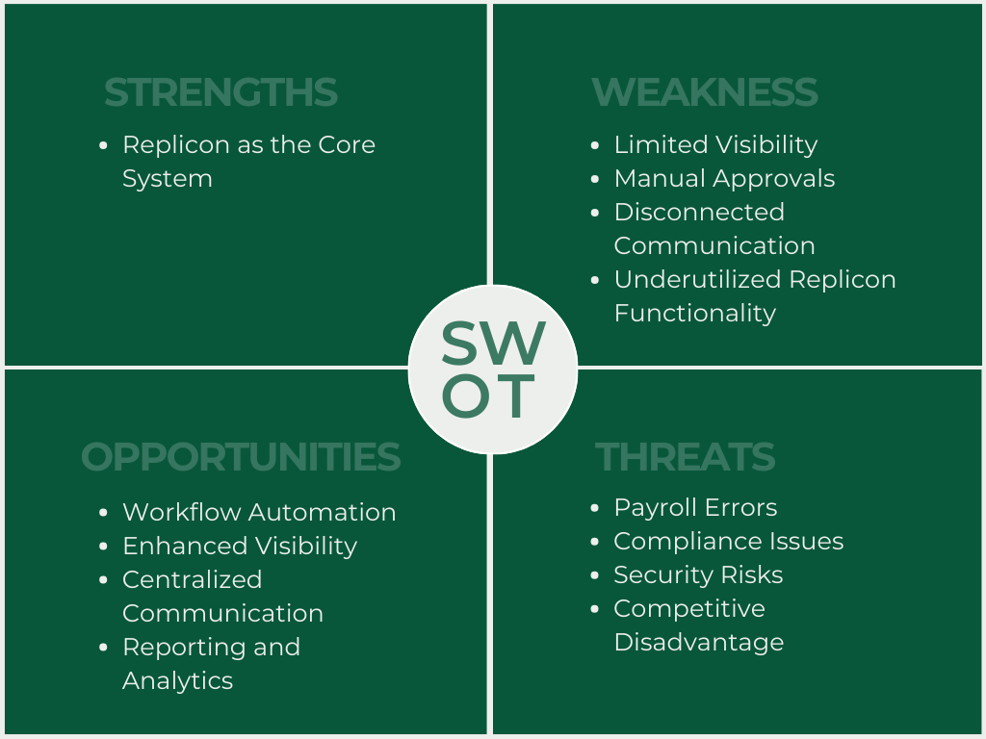

*This figure outlines the SWOT Analysis of the current process for approving overtime requests within the organization.*

**Strengths**

The good news is that the organization has a solid foundation with Replicon. It's like having a reliable toolbox with all the essential tools for tracking time and managing overtime. Employees can easily log their overtime hours, and the system keeps a record of all the requests, which is a great starting point.

**Weaknesses**

However, the current process feels a bit like a bumpy road. It relies heavily on emails and messages flying back and forth, with the Operations Manager having to manually check and approve each request. Imagine a busy traffic junction with no traffic lights – things can get chaotic and slow. But the biggest issue is the lack of visibility. It's like everyone is driving with a foggy windshield; employees don't know what's happening with their requests, and managers lack a clear view of the overall overtime situation. This can lead to frustration, delays, and even mistakes in payments.

**Opportunities**

The good news is that there's a lot of room for improvement! Replicon has some fantastic features that are currently underutilized. It's like having a powerful car with a built-in GPS and cruise control, but you're still driving manually. By automating the approval process, it's like switching on that cruise control and letting the system handle the routine tasks, freeing up the Operations Manager to focus on more important things.

But beyond just utilizing Replicon's features, the organization needs to create a process where everyone has a clear view of what's happening. Imagine a traffic management system with real-time updates on traffic flow and road conditions, accessible to all drivers. This is what's needed for overtime management – a transparent system where employees, Team Leads, and Managers can all track the status of requests and have a shared understanding of the overtime landscape.

**Threats**

If these issues aren't addressed, it's like driving with a flat tire – you might eventually reach your destination, but it will be a bumpy and frustrating ride. Employees might become unhappy with the lack of transparency and potential delays in getting paid. Errors in calculations can also occur, leading to payroll headaches. Moreover, inconsistent practices might even lead to compliance issues with labor laws, which is like getting a speeding ticket. Finally, with sensitive information being shared through emails, there's always a risk of data breaches, like leaving your car unlocked in a busy parking lot.

In a nutshell, the organization has the right tools in Replicon, but it needs to establish a clear and transparent process with full visibility for all stakeholders. This, combined with optimizing Replicon's features, will create a smoother, more efficient overtime management system, benefiting everyone involved.

# Proposed Solution

## Technical Background

The proposed OT time tracking system prioritizes a lean and efficient technology stack to minimize development and operational overhead. For hardware, the system leverages existing developer workstations for development, while a single, moderately sized virtual server hosted on Amazon Web Services (AWS) serves as the production environment. Specifically, an AWS EC2 t3. micro or t3. A small instance is recommended for its cost-effectiveness and manageability. A managed database service, AWS RDS for MySQL, is selected for its ease of use and the widespread familiarity with MySQL. Software choices are similarly streamlined, with the front-end utilizing HTML, CSS, and plain JavaScript, complemented by the Bootstrap UI library for rapid development. The backend is built using Node.js with the Express.js framework, facilitating a unified JavaScript environment across both frontend and backend. A RESTful API is implemented for seamless communication, and JWT authentication ensures secure access. Git, hosted on GitHub, manages version control. The server operating system will be Ubuntu Linux. The peopleware aspect focuses on a single full-stack developer proficient in Node.js and JavaScript, potentially supported by a part-time project manager. Testing is conducted by the development team and select end-users, while training is facilitated through comprehensive documentation and readily available online tutorials. Network requirements are kept simple, relying on a reliable internet connection and AWS's built-in security features, with HTTPS implemented for secure communication. This focused approach aims to create a functional and maintainable system with minimal resource expenditure.

## Feasibility

**Operational Feasibility**

The project is operationally viable since it responds to existing inefficiencies and provides greater visibility to stakeholders. The system suggested here exists workflows and integrates with Replicon, Microsoft Teams, and Outlook. Moreover, the implementation of automated workflows and dashboards will make the process more efficient with less manual intervention.

**Economic Feasibility**

OT request approval automation removes processing inefficiencies through manual processes and provides real-time insight into OT requests, supporting better decision-making. Managers and employees can concentrate on value-added work rather than an administrative burden, resulting in greater efficiency and productivity. Minimizing unnecessary OT approvals reduces unnecessary labor, while deeper insights into the data enable managers to allocate resources effectively without overstaffing. Streamlined approval processes minimize delays and bottlenecks, resulting in optimized operations.

**Technical Feasibility**

The project is technically feasible, leveraging Capgemini’s expertise in software development and integration. The existing IT infrastructure supports the integration of a tracking solution with Replicon and Microsoft applications. Furthermore, implementing.

**Schedule Feasibility**

A phased implementation plan will result in timely deployment. The project can be implemented in phases such as gathering requirements and development, thereby reducing interruptions to existing operations. The project may be carried out in separate phases, beginning with requirements gathering, then design, development, testing, and deployment. Each stage is meticulously planned to sequentially leverage the success of the earlier stage, making a seamless transition and aligning with business goals.

## Requirements Analysis

### **Project Vision**

The AI-powered Overtime (OT) Tracking and Approval System is designed to revolutionize workforce management within Capgemini by creating a streamlined, transparent, and data-driven approach to OT approvals. This system is not just a tracking tool, but a strategic solution aimed at enhancing operational efficiency, improving employee experience, and optimizing business processes through advanced automation and AI-driven insights.

By integrating intelligent automation, the system will reduce administrative burdens associated with OT approvals, ensuring a seamless and structured workflow. Employees will benefit from real-time access to their OT balance, reducing uncertainty and delays. Team leaders and operations managers will gain deeper insights into workforce trends, enabling them to allocate resources more effectively and minimize unnecessary costs.

A key component of this vision is predictive analytics, which will help forecast workload patterns and proactively manage OT requirements. AI-driven anomaly detection will flag unusual or excessive OT requests, preventing compliance issues and optimizing labor costs. Additionally, the system will integrate with existing payroll and workforce management platforms, ensuring data accuracy and alignment with company policies.

Ultimately, this initiative reflects Capgemini’s commitment to leveraging cutting-edge technology to drive operational transformation. By implementing an AI-powered OT management system, Capgemini aims to foster a more efficient, data-driven, and employee-centric work environment, ensuring long-term business sustainability and success.

**Target Users and Their Needs**

Table 2 Target Users and Their detailed needs

|  |  |
| --- | --- |
| **User Role** | **Needs and Expectations** |
| Employee | Easy access to OT balance, seamless request submission, timely updates. |
| Team Lead | Efficient review process, ability to monitor team OT trends. |
| Operations Manager | Full visibility into OT requests, data-driven decision-making tools. |
| Team Manager | Supervises workload distribution, ensures smooth OT processes. |
| Developers | Ensure a reliable, secure, and efficient OT tracking system with seamless integration, automation, and user driven improvements. |

### **Prototype (Mock Flow / Wireframe)**

Figure Sign in Wireframe

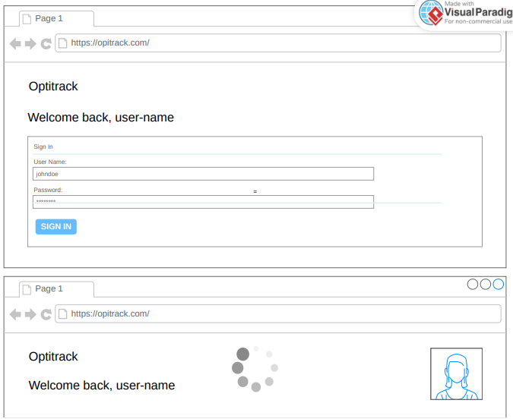

Figure Employee Account

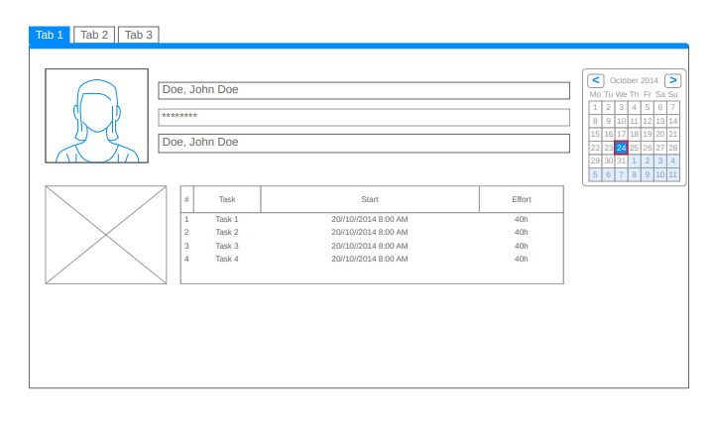

Figure OT Request Page Wireframe

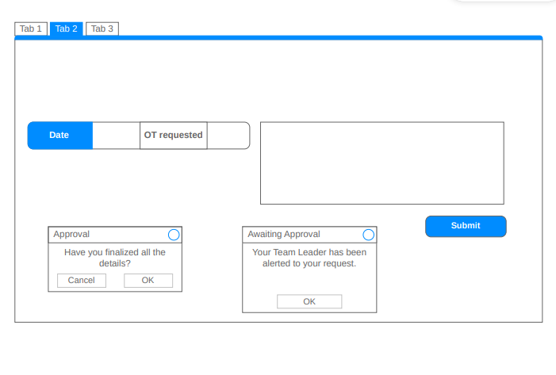

Figure Analytics Page Wireframe

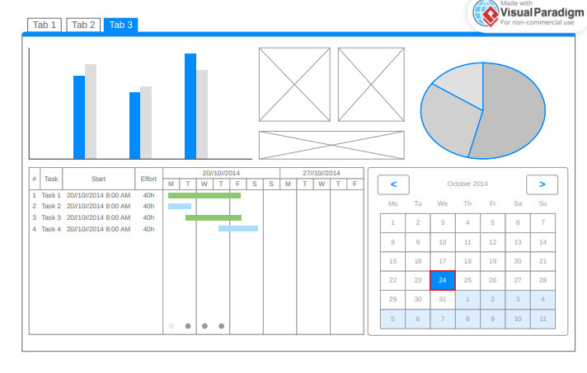

Figure Manage Employee Account - Manager Side

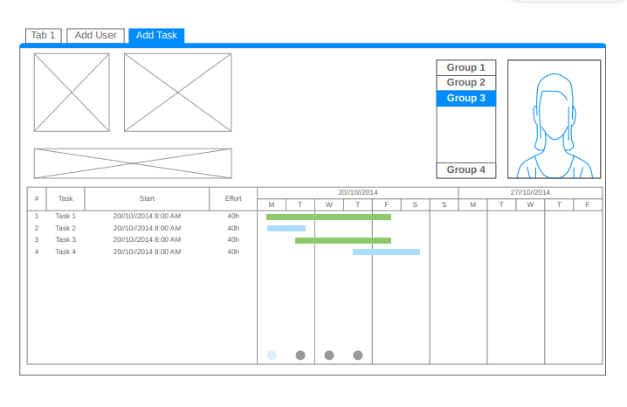

Figure Manage Recommendation - Manager Side Wireframe

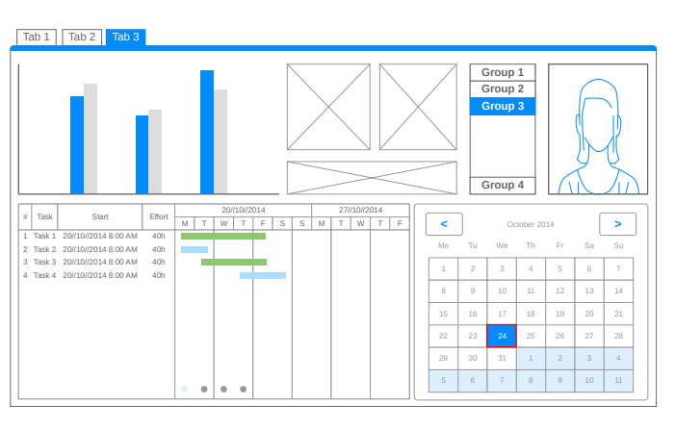

## Project Lean Canvas

Table 3 Lean Canvas

|  |  |  |  |  |  |  |  |  |  |  |  |
| --- | --- | --- | --- | --- | --- | --- | --- | --- | --- | --- | --- |
|  |  | Designed for: | | | | | Designed by: | | Date: | | Version: |
| **Lean Canvas** | | Capgemini | | |  | | Group 1 |  | 2/28/25 |  | 2.0 |
|  |  |  | | | | |  | |  | | |
| **Problem** | **Solution** | | **Unique Value Proposition** | | | **Unfair Advantage** | | | **Customer Segments** | | |
| * Lack of visibility into OT requests across the team. * Inefficient and time-consuming manual OT approval process. * Approvals granted without proper justification, leading to potential overspending. | * A comprehensive OT management system with:   + Real-time dashboard for tracking OT requests.   + Automated approval workflow with customizable levels.   + Mandatory field for detailed justification of OT.   + Automated reports on team productivity and OT utilization.   + Employee self-service portal for tracking OT balance. | | A streamlined, AI assisted OT management system that increases efficiency, transparency, and employee satisfaction while optimizing resource utilization and reducing administrative overhead. | | | | * Ensures a user-friendly and intuitive system for all stakeholders. * Streamlines implementation, data flow, and reduces onboarding friction. This pre-existing infrastructure is difficult for competitors to match. | | * Employees needing to log and track OT. * Team leads responsible for approving OT requests. * Operations managers monitoring OT usage and trends. * HR and administrative departments managing compliance and employee satisfaction. | | |
| **Existing Alternatives** | **Key Metrics** | | **High-Level Concept** | | | | **Channels** | | **Early Adopters** | | |
| * Manual OT logging using spreadsheets or paper forms. * Basic time-tracking software without AI capabilities. * Traditional approval processes involving emails or physical documents. | * Reduction in OT approval time. * Decrease in unjustified OT costs. * Improvement in employee satisfaction with OT process. * Increase in manager visibility and control over OT. * Adoption rate of the new system. * Frequency and quality of productivity insights generated. | | The system is like a combination of Jira and Tableau for overtime management - providing structured workflows and powerful data visualization. | | | | * Direct communication with Ms. Rochelle and key stakeholders. * Presentations and demonstrations to management. * Pilot program within the Collections team. | | * Companies with high OT usage and a need for better resource management. * Organizations seeking to leverage AI for operational efficiency. * HR departments looking to improve employee satisfaction and compliance. | | |
| **Cost Structure** | | | | **Revenue Structure** | | | | | | | |
| * Software development and implementation costs. * Ongoing maintenance and support. * Training and onboarding for users. * Potential integration costs with existing systems. * servers and related hardware | | | | * No concrete projections yet, but estimate potential cost savings and revenue based on:   + Current OT spending.   + Number of potential users.   + Market pricing for similar solutions.   + Gross Margin: | | | | | | | |
|  | | | | | | | | | | | |

### User Classes and Characteristics

Table 4 User and Characteristics Table

|  |  |
| --- | --- |
| Roles | **Description** |
| Employee | Requests overtime through the system, tracks OT balance, and submits justifications. |
| Team Lead | Reviews and approves/disapproves OT requests before forwarding them to the operations manager. |
| Operations Manager | Has full visibility of OT requests, oversees approvals, and manages resource allocation. |
| Team manager | Supervises workload distribution, ensures smooth OT processes. |
| Developers | Ensure a reliable, secure, and efficient OT tracking system with seamless integration, automation, and user driven improvements. |

### Product Backlog

Table 5 Product Backlog Table

|  |  |  |  |  |  |  |  |
| --- | --- | --- | --- | --- | --- | --- | --- |
| ID | As a... | |  | | --- | | I want to be able to... | | |  | | --- | | So that... | | |  | | --- | | **Priority** | |
| 1 | Employee | Log in securely | I can access my OT records | Must |
| 2 | Employee | Submit OT requests easily | I can ensure timely approvals | Must |
| 3 | Employee | Track my OT balance in real-time | I know my available OT hours | Must |
| 4 | Team Lead | Approve or reject OT requests efficiently | I can manage team overtime effectively | Must |
| 5 | Operations Manager | Access OT trend analysis | I can optimize workforce planning | Should |
| 6 | Operations Manager | Get AI-driven OT predictions | I can proactively manage workloads | Could |
| 7 | Manager | Detect unusual OT requests | I can ensure compliance with policies | Should |
| 8 | Admin | Sync OT data with the payroll system | Payments are accurate | Must |
| 9 | Employee | Access the system from my phone | I can check my OT status on the go | Could |
| 10 | User | Receive real-time notifications | I am informed about request status | Must |
| 11 | Admin | Track all OT requests and approvals | I can maintain compliance | Must |
| 12 | Employee | View a dashboard of my OT requests | I can track my request statuses | Must |

### **Product Roadmap**

**Phase 1: Research & Analysis (1–2 Months)**

* Interview stakeholder participants (Ms. Rochelle, Team Leaders, Ops Manager, Staff).
* Review current OT process in Replicon and determine pain points.
* Create project schedule and resource plan.

**Phase 2: Design & Prototyping (3-5 Months)**

* + Design wireframes for the OT tracker system.
  + Finalize approval workflow logic and user access roles.
  + Secure necessary approvals from key stakeholders.

**Phase 3: Development & Integration (1-3Months)**

* Employee OT request submission with contextual information.
* Real-time visibility dashboard for Managers, Team Leads, and Operations.
* Automated approval process with notifications.

**Phase 4: Continuous Improvement (4+Months)**

* Establish continuous feedback.

**Release Plan**

Table 6 Release Plan Table

|  |  |  |
| --- | --- | --- |
| **MNTSDEV** | **MSYADD1** | **MCSPROJ** |
| * **Project Proposal:** Define project scope, objectives, and deliverables. * **Product Vision:** Articulate the overall goal and value proposition of the OT management system. * **Backlog:** Create and prioritize a list of features and user stories. * **Product Roadmap:** Develop a high-level timeline visualizing releases and key features. * **Release Plan:** Outline features for each Minimum Viable Product (MVP) release. * **Increment Release 1 (MVP):**   + Secure Login   + Submit OT Requests   + Real-time OT Tracking * **Requirements Gathering:** Conduct thorough requirements gathering, including user interviews and analysis of existing systems. | * **Design Diagrams:** * Structure Diagrams: Create Data Flow Diagrams (DFD) and Entity-Relationship Diagrams (ERD) to model data and processes. * Object-Oriented Diagrams: Develop Use Case Diagrams, Class Diagrams, and Activity Diagrams to represent system behavior and structure. * **Prototyping:** Develop a functional prototype of the system based on the finalized design. * **Increment Release 2 (MVP):** * Approval Workflow (potentially including basic reporting) * Notifications * **Development:** Begin development of core features for Release 1 and Release 2. | * **Increment Release 3 (MVP):** * Payroll Sync * Compliance Tracking * Advanced Reporting and Analytics Features * **Development:** Complete development of all remaining features and MVP releases. * **CI/CD Pipeline:** Implement a Continuous Integration/Continuous Deployment pipeline for automated building, testing, and deployment. * **Other Workflow Improvements:** Integrate any additional workflow enhancements based on user feedback or further analysis. * **Contingency Plans:** Define and document backup plans and risk mitigation strategies. * **System Hand-off:** * Source Code: Deliver well-documented source code. * Development Artifacts: Provide design specifications, test cases, and deployment guides. * User and Admin Manuals: Create comprehensive user and administrator manuals. |

### **Use Case Diagram**

Figure Use Case Diagram

### **Use Case Full Description**

Table 7 Manage Employee Account Use Case Description

|  |  |  |
| --- | --- | --- |
| **Use Case Name:** | Manage Employee Account | |
| **Scenario:** | A Team Leader needs to view, create, or update employee account information within the system. | |
| **Triggering Event:** | A new employee joins the team and needs an account created. An existing employee's information needs to be updated (e.g., change in contact details, role, or permissions). | |
| **Brief Description:** | Allows the Team Leader to manage employee accounts, including viewing, creating, and updating account information. | |
| **Actors:** | Team Leader | |
| **Related Use Cases:** | View employee account, Update employee account | |
| **Stakeholders:** | Team Leader, Employee | |
| **Preconditions:** | The Team Leader must be logged into the system.  The Team Leader must have the necessary permissions to manage employee accounts. | |
| **Postconditions:** | Employee account information is successfully updated, or a new account is created in the system. | |
| **Flow of Activities:** | **Actor** | **System** |
| 1. Team Leader selects "Manage Employee Account." 2. Team Leader can choose to view, update or create an account. 3. Team Leader edits the necessary employee information. 4. Team Leaders saves the changes | 1.1. System displays a list of existing employee accounts.        2.1 System displays the relevant interface (view, update, or create).  5.1 System validates the input data  7.1 System updates the existing account or creates a new account.  7.2 System confirms the action with a success message. |
| **Exception Conditions:** | * If the Team Leader enters invalid data, the system displays an error message. * If the Team Leader tries to create an account with an existing username or email, the system displays an error message. * If the Team Leader does not have the necessary permissions, the system restricts access to certain functions. | |

Table 8 Manage Task Use Case Description

|  |  |  |
| --- | --- | --- |
| **Use Case Name:** | Manage Task | |
| **Scenario:** | A Team Leader needs to assign new tasks to employees or update the details of existing tasks. | |
| **Triggering Event:** | A new project is initiated, requiring task assignments.  An existing task's deadline, requirements, or assigned employee needs to be modified. | |
| **Brief Description:** | Allows the Team Leader to assign, update, and create tasks within the system. | |
| **Actors:** | Team Leader | |
| **Related Use Cases:** | View employee account, Update employee account | |
| **Stakeholders:** | Team Leader, Employee | |
| **Preconditions:** | Team Leader must be logged into the system. | |
| **Postconditions:** | Tasks are assigned, updated, or created in the system.  Affected employees are notified of the changes to their assigned tasks. | |
| **Flow of Activities:** | **Actor** | **System** |
| 1. Team Leader selects "Manage Task." 2. Team Leader chooses to assign, update or create a task. 3. Team Leader edits the necessary task information. 4. Team Leader saves the changes | 1.1 System displays a list of tasks and employees.  4.1 System validates the input data  6.1 System updates the task list and sends notifications to the assigned employees |
| **Exception Conditions:** | * If the Team Leader tries to assign a task to an employee who is unavailable or lacks the necessary skills, the system displays a warning message. * If the Team Leader tries to assign a task to an employee who is unavailable or lacks the necessary skills, the system displays a warning message. | |

Table 9 Manage OT Use Case Description Table

|  |  |  |
| --- | --- | --- |
| **Use Case Name:** | Manage OT | |
| **Scenario:** | An employee requests overtime, which goes through an approval process involving the Team Leader and the Operations Manager. | |
| **Triggering Event:** | An employee works or anticipates working hours that qualify for overtime compensation. | |
| **Brief Description:** | This use case covers the end-to-end process of managing overtime requests, from employee submission to final approval. | |
| **Actors:** | Employee, Team Leader, Team Manager, Operations Manager | |
| **Related Use Cases:** | Request OT, View OT, OT Approval | |
| **Stakeholders:** | Team Leader, Employee, Team Manager, Operations Manager | |
| **Preconditions:** | All actors (Employee, Team Leader, Operations Manager) must be logged into the system. | |
| **Postconditions:** | The OT request is either approved or rejected, and the employee is notified of the decision. | |
| **Flow of Activities:** | **Actor** | **System** |
| 1 Employee logs into the  system.  2Employee enters daily  activities, volume, and overtime.  3Employee submits the log.                  4Team Leader logs into the system.  5Team Leader reviews the log.  6Team Leader approves/rejects.      7Team Manager logs into the system.  8Team Manager reviews and approves/rejects.    9. Employee logs OT request to Replicon  10.Operations Manager receives OT request on Replicon  10.Operations Manager approves OT request on Replicon. | 3.1Validate data.  3.2Flag weekend/holiday OT.  3.3Calculate total hours.  3.4Check hour limits.  3.5Generate hour limit warnings (If applicable)  3.7Notify Team Leader.  6.1Record approval/rejection.  6.2Notify Team Manager (if approved).  8.1Record approval/rejection.  8.2 Inform Employee of Approval |
| **Exception Conditions:** | * If the Employee submits an OT request with missing information, the system prevents submission and prompts them to complete the required fields. * If the requested OT hours exceed a predefined limit, the system may automatically flag the request for higher-level review or reject it. * If the Employee attempts to submit a request for an invalid time (e.g., past date, future date beyond the allowed range), the system displays an error or warning. | |

Table 10 Manage Performance Use Case Description Table

|  |  |  |
| --- | --- | --- |
| **Use Case Name:** | Manage Performance | |
| **Scenario:** | The team leader and the team manager need to monitor and evaluate employee performance. | |
| **Triggering Event:** | A scheduled performance review cycle.  A need to analyze team or individual productivity.  A significant change (positive or negative) in an employee's performance | |
| **Brief Description:** | Allows authorized users (Team Leaders and Team Managers) to access and analyze employee performance data. | |
| **Actors:** | Team Leader, Team Manager | |
| **Related Use Cases:** | Manage Recommendations | |
| **Stakeholders:** | Team Leader, Employee, Team Manager | |
| **Preconditions:** | Team Leader and Team Manager needs to be logged in to the system | |
| **Postconditions:** | Reviewed the relevant employee performance data. | |
| **Flow of Activities:** | **Actor** | **System** |
| 1. Team Leader and Team Manager will access the Employee’s account   2 Team Leader or Team manager filters or sorts the performance metrics based on need | 1.1 System displays the account, and performance analytics |
| **Exception Conditions:** | 1.2 If the actor does not have any employees assigned to them or does not have permission to provide recommendations, the system displays a message indicating this. | |

Table 11 Manage Recommendations Use Case Description Table

|  |  |  |
| --- | --- | --- |
| **Use Case Name:** | Manage Recommendations | |
| **Scenario:** | A Team Leader or Team Manager wants to provide a recommendation or acknowledgment for an employee's performance. | |
| **Triggering Event:** | An employee demonstrates exceptional performance or makes a significant contribution.  A manager wants to provide positive feedback or nominate an employee for recognition. | |
| **Brief Description:** | Allows managers to create and manage recommendations for employees. | |
| **Actors:** | Team Leader, Team Manager | |
| **Related Use Cases:** | Approve Recommended | |
| **Stakeholders:** | Team Leader, Employee, Team Manager | |
| **Preconditions:** | Team Leader and Team Manager needs to be logged in to the system | |
| **Postconditions:** | The recommendation is recorded in the system and associated with the employee's profile. | |
| **Flow of Activities:** | **Actor** | **System** |
| 1. Team Leader and Team Manager selects the employee to recommend 2. Team Leader or Team manager submits the recommendation | 1.1 System displays the account, and performance analytics  2.1 System sends a notification to the operations manager regarding the recommendation |
| **Exception Conditions:** | * If the actor does not have any employees assigned to them or does not have permission to provide recommendations, the system displays a message indicating this. | |

Table 12 OT Approval Use Case Description Table

|  |  |  |
| --- | --- | --- |
| **Use Case Name:** | OT Approval | |
| **Scenario:** | The Operations Manager reviews and makes final decisions on overtime requests that have been submitted by employees and reviewed by Team Leaders. | |
| **Triggering Event:** | A Team Leader recommends an OT request for approval or rejection. A manager wants to provide positive feedback or nominate an employee for recognition. | |
| **Brief Description:** | The operations manager finalizes the approval of the OT request on Replicon | |
| **Actors:** | Operations Manager | |
| **Related Use Cases:** | Manage OT | |
| **Stakeholders:** | Operations Manager, Team Leader, Team Manager, Employee | |
| **Preconditions:** | The Operations Manager must be logged into the system.  Overtime requests have been approved by the Team Leader and Team Manager | |
| **Postconditions:** | The overtime request is approved  The system updates the request status and notifies the Employee and Team Leader. | |
| **Flow of Activities:** | **Actor** | **System** |
| 1. Operations Manager selects ‘For Approval’ 2. Operations Manager Reviews the OT request, employee justification, and Team Leader recommendation. 3. Approves or rejects the OT request. | 1. 1 Displays a list of pending OT requests with relevant details.  3.1 System Records the decision, updates the request status, and notifies the Employee and Team Leader. |
| **Exception Conditions:** | * If there are no pending OT requests to review, the system displays a message indicating this. * If the Operations Manager needs more information to decide, they can request additional details from the Team Leader or Employee through the system. | |

Table 13 View Reports Use Case Description Table

|  |  |  |
| --- | --- | --- |
| **Use Case Name:** | View Reports | |
| **Scenario:** | A manager needs to generate and review reports related to employee performance, tasks, and overtime. | |
| **Triggering Event:** | Need to approve requests on Replicon | |
| **Brief Description:** | The operations manager finalizes the approval of the OT request on Replicon | |
| **Actors:** | Operations Manager, Team Manager | |
| **Related Use Cases:** | Manage OT, Manage Performance | |
| **Stakeholders:** | Operations Manager, Team Leader, Team Manager, Employee | |
| **Preconditions:** | The Operations Manager must be logged into the system. | |
| **Postconditions:** | The requested report is generated and displayed to the actor. | |
| **Flow of Activities:** | **Actor** | **System** |
| 1. Operations Manager selects “View Reports” 2. Operations Manager Generates the report. | 1.1 System may provide options to customize the report (e.g. Date, etc.)  2.1 System displays the report |
| **Exception Conditions:** | * If there is no data available for the selected report type or criteria, the system displays a message. * If an error occurs during report generation, the system displays an error message. | |

# Conclusion

This phase of the project focused on establishing a comprehensive understanding of the challenges faced by the Capgemini Collections team in managing overtime and defining the objectives for an improved OT management system. Through careful analysis of the existing process and consultation with key stakeholders, we identified four core problems: lack of comprehensive team visibility, inefficient approval processes, absence of justifiable OT approvals, and limited access to actionable productivity insights.

To address these challenges, we defined a main objective: to develop and implement a comprehensive overtime management system that enhances visibility, streamlines approvals, ensures justified OT, and provides actionable productivity insights. This main objective is supported by several specific objectives, including the development of a real-time dashboard, the implementation of an automated approval workflow, the requirement for detailed justifications for OT requests, and the generation of automated reports on team productivity and OT utilization. We have accomplished significant milestones in this phase, including the definition of clear objectives and the creation of wireframes for the proposed system. This provides a strong foundation for the next iteration of this project, which will focus on further design and development. In the subsequent PBL subject, we will refine the user interface design based on the wireframes, finalize the database schema, and detail the system architecture. Additionally, we will evaluate and select appropriate technologies for development, considering factors such as scalability, security, and integration with existing Capgemini systems. Finally, we will develop a functional prototype of the system, incorporating the finalized design and selected technologies, to demonstrate key features and gather feedback from users.

# References

[1] “Our Vision and Mission,” *Capgemini Australia*. <https://www.capgemini.com/au-en/insights/research-library/our-vision-and-mission/>

[2]“What we do,” *Capgemini*. <https://www.capgemini.com/about-us/who-we-are/what-we-do/>

[3] United Nations, “The 17 Sustainable Development Goals,” *United Nations*, 2025. <https://sdgs.un.org/goals>

[4]“Unlocking Efficiency: How Automated Timesheets Transform Business Time Management | Monitask,” *Monitask*, Jul. 15, 2024. <https://www.monitask.com/en/blog/unlocking-efficiency-how-automated-timesheets-transform-business-time-management?utm> (accessed Mar. 06, 2025).

[5]I. S. Chain, “How Does Timesheet Software Affect Productivity Long Term? - IT Supply Chain,” *IT Supply Chain*, Feb. 08, 2025. <https://itsupplychain.com/how-does-timesheet-software-affect-productivity-long-term/?utm> (accessed Mar. 06, 2025).

[6]“\r\n \n Boost Business Efficiency with Automated Timekeeping\n \r\n,” *Timeandpay.com*, 2022. <https://www.timeandpay.com/boost-business-efficiency-with-automated-timekeeping?utm> (accessed Mar. 06, 2025).

[7]“DSpace,” *Wichita.edu*, 2025. <https://soar.wichita.edu/bitstreams/1d68257a-9803-4164-bf20-5acf96362836/download?utm> (accessed Mar. 06, 2025).

[8]E. Staff, “What Are Automated Timesheets? Benefits & How To Implement It,” *Tackle*, Dec. 30, 2024. <https://www.timetackle.com/automated-timesheets/?utm> (accessed Mar. 06, 2025).

[9] “Smart Employee Time Tracking Software with Screenshots | Time Doctor,” [www.timedoctor.com](https://www.timedoctor.com). <https://www.timedoctor.com/>

[10] Wrike, “Wrike,” Wrike, 2019. <https://www.wrike.com/>

[11] “Time Tracking Software - Free Automated Time Tracker TimeCamp,” [www.timecamp.com](https://www.timecamp.com). <https://www.timecamp.com/>

[12] “Connecteam: The All-in-One Employee App for Deskless Teams,” *Connecteam*. <https://connecteam.com/>

[13] CAKE.com Inc, “Free Employee Overtime Tracker — Clockify,” *Clockify*, 2025. <https://clockify.me/overtime-tracker> (accessed Mar. 05, 2025).

[14] “Time Tracking Software Suite,” *Replicon*. <https://www.replicon.com>

[15]“What is Outlook?,” support.microsoft.com. <https://support.microsoft.com/en-us/office/what-is-outlook-10f1fa35-f33a-4cb7-838c-a7f3e6228b20>

[16]Microsoft, “What is microsoft teams?,” support.microsoft.com, 2022. https://support.microsoft.com/en-us/topic/what-is-microsoft-teams-3de4d369-0167-8def-b93b-0eb5286d7a29

‌

‌

‌

# Appendices

## Appendix A: Roles and Responsibilities

## Appendix B: Minutes of the Meetings

**Meeting 1: Consultation with Advisor**

**Date:** February 19, 2025, **Time:** 7:30 AM - 9:30 AM] **Attendees:** Robyn Fruto, Sondrick Frondozo, Rick Cruz, Sir Manuel Sebastian

**Subject:** Use Case Diagram, Use Case Description, and Paper Review

**Minutes:**

1. **Use Case Diagram and Use Case Description Discussion:**
   * Detailed discussion on the methodology and best practices for creating effective Use Case Diagrams and Use Case Descriptions.
   * Exploration of specific scenarios and user interactions to ensure comprehensive representation within the diagrams.
   * Clarification of terminology and appropriate level of detail required for the descriptions.
2. **Paper Review:**
   * Comprehensive review of the drafted paper.
   * Feedback provided on overall structure, content, and clarity.
   * Specific areas for improvement identified and discussed.
   * Explanation of how to improve the use case diagrams and descriptions within the paper.
   * Went over the entire paper.
3. **Action Items:**
   * Refine Use Case Diagrams and Use Case Descriptions based on feedback.
   * Implement suggested revisions to the drafted paper.

**Meeting Adjourned:** 9:30 AM

**Prepared By:** Robyn Fruto

**Meeting 2: Consultation with Advisor**

**Date:** February 26, 2025 **Time:** 7:30 AM - 9:30 AM **Location:** [Specify Location - e.g., Advisor's Office, Virtual Meeting Room] **Attendees:** Robyn Fruto, Sondrick Frondozo, Rick Cruz, Sir Manuel Sebastian

**Subject:** Introduction Presentation, Use Case Diagram, and Use Case Description Revisions

**Minutes:**

1. **Introduction Presentation:**
   * Presentation of the project introduction.
   * Advisor provided feedback on clarity, conciseness, and overall effectiveness of the introduction.
   * Major revision points were given to the introduction.
2. **Use Case Diagram and Use Case Description Revisions:**
   * Presentation of the revised Use Case Diagrams and Use Case Descriptions.
   * Advisor provided feedback on the implemented revisions.
   * Major revision points were given to the Use Case Diagrams and Use Case Descriptions.
   * Discussion of necessary further revisions to address remaining issues and improve accuracy.
3. **Action Items:**
   * Implement major revisions to the project introduction as indicated.
   * Implement major revisions to the Use Case Diagrams and Use Case Descriptions as indicated.

**Meeting Adjourned:** 9:30 AM

**Prepared By:** Robyn Fruto

**Meeting 3: Process Meeting with Client**

**Date:** February 20, 2025 **Time:** 12:00 PM - 12:30 PM **Attendees:** Rochelle Fruto, Robyn Fruto, Ivan De Asis

**Subject:** Approval Process and System Warnings

**Minutes:**

1. **Approval Process:**
   * Discussion regarding the current approval process.
   * Client emphasized the need to include the team manager in the approval workflow.
   * Agreement reached to modify the process to incorporate the team manager's approval.
2. **System Warnings (OT Tracker):**
   * Discussion regarding system warnings related to the Overtime (OT) tracker.
   * Client highlighted the importance of clear and informative warnings to prevent errors.
   * Discussion about the types of system warnings that need to be implemented.
   * Discussion on how those warnings will be presented to the users.
3. **Action Items:**
   * Modify the approval process documentation to include the team manager.
   * Implement necessary system warnings in the OT tracker, ensuring clarity and accuracy.

**Meeting Adjourned:** 12:30 PM

**Prepared By:** Robyn Fruto

## Appendix C: Project Sharepoint Link

https://asiapacificcollege.sharepoint.com/sites/CollectionsTeamofCapgemini-OTTimeTracker/SitePages/ProjectHome.aspx