*OptiTrack: Optimized Time Tracking with Productivity Insights*

Project Documentation Submitted to the Faculty of the

School of Computing and Information Technologies

Asia Pacific College

In Partial Fulfillment of the Requirements for

Introduction to Systems and Design for IT

MSYADD1

By

|  |  |
| --- | --- |
| Robyn Dominique Fruto | Sondrick Frondrozo |
| Rick Laurence Cruz | Kurt Yuri Fegarido  Virgilio Angelo III S.Navarro |
|  |  |

Table of Contents

List of Figures iv

List of Tables v

Introduction 1

Project Context 1

Statement of the Problem 2

Objectives 2

Significance of the Project **Error! Bookmark not defined.**

Scope and Limitations **Error! Bookmark not defined.**

Review of Related Literature / Systems 5

Current System 8

Technical Background **Error! Bookmark not defined.**

List of Processes **Error! Bookmark not defined.**

SWOT Analysis **Error! Bookmark not defined.**

Proposed Solution **Error! Bookmark not defined.**

Technical Background **Error! Bookmark not defined.**

Feasibility **Error! Bookmark not defined.**

Operational Feasibility **Error! Bookmark not defined.**

Economic Feasibility **Error! Bookmark not defined.**

Technical Feasibility **Error! Bookmark not defined.**

Schedule Feasibility **Error! Bookmark not defined.**

Requirements Analysis **Error! Bookmark not defined.**

Project Vision **Error! Bookmark not defined.**

Prototype (Mock Flow / Wireframe) 8

Project Lean Canvas 11

User Classes and Characteristics **Error! Bookmark not defined.**

Product Backlog 14

Product Roadmap 15

Release Plan **Error! Bookmark not defined.**

Use Case Diagram 22

Use Case Full Description **Error! Bookmark not defined.**

Conclusion 50

References **Error! Bookmark not defined.**

Appendices 52

Appendix A: Roles and Responsibilities 52

Appendix B: Minutes of the Meetings 55

Appendix C: Methodology **Error! Bookmark not defined.**

Appendix D: Project Sharepoint Link 53

# List of Figures

Figure 1 SWOT Analysis of the Current System **Error! Bookmark not defined.**

Figure 2 Sign in Wireframe 8

Figure 3 Employee Account 8

Figure 4 OT Request Page Wireframe 9

Figure 5 Analytics Page Wireframe 9

Figure 6 Manage Employee Account - Manager Side 10

Figure 7 Manage Recommendation - Manager Side Wireframe 10

Figure 8 15

Figure 9 16

Figure 10 16

Figure 11 18

Figure 12 19

Figure 13 20

Figure 14 20

Figure 15 21

Figure 16 Use Case Diagram 22

Figure 17 22

Figure 18 44

# List of Tables

Table 1 List of Processes in the Current System **Error! Bookmark not defined.**

Table 2 Target Users and Their detailed needs 8

Table 3 Lean Canvas 11

Table 4 User and Characteristics Table 14

Table 5 Product Backlog Table 14

Table 6 Manage Employee Account Use Case Description 22

Table 7 24

Table 8 Manage Task Use Case Description 25

Table 9 25

Table 10 Manage OT Use Case Description Table 27

Table 11 OT Approval Use Case Description Table 34

Table 12 View Reports Use Case Description Table 36

Table 13 Release Plan Table 52

# Introduction

Overtime (OT) management plays a crucial role in workforce efficiency, ensuring fair compensation while optimizing operational productivity. However, the Capgemini Collections team faces significant challenges due to inefficiencies in the existing OT tracking and approval process. The reliance on third-party software such as Replicon has resulted in a lack of transparency, manual data retrieval inefficiencies, and approval delays. Employees struggle to track their OT balance, team leaders encounter bottlenecks in approvals, and operations managers lack real-time visibility into OT data, leading to inefficiencies and potential unnecessary costs.

To address these issues, this project focuses on the development and implementation of an advanced OT tracker integrated with productivity insights. The new system aims to enhance transparency, streamline approvals, and provide actionable workforce analytics. By automating OT approvals and improving data visibility, the system will facilitate better resource allocation and data-driven decision-making. Employees will gain instant access to their OT balance, team leaders will benefit from an organized and structured approval workflow, and operations managers will have a comprehensive view of OT trends for improved workforce planning.

[1] Aligned with Capgemini’s mission of driving operational transformation, this project integrates seamlessly with existing workflows while introducing automated approval processes and real-time analytics. The primary objectives include the creation of a real-time dashboard for tracking OT requests, the automation of approval workflows to expedite decision-making, and the generation of detailed reports to assess productivity and OT utilization. The expected outcomes include reduced operational costs, improved employee morale, enhanced productivity, and strengthened client relationships.

By implementing this advanced OT tracking system, Capgemini’s Collections team will achieve a more transparent, efficient, and optimized approach to overtime management, ensuring long-term business success and continuous operational improvement.

## Project Context

Capgemini, [2] a global leader in business and technology consulting, is committed to empowering clients to achieve organizational transformation and performance improvement through a human-centered approach to technology. This commitment is exemplified in their strategic partnerships with key clients, such as Selecta, where operational efficiency is paramount. Within Capgemini's Collections team, a critical function supporting these client relationships, an operational inefficiency was identified regarding overtime (OT) management. Specifically, Ms. Rochelle, a key stakeholder, observed significant challenges associated with the existing OT process, which relies on the third-party software, Replicon.

The current system is characterized by a lack of transparency and an inefficient approval workflow. Employees submit OT requests directly to Replicon, which are then routed to the Operations Manager for approval. This process lacks critical contextual information, resulting in approvals often being granted without proper justification. Furthermore, Ms. Rochelle, Team Managers and team leaders are required to engage in time-consuming information retrieval to ascertain the necessity of OT requests, creating significant bottlenecks and delays. This lack of visibility impedes effective resource allocation and potentially incurs unnecessary operational costs.

To address these challenges, the project aims to develop and implement an OT tracker with integrated productivity insights. This initiative is strategically aligned with Capgemini's mission to enable client transformation and performance improvement by optimizing internal operational processes. The project goal is to streamline and automate the OT management process, thereby enhancing transparency, efficiency, and productivity within the Collections team. This will be achieved through the development of a software solution that provides real-time visibility into OT requests, automates the approval workflow, and generates actionable productivity insights. The expected outcomes include reduced operational costs, improved employee morale, enhanced productivity, and strengthened client relationships, all of which contribute to Capgemini's continued success in delivering exceptional value to its clients.

## Statement of the Problem

The Capgemini Collections team, a crucial component in maintaining strong client relationships, currently operates within an overtime (OT) management framework that presents significant challenges. The existing process, heavily reliant on manual data entry and disjointed communication, has revealed critical inefficiencies that hinder operational effectiveness and potentially impact client service. Recognizing the need for a more robust and transparent system, this research aims to address the following core problems:

* Lack of Comprehensive Team Visibility
* Inefficient and Un streamlined Approval Process
* Limited Access to Actionable Productivity Insights

Addressing these challenges is critical to optimizing the Collections team's performance, reducing operational costs, and reinforcing Capgemini's commitment to delivering exceptional client service.

## Objectives

This system aims to enhance visibility, streamline approvals, ensure justified OT usage, and provide actionable productivity insights. The following objectives will guide the development and implementation process:

* Develop and deploy a real-time dashboard displaying all OT requests with filters for status, team, and date range, accessible to all team members, reducing visibility issues, and communication bottlenecks by 100%
* Implement an automated OT approval workflow with customizable approval levels based on employee role and OT volume, reducing average OT approval time by 90%.
* Implement an AI system to generate automated weekly reports on team productivity and OT utilization.

**Significance of the Project**

Capgemini is deploying an OT time tracker with embedded AI productivity insights to better manage overtime. Automation of approval workflow reduces intervention, enabling good decision-making. It also helps the employees by granting them real-time visibility into the OT allocation and approvals.

**Who Benefits and How?**

* **Employees** – Gain improved transparency and control over their overtime (OT) requests. The new system provides real-time access to OT balances, request statuses, and approval updates, ensuring a fair and efficient process. Employees can also justify their OT usage, fostering accountability and work-life balance.
* **Team Leads** – Experience reduced delays in OT approvals through an automated, structured workflow. By incorporating justifications for OT requests, team leaders can make informed decisions, ensuring OT is utilized efficiently while reducing unnecessary workload.
* **Operations Managers** – Gain comprehensive visibility into OT patterns and productivity insights. The system streamlines OT approvals, minimizes approval bottlenecks, and ensures that OT hours are allocated based on justified business needs. This enhances workforce planning and resource distribution.
* **Team Manager** – Benefits from optimized overtime management, leading to reduced operational costs, increased efficiency, and improved compliance with labor policies. The project supports Capgemini’s commitment to digital transformation and operational excellence, reinforcing its ability to deliver value to clients by maintaining a well-managed and productive workforce.

**Alignment with SDGs**

[3] SDG #8: Decent Work and Economic Growth

This can be accomplished by developing a more sustainable and productive workforce through promoting fair wages, reducing employees, and ensuring transparency in labor practices.

SDG #9: Industry, Innovation, and Infrastructure

This is accomplished by leveraging technology to increase productivity, streamline labor management, and optimize resource allocation across industries.

**Scope and Limitations**

The Overtime (OT) Tracking System for Capgemini’s Collections team is designed to streamline approvals and provide real-time productivity insights. This system will enable employees to instantly track their OT, allowing for greater transparency and accountability. Team leaders will benefit from an efficient approval process, reducing administrative overhead and ensuring timely authorizations. Additionally, operations managers will have access to advanced analytics, helping them optimize workforce planning and resource allocation. By enhancing visibility and efficiency, this system aims to improve overall productivity and decision-making within the Collections team.

**Scope:**

* Weekly productivity and OT reports.
* Employees need to report details of work done during OT hours.
* Enhanced visibility to reduce redundant of the employees OT approvals.
* All functionalities include deployment of the dashboard and automation of workflows.

**Limitations:**

* The system requires employees to enter proper reasons for OT requests.
* Although automation will make approvals easier, some special OT cases might need to be handled manually

# Review of Related Literature

The advancement of technology has significantly influenced how businesses track employee work hours, particularly in managing overtime (OT). Traditional manual timekeeping methods, often prone to errors and inefficiencies, have gradually evolved into automated systems that enhance accuracy, streamline payroll processes, and improve overall operational efficiency. This review explores the historical evolution of time tracking, the impact of automated systems on business operations, the role of technology in workforce management, and the importance of effective overtime tracking. Additionally, emerging trends in time management, particularly in the context of remote work, are discussed to provide insights into future developments in this field.

**The Evolution of Time Tracking**

[4] The transitions from manual to digital time-tracking systems marked a pivotal shift in workforce management. Initially, businesses relied on manual timekeeping methods, such as punch cards and paper-based records, which were often labor-intensive and error-prone. The introduction of digital timesheets, particularly in spreadsheet form, allowed for easier calculations and improved reporting. Over time, specialized time-tracking software emerged, offering features like automated calculations, payroll integration, and real-time monitoring. With the rise of cloud-based platforms, companies gained the ability to access employee work-hour data remotely, improving flexibility and collaboration across multiple locations. These technological advancements have laid the foundation for the widespread adoption of automated time-tracking systems in modern organizations.

**Automated Timesheets and Their Impact on Business Operations**

[5] Automated timesheet systems have revolutionized payroll and billing processes, significantly reducing manual data entry errors and ensuring fair compensation for employees. These systems facilitate real-time tracking of work hours, enabling businesses to maintain accurate records and improve resource allocation. Research has shown that organizations that implement automated time-tracking solutions experience notable increases in productivity. According to Harvard Business Review, businesses utilizing automated tracking tools report an 8% to 15% increase in workforce efficiency. Additionally, automation simplifies compliance with labor regulations, reducing the risks associated with payroll mismanagement and overtime disputes.

**The Role of Technology in Time Management**

[6] The integration of advanced technology into time management has significantly enhanced business operations by improving accuracy and efficiency. Automated timekeeping systems ensure precise tracking of employee attendance, reducing payroll discrepancies and eliminating the risks associated with manual time entry errors. Businesses that adopt these technologies report improved workflow management and streamlined payroll processes. Furthermore, cloud-based solutions allow companies to manage workforce data remotely, supporting hybrid and remote work environments. The ability to generate real-time reports and analytics further strengthens decision-making, helping businesses optimize workforce efficiency and cost-effectiveness.

**The Importance of Overtime Tracking**

[7] Effective overtime tracking plays a critical role in managing labor costs and ensuring compliance with employment regulations. Many businesses struggle with optimizing work schedules while controlling overtime expenses. Automated overtime tracking systems help address this challenge by providing accurate, real-time records of employee work hours, allowing managers to make data-driven scheduling decisions. Additionally, automated systems ensure adherence to labor laws, preventing potential legal disputes related to overtime pay. Research suggests that efficient overtime management can help businesses reduce labor costs while maintaining productivity. By implementing automated overtime tracking, companies can improve workforce management strategies while ensuring employee well-being and fair compensation.

**The Future of Time Management: Emerging Trends**

[8] As remote and hybrid work models continue to expand, businesses are increasingly relying on cloud-based and mobile-accessible time-tracking solutions. The growing need for secure and flexible workforce monitoring has prompted improvements in data encryption, access control measures, and compliance with data privacy regulations. Furthermore, artificial intelligence (AI) and machine learning are being integrated into time-tracking systems, allowing companies to automate workforce scheduling, predict staffing needs, and optimize employee workload distribution. These advancements highlight the continuous evolution of time management technologies, emphasizing the importance of adaptability in workforce optimization.

**Review of Related Systems**

**Time Doctor**

[9] Time Doctor is a robust time-tracking and staff monitoring application made to assist companies in effectively managing work schedules. It has payroll integration, overtime computation, productivity tracking, and automated time tracking. For remote teams and businesses looking for in-depth information on employee work habits, Time Doctor is very helpful. Its surveillance functions, however, can be overly invasive for certain customers, and its cost might not be affordable for smaller companies. Our OT tracking system will offer options for tracking and monitoring overtime while striking a balance.

‌**Wrike**

[10] Wrike is a time-tracking and project management application with tools for controlling overtime and keeping track of employee work hours. Teams that must oversee projects while guaranteeing working-hour policies will find it very helpful. Wrike is a great option for companies with project-based workflows since it provides time tracking, task management, reporting, and collaboration features. Businesses may want further customization to completely integrate overtime monitoring, though, as Wrike might be more geared toward project management than specific OT tracking. Our OT tracking system will be user-friendly while integrating extensive OT management capabilities.

**Timecamp**

[11] TimeCamp is a versatile time-tracking tool known for its AI-driven tracking and automated timesheet management. It offers overtime monitoring, project tracking, budget management, and invoicing features. TimeCamp's strong integration options make it ideal for project-based work and freelancers. However, its mobile functionality is somewhat limited, and some key features require premium subscription plans. Our OT tracking system will ensure seamless mobile compatibility to support businesses that rely on remote access.

‌**Connecteam**

[12] Connecteam is complete workforce management software designed for deskless workers. OT management system is required, though one that improves real-time decision-making, approval speed, and transparency features like GPS time tracking, automated scheduling, real-time communication, task management, mobile training, HR document. These gaps would be filled by incorporating AI-powered insights into Capgemini's operations, which would be consistent with the business's dedication to operational transformation. A data-driven workforce management plan would be fueled by this clever solution, which would benefit team leaders, employees, and the company.

**Clockify**

[13] Clockify, a time-tracking program, has an Overtime Tracker function that helps employers and workers track overtime. It interfaces with timesheets, reports, and payroll processing for precise computations. Clockify also allows businesses to set overtime thresholds and interfaces with payroll software for easier compensation computations. The proposed AI-powered OT tracking and approval solution for Capgemini's Collections team aims to improve overtime management, make it more open, equitable, and effective, aligning with Capgemini's objectives of operational transformation and corporate success.

‌ This literature review explores the evolution of time tracking from manual methods to automated systems, highlighting the benefits of increased accuracy, streamlined processes, and real-time data analysis, particularly for managing overtime (OT). The review emphasizes the importance of accurate OT tracking for cost management and legal compliance, and it discusses the need for adaptable and secure solutions in response to trends like AI integration and remote work. Additionally, it examines existing time-tracking systems (Time Doctor, Wrike, Timecamp, Connecteam, and Clockify), noting their strengths and limitations, to inform the development of a proposed AI-powered OT tracking system for Capgemini that aims to improve efficiency, transparency, and alignment with company objectives.

# Current System

**Target Users and Their Needs**

Table Target Users and Their detailed needs

|  |  |
| --- | --- |
| **User Role** | **Needs and Expectations** |
| Employee | Easy access to OT balance, seamless request submission, timely updates. |
| Team Lead | Efficient review process, ability to monitor team OT trends. |
| Operations Manager | Full visibility into OT requests, data-driven decision-making tools. |
| Team Manager | Supervises workload distribution, ensures smooth OT processes. |
| Developers | Ensure a reliable, secure, and efficient OT tracking system with seamless integration, automation, and user driven improvements. |

### **Prototype (Mock Flow / Wireframe)**

Figure Sign in Wireframe

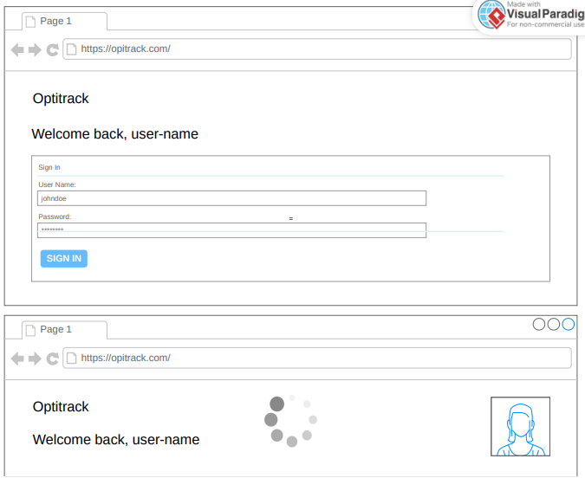

Figure Employee Account

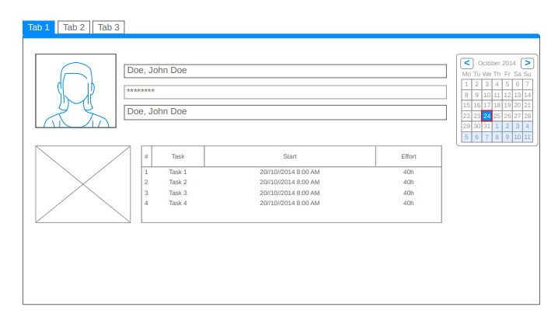

Figure OT Request Page Wireframe

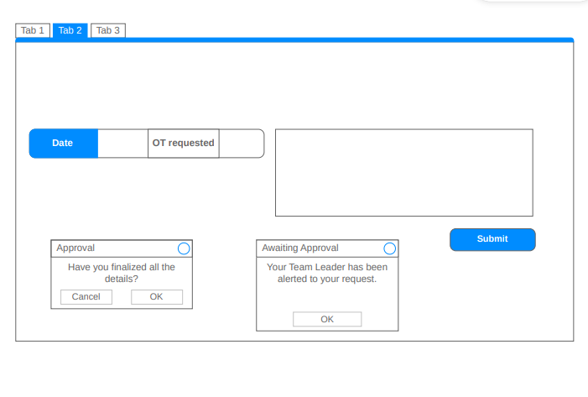

Figure Analytics Page Wireframe

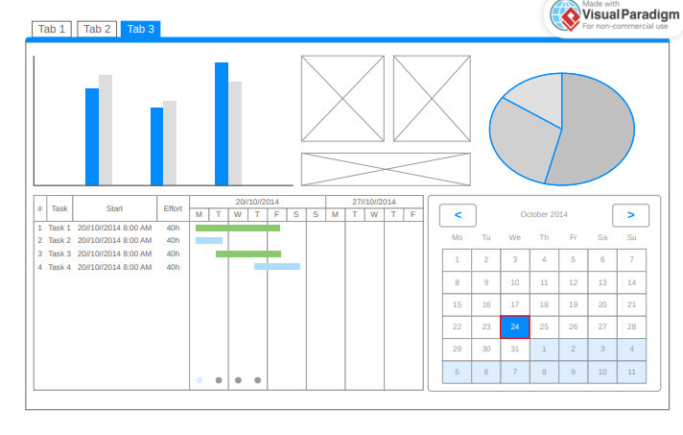

Figure Manage Employee Account - Manager Side

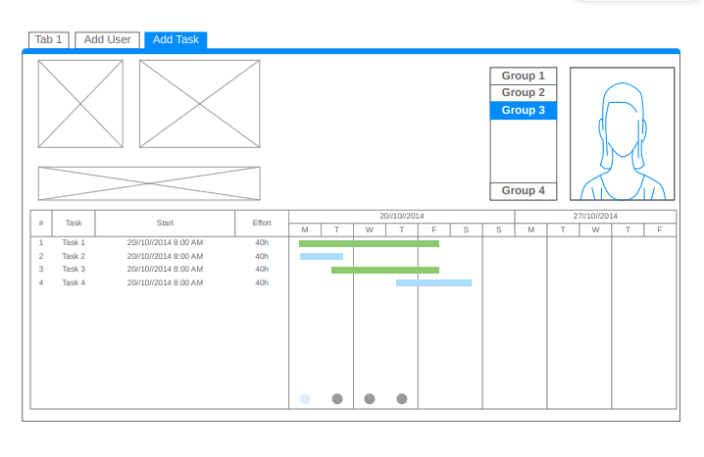

Figure Manage Recommendation - Manager Side Wireframe

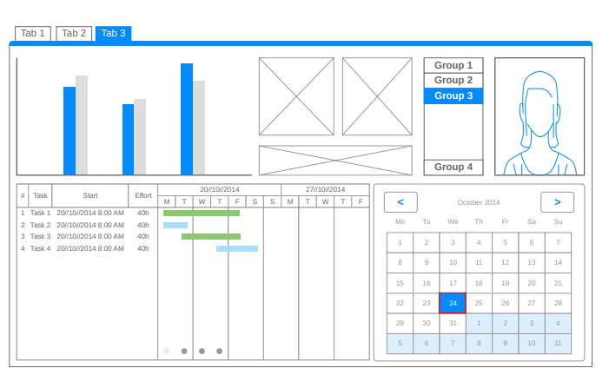

### Project Stack

### Project Stack

The project runs entirely within **GitHub Codespaces**, which provides a preconfigured development environment in the cloud. The backend is built using **Go (Golang)** and the lightweight **Horilla** framework, which relies on **Gorilla Mux** for routing and Go’s built-in html/template package for server-side rendering. Version control and collaboration are handled through **Git** and **GitHub**, making it easy to track changes and work with a team. To run the application, developers simply open the Codespace and use the command go run main.go. For the frontend, standard **HTML**, **CSS**, and **JavaScript** are used, with **Bootstrap** optionally included for faster UI development. This minimal tech stack ensures quick setup and easy maintenance, ideal for simple, independently deployed web apps.

### Github Repository

https://github.com/APC-SoCIT/APC-2024-2025-T3-Optitrack

## Project Lean Canvas

Table Lean Canvas

|  |  |  |  |  |  |  |  |  |  |  |  |
| --- | --- | --- | --- | --- | --- | --- | --- | --- | --- | --- | --- |
|  |  | Designed for: | | | | | Designed by: | | Date: | | Version: |
| **Lean Canvas** | | Capgemini | | |  | | Group 1 |  | 2/28/25 |  | 2.0 |
|  |  |  | | | | |  | |  | | |
| **Problem** | **Solution** | | **Unique Value Proposition** | | | **Unfair Advantage** | | | **Customer Segments** | | |
| * Lack of visibility into OT requests across the team. * Inefficient and time-consuming manual OT approval process. * Approvals granted without proper justification, leading to potential overspending. | * A comprehensive OT management system with:   + Real-time dashboard for tracking OT requests.   + Automated approval workflow with customizable levels.   + Mandatory field for detailed justification of OT.   + Automated reports on team productivity and OT utilization.   + Employee self-service portal for tracking OT balance. | | A streamlined, AI assisted OT management system that increases efficiency, transparency, and employee satisfaction while optimizing resource utilization and reducing administrative overhead. | | | | * Ensures a user-friendly and intuitive system for all stakeholders. * Streamlines implementation, data flow, and reduces onboarding friction. This pre-existing infrastructure is difficult for competitors to match. | | * Employees needing to log and track OT. * Team leads responsible for approving OT requests. * Operations managers monitoring OT usage and trends. * HR and administrative departments managing compliance and employee satisfaction. | | |
| **Existing Alternatives** | **Key Metrics** | | **High-Level Concept** | | | | **Channels** | | **Early Adopters** | | |
| * Manual OT logging using spreadsheets or paper forms. * Basic time-tracking software without AI capabilities. * Traditional approval processes involving emails or physical documents. | * Reduction in OT approval time. * Decrease in unjustified OT costs. * Improvement in employee satisfaction with OT process. * Increase in manager visibility and control over OT. * Adoption rate of the new system. * Frequency and quality of productivity insights generated. | | The system is like a combination of Jira and Tableau for overtime management - providing structured workflows and powerful data visualization. | | | | * Direct communication with Ms. Rochelle and key stakeholders. * Presentations and demonstrations to management. * Pilot program within the Collections team. | | * Companies with high OT usage and a need for better resource management. * Organizations seeking to leverage AI for operational efficiency. * HR departments looking to improve employee satisfaction and compliance. | | |
| **Cost Structure** | | | | **Revenue Structure** | | | | | | | |
| * Software development and implementation costs. * Ongoing maintenance and support. * Training and onboarding for users. * Potential integration costs with existing systems. * servers and related hardware | | | | * No concrete projections yet, but estimate potential cost savings and revenue based on:   + Current OT spending.   + Number of potential users.   + Market pricing for similar solutions.   + Gross Margin: | | | | | | | |
|  | | | | | | | | | | | |

### User Classes and Characteristics

Table User and Characteristics Table

|  |  |
| --- | --- |
| Roles | **Description** |
| Employee | Requests overtime through the system, tracks OT balance, and submits justifications. |
| Team Lead | Reviews and approves/disapproves OT requests before forwarding them to the operations manager. |
| Operations Manager | Has full visibility of OT requests, oversees approvals, and manages resource allocation. |
| Team manager | Supervises workload distribution, ensures smooth OT processes. |
| Developers | Ensure a reliable, secure, and efficient OT tracking system with seamless integration, automation, and user driven improvements. |

### Product Backlog

Table Product Backlog Table

|  |  |  |  |  |  |  |  |
| --- | --- | --- | --- | --- | --- | --- | --- |
| ID | As a... | |  | | --- | | I want to be able to... | | |  | | --- | | So that... | | |  | | --- | | **Priority** | |
| 1 | Employee | Log in securely | I can access my OT records | Must |
| 2 | Employee | Submit OT requests easily | I can ensure timely approvals | Must |
| 3 | Employee | Track my OT balance in real-time | I know my available OT hours | Must |
| 4 | Team Lead | Approve or reject OT requests efficiently | I can manage team overtime effectively | Must |
| 5 | Operations Manager | Access OT trend analysis | I can optimize workforce planning | Should |
| 6 | Operations Manager | Get AI-driven OT predictions | I can proactively manage workloads | Could |
| 7 | Manager | Detect unusual OT requests | I can ensure compliance with policies | Should |
| 9 | Employee | Access the system from my phone | I can check my OT status on the go | Could |
| 10 | User | Receive real-time notifications | I am informed about request status | Must |
| 11 | Admin | Track all OT requests and approvals | I can maintain compliance | Must |
| 12 | Employee | View a dashboard of my OT requests | I can track my request statuses | Must |
|  |  |  |  |  |

### **Data Flow Diagrams**

#### Data Flow Diagram Level 0

Figure

#### Data Flow Diagram Level 1

Figure

#### Data Flow Diagram Level 2 Process 1

Figure

#### Data Flow Diagram Level 2 Process 2

#### Data Flow Diagram Level 2 Process 3

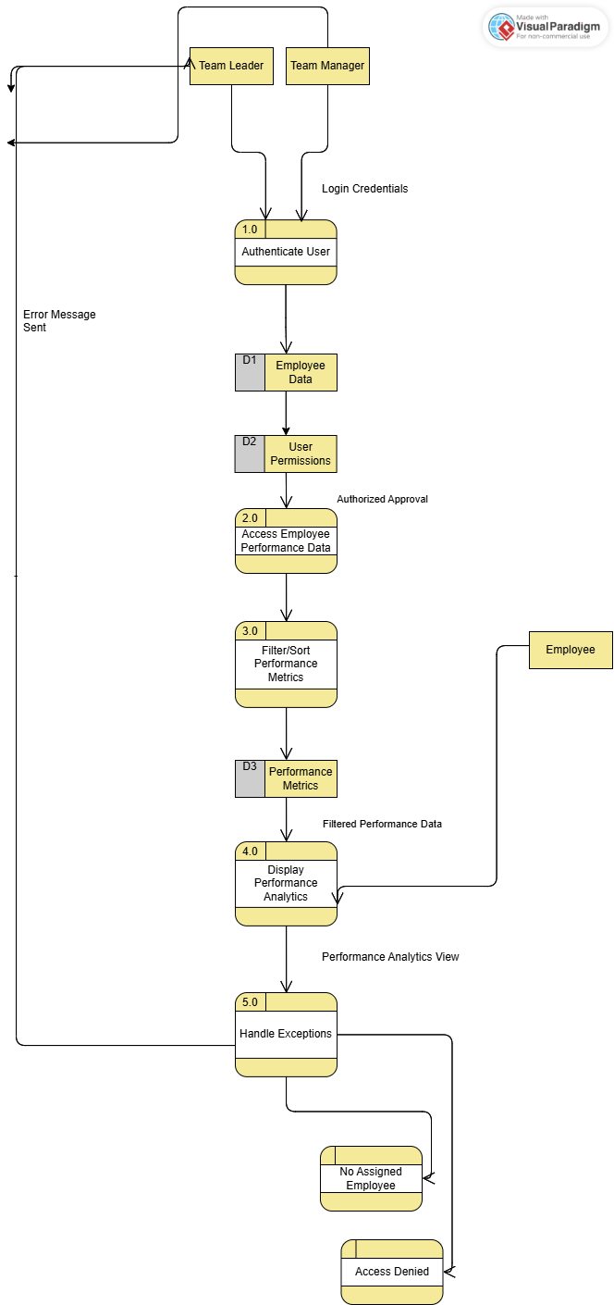

Figure

#### Data Flow Diagram Level 2 Process 4

Figure

#### Data Flow Diagram Level 2 Process 5

Figure

Figure

#### Data Flow Diagram Level 2 Process 6

Figure

### 

### Use Case Diagram

Figure Use Case Diagram

Figure

### **Use Case Full Description**

Table Manage Employee Account Use Case Description

|  |  |
| --- | --- |
| **Use Case ID** | OT_UC_1 |
| **Use Case Name** | Create Account |
| **Created By** | Kurt Yuri C. Fegarido |
| **Description** | This use case enables employees to register a new account on the Optitrack website to gain access to its features. |
| **Primary Actor** | Employee |
| **Secondary Actor** | None |
| **Include Use Case** | None |
| **Preconditions** | * The user must not already have an existing account. * The system is accessible and online. |
| **Postconditions** | * **Success:** The user is successfully registered, and a confirmation email is sent. * **Failure:** The user is notified of the failure reason and prompted to retry. |
| **Triggers** | * The user wants to create an account on the Optitack to access its features. |
| **Main Flow** | 1. User navigates to the registration page. 2. System prompts the user to enter details such as: 3. Username 4. Name 5. Age 6. Address 7. Email Address 8. Contact Number 9. Password (meeting security requirements) 10. User submits the registration form. 11. System validates the information. 12. System sends a confirmation email. 13. User clicks the confirmation link in the email. 14. The system activates the account and displays a success message. |
| **Alternate Flows** | 4a. Invalid Input:   1. If the user provides invalid or incomplete information, the system notifies the user. 2. The user is prompted to correct the input.   4b. Duplicate Username:   1. System notifies the user that the Username is already taken. 2. User is prompted to use a different Username.   4c. Duplicate Email Address:   1. System notifies the user that the email is already registered. 2. User is prompted to use a different email.   4d. Password Requirements Not Met:   1. System notifies the user that the password did not meet the security requirements. 2. User is prompted to use a different password.   5a. Email Not Received   1. User requests the system to resend the confirmation link. |
| **Special Requirements** | * Email verification links should expire after 5 minutes. |
| **Assumptions** | * Users have access to a valid email address. |

Table

|  |  |
| --- | --- |
| **Use Case ID** | OT_UC_2 |
| **Use Case Name** | Update Account |
| **Created By** | Kurt Yuri C. Fegarido |
| **Description** | This use case allows users to update their account details, such as personal information, email, or password. |
| **Primary Actor** | Employee |
| **Secondary Actor** | None |
| **Include Use Case** | None |
| **Preconditions** | * The user must already have an existing account. * The user must be logged in to the system. * The system is accessible and online. |
| **Postconditions** | * **Success:** The account details are updated, and the user receives a notification confirming the changes. * **Failure:** The user is notified of the failure reason (e.g., invalid input, session timeout) and prompted to retry |
| **Triggers** | * The user wants to modify their account information. |
| **Main Flow** | 1. User navigates to the account settings page. 2. System displays the current account details. 3. User edits the desired fields (e.g., username, name, age, address, contact number, email address, password). 4. User submits the updated details. 5. System validates the input and applies the changes. 6. User receives a confirmation notification about the update. |
| **Alternate Flows** | 4a. Invalid Input:   1. If the user provides invalid or incomplete information, the system notifies the user. 2. The user is prompted to correct the input.   4b. Duplicate Username:   1. System notifies the user that the Username is already taken. 2. User is prompted to use a different Username.   4c. Duplicate Email Address:   1. System notifies the user that the email is already registered. 2. User is prompted to use a different email.   4d. Password Requirements Not Met:   1. System notifies the user that the password did not meet the security requirements. 2. User is prompted to use a different password.   5a. Session Timeout:   1. If the user's session expires during the update process, the system redirects the user to the login page. 2. User logs in again and restarts the update process. |
| **Special Requirements** | * Sensitive information (e.g., passwords) must be encrypted during transmission and storage. |
| **Assumptions** | * Users know their current account credentials for sensitive updates like password changes. |

Table Manage Task Use Case Description

Table

|  |  |
| --- | --- |
| **Use Case ID** | OT_UC_3 |
| **Use Case Name** | Manage Tasks |
| **Created By** | Virgilio Angelo S. Navarro III |
| **Description** | This use case describes the process by which the team leader assigns, updates, sets, or adjusts tasks to the employees. |
| **Primary Actor** | Team Leader |
| **Secondary Actor** | Employee |
| **Include Use Case** | View Manage Tasks Use Case |
| **Preconditions** | The Team Leader is logged into the OT Tracker system.  Employees are available to receive tasks and access the system.  The system supports task assignments, updates, and due date management.  The Team Leader has the necessary permissions to assign and manage tasks. |
| **Postconditions** | Success:  The task is successfully assigned to the employee with the correct details.  The system records the task assignment, and the employee is notified with all necessary information.  Failure:  Team Leader fails to assign tasks or set due dates due to system errors, the tasks remain unassigned or without due dates. |
| **Triggers** | A task is ready to be assigned, updated, or have its due date set, prompted by project requirements, team member availability, or system notifications. |
| **Main Flow** | The Team Leader creates a new task or identifies an existing task that needs to be assigned.  The Team Leader selects a team member to assign the task to and enters task details.  The Team Leader sets a due date for the task, ensuring it aligns with the project timeline.  The system automatically notifies the assigned team member about the new task and due date.  The Team Leader may update the task’s status based on team member feedback or progress.  The Team Leader monitors the task progress.  Once the task is finished, the Team Leader marks it as completed in the system. |
| **Alternate Flows** | 1A: Team Member Is Not Available  If the team member selected by the Team Leader is unavailable the system notifies the Team Leader.    3A: Invalid Due Date  If the Team Leader attempts to set a due date in the past, or any invalid date, the system flags the date as invalid and prompts the Team Leader to select a future date. |
| **Special Requirements** | Notifications should be sent to team members when tasks are assigned, updated, or due dates are changed. |
| **Assumptions** | The Team Leader has the required permissions to assign, update, and manage tasks within the system. |

Table Manage OT Use Case Description Table

|  |  |
| --- | --- |
| **Use Case ID** | OT_UC_4 |
| **Use Case Name** | Manage OT |
| **Created By** | Rick Laurence Cruz |
| **Description** | This case covers the workflow for OT requests, from employee submission to approval by the Team Leader, Team Manager, and Operations Manager. |
| **Primary Actor** | Employee |
| **Secondary Actor** | Team Leader, Team Manager, Operations Manager |
| **Include Use Case** | Request OT  View OT  OT Approval |
| **Preconditions** | All employees log into the system.  Employees must have recorded their task. |
| **Postconditions** | OT requests are approved and recorded. The employee is notified.  OT request is rejected, and the employee is notified. |
| **Triggers** | The employee work or works overtime hours and submit a request for approval. |
| **Main Flow** | Employee logs into the system.  Employees record their task and overtime hours.  Employees submit the OT request.  Team Leader reviews the OT request.  Team Leader approves or rejects the OT request.  If approved, the Team Manager reviews the OT request.  The team Manager approves or rejects the OT request. |
| **Alternate Flows** | 4a. Overtime exceeds:   1. The request is automatically rejected by Team Leader.   4b. Team Leader Rejected for Approval   1. The system will record the rejected and notify the employee. |
| **Special Requirements** | Audit for all OT submissions and approvals. |
| **Assumptions** | Employees enter activity and overtime data.  Team Leaders, Team Managers, and Operations Managers review OT requests. |

|  |  |
| --- | --- |
| **Use Case ID** | OT_UC_5 |
| **Use Case Name** | OT Approval |
| **Created By** | Rick Laurence Cruz |
| **Description** | This case describes the process where the Operations Manager reviews, approves, or rejects overtime (OT) requests that have been approved by the Team Leader and Team Manager. |
| **Primary Actor** | Operations Manager |
| **Secondary Actor** | Team Leader, Team Manager, Employee |
| **Include Use Case** | * OT approval |
| **Preconditions** | * Overtime requests must have been approved by both the Team Leader and Team Manager. |
| **Postconditions** | * The OT request is approved or not approved, the system updates the request status and notifications are sent to the Employee and Team Leader. * If no action is taken, the OT request remains pending. |
| **Triggers** | * A Team Leader recommends an OT request for final approval or rejection. |
| **Main Flow** | 1. The Operations Manager logs into the system. 2. The Operations Manager accesses for approval. 3. The System display a list of pending OT requests. 4. The Operations Manager reviews each OT request. 5. The Operations Manager approves or rejects the OT request. |
| **Alternate Flows** | 5a. No Pending Requests:   1. The system displays a message, "No pending OT requests available for review." |
| **Special Requirements** | * Notifications must be sent to the Employee and Team Leader. * The system must allow the Operations Manager to view full request history, including previous approvals. |
| **Assumptions** | * All overtime requests reached by the Operations Manager have been validated by prior approval. |

|  |  |
| --- | --- |
| **Use Case ID** | OT_UC_6 |
| **Use Case Name** | View Assigned Employee Performance |
| **Created By** | Robyn Dominique  Fruto |
| **Description** | This use case allows Team Leaders and Team Managers to access performance data of their assigned employees to monitor work trends, productivity, and performance-related changes. |
| **Primary Actor** | Team Leader |
| **Secondary Actor** | Team Manager |
| **Include Use Case** | None |
| **Preconditions** | * The actor must be logged into the system. * The actor must have assigned employees. |
| **Postconditions** | * **Success:** The actor successfully views performance analytics of their assigned employees. * **Failure:** The system informs the actor that they do not have access or assigned employees. |
| **Triggers** | * Start of a scheduled performance review cycle. * A need to analyze team or individual productivity. * Detection of a significant performance change. |
| **Main Flow** | 1. Actor logs into the system. 2. Actor navigates to the Employee Performance module. 3. System authenticates access and displays a list of assigned employees. 4. The actor selects an employee from the list. 5. System displays the performance analytics of the selected employee. |
| **Alternate Flows** | 3a. No Assigned Employees:  System displays a message: "No employees assigned to your account.  3b. Unauthorized Access:  System displays a message: "You do not have permission to access this data. |
| **Special Requirements** | * Real-time data visualization for productivity trends. |
| **Assumptions** | * Team Leaders and Managers only see data for employees assigned to them. |

|  |  |
| --- | --- |
| **Use Case ID** | OT_UC_7 |
| **Use Case Name** | Sort Performance Metrics |
| **Created By** | Robyn Dominique  Fruto |
| **Description** | This use case allows Team Leaders and Team Managers to filter and sort performance metrics based on various criteria (e.g., time range, KPIs, anomalies) for effective performance analysis. |
| **Primary Actor** | Team Manager |
| **Secondary Actor** | Team Leader |
| **Include Use Case** | View Assigned Employee Performance |
| **Preconditions** | * User must be logged into the system. * Performance data must be available for at least one employee. |
| **Postconditions** | * **Success:** The system displays sorted/filtered performance data based on the selected criteria. * **Failure:** The system displays an appropriate error message if filters return no results. |
| **Triggers** | * The user wants to analyze specific performance indicators or timeframes. |
| **Main Flow** | 1. User accesses the performance analytics module. 2. User selects filtering criteria (e.g., "Last 30 days", "Low productivity", "Exceeds Targets"). 3. User applies the selected filters. 4. System processes and displays the sorted/filtered results |
| **Alternate Flows** | 4a. No Results Found   1. System displays a message: "No data found matching your filter criteria." |
| **Special Requirements** | * Filters should include date ranges, KPI thresholds, and comparison views. |
| **Assumptions** | * Performance metrics are updated regularly and accurately. |

|  |  |
| --- | --- |
| **Use Case ID** | OT_UC_8 |
| **Use Case Name** | Detect and Respond to Performance Changes |
| **Created By** | Robyn Dominique  Fruto |
| **Description** | This use case allows the system to notify Team Leaders and Team Managers when a significant positive or negative performance change is detected in an employee’s record. |
| **Primary Actor** | System |
| **Secondary Actor** | Team Leader, Team Manager |
| **Include Use Case** | View Assigned Employee Performance |
| **Preconditions** | * System is monitoring employee performance data. * Thresholds for significant changes are pre-configured. |
| **Postconditions** | * **Success:** A notification is sent to the actor regarding the employee’s performance change. * **Failure:** No notification is sent if thresholds are not met. |
| **Triggers** | * Detection of a performance anomaly by the system (e.g., a 20% drop-in task completion rate). |
| **Main Flow** | 1. System detects a significant change in performance data. 2. System evaluates the severity of the change based on thresholds. 3. System sends a performance alert notification to the actor. 4. Actor clicks on the notification to view details. 5. System displays the detailed performance change data |
| **Alternate Flows** | 3a. Alert Dismissed or Ignored:  Actor may choose to dismiss the alert without taking immediate action. |
| **Special Requirements** | * Notifications should be timestamped and categorized (Positive/Negative). |
| **Assumptions** | * Anomaly detection algorithms are reliable and tuned to operational goals. |

|  |  |
| --- | --- |
| **Use Case ID** | OT_UC_9 |
| **Use Case Name** | Manage Employee side – manager side |
| **Created By** | Sondrick Frondozo |
| **Description** | Allows the manager to add users, assign tasks, and monitor the employee’s progress and task efforts via a visual timeline (Gantt Chart style). <https://www.freepik.com/free-photos-vectors/gantt-chart> |
| **Primary Actor** | Employee |
| **Secondary Actor** | None |
| **Include Use Case** | None |
| **Preconditions** | Manager must be logged into the system.  Employee accounts exist in the system. |
| **Postconditions** | New tasks are assigned to employees.  Updates to employee information or assignments are saved. |
| **Triggers** | Manager selects a user or adds a new task. |
| **Main Flow** | 1. Manager logs into the system.  2. Manager selects an employee from the group list.  3. Manager views employee task timelines.  4. Manager clicks "Add User" to add a new employee.  5. Manager clicks "Add Task" to assign a new task.  6. Manager saves the change. |
| **Alternate Flows** | If no employees exist, the system prompts the manager to add a new user first.  If no tasks are assigned, the timeline appears empty. |
| **Special Requirements** | Timeline view must update in real time.  System must show task duration and effort clearly. |
| **Assumptions** | Employees and tasks are regularly updated by the manager. |
| **Use Case ID** | OT_UC_2 |
| **Use Case Name** | manage recommendations -manager side wireframe |
| **Created By** | Sondrick N. Frondozo |
| **Description** | Allows the manager to manage employee recommendations, track task progress visually, and view performance through charts and calendars. |
| **Primary Actor** | Employee |
| **Secondary Actor** | None |
| **Include Use Case** | None |
| **Preconditions** | Manager must be logged into the system.  Recommendation data must be available. |
| **Postconditions** | Recommendations are reviewed or updated.  Task progress and recommendations are recorded. |
| **Triggers** | Manager switches to the Recommendations tab. |
| **Main Flow** | 1. Manager logs into the system.  2. Manager clicks the "Recommendations" tab.  3. Manager views performance charts.  4. Manager views task progress timelines.  5. Manager uses the calendar to check task schedules.  6. Manager updates or approves recommendations. |
| **Alternate Flows** | If no recommendation data exists, the system displays "No data available".  Manager can filter results by date using the calendar. |
| **Special Requirements** | Bar charts must be dynamic and reflect current data.  Calendar must allow date-based filtering of tasks. |
| **Assumptions** | Data for recommendations is updated regularly. |

Table OT Approval Use Case Description Table

|  |  |
| --- | --- |
| **Use Case ID** | OT_UC_10 |
| **Use Case Name** | Approval OT Request |
| **Created By** | Rick Laurence Cruz |
| **Description** | This case details the workflow of approval, which employee submit their OT request. It includes the review of approval and rejection by Team Leader, Team Manager and Operation Manager |
| **Primary Actor** | Team Leader |
| **Secondary Actor** | Team Manager, Operations Manager |
| **Include Use Case** | * Request OT * OT Approval |
| **Preconditions** | * All employees log into the system. * The employee has submitted a complete OT request with tasks recorded. * All approved are verified by the system. |
| **Postconditions** | * The OT request is either approved or rejected. * The employee is notified. |
| **Triggers** | * The OT request is submitted by an employee for approval. |
| **Main Flow** | 1. System receives the OT request submitted by the employee. 2. System receives the OT request to the designated Team Leader. 3. Team Leader logs into the system and views the OT request. 4. Team Leader reviews the OT recorded tasks. 5. Team Leader approves the request. 6. System sends the OT request to the Team Manager. 7. Team Manager logs into the system and reviews the request. 8. The Team Manager approves the request. 9. System sends the OT request to the Operations Manager. 10. Operations Manager logs into the system and reviews the request. 11. Operations Manager approves the request. 12. System updates the OT request status to “Approved”. 13. System sends a notification to the employee about approval. |
| **Alternate Flows** | 4a. Team Leader Rejects Request   1. Team Leader rejects the OT request. 2. System updates the request status to “Rejected”. 3. System sends a rejection notification to the employee. 4. System logs the rejection with reason. |
| **Special Requirements** | * A notification system must be in place for real-time updates for employees. |
| **Assumptions** | * System Access   All employees, Team Leaders, Team Managers, and Operations Managers have valid login credentials and access to the OT system.   * Data Entry   Employees are responsible for accurately entering their work tasks and overtime hours before submitting an OT request. |

Table View Reports Use Case Description Table

|  |  |
| --- | --- |
| **Use Case ID** | OT_UC_11 |
| **Use Case Name** | Access Report Generation Module |
| **Created By** | Robyn Dominique  Fruto |
| **Description** | This use case allows the Operations Manager or Team Manager to access the "View Reports" section to begin generating employee performance, task, or overtime reports. |
| **Primary Actor** | Operations Manager |
| **Secondary Actor** | Team Manager |
| **Include Use Case** | None |
| **Preconditions** | * The Operations Manager or Team Manager must be logged into the system. * The system must be online and functional. |
| **Postconditions** | * **Success:** The "View Reports" page opens and is ready for customization. * **Failure:** The system displays an access error message if the module is unavailable. |
| **Triggers** | * The manager needs to generate or review reports related to employee activities. |
| **Main Flow** | 1. Actor logs into the system. 2. Actor selects "View Reports" from the main dashboard. 3. System opens the "View Reports" page and displays customization options (e.g., report type, date range). |
| **Alternate Flows** | 3a. Module Not Available:   * System displays "The Reports module is currently unavailable. Please try again later." |
| **Special Requirements** | * Quick system response (within 3 seconds of clicking "View Reports"). |
| **Assumptions** | * Actor has the correct user role permissions. |

|  |  |
| --- | --- |
| **Use Case ID** | OT_UC_12 |
| **Use Case Name** | Generate Customized Reports |
| **Created By** | Robyn Dominique  Fruto |
| **Description** | This use case enables the Operations Manager or Team Manager to generate a customized report based on selected criteria such as date range or specific report type. |
| **Primary Actor** | Operations Manager |
| **Secondary Actor** | Team Manager |
| **Include Use Case** | Access Report Generation Module |
| **Preconditions** | * Actor must have access to the "View Reports" module. * Relevant data must exist for the selected criteria. |
| **Postconditions** | **Success**: The requested report is generated and displayed on the system.  **Failure**: An error message is displayed if data is unavailable or a system error occurs during report generation. |
| **Triggers** | * Actor customizes and submits report generation parameters (e.g., date range, report type). |
| **Main Flow** | * Actor selects customization criteria for the report (e.g., date, type of report). * Actor clicks "Generate Report." * System processes the request. * System displays the generated report to the actor. |
| **Alternate Flows** | 4a. No Data Available:  System displays: "No data available for the selected criteria."  4b. Error During Generation:  System displays: "An error occurred while generating the report. Please try again." |
| **Special Requirements** | * Reports should be exportable to PDF or Excel formats. * Reports must load within 5 seconds after submission |
| **Assumptions** | * System is connected to the latest database updates. |

### Test Cases

### Activity Diagram with Swimlanes

Figure

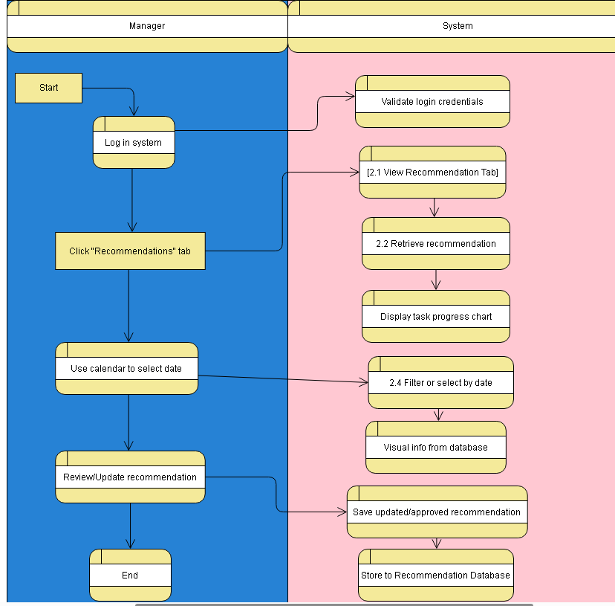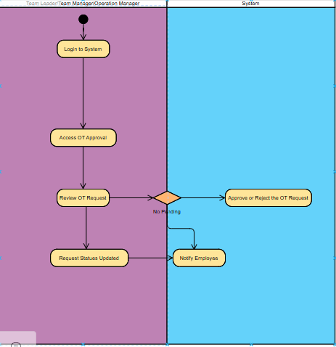

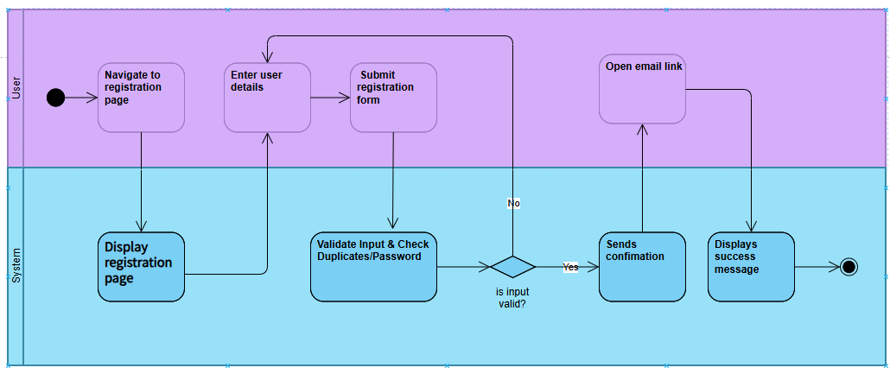

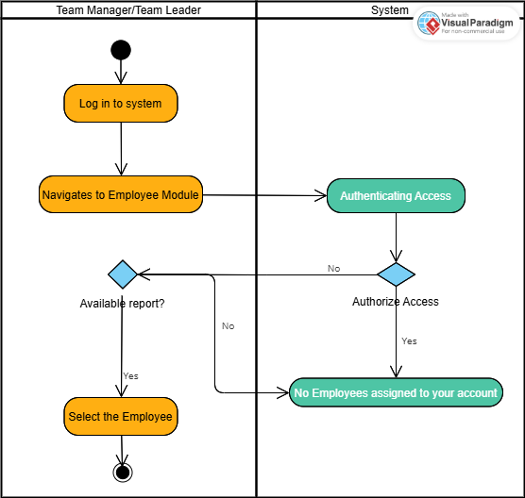

### Entity Relationship Diagram

### 

# Conclusion

This phase of the project focused on establishing a comprehensive understanding of the challenges faced by the Capgemini Collections team in managing overtime and defining the objectives for an improved OT management system. Through careful analysis of the existing process and consultation with key stakeholders, we identified four core problems: lack of comprehensive team visibility, inefficient approval processes, absence of justifiable OT approvals, and limited access to actionable productivity insights.

To address these challenges, we defined a main objective: to develop and implement a comprehensive overtime management system that enhances visibility, streamlines approvals, ensures justified OT, and provides actionable productivity insights. This main objective is supported by several specific objectives, including the development of a real-time dashboard, the implementation of an automated approval workflow, the requirement for detailed justifications for OT requests, and the generation of automated reports on team productivity and OT utilization. We have accomplished significant milestones in this phase, including the definition of clear objectives and the creation of wireframes for the proposed system. This provides a strong foundation for the next iteration of this project, which will focus on further design and development. In the subsequent PBL subject, we will refine the user interface design based on the wireframes, finalize the database schema, and detail the system architecture. Additionally, we will evaluate and select appropriate technologies for development, considering factors such as scalability, security, and integration with existing Capgemini systems. Finally, we will develop a functional prototype of the system, incorporating the finalized design and selected technologies, to demonstrate key features and gather feedback from users.

# References

[1] “Our Vision and Mission,” *Capgemini Australia*. <https://www.capgemini.com/au-en/insights/research-library/our-vision-and-mission/>

[2]“What we do,” *Capgemini*. <https://www.capgemini.com/about-us/who-we-are/what-we-do/>

[3] United Nations, “The 17 Sustainable Development Goals,” *United Nations*, 2025. <https://sdgs.un.org/goals>

[4]“Unlocking Efficiency: How Automated Timesheets Transform Business Time Management | Monitask,” *Monitask*, Jul. 15, 2024. <https://www.monitask.com/en/blog/unlocking-efficiency-how-automated-timesheets-transform-business-time-management?utm> (accessed Mar. 06, 2025).

[5]I. S. Chain, “How Does Timesheet Software Affect Productivity Long Term? - IT Supply Chain,” *IT Supply Chain*, Feb. 08, 2025. <https://itsupplychain.com/how-does-timesheet-software-affect-productivity-long-term/?utm> (accessed Mar. 06, 2025).

[6]“\r\n \n Boost Business Efficiency with Automated Timekeeping\n \r\n,” *Timeandpay.com*, 2022. <https://www.timeandpay.com/boost-business-efficiency-with-automated-timekeeping?utm> (accessed Mar. 06, 2025).

[7]“DSpace,” *Wichita.edu*, 2025. <https://soar.wichita.edu/bitstreams/1d68257a-9803-4164-bf20-5acf96362836/download?utm> (accessed Mar. 06, 2025).

[8]E. Staff, “What Are Automated Timesheets? Benefits & How To Implement It,” *Tackle*, Dec. 30, 2024. <https://www.timetackle.com/automated-timesheets/?utm> (accessed Mar. 06, 2025).

[9] “Smart Employee Time Tracking Software with Screenshots | Time Doctor,” [www.timedoctor.com](https://www.timedoctor.com). <https://www.timedoctor.com/>

[10] Wrike, “Wrike,” Wrike, 2019. <https://www.wrike.com/>

[11] “Time Tracking Software - Free Automated Time Tracker TimeCamp,” [www.timecamp.com](https://www.timecamp.com). <https://www.timecamp.com/>

[12] “Connecteam: The All-in-One Employee App for Deskless Teams,” *Connecteam*. <https://connecteam.com/>

[13] CAKE.com Inc, “Free Employee Overtime Tracker — Clockify,” *Clockify*, 2025. <https://clockify.me/overtime-tracker> (accessed Mar. 05, 2025).

[14] “Time Tracking Software Suite,” *Replicon*. <https://www.replicon.com>

[15]“What is Outlook?,” support.microsoft.com. <https://support.microsoft.com/en-us/office/what-is-outlook-10f1fa35-f33a-4cb7-838c-a7f3e6228b20>

[16]Microsoft, “What is microsoft teams?,” support.microsoft.com, 2022. https://support.microsoft.com/en-us/topic/what-is-microsoft-teams-3de4d369-0167-8def-b93b-0eb5286d7a29

‌

‌

# Appendices

## Appendix A: Project Vision

The AI-powered Overtime (OT) Tracking and Approval System is designed to revolutionize workforce management within Capgemini by creating a streamlined, transparent, and data-driven approach to OT approvals. This system is not just a tracking tool, but a strategic solution aimed at enhancing operational efficiency, improving employee experience, and optimizing business processes through advanced automation and AI-driven insights.

By integrating intelligent automation, the system will reduce administrative burdens associated with OT approvals, ensuring a seamless and structured workflow. Employees will benefit from real-time access to their OT balance, reducing uncertainty and delays. Team leaders and operations managers will gain deeper insights into workforce trends, enabling them to allocate resources more effectively and minimize unnecessary costs.

A key component of this vision is predictive analytics, which will help forecast workload patterns and proactively manage OT requirements. AI-driven anomaly detection will flag unusual or excessive OT requests, preventing compliance issues and optimizing labor costs. Additionally, the system will integrate with existing payroll and workforce management platforms, ensuring data accuracy and alignment with company policies.

Ultimately, this initiative reflects Capgemini’s commitment to leveraging cutting-edge technology to drive operational transformation. By implementing an AI-powered OT management system, Capgemini aims to foster a more efficient, data-driven, and employee-centric work environment, ensuring long-term business sustainability and success.

## Appendix B: Schedule/Release Plan

Table Release Plan Table

|  |  |  |
| --- | --- | --- |
| **MNTSDEV** | **MSYADD1** | **MCSPROJ** |
| * **Project Proposal:** Define project scope, objectives, and deliverables. * **Product Vision:** Articulate the overall goal and value proposition of the OT management system. * **Backlog:** Create and prioritize a list of features and user stories. * **Product Roadmap:** Develop a high-level timeline visualizing releases and key features. * **Release Plan:** Outline features for each Minimum Viable Product (MVP) release. * **Increment Release 1 (MVP):**   + Secure Login   + Submit OT Requests   + Real-time OT Tracking * **Requirements Gathering:** Conduct thorough requirements gathering, including user interviews and analysis of existing systems. | * **Design Diagrams:** * Structure Diagrams: Create Data Flow Diagrams (DFD) and Entity-Relationship Diagrams (ERD) to model data and processes. * Object-Oriented Diagrams: Develop Use Case Diagrams, Class Diagrams, and Activity Diagrams to represent system behavior and structure. * **Prototyping:** Develop a functional prototype of the system based on the finalized design. * **Increment Release 2 (MVP):** * Approval Workflow (potentially including basic reporting) * Notifications * **Development:** Begin development of core features for Release 1 and Release 2. | * **Increment Release 3 (MVP):** * Payroll Sync * Compliance Tracking * Advanced Reporting and Analytics Features * **Development:** Complete development of all remaining features and MVP releases. * **CI/CD Pipeline:** Implement a Continuous Integration/Continuous Deployment pipeline for automated building, testing, and deployment. * **Other Workflow Improvements:** Integrate any additional workflow enhancements based on user feedback or further analysis. * **Contingency Plans:** Define and document backup plans and risk mitigation strategies. * **System Hand-off:** * Source Code: Deliver well-documented source code. * Development Artifacts: Provide design specifications, test cases, and deployment guides. * User and Admin Manuals: Create comprehensive user and administrator manuals. |

## Appendix C: Product Roadmap

**Phase 1: Research & Analysis (1–2 Months)**

* Interview stakeholder participants (Ms. Rochelle, Team Leaders, Ops Manager, Staff).
* Review current OT process in Replicon and determine pain points.
* Create project schedule and resource plan.

**Phase 2: Design & Prototyping (3-5 Months)**

* + Design wireframes for the OT tracker system.
  + Finalize approval workflow logic and user access roles.
  + Secure necessary approvals from key stakeholders.

**Phase 3: Development & Integration (1-3Months)**

* Employee OT request submission with contextual information.
* Real-time visibility dashboard for Managers, Team Leads, and Operations.
* Automated approval process with notifications.

**Phase 4: Continuous Improvement (4+Months)**

* Establish continuous feedback.

## Appendix D: Minutes of the Meetings

**Meeting 1: Project Task Assignment Meeting**

**Date:** April 16, 2025  
**Time:** [Time not provided]  
**Attendees:** Robyn Fruto, Kurt Yuri Fegarido, Rick Laurence Cruz, Sondrick Frondozo  
**Absent:** Anngelo Navarro  
**Subject:** Use Case Expansion and Task Distribution

**Minutes:**

1. **Use Case Expansion:**
   * Discussed the need to expand current use cases.
   * Group agreed to create full case descriptions for each identified feature.
2. **Task Distribution:**
   * Tasks were assigned to team members as follows:
     + Manage Employee Account: Kurt Yuri Fegarido
     + Manage OT / Performance: Robyn Fruto
     + Manage Recommendation: Sondrick Frondozo
     + OT Approval: Virgillio
     + View Reports: Rick Laurence Cruz

**Action Items:**

* Ask Sir Sean if he can be the project adviser.

**Meeting Adjourned:** [Time not provided]  
**Prepared By:** Kurt Yuri Fegarido

**Meeting 2: DFD and Test Case Planning**

**Date:** April 30, 2025  
**Time:** [Time not provided]  
**Attendees:**

* Robyn Fruto – Lead
* Rick Laurence Cruz
* Sondrick Frondozo
* Anngelo Navarro  
  **Absent:**
* Kurt Yuri Fegarido (Excused)  
  **Subject:** DFD Development and Test Case Planning

**Minutes:**

1. Distribution of works among team members
2. Robyn created the DFD Level 0 diagram
3. Robyn created the DFD Level 1 diagram
4. Team discussed the approach for developing DFD Levels 0 to 2
5. Team discussed how to formulate the test cases

**Action Items:**

* None recorded

**Meeting Adjourned:** [Time not provided]  
**Prepared By:** [Not specified]

**Meeting 3: Progress Check & Prototype Testing**

**Date:** June 16, 2025  
**Time:** [Time not provided]  
**Attendees:**

* Robyn Fruto – Lead
* Kurt Yuri Fegarido – Secretary
* Rick Laurence Cruz
* Sondrick Frondozo
* Anngelo Navarro  
  **Absent:**
* None

**Subject:** Project Progress and Prototype Testing

**Minutes:**

1. Checked progress on:
   * Full use case descriptions
   * Data Flow Diagram Level 0 and 1
   * Paper nearing completion
   * Prototype testing with screenshots showing applied fully dressed use case
   * Encountered difficulty changing the title in Horilla; all other features working
2. **Next Steps:**
   * Search how to change the name in Horilla and replace it with the team's company name

**Action Items:**

* Research how to rename project title in Horilla

**Meeting Adjourned:** [Time not provided]  
**Prepared By:** Kurt Yuri Fegarido