

AI-Assisted Dental Clinic Management System
Developing an AI-Assisted Dental Clinic Management System with Predictive Appointment Scheduling and Patient Record Management
AY 2026-2027

Members:
Jon Joseph Catipon
John Carlo Jancorda
Prince Jabez Reyes
Joachim Emanuelle Tan
John Lourd Marcus De Leon

ADVISER:
Mr. Jay James Arroyo

Table of Contents
Table of Contents 1
Foreword 2
Chapter 1: Introduction 3
1.1 Project Context 4
1.2 Statement of the Problem 4
1.3 Objectives 5
1.4 Significance of the Project 5
1.5 Scope and Limitations 6
Chapter 2: Review of Related Literature and Systems 6
2.1 Related Literature on Dental Clinic Management Systems 7
2.2 Related Literature on Predictive Appointment Scheduling 7
2.3 Related Literature on Electronic Health Records and Digitization 7
2.4 Related Literature on Healthcare Automation and No-Show Prediction 7
2.5 Related Systems 8
Chapter 3: Current System 8
3.1 Technical Background 9
3.2 List of Processes 9
Paper-Based Records 9
Data Redundancy 9
File Corruption Risk 9
No Automated Reminders 9
BIR Compliance Constraint 10
3.3 SWOT Analysis 10
Chapter 4: Proposed Solution 10
4.1 Technical Background 11
4.2 Feasibility 11
Operational Feasibility 11
Economic Feasibility 12
Technical Feasibility 13
Schedule Feasibility 13
4.3 Requirements Analysis 13
4.3.1 Project Vision 14
4.3.2 Prototype 14
4.3.3 Project Lean Canvas 18
4.3.4 User Classes and Characteristics 20
4.3.5 Product Backlog 23
4.3.6 Product Roadmap 25
4.3.7 Release Plan 26
Sprint 1 — Core Foundation (Months 6–7) 27
Sprint 2 — Notifications, Cancellations & Treatment Notes (Months 7–8) 27
Sprint 3 — AI Features, Predictive Scheduling & Patient Portal (Months 8–9) 27
4.3.6 Product Roadmap 28
4.3.8 Use Case Diagram 28
4.3.9 Use Case Fully Dressed 29
Register Patient 30
Patient Log In 31
Book Appointment 32
Download Patient Record 33
View Patient Record 34
Summarize Patient Info (AI chatbot) 35
Record Treatment Notes 36
Update Dental Record 37
View Daily Appointment Schedule 38
Request Delete Patient Account 39
Chapter 5: Systems Analysis and Design Artifacts 40
5.1 Data Flow Diagrams 41
5.1.1 Context Diagram (Level 0) 41
5.1.2 Level 1 DFD 41
5.1.3 Level 2 DFD — Decomposition of “1.0 Manage Appointments” 41
5.1.4 System Architecture (C4 Model) 42
5.2 Activity Diagram with Swimlanes 44
5.3 Database Design 55
functional5.3.1 Entity-Relationship Diagram (ERD) 55
5.4 Test Cases 55
TC-001 — UC-01 Book Appointment 56
TC-002 — UC-01 Book Appointment 56
TC-003 — UC-01 Book Appointment 57
TC-004 — UC-01 Book Appointment 58
TC-005 — UC-01 Book Appointment 58
TC-006 — UC-01 Book Appointment 59
TC-007 — UC-02 Predict No Show & Reminders 60
TC-008 — UC-02 Predict No Show & Reminders 60
TC-009 — UC-02 Predict No Show & Reminders 61
TC-010 — UC-02 Predict No Show & Reminders 62
TC-011 — UC-03 Manage Cancelled Appointments 62
TC-012 — UC-03 Manage Cancelled Appointments 63
TC-013 — UC-03 Manage Cancelled Appointments 64
TC-014 — UC-04 Generate Patient Report 64
TC-015 — UC-04 Generate Patient Report 65
TC-016 — UC-04 Generate Patient Report 66
TC-017 — UC-05 Retrieve Patient Record 66
TC-018 — UC-05 Retrieve Patient Record 67
TC-019 — UC-05 Retrieve Patient Record 68
TC-020 — UC-06 Summarize Patient Info (AI chatbot) 68
TC-021 — UC-06 Summarize Patient Info (AI chatbot) 69
TC-022 — UC-06 Summarize Patient Info (AI chatbot) 70
TC-023 — UC-07 Record Treatment Notes 70
TC-024 — UC-07 Record Treatment Notes 71
TC-025 — UC-07 Record Treatment Notes 72
TC-026 — UC-08 Create and Update Patient Profile 72
TC-027 — UC-08 Create and Update Patient Profile 73
TC-028 — UC-08 Create and Update Patient Profile 74
TC-029 — UC-09 View Daily Appointment Schedule 75
TC-030 — UC-09 View Daily Appointment Schedule 75
TC-031 — UC-09 View Daily Appointment Schedule 76
5.5 Sprint Backlog 77
Sprint 1 — Core Foundation (Months 6–7) 78
Sprint 2 — Notifications, Cancellations & Treatment Notes (Months 7–8) 78
Sprint 3 — AI Features, Predictive Scheduling & Patient Portal (Months 8–9) 78
5.6 Partially Working Cloud-Hosted Prototype 79
5.6.1 Minimum Scope for the Prototype 80
5.6.2 Suggested Hosting Path 80
Consistent with the Economic Feasibility section of Chapter 4, the prototype runs entirely on the Vercel and Supabase Free Tiers. Supabase provides a managed PostgreSQL database instance, and the Nest.js REST API is deployed to Vercel alongside the React frontend. The single Supabase instance serves both clinic branches, with each patient and appointment record tagged by branch so that data stays properly separated while still running on one free-tier database. The React web application can point its API base URL at the Vercel-hosted backend so the team can demo booking and record retrieval live, from any browser, without a local server. 80
5.6.3 Status 80
Conclusion 80
References 81
Appendices 82
Appendix A: Roles and Responsibilities 83
Appendix B: Minutes of the Meeting 83
Client Interview — 04/27/2026, 8:00 PM 84
Team Meeting — 8/4/2026, 9:00 PM 84
Secretary Interview — 23 min 19 sec recording 84
Appendix C: Methodology 85
As-Is Scenario Map 86
To-Be Scenario Map 87
User Stories 88
Secretary 89
Dentist 89
Patient 90
Empathy Map — Dentist / Clinic Owner 91
Empathy Map — Secretary (Dental Clinic) 92
Storyboard 93
Appendix D: Project SharePoint Link 96
Appendix E: Requirements Traceability Matrix (RTM) 97
Appendix F: RACI Matrix 100

Foreword
This is the combined project document: the original capstone paper (Chapters 1–4, Conclusion, References, and Appendices A–F) together with the new Chapter 5, Systems Analysis and Design Artifacts, produced for the SSYADD1/MSYADD1 requirement. Chapter 5 and its artifacts trace directly back to the use cases, product backlog, and RACI assignments defined earlier in this same document.

Chapter 1: Introduction

1.1 Project Context
The delivery of quality dental care depends not only on clinical expertise but also on the efficiency of administrative operations. For many small and independent dental clinics in the Philippines, day-to-day management remains heavily reliant on manual, paper-based processes that have become increasingly unsustainable as patient volumes grow.
This project is being developed as a startup venture by the team, with the goal of building DentalFlow into a commercial digital clinic management platform. The team’s pilot customer is a licensed dentist who owns and operates two private dental clinics. For this project, the system will be developed and deployed to support both branches, using a shared cloud-hosted database on the Vercel to keep each branch’s records and workflows properly separated while still operating under a single, unified platform.
The clinic is managed day-to-day by a dedicated secretary whose primary responsibilities include scheduling patient appointments, reminding patients of their upcoming visits, and maintaining all physical patient records. When a new patient visits the clinic, the secretary first collects and records their personal information, dental history, and medical history on a paper form. The patient is then directed to the operating area, where the dentist conducts an interview and proceeds with the examination and treatment.
Appointments are currently scheduled by phone or walk-in. Patients contact the clinic, the secretary manually checks a paper logbook for available slots, and the appointment is written by hand. The client enforces a strict punctuality policy; all patients are required to be on time, and those who anticipate being late are expected to send a message in advance. Despite this policy, the clinic still experiences scheduling issues. As the client confirmed during the interview, scheduling overlaps still occur even under the current system, with double bookings happening on occasion.
A particularly significant operational gap arises when a patient cancels or fails to show up for their scheduled appointment. As the client directly stated during the interview, when a patient does not attend, the slot simply goes to waste. There is no system in place to reassign the slot, notify a waiting patient, or take any corrective action. This results in lost consultation time and reduced clinic revenue.
Beyond scheduling, the clinic also faces a serious records management challenge. The secretary is responsible for maintaining thousands of physical patient folders stored in filing cabinets. Retrieving a specific record requires manually searching through these cabinets one by one, a tedious and time-consuming process. The volume of paper records has created a significant storage crisis, as the clinic continues to run out of physical space to accommodate new files. During consultations, the dentist and clinical staff must review these handwritten records while the patient is in the dental chair, record new findings by hand on physical dental charts, and update the patient's history in real time all on paper.
The client expressed strong interest in modernizing clinic operations, responding positively to the concept of an AI-assisted management system during the interview. The client specifically acknowledged the value of a predictive scheduling feature, noting that the ability to avoid overlaps and manage appointment slots more intelligently would be a significant improvement. The client also noted that going digital would make the secretary's workflow easier and shorter by removing the burden of manual follow-ups and physical filing.
The goal of this project is to develop an AI-Assisted Dental Clinic Management System that addresses these operational challenges by digitizing patient records and implementing a predictive appointment scheduling feature. The system aims to eliminate the storage crisis caused by paper records, reduce the rate of missed and wasted appointments through automated reminders and prediction, and provide the clinic with a smarter, more efficient way to manage its daily operations.

1.2 Statement of the Problem
This project seeks to address the following:
• Inefficient management of cancelled and missed appointments: When patients cancel or fail to attend scheduled appointments, the clinic lacks an automated or structured process to manage the vacant time slot. As a result, cancelled appointments are not reassigned, leading to unused consultation hours and reduced clinic productivity.
• Absence of a patient waiting list or notification mechanism: The clinic does not have a system to notify other patients when an appointment slot becomes available. Even when patients inform the clinic in advance of cancellation, there is no mechanism to alert waiting patients, preventing optimal utilization of available time and delaying care for other patients.
• Inefficient record management due to paper-based patient documentation: The clinic faces inefficiencies in managing patient records because personal information, dental history, and medical history are documented and stored exclusively on physical paper forms. This manual system limits organization slows down record handling, and increases the risk of lost, damaged, or outdated patient information.
• Difficulty in generating reports: Due to the lack of a centralized digital record system, both the dentist and the secretary experience challenges in quickly retrieving comprehensive patient data. This can lead to inefficiencies during consultations, inconsistent documentation, and potential impacts on the quality and continuity of patient care.

1.3 Objectives
General Objective:
To design and develop an AI-assisted dental clinic management system that digitizes patient record management and optimizes appointment scheduling, with the goal of improving the operational efficiency of the clinic and the quality of care delivered to its patients within the nine-month project lifecycle.
Specific Objectives:
• To reduce unused consultation slots caused by cancellations and no-shows by at least 30% within the nine-month project lifecycle, as measured through the system's appointment tracking logs. The clinic currently has no mechanism to reassign cancelled slots, resulting in all cancelled appointments going to waste. By the end of the refinement phase, the system should reduce unused consultation slots caused by cancellations and no-shows by at least 30% compared to the baseline rate recorded during the first month of deployment.
• To enable clinic staff to retrieve any complete patient record within 3 minutes of initiating a search by the end of the refinement phase, as validated through user acceptance testing with the clinic secretary. The clinic secretary currently retrieves patient records by manually searching through physical filing cabinets, a process that has no defined time standard.
• To fully automate at least 3 manual administrative tasks (appointment reminders, record retrieval, and slot management) by the end of the refinement phase, as validated through secretary feedback during user acceptance testing.
• To successfully migrate and store 100% of newly registered patient records in a centralized digital database with automated cloud backup by the end of the development phase, as verified through system testing and client sign-off.

1.4 Significance of the Project
DentalFlow creates value for the following stakeholders:
To the Clinic Owner
The system reduces time lost to administrative inefficiencies and provides better visibility over the clinic's daily schedule. Cancelled and missed appointment slots can be identified and reassigned quickly, reducing lost revenue and improving overall clinic productivity. The system also eliminates the risk of scheduling overlaps that currently occur under the manual logbook system.
To the Clinic Secretary
As the primary user of the system, the secretary benefits most directly from this project. Tasks that previously required manual searching through filing cabinets, handwriting appointment entries, and personally following up with patients can now be handled digitally — making the administrative workflow significantly easier, faster, and more organized.
To the Patients
Patients receive automated reminders before their appointments, reducing the likelihood of forgetting or missing their scheduled visits. They can also access their own profiles, view their appointment history, and receive notifications directly on their phones, improving their overall experience with the clinic.
To Future Developers and Researchers
This project serves as a reference for future studies on AI-assisted clinic management systems, particularly in the context of small independent dental practices in the Philippines where digital adoption in healthcare administration remains limited.
This project also contributes to SDG 3: Good Health and Well-Being by improving the delivery of dental care through more efficient clinic operations, better patient engagement, and more reliable continuity of care.

1.5 Scope and Limitations
This project covers the design and development of DentalFlow, a dental clinic management system built as a startup product and piloted across both branches of the pilot customer’s dental practice. The system includes the following:
• A digital patient record module for creating, retrieving, updating, and archiving patient information in a centralized and secure database.
• An AI-assisted appointment scheduling module that predicts no-show risk based on historical appointment patterns, sends automated reminders to patients, and flags cancelled or at-risk slots for reassignment.
• Basic user authentication for the clinic secretary and authorized staff.
• A desktop application interface installable on the workstation at each branch, with both branches syncing to the same cloud-hosted database on the Vercel Free Tier so records and schedules stay consistent across locations.
The following are the limitations of this project:
• The system is piloted with a single dental practice (both of its branches) and does not yet include the multi-tenant onboarding tools that would be required to independently support additional, unrelated clinics as future paying customers.
• The system will not handle billing, invoicing, or payment processing.
• Integration with external health information systems or insurance providers is not included in this version.
• The predictive scheduling model's accuracy may be limited during early deployment due to insufficient historical appointment data.
• The system does not include treatment prediction or clinical decision support features, as these fall outside the administrative scope of the project.

Chapter 2: Review of Related Literature and Systems

2.1 Related Literature on Dental Clinic Management Systems
The digitization of dental clinic operations has been a growing area of research in recent years. Several studies have proposed and developed systems aimed at replacing manual, paper-based processes in small dental practices. Kok et al. developed a Dental Clinic Management System (DCMS) that allows patients to manage their own appointments, view their dental history, and receive feedback from dentists, demonstrating that transitioning from paper records to a digital platform significantly reduces administrative workload and improves overall clinic efficiency. Similarly, a study conducted for Ruth Aranez Dental Clinic presented a comprehensive clinic management system covering patient records, appointment handling, and decision support, validating that custom-built systems are a practical and effective solution for small independent practices. Building on this, another local study proposed a web-based dental management system with SMS notification and a decision support module for detecting tooth disease, further showing that integrating notification features into clinic systems improves patient engagement and reduces missed appointments.
These studies collectively establish that small dental clinics stand to benefit greatly from purpose-built digital management systems, and that the core features of patient record management and appointment scheduling are the most critical areas to address — both of which are the primary focus of this project. The operational challenges observed in the client's clinic, including physical paper records, manual appointment logbooks, and the absence of any notification system, are consistent with the pain points documented across these prior studies, further reinforcing the relevance and necessity of the proposed system.

2.2 Related Literature on Predictive Appointment Scheduling
The use of artificial intelligence and machine learning in managing healthcare appointments has been extensively studied. Salazar et al. conducted a systematic literature review of 24 articles on machine learning techniques applied to no-show appointments, finding that sending reminders to patients identified as high-risk by predictive models reduced no-show rates from 19.3% to 15.9% [1]. This directly supports the predictive scheduling feature proposed in this project, where the system is designed to flag at-risk appointment slots and trigger automated reminders to reduce wasted consultation time. At the IEEE level, a study published in IEEE Access proposed an integer linear optimization model that uses machine learning to estimate each patient's likelihood of attending their appointment, demonstrating that predictive scheduling significantly improves resource utilization across multiple medical specialties [2]. Furthermore, Oikonomidi et al. conducted a rapid systematic review and found high-certainty evidence that predictive model-based text message reminders reduced no-shows with a median risk ratio of 0.91 — meaning roughly 9% fewer missed appointments simply by sending AI-targeted reminders [3].
The literature in this area strongly supports the inclusion of a predictive scheduling module in this project, as the evidence consistently shows that automated reminders and scheduling optimizations lead to measurable reductions in no-show rates across various healthcare settings. This is especially relevant given the client's direct acknowledgment during the interview that wasted appointment slots represent a significant operational and revenue problem for his clinic.

2.3 Related Literature on Electronic Health Records and Digitization
The shift from paper records to electronic health records (EHR) has been a major focus in healthcare informatics research globally. Closer to the context of this project, a Philippine-based systematic review by Derecho et al. examined EMR adoption in developing economies and identified usability, usefulness, and infrastructure as the key factors influencing adoption — highlighting the need for simple and accessible systems that clinic staff with minimal technical background can operate [4]. Akwaowo et al. further found that perceived usefulness and anticipated success significantly drive clinician adoption of EMRs in developing countries, while data security concerns negatively affect it, underscoring the importance of building trust into the system design [5].
These findings directly informed the design priorities of this project. The clinic currently maintains thousands of physical patient folders that must be manually searched during each consultation, creating significant inefficiencies in record retrieval and contributing to the storage crisis the client identified. The emphasis on a user-friendly interface, secure data handling, and accessible design in this project directly reflects the adoption factors identified in the Philippine and developing-country literature, ensuring that the system can realistically be operated by the clinic secretary without requiring specialized technical training.

2.4 Related Literature on Healthcare Automation and No-Show Prediction
Research from neighboring Southeast Asian countries provides particularly relevant context for this project. Hamdan et al. applied machine learning techniques to predict outpatient no-show appointments in a Malaysian tertiary hospital, confirming their effectiveness in an Asian healthcare setting closely comparable to the Philippine context of this study [6].
Taken together, these findings confirm that the demand for AI-driven clinic management tools is growing rapidly, and that the features proposed in this project — predictive scheduling and digital record management — are aligned with current industry trends and evidence-based best practices. The absence of any automated scheduling or no-show management mechanism in the current clinic workflow represents a clear gap that this project is positioned to address.

2.5 Related Systems
Beyond academic literature, several existing systems provide useful points of comparison for this project. LocalMed is an online dental scheduling platform that integrates directly with practice management systems to eliminate double-bookings and scheduling conflicts [7]. While effective, LocalMed is designed for larger practices that already have existing digital infrastructure, making it inaccessible to small independent clinics like the one operated by the client in this project. Similarly, GoodCall offers a conversational AI assistant for dental appointment booking via phone, text, and web, demonstrating the feasibility of AI in dental scheduling [8]. However, it requires prior integration with existing software, which presents a barrier for clinics that are starting from zero. Finally, the October 2024 partnership between Open Dental and Bola AI to integrate voice-based periodontal charting into clinic workflows demonstrates the broader industry trend toward embedding AI directly into clinic management systems [9].
The gap identified across these existing systems is clear: while AI-powered, AI-assisted, and digital clinic tools exist, none of them are designed specifically for small, independent dental clinics in the Philippines that lack existing digital infrastructure and technical staff. LocalMed and GoodCall both presuppose an existing practice management system as a prerequisite, while the Open Dental and Bola AI integration targets clinics already operating at a higher level of digital maturity. This project directly addresses that gap by designing a system from the ground up for a clinic that currently operates entirely on paper, ensuring that the solution is appropriately scoped, accessible, and deployable without any prior digital infrastructure.

Chapter 3: Current System

3.1 Technical Background
Record Keeping: Physical Paper Folders
Patient charts and dental records are stored in physical folders organized manually by the secretary. There is no digital indexing or searchable database; retrieval is done by physically going through folders one by one.
Data Encoding: Microsoft Excel
Patient information is manually transcribed from paper forms into an Excel spreadsheet on the clinic computer. The file is stored locally with no cloud sync or automatic backup, making it vulnerable to permanent loss in the event of hardware failure.
Appointment Management: Paper Logbook
All appointment bookings, cancellations, and reschedules are recorded by hand in a physical logbook. There is no conflict detection or automated scheduling system, making double-bookings and scheduling gaps a recurring risk.
Patient Reminders: Manual Calls and Messages
Appointment reminders are sent by the secretary through personal phone calls or text messages to each patient individually. The process is entirely manual, time-consuming, and inconsistent, with no automated trigger or tracking system in place.
Compliance: Physical Paper Records for BIR
The clinic maintains all records in paper format to comply with Bureau of Internal Revenue requirements. No digital export or compliance tool exists; the secretary manually prepares and organizes paper documents for any audit or inspection.
Hardware: Single Clinic Computer
The clinic operates on a single local computer used for Excel encoding and general administrative tasks. There are no networked devices, no server infrastructure, and no backup hardware available.

3.2 List of Processes

Paper-Based Records
• Patient visits the clinic for a consultation.
• The secretary manually retrieves the patient's physical folder from the storage area.
• The secretary records the visit details by hand onto the paper chart.
• The physical folder is returned to storage after the consultation.
• Records are occasionally lost or misplaced with no recovery option.

Data Redundancy
• The secretary receives new patient information or updated records.
• The secretary manually writes the information onto a paper form.
• The secretary then re-encodes the same information into an Excel spreadsheet on the computer.
• Any updates require the same double-entry process to be repeated.

File Corruption Risk
• The secretary encodes patient data into the computer.
• Data is saved locally on the clinic computer with no backup system in place.
• In the event of a computer crash or hardware failure, all locally stored data is lost.
• There is no cloud backup or recovery process available to restore lost files.

No Automated Reminders
• The secretary manually checks the appointment logbook for upcoming schedules.
• The secretary personally calls or messages each patient one by one to remind them of their appointment.
• If the secretary is busy or forgets, the reminder is not sent.
• Patient misses the appointment due to no reminder, resulting in a wasted consultation slot.

BIR Compliance Constraint
• Clinic attempts to shift toward digital record-keeping.
• BIR audit or inspection requires submission of paper-based records.
• Clinic must maintain physical paper copies of all records regardless of any digital system in place.
• Fully paperless operation remains impossible under current BIR regulations.

3.3 SWOT Analysis
STRENGTHS | WEAKNESSES
• The clinic has an existing patient record system, even if paper-based, meaning staff are already familiar with the data being managed.  • Paper records require no internet connection, electricity beyond basic lighting, or technical knowledge to operate.  • BIR compliance is naturally met since paper records are already in the format required by the Bureau of Internal Revenue.  • The secretary has developed a working routine around the current system, meaning day-to-day operations continue without technical disruptions. | • Patient charts are stored manually and are vulnerable to physical loss, damage, or misplacement with no backup or recovery option.  • Records are hand-transcribed from paper to Excel, creating duplicate work that consumes significant secretary time each day.  • The current system has no protection against data loss from hardware failure, as the secretary herself expressed fear of losing data in a computer crash.  • There is no automated reminder system in place, requiring the secretary to personally call or message each patient, which is time-consuming and inconsistent.  • Manual appointment booking in a paper logbook creates a high risk of scheduling conflicts, double-bookings, and wasted consultation slots.
OPPORTUNITIES | THREATS
• Replacing the paper system with a digital solution would eliminate redundant paper-to-Excel transcription and free up significant secretary time daily.  • Automated SMS and email reminders can directly reduce no-show rates, which the clinic has already identified as a recurring operational and revenue problem.  • Cloud-based storage would eliminate the risk of data loss from computer crashes and provide a secure, retrievable backup of all patient records.  • A digital system would make patient records instantly searchable by name or ID, eliminating the need to manually go through thousands of physical folders.  • The growing push for healthcare digitalization in the Philippines creates a favorable environment for transitioning to a modern clinic management system. | • BIR regulations currently require paper records, meaning the clinic cannot fully abandon physical documentation regardless of how digital the new system becomes.  • Internet downtime at the clinic location could disrupt access to a web-based system during operating hours.  • The Data Privacy Act of the Philippines (RA 10173) imposes legal obligations on how patient data is stored, accessed, and protected, which must be addressed in any digital solution.  • Staff unfamiliarity with new technology could slow adoption and temporarily reduce clinic efficiency during the transition period.

Chapter 4: Proposed Solution

4.1 Technical Background
Frontend: React Web Application
The system is built as a web application using React. This approach allows the clinic secretary and dentist to access the system seamlessly through any standard web browser, eliminating the need for local desktop installation or hardware-specific setups. Developing the frontend in React ensures a highly responsive, modern user interface that can easily scale and receive updates without requiring manual software patches on the clinic's computers.
Backend: Nest.js REST API with Supabase and External PDF Generator
The backend is powered by a REST API built using the Nest.js framework, which provides a strict, modular architecture for all data processing and business logic. Patient records, appointment data, dental charts, and system logs are stored in a structured relational database hosted on Supabase, which provides a fully managed PostgreSQL database out-of-the-box. A separate external PDF Generator service is integrated specifically for handling the creation of printable documents such as BIR-compliant forms, digital prescriptions, and patient record exports.
Cloud Storage: Vercel and Supabase
All frontend and backend code is deployed and hosted on Vercel, utilizing its seamless serverless infrastructure. The database is hosted securely on Supabase. Automated daily backups are configured within Supabase to ensure that a full and recent copy of all patient records, appointments, and system data is always available for recovery without any manual action from the secretary.
Notifications: SMTP Email Reminders
The system uses SMTP-based email to automatically send appointment reminders to patients at least 24 hours before their scheduled consultation. Reminder messages are generated and dispatched by the backend without any manual action from the secretary, and each message includes the patient's name, appointment date, appointment time, and the clinic's contact details.
Hardware: Existing Clinic Computer
The DCMS is designed to run on the clinic's existing computer hardware with minimal upgrades or additional purchases. The Electron-based desktop application is lightweight and optimized to perform reliably on standard office-grade hardware, ensuring that the clinic incurs zero additional capital expense on equipment as part of the system deployment.
Design Basis: Nielsen's 10 Usability Heuristics + ISO 9241-11
The user interface of the DCMS is designed in accordance with Nielsen's 10 Usability Heuristics and the ISO 9241-11 standard for ergonomics of human-system interaction, ensuring that both the clinic secretary and the dentist can operate the system confidently after a single orientation session, without requiring ongoing technical support.

4.2 Feasibility

Operational Feasibility
The system is operationally feasible as it directly addresses the confirmed pain points of the clinic's daily operations and is designed around the actual workflows of its users:
For the Secretary (primary user):
• Replaces manual paper logbooks with a digital appointment calendar.
• Eliminates the need to physically search through thousands of patient folders.
• Automated reminders replace manual patient follow-up calls.
• Welcomed the idea of automation during the client interview — “She genuinely liked the idea of automating reminders.”
For the Dentist:
• Can view the full day appointment schedule in advance.
• Access complete patient records digitally during consultation.
• Predictive algorithm flags (python being the planned language to use) high no-show risk appointments early.
For the Patients:
• Receive automated reminders before their appointments.
• No longer need to rely on personal memory for their schedule.
Operational Fit:
• Designed for non-technical staff — minimal training required.
• Piloted with one dental practice across both of its branches, keeping the scope realistic and manageable while still validating the platform’s multi-branch capability.
• Does not interfere with BIR paper requirements as the system operates alongside existing compliance workflows.

Economic Feasibility
Cost of the Problem (Current State):
• Every cancelled or missed appointment results in lost consultation time and reduced clinic revenue — confirmed directly by the dentist during the client interview (“Wala” — no system exists to recover wasted slots).
• Secretary spends significant paid work hours manually calling patients, searching filing cabinets, and managing paper records.
• Physical storage for thousands of patient folders consumes clinic space and resources.
• Scheduling overlaps confirmed by the client result in disrupted operations and patient dissatisfaction.
Benefits of the System (Proposed State):
• Reduces unused consultation slots to no more than 2 per operating day, directly recovering lost clinic revenue.
• Ensures at least 1 cancelled slot per day is reassigned to another patient, maximizing consultation time.
• Eliminates the cost of physical storage — all records stored digitally in a centralized database backed by Vercel.
• Frees up secretary time from manual tasks, allowing staff to focus on higher-value responsibilities.
• Reduces incomplete or missing patient records to no more than 1 occurrence per month, reducing risks of poor patient care.
Development and Operational Cost Considerations:
• Built as a desktop application requiring no special hardware beyond the clinic's existing workstation.
• No need for external system integration or additional infrastructure.
• Designed to support both branches of the pilot customer’s practice on a single shared cloud database, keeping development scope and cost manageable through the Vercel rather than separate infrastructure per branch.
• Utilizes the Vercel and Supabase Free Tiers for initial academic deployment and testing, bringing immediate hosting and database costs to PHP 0.00.
• Eliminates traditional cloud hosting estimates (previously PHP 500 to PHP 1,000 per month) as the generous free tiers of Vercel and Supabase easily accommodate the data volume of a small independent clinic.
Commercial Viability and Cost Recovery:
• Features a highly scalable web-based architecture allowing the team to commercialize and deploy the application to other small independent dental clinics for profit.
• Generates sustainable revenue through a software subscription model to fully cover any future Vercel or Supabase scaling tiers, database maintenance, and future updates post-deployment.

Technical Feasibility
The system is technically feasible as it addresses clearly defined operational problems with proven and accessible technologies:
• Desktop Application: Built using frameworks that support desktop development.
• Centralized Database: Patient records, appointment history, dental and medical history are stored in a secure, centralized database, eliminating the need for physical filing cabinets.
• Algorithm — Predictive Scheduling: Machine learning analyzes past appointment patterns to predict no-show risk, a technique already validated in multiple healthcare studies including Malaysian and Philippine contexts.
• AI Assistant: An AI chatbot interface allows the dentist or secretary to query patient records, generate summaries and reports through natural language, compiled with the use of Llama.
• Automated Reminders: The system automatically sends appointment reminders to patients, replacing the secretary's manual follow-up calls.
• User-Friendly Interface: Designed for non-technical clinic staff, specifically the secretary, with minimal training required for daily operation.
• PDF Generation: A way to export database information as PDF for printing, feasible with the use of a Ruby API.

Schedule Feasibility
The project is schedule-feasible given its clearly defined scope, piloted across both branches of a single dental practice, and focused on two core modules. The estimated project timeline is 9 to 12 months:
• Phase 1 — Requirements Gathering (Month 1 – Month 4): Client interview, follow-up interview with the clinic secretary, pain points/workflows/user stories documented.
• Phase 2 — System Design (Month 2 – Month 5): As-Is and To-Be scenario maps, user stories for secretary/dentist/patient defined, empathy maps for all stakeholders completed.
• Phase 3 — Development (Month 6 – Month 9): Desktop application development, centralized patient record database setup, AI Assistant integration for no-show prediction and chatbot.
• Phase 4 — Testing & Deployment (Month 8 – Month 9): System testing with client, deployment on clinic's existing workstation, evaluation of no-show workflow alongside the system.
• Phase 5 — Monitoring & Evaluation (Month 8 – Month 9): Monitor no-show rates and slot reassignment performance, evaluate if objectives are being met, apply corrections and improvements based on real clinic data.

4.3 Requirements Analysis

4.3.1 Project Vision
Identity
The AI-Assisted Dental Clinic Management System is a desktop application developed specifically for small, independent dental clinics in the Philippines that currently operate entirely on manual, paper-based processes. The system is being built as a startup product, piloted in direct partnership with a licensed dentist who owns and operates two private dental clinic branches, ensuring that every feature and design decision is grounded in the real, confirmed operational challenges of the clinics and their staff.
The system is AI-assisted, meaning that artificial intelligence serves as a support layer that enhances the decision-making and workflows of clinic staff. The AI does not make decisions on behalf of users; it analyzes data, surfaces recommendations, sends automated notifications, and generates summaries to help the secretary and dentist act more efficiently. All final actions, including confirming bookings, reassigning slots, and approving records, remain under the control of authorized clinic staff.
Core Purpose
The system exists to solve four confirmed operational problems identified through client interviews and research:
• The clinic loses consultation time and revenue every time a patient cancels or fails to show up, with no system in place to recover or reassign the vacant slot.
• The clinic has no mechanism to notify patients waiting when an appointment slot becomes available, preventing optimal use of available consultation time.
• Thousands of physical patient folders stored in filing cabinets make record retrieval slow, unreliable, and unsustainable as patient volume grows.
• The absence of a centralized digital record system makes it difficult and time-consuming for the dentist and secretary to quickly retrieve complete and accurate patient information during consultations and generate reports when needed.
To address these problems the system delivers two core modules:
Patient Record Management Module
A centralized, secure digital database that stores and organizes all patient information including personal details, dental history, medical history, past treatments, and appointment records. Records can be retrieved within five minutes during a patient visit, replacing the manual cabinet search process entirely. An AI chatbox is built into this module, allowing the dentist or secretary to ask the AI to summarize a patient's information or generate a full patient report directly from the stored records using natural language — no technical knowledge required.
Predictive Appointment Scheduling Module
A scheduling system backed by a predictive algorithm that analyzes each patient's appointment history to flag those at high risk of not showing up. The system automatically sends reminders to at-risk patients ahead of their appointments and alerts the secretary to act on flagged slots proactively. Cancelled slots are flagged instantly and made available for reassignment to waiting patients the same day, ensuring that no consultation time goes to waste.
Long-Term Objective
In the long term, this system aims to establish a sustainable, scalable digital foundation for the clinic's administrative operations — one that can realistically be operated by non-technical staff with minimal training, grows more accurate over time as the predictive algorithm accumulates more appointment data, and sets a precedent for digital adoption in small, independent dental practices across the Philippines where manual clinic management remains the norm. The system also contributes to SDG 3: Good Health and Well-Being by improving the efficiency of dental care delivery, strengthening patient engagement through automated communication, and ensuring reliable continuity of care for every patient across every visit.

4.3.2 Prototype
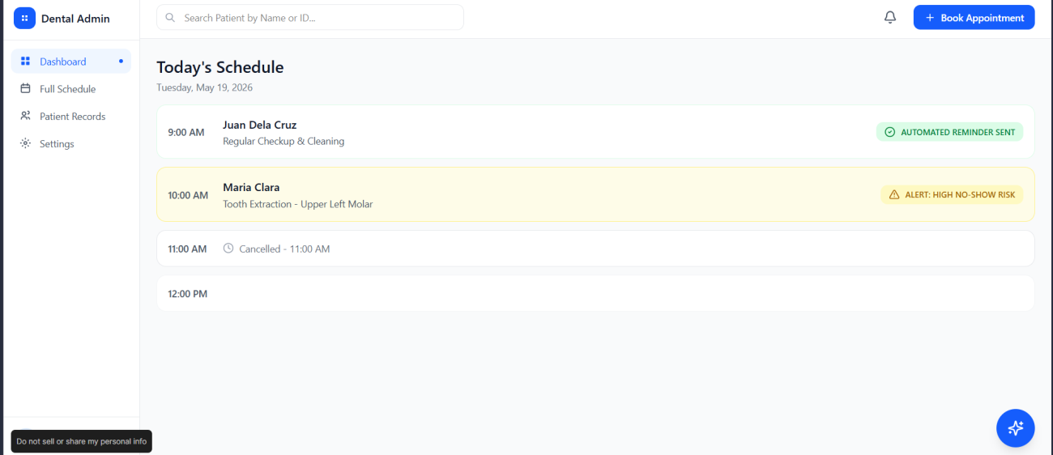
Figure 1. Figma Prototype — Dashboard Page.
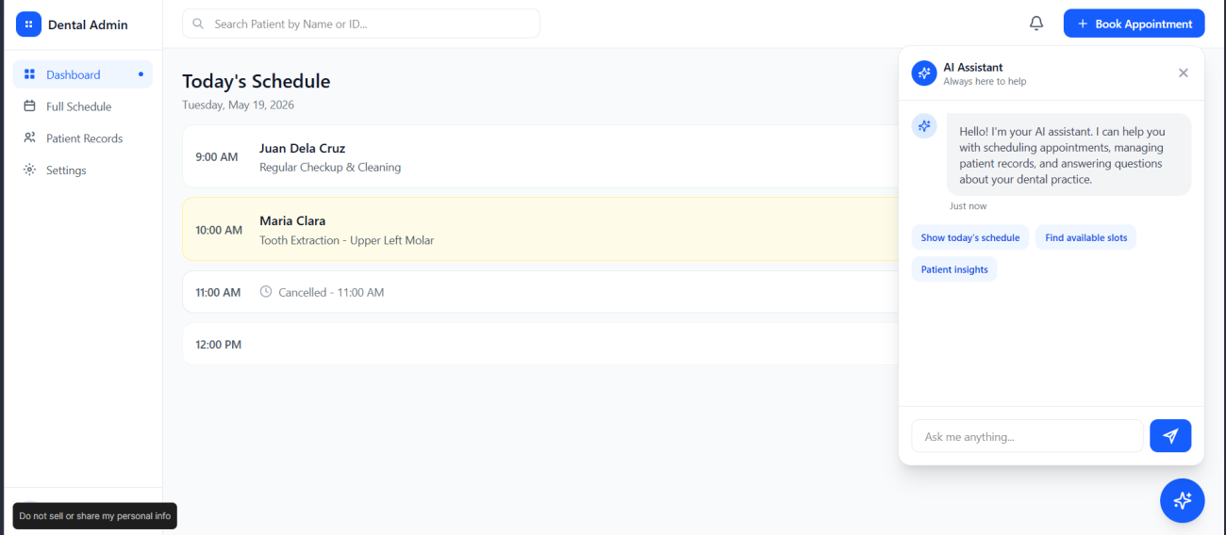
Figure 2. Figma Prototype — AI Assistant Chatbot.
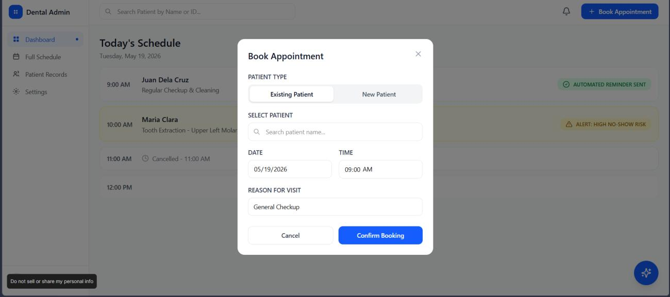
Figure 3. Figma Prototype — Book Appointment Component.
Appointment toggling for when the patient has attended the clinic in the past, expanding the patient record. New patients will be entered into the Patient Records.

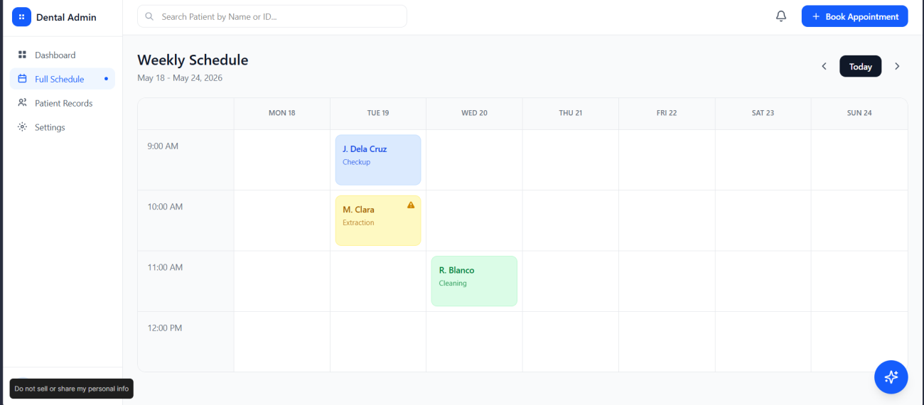
Figure 4. Figma Prototype — Schedule Page.
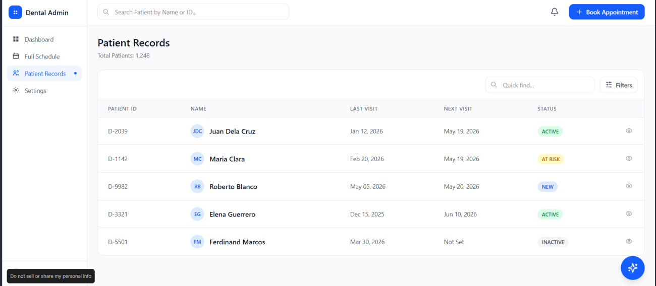
Figure 5. Figma Prototype — Patient Record Page.
The Patient Records can be viewed through the eye icon on the right.
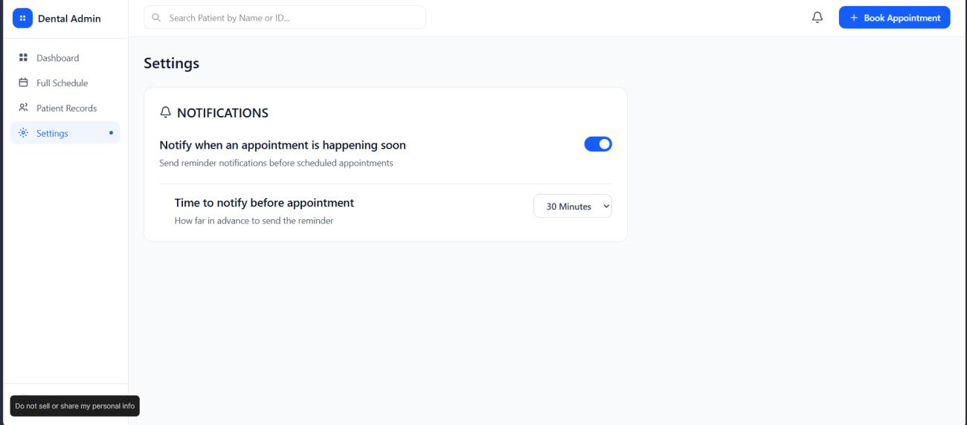
Figure 6. Figma Prototype — Settings Page.
This notification is separate from notifying the patient; this notifies the user if they are to expect someone soon.

4.3.3 Project Lean Canvas
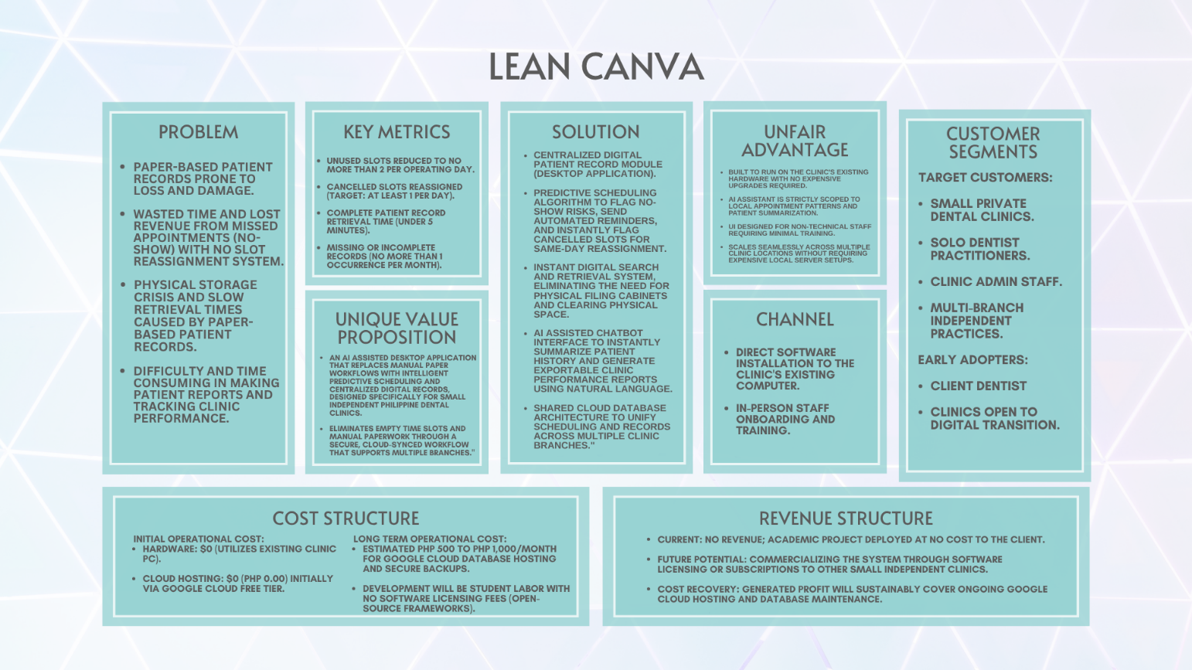
Figure 7. Project Lean Canvas.

4.3.4 User Classes and Characteristics
User Class | Secretary — Primary User
Description | The clinic secretary is the frontline administrator and the most frequent user of the system. She handles all daily operations — appointment bookings, patient check-ins, record retrieval, and patient reminders. The system was designed primarily around her workflow to reduce manual, repetitive tasks confirmed during the client interview.
Technical Proficiency | Low to Moderate — familiar with Excel and basic computer use; no programming knowledge required
Access Level | Full access to all administrative features; excludes clinical treatment note entry
Primary Goals | Book and manage appointments digitally, retrieve patient records instantly, monitor dashboard alerts, reassign vacant slots, and receive automated reminder support
Use Cases | UC-01, UC-02, UC-03, UC-06, UC-07, UC-09, UC-11
Frequency of Use | Daily throughout all clinic operating hours
Special Considerations | Interface must require minimal training. Expressed enthusiasm for automated reminders during interview (“She genuinely liked the idea of automating reminders”). Concerned about data loss from computer crashes.

User Class | Dentist / Clinic Owner — Secondary User
Description | The dentist is the clinic owner who oversees all clinical operations. He accesses the system to review complete patient records before and during consultations, record treatment notes digitally, and monitor the daily schedule and no-show risk flags.
Technical Proficiency | Moderate — comfortable with digital tools; does not require a technical background to operate the system
Access Level | Full system access including clinical treatment notes, AI chatbox, clinic reports, and schedule overview
Primary Goals | View daily and weekly schedule, review complete patient history during consultations, record treatment notes digitally, monitor no-show risk flags, generate clinic performance reports
Use Cases | UC-07, UC-08, UC-09, UC-10, UC-11
Frequency of Use | Daily, primarily during consultations and at the start and end of each clinic day
Special Considerations | Confirmed wasted slots as a key pain point (“Wala”). Reacted positively to AI scheduling feature (“Maganda yan”). Manages two clinic branches; system covers both branches on a shared cloud database.

User Class | Patient — External User
Description | Patients interact with the system externally. They receive automated booking confirmations and appointment reminders, and may access their own dental profile, appointment history, and treatment records. They have no access to administrative or clinical management features.
Technical Proficiency | Varies — system must be accessible to users with minimal digital experience across all age groups
Access Level | Limited to own profile, appointment history, and treatment records only; protected by personal login credentials
Primary Goals | Receive appointment reminders, confirm or reschedule visits, and view personal dental and treatment records
Use Cases | UC-01, UC-02, UC-05
Frequency of Use | Occasional — at time of booking, before scheduled appointments, and during post-visit follow-up
Special Considerations | Patient data is protected under RA 10173 (Data Privacy Act of the Philippines). Login authentication is required for all personal record access.

User Class | AI Assistant — System Actor
Description | The AI Assistant is a system actor that supports clinic staff by performing automated background tasks within defined boundaries. It monitors appointments, calculates no-show risk, sends automated reminders, flags vacant slots for secretary review, and generates patient summaries and clinic reports via the AI chatbox. It does not make decisions independently; all actions requiring judgment are surfaced to the secretary or dentist for confirmation.
Technical Proficiency | N/A — autonomous system actor; no human operation required for core background functions
Access Level | Read and write access to appointment and patient data within defined system boundaries; cannot override confirmed bookings without secretary action
Primary Goals | Predict no-show risk per patient, trigger automated reminders, flag and suggest slot reassignments, generate patient summaries and clinic performance reports on demand
Use Cases | UC-03, UC-04, UC-05, UC-07, UC-08, UC-09
Frequency of Use | Continuous — runs in the background throughout all clinic operating hours
Special Considerations | Prediction accuracy improves as more appointment history is collected. Operates on rule-based logic during early deployment until sufficient data exists for full AI model training.

User Class | PDF Generator
Description
Technical Proficiency
Access Level
Primary Goals
Use Cases
Frequency of Use
Special Considerations

User Class | SMTP — External Actor
Description | A programmatic external actor responsible for accepting outbound mail traffic from the application backend and routing it to destination mail servers. It acts as an intermediary for all automated user notifications, ensuring reliable message delivery, transport-layer encryption, and bounce/status tracking outside the core application boundary.
Technical Proficiency | N/A — mostly autonomous external actor; its API is called and programmed into the application's backend.
Access Level | Access to read Recipient and Sender E-Mail Address and Preset Email Payloads
Primary Goals | Allow the system to send email notifications of reminders for their scheduled appointments and account and requested information deletion.
Use Cases | UC-04, UC-11
Frequency of Use | Consistent — always reminds patients of their schedules 24 hours before their scheduled appointment. May additionally be used to remind patients that their requested information deletion will be completed.
Special Considerations | N/A

4.3.5 Product Backlog
ID | Type | Description | Priority | Pts | Status | Sprint | Acceptance Criteria
1 | Feature | Digital appointment management system for the clinic | High | 20 | To Do | Sprint 1 | Secretary can book, cancel, reschedule digitally with no double-booking.
2 | User Story | As a secretary, I want to manage patient appointments digitally so I can avoid scheduling conflicts and overlaps. | High | 8 | To Do | Sprint 1 | Booking form saves correctly; occupied slots blocked; changes reflected within 3 seconds.
3 | User Story | As a secretary, I want to search for a patient record by name or ID so I don't have to search through physical folders. | High | 5 | To Do | Sprint 1 | Correct record returned within 5 seconds; full profile displayed without extra clicks.
4 | User Story | As a secretary, I want to register a new patient so their information is stored digitally and retrievable. | High | 3 | To Do | Sprint 1 | Patient saved with all required fields; unique ID generated; immediately searchable.
5 | User Story | As a secretary, I want the system to automatically send reminders so I don't have to personally contact each patient. | High | 5 | To Do | Sprint 2 | Reminder sent 24 hrs before automatically; missing contact flagged on dashboard.
6 | User Story | As a secretary, I want to see available slots after cancellations and reassign them quickly. | High | 5 | To Do | Sprint 2 | Slot marked available immediately; reassignable in under 3 clicks; schedule updates in real time.
7 | User Story | As a secretary, I want to cancel or reschedule an existing appointment so the schedule stays accurate. | High | 3 | To Do | Sprint 2 | Cancellation updates schedule instantly; freed slot available for rebooking; patient record updated.
8 | User Story | As a secretary, I want to generate a summary report of appointments and no-shows. | Medium | 3 | To Do | Sprint 3 | Report generated for any date range; includes visits, appointments, no-shows; exportable.
9 | Feature | Patient records digitalization and dental chart management | High | 20 | To Do | Sprint 1 | All patient records stored digitally; searchable; retrievable within 5 seconds.
10 | User Story | As a dentist, I want to view a clear daily/weekly appointment schedule so I can plan my day. | High | 3 | To Do | Sprint 1 | Time-sorted schedule shows name, time, type; auto-updates; daily/weekly toggle available.
11 | User Story | As a dentist, I want to access a patient's complete dental/medical history digitally. | High | 5 | To Do | Sprint 1 | Full history shown chronologically in labeled sections; loads within 5 seconds.
12 | User Story | As a dentist, I want to record treatment notes digitally after each consultation. | High | 5 | To Do | Sprint 2 | Notes saved with timestamp, linked to patient ID; prior notes shown in reverse order.
13 | User Story | As a dentist, I want to know which patients are high no-show risk so I can prepare for empty slots. | Medium | 8 | To Do | Sprint 3 | High-risk flag shown on schedule for dentist and secretary; 48-hr early reminder triggered.
14 | User Story | As a dentist, I want to create and sign digital prescriptions. | Medium | 5 | To Do | Sprint 3 | Prescription created and signed digitally; sent via email; printable format retained.
15 | NFR | System must load all records/schedule views within 5 seconds under normal conditions. | High | 5 | To Do | Sprint 2 | All pages/record retrievals complete within 5 seconds on clinic's existing hardware.
16 | NFR | System must comply with RA 10173 (Data Privacy Act) for patient data protection. | High | 5 | To Do | Sprint 1 | Patient data accessible only via authenticated login; access logs maintained; no unauthorized exposure.
17 | User Story | As a patient, I want to book an appointment at a time that works for my schedule. | Medium | 5 | To Do | Sprint 2 | Available slots shown only; booking confirmed within 3 seconds; confirmation sent within 5 minutes.
18 | User Story | As a patient, I want to receive an automated reminder before my appointment. | High | 3 | To Do | Sprint 2 | Reminder sent 24 hrs before; includes date/time/clinic details; patient can confirm or reschedule.
19 | User Story | As a patient, I want to reschedule my appointment when unforeseen circumstances arise. | Medium | 3 | To Do | Sprint 2 | Reschedule saved after confirmation; original slot freed immediately; confirmation within 5 minutes.
20 | User Story | As a patient, I want to access my own dental profile and appointment history. | Low | 5 | To Do | Sprint 3 | Patient login grants access to own profile only; loads within 5 seconds; protected by authentication.

4.3.6 Product Roadmap
The table below summarizes the phased roadmap spanning Design, Development, and Refinement (Months 1–9), condensed from the original Gantt-style chart for readability.
Feature / Deliverable | Phase / Timeline | Description
Requirements Gathering | Design (M1–M2) | Client interview & analysis; design thinking & empathy mapping; As-Is/To-Be mapping
Documentation | Design (M1–M4) | SOW & Lean Canvas; RRL & paper draft; final design paper
UI/UX Design | Design (M2–M3) | Wireframes; UI mockups & prototype; UI refinement
System Architecture | Design (M2–M3) | Tech stack decision; system architecture design
MILESTONE 1 | End of Design Phase | Design Phase Complete — Paper & Prototype Approved
Database Setup | Development (M5–M6) | Database design & setup
Patient Record Module | Development (M6–M7) | Build record module; testing & integration
Scheduling Module | Development (M6–M7) | Build scheduling module; slot reassignment feature
AI Chatbot | Development (M7–M8) | Chatbot basic setup; booking & reminder features; report generation
Notification System | Development (M7–M8) | Automated reminders & alerts
MILESTONE 2 | End of Development Phase | Development Complete — Core Features Built & Integrated
System Testing | Refinement (M8) | Unit & integration testing
User Acceptance Testing | Refinement (M8–M9) | UAT with client & secretary; feedback & bug fixes
AI Model Refinement | Refinement (M8–M9) | Train AI on collected data; prediction accuracy check
Deployment | Refinement (M9) | System deployment & handover
MILESTONE 3 | End of Project | Project Complete — System Deployed & Handed Over to Client

4.3.7 Release Plan
The release plan outlines the three planned development sprints, covering the core development phase (Months 6–9).

Sprint 1 — Core Foundation (Months 6–7)
Backlog ID | Feature / Deliverable | Module | Points | Priority
PB-01 | Digital appointment booking with conflict detection and real-time calendar | Appointment & Scheduling | 8 | High
PB-02 | Instant patient record search by name or ID; full profile retrieval | Patient Records | 5 | High
PB-05 | Daily appointment schedule view (daily/weekly toggle) for dentist | Appointment & Scheduling | 3 | High
PB-06 | Dentist access to complete digital dental/medical history during consultation | Patient Records | 5 | High

Sprint 2 — Notifications, Cancellations & Treatment Notes (Months 7–8)
Backlog ID | Feature / Deliverable | Module | Points | Priority
PB-03 | Automated 24-hour SMTP email reminders with missing-contact flagging | Notifications | 5 | High
PB-04 | Cancelled slot flagging and same-day reassignment (3-click max) | Appointment & Scheduling | 5 | High
PB-07 | Digital treatment note recording with timestamp; reverse-chronological history | Patient Records | 5 | High
PB-09/10/11 | Patient-facing booking, automated reminder receipt, self-service reschedule | Appt. & Notifications | 11 | Med/High

Sprint 3 — AI Features, Predictive Scheduling & Patient Portal (Months 8–9)
Backlog ID | Feature / Deliverable | Module | Points | Priority
PB-08 | No-show risk prediction model; high-risk flag; 48-hour early reminder trigger | AI / Predictive Scheduling | 8 | Medium
PB-12 | Patient self-service portal: authenticated login, profile, history, records | Patient Records | 5 | Low

4.3.6 Product Roadmap
The table below summarizes the Gantt-style product roadmap spanning the Design, Development, and Refinement phases (Months 1–9), condensed from the original roadmap chart for readability.

4.3.8 Use Case Diagram
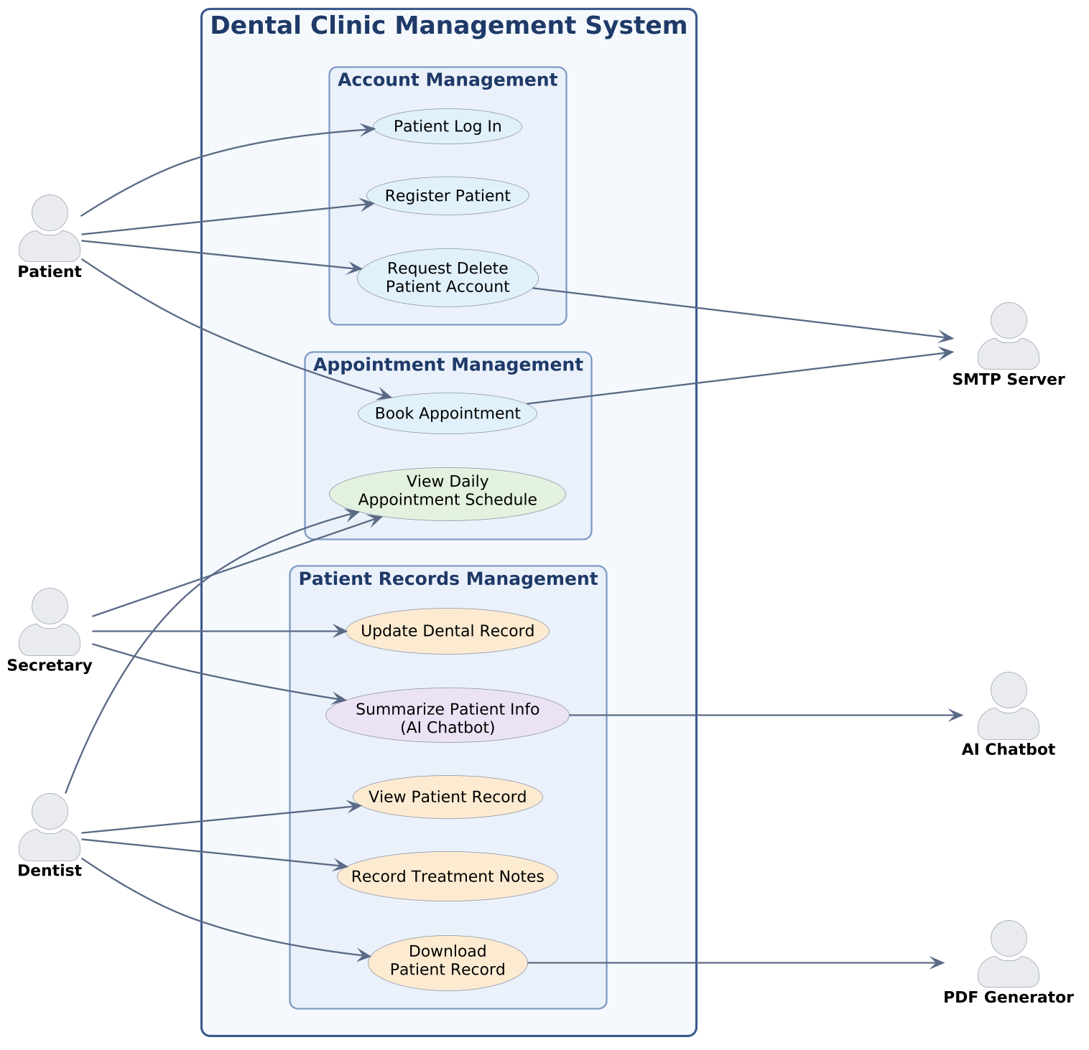
Figure 8. Use Case Diagram (PlantUML).

4.3.9 Use Case Fully Dressed

Register Patient
Use Case ID: | UC-01
Use Case Name: | Register Patient
Created By: | Prince Jabez Reyes
Date Created: | October 7, 2026
Description: | This use case allows the patient to sign up a new account
Primary Actor: | Patient
Secondary Actor: | System
Preconditions: | 1. The patient doesn’t have an existing account  2. Patient is not currently logged in  3. System is available and redirects patient to the login page
Postconditions | 1. A new patient account has been created and stored in the database  2. Patient receives a confirmation of successful registration  3. System redirects patient to login page  4. System is ready to accept login credentials for newly created account
Main Flow: | 1. The system displays homepage  2. The system display signup and login button  3. The patient selects the sign-up button  4. The system redirects the patient to the registration page  5. The system displays the required fields (First name, Last name, Middle name, address, email, password, confirm password, allergies, medical history, sex, birthday).  6. Patient then fills the required fields then presses submit.  7. The system checks the required fields if they’re filled, password meets strength requirements, and contents are valid.  8. The system displays “Registration Successful” and stores the credentials on a database.
Alternative Flow: | At step 6: Alternative Flow 1: Patient registers with required fields not filled  1. System detects not all required fields are inputted  2. System then display’s error message: “Please fill in the required fields”  3. Returns to main flow step 3.  At step 6: Alternative Flow 2: Password does not meet the strength requirements:  1. System checks if the password meets the strength requirements (One uppercase letter, minimum length of 8 characters, one special character, and at least containing one number)  2. System displays a message “Password must be at least 8 characters containing one uppercase letter, one special character and at least containing one number”  3. Returns to main flow step 3

Patient Log In
Use Case ID: | UC-02
Use Case Name: | Patient Log-In
Created By: | Prince Jabez Reyes
Date Created: | October 7, 2026
Description: | This use case allows the patient to log in to the system
Primary Actor: | Patient
Secondary Actor: | System
Preconditions: | 1. The patient has already registered for an account  2. Patient is not currently logged in  3. System is available and redirects patient to login page
Postconditions | 1. Patient is authenticated and logged in the system  2. The system redirects patient to homepage  3. The system is ready to process patient’s actions like book appointments, for example.
Main Flow: | 1. System displays the homepage  2. System displays sign up and log in button  3. Patient selects the log in button  4. System redirects the patient to login page  5. System displays login form with email and password fields.  6. Patient enters email and password and presses the login button.  7. System retrieves the credentials and checks if fields are filled.  8. System then queries to verify credentials to match an existing account.  9. The system then compares the entered password to the hashed password stored in the database.  10. The system then creates a session token for the patient.  11. System redirects the patient to the homepage.
Alternative Flow: | At step 7: Alternative Flow 1: Invalid credentials  1. System queries the database and finds no matching email with OR password.  2. System displays an error message: “Invalid email or password”.  3. Returns to main flow step 6  At step 7: Alternative Flow 2: Empty log-in fields  1. System checks if fields are not empty  2. System finds empty fields and displays: “Please fill the required fields” outlining the empty field.  3. Returns to main flow step 6

Book Appointment
Use Case ID: | UC-03
Use Case Name: | Book Appointment
Created By: | Prince Jabez Reyes
Date Created: | September 10, 2026
Description: | This use case allows the patient to book an appointment online and the secretary to manage the appointment made by the patient.
Primary Actor: | Patient
Secondary Actor: | SMTP
Preconditions: | 1. The patient must have a registered account and be logged into the system.  2. The dental clinic's appointment schedule and available time slots must be configured.  3. The system must be connected to the database.
Postconditions | 1. A new appointment record is saved in the database.  2. The selected appointment time slot is marked as reserved or unavailable.  3. The patient receives confirmation of the booked appointment.
Main Flow: | 1. The system shows the homepage  2. The system displays a calendar icon for appointment  3. The patient selects the calendar icon  4. The system redirects the patient to book appointment page  5. The system displays the services, dates, and time slots.  6. The patient selects a preferred dental service.  7. The patient selects a preferred date and time.  8. The system displays the appointment details for confirmation.  9. The patient confirms the appointment request.  10. The system validates the selected schedule and checks availability.  11. The system saves the appointment details in the database.  12. The system marks the selected time slot as unavailable.  13. The system displays a confirmation message to the patient.  14. The system checks the patient’s No-Show Risk Status.  15. The system sends a confirmation email through an SMTP server including how often they will be reminded.
Alternative Flow: | At Step 6: Alternative Flow 1: Patient does not select a dental service  1. Patient attempts to proceed without selecting a dental service  2. System displays a prompt message: “Please select a dental service”  3. Returns to main flow step 6  At Step 8: Alternative flow 3: Patient changes appointment details  1. The patient reviews the appointment details after the system displays it.  2. The patient presses the “change appointment details” button.  3. The patient changes appointment details like date, time or service  4. Returns to main flow step 8

Download Patient Record

Use Case ID: | UC-04
Use Case Name: | Download Patient Record
Created By: | John Carlo Jancorda
Date Created: | September 10, 2026
Description: | This use case displays the dentist or authorized clinic staff to generate a report containing relevant information from a patient's record.
Primary Actor: | Dentist
Secondary Actor: | Patient, PDF Generator
Preconditions: | 1. The dentist must be logged into the system.  2. The patient must have an existing record.  3. The system must be connected to the Patient's database.  4. The dentist is in the Patient Database Page
Postconditions | 1. The requested patient information is retrieved.  2. A Patient Record is generated based on the patient information in the database
Main Flow: | 1. The system displays the search bar.  2. The dentist selects the search bar and types the patient’s name.  3. The system searches the database for the patient.  4. The system displays the search results, showing each patient’s full name (including middle initial).  5. The dentist selects the patient.  6. The system expands the selected patient to show their sex, birthday, and age, along with a View button and a Download button.  7. The dentist presses the Download button.  8. The system collects the patient’s information from the database.  9. The system compiles the gathered information and fills out the template for the patient record.  10. The system calls the PDF Generator to convert the compiled data into a PDF file.  11. The system displays the generated patient record to the dentist.  12. The system prompts the dentist to download the file.  13. The dentist downloads the patient record.
Alternative Flow: | At Step 6: Alternative flow 1: Same Name, Wrong Patient  1. The dentist compares the sex, birthday, and age shown with the patient’s actual details, confirming with the patient if needed.  2. If the details do not match, the dentist selects a different patient from the search results.  3. The flow returns to Main Flow Step 5

View Patient Record

Use Case ID: | UC-05
Use Case Name: | View Patient Record
Created By: | John Carlo Jancorda
Date Created: | September 10, 2026
Description: | This use case allows a dentist or secretary to retrieve an existing patient's record for viewing and use in clinic activities.
Primary Actor: | Dentist
Secondary Actor: | Patient
Preconditions: | 1. The dentist must be logged into the system.  2. The patient must have an existing record.  3. The system must be connected to the Patient's database.  4. The dentist is in the Patient Database Page
Postconditions | 1. The requested patient record is retrieved from the database.  2. The patient's available information is displayed to the authorized user.  3. The retrieved record can be used in related use cases such as Generate Patient Report and Summarize Patient Info.
Main Flow: | 1. The system displays the search bar.  2. The dentist selects the search bar and types the patient’s name.  3. The system searches the database for the patient.  4. The system displays the search results, showing each patient’s full name (including middle initial).  5. The dentist selects the patient.  6. The system expands the selected patient to show their sex, birthday, and age, along with a View button and a Download button.  7. The dentist presses the View button.  8. The system collects the patient’s information from the database.  9. The system compiles the gathered information and fills out the template for viewing the patient record.  10. The system displays the patient record to the dentist.
Alternative Flow: | At Step 4: Alternative flow 1: Same Name, Wrong Patient  1. The dentist compares the sex, birthday, and age shown with the patient’s actual details, confirming with the patient if needed.  2. If the details do not match, the dentist selects a different patient from the search results.  3. The flow returns to Main Flow Step 5

Summarize Patient Info (AI chatbot)

Use Case ID: | UC-06
Use Case Name: | Summarize Patient Info (AI chatbot)
Created By: | Prince Jabez Reyes
Date Created: | September 10, 2026
Description: | This use case allows the AI chatbot to summarize relevant information from a retrieved patient record to assist the authorized user in understanding the patient's available information.
Primary Actor: | Secretary
Secondary Actor: | Dentist
Preconditions: | 1. The user must be logged into the system.  2. The user must be authorized to access the patient's records.  3. A patient record must be available for retrieval.  4. The AI chatbot function must be available.
Postconditions | 1. The patient's available record information is summarized.  2. The summary is displayed to the authorized user.  3. The summary can assist the user in reviewing patient info
Main Flow: | 1. The dentist/secretary enters the patient’s name in the AI chatbot prompt.  2. The system retrieves the patient’s information from the database and passes it to the AI chatbot.  3. The AI chatbot analyzes the retrieved information.  4. The AI chatbot generates a concise summary.  5. The system displays the summary in the chat box.  6. The dentist/secretary reviews the summary.
Alternative Flow: | At Step 1: Alternative flow 1: Patient not found  1. The chatbot tells the dentist/secretary it could not find the patient.  2. The chatbot asks the dentist/secretary to type the name again.  3. Returns to main flow 5  At Step 2: Alternative flow 2: Several patients with the same name  1. The chatbot lists the matching patient's name.  2. The chatbot will ask clarifying questions to identify the patient the user is referring to.  3. The dentist/secretary chooses the correct one.  4. The flow continues at step 6.

Record Treatment Notes

Use Case ID: | UC-07
Use Case Name: | Record Treatment Notes
Created By: | Prince Jabez Reyes
Date Created: | September 10, 2026
Description: | This use case allows the dentist to record and update notes about a patient's dental treatment in the patient's record.
Primary Actor: | Dentist
Secondary Actor: | Secretary
Preconditions: | 1. The dentist must be logged into the system.  2. The patient must have an existing profile.  3. The dentist must have permission to record treatment information.  4. The system must be connected to the Patient's database.  5. The dentist is in the Patient Database Page
Postconditions | 1. The treatment notes are saved in the patient's records.  2. The updated patient record is available to authorized users.  3. The treatment information is retained for future reference.
Main Flow: | 1. The system displays the search bar.  2. The dentist enters the patient’s name in the search bar.  3. The system displays the matching patient’s name.  4. The dentist selects the patient.  5. The system retrieves the patient’s records.  6. The system displays the treatment icon and the update button.  7. The dentist selects the Record Treatment Notes button.  8. The system displays the treatment notes interface.  9. The system displays the plus icon and the edit button.  10. The dentist selects the plus icon.  11. The system displays a text editor.  12. The dentist enters the treatment details and notes.  13. The dentist reviews the information entered.  14. The dentist selects Save.  15. The system validates the notes and saves them to the database.  16. The system displays confirmation that the treatment notes were saved.
Alternative Flow: | At Step 7: Alternative flow 1: Patient not found  1. The system displays “No patient found.”  2. The dentist types the name again.  3. Returns to main flow 6  At Step 13: Alternative flow 2: Editing an existing note  1. The dentist selects the edit button instead of the plus icon.  2. The system displays the existing note.  3. The dentist changes the note.  4. Continues to main flow 17  At Step 19: Alternative flow 3: Notes are empty  1. The system finds no notes were entered.  2. The system asks the dentist to enter notes before saving.  3. Returns to main flow 16.  At Step 18: Alternative flow 4: Dentist doesn't save  1. The dentist leaves the page without saving.  2. The system discards the entered notes and keeps the record unchanged.

Update Dental Record

Use Case ID: | UC-08
Use Case Name: | Update Dental Record
Created By: | Prince Jabez Reyes
Date Created: | September 10, 2026
Description: | This use case allows authorized clinic staff to create a new patient profile and update existing patient information.
Primary Actor: | Secretary
Secondary Actor: | Patient, Dentist
Preconditions: | 1. The secretary must be logged into the system using authorized credentials.  2. The secretary is in the Patient Database Page  3. For an update, an existing patient profile is required.
Postconditions | 1. Updated patient information is saved for an existing patient.  2. The patient record is available to authorized clinic users.  3. The database contains the latest saved profile information.
Main Flow: | 1. The system displays the patient search bar interface.  2. The secretary enters the patient’s name in the search field.  3. The system searches the database for patient records that match the entered name.  4. The system displays the matching patient profile.  5. The secretary selects the patient.  6. The system displays the patient’s treatment notes and an Update button.  7. The secretary selects the Update button.  8. The system displays the dental chart template.  9. The secretary fills out the patient’s dental chart.  10. The secretary selects the Update button at the end of the template.  11. The system validates the information entered.  12. The system updates the patient’s dental record in the database.  13. The system displays a confirmation message “Record Updated”.
Alternative Flow: | At Step 5: Alternative flow 1: Patient not found  1. The system displays “Patient not found”  2. The secretary types the name again.  3. Returns to main flow 4  At Step 11: Alternative flow 2: Missing or Incorrect information  1. The system highlights the fields that are missing or incorrect.  2. The secretary fixes them by inputting the right information and filling out missing fields  3. Returns to main flow 10  At Step 9: Alternative flow 3: Secretary does not save the updated information  1. The secretary leaves without updating.  2. The system keeps the old record unchanged.

View Daily Appointment Schedule

Use Case ID: | UC-09
Use Case Name: | View Daily Appointment Schedule
Created By: | Prince Jabez Reyes
Date Created: | September 10, 2026
Description: | This use case allows authorized clinic staff to view the appointments scheduled for a selected day.
Primary Actor: | Secretary
Secondary Actor: | Dentist
Preconditions: | 1. The user must be logged into the system.  2. Appointment information must be available in the database.  3. The user must have permission to view the appointment schedule.
Postconditions | 1. The selected day's appointment schedule is displayed.  2. The user can review appointment times, patients, and appointment status.  3. The schedule reflects the latest available appointment information.
Main Flow: | 1. The system displays the homepage  2. The system displays the calendar icon  3. The user selects the calendar icon  4. The system redirects the user to the appointment page  5. The system shows the appointment booked saved in the database in the form of a calendar.  6. The system displays the current day's appointment schedule.  7. The system displays the scheduled appointments in time order.  8. The user views the appointment status and details.
Alternative Flow: | At Step 6: Alternative flow 1: The system displays “No appointments scheduled.”  1. The system displays “No appointments scheduled.”  2. The user can pick another day

Request Delete Patient Account

Use Case ID: | UC-10
Use Case Name: | Request Delete Patient Account
Created By: | Prince Jabez Reyes
Date Created: | September 10, 2026
Description: | This use case allows a patient to request the deletion of their patient account and associated personal information. The system verifies the patient's identity and checks whether any patient records are subject to legal or mandatory retention requirements before the deletion request is processed.
Primary Actor: | Patient
Secondary Actor: | Secretary / Authorized Clinic Staff, SMTP server
Preconditions: | 1. The patient must have an existing account in the dental clinic system.  2. The patient must be logged into the system or successfully verify their identity.  3. The system must be operational and connected to the patient's database.  4. The patient must have permission to submit an account deletion request.
Postconditions | 1. The patient's account and personal information are removed or deactivated from the system when the deletion request is approved.  2. Any information required to be retained by law remains securely stored and is not deleted.  3. The deletion request and its outcome are recorded in the system's audit log.  4. The patient is notified whether the deletion request was approved, partially approved, or denied.
Main Flow: | 1. The system displays the homepage  2. The system displays the profile icon  3. The patient selects the profile icon  4. The system redirects the patient to profile page  5. The system displays the name, email, contact number, etc.,  6. The system display at the end the Delete Patient Account button  7. The patient selects the Delete Patient Account button.  8. The patient will then be redirected to the deletion form page  9. The system displays the form of fields (reason for deletion and additional requests regarding the deletion of records).  10. The system displays information about the consequences of account deletion, including information that certain clinical records may be retained when required by law.  11. The patient confirms the account deletion request by pressing the confirm button  12. The system will show a pop-up box container containing: “OTP has been sent to your email, please enter the OTP on the input box below”. The system also displays a “resend OTP” button below the input box.  13. The patient checks their email inbox for the OTP  14. The patient enters the OTP in the input box  15. The system will prompt patient to not use the account and wait for email for confirmation  16. The system holds the request for 24 hours and scans the patient’s profile for related data. (upcoming appointments, waiting list entries).  17. After the 24 hours, the system connects to the SMTP server and sends an email to the patient that the deletion will proceed.  18. The system will proceed to delete all information related to the patient.
Alternative Flow: | At Step 11: Alternative flow 1: Patient cancels the account deletion request  1. The patient presses the cancel button  2. The system returns to the profile page. The account stays active.  At step 9: Alternative flow 2: Patient requests deletion of clinical records along with the account  - The patient also selects the option to also delete their clinical records (treatment history, dental charts, X-rays, prescriptions) on the deletion form.  - The system then requests a picture of an affidavit of deletion or consent.  - The system displays a warning that some clinical records may be legally required to be retained, and that deleted records cannot be recovered.  - The patient confirms the request by pressing the confirm button, and the flow continues at step 11.

Chapter 5: Systems Analysis and Design Artifacts
This chapter supplements Chapter 4 with the systems analysis and design artifacts required for SSYADD1/MSYADD1: Data Flow Diagrams (Context, Level 1, and Level 2), an Activity Diagram with swimlanes, the Database Design (ERD and Data Dictionary), a Test Case matrix, a Sprint Backlog, and a scope note on the partially working cloud-hosted prototype. Every artifact below traces back to the use cases, product backlog items, and RACI assignments already defined in Chapter 4.

5.1 Data Flow Diagrams
The DFDs below model how data moves between the clinic's actors (Patient, Secretary, Dentist) and the AI-Assisted Dental Clinic Management System, following standard levelling: Context (Level 0), Level 1 (major processes), and Level 2 (decomposition of the Appointment Management process).

5.1.1 Context Diagram (Level 0)
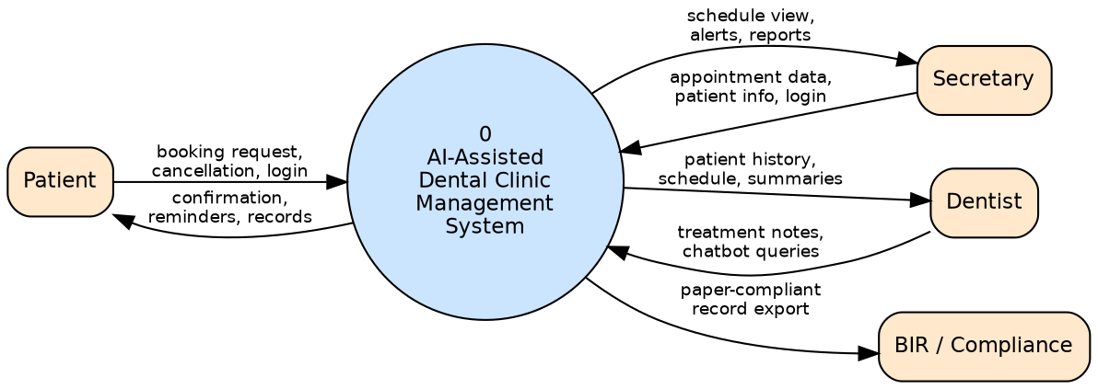
Figure 9. Context Diagram — the system as a single process against its external entities.

5.1.2 Level 1 DFD
Level 1 decomposes the system into its five major processes and introduces the core data stores.
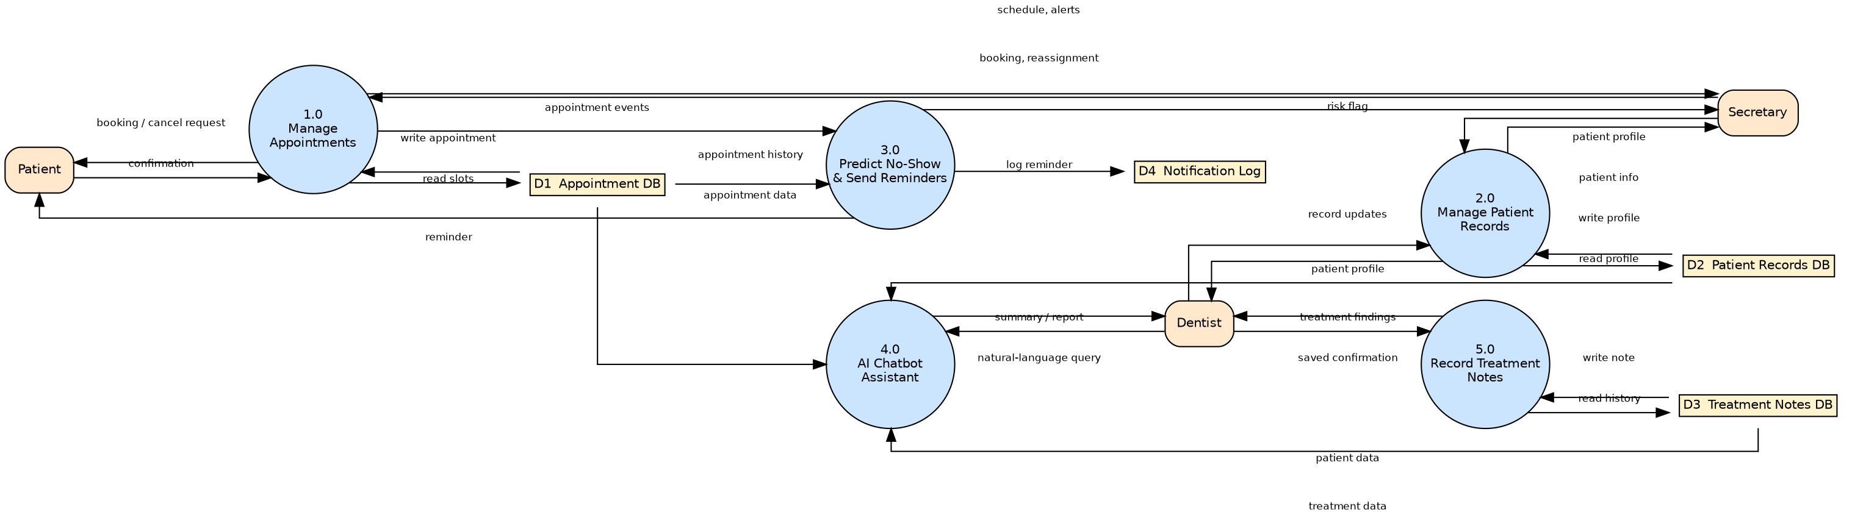
Figure 10. Level 1 DFD — Manage Appointments, Manage Patient Records, Predict No-Show & Send Reminders, AI Chatbot Assistant, and Record Treatment Notes.

5.1.3 Level 2 DFD — Decomposition of “1.0 Manage Appointments”
Level 2 expands the Appointment Management process into its three constituent sub-processes: Book Appointment, Cancel/Reschedule, and Flag & Reassign Vacant Slot.
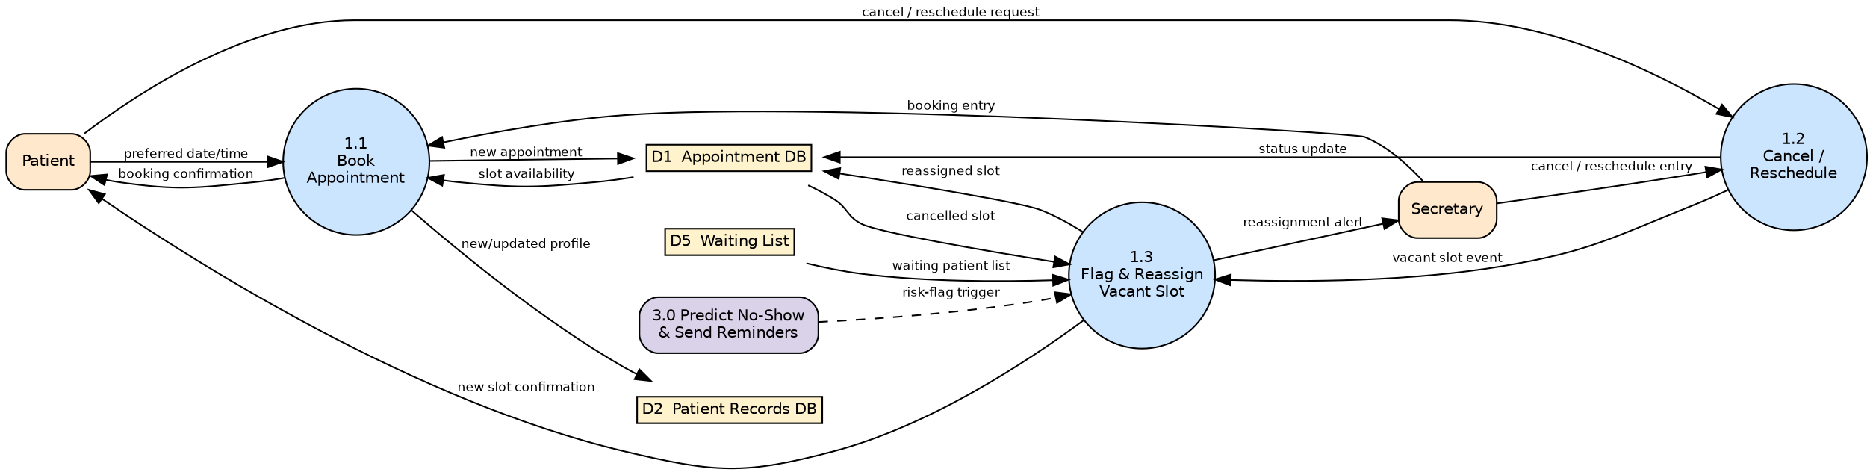
Figure 11. Level 2 DFD — sub-processes of Manage Appointments.

5.1.4 System Architecture (C4 Model)

System Context Diagram (C4 Level 1):
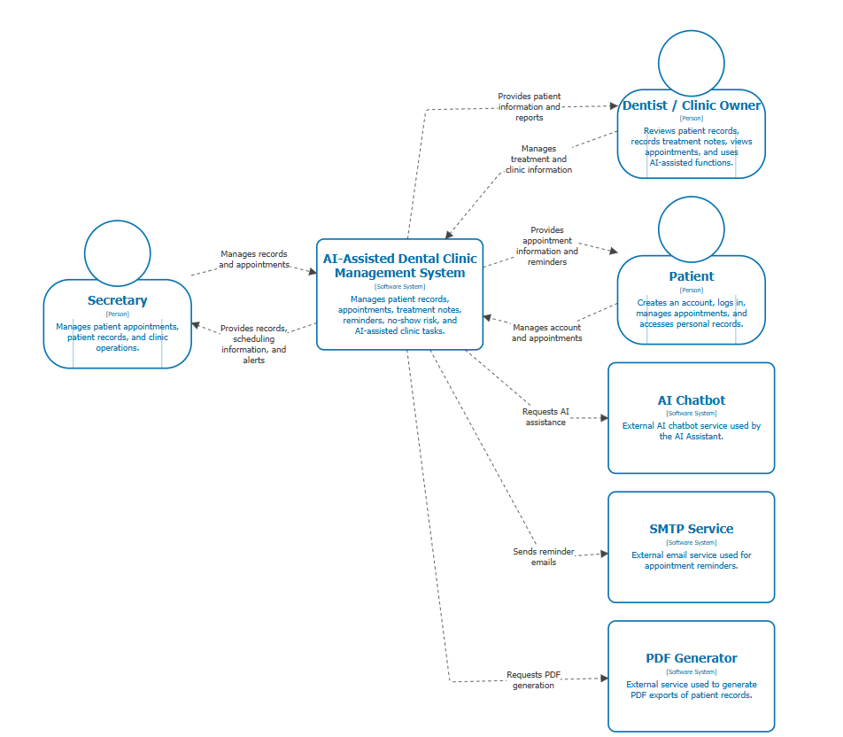

Container Diagram (C4 Level 2):
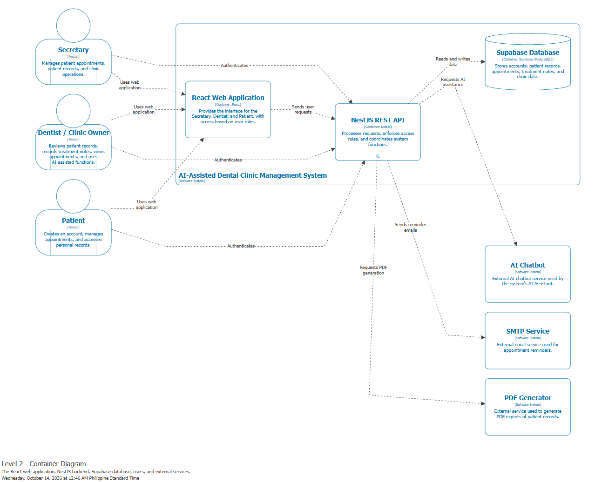

Component Diagram (C4 Level 3):

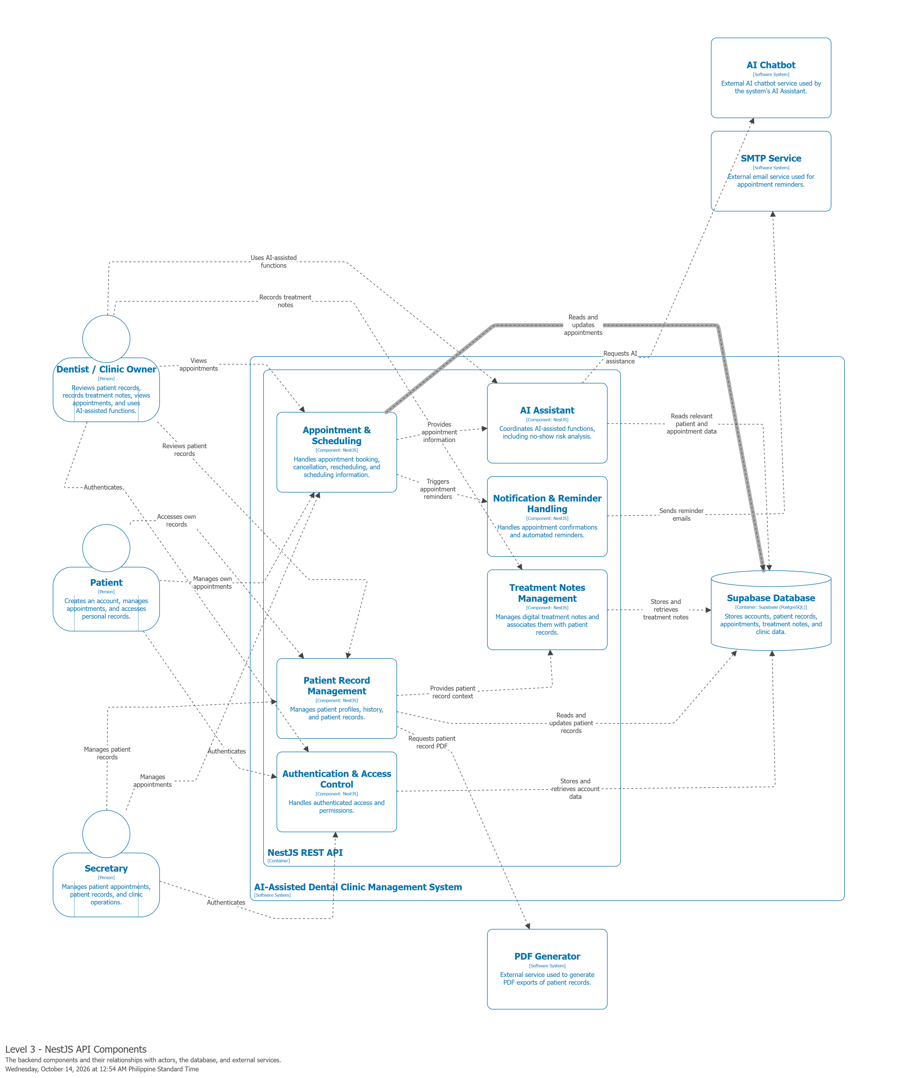

5.2 Activity Diagram with Swimlanes
The diagram below traces the Book Appointment activity (UC-01) across the three participating lanes — Patient, Secretary, and System — showing decision points for existing vs. new patients and for slot availability.
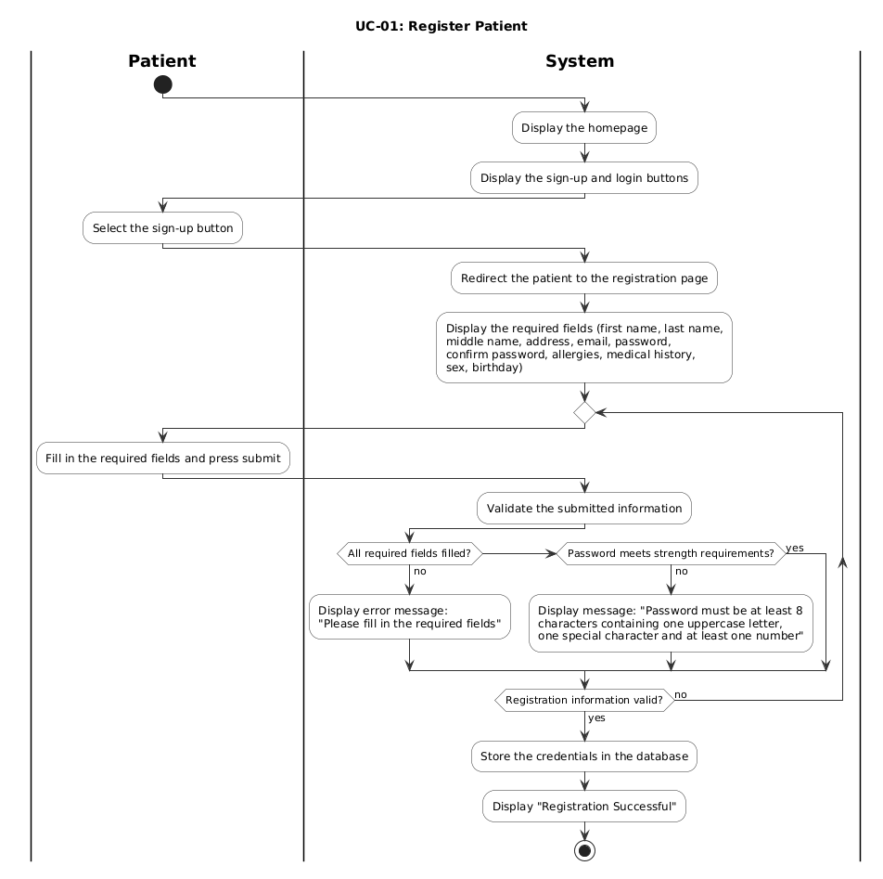
Figure 12. Activity Diagram with Swimlanes in a Register Patient
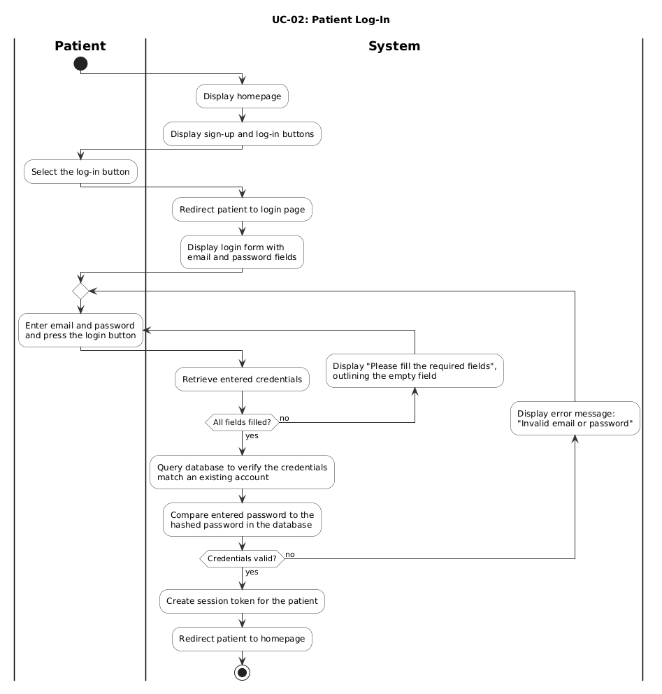
Figure 13. Activity Diagram with Swimlanes in a Register Log-In

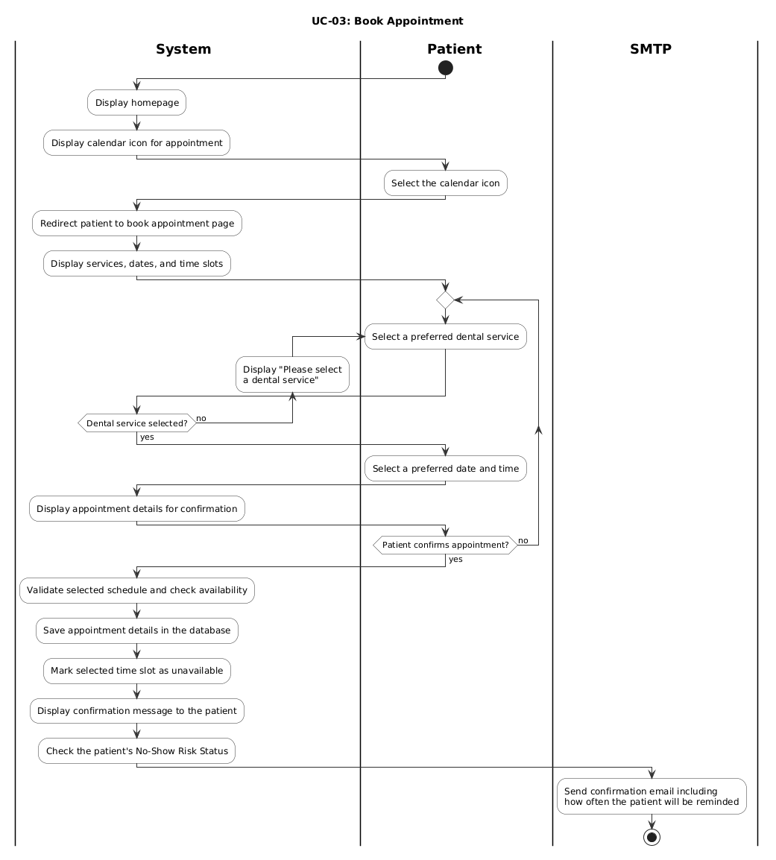
Figure 14. Activity Diagram with Swimlanes in a booking appointment

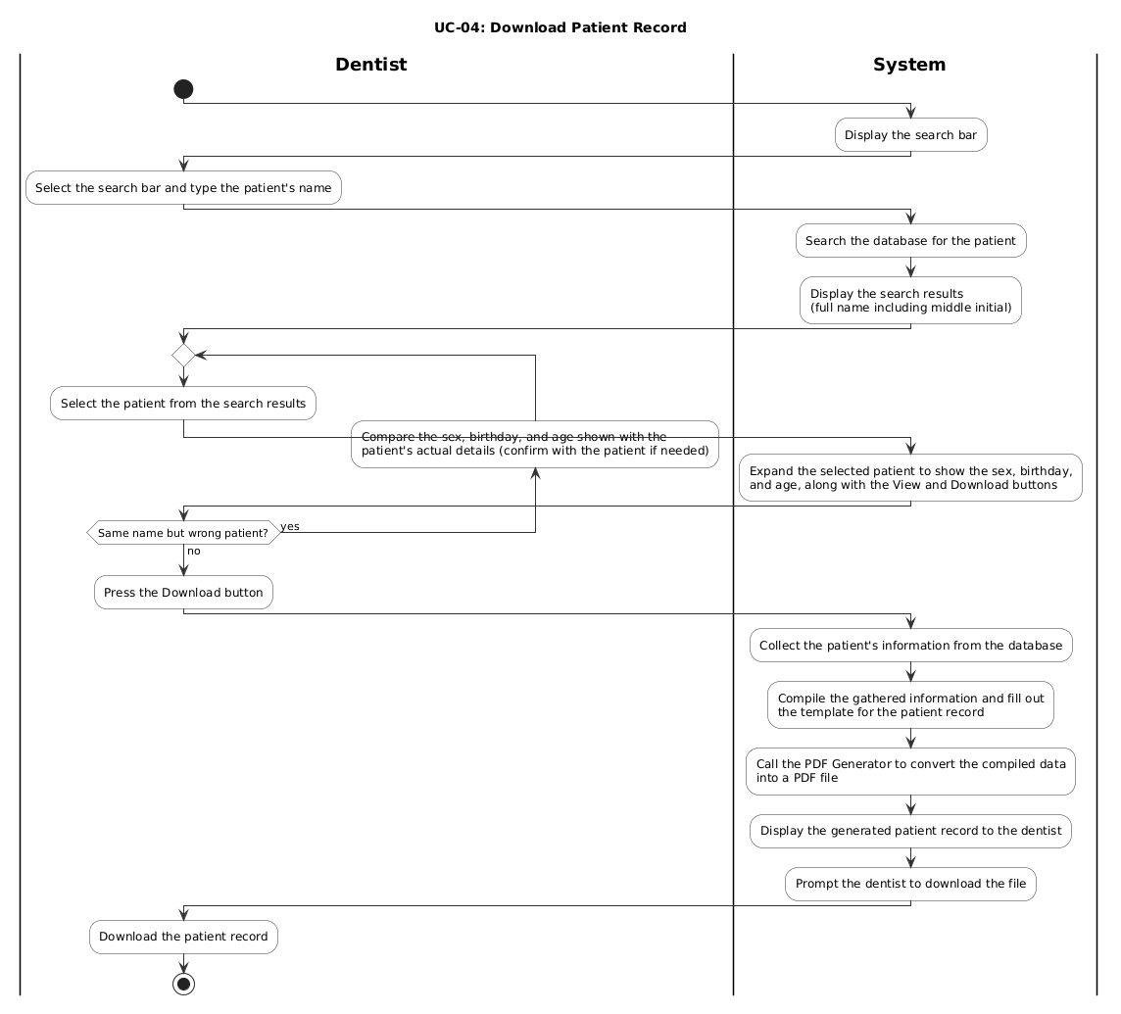
Figure 15. Activity Diagram with Swimlanes in Download Patient Record

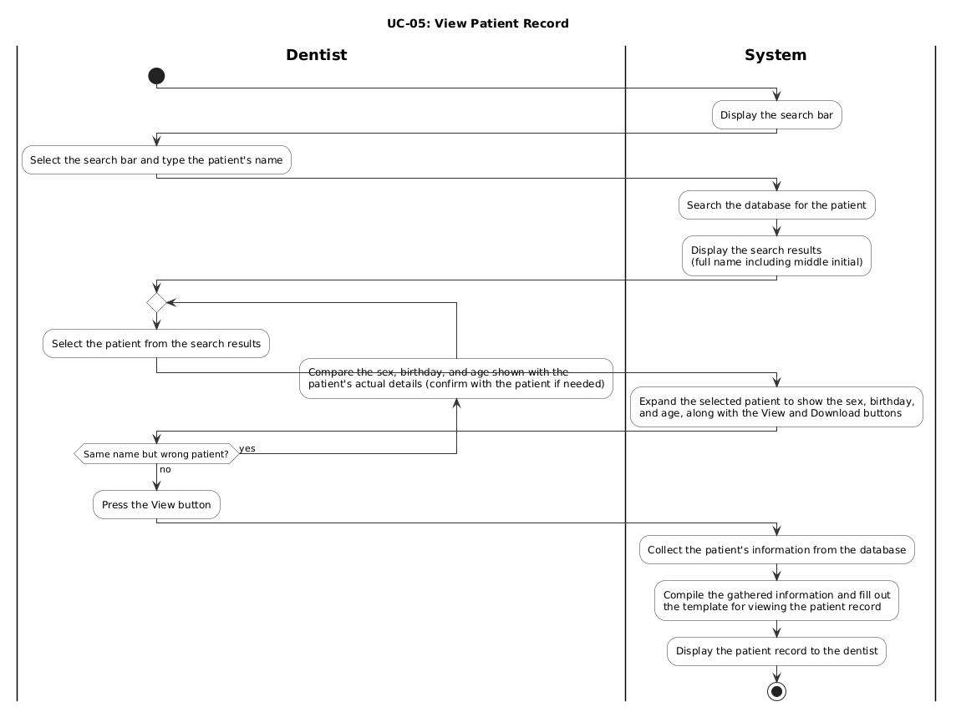Figure 16. Activity Diagram with Swimlanes in
View Patient Record

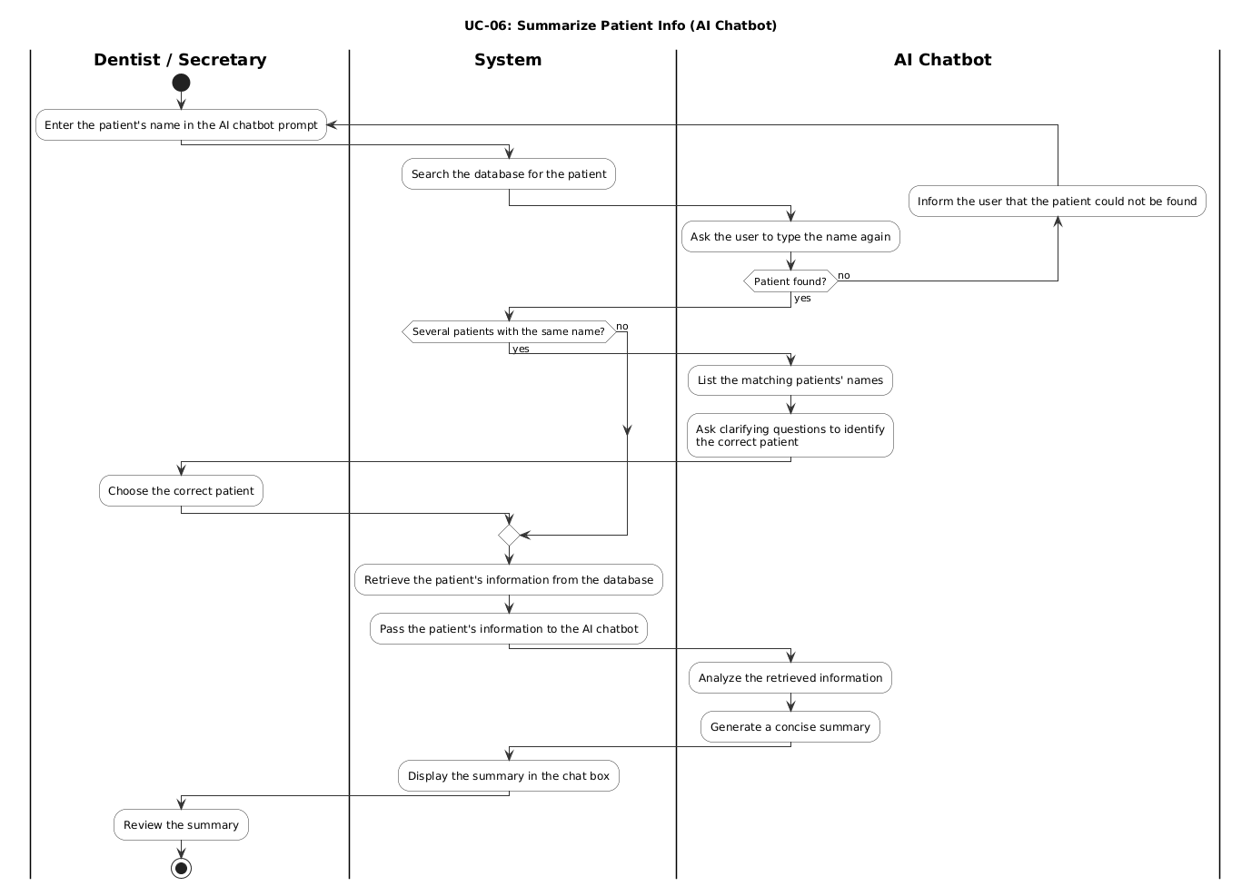Figure 17. Activity Diagram with Swimlanes in Summarize Patient Info

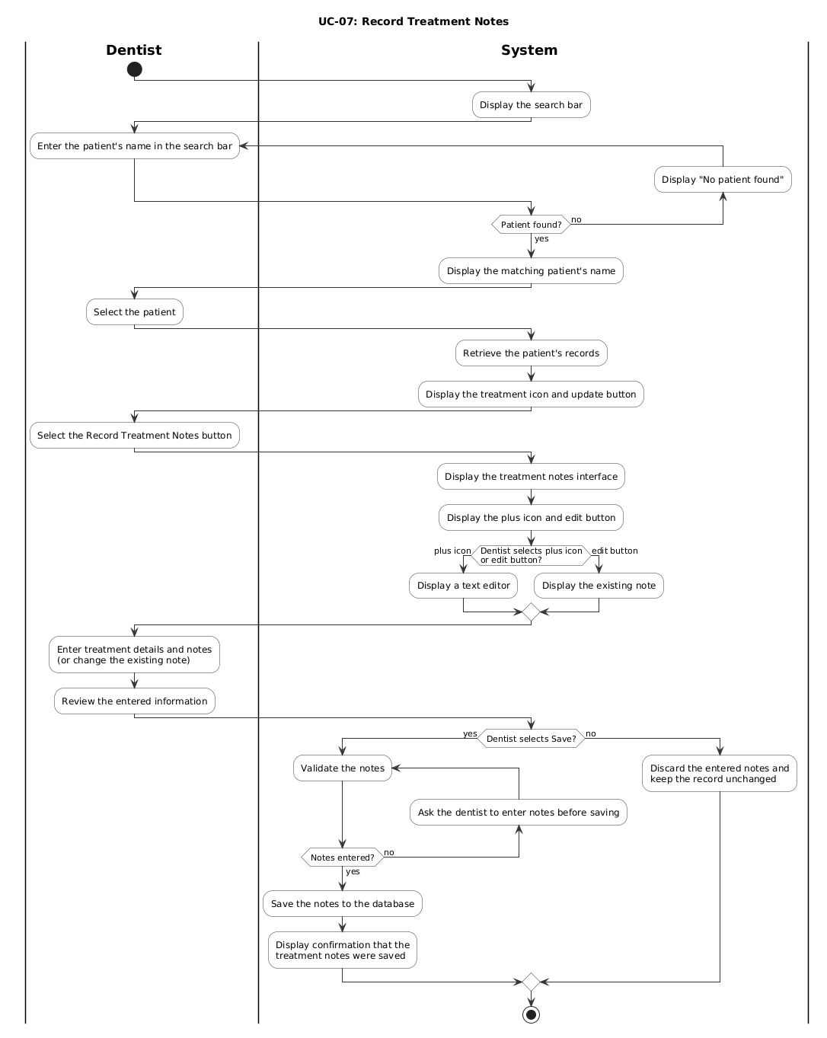
Figure 18. Activity Diagram with Swimlanes in Record Treatment Notes
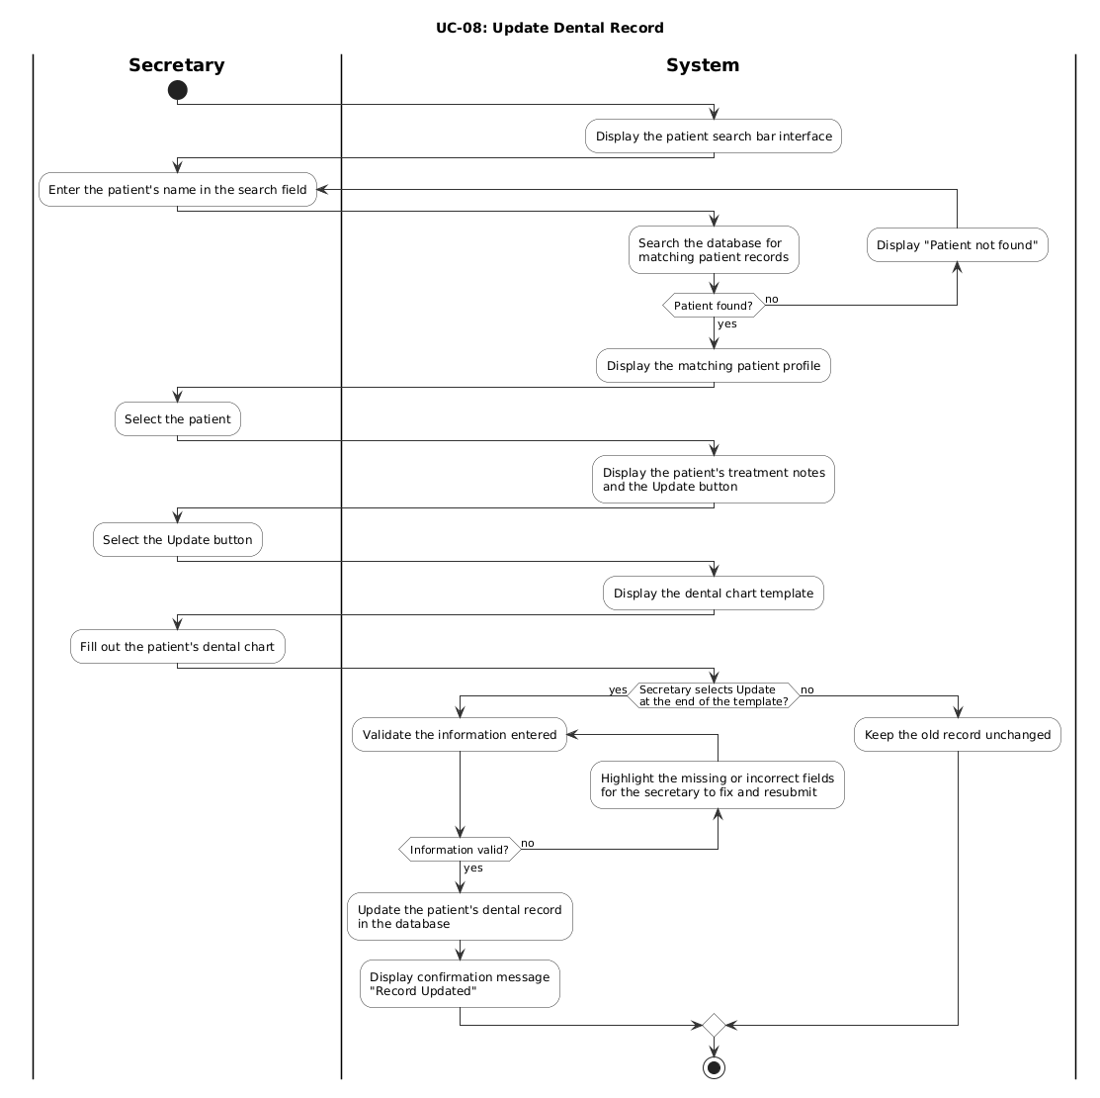Figure 19. Activity Diagram with Swimlanes in Update Dental Record
Figure 19. Activity Diagram with Swimlanes in Update Dental Record

Figure 20. Activity Diagram with Swimlanes in Request Delete Patient Account

5.3 Database Design

functional5.3.1 Entity-Relationship Diagram (ERD)
The relational model below supports the Patient Records, Appointment/Scheduling, and Consultation modules described in Chapter 4.
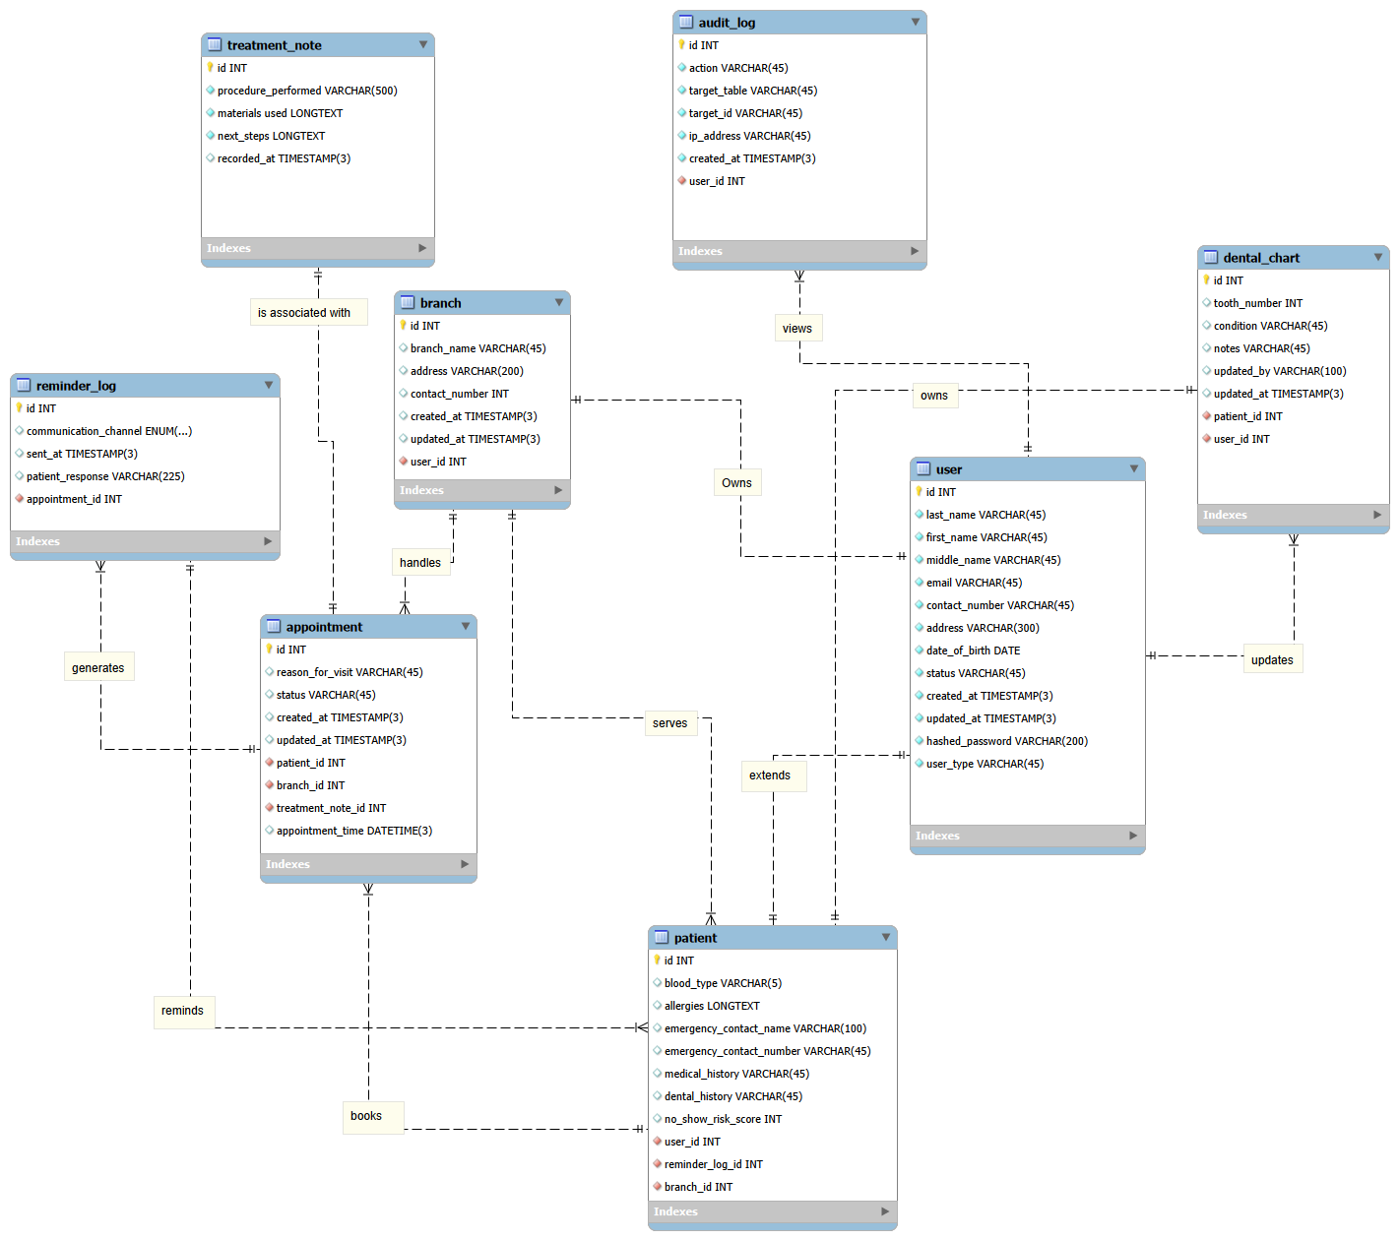
Figure 13. Entity-Relationship Diagram.

5.4 Test Cases

TC-001 — UC-01 Book Appointment
Test Case ID | TC-001
Use Case ID | UC-01
Use Case Name | Book Appointment
Test Case Description | Verify that a logged-in patient can successfully book an available appointment.
Version | 1.0
Created By | Prince Jabez Reyes
Reviewed By
Prerequisites | Patient account exists and is logged in; clinic schedule and slots are configured; database is available.
Step Details | 1. Open Book Appointment.  2. Select a service and dentist.  3. Select an available date and time.  4. Review the appointment details.  5. Confirm the appointment.
Test Data | Patient: existing registered patient; Service: Dental consultation; Dentist: available dentist; Slot: an available configured slot.
Expected Results | Appointment is saved; selected slot becomes unavailable; confirmation is displayed/sent; secretary can manage the appointment, and dentist can see it on the schedule.
Actual Results
Tester's Name
Date Tested
Status
Comments

TC-002 — UC-01 Book Appointment
Test Case ID | TC-002
Use Case ID | UC-01
Use Case Name | Book Appointment
Test Case Description | Verify that an unauthenticated patient is redirected to login before booking.
Version | 1.0
Created By | Prince Jabez Reyes
Reviewed By
Prerequisites | Patient is logged out; booking page is accessible; system is available.
Step Details | 1. Attempt to book an appointment.  2. Observe the system response.  3. Log in successfully.  4. Confirm return to the booking page.
Test Data | Valid patient login credentials.
Expected Results | System redirects to login; after successful login, patient returns to booking page and can continue.
Actual Results
Tester's Name
Date Tested
Status
Comments

TC-003 — UC-01 Book Appointment
Test Case ID | TC-003
Use Case ID | UC-01
Use Case Name | Book Appointment
Test Case Description | Verify system response when no appointment slots are available for the selected date and dentist.
Version | 1.0
Created By | Prince Jabez Reyes
Reviewed By
Prerequisites | Patient is logged in; selected dentist has no available slots on test date.
Step Details | 1. Open Book Appointment.  2. Select the dentist and date with no available slots.  3. Review the displayed availability message.  4. Select another date or slot.
Test Data | Date/dentist combination with all slots occupied; alternate date with an available slot.
Expected Results | System informs patient that no slots are available and allows selection of another date, dentist, or time.
Actual Results
Tester's Name
Date Tested
Status
Comments

TC-004 — UC-01 Book Appointment
Test Case ID | TC-004
Use Case ID | UC-01
Use Case Name | Book Appointment
Test Case Description | Verify that a slot taken by another booking before confirmation cannot be double-booked.
Version | 1.0
Created By | Prince Jabez Reyes
Reviewed By
Prerequisites | Patient is logged in; a slot initially appears available; a second booking can reserve the same slot during the test.
Step Details | 1. Select an available slot.  2. Have another booking reserve that slot before the first patient confirms.  3. Confirm the first booking.
Test Data | Same dentist, date, and time slot for two booking attempts.
Expected Results | System detects that the slot is no longer available, informs the patient, and does not create a conflicting appointment; patient can choose another slot.
Actual Results
Tester's Name
Date Tested
Status
Comments

TC-005 — UC-01 Book Appointment
Test Case ID | TC-005
Use Case ID | UC-01
Use Case Name | Book Appointment
Test Case Description | Verify that cancelling during appointment review creates no appointment.
Version | 1.0
Created By | Prince Jabez Reyes
Reviewed By
Prerequisites | Patient is logged in and has reached the appointment details review screen.
Step Details | 1. Select service, dentist, date, and time.  2. Review appointment details.  3. Choose not to proceed/cancel the booking.
Test Data | An available appointment slot.
Expected Results | Booking process is cancelled and no appointment record is created; slot remains available.
Actual Results
Tester's Name
Date Tested
Status
Comments

TC-006 — UC-01 Book Appointment
Test Case ID | TC-006
Use Case ID | UC-01
Use Case Name | Book Appointment
Test Case Description | Verify that the secretary can manage an appointment created by a patient.
Version | 1.0
Created By | Prince Jabez Reyes
Reviewed By
Prerequisites | The secretary has valid preset credentials; at least one patient's appointment exists.
Step Details | 1. Log in as secretary.  2. Open the appointment list.  3. Select the test appointment.  4. Confirm, reschedule, or cancel it.  5. Check updated status and patient notification where applicable.
Test Data | Existing appointment; alternate available slot for rescheduling.
Expected Results | System updates appointment status and schedule; patient is notified if applicable.
Actual Results
Tester's Name
Date Tested
Status
Comments

TC-007 — UC-02 Predict No Show & Reminders
Test Case ID | TC-007
Use Case ID | UC-02
Use Case Name | Predict No Show & Reminders
Test Case Description | Verify prediction and reminder processing for an upcoming appointment with sufficient data.
Version | 1.0
Created By | Prince Jabez Reyes
Reviewed By
Prerequisites | Upcoming appointment exists in database; relevant patient/appointment history is available; prediction and reminder services are operational.
Step Details | 1. Allow system to retrieve upcoming appointments.  2. Run/observe prediction analysis.  3. Review recorded prediction.  4. Allow reminder generation and sending.  5. Check reminder status as secretary.
Test Data | Upcoming appointment with complete relevant history and valid patient contact details.
Expected Results | Prediction is generated and associated with appointment; reminder is generated and sent through configured channel; status is recorded and visible to secretary.
Actual Results
Tester's Name
Date Tested
Status
Comments

TC-008 — UC-02 Predict No Show & Reminders
Test Case ID | TC-008
Use Case ID | UC-02
Use Case Name | Predict No Show & Reminders
Test Case Description | Verify handling of insufficient information for a reliable no-show prediction.
Version | 1.0
Created By | Prince Jabez Reyes
Reviewed By
Prerequisites | Upcoming appointment exists but required prediction data is missing or incomplete; system is operational.
Step Details | 1. Retrieve the appointment.  2. Run prediction processing.  3. Inspect prediction status and appointment processing.
Test Data | Appointment record with missing/incomplete prediction fields.
Expected Results | Prediction is marked Unavailable; appointment process continues without a prediction.
Actual Results
Tester's Name
Date Tested
Status
Comments

TC-009 — UC-02 Predict No Show & Reminders
Test Case ID | TC-009
Use Case ID | UC-02
Use Case Name | Predict No Show & Reminders
Test Case Description | Verify that a failed reminder attempt is recorded and surfaced to the secretary.
Version | 1.0
Created By | Prince Jabez Reyes
Reviewed By
Prerequisites | Upcoming appointment requires a reminder; notification service is unavailable or patient contact information is missing.
Step Details | 1. Trigger reminder processing.  2. Cause/ensure notification failure or missing contact.  3. Review reminder status as secretary.
Test Data | Appointment with missing/invalid contact details or simulated notification service failure.
Expected Results | Reminder is marked Failed; failure is displayed to secretary; secretary can use another available contact method.
Actual Results
Tester's Name
Date Tested
Status
Comments

TC-010 — UC-02 Predict No Show & Reminders
Test Case ID | TC-010
Use Case ID | UC-02
Use Case Name | Predict No Show & Reminders
Test Case Description | Verify that a patient with an already-confirmed appointment does not receive a duplicate reminder.
Version | 1.0
Created By | Prince Jabez Reyes
Reviewed By
Prerequisites | Upcoming appointment is marked confirmed; reminder service is operational.
Step Details | 1. Run upcoming appointment reminder check.  2. Allow system to inspect confirmation status.  3. Review reminder log.
Test Data | Appointment with confirmation status = Confirmed.
Expected Results | System does not send a duplicate reminder and records/retains the appointment as confirmed.
Actual Results
Tester's Name
Date Tested
Status
Comments

TC-011 — UC-03 Manage Cancelled Appointments
Test Case ID | TC-011
Use Case ID | UC-03
Use Case Name | Manage Cancelled Appointments
Test Case Description | Verify that secretary can review and update a cancelled appointment and release its slot.
Version | 1.0
Created By | Prince Jabez Reyes
Reviewed By
Prerequisites | Secretary is logged in; a cancelled appointment exists; appointment module is available.
Step Details | 1. Open appointment management.  2. View scheduled/cancelled appointments.  3. Select cancelled appointment.  4. Review details.  5. Update status as needed.  6. Save and inspect slot availability.
Test Data | Cancelled appointment with patient and slot details.
Expected Results | Appointment record reflects updated status; affected slot availability is updated; record remains available for reference and relevant users can receive updates.
Actual Results
Tester's Name
Date Tested
Status
Comments

TC-012 — UC-03 Manage Cancelled Appointments
Test Case ID | TC-012
Use Case ID | UC-03
Use Case Name | Manage Cancelled Appointments
Test Case Description | Verify system response when the selected cancelled appointment cannot be found.
Version | 1.0
Created By | Prince Jabez Reyes
Reviewed By
Prerequisites | Secretary is logged in; appointment management is available; search criteria do not match a cancelled appointment.
Step Details | 1. Search for a cancelled appointment using unmatched criteria.  2. Review system response.  3. Try another search if needed.
Test Data | Nonexistent appointment identifier or unmatched patient/date criteria.
Expected Results | System states that the appointment cannot be found and allows another search.
Actual Results
Tester's Name
Date Tested
Status
Comments

TC-013 — UC-03 Manage Cancelled Appointments
Test Case ID | TC-013
Use Case ID | UC-03
Use Case Name | Manage Cancelled Appointments
Test Case Description | Verify that a cancelled appointment can be restored or rescheduled to an available slot.
Version | 1.0
Created By | Prince Jabez Reyes
Reviewed By
Prerequisites | Secretary is logged in; cancelled appointment exists; at least one alternative slot is available.
Step Details | 1. Select cancelled appointment.  2. Choose restore or reschedule.  3. Review available dates and slots.  4. Select an available slot.  5. Save changes.
Test Data | Cancelled appointment; alternate available date/time.
Expected Results | System updates appointment details and status; selected slot is reserved and schedule reflects the change.
Actual Results
Tester's Name
Date Tested
Status
Comments

TC-014 — UC-04 Generate Patient Report
Test Case ID | TC-014
Use Case ID | UC-04
Use Case Name | Generate Patient Report
Test Case Description | Verify that an authorized dentist can generate and view a patient report.
Version | 1.0
Created By | Prince Jabez Reyes
Reviewed By
Prerequisites | Dentist is logged in and authorized; patient record exists; database is available.
Step Details | 1. Select Generate Patient Report.  2. Search/select the patient.  3. Allow system to retrieve and compile record information.  4. View and review generated report.
Test Data | Existing patient with populated profile and available record information.
Expected Results | System retrieves current patient information, generates the report, and displays it to the authorized dentist.
Actual Results
Tester's Name
Date Tested
Status
Comments

TC-015 — UC-04 Generate Patient Report
Test Case ID | TC-015
Use Case ID | UC-04
Use Case Name | Generate Patient Report
Test Case Description | Verify report generation response when the patient record does not exist.
Version | 1.0
Created By | Prince Jabez Reyes
Reviewed By
Prerequisites | Dentist is logged in and authorized; database is available; no record matches search criteria.
Step Details | 1. Open Generate Patient Report.  2. Search for a nonexistent patient.  3. Review system response.
Test Data | Patient name/ID not present in database.
Expected Results | System indicates no matching record was found and allows another search or authorized profile creation.
Actual Results
Tester's Name
Date Tested
Status
Comments

TC-016 — UC-04 Generate Patient Report
Test Case ID | TC-016
Use Case ID | UC-04
Use Case Name | Generate Patient Report
Test Case Description | Verify that an unauthorized user is denied access to patient report generation.
Version | 1.0
Created By | Prince Jabez Reyes
Reviewed By
Prerequisites | A user account without permission to access patient information is logged in.
Step Details | 1. Attempt to generate a patient report.  2. Observe access-control response.
Test Data | Authenticated account without report/patient-record permission.
Expected Results | System denies access and displays an authorization error (for example, 403 Forbidden); no patient report is exposed.
Actual Results
Tester's Name
Date Tested
Status
Comments

TC-017 — UC-05 Retrieve Patient Record
Test Case ID | TC-017
Use Case ID | UC-05
Use Case Name | Retrieve Patient Record
Test Case Description | Verify that an authorized user can retrieve an existing patient record.
Version | 1.0
Created By | Prince Jabez Reyes
Reviewed By
Prerequisites | User is logged in and authorized; patient record exists; database is connected.
Step Details | 1. Open Retrieve Patient Record.  2. Enter identifying information.  3. Submit search.  4. Review displayed patient record.
Test Data | Existing patient name or patient ID.
Expected Results | System finds and displays the matching patient record to the authorized user.
Actual Results
Tester's Name
Date Tested
Status
Comments

TC-018 — UC-05 Retrieve Patient Record
Test Case ID | TC-018
Use Case ID | UC-05
Use Case Name | Retrieve Patient Record
Test Case Description | Verify response when no patient record matches the search.
Version | 1.0
Created By | Prince Jabez Reyes
Reviewed By
Prerequisites | User is logged in and authorized; database is available; search value has no matching record.
Step Details | 1. Open patient search.  2. Search using unmatched identifying information.  3. Review result.
Test Data | Nonexistent patient name or ID.
Expected Results | System displays that no matching patient record was found and allows another search.
Actual Results
Tester's Name
Date Tested
Status
Comments

TC-019 — UC-05 Retrieve Patient Record
Test Case ID | TC-019
Use Case ID | UC-05
Use Case Name | Retrieve Patient Record
Test Case Description | Verify system response when the patient database is unavailable.
Version | 1.0
Created By | Prince Jabez Reyes
Reviewed By
Prerequisites | User is logged in and authorized; database connection is unavailable or simulated as unavailable.
Step Details | 1. Request a patient record.  2. Allow system to attempt database access.  3. Review error response.
Test Data | Existing patient identifier; database connection disabled for test.
Expected Results | System displays an error and does not present a falsely retrieved or stale record as current.
Actual Results
Tester's Name
Date Tested
Status
Comments

TC-020 — UC-06 Summarize Patient Info (AI chatbot)
Test Case ID | TC-020
Use Case ID | UC-06
Use Case Name | Summarize Patient Info (AI chatbot)
Test Case Description | Verify that AI chatbot summarizes a retrieved patient record.
Version | 1.0
Created By | Prince Jabez Reyes
Reviewed By
Prerequisites | User is logged in and authorized; patient record has been retrieved; AI chatbot is available.
Step Details | 1. Retrieve a patient record.  2. Select Summarize Patient Info.  3. Allow chatbot to analyze available information.  4. Review displayed summary.  5. Return to full record if needed.
Test Data | Retrieved patient record containing available profile, dental/medical history, and treatment information.
Expected Results | AI generates and displays a concise summary based on available record information; original record remains unchanged and accessible.
Actual Results
Tester's Name
Date Tested
Status
Comments

TC-021 — UC-06 Summarize Patient Info (AI chatbot)
Test Case ID | TC-021
Use Case ID | UC-06
Use Case Name | Summarize Patient Info (AI chatbot)
Test Case Description | Verify system prompts user to retrieve a patient record before requesting a summary.
Version | 1.0
Created By | Prince Jabez Reyes
Reviewed By
Prerequisites | User is logged in and authorized; no patient record has been retrieved; chatbot function is available.
Step Details | 1. Select Summarize Patient Info without retrieving a record.  2. Review system prompt.  3. Retrieve the appropriate patient record.
Test Data | No active/retrieved patient record.
Expected Results | System asks user to retrieve a patient record first and allows the user to continue after retrieval.
Actual Results
Tester's Name
Date Tested
Status
Comments

TC-022 — UC-06 Summarize Patient Info (AI chatbot)
Test Case ID | TC-022
Use Case ID | UC-06
Use Case Name | Summarize Patient Info (AI chatbot)
Test Case Description | Verify fallback when AI summary generation is unavailable.
Version | 1.0
Created By | Prince Jabez Reyes
Reviewed By
Prerequisites | User is logged in and authorized; patient record is retrieved; AI function is unavailable or simulated to fail.
Step Details | 1. Request a summary.  2. Trigger/observe AI processing failure.  3. Review message and open full record.
Test Data | Retrieved patient record; AI service unavailable.
Expected Results | System states that summary cannot be generated; user can continue reviewing the full patient record.
Actual Results
Tester's Name
Date Tested
Status
Comments

TC-023 — UC-07 Record Treatment Notes
Test Case ID | TC-023
Use Case ID | UC-07
Use Case Name | Record Treatment Notes
Test Case Description | Verify that dentist can save treatment notes to an existing patient record.
Version | 1.0
Created By | Prince Jabez Reyes
Reviewed By
Prerequisites | Dentist is logged in and authorized to record treatment information; patient profile exists; database is connected.
Step Details | 1. Select patient.  2. Retrieve patient record.  3. Open Record Treatment Notes.  4. Enter treatment details.  5. Review and save.  6. Verify confirmation and record contents.
Test Data | Existing patient; complete treatment information and notes.
Expected Results | System validates and saves notes linked to patient record; confirmation is displayed and notes are available to authorized users for future reference.
Actual Results
Tester's Name
Date Tested
Status
Comments

TC-024 — UC-07 Record Treatment Notes
Test Case ID | TC-024
Use Case ID | UC-07
Use Case Name | Record Treatment Notes
Test Case Description | Verify that treatment note entry is blocked when patient record cannot be retrieved.
Version | 1.0
Created By | Prince Jabez Reyes
Reviewed By
Prerequisites | Dentist is logged in; selected patient record cannot be retrieved.
Step Details | 1. Select patient.  2. Attempt to retrieve the record.  3. Attempt to open/save treatment notes.
Test Data | Patient identifier with unavailable/nonexistent record.
Expected Results | System displays an error or not-found message and prevents saving notes until the correct patient record is available.
Actual Results
Tester's Name
Date Tested
Status
Comments

TC-025 — UC-07 Record Treatment Notes
Test Case ID | TC-025
Use Case ID | UC-07
Use Case Name | Record Treatment Notes
Test Case Description | Verify validation when required treatment-note information is incomplete.
Version | 1.0
Created By | Prince Jabez Reyes
Reviewed By
Prerequisites | Dentist is logged in and authorized; patient record exists; treatment note form is available.
Step Details | 1. Open treatment notes for patient.  2. Leave required information blank or enter invalid required data.  3. Save the notes.  4. Complete missing information and save again.
Test Data | Treatment note with one or more required fields missing; then corrected complete data.
Expected Results | System displays validation message and does not save incomplete notes; after correction, notes are saved successfully.
Actual Results
Tester's Name
Date Tested
Status
Comments

TC-026 — UC-08 Create and Update Patient Profile
Test Case ID | TC-026
Use Case ID | UC-08
Use Case Name | Create and Update Patient Profile
Test Case Description | Verify secretary can create a new patient profile with valid required information.
Version | 1.0
Created By | Prince Jabez Reyes
Reviewed By
Prerequisites | Secretary is logged in and authorized; database is connected; patient does not already exist.
Step Details | 1. Open Create and Update Patient Profile.  2. Choose create new profile.  3. Enter required patient information.  4. Review and save.  5. Search for the newly created patient.
Test Data | Unique patient details with all required fields completed.
Expected Results | System validates and saves new profile; confirmation appears; record is available to authorized clinic users.
Actual Results
Tester's Name
Date Tested
Status
Comments

TC-027 — UC-08 Create and Update Patient Profile
Test Case ID | TC-027
Use Case ID | UC-08
Use Case Name | Create and Update Patient Profile
Test Case Description | Verify that a possible duplicate patient profile is detected.
Version | 1.0
Created By | Prince Jabez Reyes
Reviewed By
Prerequisites | Secretary is logged in and authorized; a patient profile with matching identifying details already exists.
Step Details | 1. Choose create new profile.  2. Enter identifying details matching an existing patient.  3. Submit/save.  4. Review duplicate warning and existing record.
Test Data | Patient details matching an existing profile.
Expected Results | System detects a possible duplicate, displays a message, and allows secretary to review/update existing record instead of creating a duplicate.
Actual Results
Tester's Name
Date Tested
Status
Comments

TC-028 — UC-08 Create and Update Patient Profile
Test Case ID | TC-028
Use Case ID | UC-08
Use Case Name | Create and Update Patient Profile
Test Case Description | Verify validation of invalid or incomplete patient profile information.
Version | 1.0
Created By | Prince Jabez Reyes
Reviewed By
Prerequisites | Secretary is logged in and authorized; profile form is available; database is connected.
Step Details | 1. Create or edit a patient profile.  2. Omit a required field or enter invalid information.  3. Save.  4. Correct the information and save again.
Test Data | Profile with required data missing/invalid, followed by valid corrected data.
Expected Results | System displays validation messages and does not save invalid/incomplete data; corrected profile saves successfully.
Actual Results
Tester's Name
Date Tested
Status
Comments

TC-029 — UC-09 View Daily Appointment Schedule
Test Case ID | TC-029
Use Case ID | UC-09
Use Case Name | View Daily Appointment Schedule
Test Case Description | Verify authorized secretary or dentist can view appointments for a selected date in time order.
Version | 1.0
Created By | Prince Jabez Reyes
Reviewed By
Prerequisites | User is logged in and authorized; appointment records exist; database is available.
Step Details | 1. Open View Daily Appointment Schedule.  2. View current day schedule.  3. Select another date.  4. Review appointments, patient names, times, and statuses.
Test Data | Selected date with multiple appointments at different times.
Expected Results | System displays appointments for selected date in time order with relevant patient, time, and status details.
Actual Results
Tester's Name
Date Tested
Status
Comments

TC-030 — UC-09 View Daily Appointment Schedule
Test Case ID | TC-030
Use Case ID | UC-09
Use Case Name | View Daily Appointment Schedule
Test Case Description | Verify schedule display for a date with no appointments.
Version | 1.0
Created By | Prince Jabez Reyes
Reviewed By
Prerequisites | User is logged in and authorized; selected date has no appointments; database is available.
Step Details | 1. Open daily schedule.  2. Select a date with no appointments.  3. Review displayed result.
Test Data | Date with no appointment records.
Expected Results | System displays a message that no appointments are scheduled for the selected day.
Actual Results
Tester's Name
Date Tested
Status
Comments

TC-031 — UC-09 View Daily Appointment Schedule
Test Case ID | TC-031
Use Case ID | UC-09
Use Case Name | View Daily Appointment Schedule
Test Case Description | Verify system response when appointment schedule cannot be retrieved.
Version | 1.0
Created By | Prince Jabez Reyes
Reviewed By
Prerequisites | User is logged in and authorized; appointment database is unavailable or simulated as unavailable.
Step Details | 1. Request the daily appointment schedule.  2. Allow system to attempt retrieval.  3. Review error message.  4. Retry after database connection is restored.
Test Data | Selected date; database connection unavailable, then restored.
Expected Results | System displays an error when retrieval fails; user can retry after connection is restored and view the schedule.
Actual Results
Tester's Name
Date Tested
Status
Comments

5.5 Sprint Backlog
The Sprint Backlog breaks each Release Plan sprint (Chapter 4, Section 4.3.7) down into assignable, hour-estimated tasks per team member, aligned with the RACI matrix in Appendix F.

Sprint 1 — Core Foundation (Months 6–7)
Task ID | Task Description | Linked PB Item | Owner | Est. Hrs | Status
S1-T1 | Set up MySQL/PostgreSQL schema for Patient, Appointment, Staff tables | PB-01/02 | John Carlo | 16 | To Do
S1-T2 | Build booking form UI (Electron) with real-time slot check | PB-01 | Prince | 20 | To Do
S1-T3 | Implement conflict-detection logic on the REST API | PB-01 | John Carlo | 12 | To Do
S1-T4 | Build patient search (name/ID) with instant results | PB-02 | Prince | 14 | To Do
S1-T5 | Build new-patient registration form + unique ID generation | PB-02 | Prince | 10 | To Do
S1-T6 | Build dentist daily/weekly schedule view | PB-05 | Prince | 10 | To Do
S1-T7 | Implement authenticated login (RA 10173 access control) | System-wide | John Carlo | 12 | To Do
S1-T8 | Write and execute Sprint 1 test cases (TC-01, 02, 03, 13, 17) | QA | John Lourd | 10 | To Do

Sprint 2 — Notifications, Cancellations & Treatment Notes (Months 7–8)
Task ID | Task Description | Linked PB Item | Owner | Est. Hrs | Status
S2-T1 | Integrate SMTP service for automated email reminders | PB-03 | John Carlo | 14 | To Do
S2-T2 | Build “No Contact Info” flagging on dashboard | PB-03 | Prince | 8 | To Do
S2-T3 | Build cancellation workflow and real-time slot release | PB-04 | Prince | 12 | To Do
S2-T4 | Build vacant-slot flag + reassignment UI (≤3 clicks) | PB-04 | Prince | 14 | To Do
S2-T5 | Build digital treatment-note entry with timestamping | PB-07 | Prince | 12 | To Do
S2-T6 | Build patient-facing booking + reschedule flow | PB-09/10/11 | John Carlo | 18 | To Do
S2-T7 | Write and execute Sprint 2 test cases (TC-04, 05, 06, 09, 10, 15) | QA | John Lourd | 12 | To Do

Sprint 3 — AI Features, Predictive Scheduling & Patient Portal (Months 8–9)
Task ID | Task Description | Linked PB Item | Owner | Est. Hrs | Status
S3-T1 | Implement rule-based no-show risk scoring (baseline) | PB-08 | John Carlo | 16 | To Do
S3-T2 | Surface high-risk flag on dashboard + trigger 48-hr reminder | PB-08 | Prince | 10 | To Do
S3-T3 | Integrate Llama-based AI chatbox for summaries/reports | AI Chatbox | John Carlo | 20 | To Do
S3-T4 | Build PDF export via Ruby API for BIR-compliant records | REQ-38 | Prince | 10 | To Do
S3-T5 | Build patient self-service portal (login, profile, history) | PB-12 | Prince | 14 | To Do
S3-T6 | Deploy prototype to Vercel for UAT | Prototype | John Carlo | 10 | To Do
S3-T7 | Conduct UAT with client and secretary; log feedback | UAT | Jon Joseph | 8 | To Do
S3-T8 | Write and execute Sprint 3 test cases (TC-07, 08, 11, 12, 14, 16, 18) | QA | John Lourd | 12 | To Do

5.6 Partially Working Cloud-Hosted Prototype
Unlike the diagrams and tables above, the prototype is a running application rather than a document artifact. This section defines its scope so the team can build and host it before submission.

5.6.1 Minimum Scope for the Prototype
To count as “partially working” and cloud-hosted, the prototype should demonstrate the following end-to-end, even in a simplified form:
• Secretary login (authenticated) connecting to a live cloud database
• Book Appointment flow with real-time conflict detection (UC-01)
• Patient record search returning a stored profile (UC-07)
• Cancel/reassign flow updating slot status in real time (UC-02, UC-03)
• At least one automated reminder or notification firing on a schedule (UC-05)

5.6.2 Suggested Hosting Path

Consistent with the Economic Feasibility section of Chapter 4, the prototype runs entirely on the Vercel and Supabase Free Tiers. Supabase provides a managed PostgreSQL database instance, and the Nest.js REST API is deployed to Vercel alongside the React frontend. The single Supabase instance serves both clinic branches, with each patient and appointment record tagged by branch so that data stays properly separated while still running on one free-tier database. The React web application can point its API base URL at the Vercel-hosted backend so the team can demo booking and record retrieval live, from any browser, without a local server.

5.6.3 Status
This prototype has not yet been built. Recommended next step: scaffold the Node.js/Express API and database schema, or a simplified web version of the booking and record-search screens, and deploy it to Vercel (or another free host) ahead of UAT.

Conclusion
This project presented the design and development of an AI-Assisted Dental Clinic Management System for a private dental clinic. The system was conceived in direct response to the operational challenges identified through a client interview and design thinking process — specifically, the inefficient management of cancelled and missed appointments and the absence of a centralized digital system for patient records.
The study found that the clinic's current manual, paper-based operations are no longer sustainable given the growing volume of patients and records. The secretary's workflow is burdened by repetitive tasks such as manually searching through thousands of physical folders, personally reminding each patient of their appointments, and managing a paper logbook with no mechanism to handle cancellations or reassign vacant slots. As the client himself confirmed during the interview, when a patient does not show up, the slot simply goes to waste with no corrective action taken.
The proposed system directly addresses these problems through three core components: a digital patient record management module, an algorithm-driven appointment scheduling module, and an AI chatbot assistant. The digital record module eliminates the need for physical filing by centralizing all patient information in a secure, searchable database. The scheduling module uses a predictive algorithm that analyzes each patient's historical appointment patterns — including past no-shows, cancellations, and reschedules — to calculate a no-show risk score for each upcoming appointment. Based on this score, the system automatically sends reminders to at-risk patients and alerts the secretary to act on flagged slots proactively. Cancelled slots are flagged instantly and made available for reassignment to waiting patients the same day, ensuring that no consultation time goes to waste. The AI chatbot serves as the intelligent interface of the system, allowing the dentist or secretary to retrieve patient summaries, generate clinic performance reports, and interact with patient records through natural language — no technical knowledge required.
The feasibility analysis confirmed that the system is operationally, economically, technically, and schedule-wise viable for the clinic's context. The interface is designed for ease of use by non-technical staff, the development timeline is distributed across three structured phases, and the predictive algorithm is designed to improve incrementally as more clinic appointment data becomes available.
It is acknowledged that the predictive algorithm's accuracy will be limited during early deployment due to the absence of sufficient historical digital data. However, this limitation is addressed by designing the system to operate on basic rule-based thresholds initially — for example, flagging patients with two or more prior no-shows as high risk — with the algorithm refining its scoring as appointment records accumulate over time.
Overall, this project demonstrates that even small, independent dental clinics in the Philippines can benefit significantly from digital transformation. By replacing paper-based processes with a centralized, AI-assisted platform, the clinic stands to recover lost consultation time, reduce the administrative burden on the secretary, improve patient engagement through automated reminders, and gain data-driven insights into clinic performance — all of which contribute to a higher quality of dental care delivery.
Chapter 5 of this document extends this work into systems analysis and design: the data flow diagrams, activity diagram, database design, test cases, and sprint backlog translate the requirements above into a concrete technical blueprint the development team can build directly from, with the partially working cloud-hosted prototype identified as the next deliverable.

References
[1] Salazar, L. H. A., Parreira, W. D., Fernandes, A. M. da R., & Leithardt, V. R. Q. (2022). No-show in medical appointments with machine learning techniques: a systematic literature review. Information (Switzerland), 13(11), Article 507. https://doi.org/10.3390/info13110507
[2] Valenzuela-Núñez, C., Latorre-Núñez, G., & Troncoso-Espinosa, F. (2024). Smart medical appointment scheduling: Optimization, machine learning, and overbooking to enhance resource utilization. IEEE Access, 12, 7551–7562. https://doi.org/10.1109/ACCESS.2024.3349953
[3] Oikonomidi, T., Norman, G., McGarrigle, L., Stokes, J., van der Veer, S. N., & Dowding, D. (2023). Predictive model-based interventions to reduce outpatient no-shows: A rapid systematic review. Journal of the American Medical Informatics Association, 30(3), 559–569. https://doi.org/10.1093/jamia/ocac242
[4] Derecho, K. C., Cafino, R., Aquino-Cafino, S. L., Isla, A., Jr., Esencia, J. A., Lactuan, N. J., Maranda, J. A. G., & Velasco, L. C. P. (2024). Technology adoption of electronic medical records in developing economies: A systematic review on physicians' perspective. Digital Health, 10. https://doi.org/10.1177/20552076231224605
[5] Akwaowo, C. D., Sabi, H. M., Ekpenyong, N., Isiguzo, C., Andem, M., Maduka, O., Dan, E., Umoh, B., Ekpin, V., & Uzoka, F. M. (2022). Adoption of electronic medical records in developing countries — A multi-state study of the Nigerian healthcare system. Frontiers in Digital Health, 4, Article 1017231. https://doi.org/10.3389/fdgth.2022.1017231
[6] Ahmad Hamdan, A. F., & Abu Bakar, A. (2023). Machine learning predictions on outpatient no-show appointments in a Malaysia major tertiary hospital. Malaysian Journal of Medical Sciences, 30(5), 169–180. https://doi.org/10.21315/mjms2023.30.5.14
[7] LocalMed. (n.d.). Online dental scheduling platform. Dental Intelligence. https://www.localmed.com
[8] GoodCall. (n.d.). AI phone agent and virtual receptionist for dental practices. https://www.goodcall.com
[9] Bola Technologies, Inc. (2024, October 10). Open Dental integrates Bola AI voice into practice management solution [Press release]. PR Newswire. https://www.prnewswire.com/news-releases/open-dental-integrates-bola-ai-voice-into-practice-management-solution-302270496.html

Appendices

Appendix A: Roles and Responsibilities
Jon Joseph Catipon — Leader | Supervise the overall task of the project timeline and deliverables. Secure all outputs are on track.
Prince Jabez Reyes — Developer | Ensures the system is working perfectly. Develop the interface of the system.
John Carlo Jancorda — Technical/Developer Lead | Leads the system architecture and development decisions. Reviews the code quality and the feasibility of all features.
Joachim Emanuelle Tan — Documentation Lead | Responsible for the documentation of the project. Secures all documents are aligned with advisor and panelist feedback.
John Lourd De Leon — Tester | Conducts tests for all system features in the project. Gives feedback about issues and documents bugs.

Appendix B: Minutes of the Meeting

Client Interview — 04/27/2026, 8:00 PM
Attendees: Joachim Tan, Prince Jabez Reyes, Jon Joseph Catipon, Joseph Jon Catipon (Client)
Discussion: The meeting was a client interview conducted with Joseph Jon Catipon, a dentist with two clinic branches, aimed at gathering information about the dental clinic's current business processes to support the development of the group's AI-assisted dental clinic management system.
Action:
• Joseph Jon Catipon explained the current patient intake process, which involves appointment scheduling through a secretary, arrival at an allotted time slot, filling up of patient information forms, and a follow-up interview inside the operating area.
• Joachim Tan led the interview, asking questions about the clinic's scheduling process, handling of no-shows, and the possibility of implementing the product across the client's two clinic branches.
• Prince Jabez Reyes presented the group's proposed product concept to the client, which includes an AI feature that predicts patient no-shows and sends automated scheduling reminders to patients based on past visit patterns.
• Joseph Jon Catipon confirmed that the secretary currently handles all scheduling and patient follow-ups, and expressed that automation of this role would significantly reduce her workload.
• The group requested permission to conduct a follow-up interview with the clinic secretary, to which Joseph Jon Catipon agreed, noting that it would need to be done in person at the clinic Advising Meeting — 8/4/2026, 2:30–3:30 PM
Adviser: Manuel L. Calimlim, Jr.
Attendees: Joachim Tan, John Carlo Jancorda, Prince Jabez Reyes, Jon Joseph Catipon, John Lourd De Leon, Manuel L. Calimlim, Jr.
Discussion: The meeting covered the revisions made to the paper and the daily updates and concerns related to the project.
Action:
• John Carlo Jancorda provided input regarding the context of one of the problem statements.
• Jon Joseph Catipon helped clarify some of the identified problems with the client and consulted with Manuel L. Calimlim, Jr. on certain parts of the document.
• Joachim Tan reported issues found in the paper and discussed them with Manuel L. Calimlim, Jr.
• Prince Jabez Reyes reported issues found in the paper and discussed them with Manuel L. Calimlim, Jr.
• Manuel L. Calimlim, Jr. raised concerns that the objectives in the document had not yet been updated and asked the group whether anything else was still missing. He also informed the group that he would be unavailable for advising in the coming days as he would be serving as a panelist, and advised the group to submit the paper by Friday for his review.

Team Meeting — 8/4/2026, 9:00 PM
Attendees: Joachim Tan, John Carlo Jancorda, Prince Jabez Reyes, Jon Joseph Catipon, John Lourd De Leon
Discussion: The meeting covered the designated work to be done by each member of the group and revising the paper.
Action:
• John Carlo sends a link to post the finished work of each member of the group.
• Jon confirms the schedule of the members who will interview the secretary and the content of the video teaser.
• Joachim gives the schedule for the teaser video and notes what needs to be edited.
• Prince gives an input idea for the content of the video teaser.

Secretary Interview — 23 min 19 sec recording
• 00:24 — John Carlo questions the secretary about handling patient records; she answers that a patient goes through her to make an appointment and finalize scheduling.
• 1:02 — John Carlo asks about the hassles of using paper records and whether information has ever been lost; the secretary says “Minsan lang” (only sometimes).
• 3:15–3:48 — Prince asks about record storage; the secretary explains the clinic currently uses paper, having previously stored records digitally before the clinic owner decided to revert to paper.
• 4:10–4:18 — John Carlo asks if there are other forms besides patient records; the secretary says there are none.
• 5:33 — The secretary states that after finalizing patient records, she can put the data into an Excel spreadsheet instead of encoding it directly.
• 11:40–11:52 — The secretary raises a concern about files being corrupted or deleted if the computer crashes; Prince explains that SSD-based storage would not be affected by a computer crash in the same way.
• 13:34 — The secretary confirms that the BIR requirement is still paper-based.
• 16:10–16:14 — John Carlo asks how the secretary handles sudden cancellations; she says it simply becomes a free slot unless someone walks in for an appointment.
• 17:10 — The secretary states she liked the idea of automating reminders to patients about their clinic schedules.

Appendix C: Methodology

As-Is Scenario Map
 | 1. Appointment Booking | 2. Pre-Appointment | 3. Patient Arrival | 4. Record Retrieval | 5. Consultation & Treatment | 6. Post-Visit & Follow-up
Patient Actions | • Patient calls the clinic or walks in to book an appointment  • Verbally tells the secretary their preferred date and time  • Waits while secretary manually checks the paper logbook for an open slot  • Receives verbal confirmation only — no written or digital confirmation given | • Patient has no reminder from the clinic  • Relies entirely on personal memory to remember date and time  • No way to check or confirm their booking | • Patient arrives at the clinic  • States name verbally to the secretary  • Waits while secretary manually searches filing cabinets for their folder  • May be asked to verbally repeat dental/medical history if record is hard to find or incomplete | • No digital record to refer to | • Patient proceeds to the operating area  • Dentist interviews the patient and reviews the paper record  • Undergoes dental examination and treatment  • Receives verbal explanation of findings and treatment plan | • Patient leaves the clinic after treatment  • No automated follow-up or next-visit reminder is sent  • Must personally call again to rebook their next appointment  • No access to their own records or treatment history
Secretary Actions | • Answers the phone or attends to walk-in patient  • Manually flips through the paper logbook to check for available slots  • Writes appointment details by hand in the logbook  • No digital record of the booking is created | • No reminder is sent to the patient before their appointment  • Has no way to know which patients might not show up  • Reserved slot remains unconfirmed with no follow-up mechanism  • Must personally call patients to remind them — time-consuming and inconsistent | • Greets the arriving patient  • Manually searches through thousands of physical folders one by one to locate the correct record  • Process is slow especially during busy hours | • Retrieves the paper folder and hands it to the dentist or clinical staff  • Updates the logbook manually if any changes are needed  • If a record is misfiled or missing, must search again or ask the patient to re-fill information | • Waits outside the treatment area during consultation  • Prepares any billing or payment records manually after treatment if needed | • Manually re-files the patient folder back into the cabinet after the visit  • No automated system to schedule a follow-up or next appointment  • No data is collected for tracking appointment patterns or patient retention
Dentist Actions | • Not involved in the booking process  • Unaware of the day's full appointment schedule until the day itself  • Has no advance data on which patients might cancel or not show up  • Cannot plan the day's workload ahead of time | • Scheduling overlaps occasionally occur even under the current system (confirmed by client during interview) | • Reviews the paper record handed by the secretary before seeing the patient  • May need to ask the patient to verbally repeat their history if the record is unclear, incomplete, or missing  • Must wait if the record is misfiled or cannot be found quickly | • Relies on the patient's verbal recall when written records are unavailable  • Risk of proceeding with incomplete patient information | • Conducts the patient interview in the operating area  • Examines and treats the patient while referring to the handwritten paper record  • Writes new treatment findings and clinical notes by hand directly onto the paper form in real time  • Verbally recommends next visit before patient leaves | • No digital log of treatment history is maintained  • Cannot easily review patient trends, patterns, or past treatments across visits  • Treatment continuity depends entirely on the paper folder being intact and correctly filed
Pain Points | • No digital confirmation of booking sent to patient  • Double bookings or overlaps can occur (confirmed by client) | • Logbook can be lost, damaged, or illegible  • High no-show rate due to no automated reminders  • Secretary must manually call each patient — inefficient and inconsistent | • Wasted slots with no proactive system to prevent or reassign them  • When patient cancels or no-shows, slot simply goes to waste (confirmed: “Wala”) | • Slow and tedious record retrieval — searching cabinets one by one  • Thousands of physical folders taking up massive floor space — clinic running out of storage  • High risk of records being misfiled, lost, or damaged | • Missing or incomplete records slow down the entire consultation  • Patient must repeat their history verbally — inconsistent and unreliable  • No centralized system to consolidate all patient data in one place | • Handwritten treatment notes are hard to read and inconsistent  • No structured digital format for recording findings  • Dentist cannot quickly reference past treatments during consultation  • No follow-up or next-visit mechanism — patient continuity is lost  • No data available for clinic analytics, no-show tracking, or performance review
Opportunities (Proposed System) | • Digital booking with real-time slot availability  • Automated booking confirmation sent to patient via SMS or notification  • Eliminates double bookings and logbook errors | • Automated appointment reminders sent 24 hours and 1 hour before visit  • No-show risk prediction flags high-risk appointments early  • Secretary notified in advance to act on at-risk slots | • Instant digital record lookup by patient name or ID  • No more searching through physical cabinets | • All records compressed into a secure centralized digital database — no physical space needed  • Complete and accurate patient profile always accessible  • Secretary can pull up any record within 5 minutes during a visit | • Dentist records treatment notes digitally directly into the patient profile  • Structured digital fields ensure consistent and readable documentation  • Notes auto-saved after each session — no paper charts needed | • Automated next-visit scheduling and reminders after each consultation  • Cancelled slots flagged and reassigned to waiting patients the same day  • Patient can access their own profile, appointment history, and treatment records anytime

To-Be Scenario Map
 | 1. Appointment Booking | 2. Pre-Appointment | 3. Patient Arrival | 4. Record Retrieval | 5. Consultation & Treatment | 6. Post-Visit & Follow-up
Patient Actions | • Patient books appointment through the system via phone or web  • Views available slots in real time — no waiting for manual logbook check  • Receives instant digital confirmation of their booking  • Patient profile is created or updated automatically | • Patient receives an automated reminder notification before the appointment  • Can confirm, reschedule, or cancel directly through the notification  • No need to rely on personal memory — system handles reminders automatically | • Patient arrives at the clinic  • States name to secretary — record pulled up instantly on screen  • No waiting while cabinets are searched  • Smooth and fast check-in process | • Patient record is already on screen when they arrive  • No need to repeat dental or medical history verbally  • All past treatments, history, and notes are visible and up to date | • Patient proceeds to operating area immediately  • Undergoes dental examination and treatment  • Dentist reviews complete digital patient profile during consultation  • Receives clear explanation of findings based on documented history | • Treatment is more informed and consistent across visits  • Patient receives automated next-visit reminder after consultation  • Can access their own profile, appointment history, and treatment records anytime  • No need to call the clinic to rebook — system prompts them when it's time
Secretary Actions | • Opens the system and checks real-time appointment calendar  • Creates or updates patient profile digitally during booking  • Books appointment with a few clicks — no paper logbook needed  • System automatically sends booking confirmation to patient | • System automatically sends reminders to all patients before their appointments  • Secretary no longer needs to personally call each patient  • System flags high-risk appointments so secretary can follow up if needed  • More time freed up for other tasks | • Greets patient at the door  • Searches patient name or ID in the system — record loads in seconds  • No more searching through physical filing cabinets  • Check-in process is fast and organized | • Confirms patient details on screen and updates if needed  • All records are centralized and secure — no risk of losing or misfiling a folder  • Secretary can handle multiple patients efficiently without delays | • Monitors the day's appointment schedule on the dashboard  • Prepares next steps digitally after consultation  • Any billing or payment notes can be added to the patient's profile | • System automatically suggests next appointment after treatment  • Cancelled slots are flagged instantly — secretary can reassign them the same day  • All records auto-saved — no manual re-filing needed  • Secretary can track patient retention and appointment patterns through the dashboard
Dentist Actions | • Not directly involved in booking  • Can view upcoming appointments on the dashboard at any time  • Knows the day's schedule in advance — can plan workload properly | • System provides advance data on no-show risk for each patient  • Dentist can prepare for possible empty slots ahead of time  • No more scheduling surprises or overlaps | • Patient record is already pulled up and ready before the patient enters the operating area  • Dentist can review complete history before the consultation begins | • Full patient profile available on screen — dental history, medical history, past treatments, previous notes  • No more relying on handwritten records that are hard to read  • Dentist can make more informed decisions during treatment | • Dentist records treatment notes digitally during or after consultation  • Notes are auto-saved to the patient's profile immediately  • Structured digital format ensures consistent and readable documentation  • Can review past treatments instantly during the session | • Complete digital treatment history maintained for every patient  • Can easily review patient trends, patterns, and past treatments across visits  • Treatment continuity is ensured regardless of how long ago the last visit was
System / AI Actions | • Real-time slot availability displayed automatically  • Patient profile created or matched upon booking  • Booking confirmation sent to patient instantly | • Automated reminders sent before appointment  • AI analyzes patient history to predict no-show risk  • High-risk appointments flagged and alerted to secretary in advance | • Patient record retrieved instantly upon name or ID search  • System verifies patient identity and appointment details automatically | • Centralized database serves complete patient profile instantly  • All records encrypted and securely stored  • No physical storage needed — all data in the cloud | • Treatment notes auto-saved to patient profile after each session  • System maintains complete and consistent documentation automatically | • Cancelled slots automatically flagged and made available for reassignment  • System notifies waiting patients of newly available slots  • Next visit automatically suggested based on treatment received  • Data collected for clinic analytics and performance tracking
Improvements vs. As-Is | • No more paper logbook  • Real-time availability  • Instant digital confirmation  • No double bookings | • No more manual reminders  • Automated notifications  • AI flags high-risk slots early  • Secretary time freed up | • Record retrieved in seconds  • No more cabinet searching  • Fast and smooth check-in | • No storage space needed  • Complete record always available  • No repeated history questions  • Secure centralized database  • No lost or damaged records | • Digital treatment notes  • Consistent documentation  • Full history accessible  • More informed consultations | • Cancelled slots reassigned same day  • Patient retention tracked  • Automated next-visit reminders  • Clinic analytics available

User Stories

Secretary
1. As a clinic secretary, I want to manage patient appointments digitally, so that I no longer have to manually write bookings in a paper logbook and avoid scheduling conflicts and overlaps.
Acceptance Criteria:
• The system provides a digital booking form where the secretary can input the patient name, preferred date, time slot, and appointment type, and saves the entry upon confirmation.
• When a secretary attempts to book a time slot that is already occupied, the system highlights the conflict and prevents the booking from being saved until a different slot is selected.
• Any booking, cancellation, or rescheduling action is reflected in the master schedule within 3 seconds without requiring a page reload.

2. As a clinic secretary, I want to search for a patient's record instantly by name or ID, so that I don't have to manually search through thousands of physical folders one by one just to find one file.
Acceptance Criteria:
• The system provides a search bar that accepts both full name and partial name input, as well as patient ID, and returns all matching records ranked by closest match.
• The full list of matching patient records is displayed on screen within 5 seconds of submitting the search query, regardless of the total number of records in the database.
• The retrieved record displays the patient's complete profile including personal information, contact details, appointment history, and dental chart without requiring additional clicks to load each section.

3. As a clinic secretary, I want to have the system automatically send reminders to patients before their appointments, so that I don't have to personally call or message each patient myself to remind them.
Acceptance Criteria:
• The system automatically generates and sends an SMS or email reminder to the patient exactly 24 hours before the scheduled appointment time without any action required from the secretary.
• The reminder message includes the patient's full name, appointment date, appointment time, and clinic contact number.
• If a patient record has no saved contact number or email address, the system automatically tags the appointment with a “No Contact Info” flag and displays it in a separate follow-up list visible to the secretary on the dashboard.

4. As a clinic secretary, I want to see when a slot becomes available after a cancellation and reassign it quickly, so that the empty slot doesn't go to waste, and another patient can take it the same day.
Acceptance Criteria:
• When an appointment is cancelled, the system immediately updates the time slot status to “Available” and displays it in the open slots panel on the same scheduling screen without requiring navigation away.
• The secretary can select the newly available slot and assign it to another patient in under 3 clicks from the moment the cancellation is confirmed.
• Once reassigned, the slot displays the new patient's name, contact number, and appointment type in real time, and the previous patient's booking is moved to a cancelled records log.

Dentist
1. As a dentist, I want to see a clear overview of my daily appointment schedule, so that I know exactly how many patients are coming and can plan my day properly without surprises
Acceptance Criteria:
• The system displays a time-sorted list of all appointments for the current day, showing each entry's patient full name, scheduled time, and appointment type on a single screen.
• When a new booking, cancellation, or reschedule is made by the secretary, the dentist's schedule view reflects the change automatically within 3 seconds without requiring a manual refresh.
• The dentist can toggle between a daily view and a weekly view showing all appointments across seven days using a visible switch at the top of the schedule screen.

2. As a dentist, I want to access a patient's complete dental and medical history digitally during consultation, so that I don't have to rely on handwritten paper records that are hard to read or may be incomplete.
Acceptance Criteria:
• Upon opening a patient profile, the system displays a chronological list of all past consultations including the date of visit, procedures performed, diagnoses recorded, and the name of the attending dentist.
• All records are displayed in typed, legible text and are organized under clearly labeled sections such as Dental History and Medical History.
• The complete patient profile including all historical records fully loads and is ready for interaction within 5 seconds of the dentist opening the profile.

3. As a dentist, I want to record my treatment notes digitally after each consultation, so that the patient's profile is always updated and I can easily review past treatments in future visits.
Acceptance Criteria:
• After each consultation, the system provides an input form where the dentist can encode the diagnosis, procedure performed, materials used, and recommended next steps, and saves all entries upon submission.
• Each saved entry is automatically timestamped, tagged to the correct patient ID, and stored in the patient's profile without overwriting or replacing any prior entries.
• All previously recorded treatment notes for a patient are displayed in reverse chronological order within the patient's profile and are fully readable during any future consultation.

4. As a dentist, I want to know in advance which patients are at risk of not showing up, so that I can prepare for possible empty slots and the secretary can act on them early.
Acceptance Criteria:
• The system automatically evaluates each booked appointment against the patient's history of missed or cancelled appointments and applies a “High No-Show Risk” flag to any appointment where the patient has missed two or more prior bookings.
• Flagged appointments are displayed with a visible warning indicator in both the dentist's schedule view and the secretary's booking dashboard so both can act on them without switching screens.
• When an appointment is flagged as high risk, the system automatically sends an additional reminder to the patient 48 hours before the appointment on top of the standard 24-hour reminder.

Patient
1. As a patient, I want to book a dental appointment at a time that works for my schedule, so that I can receive dental care without disrupting my daily routine.
Acceptance Criteria:
• The system presents the patient with a calendar view showing only available time slots highlighted, and grays out all fully booked dates and times to prevent selection of unavailable options.
• Upon selecting a time slot and confirming the booking, the system saves the appointment and displays a confirmation screen showing the appointment date, time, and clinic address within 3 seconds.
• The patient receives an SMS or email confirmation containing their appointment details, the clinic's contact number, and a reference number for the booking within 5 minutes of confirming.

2. As a patient, I want to receive an automated reminder before my appointment, so that I don't forget my schedule and inform the clinic early if I need to reschedule.
Acceptance Criteria:
• The system sends an automated reminder message to the patient's registered contact number or email address exactly 24 hours before the scheduled appointment without any manual trigger.
• The reminder message contains the patient's name, the exact date and time of the appointment, the name of the clinic, and the clinic's contact number for rescheduling.
• The reminder message includes a reply option or link that allows the patient to confirm attendance or request a reschedule, and the secretary is notified of the patient's response on the dashboard.

3. As a patient, I want to reschedule my appointment when unforeseen circumstances come up, so that I can still receive my dental service at a later time without losing my slot entirely.
Acceptance Criteria:
• The system allows the patient or secretary to initiate a reschedule request by selecting a new available slot from the calendar, and the change is saved only after explicit confirmation from the user.
• Upon rescheduling, the original time slot is immediately released and marked as available in the system, making it bookable by another patient within seconds of the change being confirmed.
• The patient receives an SMS or email notification containing the updated appointment date, time, and clinic details within 5 minutes of the reschedule being confirmed.

4. A s a patient, I want to access my own dental profile and appointment history, so that I can stay informed about my treatments and upcoming visits without having to call the clinic.
Acceptance Criteria:
• The system provides the patient with a personal login that grants access to a profile page displaying their full treatment history, list of past visits with dates and procedures, and all upcoming appointments.
• The profile page presents information under clearly labeled sections and loads all content within 5 seconds of the patient logging in.
• Patient profile data is protected by login authentication and is not accessible to any other patient account; only the patient themselves and authorized clinic staff with valid credentials can view or modify the records.

Empathy Map — Dentist / Clinic Owner
Says:
• “Wala” when asked what happens when a patient doesn't show up
• “Be on time. That's the only strict thing I have.”
• “Maganda yan” when the AI scheduling feature was explained
• “Kahit ngayon nag-overlap pa rin ako” — scheduling overlaps still happen
• “We have to keep up with the times, of course”
• “It'll be easier so patients can access their profile and send a ping to their cellphone”
Thinks:
• The current system is outdated and unsustainable
• Wasted slots mean wasted money and time
• A digital system would make the secretary's job much easier
• Patients should be able to manage their own appointments
• The clinic needs something simple enough for non-tech staff to use
• Running two clinics makes organization even more important
Does:
• Enforces a strict on-time policy for all patients
• Conducts patient interviews in the operating area before treatment
• Reviews handwritten paper records while patient is in the dental chair
• Writes treatment notes by hand on physical dental charts
• Manages two separate clinics with independent records and workflows
• Relies on the secretary to handle all administrative tasks
Feels:
• Frustrated that cancelled slots just go to waste with no solution
• Accepting of the current manual system but clearly aware it's not ideal
• Excited about the possibility of AI managing schedules
• Relieved at the idea of the secretary having a lighter workload
• Slightly overwhelmed managing two clinics without a digital system

Empathy Map — Secretary (Dental Clinic)
Says:
• “Minsan lang” — information loss from paper records happens, but only sometimes
• Patients go through her for appointments and scheduling
• They currently use paper for patient records, even though they previously stored records digitally before reverting
• The clinic owner decided to go back to paper
• There are no other forms to fill out besides patient records
• After finalizing records, she can put data into an Excel spreadsheet rather than encoding it directly
• BIR requirements still mandate paper
• Sudden cancellations just become a free slot unless a walk-in comes in
Thinks:
• Paper is the standard because that's what the clinic owner decided — it's not her call to change it
• Digital storage is risky because computer crashes could corrupt or delete files
• The Excel spreadsheet step feels like an acceptable middle ground between paper and full digital encoding
• BIR compliance is a hard constraint that keeps paper in the workflow regardless of any digitization efforts
Does:
• Manages patient appointments and scheduling as the front-of-process handler
• Maintains patient records manually on paper
• Transfers finalized paper records into an Excel spreadsheet
• Handles schedule gaps caused by cancellations on the fly
Feels:
• Somewhat resigned to paper-based processes since the decision came from above
• Mildly concerned about data loss from paper (acknowledges it happens occasionally)
• Noticeably worried about file corruption or deletion from computer crashes
• Genuinely enthusiastic about the idea of automated patient reminders
Pains:
• Risk of information loss due to paper records, even if infrequent
• No control over the reversion to paper — decision was imposed by clinic owner
• Manual, redundant process of transcribing paper records into Excel
• Fear of digital file loss from system crashes
• BIR compliance forces paper into the workflow regardless of any digital improvements
Gains:
• Would benefit from automated reminders to reduce the manual effort of notifying patients
• A more reliable digital records system could ease her concern about data loss
• Clearer storage solutions (like cloud or SSD-based saving) could reduce crash-related anxiety

Storyboard
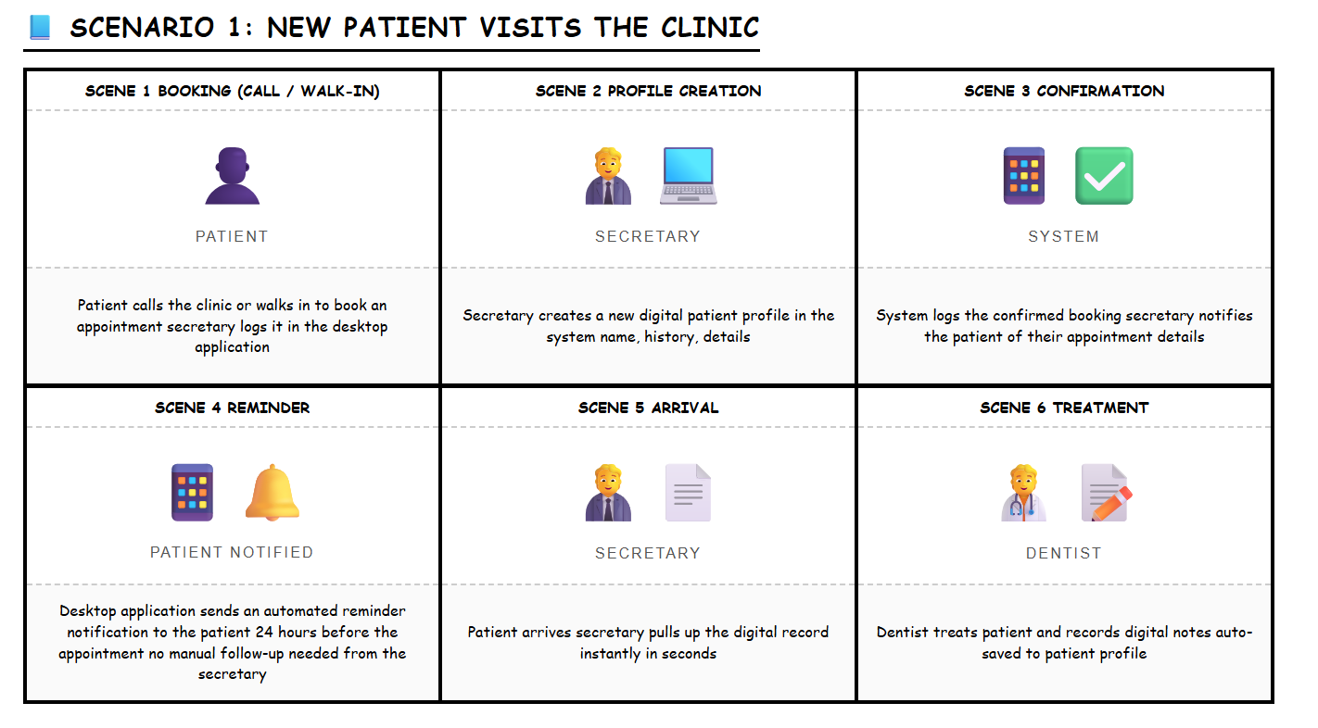
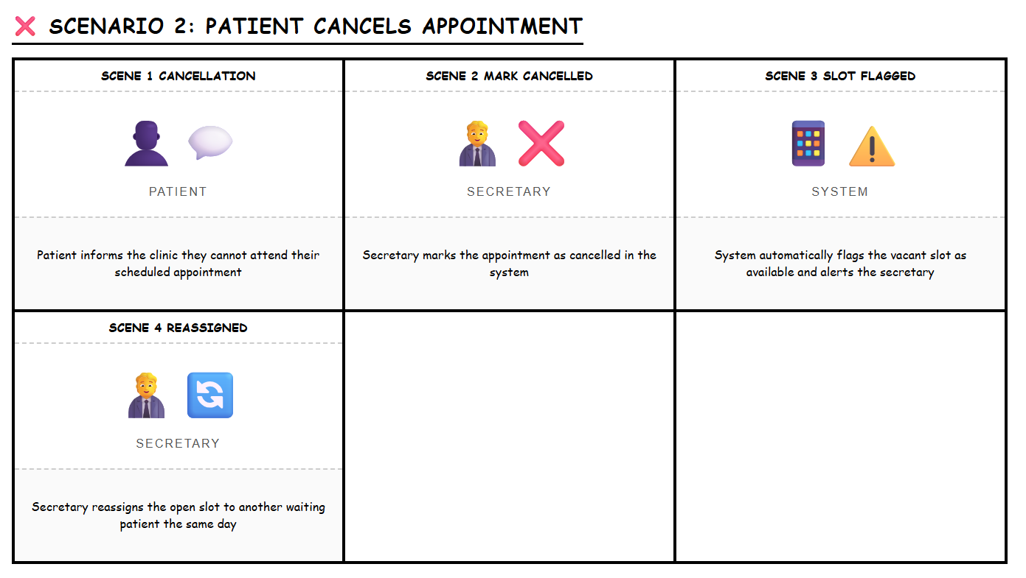
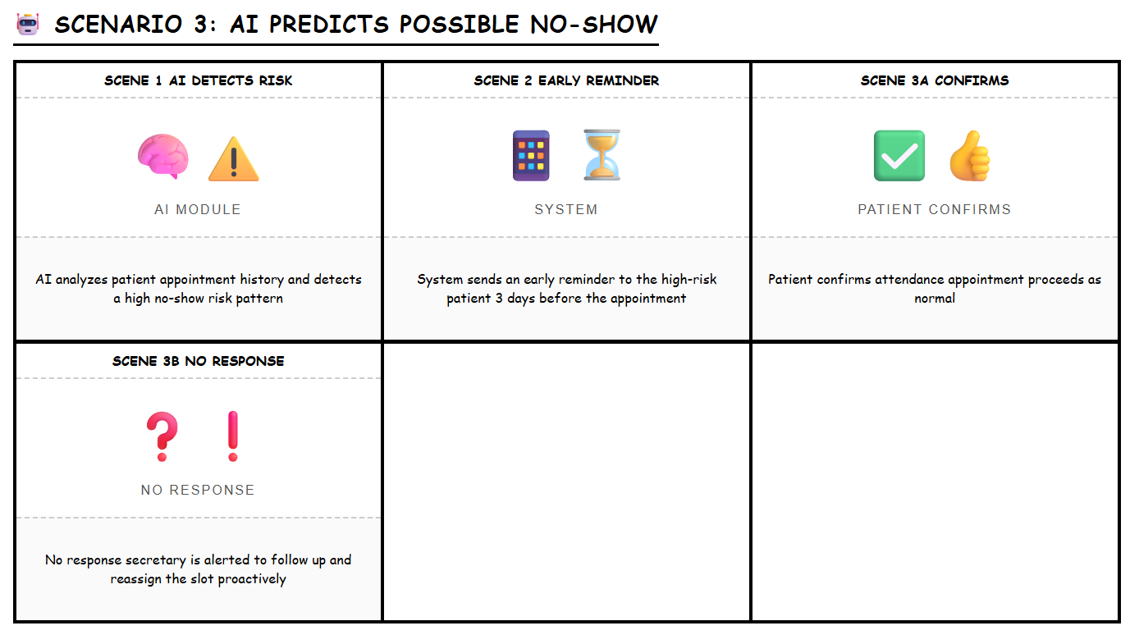
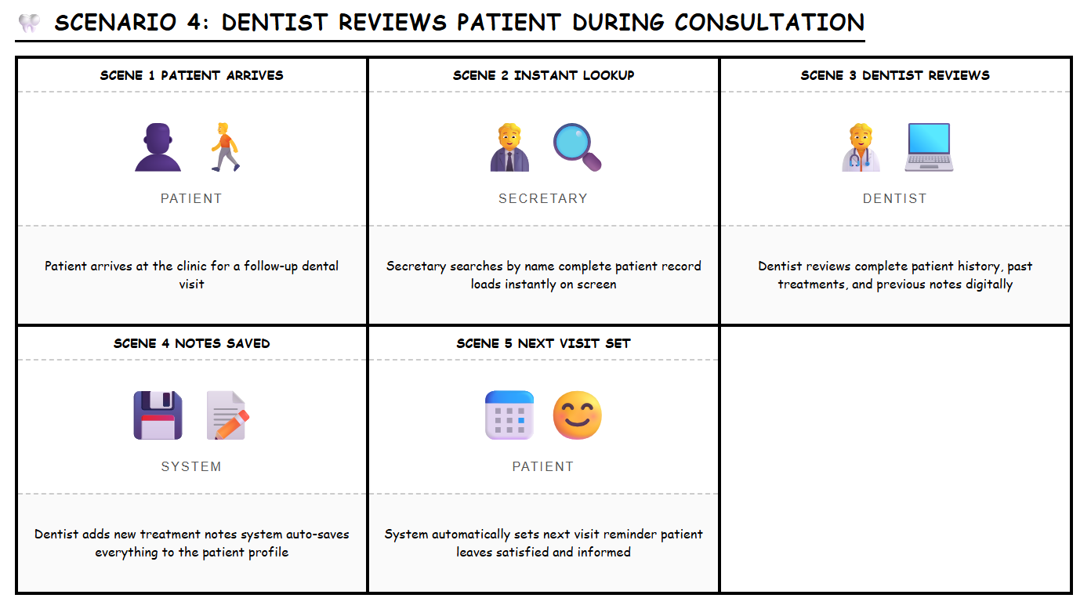
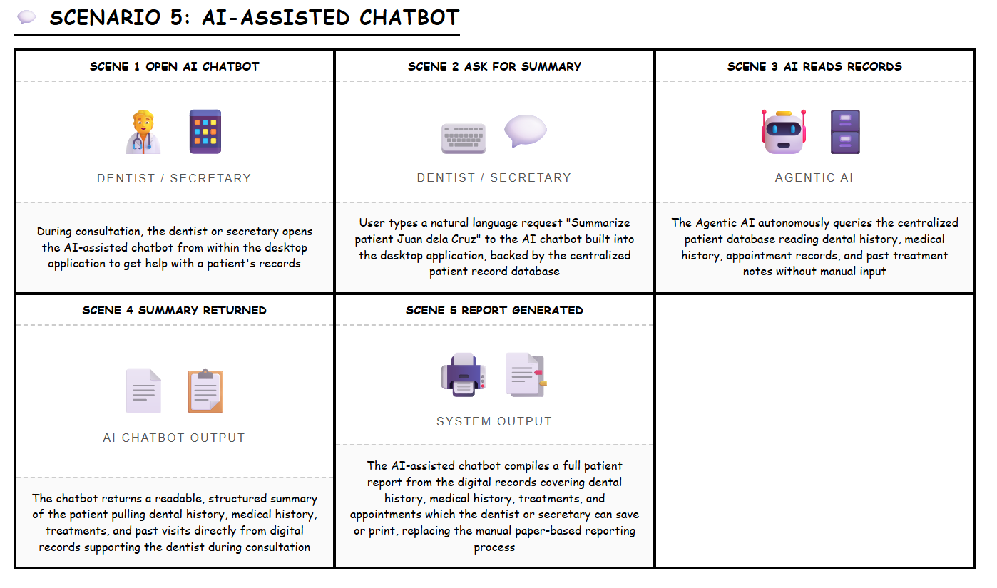

Appendix D: Project SharePoint Link
SharePoint Link: (see project SharePoint repository shared with the adviser and panelists for full working files, source assets, and revision history)

Appendix E: Requirements Traceability Matrix (RTM)
R = Responsible | A = Accountable | C = Consulted | I = Informed (see Appendix F for role assignments). The matrix below traces each system requirement back to its source and forward to its use case, user story, and module.
Req. ID | Requirement Description | Source | Use Case(s) | User Story | Module | Priority | Status
REQ-01 | Secretary must be able to book a dental appointment for a patient through the system | User Story 1 (Secretary); Statement of the Problem | UC-01 | USSEC-01 | Appointment Module | High | In Progress
REQ-02 | System must prevent double bookings by detecting scheduling conflicts in real time | Client Interview; SWOT Weaknesses | UC-01 | USSEC-01 | Appointment Module | High | In Progress
REQ-03 | System must send an automatic booking confirmation to the patient upon scheduling | User Story 3 (Patient); Objectives | UC-01 | USPAT-01 | Appointment Module | High | In Progress
REQ-04 | Secretary must be able to process a patient cancellation and update the appointment status | User Story 1 (Secretary); Statement of the Problem | UC-02 | USSEC-04 | Appointment Module | High | In Progress
REQ-05 | System must automatically flag a cancelled slot as available for reassignment | Client Interview (‘Wala’); Objectives | UC-02, UC-03 | USSEC-04 | Appointment Module | High | In Progress
REQ-06 | Secretary must be able to reassign a vacant slot to another patient within 3 clicks | User Story 1 (Secretary); Objectives | UC-03 | USSEC-04 | Appointment Module | High | In Progress
REQ-07 | System must notify the secretary when an appointment slot becomes open for reassignment | User Story 1 (Secretary) | UC-03 | USSEC-04 | Appointment Module | Medium | In Progress
AI SCHEDULING MODULE
REQ-08 | System must analyze patient appointment history to calculate a no-show risk score per patient | Related Literature (Salazar et al.); Objectives | UC-04 | USDEN-04 | AI Scheduling Module | High | In Progress
REQ-09 | System must flag high-risk appointments on the secretary's and dentist's dashboard | User Story 2 (Dentist); Objectives | UC-04 | USDEN-04 | AI Scheduling Module | High | In Progress
REQ-10 | System must automatically send an appointment reminder 24 hours before a scheduled visit | User Story 1 (Secretary); User Story 3 (Patient) | UC-05 | USSEC-03 / USPAT-02 | AI Scheduling Module | High | In Progress
REQ-11 | System must send an additional reminder 48 hours early for high-risk flagged appointments | User Story 2 (Dentist); Related Literature | UC-04, UC-05 | USDEN-04 | AI Scheduling Module | Medium | In Progress
REQ-12 | Reminder message must include patient name, appointment date/time, and clinic contact number | User Story 3 (Patient) | UC-05 | USPAT-02 | AI Scheduling Module | Medium | In Progress
REQ-13 | System must log reminder status and alert secretary if no patient response is received | User Story 1 (Secretary) | UC-05 | USSEC-03 | AI Scheduling Module | Medium | In Progress
REQ-14 | For new patients with no history, system must assign a neutral risk score and send a standard reminder | Use Case UC-04 Alt Flow | UC-04, UC-05 | USDEN-04 | AI Scheduling Module | Low | In Progress
PATIENT RECORDS MODULE
REQ-15 | Secretary or dentist must be able to create a new patient profile with personal, dental, and medical history | User Story 1 (Secretary); Statement of the Problem | UC-06 | USSEC-02 | Patient Records Module | High | In Progress
REQ-16 | System must generate a unique patient ID upon profile creation | Use Case UC-06 | UC-06 | USSEC-02 | Patient Records Module | High | In Progress
REQ-17 | System must auto-save all profile changes with a timestamp | User Story 2 (Dentist) | UC-06 | USDEN-02 | Patient Records Module | High | In Progress
REQ-18 | Secretary or dentist must be able to retrieve a complete patient record within 5 minutes during a visit | Objectives; User Story 1 (Secretary) | UC-07 | USSEC-02 | Patient Records Module | High | In Progress
REQ-19 | Search must accept full name, partial name, or patient ID and return results within 5 seconds | User Story 1 (Secretary) | UC-07 | USSEC-02 | Patient Records Module | High | In Progress
REQ-20 | System must detect and flag possible duplicate patient profiles during record creation | Use Case UC-06 Alt Flow | UC-06 | USSEC-02 | Patient Records Module | Medium | In Progress
REQ-21 | Incomplete patient profiles must be flaggable for completion on the next visit | Use Case UC-06 Alt Flow | UC-06 | USSEC-02 | Patient Records Module | Low | In Progress
AI CHATBOX MODULE
REQ-22 | AI chatbot must generate a concise summary of a patient's history and past treatments on request | User Story 2 (Dentist); Project Vision | UC-08 | USDEN-02 | AI Chatbox Module | High | In Progress
REQ-23 | AI chatbot must answer follow-up questions about a patient's records using natural language | Use Case UC-08 Alt Flow; Project Vision | UC-08 | USDEN-02 | AI Chatbox Module | Medium | In Progress
REQ-24 | AI chatbot must generate clinic performance reports on demand (e.g., no-show count, attendance rate) | User Story 2 (Dentist); Objectives | UC-09 | USDEN-04 | AI Chatbox Module | High | In Progress
REQ-25 | Generated reports must be exportable and downloadable as a PDF file | Use Case UC-09; Technical Background | UC-09 | USDEN-04 | AI Chatbox Module | Medium | In Progress
REQ-26 | AI chatbot must support custom report requests using natural language filters | Use Case UC-09 Alt Flow | UC-09 | USDEN-04 | AI Chatbox Module | Low | In Progress
CONSULTATION MODULE
REQ-27 | Dentist must be able to record treatment notes digitally into the patient profile during or after consultation | User Story 2 (Dentist); Statement of the Problem | UC-10 | USDEN-03 | Consultation Module | High | In Progress
REQ-28 | Each treatment note entry must be auto-timestamped and linked to the correct patient ID | User Story 2 (Dentist) | UC-10 | USDEN-03 | Consultation Module | High | In Progress
REQ-29 | All past treatment notes must be displayed in reverse chronological order within the patient profile | User Story 2 (Dentist) | UC-10 | USDEN-03 | Consultation Module | Medium | In Progress
REQ-30 | System must display today's full appointment schedule on the dashboard upon login | User Story 2 (Dentist); User Story 1 (Secretary) | UC-11 | USDEN-01 / USSEC-01 | Consultation Module | High | In Progress
REQ-31 | Dashboard must highlight high-risk and flagged appointments visually | User Story 2 (Dentist) | UC-11 | USDEN-04 | Consultation Module | High | In Progress
REQ-32 | Dentist must be able to toggle between daily and weekly schedule views | User Story 2 (Dentist) | UC-11 | USDEN-01 | Consultation Module | Medium | In Progress
SYSTEM / NON-FUNCTIONAL REQUIREMENTS
REQ-33 | System must be a desktop application installable on the clinic's existing workstation with no hardware upgrades | Scope & Limitations; Technical Background | All UCs | All Stories | System-Wide | High | In Progress
REQ-34 | System must require user authentication (login) for the secretary and authorized staff | Scope & Limitations | All UCs | All Stories | System-Wide | High | In Progress
REQ-35 | All patient data must be stored securely in a centralized cloud-backed database (Vercel) | SWOT Threats; Derecho et al. | UC-06, UC-07 | All Stories | System-Wide | High | In Progress
REQ-36 | System interface must be operable by non-technical clinic staff with minimal training | Operational Feasibility; Derecho et al. | All UCs | All Stories | System-Wide | High | In Progress
REQ-37 | System must comply with the Data Privacy Act of the Philippines (RA 10173) for patient data handling | SWOT Threats | All UCs | All Stories | System-Wide | High | In Progress
REQ-38 | System must support PDF export of patient records for BIR paper compliance requirements | SWOT Threats; Technical Background | UC-09 | USSEC-01 | System-Wide | Medium | In Progress

Appendix F: RACI Matrix
R = Responsible (the person who does the work) | A = Accountable (the person ultimately answerable for the task) | C = Consulted (people who provide input and feedback) | I = Informed (people kept up-to-date on progress)
Task / Deliverable | Jon Joseph (Leader) | John Carlo (Tech Lead) | Prince (Developer) | Joachim (Docs Lead) | John Lourd (Tester) | Advisor Calimlim
PHASE 1: DESIGN
Client Interview & Requirements Gathering | A | C | C | R | I | C
Empathy Map & Design Thinking | A | C | C | R | I | C
As-Is / To-Be Scenario Mapping | A | C | I | R | I | C
User Stories Definition | A | R | C | R | C | C
System Architecture Design | A | R | C | I | I | C
Tech Stack Decision | C | R | R | I | I | C
UI/UX Wireframes & Prototype (Figma) | C | C | R | I | I | C
Lean Canvas & Project Vision | A | C | C | R | I | C
Product Backlog & Roadmap | A | R | C | R | I | C
Use Case Diagram & Descriptions | A | R | C | R | I | C
Paper Draft & Documentation | A | C | I | R | I | C
PHASE 2: DEVELOPMENT
Database Design & Setup | I | R | C | I | C | C
Patient Record Module (Build) | I | A | R | I | C | I
Appointment Scheduling Module (Build) | I | A | R | I | C | I
Slot Reassignment Feature | I | A | R | I | C | I
AI Chatbot Basic Setup (Llama) | I | R | R | I | C | C
Automated Reminder & Notification System | I | A | R | I | C | I
No-Show Predictive Algorithm Integration | I | R | R | I | C | C
PDF Report Generation (Ruby API) | I | R | R | I | C | I
Frontend UI Implementation | I | C | R | I | C | I
PHASE 3: REFINEMENT
Unit & Integration Testing | I | C | C | I | R | I
User Acceptance Testing (UAT) with Client | A | C | C | I | R | C
Feedback Collection & Bug Fixes | A | C | R | I | R | C
AI Model Training & Accuracy Check | I | R | R | I | C | C
Final Paper Update & Submission | A | C | I | R | I | C
System Deployment & Handover | A | R | R | I | C | C
Project Monitoring & Evaluation | A | C | C | R | R | C

