Consultation
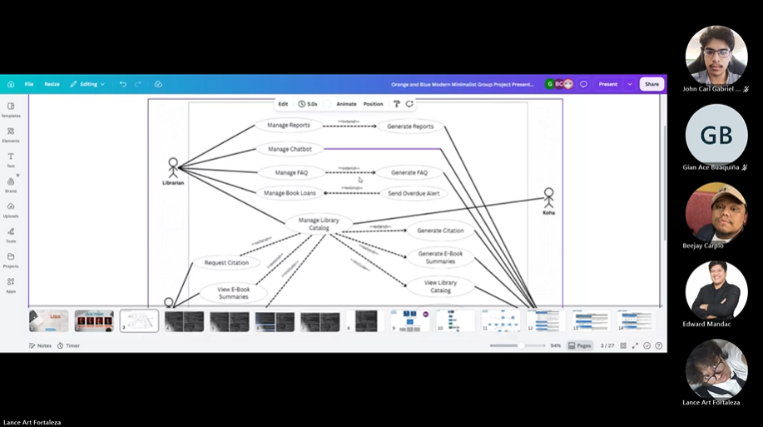
Minutes of Meeting
Date: 08-23-2026
Meeting Called By: Cache Flow
Facilitator: Edward Mandac
Link of the Meeting: Meeting in Cache Flow-20260823_210301-Meeting Recording.mp4

1. Attendees
Gian Ace Buaquiña
Beejay A. Carpio
Lance Art P. Fortaleza
John Carl Gabriel Guzman
2. Agenda
* Presentation PPT
- Review and revise the Presentation ppt slides based on faculty/advisor feedback.
- Clarify C4 model diagrams.
- Clarify the slide content.
3. Summary
-The team must be prepared to defend this specific API bypass logic and C4 diagram structure during the presentation.
- For standard requests like generating an ebook summary, the web portal hits the API gateway endpoint, passes through its service, and then pulls data from the database and external systems.
- Requests that do not need special processing, like simple catalog queries, will bypass the extra service and pull data directly from the database through a straight path from the API gateway.

* Blockers/Obstacle that encounter this week

