Weekly Status Report
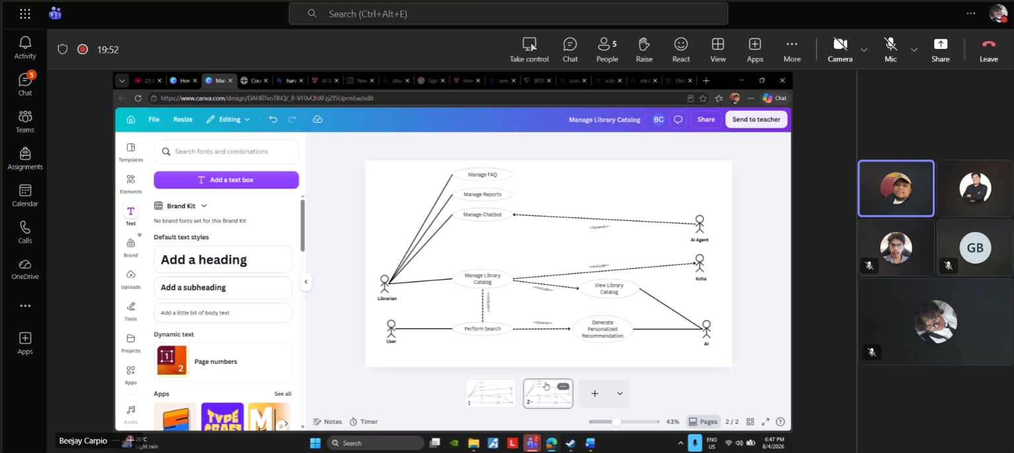
Minutes of Meeting
Date: 07-27-2028
Meeting Called By: Cache Flow
Facilitator: Edward Mandac
Link of the Meeting: Cache Flow - Weekly Status Meeting-20260804_183049-Meeting Recording

1. Attendees
Gian Ace Buaquiña
Beejay A. Carpio
Lance Art P. Fortaleza
John Carl Gabriel Guzman
2. Agenda
* What are the deliverables this week
- Finalize Use Case Diagram (add missing "Manage" use case)
- Use Case Full Description
- Initial Draft of C4 Diagrams
- Have Use Case Diagram checked/approved by adviser
3. Summary
* Status update for the week
- The team reviewed the Use Case Diagram with the adviser. The current process and improvement process layout were confirmed to be correct. The diagram still needs one more "Manage" use case to meet the required minimum of five. The Manage FAQs and Manage Reports use cases are not yet connected to the AI feature that will auto-generate frequently asked questions and reports.
- The plan for the week is to finish polishing the Use Case Diagram first, then proceed to the Use Case Full Description, and begin an initial draft of the C4 Diagrams in parallel if members have available capacity, so the workload is lighter once the 2nd and 3rd weeks begin.
- The Use Case Diagram (with the additional "Manage" use case) is targeted to be checked by the adviser on Thursday. If approved, the team will begin polishing the C4 Diagrams, with an initial C4 draft to be presented by Monday. Once the C4 Diagrams are approved, the team will proceed to update the paper to reflect the finalized diagrams.

* Blockers/Obstacle that encounter this week
- The Use Case Diagram is still missing one required "Manage" use case; a minimum of five use cases is needed before the diagram can be finalized and checked by the adviser.
- Manage FAQs and Manage Reports are not yet integrated with the AI feature for auto-generating FAQs and reports.

