Use Case 1: Payment and Subscription Management
Field | Details
Use Case Name | Payment and Subscription Management
Use Case ID | UC-10
Author | System Architect
Purpose | To allow subscribers to choose a subscription plan, process payments/renewals, manage billing details, check status, and cancel subscriptions.
Requirement Traceability | BR-10
Priority | High
Preconditions | - Subscriber is logged into the application.  - Internet connection is active.  - Payment Gateway integration is operational.
Postconditions | - Subscription plan is created, renewed, or canceled.  - Payment transaction record is stored.  - Digital invoice/receipt is generated and sent to the subscriber.
Actors | Subscriber, Payment Gateway, Admin

Flow of Actions
Basic Flow:
- The subscriber navigates to the "Subscription & Billing" section in the application.
- The system displays available subscription plans, payment options, and the subscriber's current status.
- The subscriber selects a subscription plan (or chooses to update billing details).
- The system prompts the subscriber to enter or confirm payment details.
- The subscriber submits the payment request.
- The system sends the transaction details to the Payment Gateway for verification and processing.
- The Payment Gateway processes the payment and returns a success confirmation.
- The system updates the subscriber's account status to active/renewed.
- The system automatically generates an invoice/receipt and displays it on screen while sending a copy to the subscriber's email.
- The Admin can view the updated subscription status and payment log via the admin portal.
Alternative Flows:
- Payment Declined / Failed:
  - The Payment Gateway rejects the transaction (e.g., insufficient funds or invalid card details).
  - The system displays: "Payment failed. Please check your billing information and try again."
  - The subscription status remains unchanged.
- Cancel Subscription:
  - The subscriber selects "Cancel Subscription".
  - The system prompts for confirmation and optional feedback.
  - The subscriber confirms cancellation.
  - The system updates the subscription status to set it to expire at the end of the current billing cycle.
  - The system displays: "Your subscription has been successfully canceled. You will retain access until the end of your billing cycle."

- No Internet Connection:
  - The app detects a network interruption during checkout.
  - The system displays: "Connection lost. Please check your internet connection and try again."

Test Cases for UC-10
TC ID | UC ID | Test Case Name | Test Case Description
TC-10 | UC-10 | Verify Subscription Purchase and Renewal | Ensure that a subscriber can select a plan, process payment via the Payment Gateway, receive a generated invoice/receipt, and successfully activate or extend their subscription status.
TC-11 | UC-10 | Verify Subscription Cancellation | Ensure that a subscriber can cancel an active subscription and retain access until the current billing cycle expires.
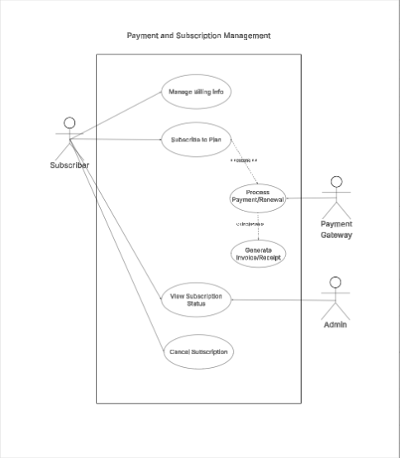
Use Case 2: Premium Content Management
Field | Details
Use Case Name | Premium Content Management
Use Case ID | UC-11
Author | System Architect
Purpose | To allow active subscribers to view exclusive premium articles, download issue/PDF bundles for offline reading, and bookmark content to their personal library.
Requirement Traceability | BR-11
Priority | High
Preconditions | - The user is logged in with an active subscriber account.  - Premium content (articles and PDF bundles) is available on the platform.  - Internet connection is available.
Postconditions | - Premium content is rendered for the user.  - Requested PDF bundle is downloaded to the user's device.  - Selected articles are saved to the user's bookmark library.
Actors | Subscriber

Flow of Actions
Basic Flow:
- The subscriber logs into the system and navigates to the "Premium Content" section.
- The system verifies active subscription access and displays premium articles and downloadable issue bundles.
- The subscriber selects a premium article to read.
- The system loads and renders the full premium article without ad distractions.
- The subscriber clicks the "Bookmark" button on an article.
- The system saves the article reference to the subscriber's personal library and displays a confirmation: "Article added to your bookmarks."
- The subscriber navigates to the "Issue Bundles" section and taps "Download Bundle".
- The system package-checks and initiates the PDF bundle download to the subscriber's local device storage.
Alternative Flows:
- Inactive or Expired Subscription:
  - An unauthenticated or free-tier user attempts to open a premium article or download a bundle.
  - The system intercepts the request and displays: "This content is exclusive to subscribers. Please upgrade your plan to access."
  - The user is provided a prompt to redirect to the Payment and Subscription screen.
- Content / Download Unavailable:
  - The requested bundle file or article is temporarily missing or undergoing updates on the server.
  - The system displays: "Content temporarily unavailable. Please try again later."
- Network Interruption During Download:
  - The connection drops while downloading a PDF bundle.
  - The app pauses or cancels the download and alerts the user: "Download failed due to connection error. Tap to retry."

Test Cases for UC-11
TC ID | UC ID | Test Case Name | Test Case Description
TC-12 | UC-11 | Verify Access to Premium Articles | Ensure that an active subscriber can view full premium articles, while free/unauthenticated users are prompted to upgrade.
TC-13 | UC-11 | Verify PDF Bundle Download | Ensure that an active subscriber can download digital magazine PDF bundles to their local device storage for offline reading.
TC-14 | UC-11 | Verify Article Bookmarking | Ensure that a subscriber can bookmark articles and view saved content within their personal library.
