Virus Spread Simulation

ITEM 1:



Insert screenshots of Python scripts and corresponding required outputs (***5 points per simulation***). Ensure that each image is properly captioned (***1 point per correctly captioned image***). Write your observations on the similarities and dissimilarities of the three tests after the images (***2 points***).

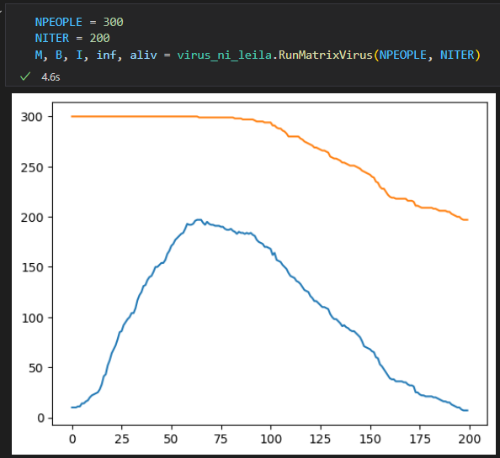

Figure :First Test

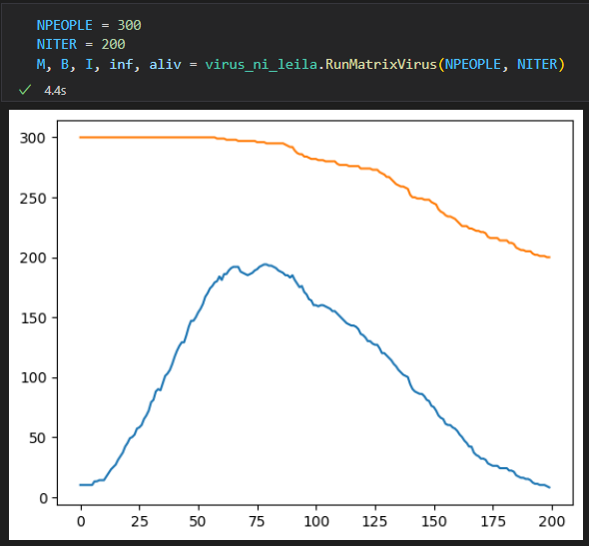

Figure : Second Test

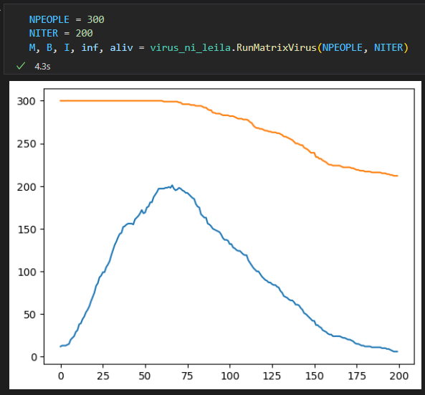

Figure : Third Test

All three tests had similar results. Each tests starts with 300 living persons and 10 infected people. Each test had around 200 infected people at around the 60th iteration. The 60th iteration is also when the number of people start to decline the same rate as the number of infected people declining. All three tests ended with the 200th iteration with there being around 200 people left and almost 0 infected.

ITEM 2:  


Insert screenshots of the edited **virus.py** code and the corresponding output. In the code image, please highlight (enclose in a rectangle or box; or point with an arrow; or identify line number/s) changes made in the original virus.py file so the specifications identified in this exercise are satisfied. Please put image captions (***10 points***).