DOST-STII IRAD Report
Generated on {date_now}
Filters applied: {applied_filters}
Excluded Data: January 1, 2025 – June 30, 2025

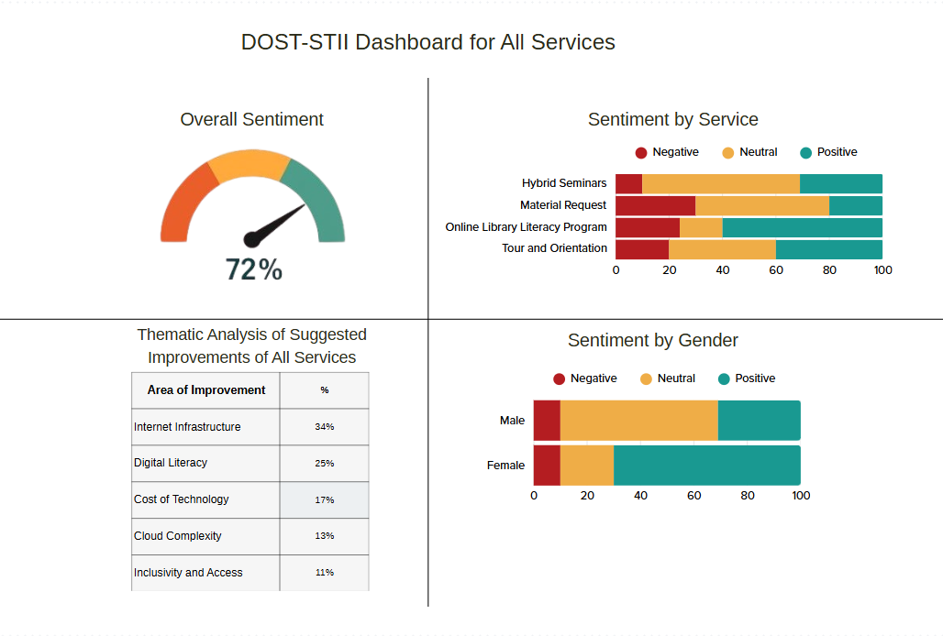
Generated Report
Total Respondents: {totalCount}
Overall Sentiment: {gauge}
User Input:
Hello world

Sentiment By Gender:
 | Negative (%) | Negative (Count) | Neutral (%) | Neutral (Count) | Positive (%) | Positive (Count)
Male | 10 | 10 | 60 | 60 | 30 | 30
Female | 10 | 10 | 20 | 20 | 70 | 70

Sentiment By Service:
 | Negative (%) | Negative (Count) | Neutral (%) | Neutral (Count) | Positive (%) | Positive (Count)
Hybrid Seminars | 10 | 10 | 20 | 20 | 70 | 70
Material Request | 10 | 10 | 20 | 20 | 70 | 70
Offline Library Literacy Program | 20 | 20 | 30 | 30 | 50 | 50
Tour and Orientation | 50 | 50 | 10 | 10 | 40 | 40

Thematic Analysis of Suggested Improvements
- Internet Infrastructure 34% - 34 counts
  - Most common keywords: internet, intranet infrastructure

- Digital Literacy: 25% - 25 counts
  - Most common keywords: illiteracy unaware digital confusion

- Cost Of Technology: 17% - 17 counts
  - Most common keywords: technology pricey unaffordable expensive

- Cloud complexity: 13% - 13 counts
  - Most common keywords: cloud hard topic vpc confusion

- Inclusivity and Access: 11% - 11 counts
  - Most common keywords: elderly impaired disability braille

