1. Implicit and explicit analogues of common methods
(a)
We can write the Butcher tableau for Gauss–Legendre methods
$$\begin{matrix}c & A \\ & b^{T}\end{matrix}=\begin{matrix}\begin{matrix}\frac{1}{2}-\frac{\sqrt{3}}{6} \\ \frac{1}{2}+\frac{\sqrt{3}}{6}\end{matrix} & \begin{matrix}\frac{1}{4} & \frac{1}{4}-\frac{\sqrt{3}}{6} \\ \frac{1}{4}+\frac{\sqrt{3}}{6} & \frac{1}{4}\end{matrix} \\ & \begin{matrix}\frac{1}{2} & \frac{1}{2}\end{matrix}\end{matrix}$$
$A=\left(\begin{matrix}\frac{1}{4} & \frac{1}{4}-\frac{\sqrt{3}}{6} \\ \frac{1}{4}+\frac{\sqrt{3}}{6} & \frac{1}{4}\end{matrix}\right)$, $b=\left(\begin{matrix}\frac{1}{2} \\ \frac{1}{2}\end{matrix}\right)$.
Assume the eigenvalue of $f$ is $λ$, which means that we can assume
$$\frac{du}{dt}=f\left(u\right)=λu$$
Plug this into implicit Runge-Kutta method and get
$$\left(\begin{matrix}k_{1} \\ k_{2}\end{matrix}\right)=f\left(\left(\begin{matrix}u_{n} \\ u_{n}\end{matrix}\right)+A∆t\left(\begin{matrix}k_{1} \\ k_{2}\end{matrix}\right)\right)=λ\left(\begin{matrix}u_{n} \\ u_{n}\end{matrix}\right)+λ∆tA\left(\begin{matrix}k_{1} \\ k_{2}\end{matrix}\right)$$
Which means that
$$\left(\begin{matrix}k_{1} \\ k_{2}\end{matrix}\right)={\left(I-λ∆tA\right)}^{-1}λ\left(\begin{matrix}u_{n} \\ u_{n}\end{matrix}\right)$$
Take this into update formula and get
$$u_{n+1}=u_{n}+∆tb^{T}\left(\begin{matrix}k_{1} \\ k_{2}\end{matrix}\right)=\left(1+λ∆tb^{T}{\left(I-λ∆tA\right)}^{-1}\left(\begin{matrix}1 \\ 1\end{matrix}\right)\right)u_{n}=ρ\left(z\right)u_{n}$$
Here $ρ\left(z\right)=1+zb^{T}{\left(I-zA\right)}^{-1}\left(\begin{matrix}1 \\ 1\end{matrix}\right)$.
Stability requires $\left|ρ\left(z\right)\right|<1$.
Let $z=λ∆t$, and $det=\left|I-zA\right|=\frac{1}{12}z^{2}-\frac{1}{2}z+1$.
Take $A$ and $b$ in and get
$$ρ\left(z\right)=1+\frac{z}{det}=\frac{\frac{1}{12}z^{2}+\frac{1}{2}z+1}{\frac{1}{12}z^{2}-\frac{1}{2}z+1}$$
We can plot the stability region on the complex plain
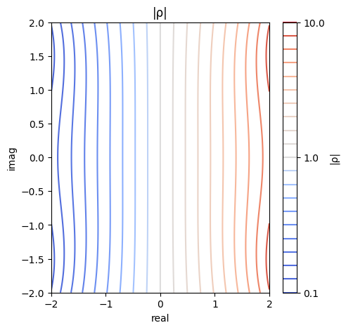
We can find that it is A-stable because $\left|ρ\left(z\right)\right|<1$ when $\operatorname{Re}\left(z\right)<0$, and it is not L-stable because $\lim_{z → -∞}{ρ\left(z\right)}= 1 ≠ 0$.
I will not recommend using this fourth-order scheme in practice because it is fully implicit, which means I need to solve nonlinear system each step.

(b)
$$\frac{du}{dt}=f\left(u\right)={u_{n}}^{'}$$
Expand $f\left(u\right)$ at $u_{n}$ to express $u_{n+1}$, $u_{n-1}$, $u_{n-2}$, etc
$$u_{n+1}=u_{n}+∆t{u_{n}}^{'}+\frac{{∆t}^{2}}{2}{u_{n}}^{''}+\frac{{∆t}^{3}}{6}{u_{n}}^{'''}+…$$
$$u_{n-1}=u_{n}-∆t{u_{n}}^{'}+\frac{{∆t}^{2}}{2}{u_{n}}^{''}-\frac{{∆t}^{3}}{6}{u_{n}}^{'''}+…$$
$$u_{n-2}=u_{n}-2∆t{u_{n}}^{'}+2{∆t}^{2}{u_{n}}^{''}-\frac{4{∆t}^{3}}{3}{u_{n}}^{'''}+…$$
Second-order method (s = 1)
$$u_{n+1}+α_{0}​u_{n}+α_{1}​u_{n-1}=βf\left(u_{n}\right)$$
$$\begin{matrix}LHS= & u_{n+1}+α_{0}​u_{n}+α_{1}​u_{n-1} \\ = & \left(1+α_{0}+α_{1}\right)u_{n}+\left(1-α_{0}\right)∆t{u_{n}}^{'}+\left(\frac{1}{2}+\frac{α_{1}}{2}\right){∆t}^{2}{u_{n}}^{''}+\left(\frac{1}{6}-\frac{α_{1}}{6}\right){∆t}^{3}{u_{n}}^{'''}+…\end{matrix}$$
Match coefficients and get
$$\left\{\begin{matrix}α_{0}=0 \\ α_{1}=-1 \\ β=2∆t\end{matrix}\right.$$
Second-order method should be
$$u_{n+1}-​u_{n-1}=2∆tf\left(u_{n}\right)$$
If we take $f\left(u_{n}\right)=λu_{n}$, then the growth rate $ρ$ can be obtained from
$$ρ^{2}-2zρ-1=0$$
Stability requires all the root $\left|ρ\left(z\right)\right|<1$.
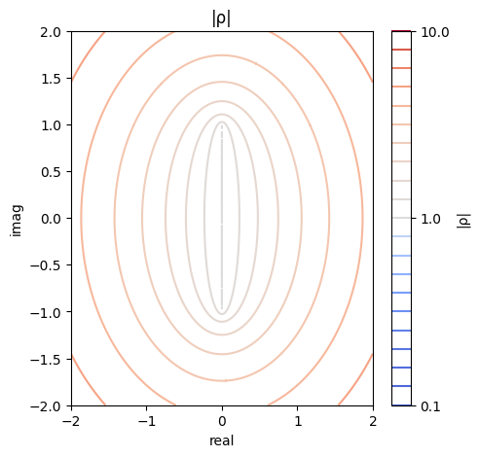
We can find that stability condition can only be satisfied when $\left|\operatorname{Imag}\left(z\right)\right|<1$.
Third-order method (s = 2)
$$u_{n+1}+α_{0}​u_{n}+α_{1}​u_{n-1}+α_{2}​u_{n-2}=βf\left(u_{n}\right)$$
$$\begin{matrix}LHS= & u_{n+1}+α_{0}​u_{n}+α_{1}​u_{n-1}+α_{2}​u_{n-2} \\ = & \left(1+α_{0}+α_{1}+α_{2}\right)u_{n}+\left(1-α_{0}-2α_{2}\right)∆t{u_{n}}^{'}+\left(\frac{1}{2}+\frac{α_{1}}{2}+2α_{2}\right){∆t}^{2}{u_{n}}^{''}+\left(\frac{1}{6}-\frac{α_{1}}{6}-\frac{4}{3}α_{2}\right){∆t}^{3}{u_{n}}^{'''}+…\end{matrix}$$
Match coefficients and get
$$\left\{\begin{matrix}α_{0}=\frac{3}{2} \\ α_{1}=-3 \\ α_{2}=\frac{1}{2} \\ β=3∆t\end{matrix}\right.$$
Third-order method should be
$$u_{n+1}+\frac{3}{2}​u_{n}-3​u_{n-1}+\frac{1}{2}​u_{n-2}=3∆tf\left(u_{n}\right)$$
If we take $f\left(u_{n}\right)=λu_{n}$, then the growth rate $ρ$ can be obtained from
$$ρ^{3}+\left(\frac{3}{2}-3z\right)ρ^{2}-3ρ+\frac{1}{2}=0$$
Stability requires all the root $\left|ρ\left(z\right)\right|<1$.
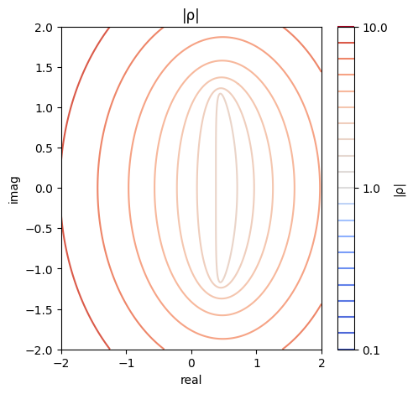
We can find that none of the point on the complex can make this method stable. The min $ρ≈1.73$.
I will not use these methods. They are not stable.

