4.2 Financial data

With our package, we would be able to play with real financial data: to fit a suitable model and make highly reasonable predictions. In this section, we take the stock return of Google from year 2015-2016 as an example. There are altogether 490 trading days during the time. The stock prices and returns are shown below:

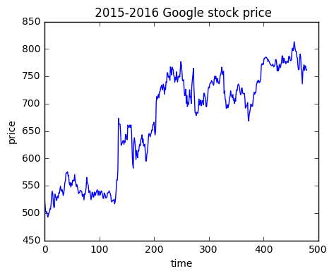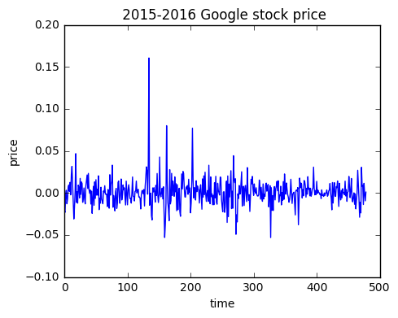

We may fit an AR(5) model according to the return in the first 480 trading days. Here, the lag value is picked in a moderate size to balance the complexity and validity. By choosing the optimization method to be stochastic gradient descent with momentum update, a fitted model is quickly returned. With the fitted model, we would be able to predict the future return as well as the future stock price for the following days. Here, we make a prediction for 5 days.

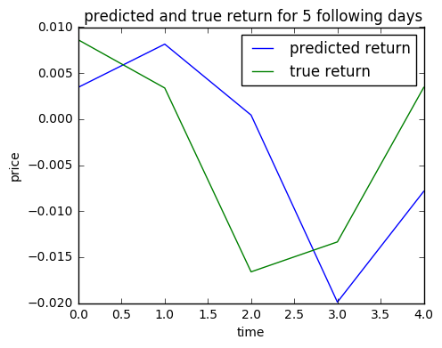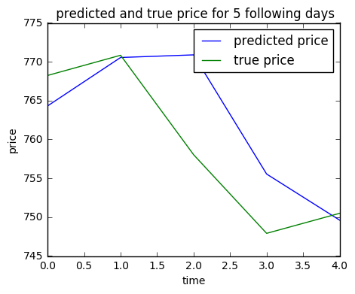

As we can see from the figure, we correctly predict the trend of the stock price. Moreover, the predicted price and the true price are very close. This lays a good foundation for the following trading section.