*Binary Game*

*AP Computer Science Principles Name__________*

The binary game is a fun way of learning to convert back and forth between binary and decimal numbers.

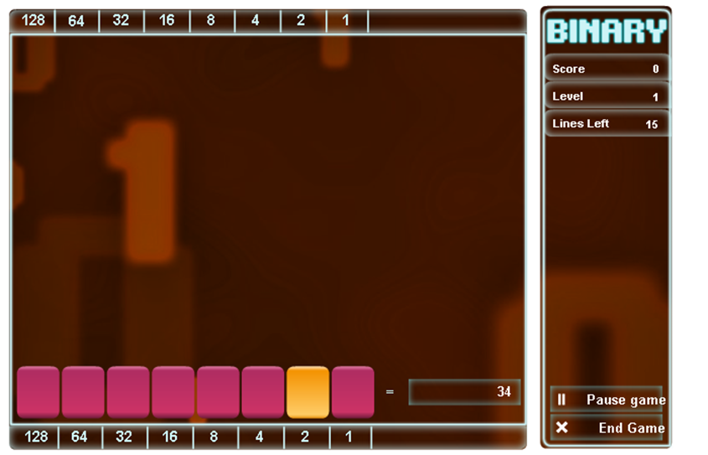

There are two kinds of problems. The first kind of problem is to convert from base 10 to binary. In the screen above we are asked to make 34 in binary. Clicking on the button above the power of two "flips" to either 1 or 0. If we click on the button (“bit”) above 32, we complete the level because 32 + 2 = 34.

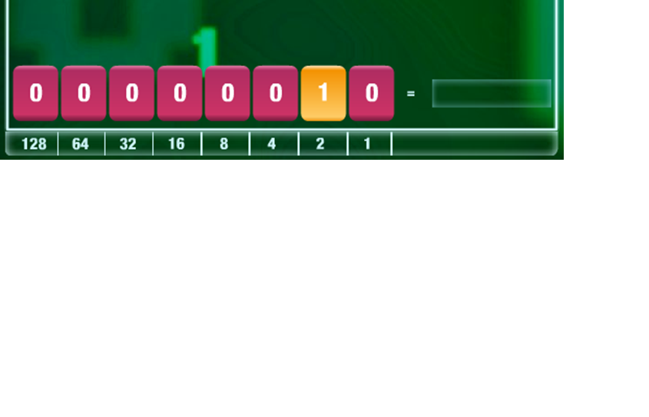

The other kind of problem is to convert from binary to base 10. In the picture above, the problem is to type the decimal number in the box to the right of the binary number.

Clicking in the box next to the equals sign lets me type or click on the number pad to enter the answer in base 10. In this case typing 2 completes the level since 00000010 is 2 in decimal. You can read the instructions for a more detailed explanation of how to play the game.

Go to the [Binary Game](http://www.wordfreegames.com/game/binary-game.html) and play it until you reach level 4. After reaching level 4 take a screen shot (the windows snipping tool is one way to do this) and paste the screen shot below.

Screenshot: