*Solve a Mystery with a Data Visualization*

*AP Computer Science Principles*

In this assignment you and a partner will write a computer program to help solve a crime. Aces Peck has been accused of breaking and entering. An alarm sounded at the storage unit for the senior facility run by CFI Care inc. at 2043 19th Avenue 3:15pm on Sunday January 1st 2017. Witnesses saw a male matching Aces’ description leaving the senior facility on foot shortly after the time of the break in. Aces lives near the corner of 45th Ave and Quintara. He claims that he only left his house at 1:30 pm to walk to the Safeway at 730 Taraval St. He says he bought a quart of milk and walked back home. He says he was at home at the time of the break in.

The police have possession of Aces’ smartphone and they have asked you to determine if the data from Aces’ phone corroborates his alibi. The police were able to gather the following time stamped gps coordinates from his phone in the format (*latitude*, *longitude*, *24 hr time*):

(37.747201,-122.503728,"13:00")

(37.747201,-122.503728,"13:10")

(37.747201,-122.503728,"13:20")

(37.747201,-122.503728,"13:30")

(37.7457331,-122.5001465,"13:40")

(37.7459013,-122.4954998,"13:50")

(37.7429473,-122.4875535,"14:00")

(37.7430309,-122.4767629,"14:10")

(37.7434253,-122.474164,"14:20")

(37.7434253,-122.474164,"14:30")

(37.7434253,-122.474164,"14:40")

(37.7448167,-122.4756721,"14:50")

(37.7469956,-122.475964,"15:00"),

(37.7496281,-122.4764707,"15:10")

(37.7486281,-122.4760707,"15:20")

(37.7482044,-122.4858554,"15:30")

(37.7456825,-122.4985913,"15:40")

(37.747201,-122.503728,"15:50")

(37.747201,-122.503728,"16:00")

**Suggested Steps to completing this assignment:**

1. Download a copy of the DataVizMystery.zip folder. Unzip it and open the DataVizMystery.pyde file. You should see the following code:

dat = [(37.747201,-122.503728,"13:00"),

(37.747201,-122.503728,"13:10"),

(37.747201,-122.503728,"13:20"),

(37.747201,-122.503728,"13:30"),

(37.7457331,-122.5001465,"13:40"),

(37.7459013,-122.4954998,"13:50"),

(37.7429473,-122.4875535,"14:00"),

(37.7430309,-122.4767629,"14:10"),

(37.7434253,-122.474164,"14:20"),

(37.7434253,-122.474164,"14:30"),

(37.7434253,-122.474164,"14:40"),

(37.7448167,-122.4756721,"14:50"),

(37.7469956,-122.475964,"15:00"),

(37.7496281,-122.4764707,"15:10"),

(37.7486281,-122.4760707,"15:20"),

(37.7482044,-122.4858554,"15:30"),

(37.7456825,-122.4985913,"15:40"),

(37.747201,-122.503728,"15:50"),

(37.747201,-122.503728,"16:00")]

minLat = 37.752242 # minimum latitude in map

maxLat = 37.728825 # maximum latitude in map

minLong = -122.509245 # minimum longitude in map

maxLong = -122.454380 # maximum longitude in map

def setup():

size(957,522)

global img

img = loadImage("Map.PNG")

textSize(20)

textAlign(CENTER,CENTER)

fill(0,0,255)

noLoop();

def draw():

image(img,0,0,957,522)

2. Run the program. You should see the following map of San Francisco:

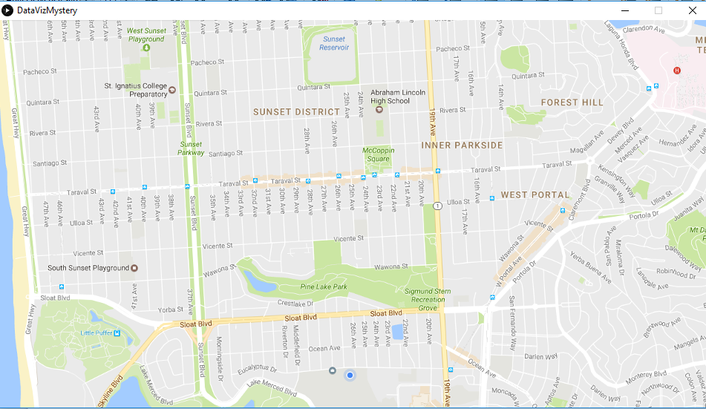

3. The map (taken from Google maps) shows a portion of San Francisco between between latitudes 37.752242 and 37.728825 and longitudes -122.509245 and -122.454380 . Note the four variables that hold the minimum and maximum longitudes and latitudes for the map:

**minLat = 37.752242**

**maxLat = 37.728825**

**minLong = -122.509245**

**maxLong = -122.454380**

4. Look at the list of smartphone data **dat**. Each element is a group of three numbers, a longitude, a latitude and a time in 24 hour format.

**dat = [(37.747201,-122.503728,"13:00"),**

**(37.747201,-122.503728,"13:10"),**

**(37.747201,-122.503728,"13:20"),**

**(37.747201,-122.503728,"13:30"),**

**(37.7457331,-122.5001465,"13:40"),**

**(37.7459013,-122.4954998,"13:50"),**

**(37.7429473,-122.4875535,"14:00"),**

**(37.7430309,-122.4767629,"14:10"),**

**(37.7434253,-122.474164,"14:20"),**

**(37.7434253,-122.474164,"14:30"),**

**(37.7434253,-122.474164,"14:40"),**

**(37.7448167,-122.4756721,"14:50"),**

**(37.7469956,-122.475964,"15:00"),**

**(37.7496281,-122.4764707,"15:10"),**

**(37.7486281,-122.4760707,"15:20"),**

**(37.7482044,-122.4858554,"15:30"),**

**(37.7456825,-122.4985913,"15:40"),**

**(37.747201,-122.503728,"15:50"),**

**(37.747201,-122.503728,"16:00")]**

5. Now we are going to extract the first three numbers from the list. Add the line of code shown below to the last line of the **draw** function

**def draw():**

**image(img,0,0,957,522)**

**lat,lng,tme = dat[0] # pull first three numbers out of list**

6. Now we need to map the latitude and longitude to our map. [Processing’s **map()**](http://py.processing.org/reference/map.html) function will do exactly that. The latitude will map to the y axis and the longitude will map to the x axis. Add the following code and run the program:

**def draw():**

**image(img,0,0,957,522)**

**lat,lng,tme = dat[0]**

**y = map(lat, minLat,maxLat , 0, height)**

**x = map(lng, minLong, maxLong, 0, width)**

**text(tme,x,y)**

You should see the following map. It shows that at 1 pm (13:00 in 24 hr format) Aces was at his home near the corner of Quintara and 45th.

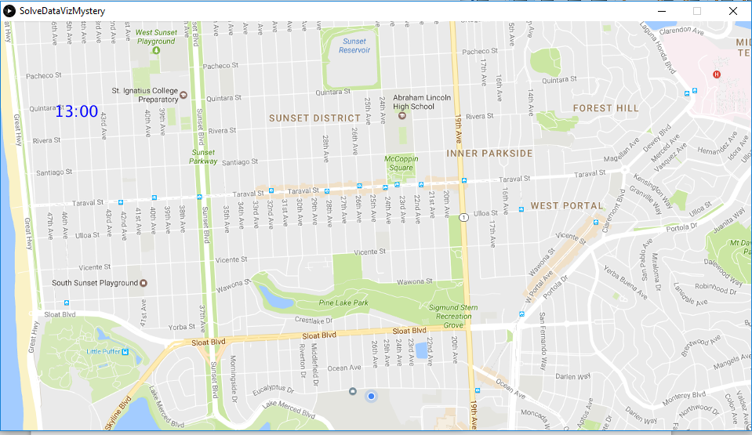

7. Continue mapping the data to the map to trace Aces’ movements that day. You may want to use a for each loop to avoid duplicating code. You may also want to “clean” the data by removing data that isn’t helpful in solving the mystery.

8. Once you understand Aces’ movements you should be able to answer the question “Does the data corroborate his alibi?” When you think you know the answer, call your instructor over and explain your reasoning.