**Make your own Cat 5e Ethernet Cable**

**AP Computer Science Principles**

In this lab, you will construct a Cat 5e Ethernet cable that will be yours to keep.

**Cut and strip a length of Ethernet cable**

1. Cut a length of Ethernet cable
2. Strip about ½" off the end, being careful to cut only the jacket and not the wires inside
3. Untwist the wires and use the picture below to flatten them into the correct order

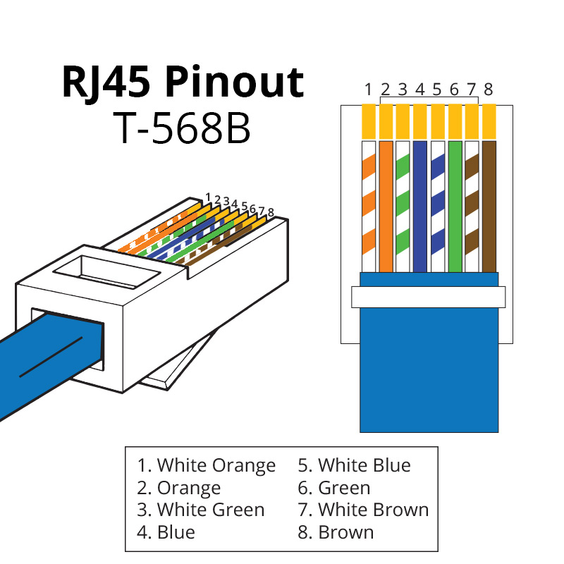

**Attach the RJ-45 Plugs**

1. 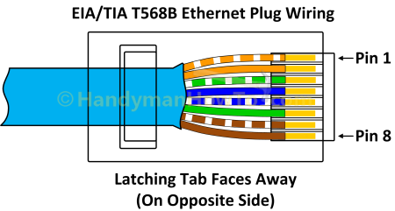Slide the wires into the plug, and then pull them out. This will help shape the wires before you trim them.
2. Trim the wires until the cable jacket slides all the way into the plug and the wires press against the end
3. **Important**: Make sure the jacket of the cable goes all the way into the plug as shown in the picture on the right. It will be "grabbed" when the plug is crimped and hold the plug in place.
4. Repeat steps 4, 5, and 6 until you are satisfied that the wires fit into the plug correctly
5. When you are satisfied, forcefully crimp the plug onto the wire

**Test the cable**

1. Plug in both ends of your cable to the cable tester as shown in the picture to the right
2. Turn the power switch on the side of the cable tester to “on”
3. Press Enter (The Blue Button)
4. The tester will show if the pinouts match. On a correctly wired cable all the numbers should match up. 1 to 1, 2 to 2, 3 to 3 and so on as shown in the photo below.

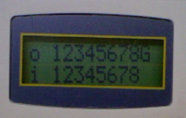

**Common Problems**

* Wires in wrong order (Pin 1 is on the left as you look at the plug with the latch away from you)
* Wires don’t reach all the way to the “copper teeth” at the end of the plug
* Cable jacket isn’t “grabbed” by the plug
* When stripping cable jacket, the wires are partially cut, leading to shorts
* Plug was not crimped with sufficient force to push the “copper teeth” in to contact with the copper wire