AP Computer Science Principles

Virtual Desktop Assembly Lab Name ___________*KEY*____________

Instructions: This lab will teach you the basics of computer assembly using a simulated “virtual” PC. To start, use the Windows file explorer to navigate to *This PC | Local Disk C: |en_ITEC_VA_Desktop_v40*. Open the folder and right click on *index.html*. Choose *Open With | Microsoft Edge*.

You should see a welcome screen similar to the picture below.

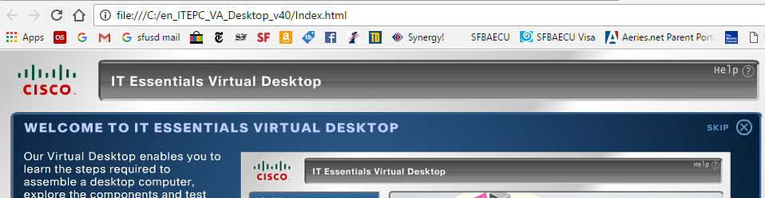(**OPTIONAL:** You may find it easier to visit one of the following links instead:

<http://umhelena.edu/VirtualComputers/Desktop/en_ITEPC_VA_Desktop_v40/RootMovie.swf?lesson=7>  
<http://phs.ironk12.org/en_ITEPC_VA_Desktop_v40/Index.html>

Click on the right arrow at the bottom to take a quick tour of the Cisco IT essentials virtual desktop program. When you finish, you should see a picture similar to the one below.

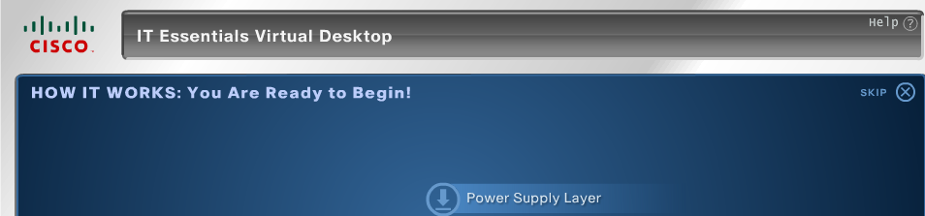

get the message *How it works: you are ready to begin!* click on the *power supply* under *Learn* to start the simulation. Drag the parts from the antistatic mat to the computer case and move them into position. As you use Virtual Desktop to practice putting a computer together, answer the following questions.

1. What are the 7 categories (“layers”) listed that are typically part of a computer build?

i. ___*Power Supply*____ ii. __*Motherboard*_________

iii. ___*Adapter Cards*__________ iv. _____*Internal Drives*________________

v. ______*External Drives*_______ vi. ______*Internal Cables*_________

vii. ______*External Cables*_____________

2. Click on the Power Supply Layer. Install the power supply and screws. Now click on Motherboard. You should see a picture of the motherboard like this.

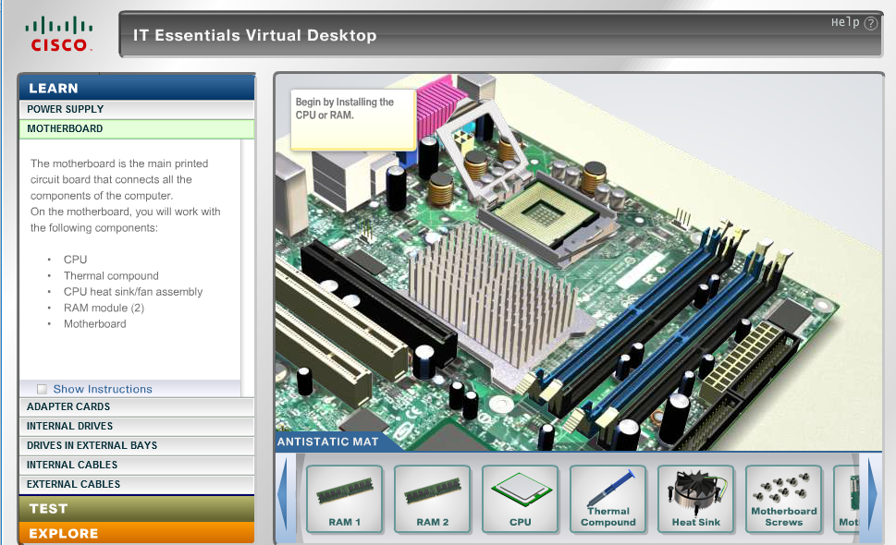

Why do you think you are asked to install the RAM and CPU on the motherboard before installing the motherboard in the case?

*You have more room to work (more space for your hands) when the motherboard is outside the case.*

3. Install the RAM. Is it possible to install the RAM backwards? Why or why not?

*No. The RAM has a notch that won’t fit in the motherboard backwards.*

4. Install the CPU. What is the significance of the triangle on one corner of the CPU? What do you think would happen if the CPU was crooked when the load plate is closed?

*The triangle of the CPU matches the corner of the socket that is different. This helps make sure the CPU goes into the socket correctly. If the CPU were crooked, it would break when the load plate is closed and the computer would not function.*

5. Install the Thermal Compound. What is the purpose of the thermal compound?

*The thermal compound fills the microscopic gaps between the CPU and heat sink to ensure that heat flows away from the CPU and into the heat sink.*

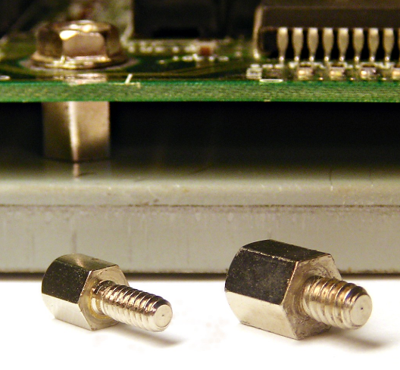6. Install the heat sink and heat sink fan. Click on the install motherboard button. Note that there are standoffs already installed in the case. A standoff is a screw on one side and a hole on the other that insures the motherboard is not touching the metal case. The picture on the right shows some standoffs.

Why do you think it is important that the motherboard doesn’t touch the metal case?

*If one of more of the circuits on the motherboard touched the metal case it would cause an electrical short and the computer would not function.*

7. Install the motherboard screws. Why is it important to ensure the motherboard standoffs line up with the holes for the screws on your particular motherboard?

*The screws attach to the standoffs to secure the motherboard. If the screw holes didn’t line up with the standoffs, it wouldn’t be possible to install the motherboard.*

8. Installs the two NIC cards. What does NIC stand for? Why is it important to have a NIC in a modern computer?

*Network Interface Card. Without one or more NIC cards the computer would not be able to connect to the internet.*

9. Finish installing the adapter cards and begin installing the internal and external drives. What are the three types of internal and external drives that were installed on the virtual computer. How many internal and external drives does your computer in room 334 have? What type(s) of internal and external drives are installed in your computer in room 334?

*The virtual computer has one internal hard drive and two external drives, optical and floppy. The computers in room 334 have only one internal drive. They do not have external drives as most people use thumb drives instead.*

10. Finish installing the internal cables. Save this worksheet to your computer and submit it to the school loop drop box for the assignment by choosing *Submit: From Device*.