**AP Computer Science Principles**

**Wireshark Part 2**

In this lab, we’ll solve one of the puzzles from the [2013 Toaster Wars high school hacking competition](https://2013.picoctf.com/). The background story is that a robot has crashed in your backyard, and you need to hack into it to discover why it’s there. For this problem, we’ve discovered that the robot is communicating wirelessly with a space ship and we’ve captured the packets that were sent back and forth. The captured packets are in the file [first_contact.pcap](https://2013.picoctf.com/problems/first_contact.pcap). Your goal is to find the location of the ship by inspecting the network traffic.

1. Click on the link [first_contact.pcap](https://2013.picoctf.com/problems/first_contact.pcap) to download the file.
2. Start wireshark by going to the start menu and choose *All programs | wireshark.*
3. Choose *File | Open*
4. Browse to the folder where you downloaded **first_contact.pcap** and open it. You should see something similar to the picture below

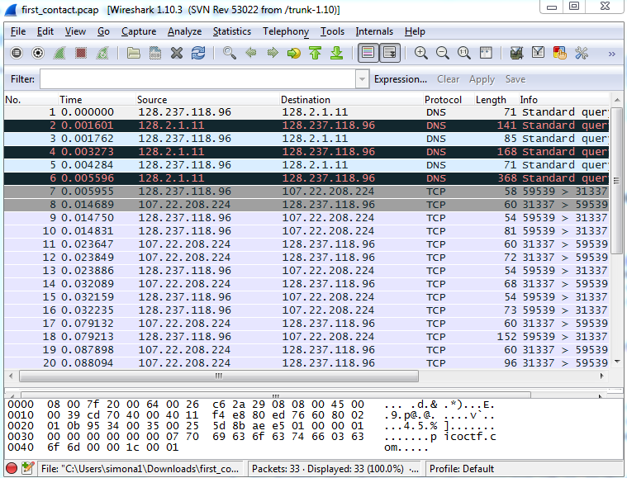

1. Look through the packets for clues about the location. When you discover the location, google it
2. It’s a famous place. If you think you found it, call your instructor over