Lowell High School AP CS Principles
Use Wireshark to capture 6 DNS, HTTP
and ICMP (ping) packets

Wireshark

Wireshark is a type of program called a network protocol analyzer. It lets you read the individual packets that are sent on your network and identify the protocols they use. In this lab you will use Wireshark to look at at least 6 packets using the DNS, HTTP and ICMP (ping) protocols.

Find your IP address

Run ipconfig from the command prompt and enter your IP address here:_____________________________________

Start Wireshark
One way to start Wireshark is to click on the start menu at the bottom left of the screen, choose All Apps and scroll to Wireshark under W.

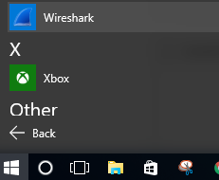
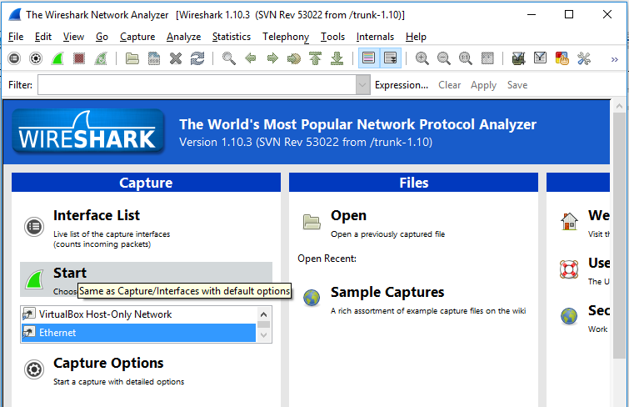
After Wireshark starts, click on Ethernet and then click Start to begin capturing packets.Browse to a Web Page
Open a web browser like Chrome. Go to a webpage that uses HTTP (not HTTPS) like http://mrsimon.net. Then choose Capture | Stop in Wireshark.
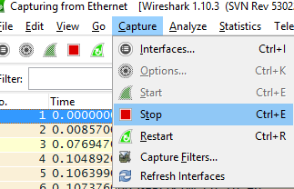

DNS packets
To get to our HTTP website, we first need to get the IP address for mrsimon.net. Here you can see DNS packets going back and forth from my computer 10.66.4.16 requesting mrsimon.net’s IP address. The requests went to a DNS server at 156.1.180.201. Each packet is a single horizontal line. For each packet, there is a field for Time, Source, Destination, Protocol, Length and Info.
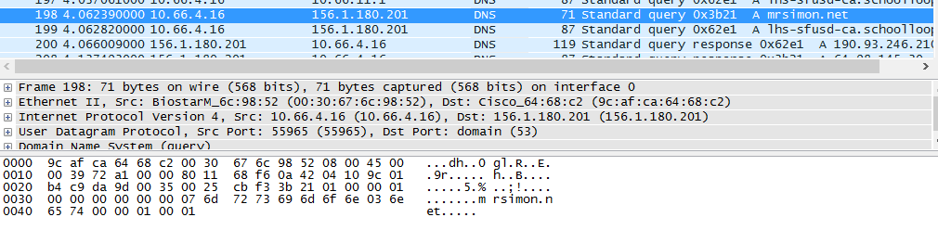
You will want to paste a similar screen shot at the bottom of this worksheet
HTTP packets
Here is a screen shot showing HTTP packets sent back and forth between my computer and http://mrsimon.net
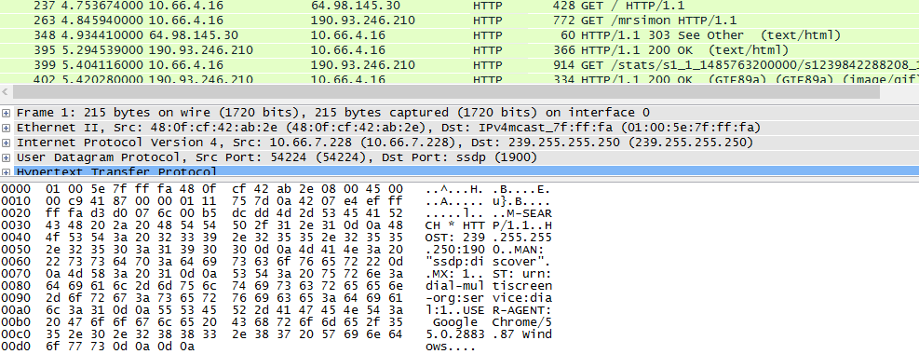
ping a neighbors IP address.
First, find a partner and ask them their IP address. Start capturing packets again in Wireshark, and then use the command prompt to ping your neighbors IP. You below that I pinged a neighbor at 10.6.2.55 in my command prompt.
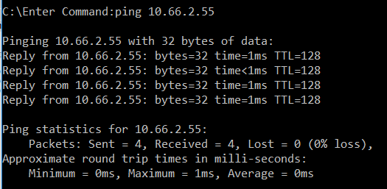
Here are my captured ping packets in Wireshark traveling back and forth from my computer at 10.6.4.16 to my neighbors computer at 10.66.2.55
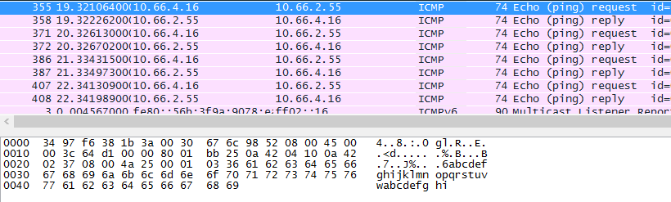
Paste screen shots from Wireshark of at least 6 packets below.
Capture and least two packets each for a DNS lookup, a HTTP web page, and an ICMP ping request. If you have extra time, feel free to capture other packets as well. Paste your screen shots below and submit your completed worksheet to the school loop drop box for the assignment.

