Hexadecimal and ASCII in the Martian
AP Computer Science Principles Name__________

Start this assignment by watching Ridley Scott narrate a sequence from the movie “The Martian” at http://www.nytimes.com/video/movies/100000003950701/anatomy-of-a-scene-the-martian.html. In the scene Matt Damon’s character Watney digs up the Mars Pathfinder, a probe which NASA lost contact with in 1997. He fixes it and is now able to communicate with NASA through the Pathfinder by writing messages and showing them to the camera.

Just after that scene at 49’ 20” Matt Damon discusses how to improve communications using Pathfinder. The first communications reveal a few problems. For instance, Watney has a limited amount of paper to write on. The larger problem? NASA can't communicate back. All they have is a camera on a platform which can rotate 360 degrees.

So Watney decides to use the 16 character hexadecimal system to communicate instead. The hexadecimal system is comprised of 16 symbols: 0-9 and A-F. Typically it's used by programmers to condense and communicate large binary numbers easily.

After putting signs for the 16 digits and numbers in a circle around Pathfinder, Watney combines the hexadecimal system with an ASCII table. ASCII is a code that represents characters as numbers and is used to help display text onto computers among other devices. An ASCII table contains 255 characters where each is assigned a number ranging from 0 to 255. Here are a few other strings of letters and numbers NASA sends to Watney in the books. Can you figure them out using the ASCII table below?

1. 48 4F 57 41 4C 49 56 45
2. 43 52 4F 50 53 3F
3. 42 52 49 4E 47 53 4A 52 4E 52 4F 55 54

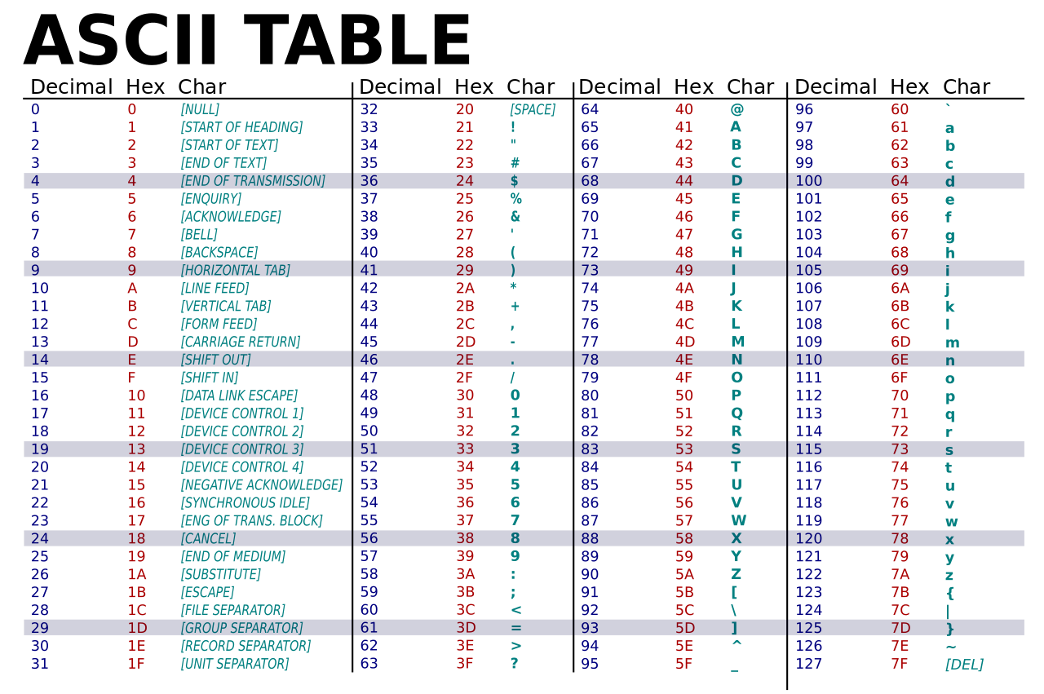
You can check your answers on the website this assignment was adapted from
http://www.businessinsider.com/the-martian-hexidecimal-language-2015-9

