Logic Gates in Logic.ly
AP Computer Science Principles Name__KEY____
Go to https://logic.ly/demo/ to complete this assignment.

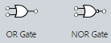
- Build the circuit shown below using two toggle switches, one OR gate and one light bulb. Make sure you are using an OR gate and not a NOR gate as shown in the picture on the right. Connect the components by clicking and dragging the white dots. The two toggle switches are shown in the off or 0 position. This position can be interpreted as false. Pressing either switch will toggle them back and forth from on 1 to off 0. The on 1 position can be interpreted as true. Use the Windows snipping tool to paste a picture of your circuit next to the picture below.
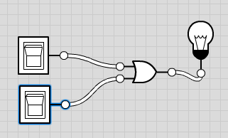

- Use your circuit to complete following truth table for an OR gate. Mark true if the light bulb is on and false if the light bulb is off.

Top Switch | Bottom Switch | Light Bulb
false | false | false
true | false | true
false | true | true
true | true | true

- Build the circuit below using two toggle switches, one AND gate and one light bulb. Connect the components by clicking and dragging the white dots. Use the Windows snipping tool to paste a picture of your circuit next to the picture below.
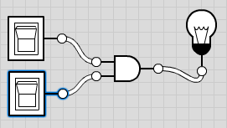

- Use your circuit to complete following truth table for an AND gate. Mark true if the light bulb is on and false if the light bulb is off.

Top Switch | Bottom Switch | Light Bulb
false | false | false
true | false | false
false | true | false
true | true | true

- Build the circuit below using three toggle switches, one AND gate, one OR gate and one light bulb. Connect the components by clicking and dragging the white dots. Use the Windows snipping tool to paste a picture of your circuit next to the picture below.

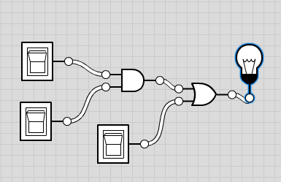

- Use your circuit to complete following table for an AND gate. Mark true if the light bulb is on and false if the light bulb is off.
Top Switch |  | Middle Switch |  | Bottom Switch | Light Bulb
false | AND | false | OR | false | false
false | AND | false | OR | true | true
false | AND | true | OR | false | false
false | AND | true | OR | true | true
true | AND | false | OR | false | false
true | AND | false | OR | true | true
true | AND | true | OR | false | true
true | AND | true | OR | true | true

Sample AP Computer Science Principles questions
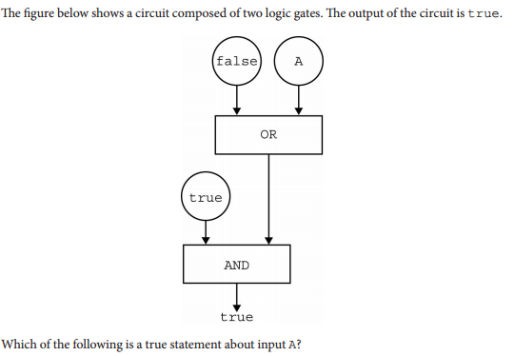

- Input A must be true
- Input A must be false
- Input A can be either true or false
- There is no possible value of Input A that will cause the circuit to have the output true

- An office building has two floors. A computer program is used to control an elevator that travels between the two floors. Physical sensors are used to set the following Boolean variables.
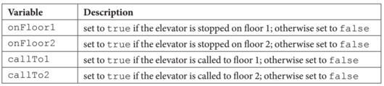
The elevator moves when the door is closed and the elevator is called to the floor that it is not currently on. Which of the following Boolean expressions can be used in a selection statement to cause the elevator to move?
  - (onFloor1 AND callTo2) AND (onFloor2 AND callTo1)
  - (onFloor1 AND callTo2) OR (onFloor2 AND callTo1)
  - (onFloor1 OR callTo2) AND (onFloor2 OR callTo1)
  - (onFloor1 OR callTo2) OR (onFloor2 OR callTo1)
Optional: If you have extra time, watch the How to make a 4 bit adder on YouTube at https://www.youtube.com/watch?v=czHU_fR3PtI. See if you can make your own 4 bit adder.

This assignment was inspired by Mobile CSP Lesson 2.10

