AP Computer Science Principles Lab
Hack your own password using Wireshark

In this lab you will use a web browser and with a protocol analyzer program called wireshark to learn how hackers can gain access to passwords and other sensitive information if it is not encrypted. This is sometimes called "replay."

- Start wireshark by going to the start menu and choose All programs | wireshark.
- Click on the interface list. You may see two interfaces. One may be labeled "sun" for the virtual machine. You'll be using other interface that has more traffic.
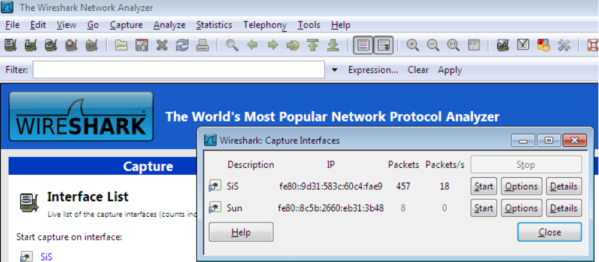
- Open the Chrome webbrowser (other browsers may not work). We need to find a website that uses an unsecured login like ftp://ftp.frognet.net/ ftp://ftp.fuller.net/ ftp://tigertech.net/ ftp://ftp.got.net/ ftp://ftp.iconnect.net/
- Don't log in yet though, first you need to start capturing the packets in wireshark
- Click Start for the interface in wireshark
- Since we are logging into an unsecured site, don't use the same password you use at secure sites. For this activity you don't actually have to login. Just try to login using a bogus email address and password.
- After attempting to login, you can go back to wireshark and stop capturing packets. Choose Capture | Stop
- In the filter box, type ftp and hit enter
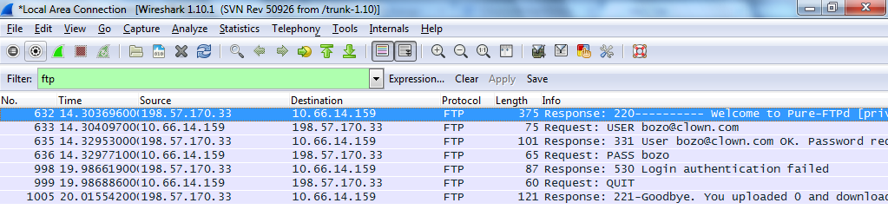
- You should be able to find two packets whose source starts with 10.66 (the ip address of your computer) and whose destination is 198.57.170.33 (the ip address of frognet.net) that contain your USER name and PASS word. Show your instructor the username and password on before moving to part two.

